Smart ride

Transportation for a Smarter City

May 17, 2016

Cognizant Technology Solutions

Contents

Introduction 3

Effectiveness 3

Effectiveness(User Point Of view) 3

Effectiveness(Transport Company Point Of view) 4

Sequence Diagram 5

Device Registration 5

Conclusion 7

1. **Introduction**

Smart Ride is an android application for the booking of public vehicles. Our solution proposes to optimize the size, cost and eventually the frequency of public vehicles plying through a set of predefined stops on a particular route. Thus the unwanted wastage of fuel, money etc. can be taken care of, with the help of this app. The scope of this application is that a person should able to register and book a vehicle by selecting pickup point, destination point, proper date and time. Once a passenger books a vehicle after giving all the required inputs, a QR code will generate on the basis of tentative or confirm booking. If booking is tentative then passenger needs to confirm the booking to avail the vehicle. Thus this application will properly evaluate and collect the actual cost of a journey from every passenger with ease.

1. **Effectiveness** 
   1. **User point of view**
2. **Clear and Simple Overview**

Our application is really simple as within few minutes and with few clicks we can book a vehicle ticket. One of the greatest advantages of online vehicle booking is for the busy travelers who don't have much time to book or purchase tickets via ticket counters.

1. **Different kinds of booking**

The application contains two types of bookings e.g. tentative and confirm. Suppose a passenger does not have enough money in his/her wallet to book confirm tickets for the next day, in that case the passenger can temporarily book a slot in the allocated vehicle by booking tentative tickets in which he doesn’t have to pay any money until he changes it to confirm booking.

1. **Proper bus timings**

This application helps the user by providing proper timing of vehicles hence helping them saving their valuable time.

1. **Idea of availability of seats**

The application helps the passenger to have an idea about the rush and availability of seats.

1. **Reliable vehicle size**

During the rush hours if the allocated vehicle gets overcrowded, passengers will get more number of vehicles in that particular route within a gap of few minutes.

1. **Vehicle Tracking**

User can also track the vehicle in which he had booked the ticket.

1. **Open for 24X7 to receive bookings**

This system allows the passenger to perform booking 24 hours a day; therefore, this booking service is always open.

* 1. **Transport company point of view**

1. **All the customer data is in a structured system**

This application holds all the previous passengers’ data in a structured manner. It is important as it will evaluate each passenger’s request for availability of seat in the vehicle. This customer list will be a best-valued resource from business point of view.

1. **Cost effective**

It is very cost effective as the size of the vehicle which will be allocated, is decided depending upon the number of passengers who have booked ticket, which is obtained from statistical data analysis over a period.

Suppose at 5 am the number of passengers are only 5. So allotting a big 30 seater bus will not be cost effective. For that we can give a 5 seater vehicle. Similarly during office hours, if there is huge rush for a particular route then according to the sum of the number of confirm bookings and some percent of tentative bookings, transport company can allot more number of vehicles in a gap of only few minutes. This will serve both cost effective as well as good transportation service for passengers.

1. **Proper Ticketing System**

If a passenger gets down after the stoppage up to which he had booked the ticket, the fare will not come back in his wallet. The whole freezed amount will be deducted from the wallet, hence making it a reliable ticketing system.

1. **Sequence Diagram**
   1. **Device Registration**

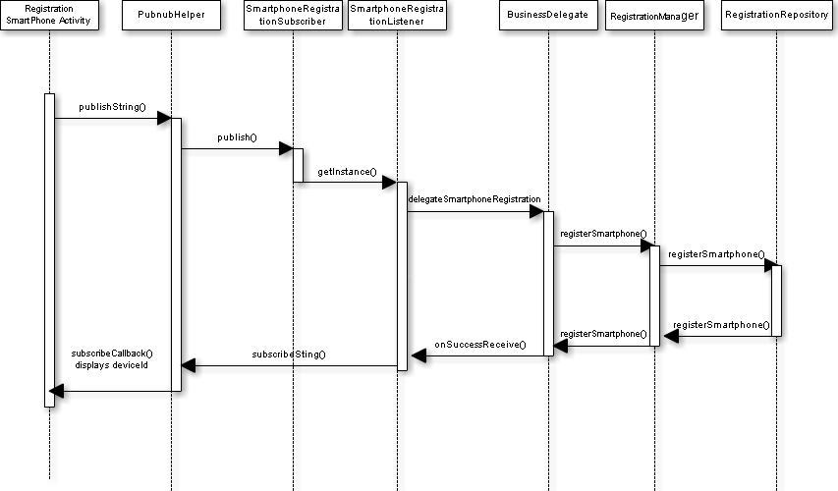

1. **Conclusion**

Smart ride is an android application for vehicle booking, which enables passengers to check availability of bus tickets, buy and pay tickets as a form of QR which needs to be scanned. It makes the passengers easy to get tickets online instead of queuing up. Smart ride is built to manage and computerize the traditional database, ticket booking, tracking the vehicle and travel is made easy.