System Requirement and Installation

**Pre-requisite software link for running this project**:

* Apache maven ( <https://archive.apache.org/dist/maven/maven-3/3.0.4/binaries/apache-maven-3.0.4-bin.zip>)
* Oracle Database Express Edition 11g (<http://www.oracle.com/technetwork/database/database-technologies/express-edition/downloads/index.html> )
* Oracle SQL Developer ( <http://www.oracle.com/technetwork/developer-tools/sql-developer/downloads/index.html> )
* Eclipse (optional)

**Oracle setup :**

First install the Oracle Database Express Edition 11g software downloaded from the given link.

After installing setting Oracle Database:

* Create a New Database User with database username, application express username and password as **‘technge_smartride_dbuser’** required for setup of this project.

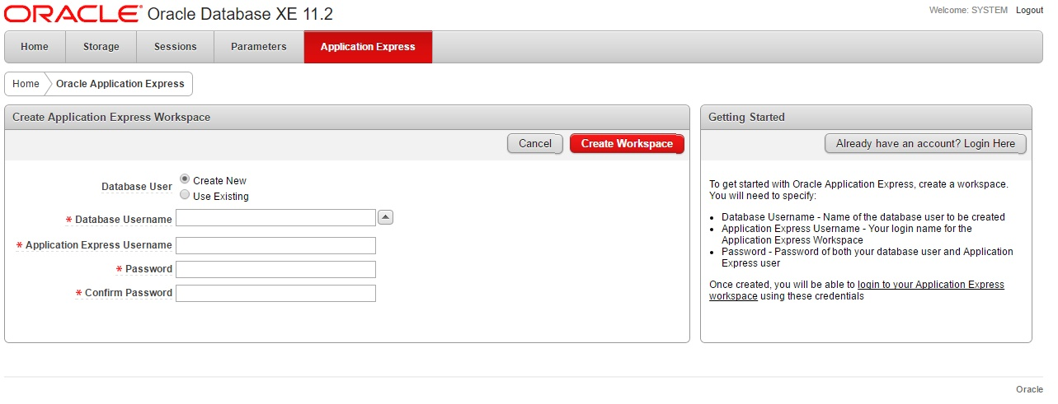

**Maven setup :**

Next you have to download the Apache maven from the provided link. After downloading you have to install that software. After installing you have to copy the path of the maven folder where maven has been already installed and provide it in system variable as shown below. You have to add this **‘%MAVEN_HOME%\bin’** in path system variable.

* First for MAVEN_HOME system variable

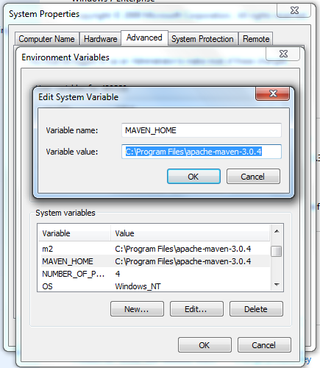

* Second for maven repository as m2 because local repository is required for maven.

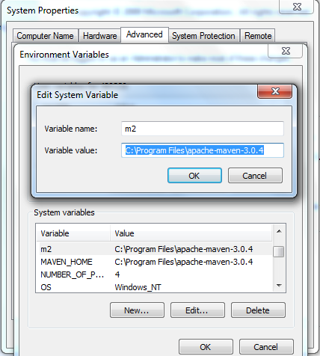

**Java setup :**

First you have download the jdk from the provided link. After installation, you have to set the path for jdk in system variable shown below:

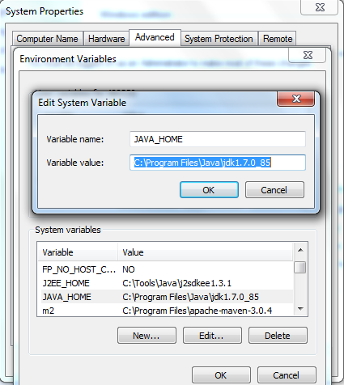

**Oracle Sql developer setup :**

* Now you have to download the Oracle SQL Developer from the provided link and install it.

After installing you have to create a new connection. After opening a new tab, you have to fill the required details as provided below. Connection_Name, Username and password has same value as **‘techengage_smartride_dbuser’**. At last you have to connect as provided below.

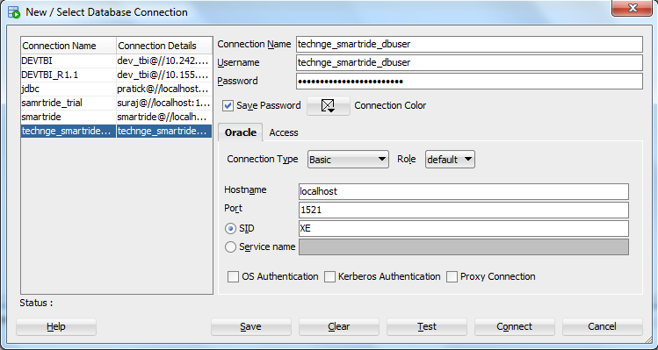

Running the application

**Setting Ojdbc connection jar:**

* First you have to create a folder as **com->oracle->ojdbc6->11.2.0** in this sequence inside this path: **C:\Users\480239\.m2\repository**. Now you have to copy the **backend_code_all** folder in your system and from there you have to copy an ojdbc jar from this path : **backend_code_all\db-connection-utils\db_drivers** and paste it inside the above created folder: **com->oracle->ojdbc6-> 11.2.0.**

**Launching backend :**

* Now build the project i.e. **backend_code_all** folder using mvn clean install command of maven in command prompt.
* In sql developer you have to run the script as given in below file:



* After full build you have to run the script present in following path:

backend_code_all\smartride-main\src\main\scripts

* First for registration of device you have to run the start_registration_subscriber.bat file. Next for booking process you have to run the start_booking_subscriber.bat file using cmd.

**Launching frontend :**

* You have to copy the Smart Ride.apk, BusScanner.apk and BusStopScanner.apk present in ‘**android_code_all**’ folder.

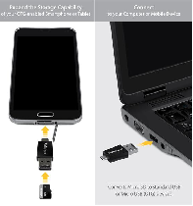

* Smart Ride.apk application runs for the purpose of registration and booking.
* BusScanner.apk runs for the purpose of entry in the bus by scanning the generated QR.
* BusStopScanner.apk runs for the purpose of confirming the offboard point and also for confirming ticket of tentative QR.