Linear Blending Skinning vs Dual Quaternion Skinning vs Spherical Blending Skinning

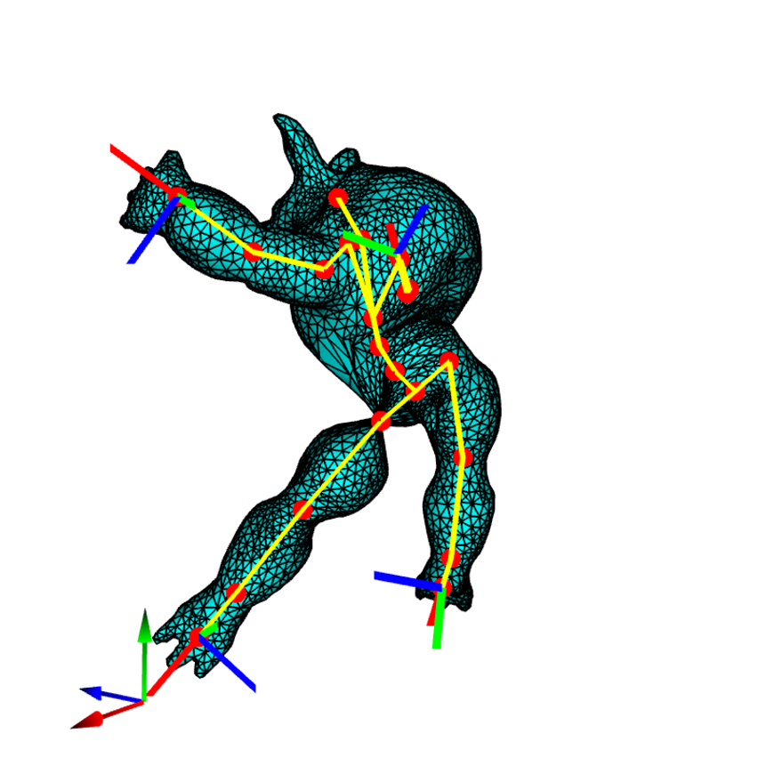

Image 1 Linear Blending Skinning

Image 2 Dual Quaternion Blending Skinning

Image 3 Spherical Blending Skinning

Linear Blending Skinning is easy to understand and implement. In normal circumstance, it has good results. However, when we start to stretch the algorithm extreme, it can produce unrealistic deformations in some areas. Image 1 demonstrated when we rotate the legs, LBS produces the classic “candy wrapper” effect around joints. Also, LBS is not excel at maintain volume. Elbow and keen areas tend to collapse when bent.

Dual Quaternion Skinning produces more natural deformations, especially around joints. It handles rotation and twist better than LBS, and it is better at maintaining the volume of the mesh during deformations. As shown above, image 2 preserves volume and mesh better under the same deformation as image 1.

Spherical Blend Skinning is less common than LSB but it offers improvements in how deformations around joints are handled. SBS uses SLERP between quaternion rotations to blend transformations. This method provide smoother and more natural deformations. Comparing to Dual Quaternion, SBS breaks easier under stress.

Pseduo Inverse IK vs Tikhonov IK vs Jacobian Transpose IK

Image 4 Pseudo inverse

Image 5 Tikhonov Regularization

Image 6 Jacobian Transpose

In general, Tikhonov regularization provides a smoother joint movement when Pseudo inverse. It is also more stable when we stretch the system to extreme. An example is shown above. In the image 3, Pseudo Inverse IK is applied. When stretching the mesh to a certain extent, the entire mesh will start destabilizing and move irregular. Image 3 demonstrates the max range I have tried to stretch the left arm without having the system destabilized. In image 4, Tikhonov regularization IK is used. The left arm is stretched far beyond it is in image 3 while the system remains very stable. In additional to the stabilization, when a part of mesh is moved under Tikhonov, the other part of the mesh moves slightly according smoothly. Though other parts of mesh also move under Pseudo inverse, the movement usually are not as smooth as what occurs in Tikhonov.

Jacobian Transpose is primary used in robotics and numerical optimization. It uses the transpose of the Jacobian matrix, which relates a set of variables to their rates of change, to find an increment that can bring the system closer to the desired state. It is simpler and faster however it is not stabler. It may not always converge. The above is the maximum that the model can be stably stretched under Jacobian transpose.