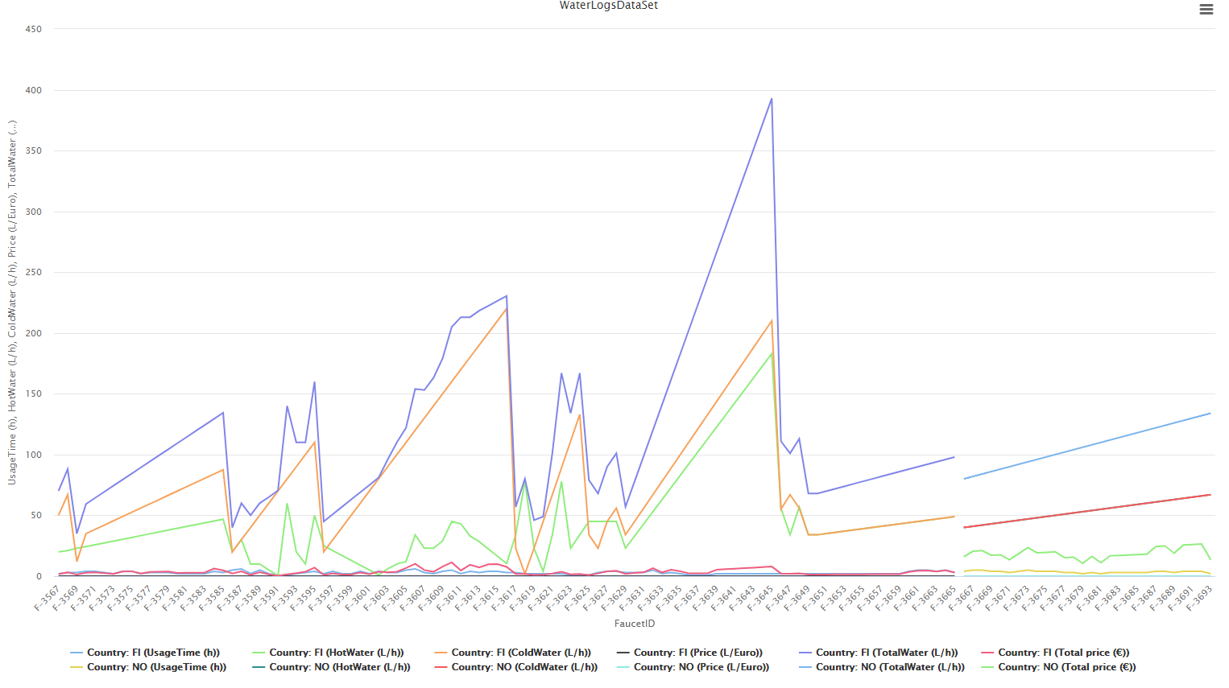Data Analytics:

Insights from above:

1. Norway uses less hot water than us (Finland)
2. The price of water (L) is higher in Norway that leads people to use less water
3. Norway uses more cold water than us(Finland)

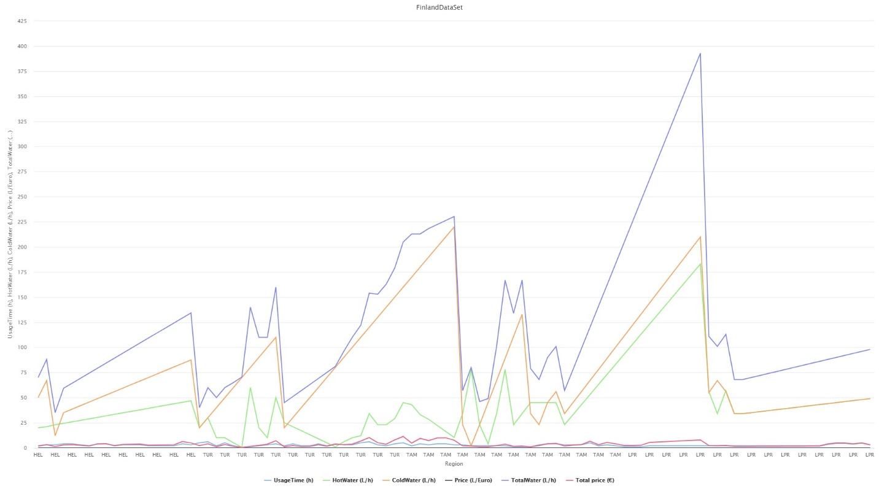

Insights from above:

1. Lappeenranta (LPR) uses more hot that other regions in Finland.
2. Tampere uses more cold water than others.
3. The price (L) is not similar in all regions of Finland.

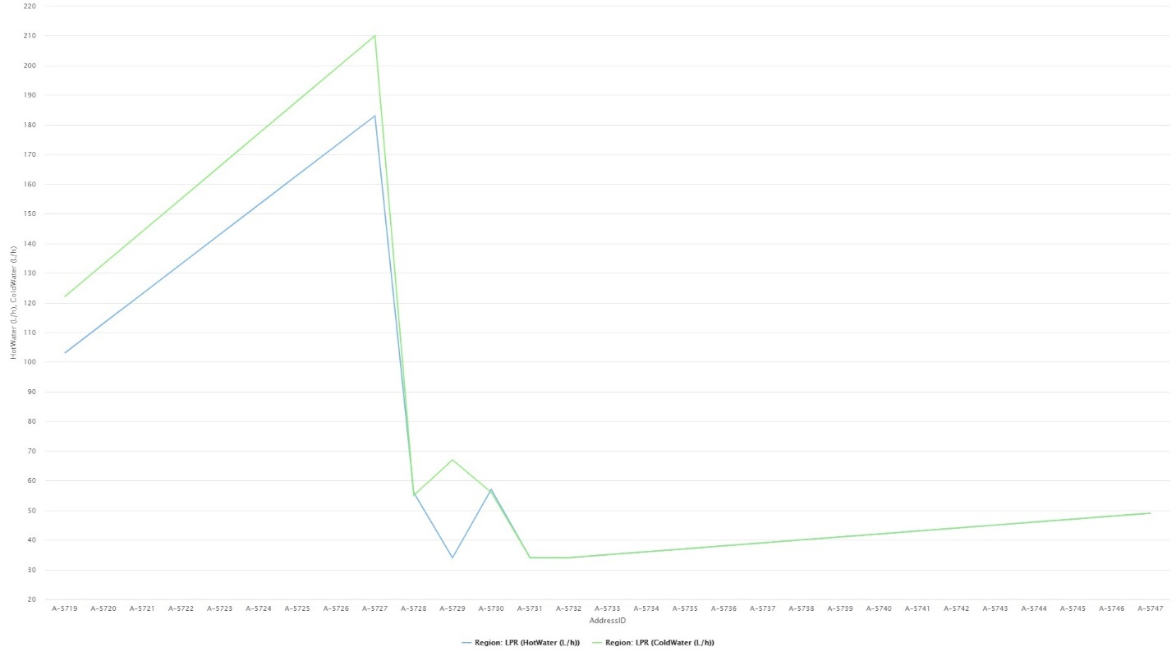

Insights from above:

1. Lappeenranta (LPR) municipal address ID A-5727 uses more hot and cold water.
2. Lappeenranta (LPR) municipal address ID A-5729 uses less hot water.

Machine Learning for Mining Knowledge:

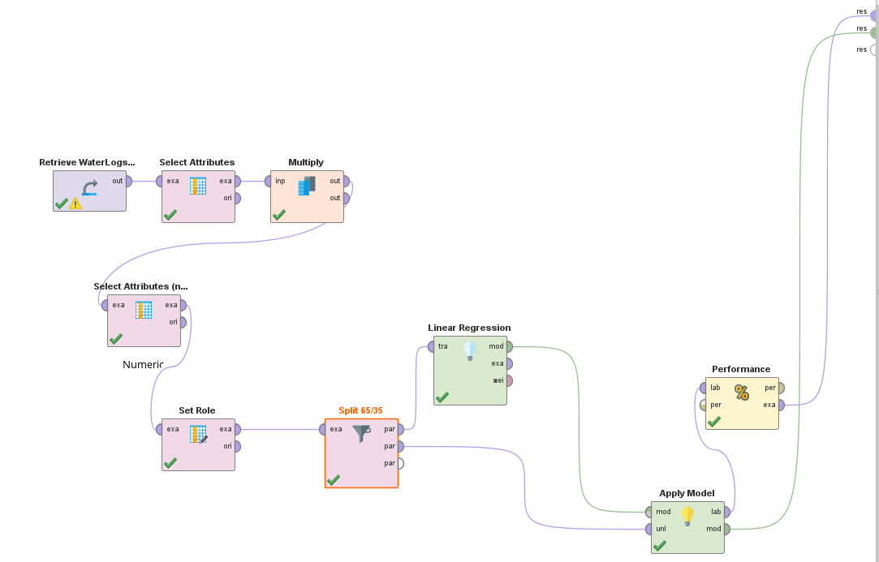Process of Work:

We used Waterlogs dataset for predicting total water usages using ML (KNN, Regression and Training model). From Waterlogs Dataset we select appropriate attribute sets and also choose numeric attributes to perform multiple linear regression. We used KNN supervised ML algorithm to perform multiple linear regression. After multiple linear regression, we use our main dataset as ratio 65% data for linear regression to build a training model and 35% data for predicting total water usages. Finally. We got the result.

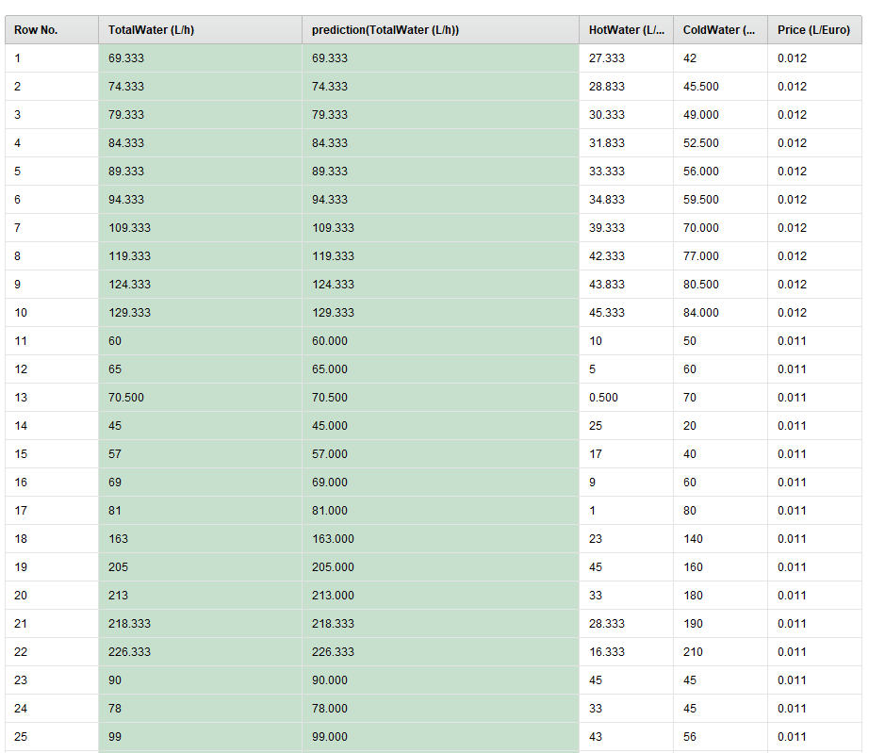

Insights from ML result:

1. Our ML training data model easily predict total water consumption based on price (L) changes.
2. We can draw many decision making insights from this Model.



