

electronic Customs management system
User Guide

On

Warehouse Declaration- aPPROVAL

Version: 1.0
Date: 05/09/2022

About Yang Khor Pvt Ltd

Yang Khor IT Solutions is a leading In-country Technology Solutions Provider providing solution in terms of hardware, software, support, and services as its complete package.
Yang Khor IT Solutions has been serving its purpose since 2005, it now has emerged to be an unprecedented leader as a Solution Integrator with a differentiated vertical approach to providing innovative solutions. Yang Khor uses its solution integration capabilities to integrate best-of-breed products through its key technology alliance partners to provide “End to End” solutions. Provide customized business solutions that help organizations accelerate revenue growth, increase market penetration, optimize operating costs and improve employee productivity, by embedding communication in their business processes.

Yang Khor IT Solutions has achieved to be the Gold Partner of HPE, Service One Partner of HPE, Microsoft Silver Partner and VMWARE Professional Partner and having this Partnership we are able to serve the best of solution to our clients. Yang Khor IT Solution initially focuses on providing the best solution in terms of hardware and software, to serve the purpose of making life better with the Advance Technology which the world is moving forward with.

DOCUMENT HISTORY
S.No | Date | Version. No | Description | Approved By
1 | 05/09/2022 | 1.0 | First Release

Contents
Chapter 1- About This Guide 4
Purpose and Audience 4
Document Conventions 4
Chapter 2- Getting Started 5
End-user experience of the self-service process 5
1. Logging In 5
1.1. Forgot/Reset password? 7
Chapter 3- Approve Exemption. 10
A. DRC Level 1 Exemption Approval 10
B. DRC Level Search Exemption 15
C. DRC Level 2 Exemption Approval 16
20
Chapter 4- Logging Out 20

Chapter 1- About This Guide
Welcome to the Trade Facilitation Baseline Customs Management System (eCMS) user guide for CFA USER! This user guide aims to enumerate the process and steps involved in using eCMS.
This user guide is divided into different topics and sub-topics. Each topic discusses and shows the steps of the modules that the eCMS.

Purpose and Audience
This user guide will help the user to get a quick reference on usage of the system.

Document Conventions
Refer to this section to familiarise yourself with the visual aids used throughout the user guide.
Navigation
To assist you with accessing screens, pages, or windows, refer to the following navigation format:
Click User Registration>>Users
Buttons, fields, and other system elements
All system elements are highlighted in Bold text.
Hyperlinks
All topics mentioned in the user guide’s content are hyperlinked. Click on the hyperlink to view the referenced topic.
Callouts
Callouts are presented differently from the original CONTENTS and highlight certain information.
There are two types of callouts: tips and warnings.

@ | A Tip provides useful information that helps you complete a task or procedure.

! | A Warning refers to information that may be critical to the system’s functionality and might affect data or system stability.

Chapter 2- Getting Started
Refer to this chapter to familiarize yourself with the eCMS System; how to log in, Approve Exemption, and log off from the system.

End-user experience of the self-service process

Logging In
To log in to the eCMS:
- Type in URL http://uat.ecms.gov.bt/ECMS/login/indexBhutan.jsp in your Internet browser to access the eCMS System.
- eCMS Front End landing page will display as below,

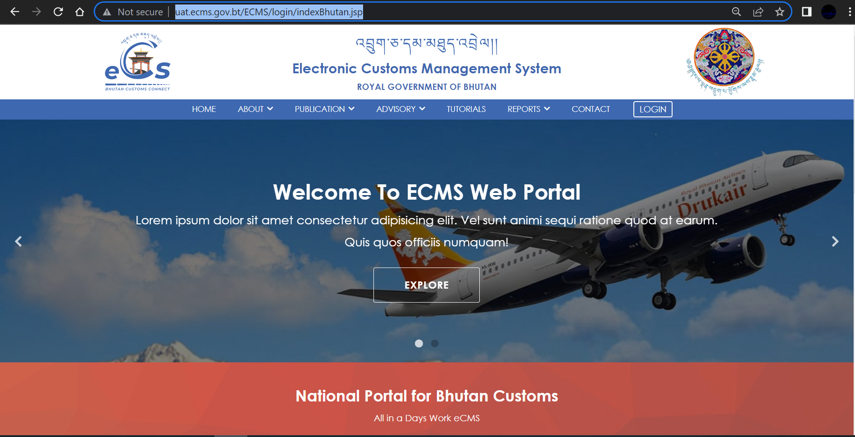

Fig.1. eCMS Landing page

- Click>>> LOGIN available on the top right corner of the landing page

  - Click >>LOGIN, the following login screen (Figure 2) is displayed

eCMS Login

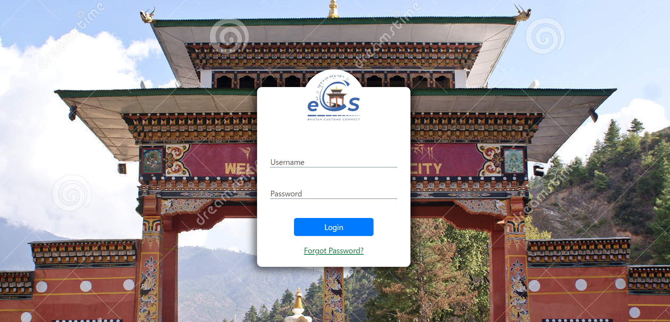
fig.2. eCMS login Page

  - Enter the USERNAME and the PASSWORD in the fields provided and Click button.

@ | In case you need to reset or forgot your password, On the login page, the user clicks the Forgot Password? link to start the process. The new password will be sent to your registered email.

Forgot/Reset password?
- If User Password is expired or forgot , Click >>“Forgot Password?”, “Forgot password Form” is displayed as shown in the figure 3 above.

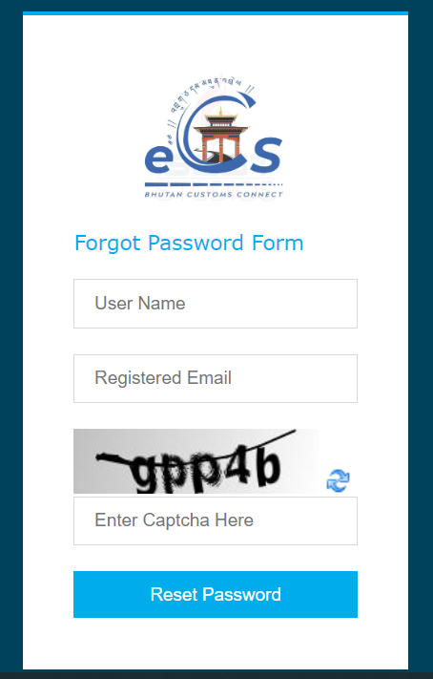
Fig.2. Forgot Password Form.
- Fill in the required details “User Name”, “Registered Email”, “Enter Captcha” and click on “Reset Password” Buttom. The subsequent screen is displayed;
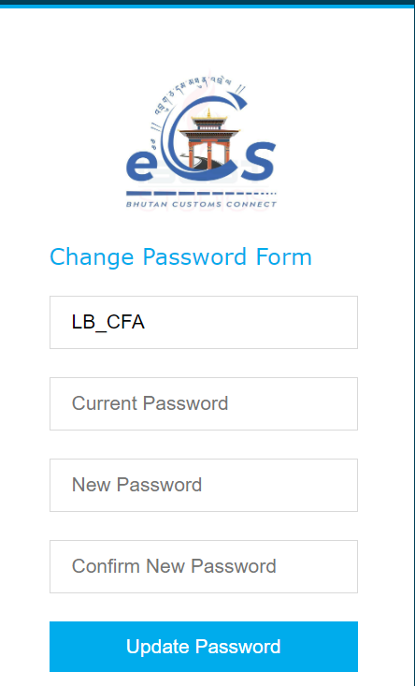
Fig.3. Update password

- Check your email for the password provided by the system and input in “Current Password” Field.
- Set your New Password and Confirm New Password.

- Click >> Update Password, the initial login page is displayed as below;

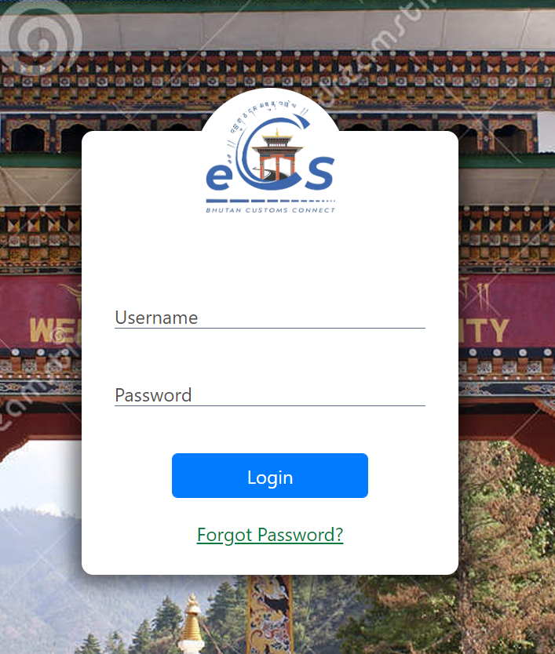
Fig.4. eCMS Login Page
- Enter the USERNAME and the NEW PASSWORD in the fields provided and Click “LOGIN” button.

Click>> LOGIN

- Upon successful login the Electronic Customs Management System Home Page will be displayed as shown below.
Dashboard Page

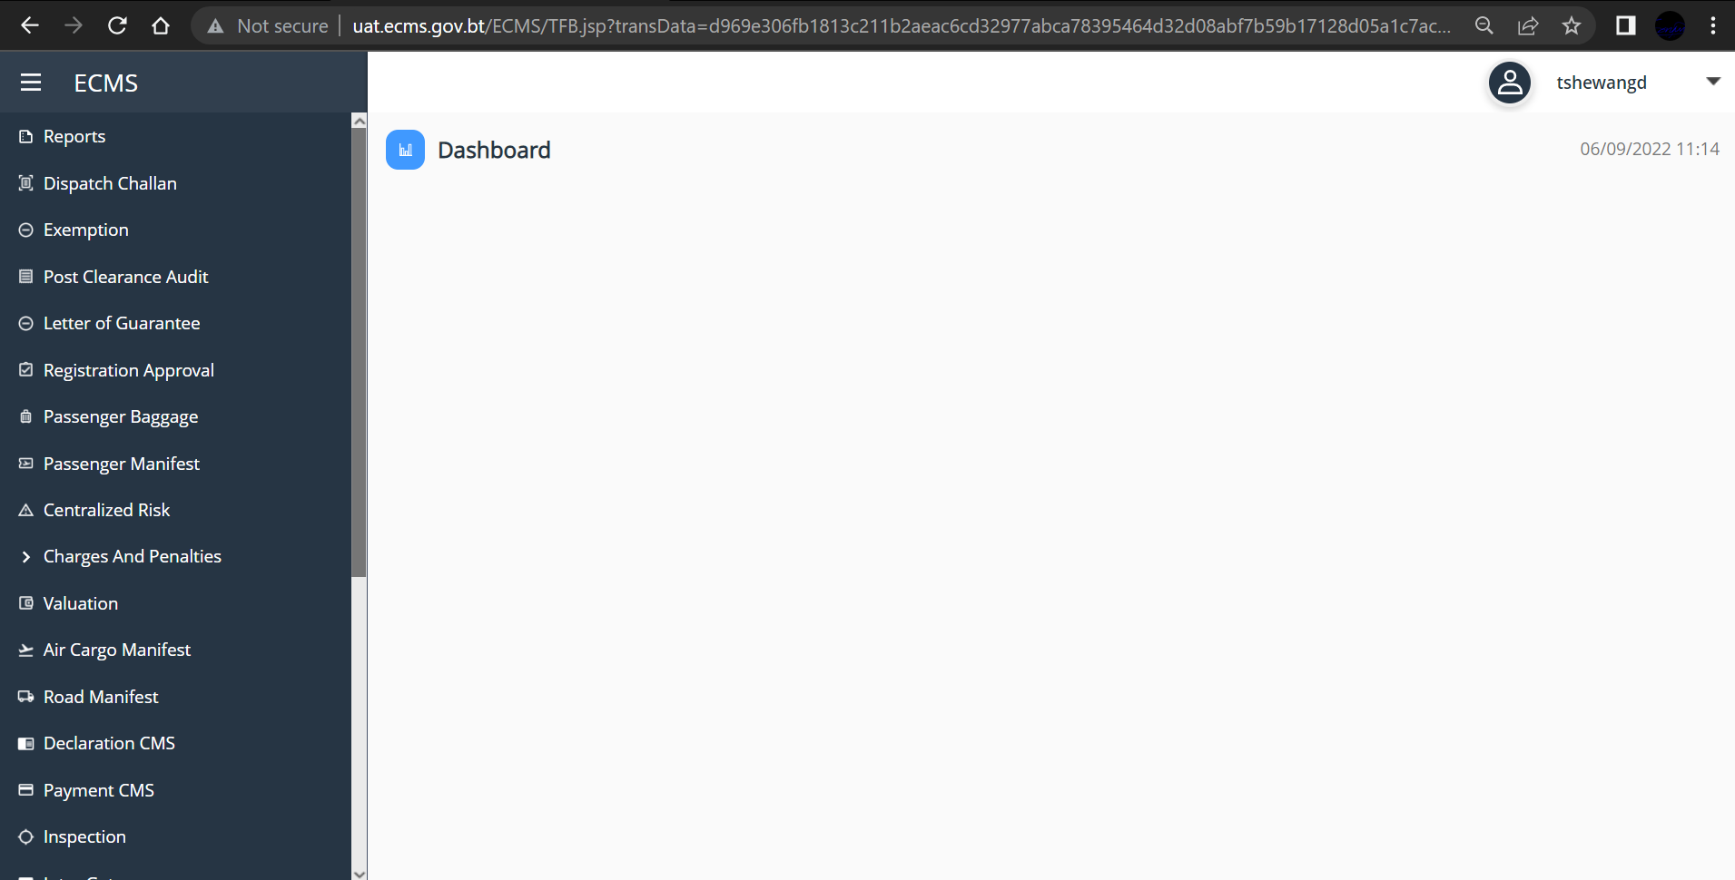
Fig.5. eCMS Dashboard (CFA)

Chapter 3- Approve Warehouse Declaration.

Warehouse Declaration Approval
- Go to Declaration menu and click on “Approve Declaration”. Subsequent Screen is displayed with the list of Declaration in the dashboard. Pending Declaration list are listed under “PENDING ACCEPTANCE DECLARATION”
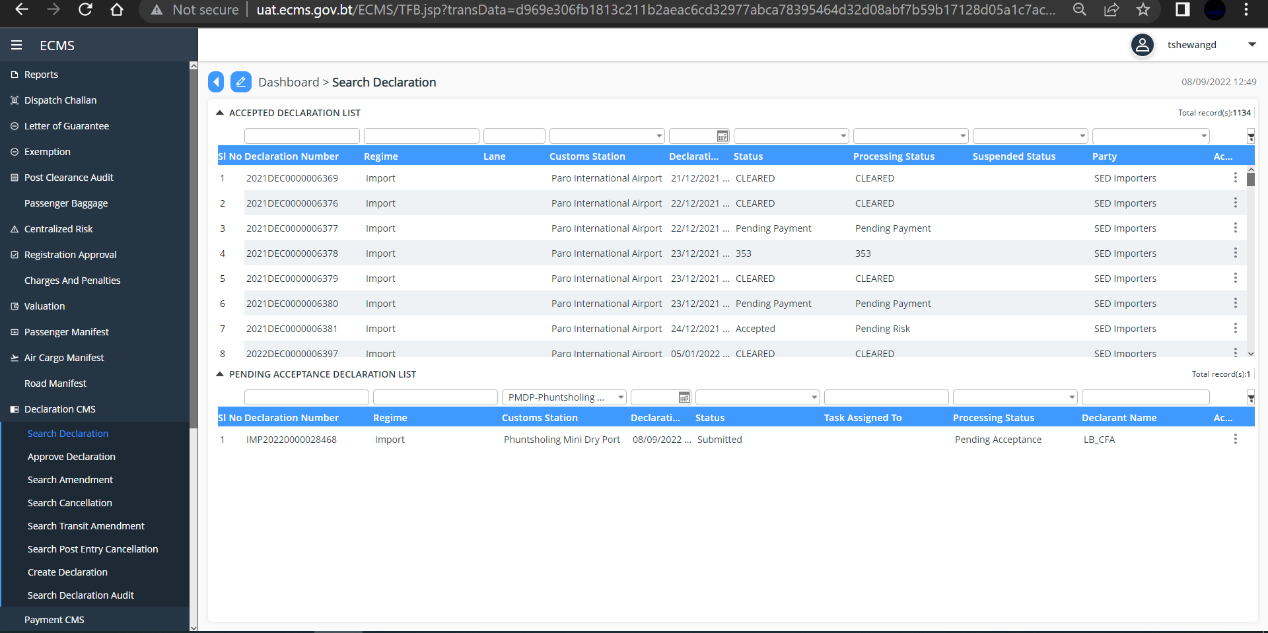
Fig.6. Approve Declaration Dashboard
@ | - You can track/search the Declaration with Declaration number/Regime/Customs Station/Date of Application/Status/Task assigned to/Processing Status/Declarant name/Action.
- Click on the Declaration to view details. The details can be view as below.

- General Information
Click to view the details
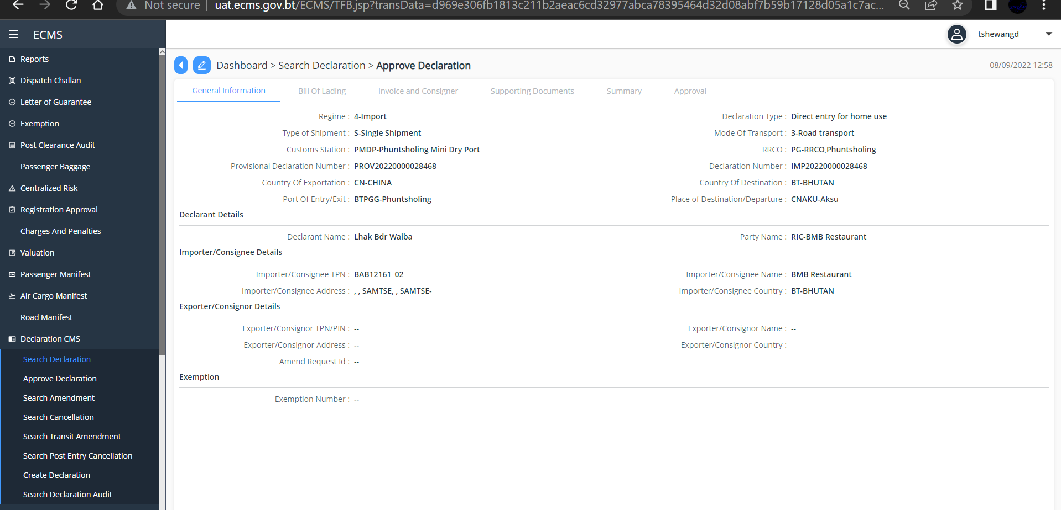
Fig.7. General Information
- Click>> Bill of lading,
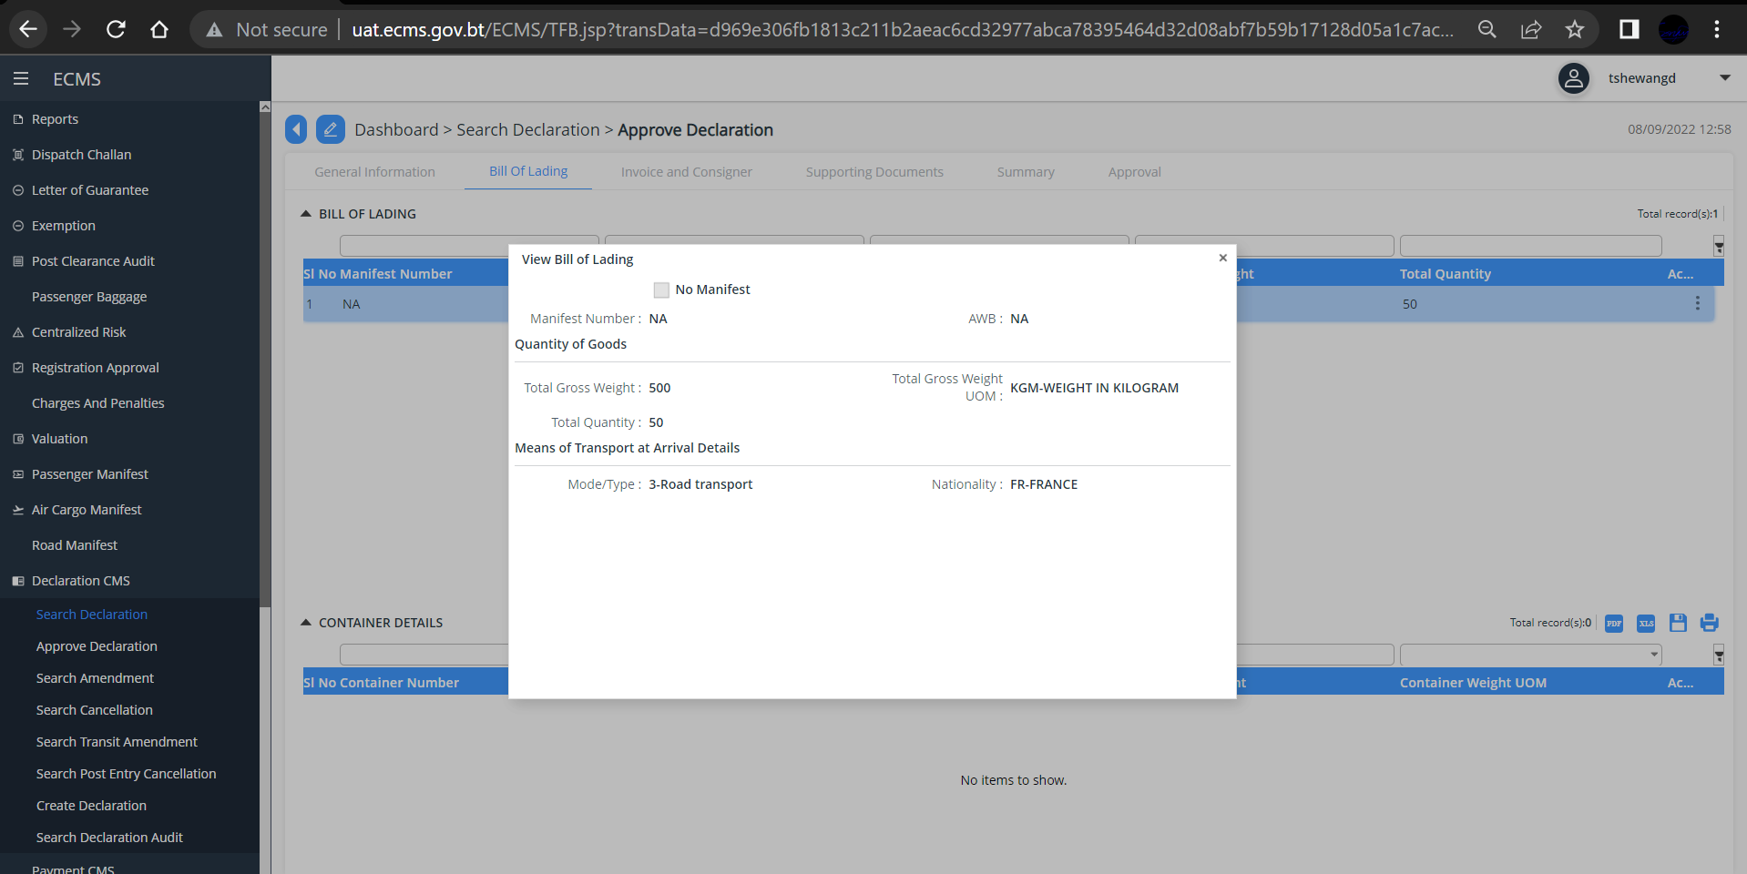
Fig.8. Bill of lading

- Invoice and Consignor
Click invoice and Consignor to View the Invoice and Commodity details
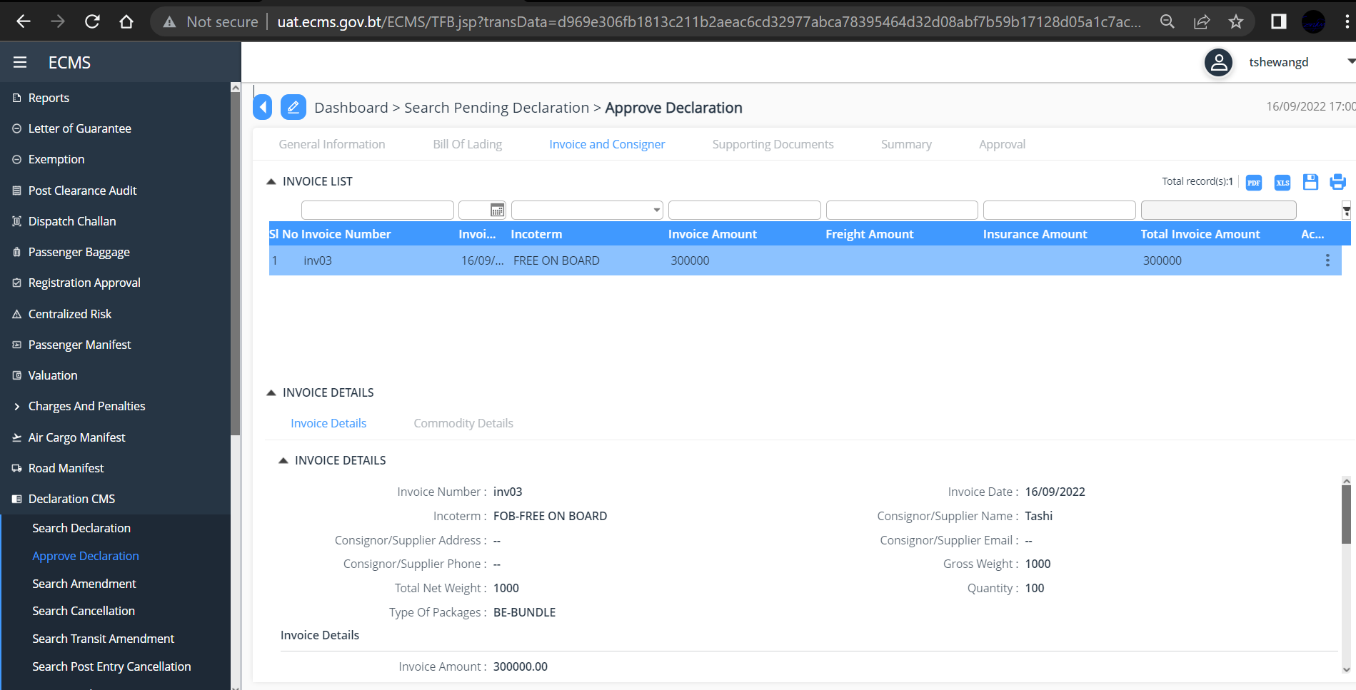
- Click>> Supporting Document
- Click on each item to view the details, OR Click the three dots available at the right end of the supporting document to view the details.
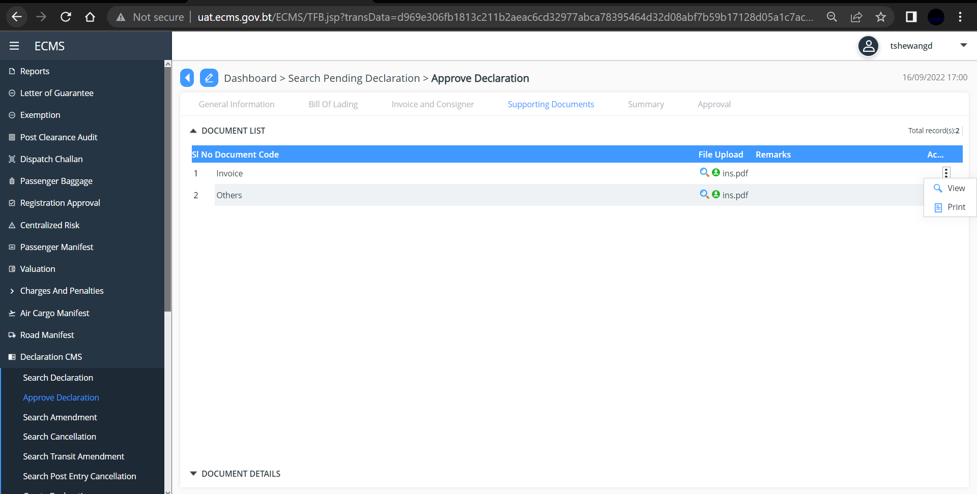
Fig.9.View supporting Document

- Click Summary, Subsequent Screen with Header details and Duty details is displayed
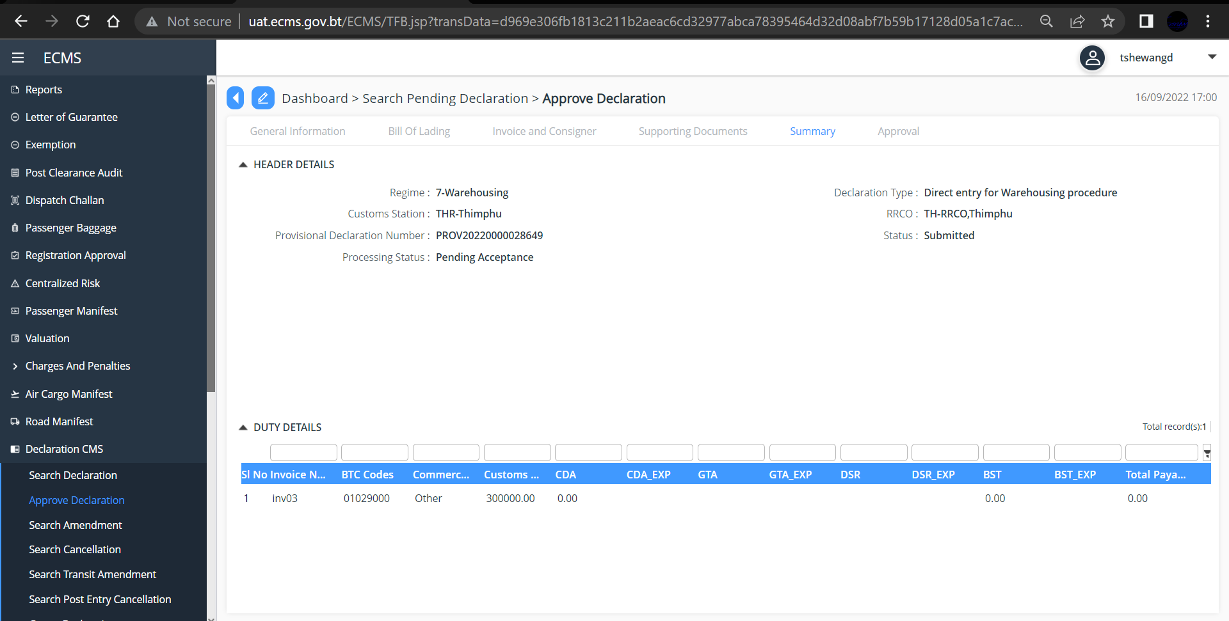
- Click>> Approval
Table item in Dropdown list consist of;

Field name | Drop down list | Description
*Status | Approved | Mandatory
 | Rejected
 | Rejected for Amendement
Remarks |  | Non-Mandatory
- From the dropdown list in the *Status Field” select your decision as “Approved”/” Rejected”/”Rejected for Amendment”.
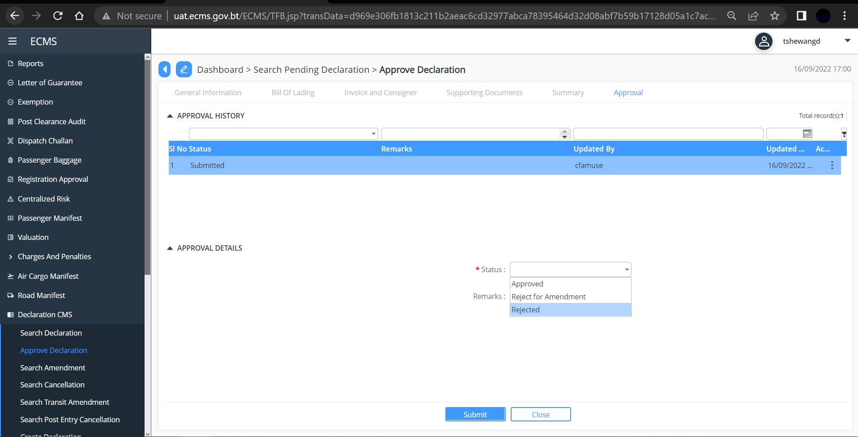
Fig.10. Approve Road Manifest
- Click >> “Submit”

B. Centralized Risk

- Select “Centralized Risk” from the menu and click on “Pending Risk Assessment”
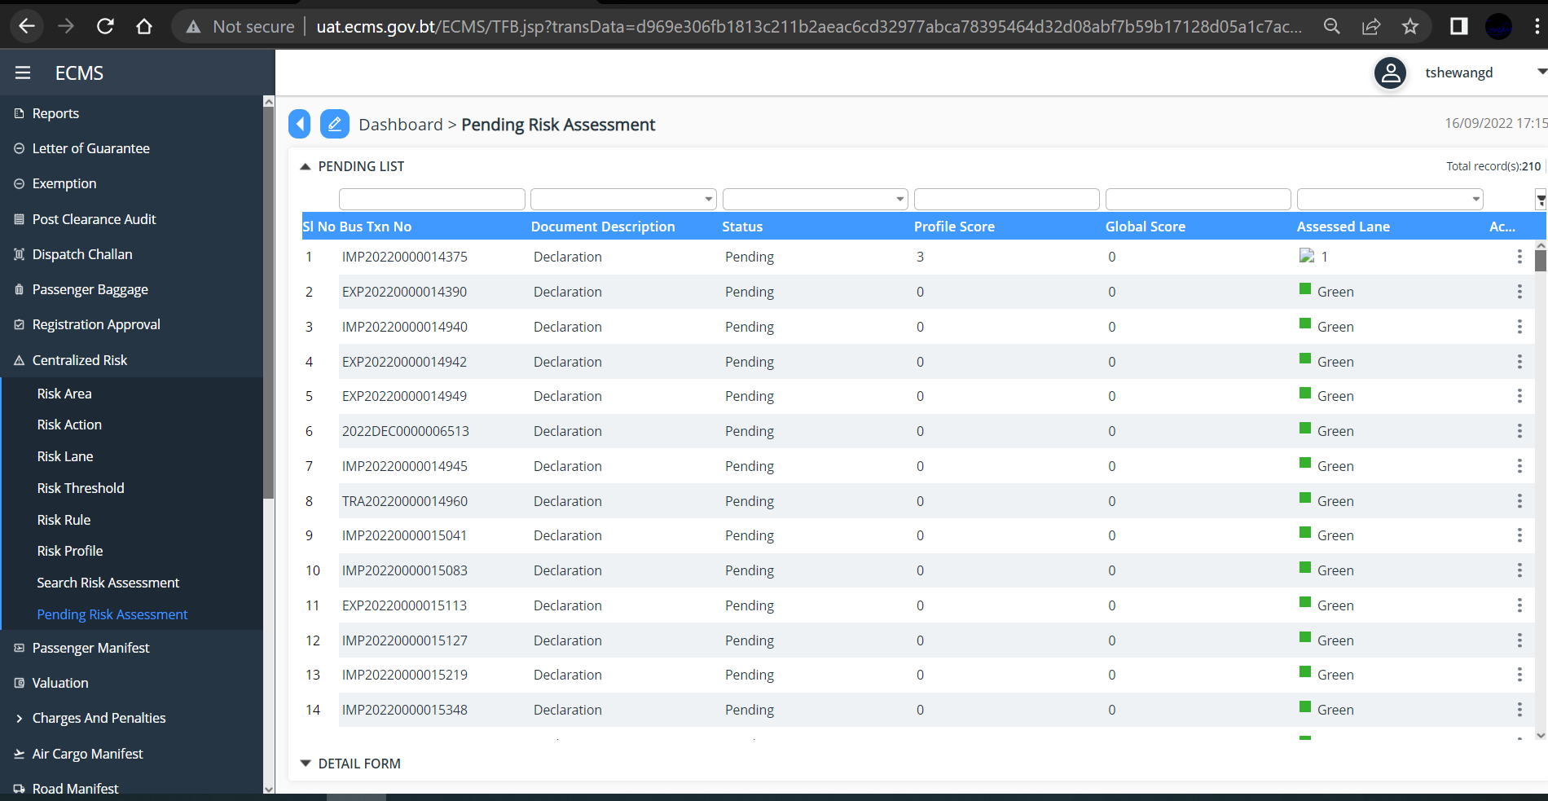

- Click on the item listes to view, below screen is displayed.
- Update the “Final Lane” from the dropdown base on its risk (Green, Yellow, Red, Blue)
- Add Remarks
- Click “Update”
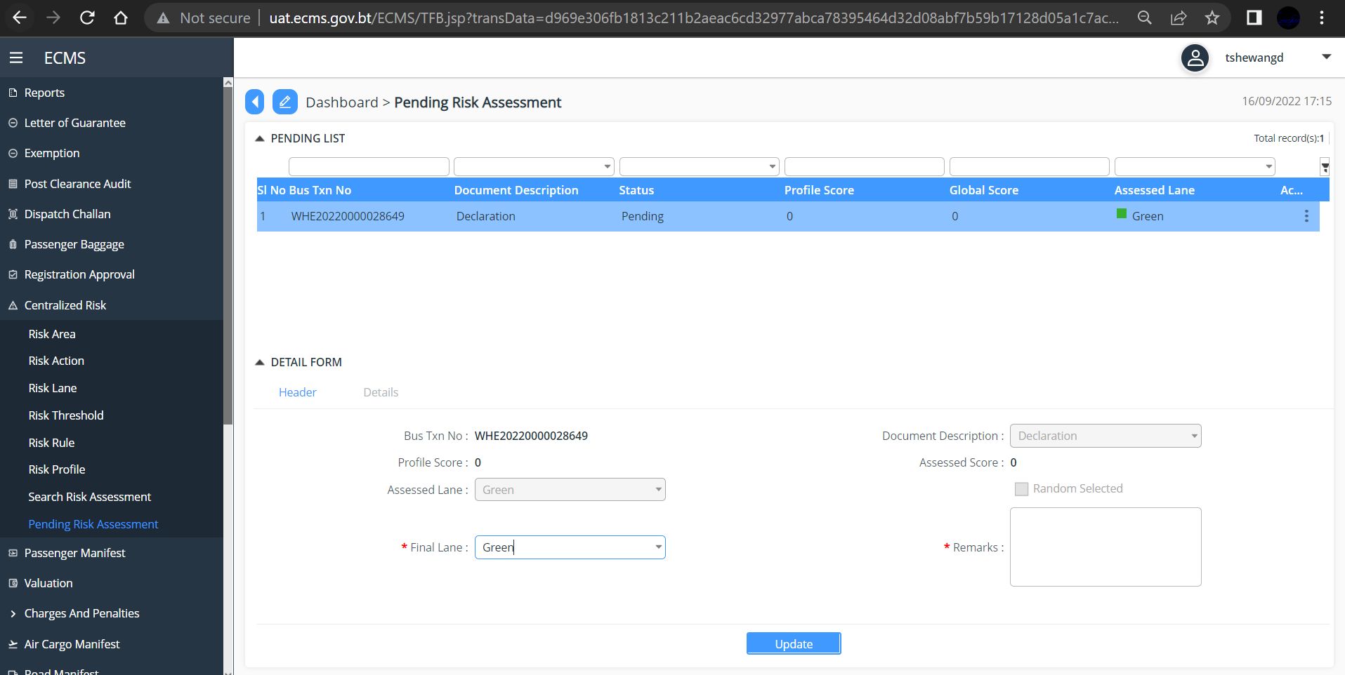

C. Release Order
1. go to Release in the menu and select “Release order”, Subsequent screen is displayed

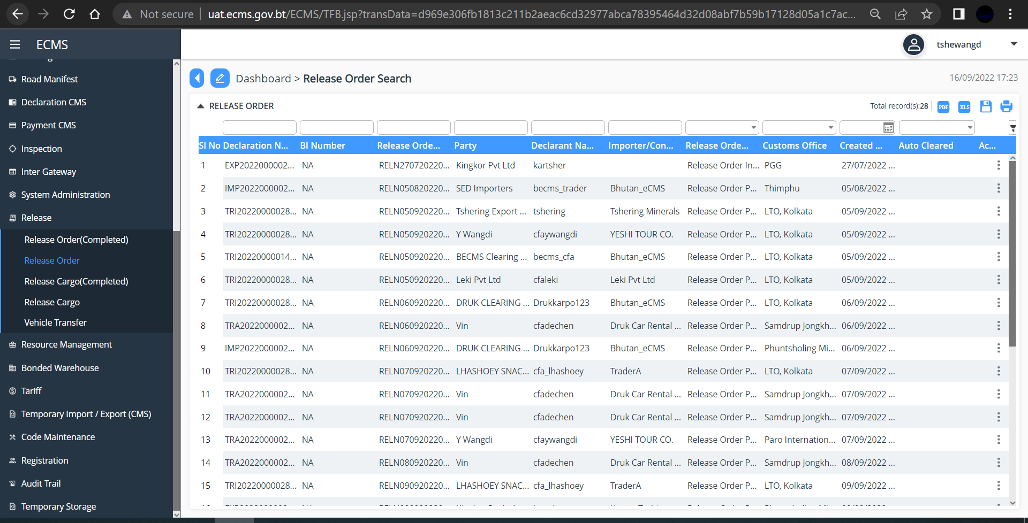

- Click on the item listed to view, subsequent screen is displayed
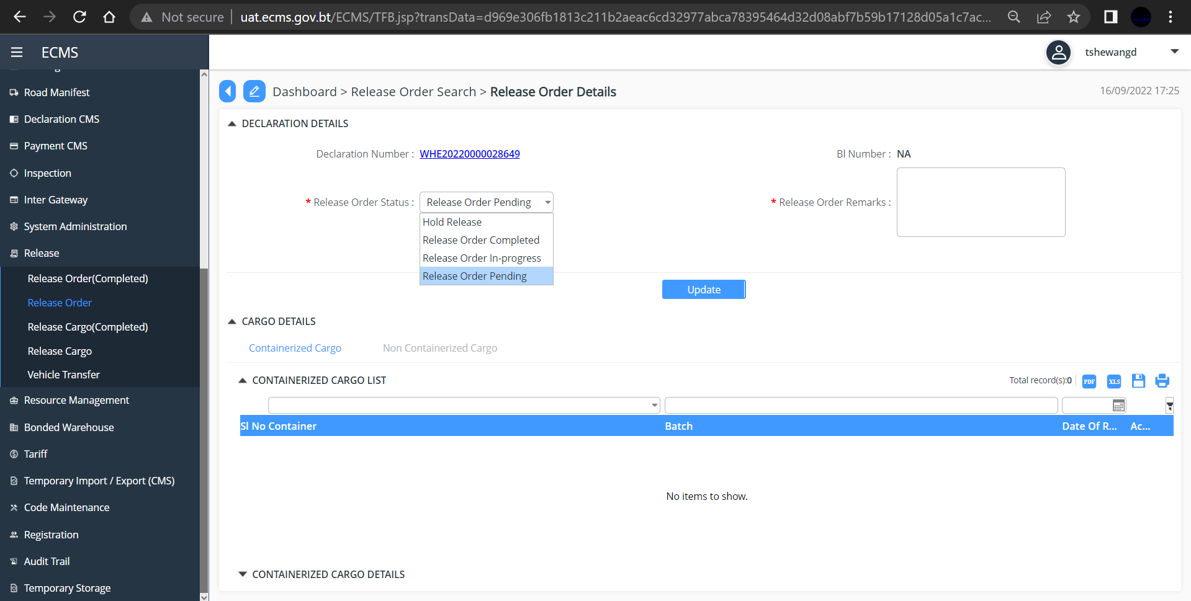

- Update the release Order Status as “ Release Order Completed”
- Fill up other mandatory fields
- Click “update”

D. Release Cargo

- Go to Release in the menu and select “Release Cargo” Subsequent Screen is Displayed
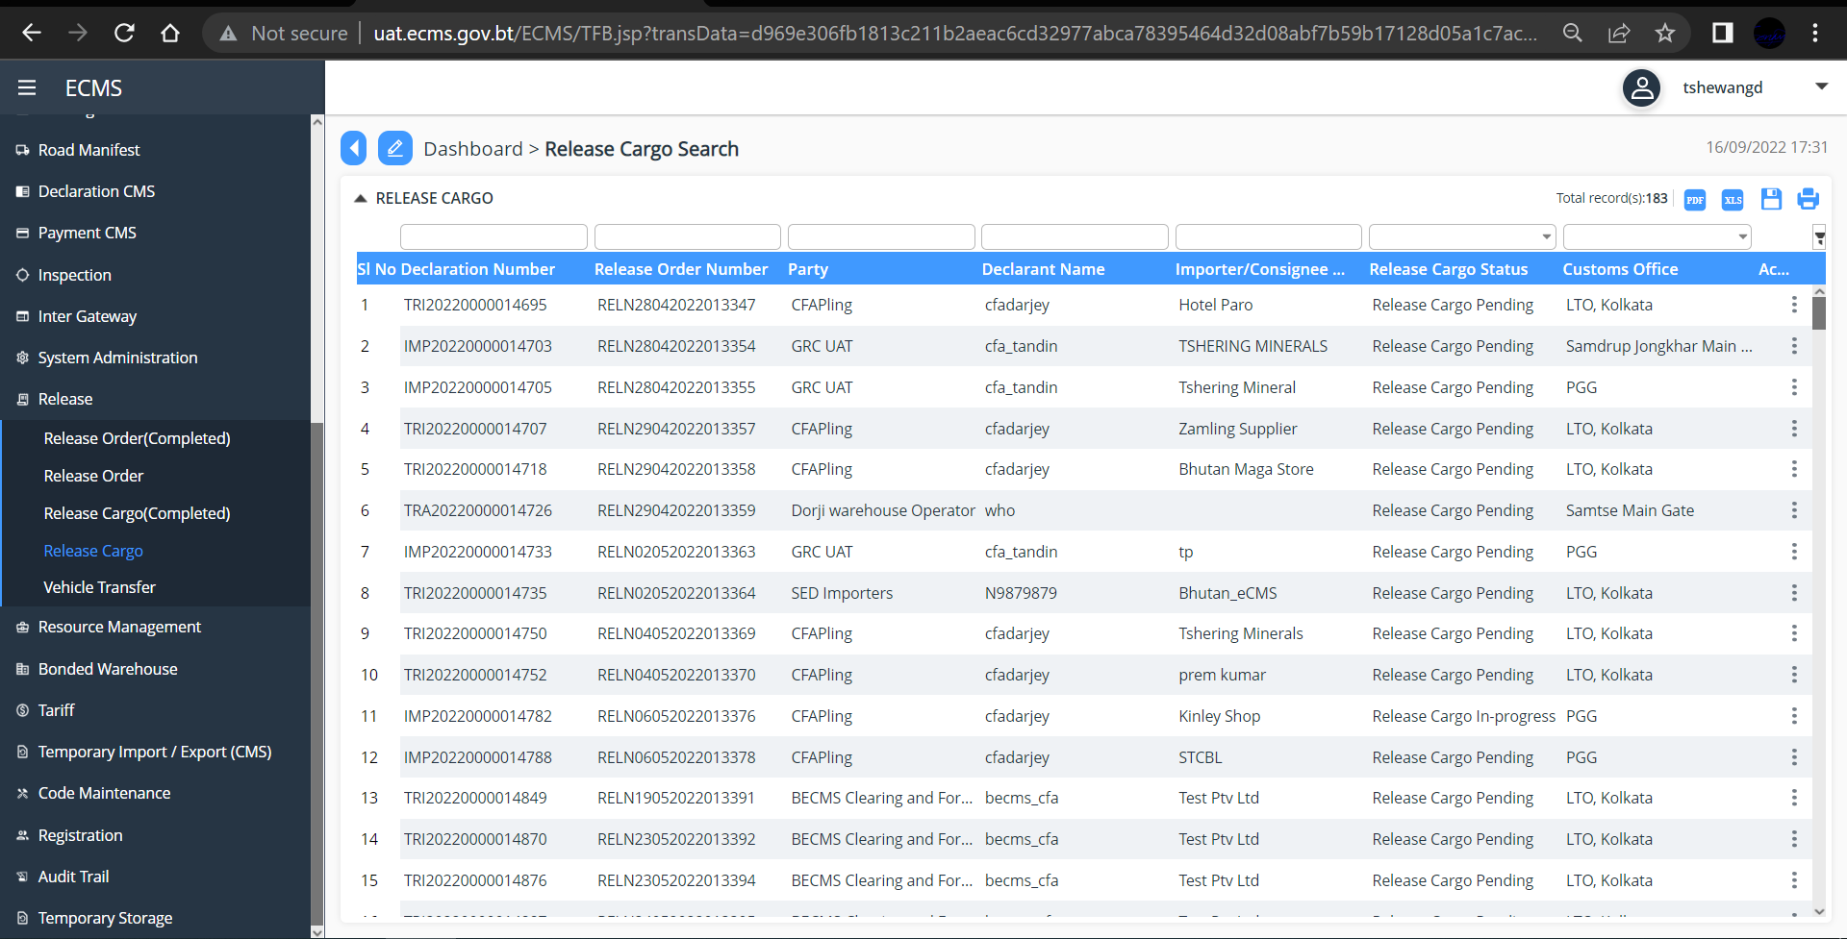

- Click on the item listed to view, subsequent screen is displayed
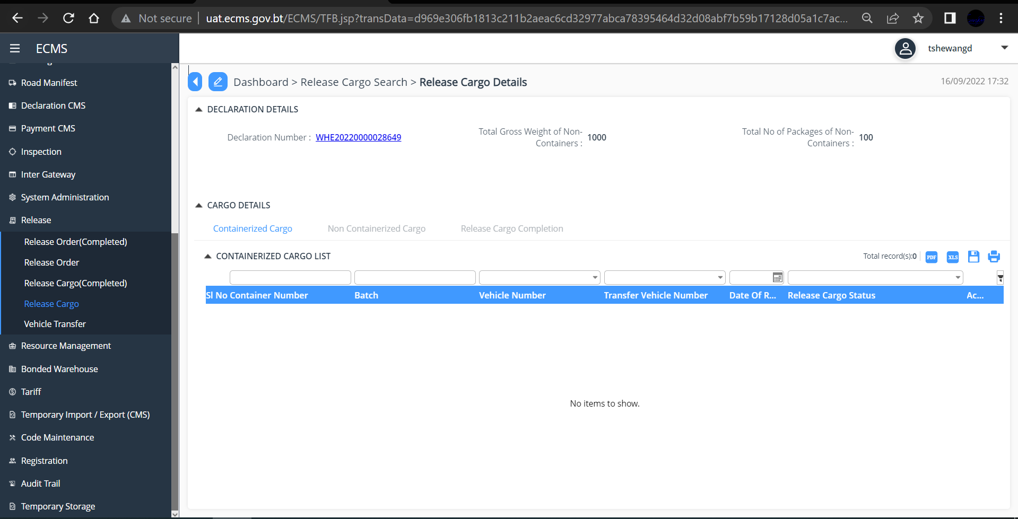

- If the cargo details submitted was containerized, click “Containerized Cargo” other wise click “Non-Containerized Cargo”. For Non-containerized Cargo, subsequent Screen is displayed.
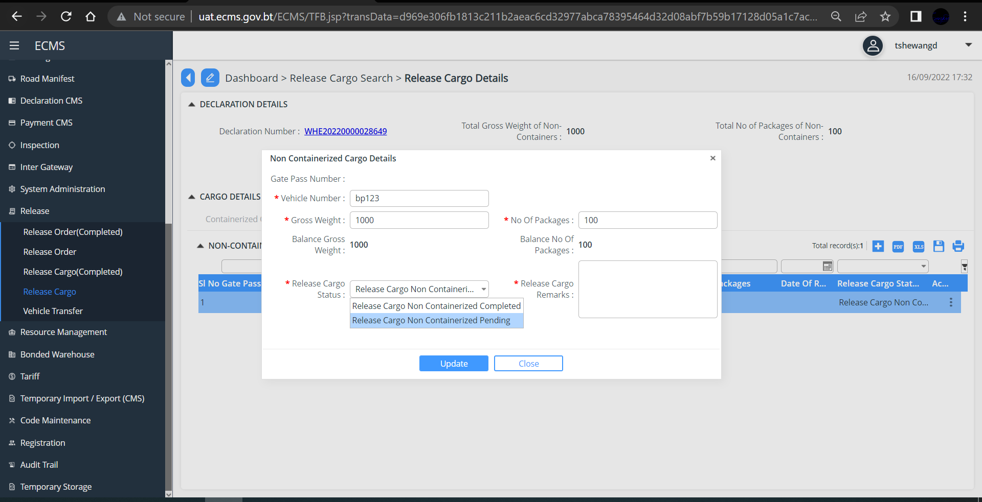
- Fill in all the mandatory fields and in the “Release Cargo Status” field Select the status as “ Release Cargo Non Containerized Completed”
- Click “Update”
- Go to “Release Cargo Completion” and under the Release Cargo Status, select “ Release Cargo Completed”

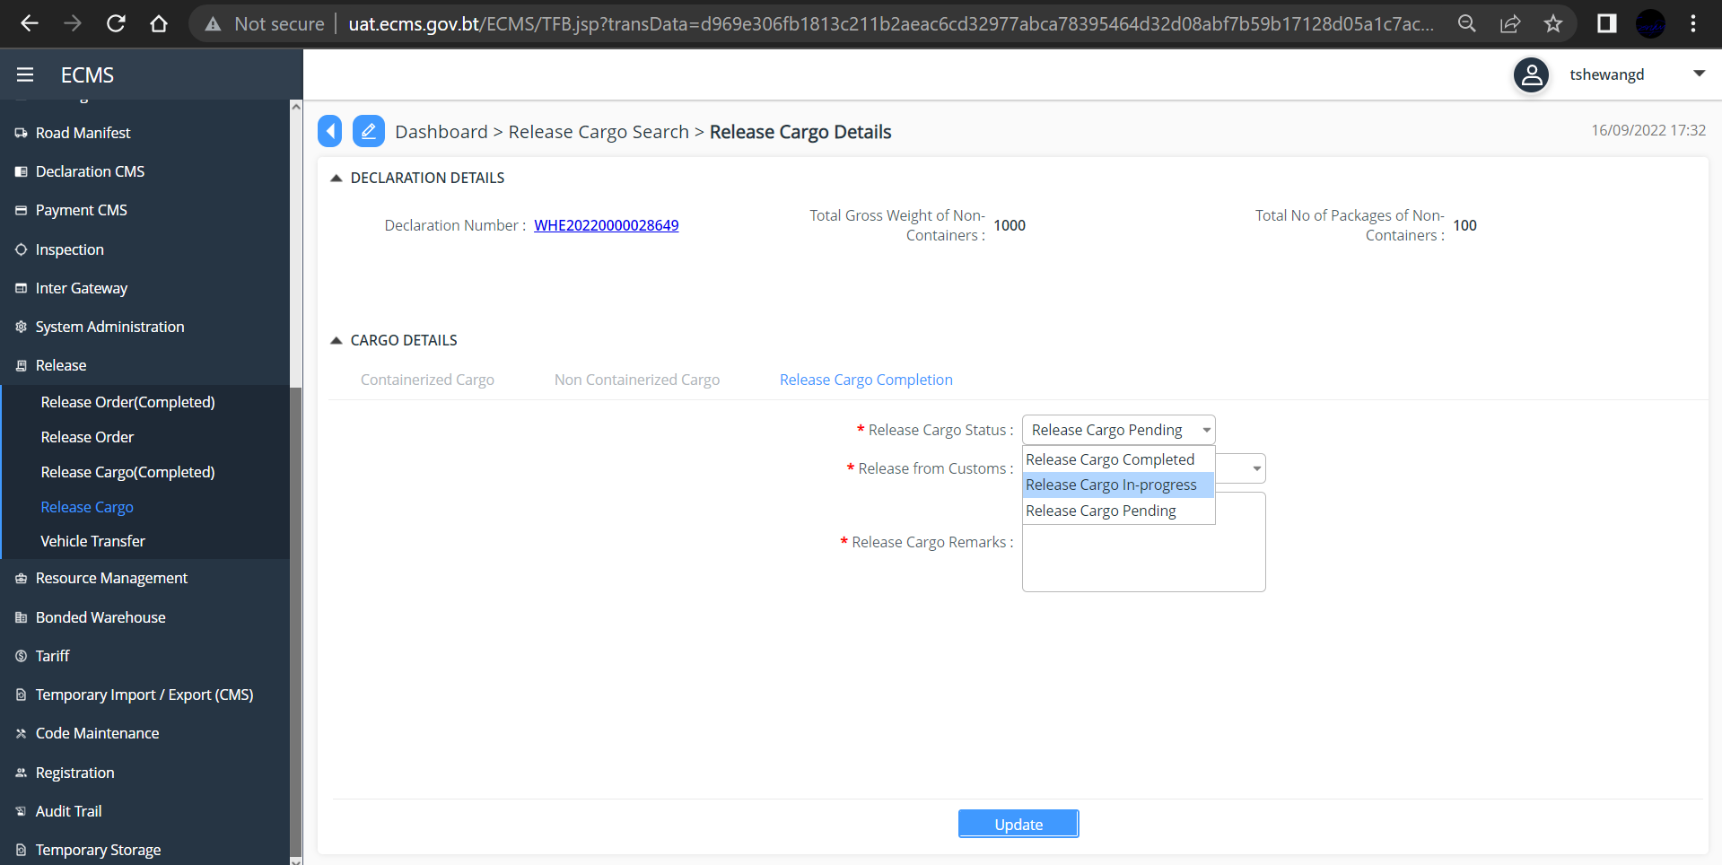

- Select “Yes” from the dropdown list in “Release from Custom” Field.
- Click “Update”
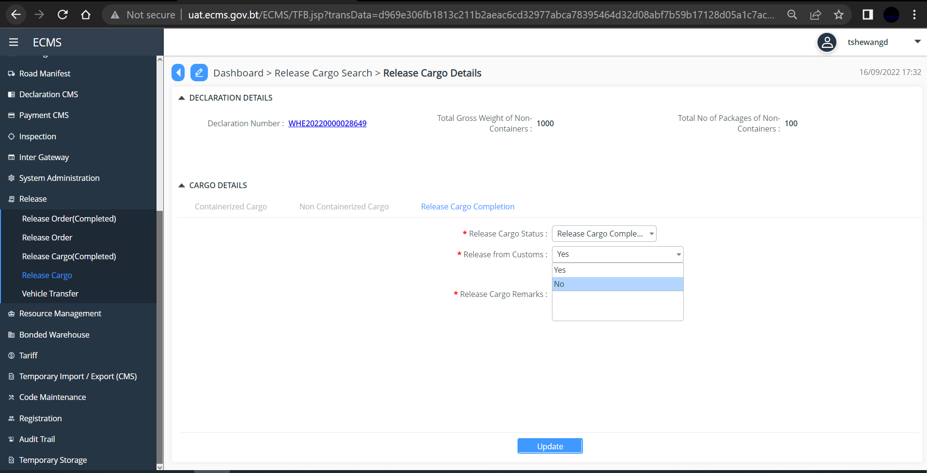

Approve EX-Warehouse after Warehousing Procedure

Approve Declaration
- Go to Declaration in the menu and click “Approve Declaration”. (You can Search the specific declaration by Searching the Declaration with Declaration number) as shown below.

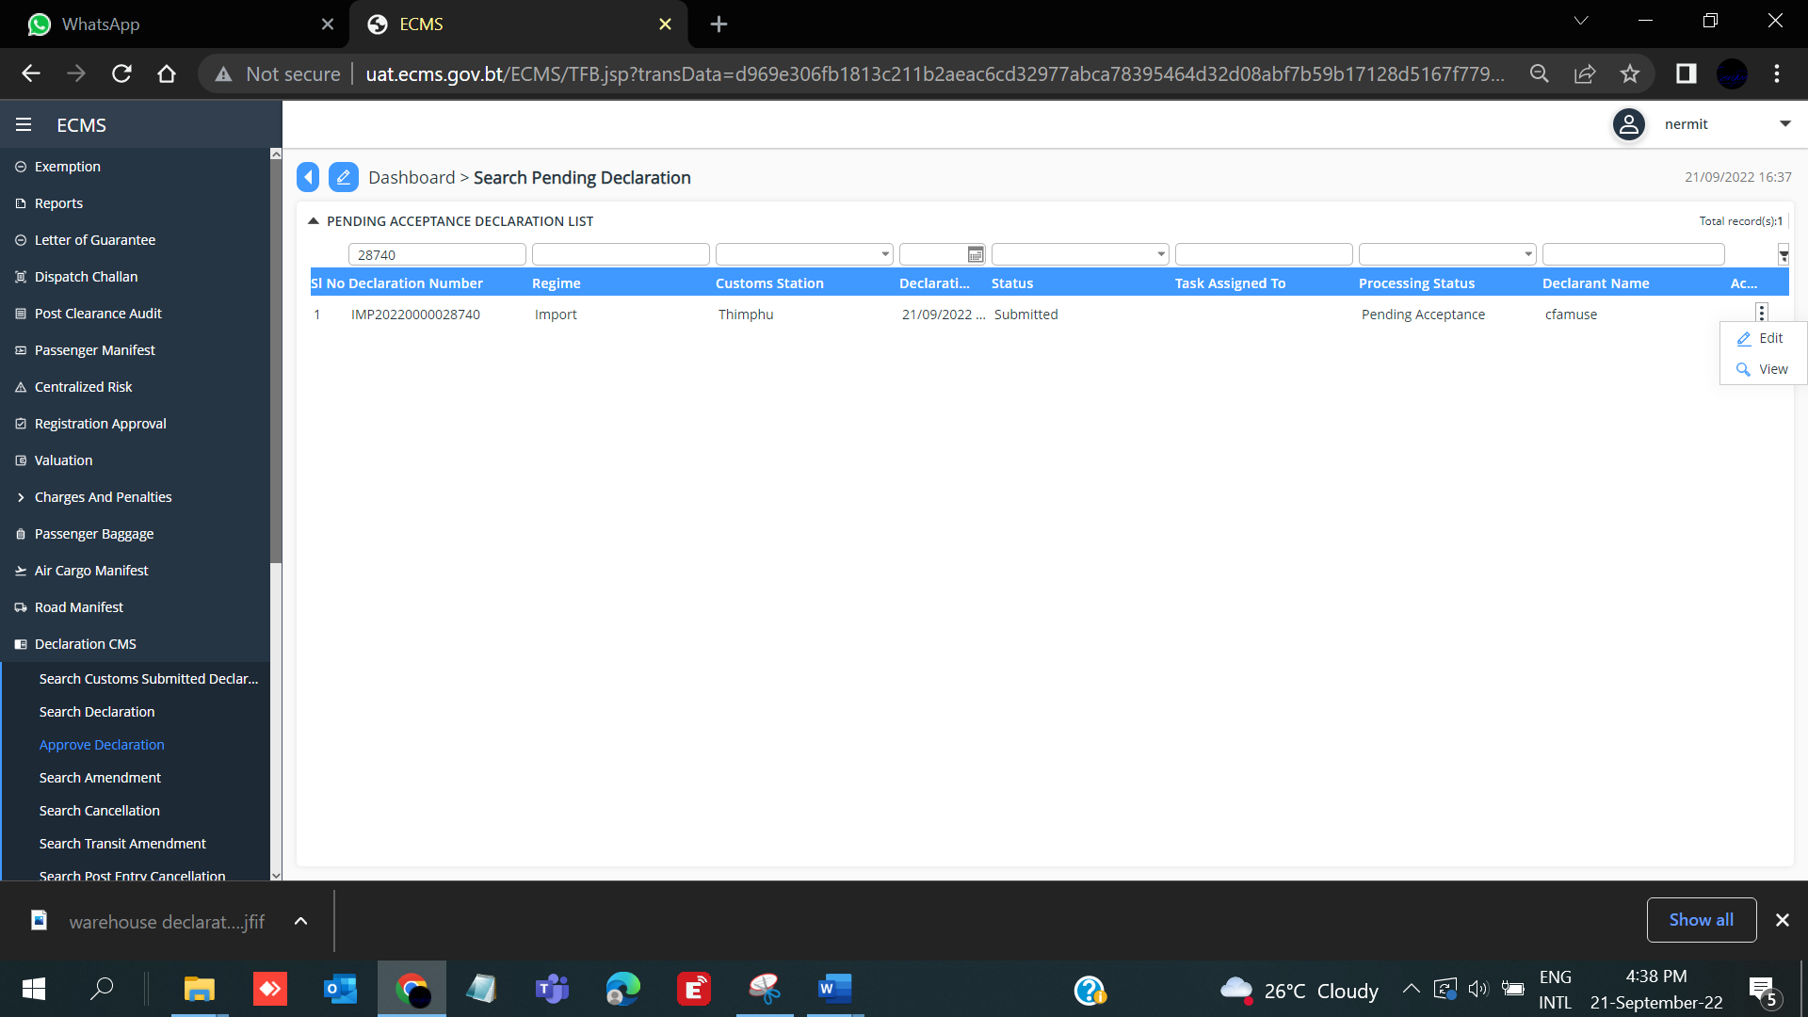

- Click on the Declaration list to view. Subsequent secreen is displayed.
- Click on each item to view (Bill of lading, Invoice and Consignor, Supporting Document, Summary, Approval)

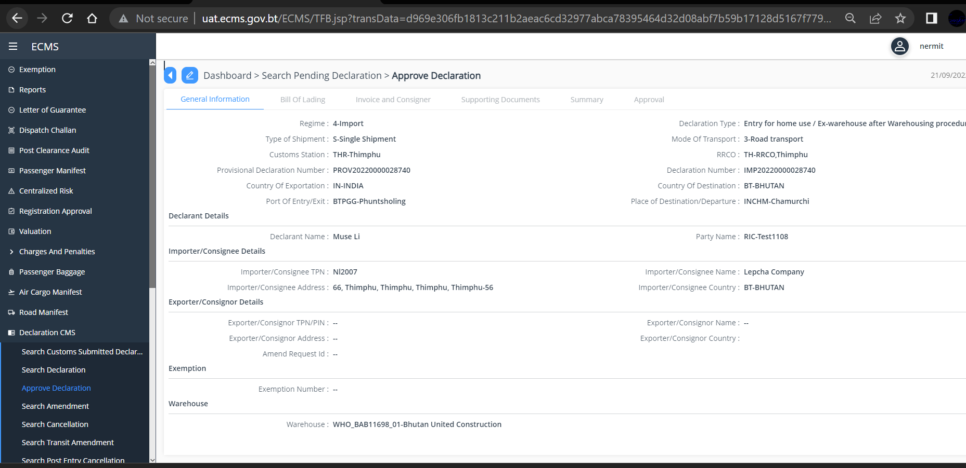

- Click “Approval” subsequent screen is displayed
- Click on the given list to get the Approval Details as shown below
- In the *Status” field, select “Approved”
- Click “Submit” button

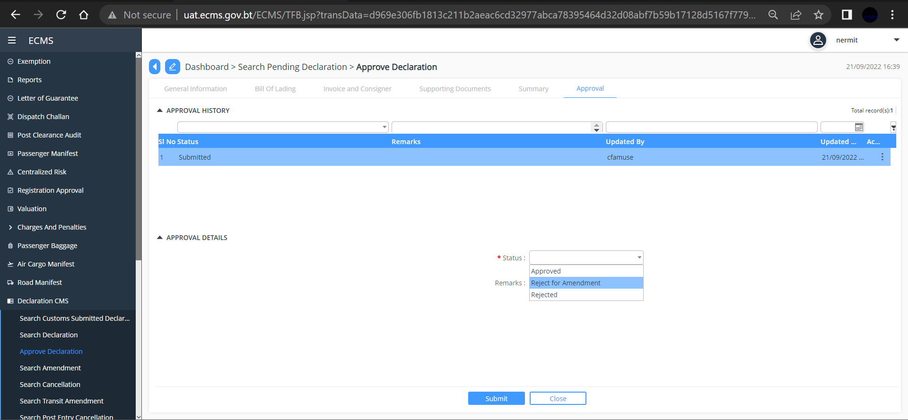

Valuation
- Go to valuation in the menu, and select “pending valuation List” (You can search the specific valuation list with the declaration number as shown below)
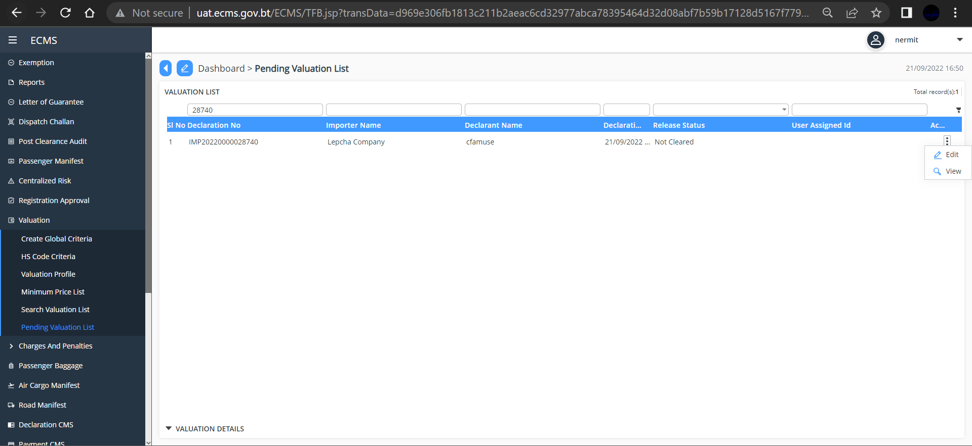

- Click on the valuation list to view the valuation details. Under valuation result you will see the following details,
- Add the custom value in the *Custom Value” filed
- Update the Release status as “Cleared” from the dropdown list.
- Click “Update” button.

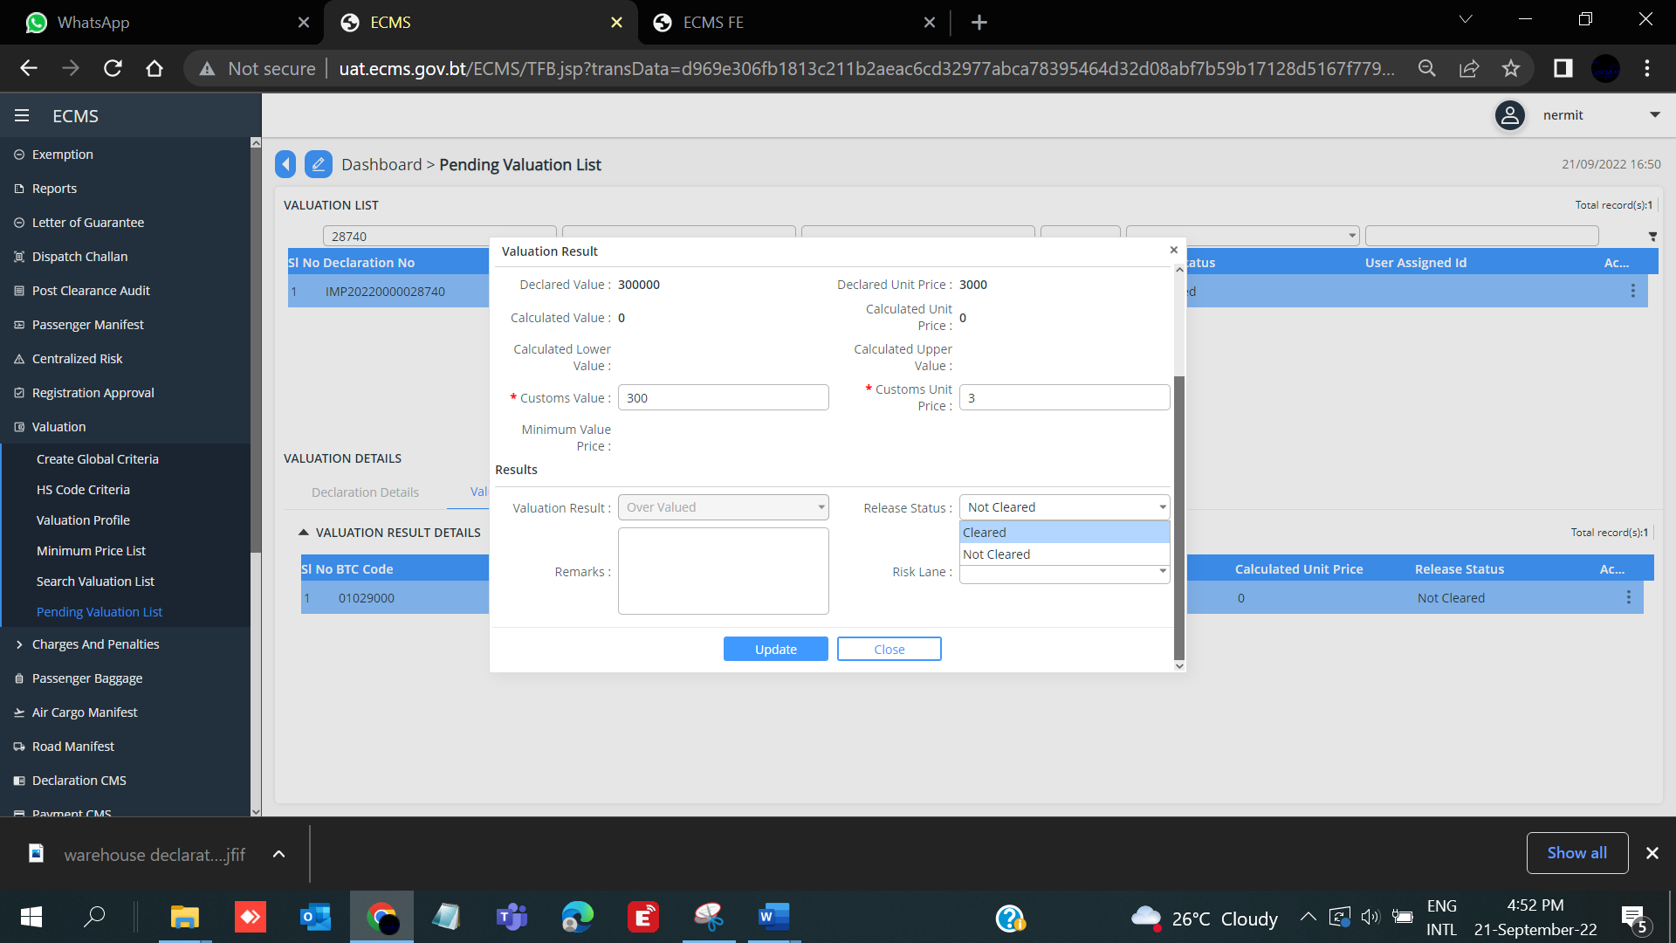

Centralized Risk
- To assess the risk, go to Centralized Risk in the Menu, and select “Pending Risk Assessment”. Subsequent screen is displayed.

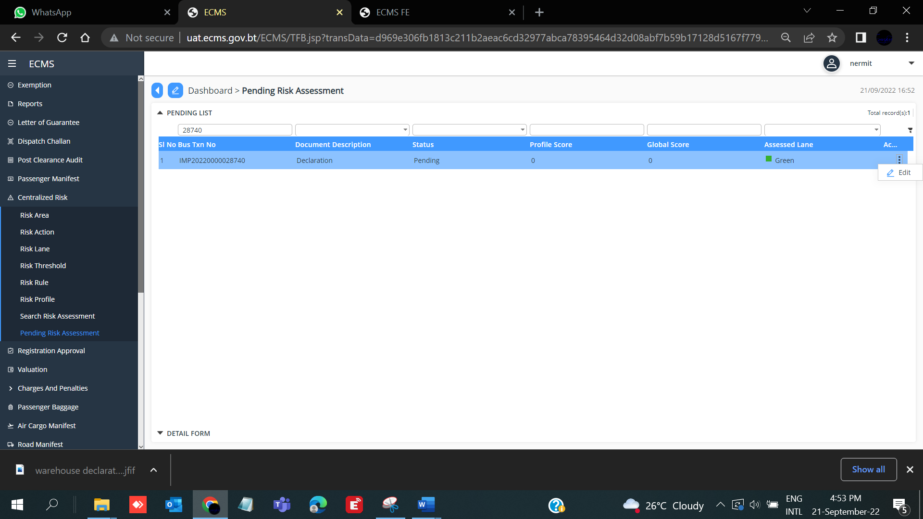

- Click on the List and subsequent screen is displayed
- Click the pending list, Detail Form are shown as below.
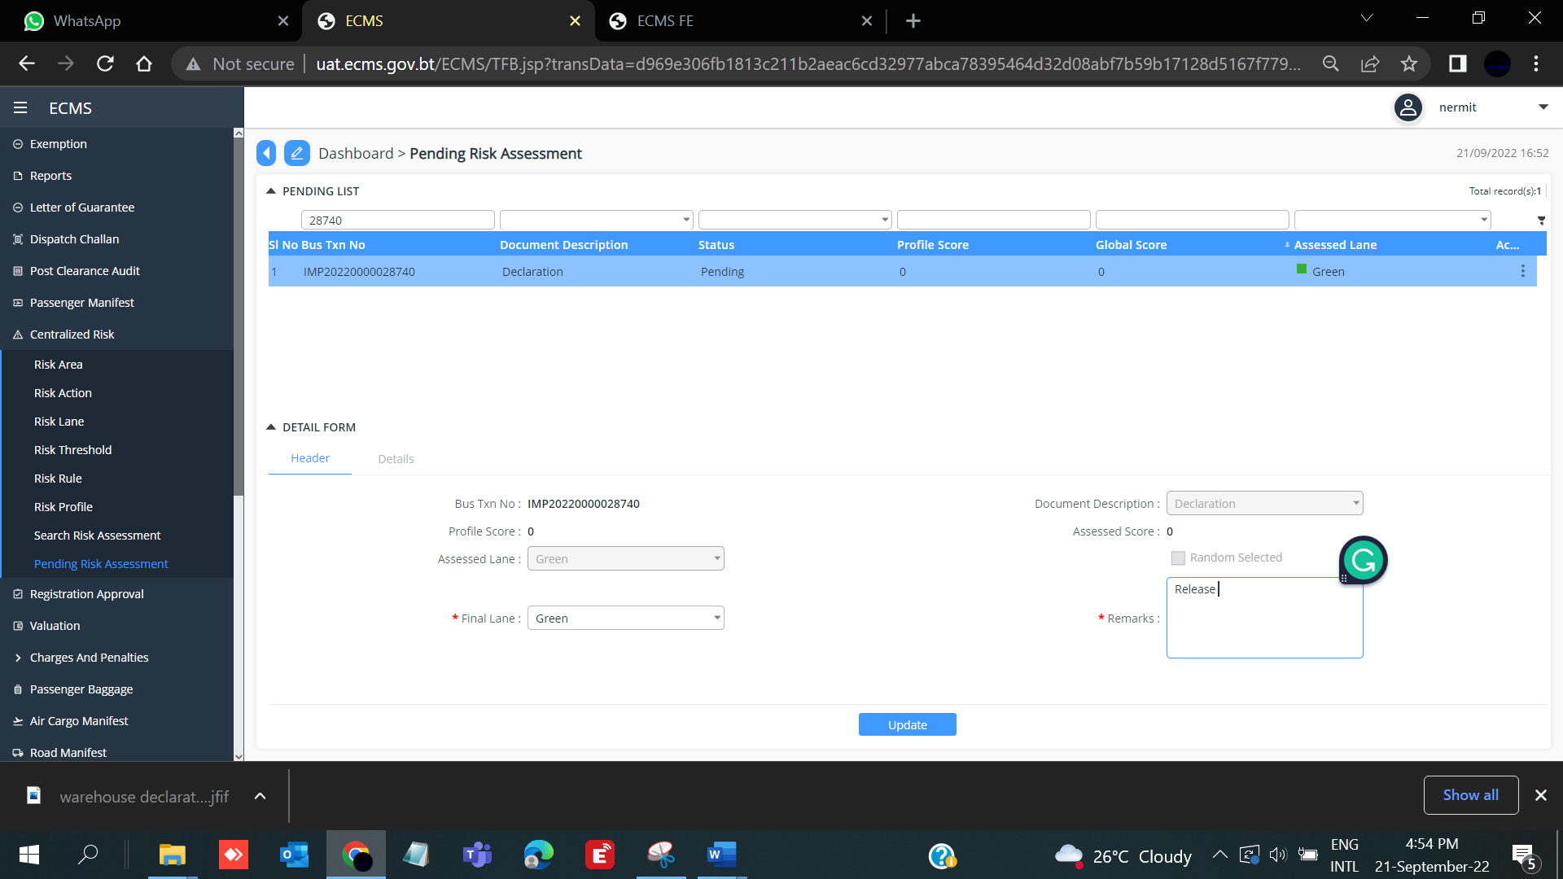

- Add the *Remarks
- Click *Update” button

Release Order

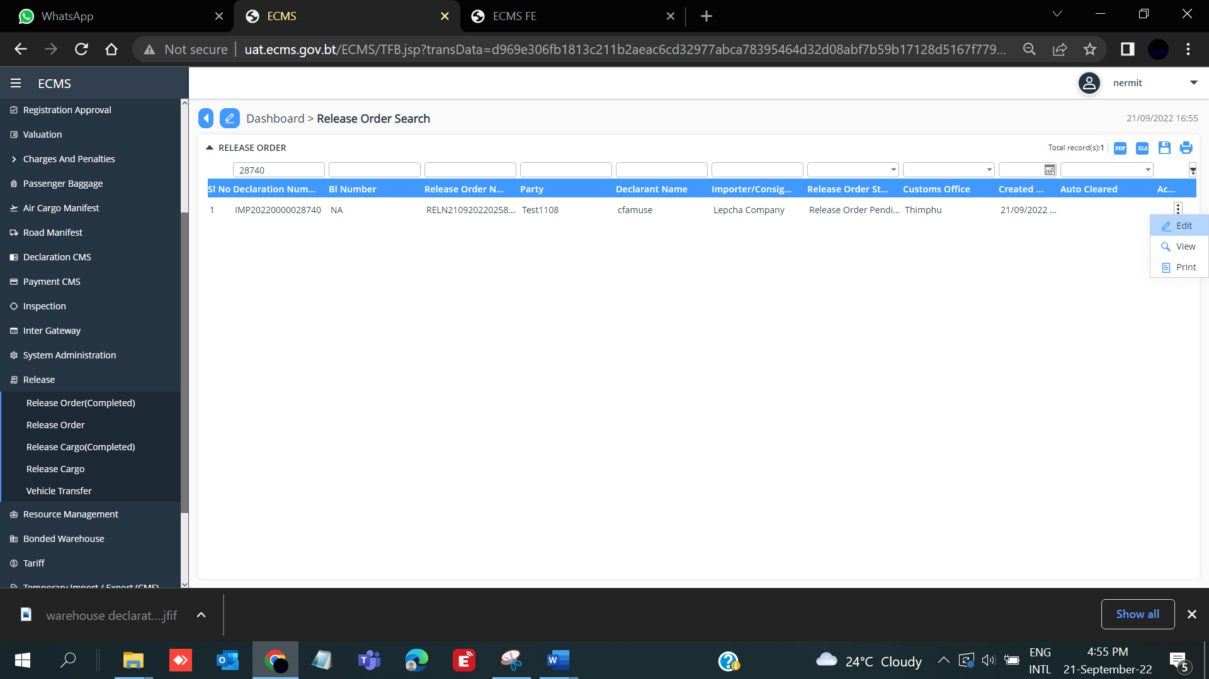

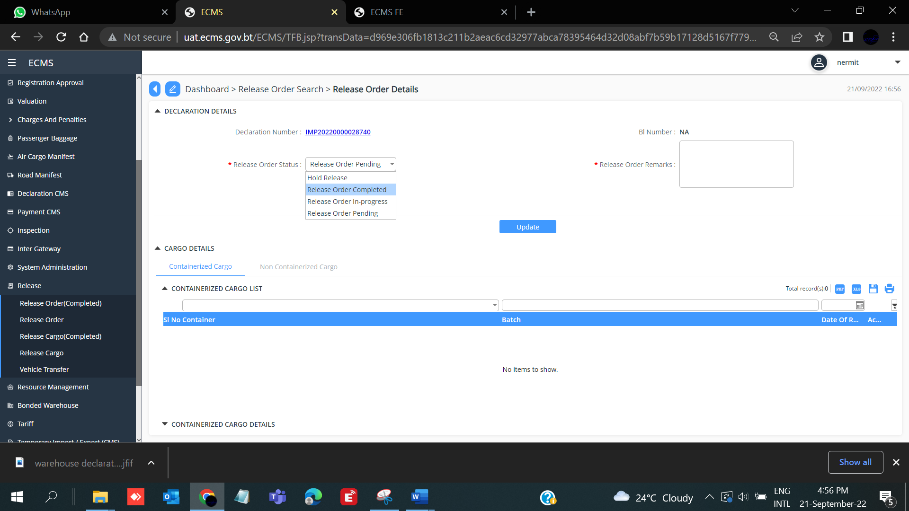

WHO; Release Goods

