eCMS MANUAL

Payment

Department of Revenue and Customs
Ministry of Finance

Table of Contents
1. Introduction 1
2. Logging in as Custom Officer 1
3. Payment CMS 1
3.1. Paid or Completed 2
3.2. Pending Payment 2
3.3. Pending Voucher 3

Introduction

The payment module is one of the clearance support modules and is primarily used by Customs Broker or Importer for all the payments to be done. The payment is done in the BRIMS. The generation of the payment instruction is handled in the eCMS by respective modules for e.g., declaration sends a payment instruction to the payment module for collection, accounting, and reporting. Likewise, any other module which has payment can leverage the payment module.

Logging in as Custom Officer

- The user needs to log into eCMS using the url: www.ecms.gov.bt
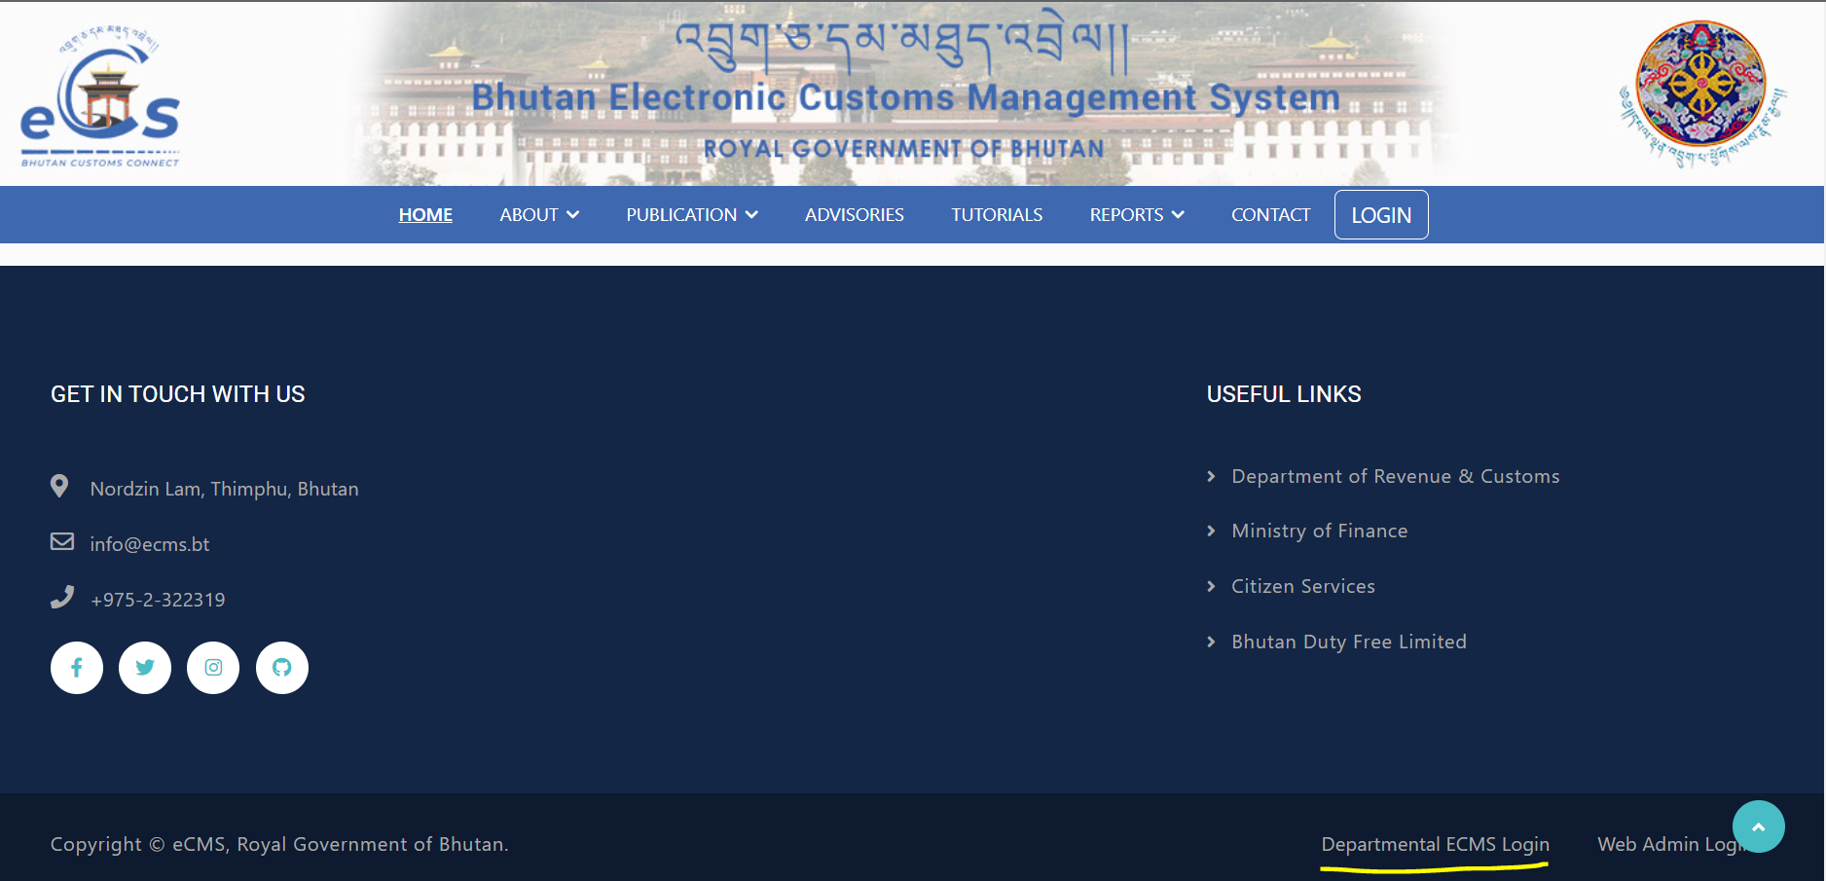
- Click on login menu and provide the required credentials to log in to the system:

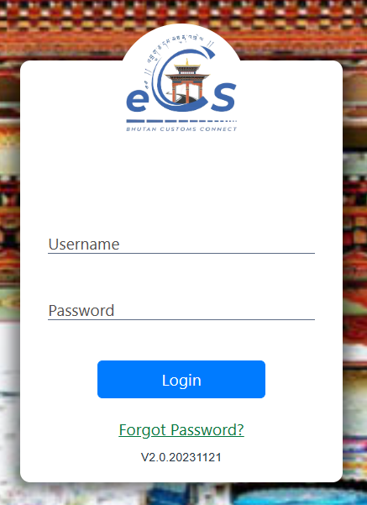

Payment CMS
- Click on the menu Payment CMS
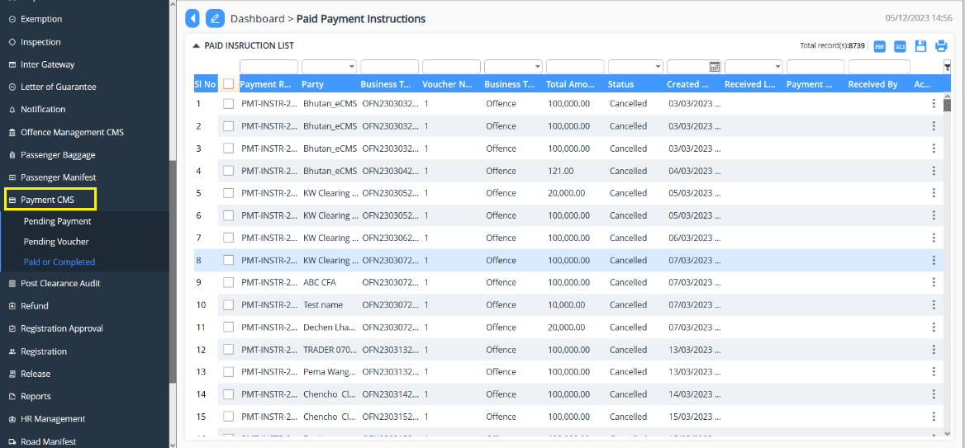

Paid or Completed

- Go to Payment CMS menu and click on “Pain or Completed”.
- List of declaration that has been made the payment will be listed for view or print if required.
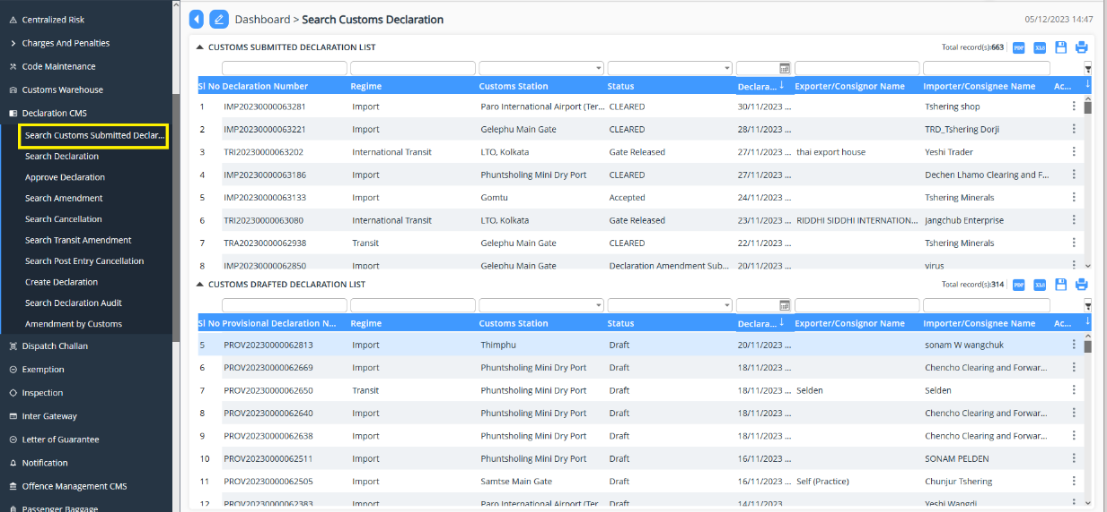

Pending Payment

- Go to Payment CMS menu and click on “Pending Payment”.
- List of declaration that has payment , voucher is generated which will be shared with the applicant for payment
  - Details: provides the overall details of the payment to be made under which declaration
  - Transaction History: gives the list of payment made associated to the declaration.
  - Payment: provided payment information
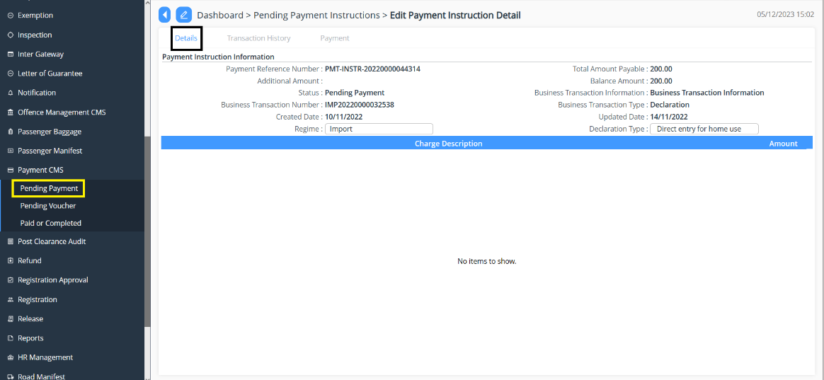
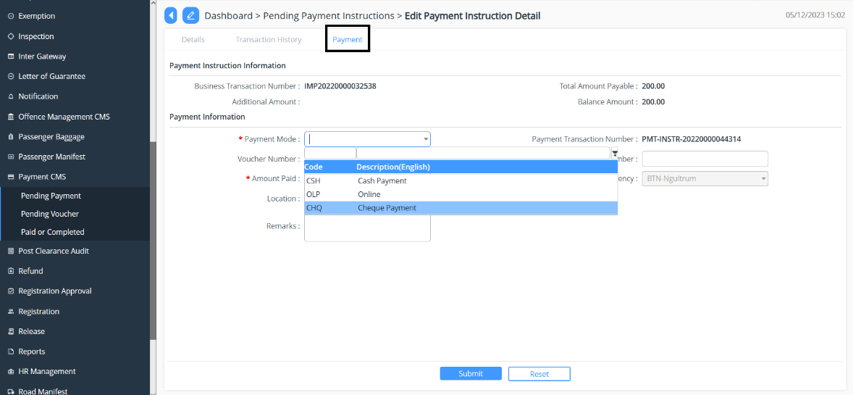

Pending Voucher

- Go to Payment CMS menu and click on “Pending Payment”.
- List of declaration that has completed payment and the voucher needs to be updated in the system is populated and action is taken on the same.
  - Details: provide a summary view of the payment
  - Voucher Details: Payment instruction information is provided
