eCMS Manual

Declaration (Regime:Import)

Department of Revenue and Customs
Ministry of Finance
Table of Contents
1. Login as Front-end user 2
2. Create Declaration 2
3. Track Application 6
4. Search amendment request 6
5. Create Amendment request 7
6. Search Cancellation 8
7. Create Cancellation 8

Login as Front-end user

- The user needs to log into eCMS using the url: www.ecms.gov.bt

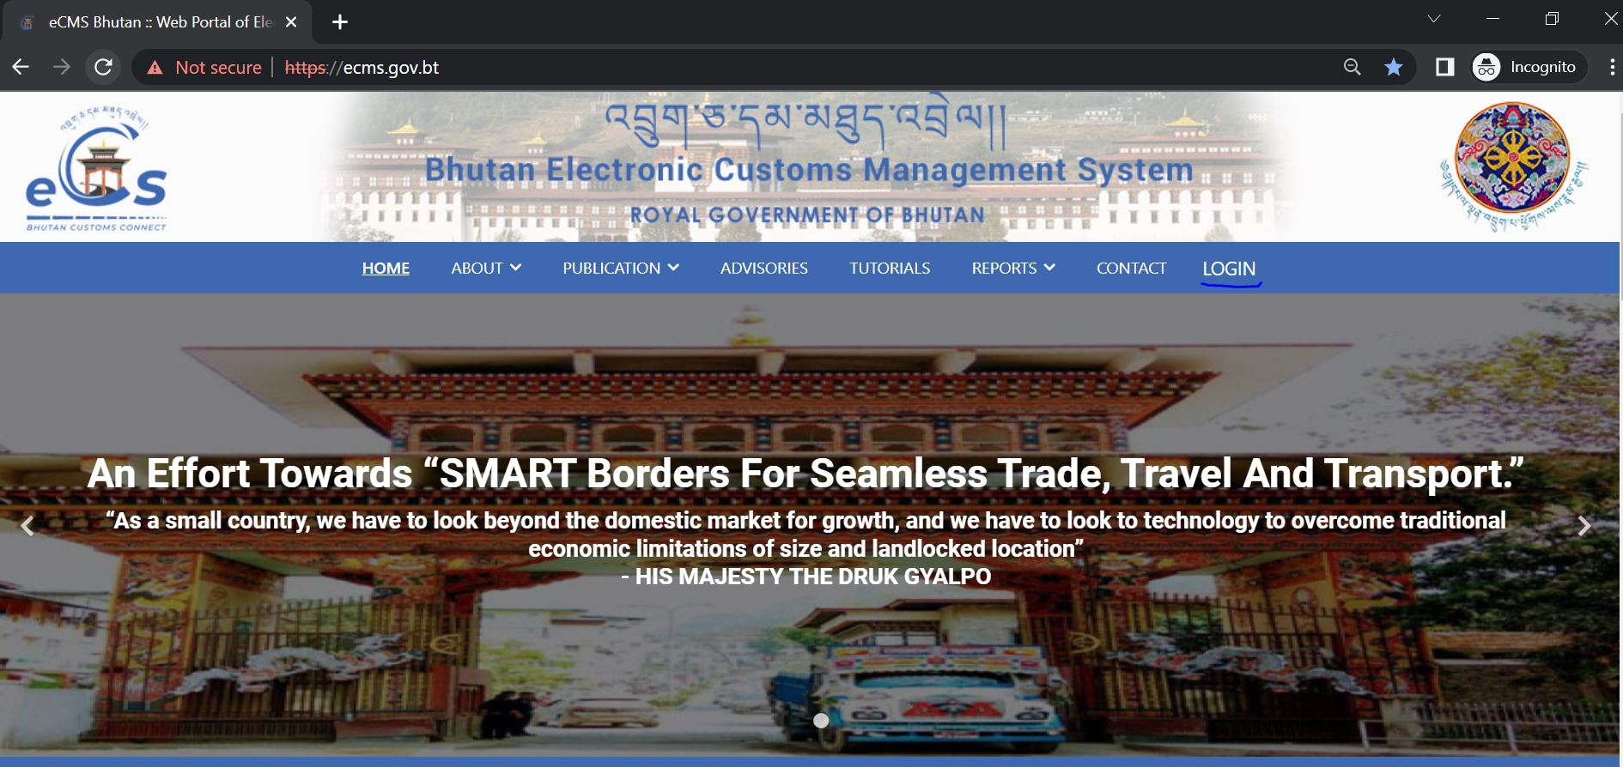

- Click on login menu and provide the required credentials to log in to the system:

Create Declaration

- Select Declaration FE from the list of menus provided in the dashboard:

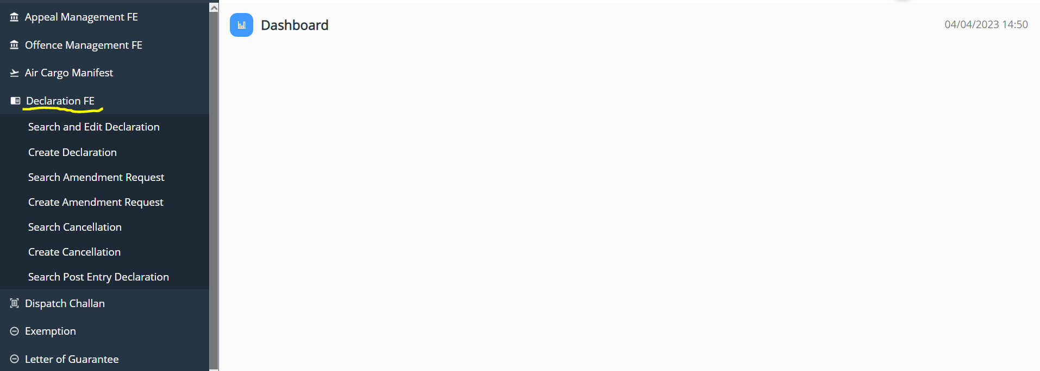

- Under the Declaration FE menu, Select Create Declaration:

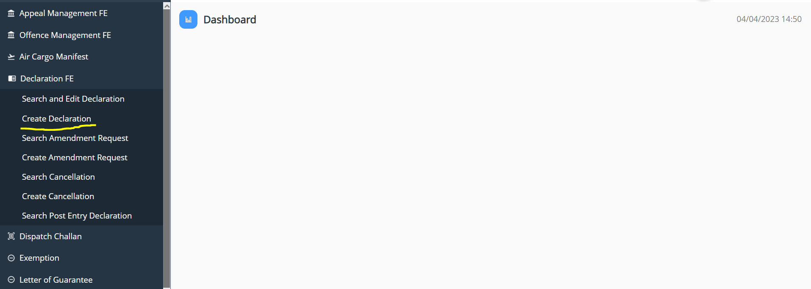

- Key in the following details:

- General information

- Select the Regime as Import ->> Select Declaration type as per the requirement and get the details filled and save the data that has been completed:

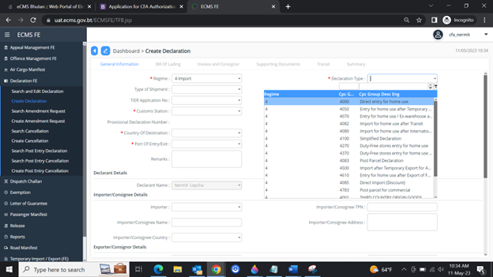

- Bill of Lading

- The user needs to add in the Bill of landing wherein we have to have Road Manifest that was created and approved for the particular details:
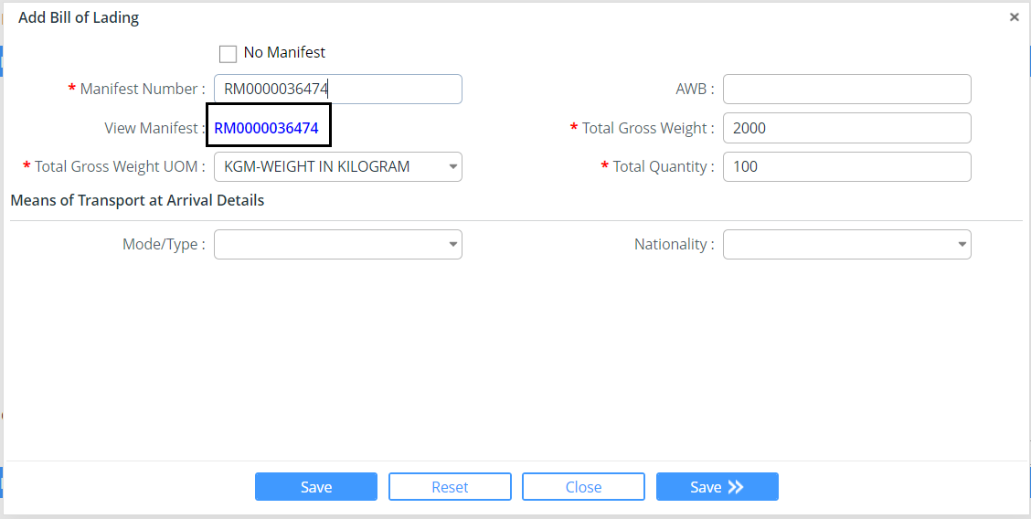

- You can view the RM that has been inserted to review if the correct Rm has been attached to the declaration by clicking on the View Manifest tab.

- Invoice and Consignor

- Invoice details will be fetched from the Road manifest linked under Bill of landing.
- The user needs to click on the invoice to add the missing details under invoice details and then add in the Commodity Detail respectively

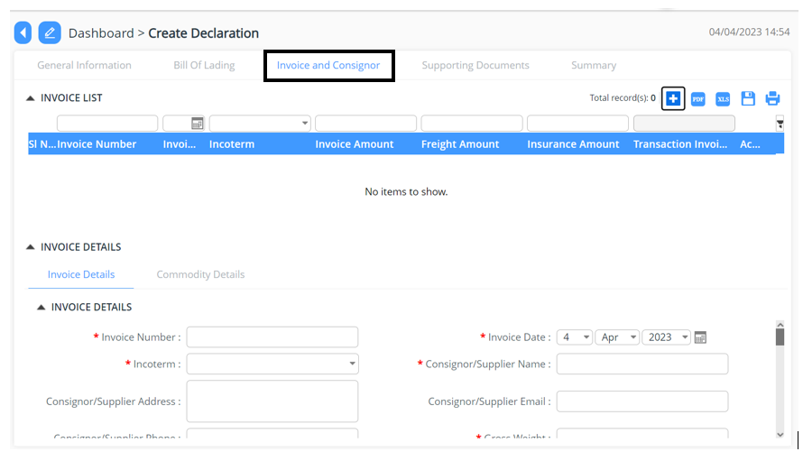
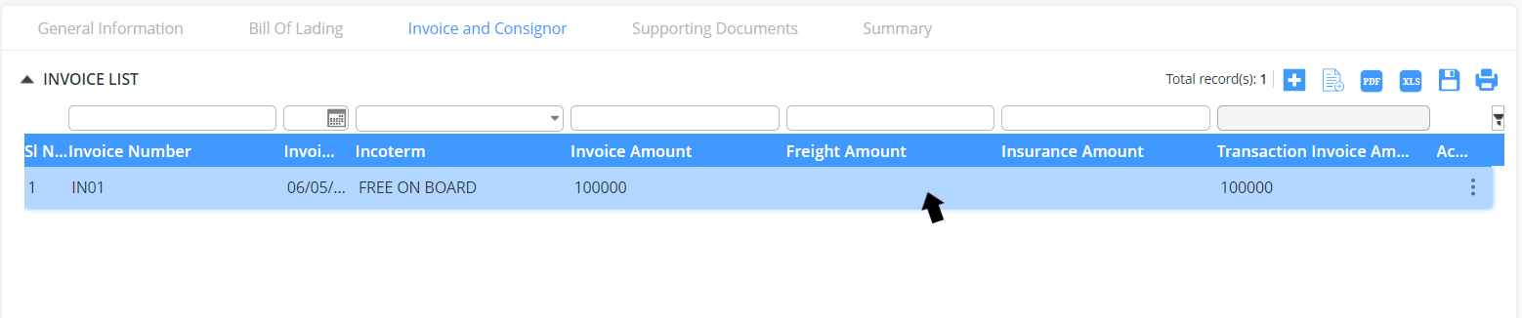
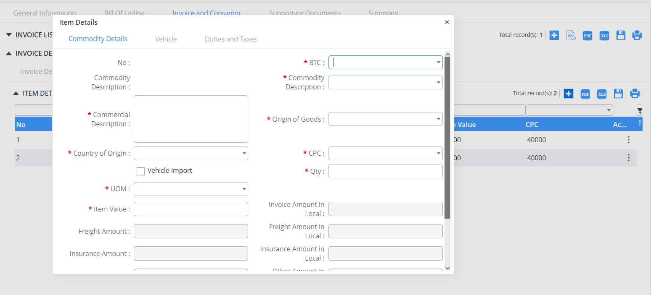

- Supporting Documents

- The declarant shall attach mandatory supporting documents (invoice) for approval:

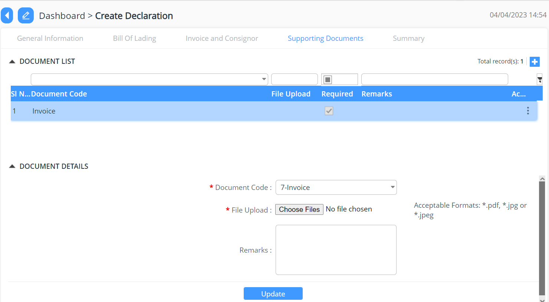

- Summary

- The declarant can review his/her declaration summary and submit the same for approval, here we have the check box to accept the terms and condition.
- Here the user can validate the declaration before submission.
- The user can submit the declaration which will allow the user to generate the reference declaration number.
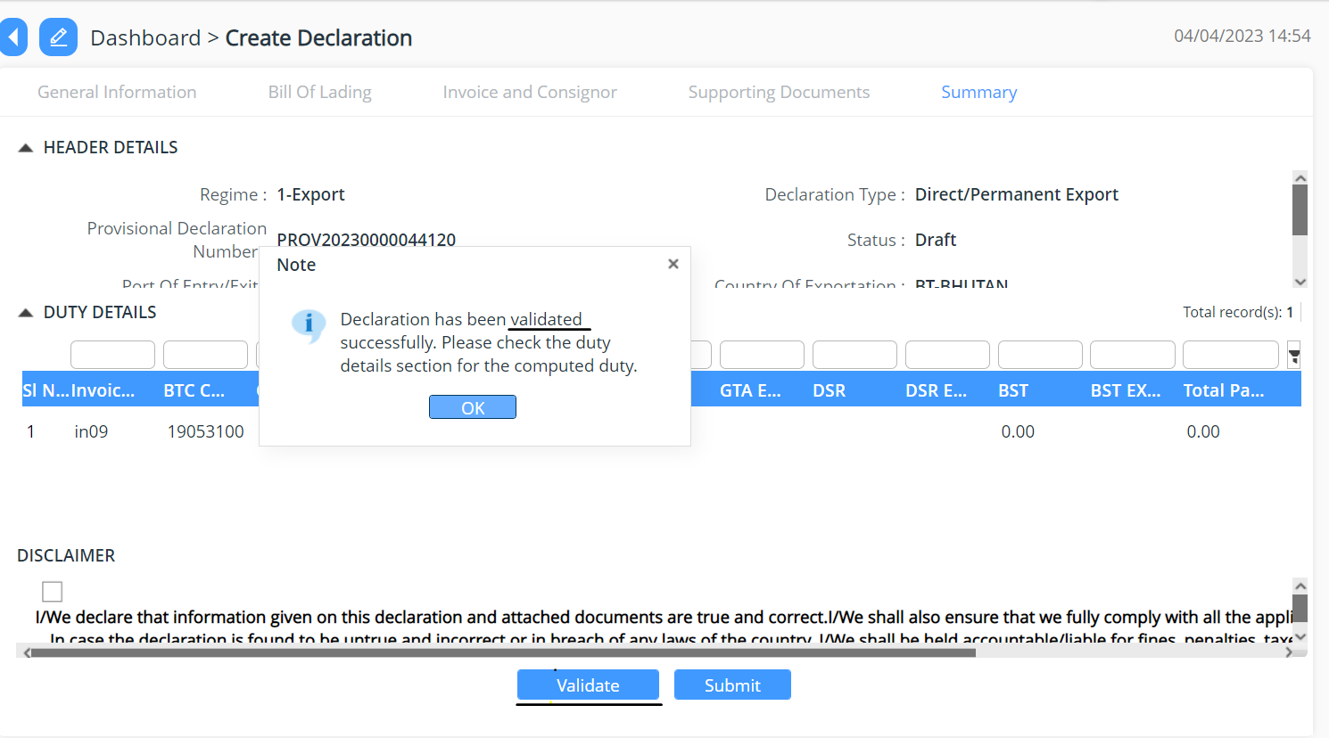

Track Application

- An application Number will be Generated:

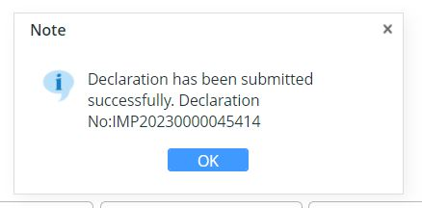

- The users will be able to track their application from Search and Edit Declaration:

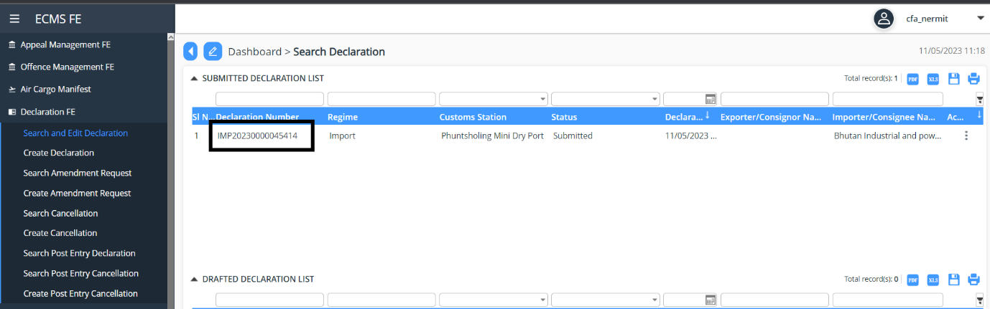

Search amendment request
- User can view the list of amendment request made under the Search amendment request:

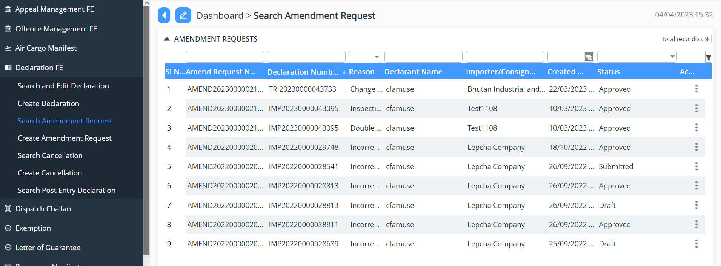

Create Amendment request
- User can request for amendment of declaration that has been submitted
- Click on Create Amendment request
- Select the declaration that need to be amended
- Provide the reason and remark for the amendment
- Submit the same

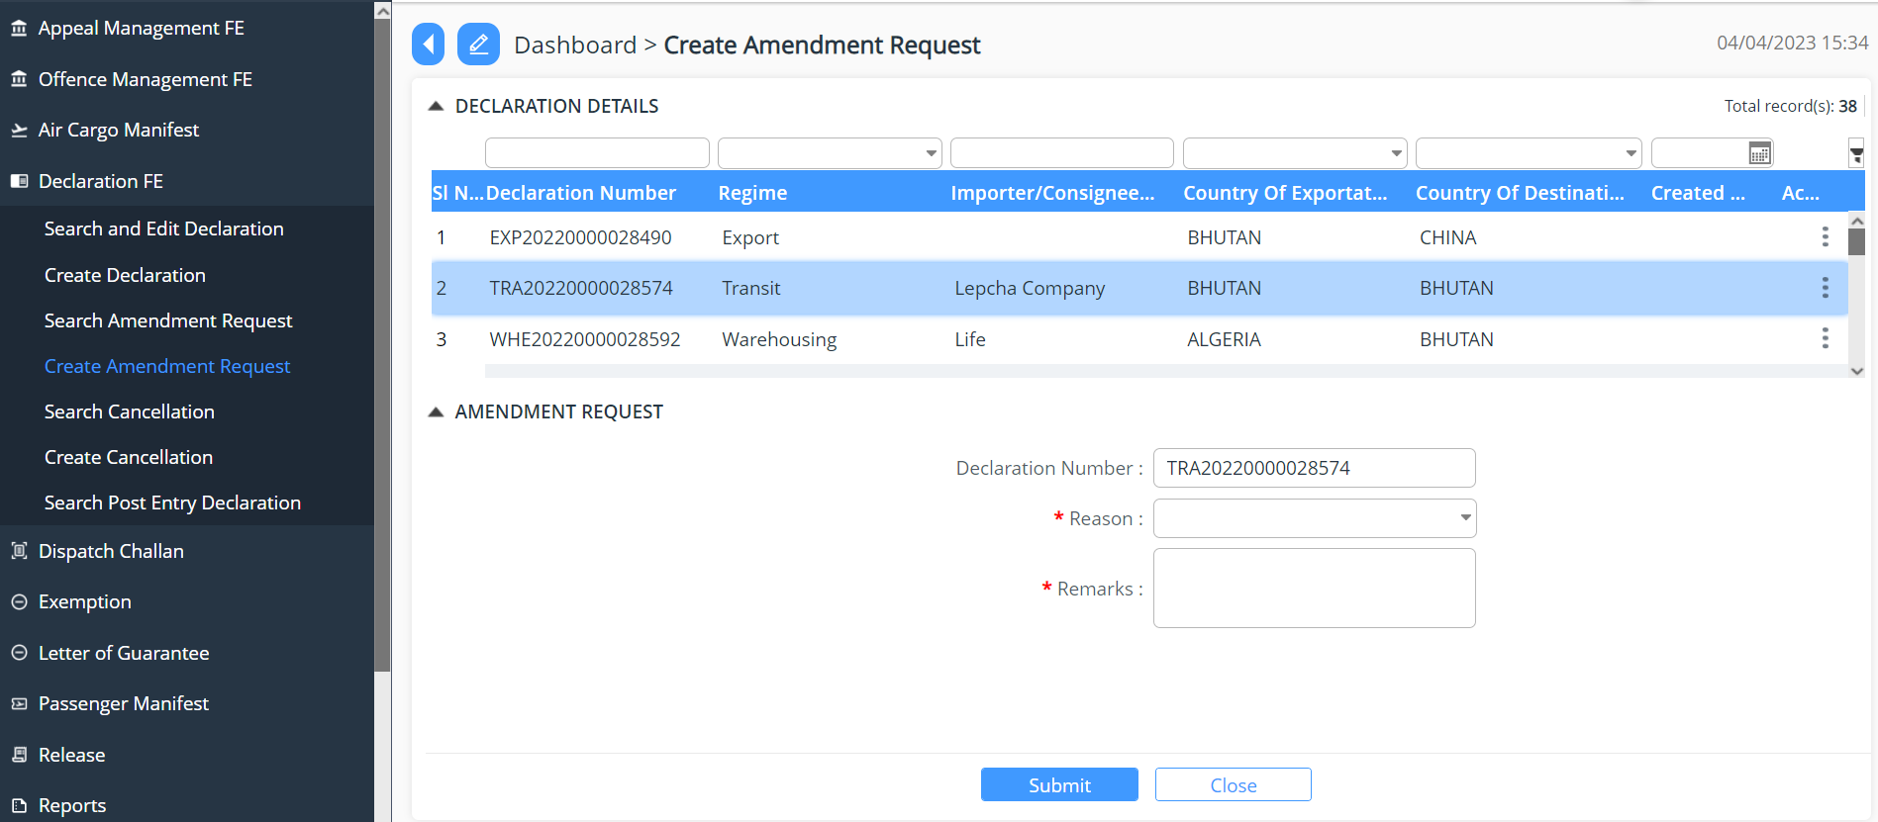

- Once the amendment request has been approved by the Custom Officer
- The declaration can be found under the Search and Edit Declaration

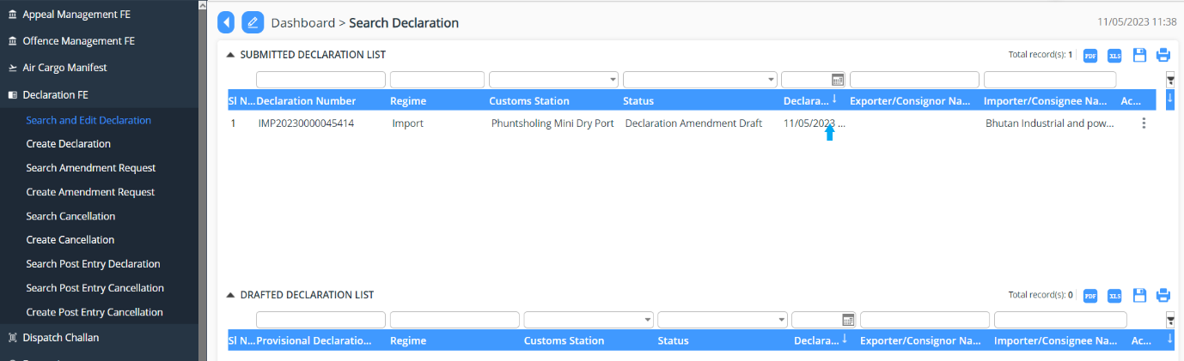

- Make the necessary changes and submit the same for amendment
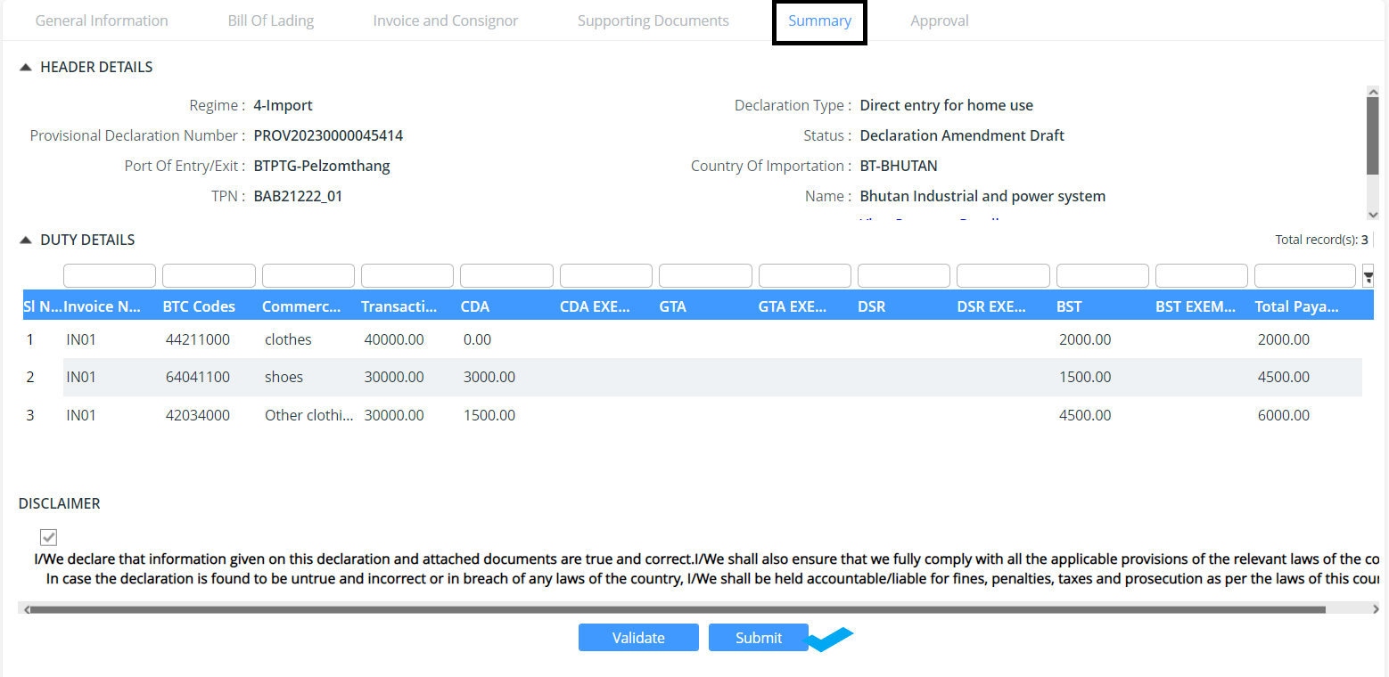

Search Cancellation
- User can also cancel the declaration submitted :

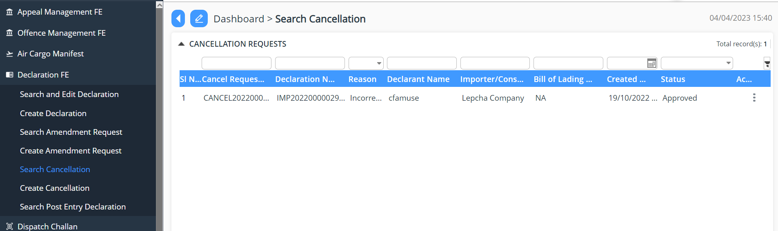

Create Cancellation
- User can create cancellation request for the declaration applied for:
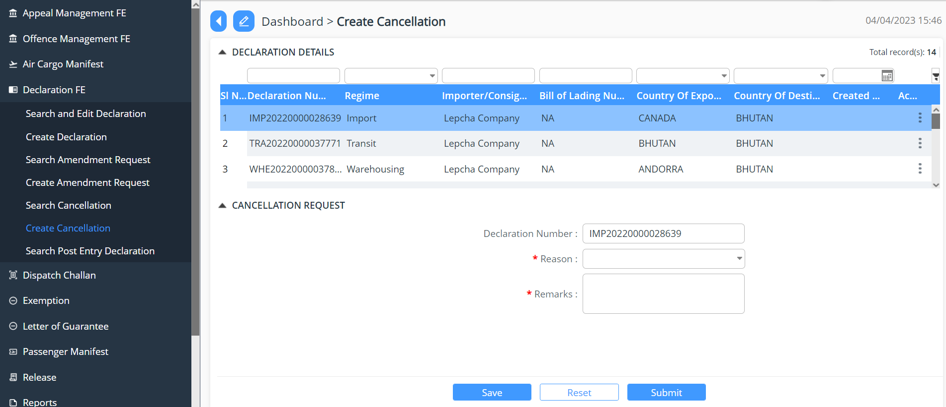

Create Post Entry Cancellation

Search Post Entry Declaration

Search Post Entry Cancellation

