eCMS MANUAL

Valuation

Department of Revenue and Customs
Ministry of Finance

Table of Contents
1. Introduction 1
2. Logging in as Valuation Officer 1
3. Valuation 2
3.1. Create Global Criteria 2
3.2. HS Code Criteria 3
3.3. Valuation Profile 4
3.4. Minimum Price List 4
3.5. Search Valuation List 5
3.6. Pending Valuation List 5

Introduction
Customs Valuation is one of the sub-systems in the CMS component of the eCMS system. In this sub-system, Customs valuation unit creates and uses the historical transaction data as reference for valuation of all commodities in the declaration.
Specific profile-based valuation range may also be defined when valuation officers are sure on the valuation of certain commodities meeting certain criteria. Profile based valuations are used to target specific cases of valuation frauds and “as such” will be used less frequently than transaction based.
This valuation sub-system also captures the value based on last transactions made during the period for all the HS Codes. For transaction method, the system builds the valuation database.
Profile based or transaction-based valuation can be selected based on the HS Code.
Once eCMS receives the declaration, the declaration value is verified with the valuation database or the profile if configured. The valuation assessment will indicate if the goods are “under value” or “overvalued” or cleared. The valuation assessing officer may update his inputs on the valuation.
Valuation process is involved in Import, Transit, Warehouse, Temporary Import, Re-Import Regime flows.

Logging in as Valuation Officer

- The user needs to log into eCMS using the url: www.ecms.gov.bt
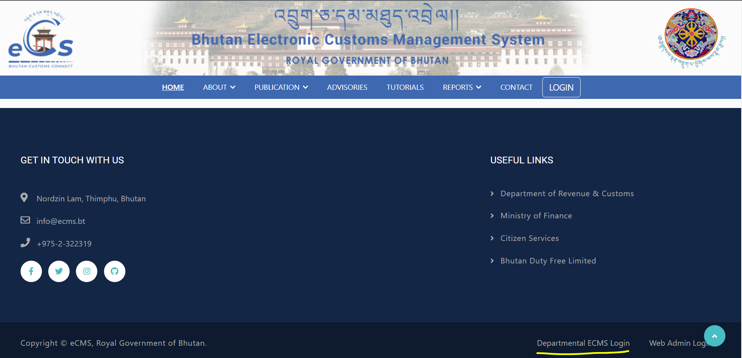
- Click on login menu and provide the required credentials to log in to the system:

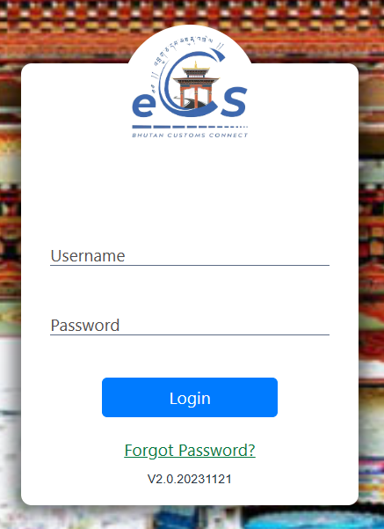

Valuation
- Click on the menu Valuation.

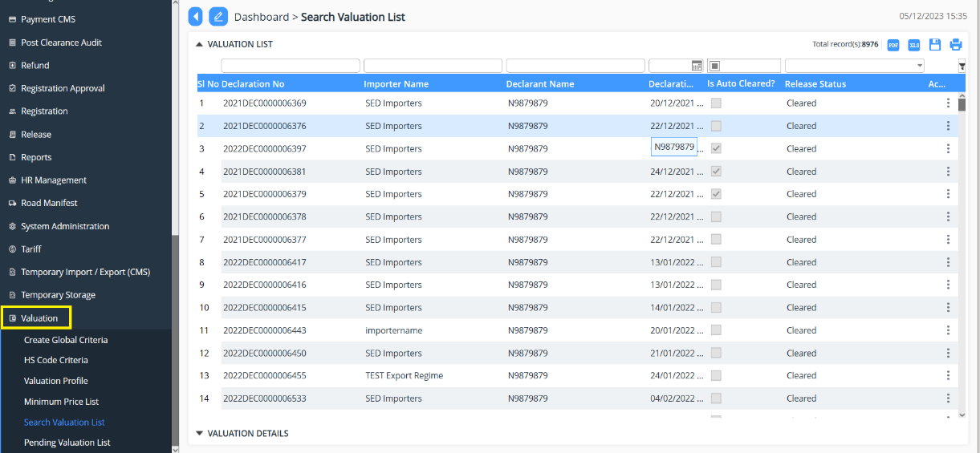

Create Global Criteria
The Global Valuation criteria refers to the default criteria for all the Items and is considered when there are no available Specific Valuation criteria for the H.S Code of that corresponding item.
This functionality allows Customs control to establish the verification criteria based on the historical valuation records available in eCMS system and the past transaction details captured in the eCMS system.
The configuration set for the criteria is used to check the value declared by the Declarant for an Item in the declaration that falls in the Customs criteria value or not.
- Click on Create Global Criteria
- Click on  to add the Global Criteria Details
- Select the valuation Type from drop down list >> Number of days/transactions>>provide the Percentile Lower >> percentile Upper>> Select Status (Active/Non Active)>> Save
- The Global Criteria gets create and can be viewed in the list.
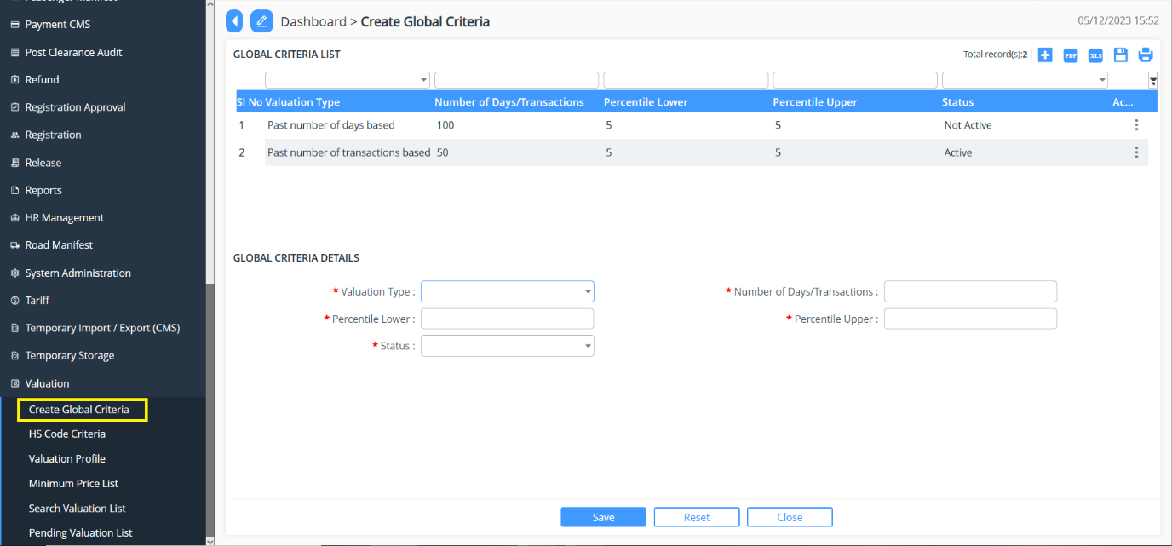

HS Code Criteria
- Click on HS Code Criteria
- Click on  to add the HS Code Criteria
- Select the BTC Code from drop down list >> Select the Valuation Type>>Provide the number of Days/Transactions >> Provide Percentile Lower>> Provide Percentile Upper Select Status (Active/Non Active)>> Save
- The HS Code Criteria gets create and can be viewed in the list.
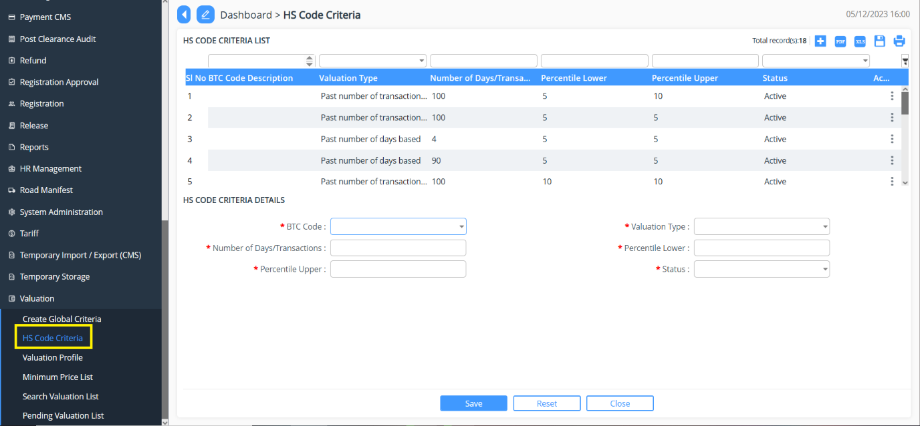

Valuation Profile
The profile-based configuration for valuation criteria is a process of setting the specific profile with valuation boundaries i.e. upper and lower limits with variance at HS Code level. \
- Click on Valuation Profile
- Click on  to add the Valuation Profile
- Provide the Profile details and Associated Criteria >> Save the same.
- The list gets create and can be viewed in the list.

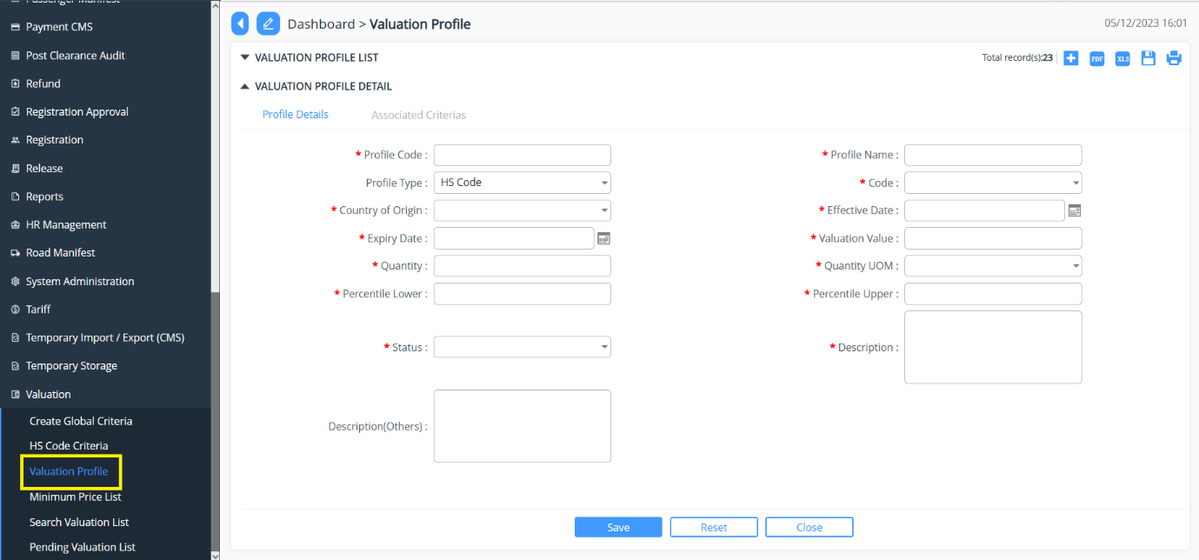

Minimum Price List
- Click on Minimum Price List
- Click on  to add the Minimum Price List
- Select the BTC Code from drop down list >> Select the UOM>>Provide Declaration>> Provide Minimum Value Price>> Select Status (Active/Non-Active)>> Save
- The list gets create and can be viewed in the list.
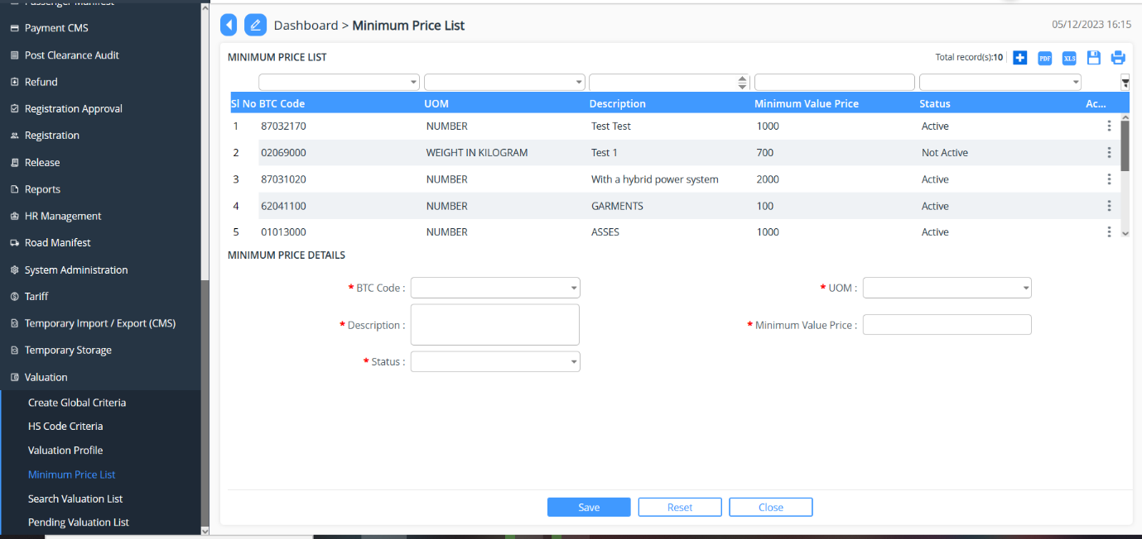

Search Valuation List
- Go to Valuation menu and click on “Search Valuation List”.
- List of declaration that has gone through valuation or pending for valuation gets populated.
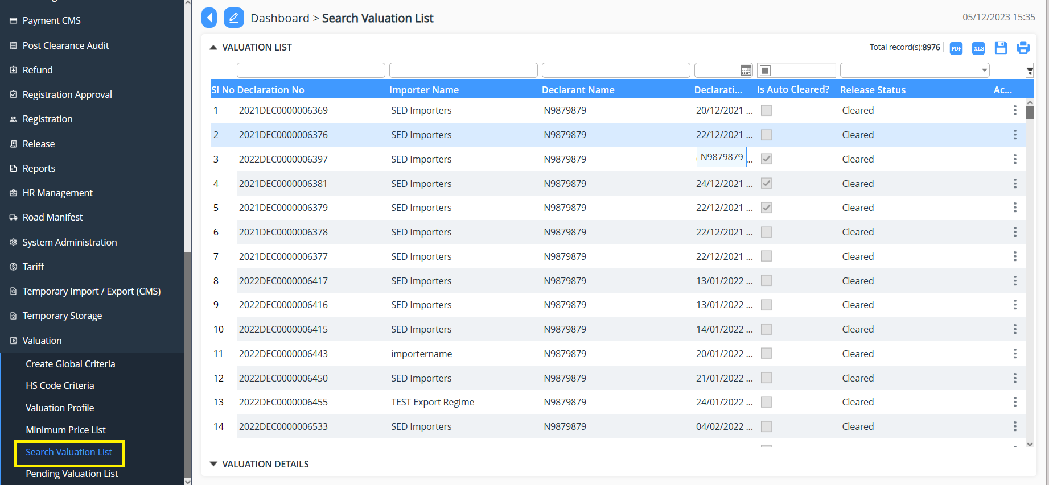

Pending Valuation List
- Go to Valuation menu and click on “Pending Valuation List”.
- List of declaration that pending Valuation will be populated.
- Select the declaration for valuation >> provide the results for valuation then update the status >> Submit the declaration.
