eCMS MANUAL

Centralized Risk

Department of Revenue and Customs
Ministry of Finance

Table of Contents
1. Introduction 1
2. Logging in as Risk Officer 1
3. Centralized Risk 1
3.1. Risk Area 2
3.2. Risk Action 2
3.3. Risk Lane 3
3.4. Risk Threshold 4
3.5. Risk Rule 4
3.6. Risk Profile 5
3.7. Search Risk Assessment 5
3.8. Pending Risk Assessment 5

Introduction
Risk assessment will be conducted on all the submitted declarations. Risk assessment will be based on the profiles configured.

Risk assessment is based on the WCO recommended principles with the objective of minimizing risk and improving overall operations efficiency via the use of risk-based selectivity approach.

Logging in as Risk Officer

- The user needs to log into eCMS using the url: www.ecms.gov.bt
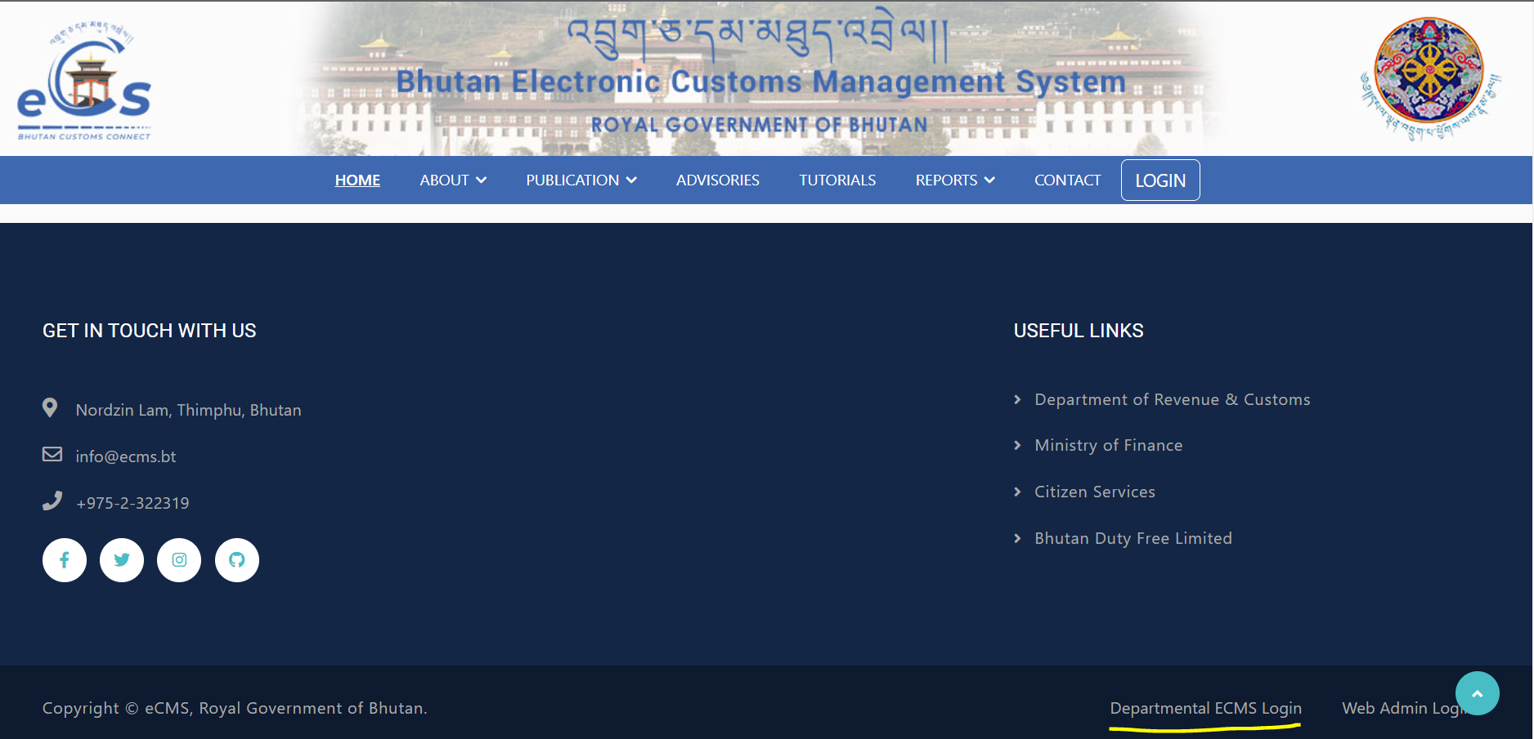
- Click on login menu and provide the required credentials to log in to the system:

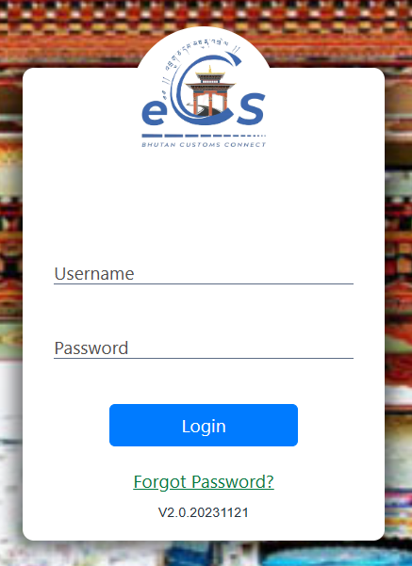

Centralized Risk
- Click on the menu Centralized Risk.

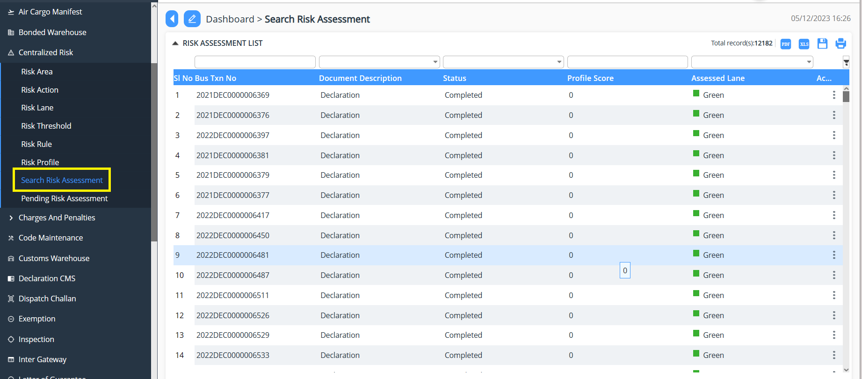

Risk Area
- Click on Risk Area
- Click on  to add the Risk Area
- Fill in the details as per requirement and Submit.
- The Risk Area gets create and can be viewed in the list.
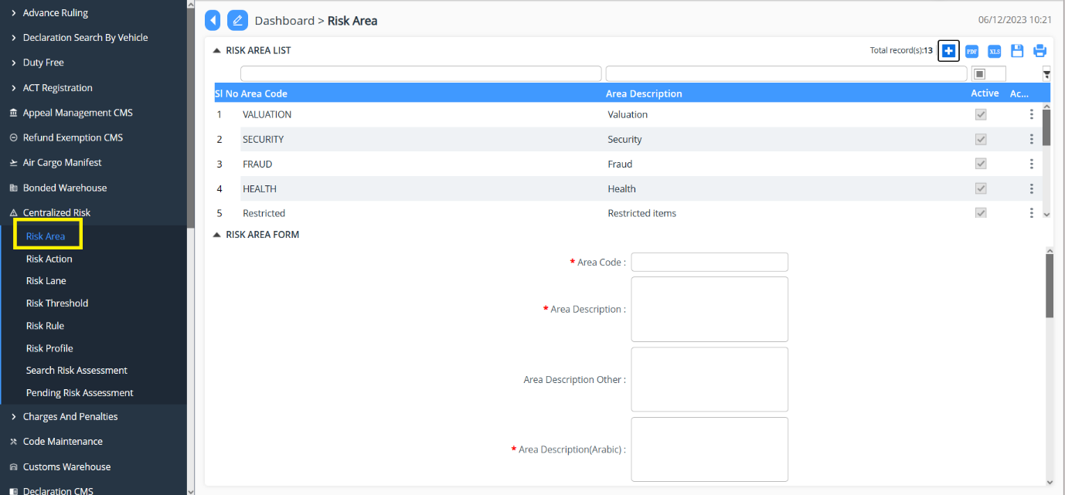

Risk Action
- Click on Risk Action
- Click on  to add the Risk Action
- Fill in the details as per requirement and Submit.
- The Risk Action gets create and can be viewed in the list.
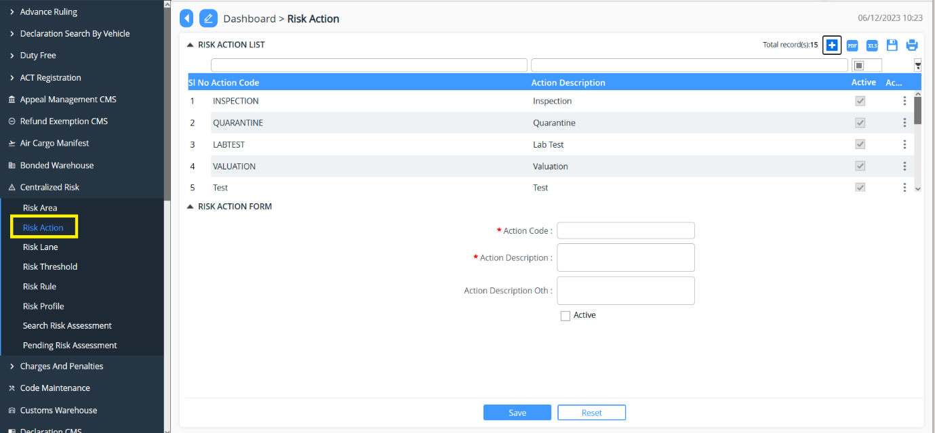

Risk Lane
- Click on Risk Lane
- Can view the lane that are RED, GREEN, YELLOW, BLUE
- To Add-> Click on  to add the Risk Lane
- Provide the details >> Save the same.
- The list gets create and can be viewed in the list.

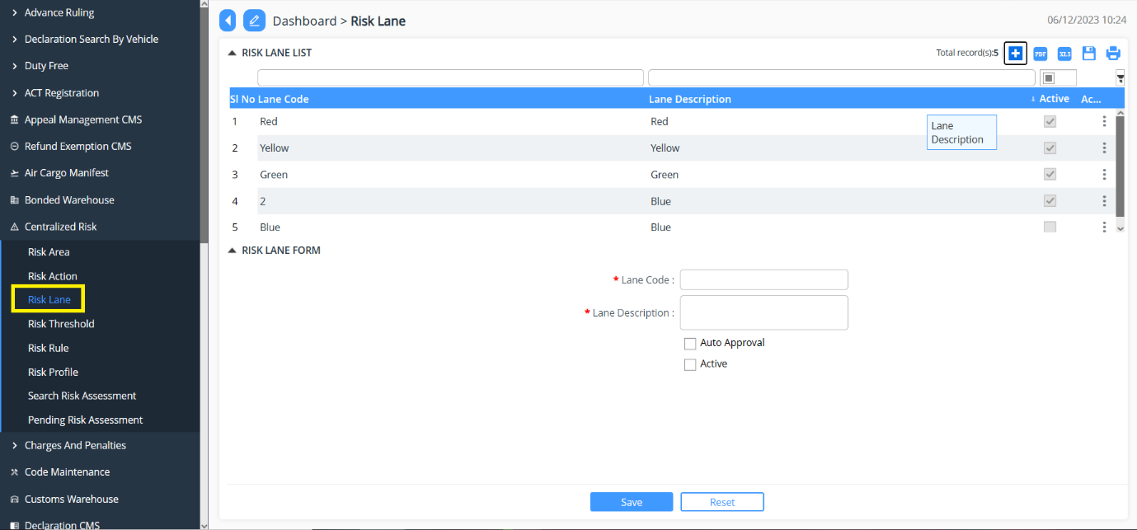

Risk Threshold
- Click on Risk Threshold
- Click on  to add the Risk Threshold
- Fill in the details >> Save the same
- The list gets create and can be viewed in the list.
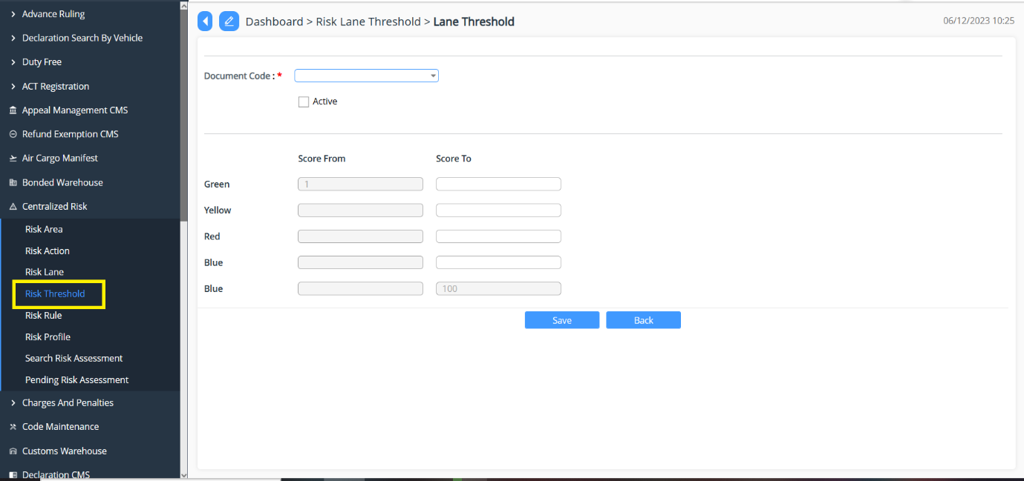

Risk Rule
- Click on Risk Rule
- Click on  to add the Risk Rule
- Fill in the details >> Save the same.
- The list gets create and can be viewed in the list
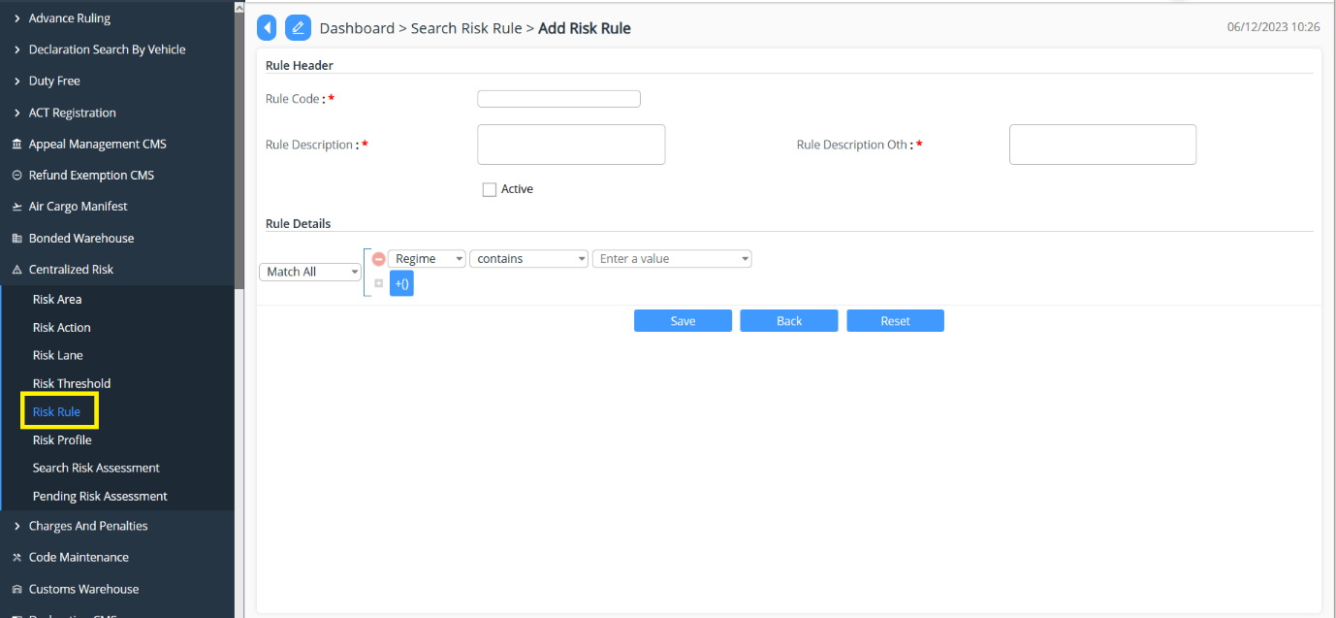

Risk Profile
- Click on Risk Rule
- Click on  to add the Risk Rule
- Fill in the details >> Save the same.
- The list gets create and can be viewed in the list
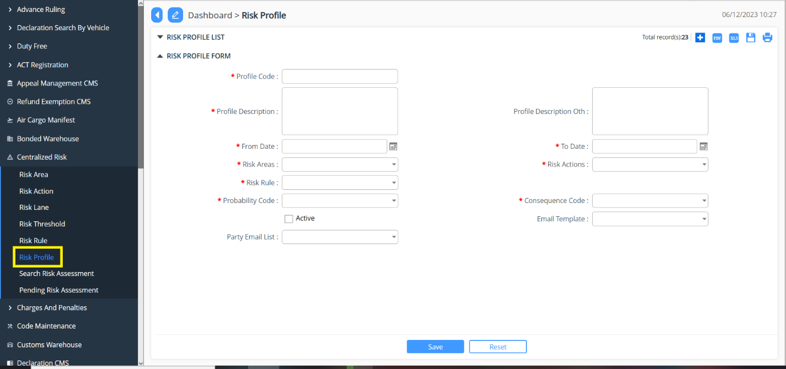

Search Risk Assessment
- Go to Centralized Risk menu and click on “Search Risk Assessment”.

- List of declaration that has risk associated will be send to the Risk , so the list can be viewed.
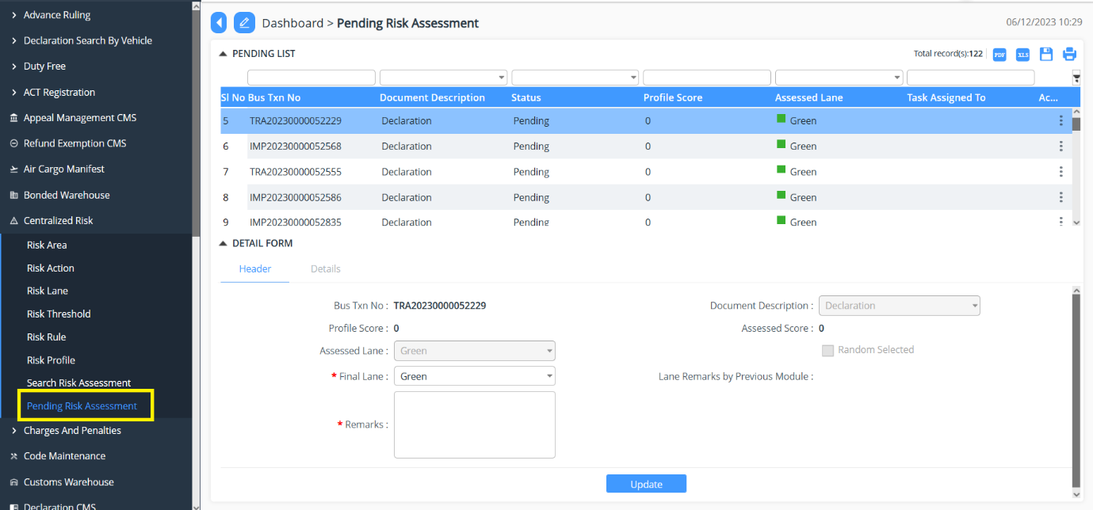

Pending Risk Assessment
- Go to Centralized Risk menu and click on “Pending Risk Assessment”.
- List of declaration that pending Risk Assessment will be populated.
- Select the declaration for Assessment >> provide the lane and give the remarks >>Update the declaration.


