eCMS MANUAL

Post Clearence Audit (PCA) User Manual

Department of Revenue and Customs
Ministry of Finance
Table of Contents

Pending for Approval 3

Log in eCMS as an auditor (Custom Officer)

- Go to Post Clearance Audit
- Click Create General Audit
- Fill up all the details under each header:
Audit details header: gives the information on which user is going for an audit and proposed audit duration.
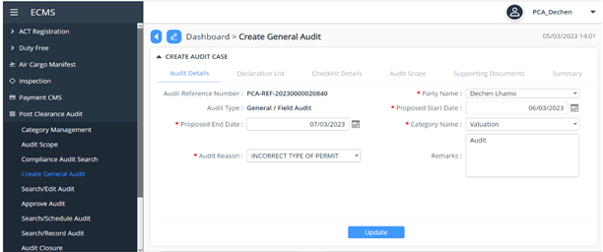

Declaration list header: list of declaration that will be audited for the particular user
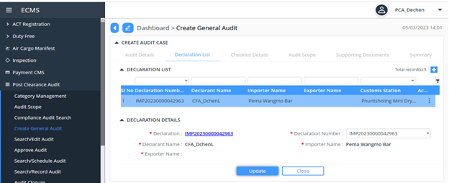

Checklist details: here the auditor needs to define the check list required for the audit
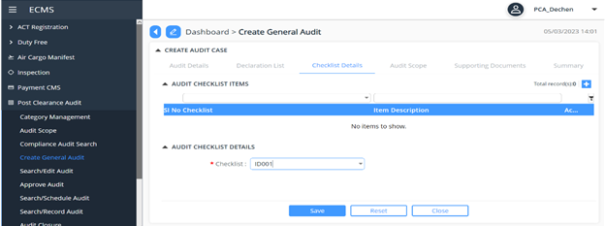

Audit Scope: the auditor will choose the audit scope
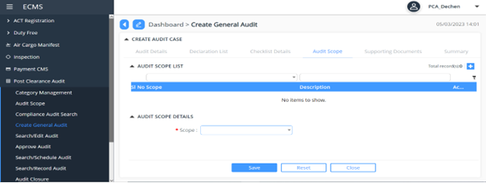

Supporting documents: list of supporting document for the audit to be performed
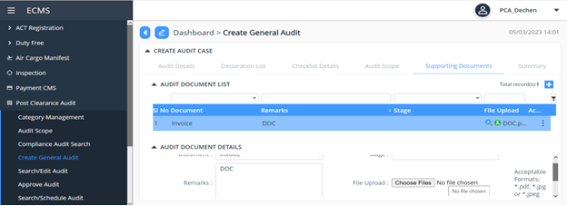

Summary: the overall view of the details that has been filled by the auditor for the audit purpose, to cross check the details before its submitted.
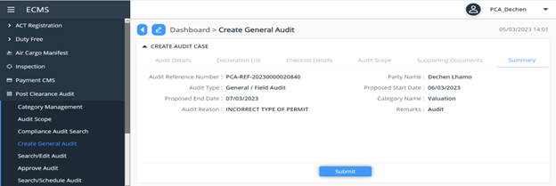

- PCA Ref. numbers is auto generated by the system , which can be later used for the check and track of the application
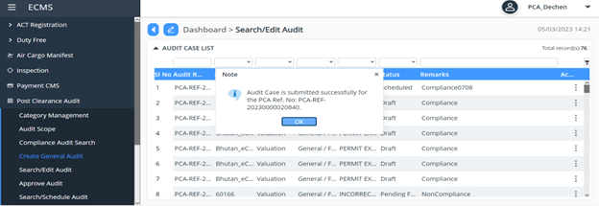

- Go to Search/Edit audit and paste the PCR ref. no. on the search panel.
- Check the status.

Pending for Approval
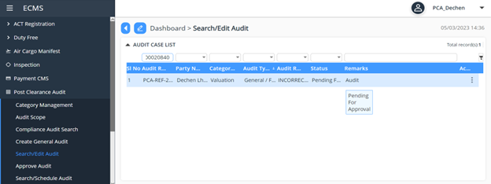

Login to Custom
- Go to Post Clearance Audit.
- Click to Approve Audit
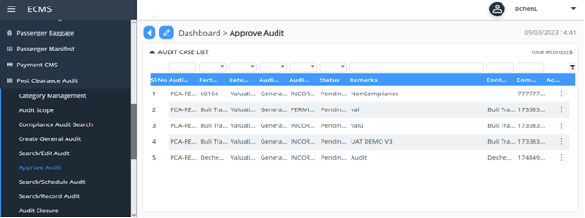
- Copy and paste the PCA ref. no. in the search panel.

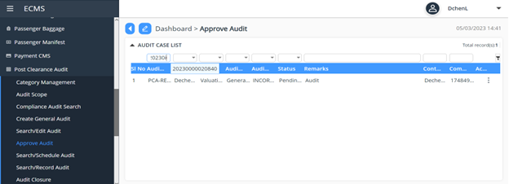
- Go to Approval, change the status as Approved and click the submit button.
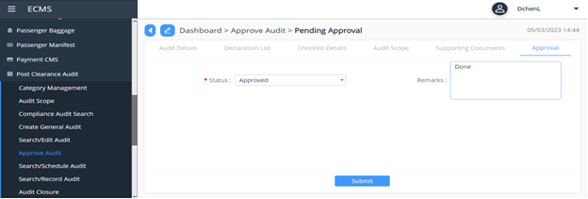
Login to PCA
  - Go to Post Clearance Audit
- Click to Search/Scheduled Audit, then go to scheduled audit and click the update button.
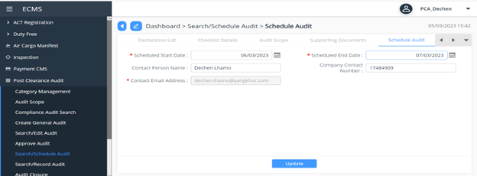

- Go to summary and click the submit button.
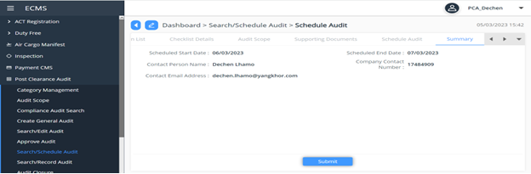
- PCA ref. number is given.
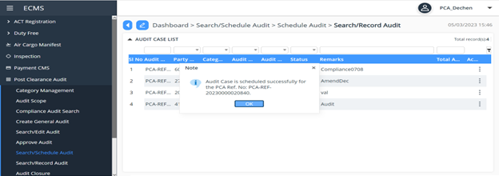
- Go to Search/Record Audit, paste the PCA ref no. in the search panel.
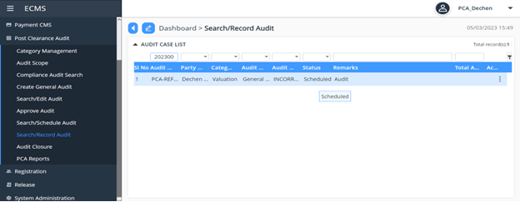

- Go to Audit result, fill up the details and click the save button.
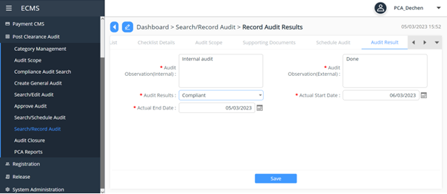
Go to Demand note, click the add button.
- Fill the Demand note details and Demand note tax details as shown below:
Then click the save button.
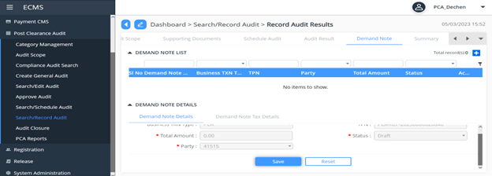

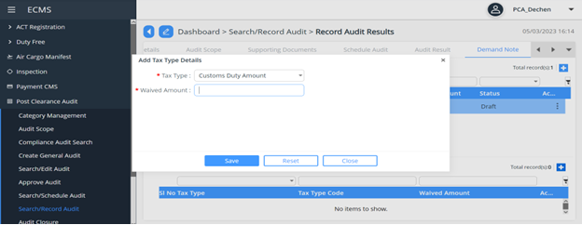

- Go to summary and click the submit button.
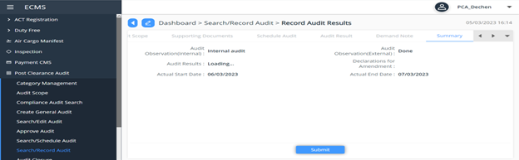
Log in Custom
- Go to Post Clearance Agent
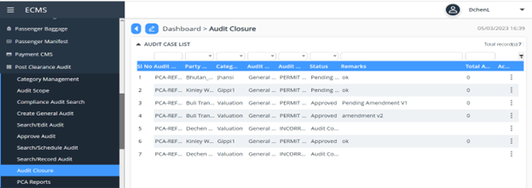
  - Click Audit closure.

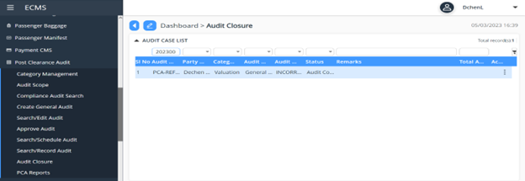Paste the PCA ref. number in the search panel.

- Go to Audit Approval, change the status as Approved and click the submit button.

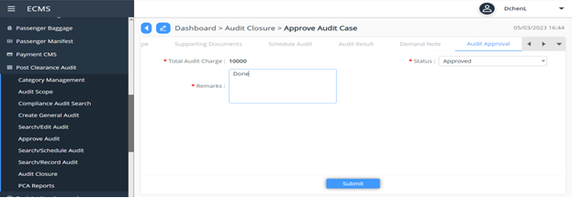

- Go to Search/Edit audit, search the PCA ref. number in the search panel.
(Status – ‘Closed’)
