System REQUIREMENTS SPECIFICATION
for
ecms -

Refund Module

Release Version 1.1 – Jun 2021

document identification no 3 char SYS ID/ DOC CODE /NN/ V M.n)  for details refer to document mgmt stds | document title | status  (draft/ released) | date of release | pages
ECMS/SRS/01/V1.1 | System requirements Specifications for ECMS Refund | released | 07.2021

 | role in the project | Name | signature | date  (dd-mm-yy)
Authors | Technical Team |  |  | 22-07-2021
Reviewers | Project Lead | Sujit Patra
Approver | Project Manager | Raghavan Jaganathan

Endorsement by system Owner (internal)
 | Name | designation | signature | date  (dd-mm-yy)
endorsed by system owner.

release history
release no | author | CR# | date | summary of changes
1.0 | karma |  | 8/19/2021 | Initial Release

CONTENTS
1. INTRODUCTION 4
1.1 Definitions and Abbreviations 4
1.2 References 5
1.3 Constraints 5
2. FUNCTIONAL REQUIREMENTS 6
2.1 Refund Overview 6
2.2 Refund Use Cases 7
2.2.1 Refund & Completed Refund Use Case 7
2.3 Refund Backend 7
2.3.1 Pre-Requisites 7
2.3.2 Process Flow 8
2.3.3 Refund Status 10
3. INTERFACES REQUIREMENTS 11
3.1 System Interfaces 11
4. Appendix 11
4.1 Configurable BLUEPRINT (CBP) 11

INTRODUCTION

The purpose of this module is to allow any external user to apply for refunds and for Customs to verify, approve or reject.

Definitions and Abbreviations
S/N | Abbreviations | Description
 | BITS | Bhutan Integrated Tax System
 | BTC | Bhutan Tariff Classification
 | CFA | Clearing and Forwarding Agent
 | CDS | Customs Declaration System
 | DITT | Department of Information Technology & Telecom
 | DRC | Department of Revenue & Customs
 | eCMS | Electronic Customs Management System
 | EMS | Express Mail Service
 | FRS | Functional Requirements Specification
 | GST | Goods and Services Tax
 | IDEC | Import Duty Exemption Certificate
 | LTO | Liaison and Transit Office
 | LoG | Letter of Guarantee
 | LCS | Land Customs Station
 | MoEA | Ministry of Economic Affairs
 | MoHCA | Ministry of Home and Cultural Affairs
 | MoF | Ministry of Finance
 | MIS | Management Information System
 | Nu | Ngultrum
 | RMA | Royal Monetary Authority
 | RGoB | Royal Government of Bhutan
 | RRCO | Regional Revenue and Customs Office
 | RTO | Regional Trade Office
 | RAMIS | Revenue Administration Management Information System
 | SARC | South Asian Association for Regional Cooperation
 | SITA | International Aeronautical Telecommunications Society
 | SCTS | Single Customs Trade System
 | SAD | Single Administration Document
 | TPN | Taxpayer Number
 | UPU | Universal Postal Union

References

Refund SRS uses the following documents as reference:

- FUNCATIONAL REQUIREMENT SPECIFICATION.docx
- TECHNICAL REQUIREMENT SPECIFICATION.docx
- Bhutan eCMS Technical Proposal TECH-3.pdf
- Bhutan eCMS Technical Proposal TECH-4.pdf
- Bhutan eCMS Technical Proposal TECH-5A.pdf
- Bhutan eCMS Technical Proposal TECH-5B.pdf
- Bhutan eCMS Technical Proposal TECH-6A.pdf
- Bhutan eCMS Technical Proposal TECH-6B.pdf

Constraints
NA

FUNCTIONAL REQUIREMENTS

Refund Overview
The motivation behind this module is to permit an external user to apply for refund and for Customs to confirm, endorse (or reject) and interaction them. There are three (3) kinds of Refunds which are listed below:

- Refund of penalties with the following of an appeal
- Refund for a wrong classification

Refunds should be made inside one (1) year of the declaration being acknowledged by the Customs

Refund Use Cases

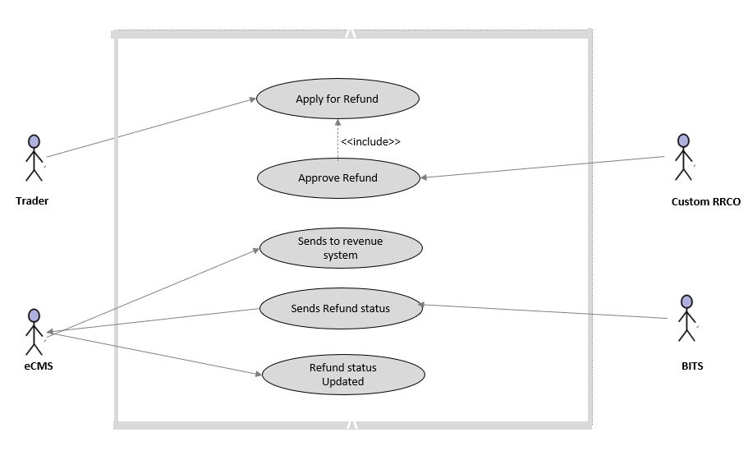
Refund & Completed Refund Use Case

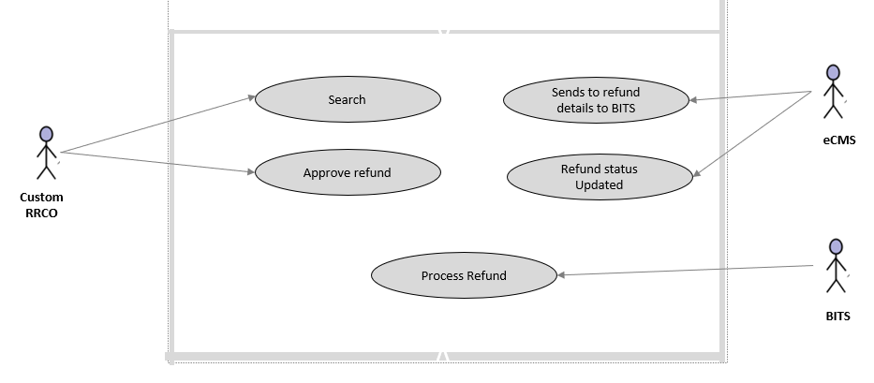

use case diagram for REFUND in ecms

Refund Backend

Pre-Requisite
BITS is ready to accept and process the refund details sent by eCMS and respond with the demand notice for the refund.

Process Flow

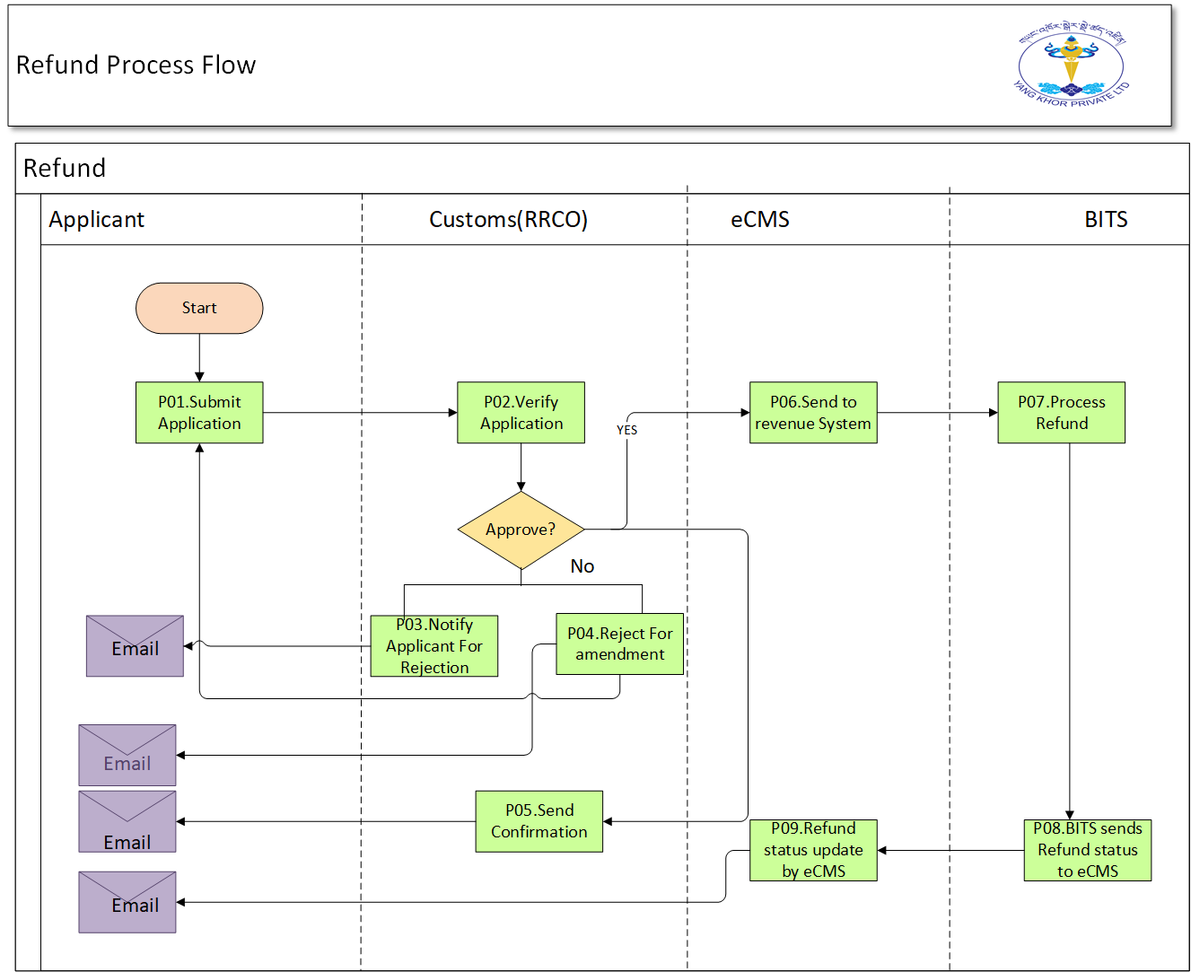

Figure 5: refund process flow

Refund Process Steps

Process Steps
P01: Submit Application
Users must be able to apply for a refund by completing an online application form and attaching scanned copies of supporting documents, including receipt number of payments, invoices, Customs declaration, and exemption certificate (if applicable). In addition, the form should also allow for the application to be linked to the original Customs Declaration.
In case the non-exempted person has paid custom duty, taxes and others., made on behalf of exempted party must define the name of importer and the ID of consignment details.

P02: Verify Application
When the application has been made, by the applicant Customs will verify the application and supporting documents.
If the application has been successfully verified, it must then be forwarded to the next available Assessor at RCCO, on a rotational basis, who will approve the application. During verification of refund application, exemption issued for the refund or not.

P03: Notify Application for Rejection
If the application for a refund is rejected, the applicant must be notified by email, including the reason for rejection.

P04: Reject for Amendment
If the application submitted is incomplete or the applicant need further amendment, the same will be reverted to the applicant for amendment by email.

P05: Send Confirmation
The applicant must be notified by email that their application has been approved

P06: Send to Revenue System
Once the refund application has been approved by the custom, it will be redirected to the revenue system which will return the generated demand notice for the refund to the eCMS.

P07: Process Refund
When processing the application, Customs must be able to enter the details of the refund against the original declaration, without changing any of the fields on the original declaration itself. Additional fields must be added, including a remarks field and detailed breakdown of the refund, separating duties, taxes, and penalties.
P08: BITS send Refund Status to eCMS
Once the refund process has been done BITS will send the refund status to eCMS.

P09: Refund Status Update By eCMS
When the refund status has been sent by the BITS, the Refund status will be updated by eCMS

Refund Status
Below shows the status transition of a Refund Instructions made.

Pending Refund: It is pending refund in the System.
Paid Refund: BITS or the revenue system will generate the demance notice against the refund made by the trader and the status refunded will be updated in the system
Cancelled Refund: Refund is Cancelled.

Status Code | Status Description | Remarks
PENDING | Pending | The “Refund Instruction” is pending to be collected.
FULL_PAID | Fully Refunded | Refund is made in full.
CANCELLED | Refund Cancelled/Rejected | Refund request is cancelled/rejected.

INTERFACES REQUIREMENTS

System Interfaces

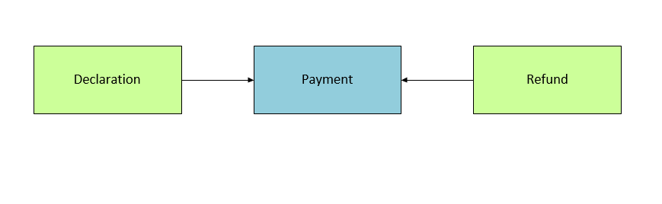

Figure 8: System Interfaces

Appendix

Configurable BLUEPRINT (CBP)

