System REQUIREMENTS SPECIFICATION
for
eCMS – applications (act, exemption)

Release No 1.0 – Sep 2021

document identification no 3 char SYS ID/ DOC CODE /NN/ V M.n)  for details refer to document mgmt stds | document title | status  (draft/ released ) | date of release | pages
eCMS /SRS/01/V1.0 | System Requirement Specifications For eCMS ACT and Exemption | Released | 09.2021 | 26

 | role in the project | Name | signature | date  (dd-mm-yy)
Authors | Technical Team | Shrinivas Udagatti  Alvin Ian P Paule  Ramoji Lokam
Reviewers | Project Lead | Sujit Patra
Approver | Project Manager | Raghavan Jaganathan

Endorsement by System Owner (internal)
 | Name | designation | signature | date  (dd-mm-yy)

release history
Release Number | associated change request number | Date (mm,yyyy) | Brief Summary of changes | Author
1.0 | First Release | 09.2021 | Initial Release | Sujit Patra

Table of Contents
Table of Contents 3
Introduction 4
A. Definitions and Abbreviations 4
B. References 6
1. Functional Requirements 7
1.1 Authorized Complaint Trader (ACT) 7
1.1.1 Pre-Requisites 7
1.1.2 Process Flow for Authorized Compliant Trader 7
1.1.3 Use Case Diagram for Authorized Compliant Trader 8
1.1.4 Business Validation 10
1.2 Import Duty Exemption 11
1.2.1 Pre-Requisites 12
1.2.2 Process Flow for Import Duty Exemption 12
1.2.3 Use Case Diagram for Import Duty Exemption 13
1.2.4 Business Validation 15
1.3 Duty Free Quota 16
1.3.1 Pre-Requisites 16
1.3.2 Process flow for Duty Free Quota 16
1.3.3 Use Case Diagram for Duty Free Quota 17
1.3.4 Business Validation 19
Appendix A 23
1. Configuration blueprint (CBP) 23
2. Types of Exemption 23
3. Annual duty free quota limits 24
4. Exemption Print 25
5. Backend Jobs 25
6. Exemption Approval Matrix 26

Introduction
This document defines & illustrates the business requirements, process flows as well as the detailed functional requirements of eCMS Application module (Authorized Compliant Trader and Exemption) to be implemented for Department of Revenue and Customs, Bhutan.

Definitions and Abbreviations
The table below lists the different acronyms and abbreviations as well as the definitions used throughout this SRS.

S/N | Abbreviations | Description
 | ACT | Authorized Compliant Trader
 | BACS | Bhutan Automated Customs System
 | BAFRA | Bhutan Agriculture and Food Regulatory Authority
 | BNB | Bhutan National Bank
 | BoB | Bank of Bhutan
 | BITS | Bhutan Integrated Tax System
 | BSTEC | Bhutan Sales Tax Exemption Certificate
 | BTC | Bhutan Tariff Classification
 | CFA | Clearing and Forwarding Agent
 | CDS | Customs Declaration System
 | CAB | Customs Act of Bhutan
 | CID | Citizens Identification Number
 | CRRB | Customs Rules and Regulations of Bhutan
 | DITT | Department of Information Technology & Telecom
 | DRC | Department of Revenue & Customs
 | eCMS | Electronic Customs Management System
 | EMS | Express Mail Service
 | FRS | Functional Requirements Specification
 | GST | Goods and Services Tax
 | IDEC | Import Duty Exemption Certificate
 | LTO | Liaison and Transit Office
 | LoG | Letter of Guarantee
 | LCS | Land Customs Station
 | MoEA | Ministry of Economic Affairs
 | MoHCA | Ministry of Home and Cultural Affairs
 | MoF | Ministry of Finance
 | MIS | Management Information System
 | Nu | Ngultrum
 | RMA | Royal Monetary Authority
 | RGoB | Royal Government of Bhutan
 | RRCO | Regional Revenue and Customs Office
 | RTO | Regional Trade Office
 | RAMIS | Revenue Administration Management Information System
 | SAARC | South Asian Association for Regional Cooperation
 | SITA | International Aeronautical Telecommunications Society
 | SCTS | Single Customs Trade System
 | SAD | Single Administration Document
 | TPN | Taxpayer Number
 | UPU | Universal Postal Union

References
The creation of the BECMS SRS was referenced using the following documents:
- FUNCATIONAL REQUIREMENT SPECIFICATION.docx
- TECHNICAL REQUIREMENT SPECIFICATION.docx
- Bhutan eCMS Technical Proposal TECH-3.pdf
- Bhutan eCMS Technical Proposal TECH-4.pdf
- Bhutan eCMS Technical Proposal TECH-5A.pdf
- Bhutan eCMS Technical Proposal TECH-5B.pdf
- Bhutan eCMS Technical Proposal TECH-6A.pdf
- Bhutan eCMS Technical Proposal TECH-6B.pdf

Functional Requirements

Authorized Complaint Trader (ACT)
An external user can apply for Authorized Compliant Trader (ACT) in eCMS. ACT are accorded certain procedural advantages in eCMS which result in a quicker and smoother clearance.
The below section details out the process of applying for an ACT in eCMS.

Pre-Requisites
- Trader should have a valid TPN which is available in eCMS PIN Master through BITS integration.
- Trader has a history of compliance which can be validated against BITS provided information in PIN master.
- Company admin has access to eCMS ACT application functionality.

Process Flow for Authorized Compliant Trader

Process ID: 01.01 – Authorized Compliant Trader
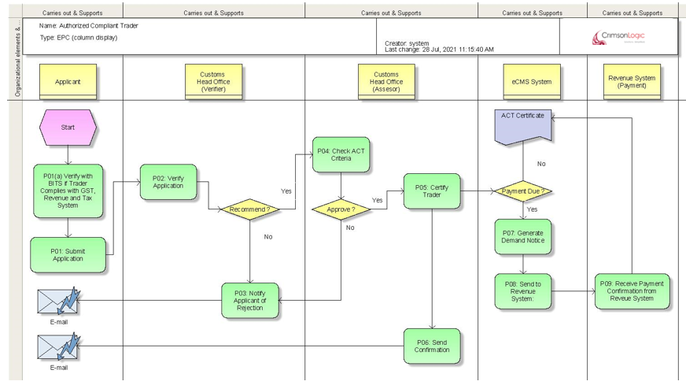

Use Case Diagram for Authorized Compliant Trader

Authorized Compliant Trader Application Submission, verification & approval/rejection.




Submit Application
Search User Applications
Verifier
(Head Office)
Assessor
(Head Office)
Company
Admin
(Trader)
Validate Application

Recommend Application

Approve/Reject Application

Process Steps
P01: Submit Application
A user will prepare an application for ACT after logging into eCMS. Before submission of the Application, eCMS will validate the provided TPN in PIN Master. Following are the steps for validation of TPN.
- System will retrieve the details from eCMS PIN Master. If the TPN keyed in is valid then System will fetch the related TPN details and display in the application. In case of importer most of the data will be prepopulated based on login TPN.

If the TPN is found and valid, then the application will be accepted for submission and the application shall be taken up for review by DRC and for certification as an ACT (Authorized Compliant Trader).

A unique reference no will be generated once the application is submitted and the same can be used by the applicant to track the status of the application. Application status can be checked through the Portal as well (Outside the login).

P02: Verify Application
System will assign the application to the work queue of a Verifer at the Customs head office on a round-roobin basis using Resource allocation module. The verifier will verify the applicant details and determine the validity of the application. The verifier based on the review will either recommend, reject, or revert for amendment.

In case of an incomplete application, the applicant must be notified that they must furnish the correct documents within thirty (30) days. The number of days should be configurable.
P03: Notify Applicant of Rejection
During verification, if the verifier concludes that the application is invalid for any reason, then the Verifier will provide reasons for rejection and reject the application. The applicant shall be notified of the rejection including the reason for rejection by email. The status of the application should be rejected.
If the application is reverted back for amendment, then the status of the application should be re-submit.

P04: Check ACT Criteria (Assessor)
If the application has been recommended for ACT by the verifier, System will assign the application to the work queue of an Assessor at the Customs head office on a round-roobin basis using Resouce allocation module.

Assessor will check recommended application detail and determine if it qualifies for ACT. If the assessor determines that the application needs to be rejected for any reason, then the assessor will reject the application and provide reasons for rejection. eCMS will notify the applicant of the rejection (please refer P03). the status of the same will be rejected.

P05: Certify Trader
During assessment, if the Assesor concludes that the provided documents and related details are in order, then the Assessor can approve the application for ACT certification. In this case, System will certify the applicant as an ACT in eCMS.
Applicable fees are configured in the System, and, if any fees are configured, System will apply fees and route for payment.

Note: Fees will be defined in the Rules files, however we have catered payment process flow, if fees are applied.
P06: Send Confirmation
Post registration, System will notify the applicant on the successful certification as an Authorized Compliant Trader (ACT).

P07: Generate Payment advice
Post approval and registration, system will determine if fees are applicable based on configuration. If no fees are applicable, system will allow printing of certificate of registration.
If fees are applicable, a payment advice shall be generated and sent to Revenue. Registration certificate printing and ACT certification shall be withheld till all payments are completed.

P08: Send to Revenue System
eCMS will integrate with Revenue system and send the payment advice generated in previous step.

P09: Receive payment confirmation from Revenue System
Revenue system will send a payment confirmation to eCMS after collecting payment in Revenue system.
After receipt of collection message, eCMS will enable printing of “Authorized Compliant Registration certificate” and ACT certification will be restored.
Additional Functionality

S/N | Additional Functionality
1. | Customs can suspend an ACT at any time if any serious irregularalities are detected. In this case, a notification shall be sent to the ACT after suspension.
2. | Customs can withdraw the suspension, and, in this case, ACT shall be activated.
3. | Customs could revoke an authorization in case if the trader did some very serious offence. In this case, the holder cannot re-apply for ACT for a period of three (3) years (configurable). A notification shall be sent to the ACT after revocation.

Business Validation
S/N | Validation Rules
1. | Trader applying for ACT should be complying as per BITS.
2. | At given time, only one ACT application can be submitted per Trader (No duplicate submission)
3. | In case applicant is required to submit additional documents during ACT Review, the applicant will need to submit requested additional documents by Customs verifying officer within thirty (30) days.
4. | Rejected Application cannot be amended and re-submitted.

Import Duty Exemption

An external registered user can apply for import duty exemption in eCMS after logging into eCMS. Exemptions can be applied for specific items and for a specific reason (for example, for setting up a Manufacturing unit etc). Approved exemptions can be referred while declaring consignments and system will accordingly exmpt applicable Customs duties and charges.
The below section details out the process of applying for an Exemption for import duty in eCMS.

Overall, Exemption will be structured as follows.
- Each exemption will be uniquely identified by the TPN of the Importer.
- Each exemption will be structured as below, and applicant will need to select at the point of submission of the application:
    - Exemption Type (Ex: Vehicle) – Applicant will need to select an Exemption type from a configured list of Exemption types. Only one Exemption type can be specified for an application.
    - Exemption Issued for (For ex: Armed Forces) – Applicant will need to select an “Exemption Issued for” from the configured list of “Exemption Issued for” under each “Exemption Type.” Only one Exemption issued for can be specified for an application.
    - Exemption Category (Ex: Vehicle Quota) - Applicant will need to select an “Exemption Category” from the configured list of “Exemption Category” under each “Exemption Issued for.”. Only one Exemption Category can be specified for an application.
In addition, an additional Exemption type named “Refund Exemption” shall be provided. This will be applied by the Applicant for Exemption after the Declaration has been cleared from Customs. In this case, the Applicant for Refund Exemption will be required to key in the Declaration number along with the TPN of the Importer. After verification of provided Declaration and Importer TPN, the applicant shall provide the Invoice and item details like any other Exemption. Post approval from Customs, the importer can apply for refund using the approved Refund exemption.

- Based on the specified Exemption type, issued for and Category, system will fetch the configured exempted tax type which may be any combination of existing tax types of namely CDR, GT, EET and GST.
- The ceiling on the value for the combination of Exemption type, issued for and category will be configured in Rules files. In case if the Ceiling on the value is not specified in Rules, then the verifier will need to manually provide the exempted Value or Quantity during review. If the ceiling is specified in the rules, then system will default the exempted value to the ceiling.
- Each exemption type will have an approval matrix (Configurable in the System) which will determine the required approvals for the exemption type and will be configured in the Rules file. For instance, certain Exemption type may require approval from RRCO followed by approval from Head office. If no rules are configured, then it will be routed by default to Head office (Verifier followed by Assesor). The SRS currently covers the default flow, but it is understood that the implementation will handle the configured routing.
- An approved exemption which has not been consumed in a declaration and nearing expiry can be extended. Applicant will need to apply for renewal.
- Exemption certificate can be printed by the Importer and Customs after final approval.

(Details of current Exemption types and Exemption certificate print is provided in the appendix section)

Pre-Requisites
- TPN of the Trader should be active and available in eCMS PIN Master through BITS integration. In case Trader does not have a TPN, they will either need to apply in BITS or use Fast TPN Link in eCMS.
- incase of CFA applying for an importer without a TPN, the TPN for the importer can be registered by the CFA by using the fast-track interface.
- Exemption will be based on TPN, and this will used to link and validate an exemption when it is applied in a declaration.
- Trader has required supporting document like item list, invoice information etc.
- Company admin has access to eCMS Import duty exemption application functionality.

Process Flow for Import Duty Exemption

Process ID: 01.02 – Import Duty Exemption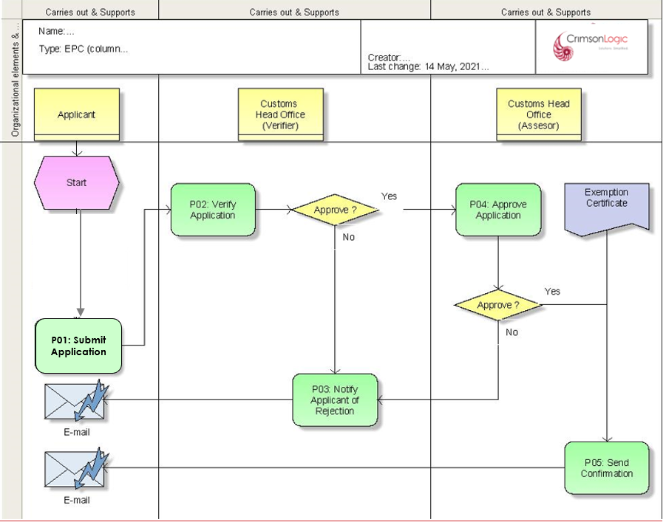

It is either the Head office or the RRCO verifying as well approving the exemption. However, some of the exemption processes are decentralised. Eg. Exemption for raw materials is verified, approved, and issued by the RRCO and exemption for plant and machinery are verified, approved, and issued by the head office.

Use Case Diagram for Import Duty Exemption

Import Duty Exemption Application Submission, verification & approval/rejection.




Submit Application
Search User Applications
Verifier
(Head Office)
Assessor
(Head Office)
Trader
/ CFA
Validate Application

Recommend Application

Approve/Reject Application

Process Steps
P01: Submit Application
- An external user will login to eCMS and prepare an application for Import Exemption. In case of a CFA applying exemption on behalf of the importer, User shall provide the TPN number of the Importer.
- System will retrieve the details from eCMS PIN Master and load the data for CFA based on entered TPN. In case of importer most the data will be prepopulated based on login TPN.
- However, If the TPN cannot be validated and is not registered with eCMS PIN Master, the system should provide a link for fast-track TPN registration in BITS.

User will provide required mandatory information for getting an exemption and submit. The following information but not limited to shall be captured in the item tab:
The HS Code of the item along with details like invoice Value, Quantity, Country of Origin (COO) etc.
- In case of Refund Exemption, the applicant will additionally need to provide the Customs cleared Declaration and Importer TPN.

Upon submission, System will generate an application number.
- Application can be to.
- Renewed (If the exemption has not been used in a declaration)
  - Expiry date only.
- Cancel (If the exemption has not been used in a declaration)
- New
(In case of a Refund Exemption, renew is not applicable)
A unique reference no will be generated once the application is submitted and the same can be used by the applicant to track the status of the application.

P02: Verify Application
When the exemption application has been submitted, System will route the application for review to the work queue of the Verifier in a round-robin basis using the Resource allocation module and based on the configured approval matrix. The Verifier will verify the applicant details and determine the validity of the application.

- The verifier based on the review will either recommend, reject, or revert for amendment. The status of the application shall reflect the action taken by the verifier.
- For each item, the verifier will mark the field on which exemption will be provided as provided below.
  - Value,
  - Quantity
The system should be able to generate and issue exemption base on either value or quanity.
(Note: In case if ceiling value is configured for the provided Exemption type, system will default the value to the configured ceiling.)

Based on this field, the exemption will be tracked in the declaration when items are declared.

P03: Notify Applicant of Rejection
During verification, if the verifier concludes that the application is invalid for any reason, then the Verifier will provide reasons for rejection and reject the application. The applicant shall be notified of the rejection including the reason for rejection by email.
Amendment: if the documents submitted are incomplete or the application needs further amendment, the same will be revereted back to the applicant for amendment
The status of the application will be as per the action taken by the verifier.

P04: Approve Application
If the exemption has been verified and recommended by the verifier, System will route the application for review to the work queue of an Assessor at the Customs Head Office on a round-robin basis using the Resouce allocation module and based on configured approval matrix.
Assessor will check recommended application detail and determine if it can be approved. If the assessor determines that the application needs to be rejected for any reason, then the assessor will reject the application and provide reasons for rejection. eCMS will notify the applicant of the rejection (please refer P03). The application can be reverted to the verifier for further review too by the assessor.

If the application is approved, the applicant must be issued an Import Duty Exemption Certificate (IDEC), which must be allocated a unique system generated reference number and will be valid for one (1) year.

In case where an exemption has been granted to a business, which is upgraded to a company and assigned a new TPN, the IDEC will no longer be valid. Essentially, system must ensure that the TPN for which the IDEC was approved is also the TPN which is using the IDEC to import goods.

Note: To claim Customs duty exemption, the importer must include the IDEC No. at Header level of the import declaration (Exemptions of the type “Refund Exemptions” cannot be linked during Declaration submission). There should be no need to attach the certificate itself, as it must be linked within the eCMS.

P05: Send Confirmation
System will notify the applicant on the approval of the Exemption request.
System to allow applicant to print the exemption from the system.

Additional Functionalities

S/N | Additional Functionality
1. | System will provide an option for Customs to search exemption details by clicking search menu and entering following details: Application Number, TPN to view individual exemption.
2 | System will alert the importer as well as customs if before the validity of the exemption expires

Business Validation
S/N | Validation Rules
1. | Total invoice value and total value of items under that invoice should match.
2. | Rejected Application cannot be amended and re-submitted.
3. | Expired exemption cannot be used during declaration
4 | Refund Exemptions cannot be used in a Declaration directly unlike other Exemptions.
5 | Only Customs cleared Declaration can be used for Refund Exemption
6 | For Refund Exemption, only one Declaration can be linked to an application,
7 | Refund Exemption can be applied multiple time for a Declaration and System will validate that exempted Item quantity is not beyond the Declared quantity.  Example, Declaration has 1000 quantity submitted by Importer for 2 parties. Exempted parties can split the quantities say 500 and 500.
8 | The Importer of the Declaration and the Applicant applying Refund Exemption cannot be the same.
9 | Refund Exemptions cannot be renewed.

Duty Free Quota
An external user can apply for Duty-Free Quota in eCMS. The application will be made available in the public portal and will not require the user to login to eCMS. The below section details out the process of applying for a Duty-Free Quota in eCMS.

Overall, Duty Free Quota will be structured as follows:
      - Applicant will provide ID number and TPN Number. ID Number will be CID in case of Bhutanese national and Passport number/ work permit no in case of non-Bhutanese.
      - TPN number should be available in eCMS PIN Master through BITS integration and will be validated.
      - System will maintain a list of available Privileged members along with quota value in USD. During verification, Customs verifier will indicate the privileged member (only one per application).
      - During verification, Customs will be able to verify all the details including configured quota value but cannot change the value.

(Details of privileged members and quota values in USD are provided in the appendix )

Pre-Requisites
- Applicant should be eligible for duty free quota.
- Bhutanese applicant should have a valid TPN.
- Foreigners applying for quota should have a valid stay and TPN
- Foreign applicant should have a valid work permit number.

Process flow for Duty Free Quota

Process ID: 01.03 – Duty Free Quota
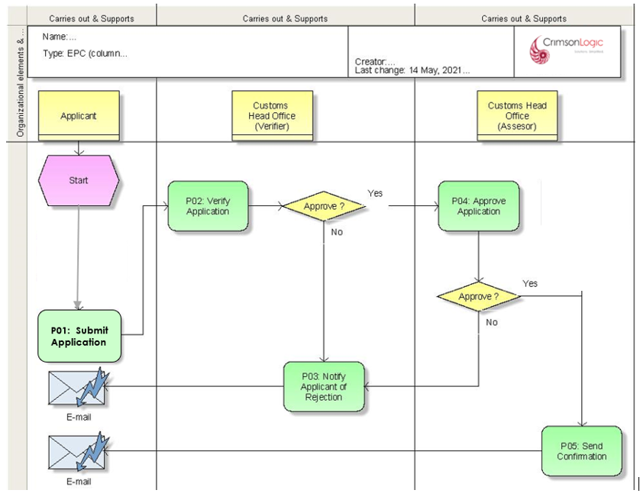

Use Case Diagram for Duty Free Quota

Duty Free Quota Application Submission, verification & approval/rejection.




Submit Application
Search User Applications
Verifier
(Head Office)
Assessor
(Head Office)
Applicant
Validate Application

Recommend Application

Approve/Reject Application

Process Steps
P01: Submit Application
An external user will prepare an application for Duty free quota outside the eCMS login.

For Bhutanese nationals:
- The system shall allow the applicant to key in CID. If the applicant keys in the CID, the same should hit the eCMS PIN Master, and list all the TPN registered against the CID.
- For the selected TPN, System will fetch the related TPN details and display in the application. For duty free quota, only individual shall be allowed (No Business or Company TPN)
- However, If the TPN cannot be validated and is not registered with eCMS, system will provide a link to the SSP (Self Service Portal) registration in BITS to apply for TPN registration in eCMS.

For Other nationals: Non-Bhutanese must provide a valid work permit and TPN, TPN verification shall be applicable and eCMS will validate the TPN with eCMS PIN Master. In case TPN cannot be validated and is not registered with eCMS, system will provide a link for the SSP in BITS to apply for TPN registration in eCMS.

Applicant shall provide mandatory information for getting a duty-free quota and submit.

Duty free quota is provided on value which shall be specified by the approving officers and not by the applicant. For foreign nationals, start date and end date of tenure should be provided.

eCMS will generate an application number when the application is submitted by the applicant.
- Application can be to.
- Renew
- New
- cancellation

P02: Verify Application
When the duty-free quota application has been submitted, System will route the application for review to the work queue of a Verifier at the Head Office on a round-robin basis using the Resouce allocation module.
The verifier based on the review outcomes will either recommend, reject, or revert for amendment.

P03: Notify Applicant of Rejection
During verification, if the verifier concludes that the application is invalid for any reason, then the Verifier will provide reasons for rejection and reject the application. The applicant shall be notified of the rejection including the reason for rejection by email.

Amendment: if the documents submitted are incomplete or the applicant need further amendment, the same will be revereted back to the applicant for amendment by email

P04: Approve Application
If the Duty-Free Quota has been verified and recommended by the verifier, System will route the application to the work queue of an Assessor at the Customs Head Office on a round-robin basis using the Resouce allocation module.
Assessor will check recommended application detail and determine if it can be approved. If the assessor determines that the application needs to be rejected for any reason, then the assessor will reject the application and provide reasons for rejection. eCMS will notify the applicant of the rejection (please refer P03)

If the application is approved, System must genetrate an approval letter with a unique system generated Quota number which shall be valid till 31st Dec of the approval year based on date of approval.

Note: Quota will not be carry forwarded to next year, unused quota will be forfeited by 31st Dec. Once the quota validity is over, it cannot be used further, and balance quota shall be forfeited and cannot be carried forward.

Duty free stores will submit the declaration in eCMS for claiming the duty exemption.

P05: Send Confirmation
System will notify the applicant on the approval of the Duty-Free Quota request and include the Quota details as well.

The quota details shall be communicating with the applicant via email and the duty-free store who is issuancingof duty-free card. No prints are required for quota from eCMS as this will be provided by the Duty-free stores.

Additional Functionalities

S/N | Additional Functionality
System will allow renewal of duty-free quota. Applicant will need to visit the Application portal and key in the Quota number along with the TPN provided at the time of submitting the application.
System will allow the user to update the existing application and submit for renewal. Application renewal will follow similar process as new application. Post renewal, a new Quota number will be generated.

 | Customs can cancel the Duty-Free quota any time

Business Validation
S/N | Validation Rules
1. | Only one application per applicant can be submitted (No duplicate)
2. | Rejected Application cannot be amended and re-submitted.

CFA Authorization
A Trader will need to authorize a CFA to act on its behalf and transact in eCMS as its representative. For this, the Trader will need to apply from the Portal (outside Login) and indicate the CFA to be authorized. Upon submission, the application shall be reviewed and approved by a Verifier at the Customs Head office. Post approval from Customs, the CFA can act on behalf of the Trader and submit declarations and other trade related documents in the System.
The below section details out the process of CFA Authorization.

Pre-Requisites
- Trader should have a valid TPN which is available in eCMS PIN Master through BITS integration.
- CFA should be registered in eCMS as a CFA Operator (Please refer to Registration SRS for detailed steps)
- Customs Verifier at Head office has access to eCMS.

Process Flow for CFA Authorization
Process ID: 01.04 – CFA Authorization

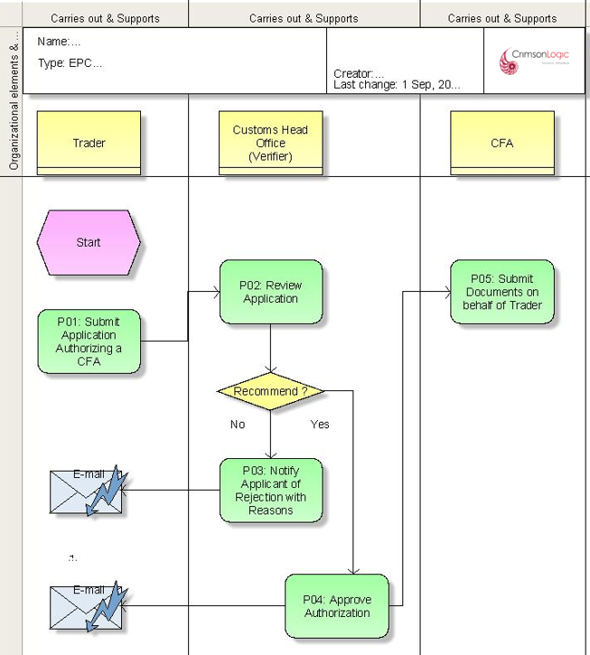

Use Case Diagram for CFA Authorization

CFA Authorization Submission, verification & approval/rejection.



Submit new Authorization
Search User Applications
Verifier
(Head Office)
Trader
Validate Application

Cancel Existing Authorization Application
Approve/Reject Application

Process Steps
P01: Submit Application
Trader will provide CID/TPN, and System will check for a valid CID and TPN through the following steps.

- The system will allow the applicant to key in CID as well as TPN. . The system will validate the kyed in CID and the TPN and accordingly allow the applicant to process further. In case of a business, the system will allow to key in the business licnese no and the TPN.
- If the TPN belongs to a Company, then the Applicant will be required to provide the Company registration number for authentication, the system will validate the keyed in TPN and the company registration number and accordingly allow the applcinat to proceed to fetch the TPN details and display in the Application.
- If the keyed in details is validated then System will fetch the related TPN details and display in the application (in case the TPN belongs to a Company, then system will follow authentication using Company registration number as mentioned in Step 2 before displaying TPN details).

After providing a valid TPN, Trader shall indicate the CFA which needs to be authorized from a list of registered and active CFA’s in eCMS and proceed to submit the application for authorizing the selected CFA. Only one CFA per application can be indicated.

The system will also allow the applicant to select the start date and end date. ( validity of the authorization)

Application can be for:
      - Create new Authorization
      - Cancel existing Authorization
A unique reference no will be generated once the application is submitted and the same can be used by the applicant to track the status of the application.

P02: Review Application
System will assign the application to the work queue of a Verifer at the Customs head office on a round-roobin basis using Resource allocation module. The verifier will verify the applicant details and determine the validity of the application. The verifier based on the review will either approve or reject the application.
P03: Notify Applicant of Rejection
During verification, if the verifier concludes that the application is invalid for any reason, then the Verifier will provide reasons for rejection and reject the application. The applicant shall be notified of the rejection including the reason for rejection by email. The status of the application should be rejected.

P04: Approve Authorization
During verification, if the Verifier concludes that the provided details are in order, then the Verifier can approve the Authorization. In this case, System will authorize the CFA to act on behalf of the Trader.
After approval, System will send a notification to the Trader and the CFA.
P05: Submit Documents on behalf of Trader
After approval and receipt of notification, the following actions are possible
            - In case of new Authorization, CFA can submit Declaration and other Trade related Documents in eCMS. System will present a list of authorized TPN’s for the CFA to choose from while creating a transaction in the System on behalf of the Trader.
            - In case of Cancellation of existing Authorization, the CFA cannot select the TPN and cannot submit for the Trader.

Additional Functionality

S/N | Additional Functionality
 | N/A

Business Validation
S/N | Validation Rules
1. | Trader can apply only one authorization for one CFA at one time. However, trader can submit multiple authorization but for different CFA at the same time.
2. | Rejected Application cannot be amended and re-submitted.
3. | If a CFA is already authorized for a Trader, the trader cannot submit another authorization for the same CFA.
4. | If during Customs review and, in the meantime, if the CFA is not active in the System for any reason, then System will not allow the approval to go through and Customs Verifier will need to reject the application.
5 | Cancellation can be applied only if the CFA is previously authorized by the Trader.

Appendix A

Configuration blueprint (CBP)

Configuration Blueprint (CBP) for ACT and Exemption

Types of Exemption

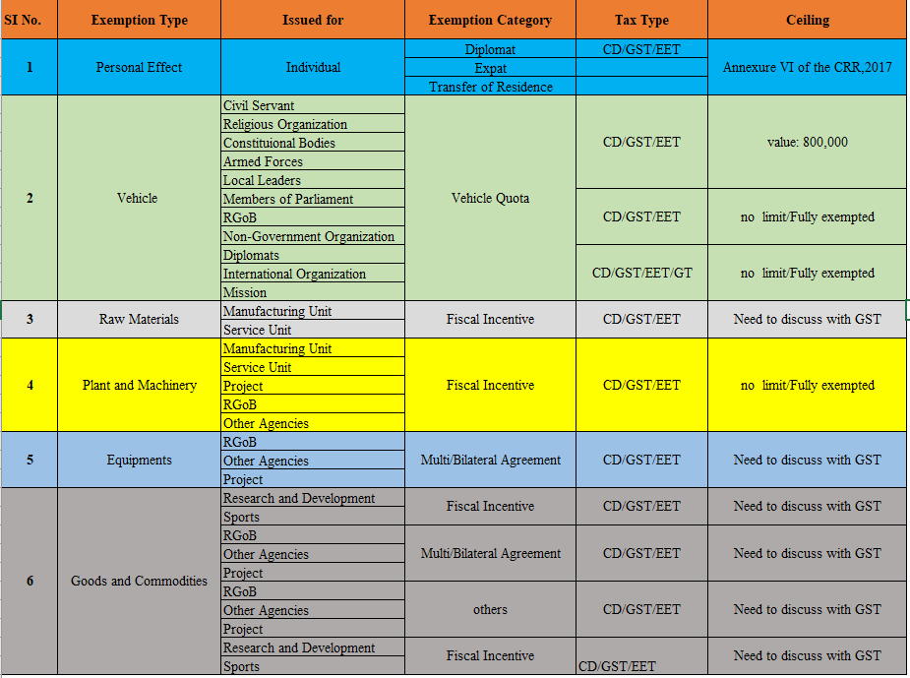
Additionally, Exemption Type “Refund Exemption” shall also be included
Sl.No | Exemption Type | Issued For | Exemption Category | Tax Type | Ceiling
7 | Refund Exemption | All | Refund | CD/GST/EET | No Limit

Annual duty free quota limits
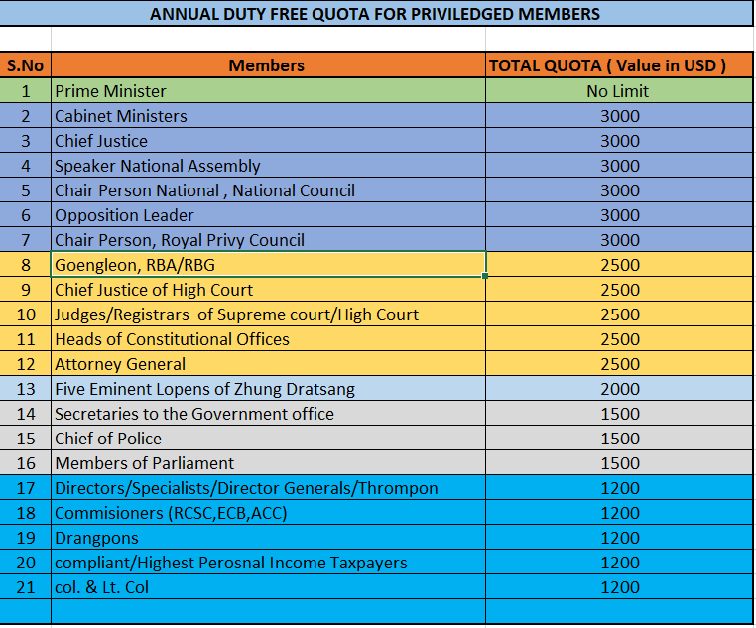

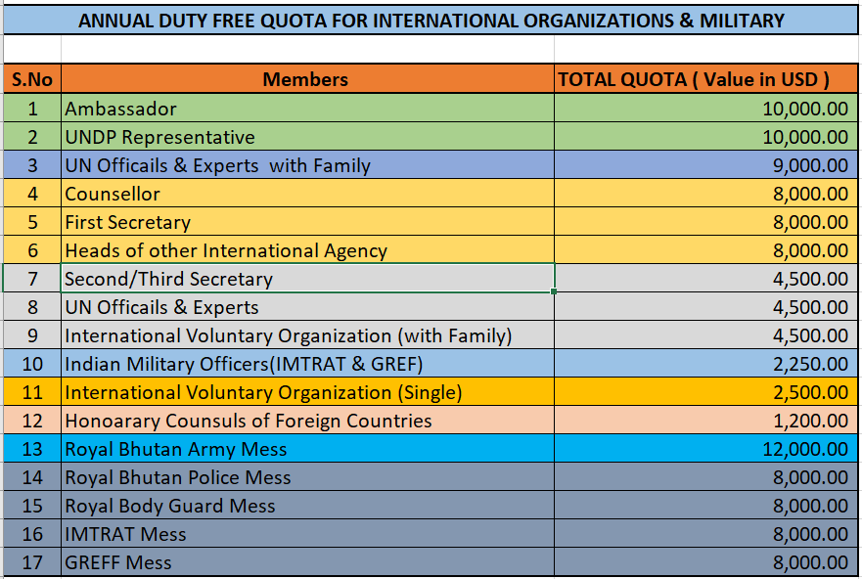

Exemption Print
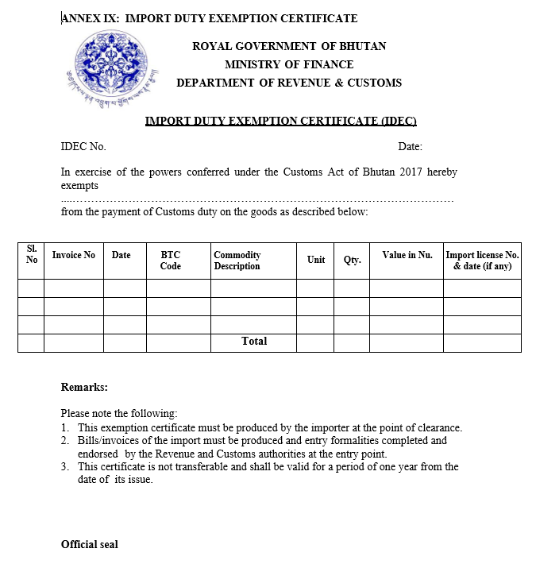

Backend Jobs

- System will check through a batch job for any updates done to PIN Master by BITS and update the ACT Status if needed for effected TPN’s.

Exemption Approval Matrix
Below is the Exemption approval matrix for different types of Import Exemption. Approval matrix for Goods and commodities need to be finalized. Approval matrix can be configured in the System using Rule File.

