System REQUIREMENTS SPECIFICATION
for
ecms – declaration processing
Part I (Import, Export,Warehouse)

Release No 1.0 – Sep 2021

document identification no 3 char SYS ID/ DOC CODE /NN/ V M.n)  for details refer to document mgmt stds | document title | status  (draft/ released ) | date of release | pages
ECMS/srs/01/V1.0 | System requirements Specifications For ECMS Declaration Processing (Import, Export and Warehouse) | DRAFT | 09.2021 | 56

 | role in the project | Name | signature | date  (dd-mm-yy)
Authors | Technical Team | Shrinivas Udagatti  Alvin Ian P Paule  Ramoji Lokam
Reviewers | Project Lead | Sujit Patra
Approver | Project Manager | Raghavan Jaganathan

Endorsement by System Owner (internal)
 | Name | designation | signature | date  (dd-mm-yy)

release history
Release Number | associated change request number | Date (mm,yyyy) | Brief Summary of changes | Author
1.0 | First Release | 09.2021 | Initial Release | Sujit Patra

Contents
1. INTRODUCTION 5
1.1 Business Architecture Of eCMS Declaration Processing 5
1.2 Scope of Declaration Processing 6
1.3 Definitions and Abbreviations 7
1.4 References 8
2. FUNCTIONAL REQUIREMENTS 9
2.1 Overview 9
2.2 Assumptions and Restrictions 9
2.3 Core Processing Steps 10
2.3.1 Description 10
2.3.2 Pre-requisite 10
2.3.3 Process Flow 10
2.3.4 Resource Assignment 14
3. DECLARATION TYPE (CPC GROUP) PROCESS FLOW 15
3.1 Import 15
3.1.1 Process Flow 15
3.1.2 Process Step 15
3.1.3 Business Rules 17
3.1.4 Business Validation 17
3.2 Temporary Admission / Import 19
3.2.1 Process Flow 19
3.2.2 Process Step 19
3.2.3 Business Rules 20
3.2.4 Business Validation 21
3.3 Re- Import Declaration 22
3.3.1 Process Flow 22
3.3.2 Process Step 22
3.3.3 Business Rules 23
3.3.4 Business Validation 24
3.4 Export 25
3.4.1 Process Flow 25
3.4.2 Process Step 25
3.4.3 Business Rules 27
3.4.4 Business Validation 28
3.5 Re-Export 29
3.5.1 Process Flow 29
3.5.2 Process Step 29
3.5.3 Business Rules 31
3.5.4 Business Validation 31
3.6 Temporary Export 33
3.6.1 Process Flow 33
3.6.2 Process Step 33
3.6.3 Business Rules 35
3.6.4 Business Validation 35
3.7 Warehouse Declaration 36
3.7.1 Process Flow 36
3.7.2 Process Step 36
3.7.3 Business Rules 37
3.7.4 Business Validation 38
3.8 EX-Warehouse Declaration 39
3.8.1 Process Flow 39
3.8.2 Process Step 39
3.8.3 Business Rules 41
3.8.4 Business Validation 42
3.9 Duty Free declaration with Customs Duty 43
3.9.1 Process Flow 43
3.9.2 Process Step 43
3.9.3 Business Rules 44
3.9.4 Business Validation 44
3.10 Duty Free declaration without Customs Duty 45
3.10.1 Process Flow 45
3.10.2 Process Step 45
3.10.3 Business Rules 46
3.10.4 Business Validation 46
3.11 Simplified Declaration (Stores) 47
3.11.1 Process Flow 47
3.11.2 Process Step 48
3.11.3 Business Rules 48
3.11.4 Business Validation 48
3.12 Simplified Declaration (Customs) 49
3.12.1 Process Flow 49
3.12.2 Process Step 49
3.12.3 Business Rules 50
3.12.4 Business Validation 50
3.13 Passenger Declaration 51
3.13.1 Process Flow 51
3.13.2 Process Step 51
3.13.3 Business Rules 52
3.13.4 Business Validation 52
3.14 User Interfaces 52
3.15 Hardware Interfaces 52
3.16 Software Interfaces 52
4. Appendix 53
4.1 Declaration Clearance Statuses 53
4.2 Payment Invoice Print 54
4.3 Release Order Print 56

INTRODUCTION

This document defines & illustrates the business requirements, process flows as well as the detailed functional requirements of the declaration processing module in eCMS.

The declaration submission is the first step in the eCMS System. After submission, the declaration goes through processing by various department of Customs. This document also illustrates the overall processing of the various regimes supported by eCMS.

Business Architecture Of eCMS Declaration Processing
The overall components of the eCMS Declaration Processing is listed below

Clearance Support
Tariff Management
Offence/Penalties
Declaration Submission
Core Clearance

Duties and Fees Calculation
Manifest Submission

Duties and Fees Payment
Temporary Import / Export Application

Declaration Submission
Appeal
Valuation

Declaration Acceptance
Risk Assessment
Refund

Document Verification
Post Clearance Audit

Inspection

Release

eCMS Declaration processing Business components

All the functions in the CMS are categorized into the following:
- Declaration submission functions
- Core Clearance functions
- Clearance support functions

Declaration submission Functions

These are module which are involved with the declaration submission and approval process. The key factor in the declaration submission is the various CPC groups and details required for a successful declaration submission and ensuring that system level validations are carried out properly to ensure a valid and well-formed declaration to be submitted in eCMS.

Core Clearance Process

These are modules within the eCMS which are directly involved in the clearance processes. The declaration is the key input for these modules and the focus is on enhancing clearance. The key factor in the core clearance process is the processing & response time, and this is the key design consideration for these modules. The core clearance process relies heavily on system processing minimizing human interventions.

Clearance Support Functions
These are modules which are involved indirectly in the clearance processes. They support the clearance end to end process. They must be seamlessly integrated into the clearance process to ensure the clearance time and processing is not affected. Response time for automated and system tasks, flexibility & feature set for functions requiring customs officers’ input is the key.

Scope of Declaration Processing
The scope of the Declaration processing implemented in eCMS covers the following:
- Regime & CPC Group-wise Declaration process flows

Definitions and Abbreviations
The table below lists the different acronyms and abbreviations as well as the definitions used throughout this SRS.

S/N | Abbreviations | Description
 | ACT | Authorized Compliant Trader
 | BACS | Bhutan Automated Customs System
 | BAFRA | Bhutan Agriculture and Food Regulatory Authority
 | BNB | Bhutan National Bank
 | BoB | Bank of Bhutan
 | BITS | Bhutan Integrated Tax System
 | BSTEC | Bhutan Sales Tax Exemption Certificate
 | BTC | Bhutan Tariff Classification
 | CFA | Clearing and Forwarding Agent
 | CDS | Customs Declaration System
 | CAB | Customs Act of Bhutan
 | CID | Citizens Identification Number
 | CRRB | Customs Rules and Regulations of Bhutan
 | DITT | Department of Information Technology & Telecom
 | DRC | Department of Revenue & Customs
 | eCMS | Electronic Customs Management System
 | EMS | Express Mail Service
 | FRS | Functional Requirements Specification
 | GST | Goods and Services Tax
 | IDEC | Import Duty Exemption Certificate
 | LTO | Liaison and Transit Office
 | LoG | Letter of Guarantee
 | LCS | Land Customs Station
 | MoEA | Ministry of Economic Affairs
 | MoHCA | Ministry of Home and Cultural Affairs
 | MoF | Ministry of Finance
 | MIS | Management Information System
 | Nu | Ngultrum
 | RMA | Royal Monetary Authority
 | RGoB | Royal Government of Bhutan
 | RRCO | Regional Revenue and Customs Office
 | RTO | Regional Trade Office
 | RAMIS | Revenue Administration Management Information System
 | SAARC | South Asian Association for Regional Cooperation
 | SITA | International Aeronautical Telecommunications Society
 | SCTS | Single Customs Trade System
 | SAD | Single Administration Document
 | TPN | Taxpayer Number
 | UPU | Universal Postal Union

References
The creation of the Declaration SRS was referenced using the following documents:
- FUNCATIONAL REQUIREMENT SPECIFICATION.docx
- TECHNICAL REQUIREMENT SPECIFICATION.docx
- Bhutan eCMS Technical Proposal TECH-3.pdf
- Bhutan eCMS Technical Proposal TECH-4.pdf
- Bhutan eCMS Technical Proposal TECH-5A.pdf
- Bhutan eCMS Technical Proposal TECH-5B.pdf
- Bhutan eCMS Technical Proposal TECH-6A.pdf
- Bhutan eCMS Technical Proposal TECH-6B.pdf

FUNCTIONAL REQUIREMENTS

Overview
The Declaration processing module in eCMS shows the overall declaration processing for different regimes and CPC.

Assumptions and Restrictions
The baseline declaration processing module will cover the processes illustrated in subsequent sections.

Core Processing Steps

Description
After the Declaration is accepted by customs, the core processing steps is triggered by the system. Based on the CPC Group certain sub-processes are optional, and some are mandatory. Refer the section on “Declaration Type Process Flows” for more details.

The generic process will consist of the sub-process as given in the table. The details of function of each sub-process will be provided in detail in the respective module document. All the below sub-process whether applicable or not depends on the CPC Group level. For e.g., for temporary import or export, an approved TIER application will be required.

Pre-requisite
The declaration to be processed should be accepted by customs

Process Flow
General Process flow for Declaration Processing
Process ID: 04.18 – General Process Flow for Declaration Processing
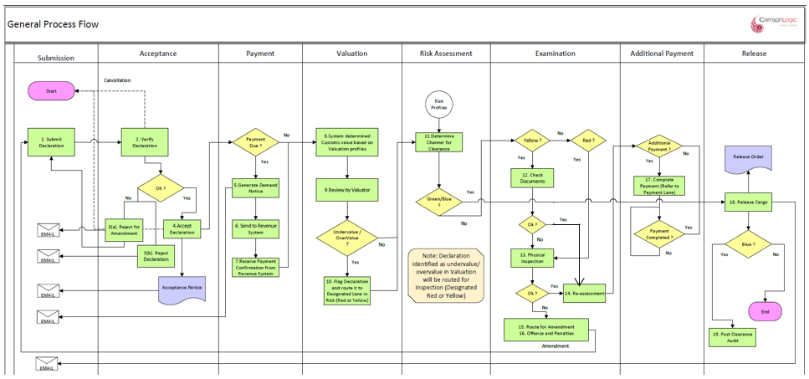

Process Steps
Payment
Description | Processing
The system will allow the trader to make payment liable through eCMS in BITS. After the payment has been completed the system will forward the declaration to the valuation process.  The system will generate a payment notice if applicable.  If there is no payment to be made by the trader the system will automatically forward the declaration to the next customs process. | a. If there is payment due  System will generate the demand notice based on the declaration submitted by the declarant. For payment, please refer to the payment process. (please incorporate a payment process explaining the integration process with BITS  b. If there is no payment due  Forward to the next core processing step
Note: Please refer payment document for the detailed process step

Valuation
Description | Processing
The valuation will determine the customs value of the declared goods based on the valuation database. | If the goods are under value, it will be flagged out and declaration will be marked as suspect for under value. Not all under-value transactions need to be routed to physical examination. Re-assessment will be triggered after document check. However, valuation decision has to be made in the valuation process.  After Examination, System will trigger a reassessment. Additional payment will be calculated by the system and will be collected through the payment module.  Please refer to the valuation SRS for detail process
Note: Please refer Valuation document for the detailed process step

Risk Assessment
Description | Processing
Risk assessment will be done based on profiles configured. The lane will be decided based on profile criteria met.  The possible outcomes are “Green”, “Blue”, “Yellow” or “Red” lanes.  “Green” lane will go for release process.  “Blue” lane will go for Post clearance audit after release.  “Yellow” will go for document verification.  “Red” will go for physical inspection. | The system will perform the risk assessment. The risk officer needs to review it and accept the risk.
Note: Please refer Risk Assessment document for the detailed process step

Examination
Description | Processing
Yellow Lane/Document Check  The document verification will be done when the lane is “Yellow”. | - If the declaration is directed to yellow lane, the declaration will be reflected in the document verifier’s dashboard  - the system will also provide a platform to the document verifier officer to submit the examination report.  - The document verification officer may review the documents and decide to release or route for physical inspection.
Red Lane/Inspection  Physical Inspection is part of the examination process and is applicable for all declaration marked for red lanes. Document officer may also route for inspection if required. | - If the declaration is directed to red lane, the declaration will be reflected in the inspections dash board  - the system will also provide a platform to the inspection officer to submit the inspection report that is standard and incorporated in the system.  - Based on the inspection REPORT, the assessor will either.  - release the goods  - send back to the declarant for amendment.  - Direct the declaration to the offences and penalties
Duty Re-assessment  Duty reassessment will be triggered when there is a change is customs value because of the valuation. Additional payment, if needed, it will be collected. | eCMS will trigger the reassessment after examination (both Document verification and Physical Inspection). System will also trigger a re-assessment if the declaration doesn’t need examination. In this case, System will call re-assessment upon completion of Valuation and Risk assessment.
Note: Please refer Examination document for the detailed process step
Additional Payment
Description | Processing
Based on the outcome of Duty Re-assessment, eCMS will route the declaration for additional payment if needed. | eCMS will trigger the additional payment after re-assessment and if additional duties and taxes need to be collected.

Release
Description | Processing
Release Order is a logical release issued by the customs when all the clearance steps are completed and payments due are paid fully | The release order is issued by the customs officer at the declaration level.
Release Cargo: The cargo release refers to the actual physical release of the cargo after completion of the customs processes. . | The gate officer captures the release cargo/gate out. Officer needs to update the completion status after items are released.
Gate out:
Note: Please refer Release document for the detailed process step

User Group | Actor / Role | Description
Customs Officer | Manifest Approving Officer (Road or Airport) | Customs Officer who approves manifest in respective customs office or border post. Officer also approve Temporary Storage (TSO) admission and release of goods.
Customs Officer | Assessor | - .  - .  - The assessor will also be responsible for the releasing the consignment based on the report from each process.
Customs Officer | - Verifier: the officer who accepts the declaration  - Valuation officer  - risk assessment officer  - physical inspection officer (offence and penalties)  - Assessor: (release cargo)  - Gate Officer | Customs Officers involved in clearances process
Customs Officer | Valuation Officer or Valuation Administrator | Customs Officer who processes Valuation and / or creates Valuation profile for the Valuation module.
Customs Officer | Risk Officer or Risk Administrator | Customs Officer who processes Risk and / or creates Risk profile for the Risk module.
Customs Officer | Post Clearance Audit Officer | Customs Officer who performs Post Clearance Audit.
CFA | Declaration submission and Payment | CFA who submits Declaration for all the importers and exporters
Exporter and Importer (EXIM) | Submission of Normal Declaration, and Payment. | Exporter / Importer who submits normal Declaration,.
Bonded Warehouse Operator | Warehouse Operator,  Airport Stores Declaration & Duty-free stores Declaration | Warehouse Operator  who performs admission and release of goods in bonded warehouse.  duty-free stores Declaration or airport stores Declaration

Resource Assignment
The various sub-process where manual intervention of processing officers is necessary, the assignment of officers is managed through a central resource assignment module. The resource assignment module assigns the declaration tasks to the specific officer based on round robin.

DECLARATION TYPE (CPC GROUP) PROCESS FLOW

Import

Process Flow
Process ID: 04.19 – Import Process

In the process flow if the valuation is under value of over value the declaration can be flagged and can be directed either to red or yellow lane
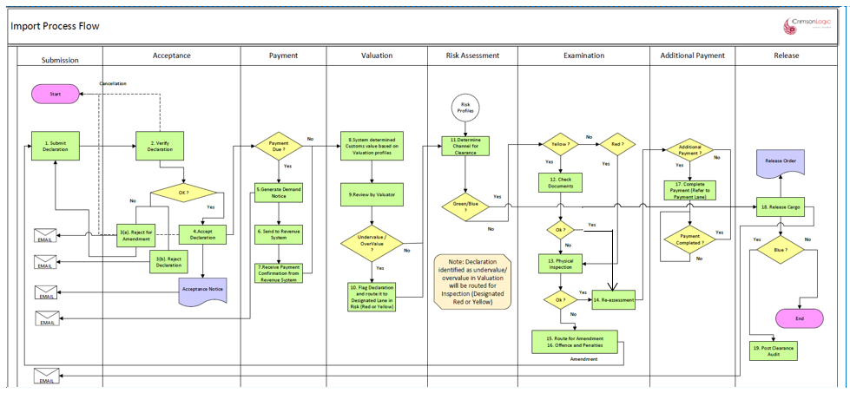

Process Step

PROCESS STEPS
Payment
- The system will allow payment for the declaration accepted by customs.
- Upon completion of payment process the system will automatically forward the declaration to the next process
- If the declaration is not subjected for payment, the system will automatically forward the declaration to the next process
- the system will also route the additional payment for a declaration to payment process.
- the additional payment will be linked to a particular declaration.

Valuation
- The system will determine the customs value at item level and accordingly determine whether the declared value is under or over value.
- The system based on the order of execution (please refer the SRS Valuation) will reflect the system value for items that are either under or overvalued.

Review by the Valuation Officer
- The system will allow the customs officer to decide on valuation based on the finding presented by the system and amend the declared value accordingly.
- The system will give an option to the valuation officer to direct the declaration to yellow or red channel.

Risk Assessment
- The system will perform the risk assessment based on the risk profile in the system
- The lane will be decided based on profile criteria met. The possible outcomes are “Green”, “Blue”, “Yellow” or “Red” lanes.
- “Green” lane will go for release process.
- “Blue” lane will go for Post clearance audit after release.
- “Yellow” will go for document verification.
- “Red” will go for physical inspection.

Examination
- Yellow Channel
- If the declaration is directed to yellow lane, the declaration will be reflected in the document verifier’s dashboard
- the system will also provide a platform to the document verifier officer to submit the examination report.
- The document verification officer may review the documents and decide to release or route for physical inspection or for re-assessment
- The system will then follow the additional payment process
- Red Lane
- If the declaration is directed to red lane, the declaration will be reflected in the inspection’s dashboard
- Upon physical inspection carried out by the inspection team, the system will also provide a platform to the inspection officer to submit the inspection report that is standard and incorporated in the system.
- Based on the inspection REPORT, the assessor will either.
- release the good
- send back to the declarant for amendment.
- Direct the declaration to the offences and penalties: Declaration intercepted with customs offence after examination can be routed to Offence and Penalties process by Inspection Officer
- Blue Lane
- The system will automatically direct the declaration submitted by ACT to blue lane
- The system will also provide a feature for the customs to direct a particular declaration to the blue lane.
- Green Lane
- The declaration directed to green lane will be released by the customs.

Note: The system will provide an option for customs to upgrade the declaration as follows;
- Green Lane to either yellow or red channel
- Yellow lane to red channel

Reassessment
- Once the declaration has been directed to offence and penalties, the system will provide an option for the customs to amend the declaration, reassess the additional payment along with the fines and penalties.
- However, the system will also maintain the original declaration submitted by the declarant
- Re-assessment by customs can either be
- Called after completion of Inspection.
- offence and penalties, wherein customs have intercepted customs offences and the same has been re-assessed as per the examination report.
Additional Payment
- If the declaration has been reassessed, the system will raise a demand notice for the additional payment linking with the declaration.
Release
- Upon completion of the customs procedures the system will generate a release order.
- The system will allow both the declarant and the customs office to print the release order if need be.
- During gate out the gate officer will be presented with the release order. Based on which the gate officer will release the cargo and the same will be recorded in the system.
- The system will record the release time

Business Rules

Process | Business Rule
valuation | Valuation review, will be executed as per valuation law by the system
Risk Assessment | System will assess the risk as per the risk profile created in the system
Yellow Lane | Yellow lane means documentation check. Customs will inform the declarant for submission of additional documents through email to validate the declared value.
Red Lane | At the time of physical inspection, the declarant or the representative of the declarant must be present.
Blue Lane | All goods imported by ACT registered traders will be directed to blue lane, and subject to PCA
Release | It is necessary for the declarant to submit the details of the vehicle where the goods have been transshipped into (if applicable). System will allow the Declarant to modify an approved declaration which is yet to be released and update the vehicle numbers in the Vehicle tab.

Business Validation

Regime | Process | Business Validation
Import | valuation | - The system will validate if the declared value is under value, over value or within the range of the customs value based on the past transaction or the valuation profile created in the system.  - Refer the details in the valuation SRS.
 | Risk Assessment | - System will direct the declaration either to green, yellow or red lane as per the risk profile created in the system  - The list of declaration along with the lane directed for each declaration will be reflected in the risk officer’s dashboard
 | Yellow Lane | - From yellow lane, as per the documentation review report, the system will allow the declaration to be released or direct the same to the red lane.  - Re –assessment
 | Red Lane | - As per the inspection report, the system will allow the declaration to be directed to  - offence and penalties  - amendment or  - re-assessment
 | Blue Lane | All goods imported by ACT registered traders will be directed to blue lane, and subject to PCA
 | Release | It is necessary for the declarant to submit the details of the vehicle where the goods has been transshipped into(if applicable). System will allow the Declarant to modify an approved declaration which is yet to be released and update the vehicle numbers in the Vehicle tab.

Temporary Admission / Import

Process Flow
Process ID: 04.20 – Temporary Admission/Import Process

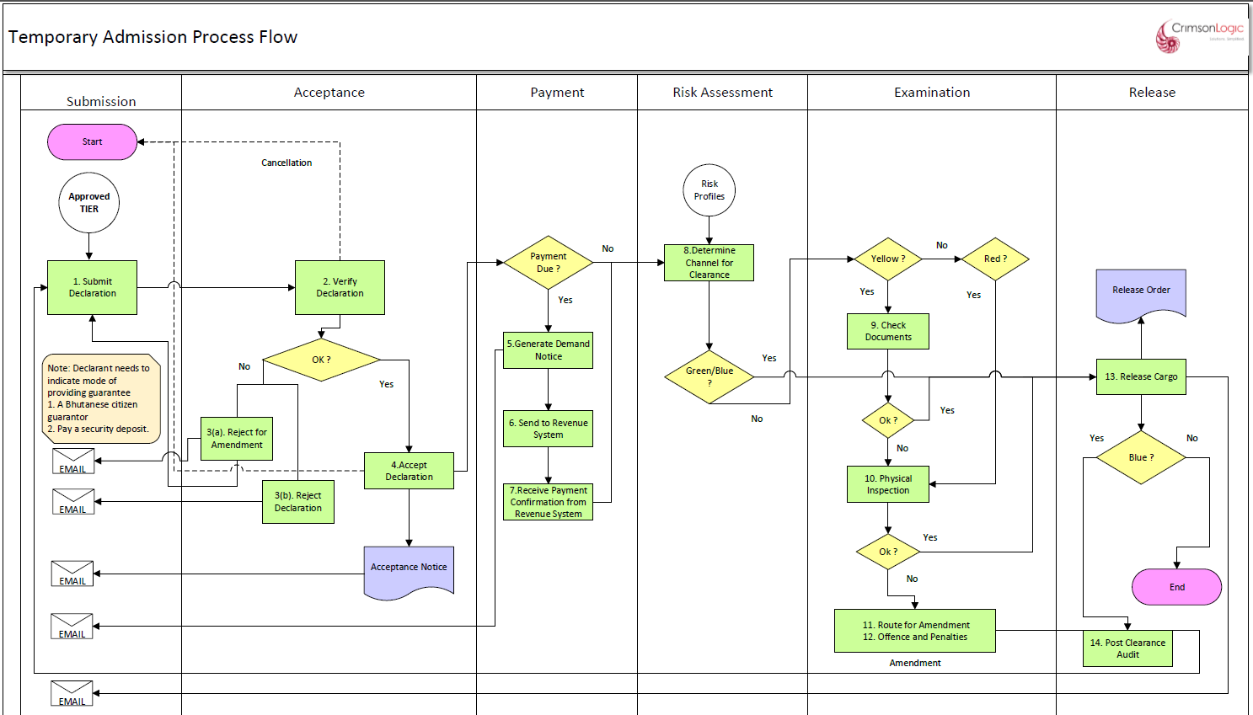
Temporary Import Process

Process Step

PROCESS STEPS
Payment
- The system will allow payment for the declaration accepted by customs.
- Upon completion of payment process the system will automatically forward the declaration to the next process
- If the declaration is not subjected for payment, the system will automatically forward the declaration to the next process

Risk Assessment
- The system will perform the risk assessment based on the risk profile in the system
- The lane will be decided based on profile criteria met. The possible outcomes are “Green”, “Blue”, “Yellow” or “Red” lanes.
- “Green” lane will go for release process.
- “Blue” lane will go for Post clearance audit after release.
- “Yellow” will go for document verification.
- “Red” will go for physical inspection.

Examination
- Yellow Channel
- If the declaration is directed to yellow lane, the declaration will be reflected in the document verifier’s dashboard
- the system will also provide a platform to the document verifier officer to submit the examination report.
- The document verification officer may review the documents and decide to release or route for physical inspection or for re-assessment
- The system will then follow the additional payment process
- Red Lane
- If the declaration is directed to red lane, the declaration will be reflected in the inspection’s dashboard
- Upon physical inspection carried out by the inspection team, the system will also provide a platform to the inspection officer to submit the inspection report that is standard and incorporated in the system.
- Based on the inspection REPORT, the assessor will either.
- release the good
- send back to the declarant for amendment.
- Direct the declaration to the offences and penalties: Declaration intercepted with customs offence after examination can be routed to Offence and Penalties process by Inspection Officer
- Blue Lane
- The system will automatically direct the declaration submitted by ACT to blue lane
- The system will also provide a feature for the customs to direct a particular declaration to the blue lane.
- Green Lane
- The declaration directed to green lane will be released by the customs.

Note: The system will provide an option for customs to upgrade the declaration as follows;
- Green Lane to either yellow or red channel
- Yellow lane to red channel

Release
- Upon completion of the customs procedures the system will generate a release order.
- The system will allow both the declarant and the customs office to print the release order if need be.
- During gate out the gate officer will be presented with the release order. Based on which the gate officer will release the cargo and the same will be recorded in the system.
- The system will record the release time

Business Rules

Process | Business Rule
valuation | Valuation review, will be executed as per valuation law by the system
Risk Assessment | System will assess the risk as per risk profile created in the system
Yellow Lane | Yellow lane means documentation check. Customs will inform the declarant for submission of additional documents through email to validate the declared value.
Red Lane | At the time of physical inspection, the declarant or the representative of the declarant must be present.
Blue Lane | All goods imported by ACT registered traders will be directed to blue lane, and subject to PCA
Release | It is necessary for the declarant to submit the details of the vehicle where the goods have been transshipped into (if applicable). System will allow the Declarant to modify an approved declaration which is yet to be released and update the vehicle numbers in the Vehicle tab.

Business Validation

Process | Business Validation
valuation | - the system will validate if the declared value is under value, over value or within the range of the customs value based on the past transaction or the valuation profile created in the system.  - Refer the details in the valuation SRS.
Risk Assessment | - System will direct the declaration either to green, yellow, or red lane as per the risk profile created in the system  - The list of declaration along with the lane directed for each declaration will be reflected in the risk officer’s dashboard
Yellow Lane | - From yellow lane, as per the documentation review report, the system will allow the declaration to be released or direct the same to the red lane.  - Re –assessment
Red Lane | - As per the inspection report, the system will allow the declaration to be directed to  - offence and penalties  - amendment or  - re-assessment
Blue Lane | All goods imported by ACT registered traders will be directed to blue lane, and subject to PCA
Release | It is necessary for the declarant to submit the details of the vehicle where the goods have been transshipped into (if applicable). System will allow the Declarant to modify an approved declaration which is yet to be released and update the vehicle numbers in the Vehicle tab.

Re- Import Declaration

Process Flow
Process ID: 04.21 – Re-Import Process

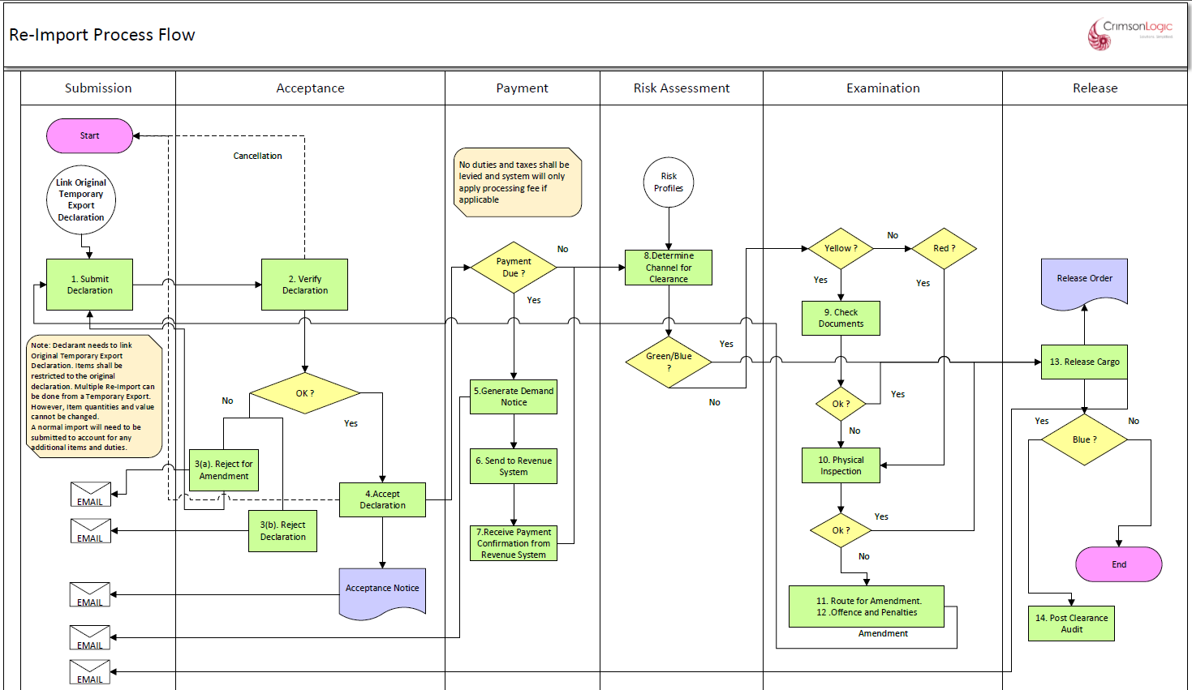
RE-Import Process

Process Step

PROCESS STEPS
Payment
- The system will allow payment for the declaration accepted by customs.
- Upon completion of payment process the system will automatically forward the declaration to the next process
- If the declaration is not subjected for payment, the system will automatically forward the declaration to the next process

Risk Assessment
- The system will perform the risk assessment based on the risk profile in the system
- The lane will be decided based on profile criteria met. The possible outcomes are “Green”, “Blue”, “Yellow” or “Red” lanes.
- “Green” lane will go for release process.
- “Blue” lane will go for Post clearance audit after release.
- “Yellow” will go for document verification.
- “Red” will go for physical inspection.

Examination
- Yellow Channel
- If the declaration is directed to yellow lane, the declaration will be reflected in the document verifier’s dashboard
- the system will also provide a platform to the document verifier officer to submit the examination report.
- The document verification officer may review the documents and decide to release or route for physical inspection or for re-assessment
- The system will then follow the additional payment process
- Red Lane
- If the declaration is directed to red lane, the declaration will be reflected in the inspection’s dashboard
- Upon physical inspection carried out by the inspection team, the system will also provide a platform to the inspection officer to submit the inspection report that is standard and incorporated in the system.
- Based on the inspection REPORT, the assessor will either.
- release the good
- send back to the declarant for amendment.
- Direct the declaration to the offences and penalties: Declaration intercepted with customs offence after examination can be routed to Offence and Penalties process by Inspection Officer
- Blue Lane
- The system will automatically direct the declaration submitted by ACT to blue lane
- The system will also provide a feature for the customs to direct a particular declaration to the blue lane.
- Green Lane
- The declaration directed to green lane will be released by the customs.

Note: The system will provide an option for customs to upgrade the declaration as follows;
- Green Lane to either yellow or red channel
- Yellow lane to red channel

Release
- Upon completion of the customs procedures the system will generate a release order.
- The system will allow both the declarant and the customs office to print the release order if need be.
- During gate out the gate officer will be presented with the release order. Based on which the gate officer will release the cargo and the same will be recorded in the system.
- The system will record the release time

Business Rules

Process | Business Rule
valuation | Value as per the temporary export declaration
Risk Assessment | System will assess the risk as per the risk profile created in the system
Yellow Lane | Yellow lane means documentation check. Customs will inform the declarant for submission of additional documents through email to validate the declared value.
Red Lane | At the time of physical inspection, the declarant or the representative of the declarant must be present.
Blue Lane | All goods imported by ACT registered traders will be directed to blue lane, and subject to PCA
Release | It is necessary for the declarant to submit the details of the vehicle where the goods have been transshipped into (if applicable). System will allow the Declarant to modify an approved declaration which is yet to be released and update the vehicle numbers in the Vehicle tab.
Duty Assessment, Re-Assessment and Additional Payment | These processes are not applicable if there is no increase in the value of the goods.  Note: To collect duties and taxes on the increase in value of the re-import, declarant must submit a separate import declaration as agreed

Note: In case of an extension approval is required the system will allow the declarant to submit a request for extension of the same.

Business Validation
Process | Business Validation
valuation | Will validate with the value declared during the temporary export
Risk Assessment | - System will direct the declaration either to green, yellow, or red lane as per the risk profile created in the system  - The list of declaration along with the lane directed for each declaration will be reflected in the risk officer’s dashboard
Yellow Lane | - From yellow lane, as per the documentation review report, the system will allow the declaration to be released or direct the same to the red lane.  - Re –assessment
Red Lane | - As per the inspection report, the system will allow the declaration to be directed to  - offence and penalties  - amendment or  - re-assessment
Blue Lane | All goods imported by ACT registered traders will be directed to blue lane, and subject to PCA
Release | It is necessary for the declarant to submit the details of the vehicle where the goods has been transshipped into(if applicable). System will allow the Declarant to modify an approved declaration which is yet to be released and update the vehicle numbers in the Vehicle tab.

Export

Process Flow
Process ID: 04.22 – Export Process
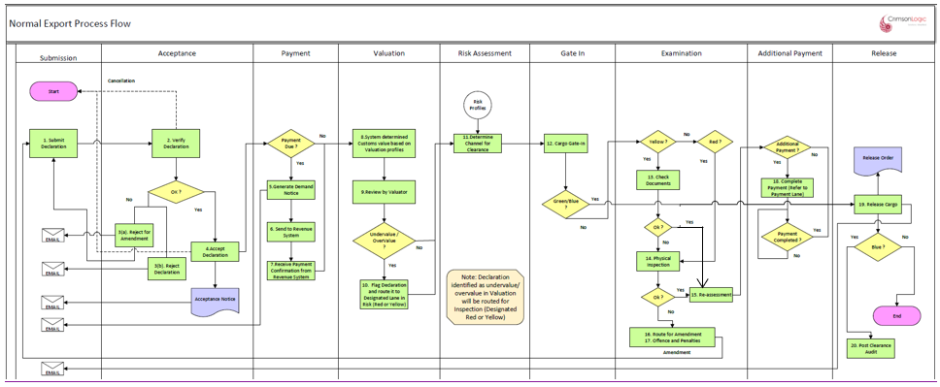
Export Process
Note: ACT users export declarations may not come to customs, and it will be released directly from premises. Risk profile must be created to route ACT users export declarations to “Release Cargo”.

Process Step

PROCESS STEPS
Payment
- The system will allow payment for the declaration accepted by customs.
- Upon completion of payment process the system will automatically forward the declaration to the next process
- If the declaration is not subjected for payment, the system will automatically forward the declaration to the next process
- the system will also route the additional payment for a declaration to payment process.
- the additional payment will be linked to a particular declaration.

Valuation
- The system will determine the customs value at item level and accordingly determine whether the declared value is under or over value.
- The system based on the order of execution (please refer the SRS Valuation) will reflect the system value for items that are either under or overvalued.

Review by the Valuation Officer
- The system will allow the customs officer to decide on valuation based on the finding presented by the system and amend the declared value accordingly.
- The system will give an option to the valuation officer to direct the declaration to yellow or red channel.

Risk Assessment
- The system will perform the risk assessment based on the risk profile in the system
- The lane will be decided based on profile criteria met. The possible outcomes are “Green”, “Blue”, “Yellow” or “Red” lanes.
- “Green” lane will go for release process.
- “Blue” lane will go for Post clearance audit after release.
- “Yellow” will go for document verification.
- “Red” will go for physical inspection.

Gate In
After completing Risk Assessment, Declaration will be routed to Gate In.
Upon completion of Gate in, Declaration shall be routed for Examination or Release based on the Risk Assessment outcomes.
Examination
- Yellow Channel
- If the declaration is directed to yellow lane, the declaration will be reflected in the document verifier’s dashboard
- the system will also provide a platform to the document verifier officer to submit the examination report.
- The document verification officer may review the documents and decide to release or route for physical inspection or for re-assessment
- The system will then follow the additional payment process
- Red Lane
- If the declaration is directed to red lane, the declaration will be reflected in the inspection’s dashboard
- Upon physical inspection carried out by the inspection team, the system will also provide a platform to the inspection officer to submit the inspection report that is standard and incorporated in the system.
- Based on the inspection REPORT, the assessor will either.
- release the good
- send back to the declarant for amendment.
- Direct the declaration to the offences and penalties: Declaration intercepted with customs offence after examination can be routed to Offence and Penalties process by Inspection Officer
- Blue Lane
- The system will automatically direct the declaration submitted by ACT to blue lane
- The system will also provide a feature for the customs to direct a particular declaration to the blue lane.
- Green Lane
- The declaration directed to green lane will be released by the customs.

Note: The system will provide an option for customs to upgrade the declaration as follows.
- Green Lane to either yellow or red channel
- Yellow lane to red channel

Reassessment
- Once the declaration has been directed to offence and penalties, the system will provide an option for the customs to amend the declaration, reassess the additional payment along with the fines and penalties.
- However, the system will also maintain the original declaration submitted by the declarant
- Re-assessment by customs can either be
- Called after completion of Inspection.
- offence and penalties, wherein customs has intercepted customs offences and the same has been re-assessed as per the examination report.
Additional Payment
- If the declaration has been reassessed, the system will give an option for customs to raise a demand notice for the additional payment linking with the declaration.
Release
- Upon completion of the customs procedures the system will generate a release order.
- The system will allow both the declarant and the customs office to print the release order if need be.
- During gate out the gate officer will be presented with the release order. Based on which the gate officer will release the cargo and the same will be recorded in the system.
- The system will record the release time

Business Rules

Process | Business Rule
valuation | Valuation review, will be executed as per valuation law by the system
Risk Assessment | System will assess the risk as per the risk profile created in the system
Yellow Lane | Yellow lane means documentation check. Customs will inform the declarant for submission of additional documents through email to validate the declared value.
Red Lane | At the time of physical inspection, the declarant or the representative of the declarant must be present.
Blue Lane | All goods imported by ACT registered traders will be directed to blue lane, and subject to PCA
Release | It is necessary for the declarant to submit the details of the vehicle where the goods have been transshipped into (if applicable). System will allow the Declarant to modify an approved declaration which is yet to be released and update the vehicle numbers in the Vehicle tab.

Business Validation
Regime | Process | Business Validation
Import | valuation | - the system will validate if the declared value is under value, over value or within the range of the customs value based on the past transaction or the valuation profile created in the system.  - Refer the details in the valuation SRS.
 | Risk Assessment | - System will direct the declaration either to green, yellow, or red lane as per the risk profile created in the system  - The list of declaration along with the lane directed for each declaration will be reflected in the risk officer’s dashboard
 | Yellow Lane | - From yellow lane, as per the documentation review report, the system will allow the declaration to be released or direct the same to the red lane.  - Re –assessment
 | Red Lane | - as per the inspection report, the system will allow the declaration to be directed to  - offence and penalties  - amendment or  - re-assessment
 | Blue Lane | All goods imported by ACT registered traders will be directed to blue lane, and subject to PCA
 | Release | It is necessary for the declarant to submit the details of the vehicle where the goods have been transshipped into (if applicable). System will allow the Declarant to modify an approved declaration which is yet to be released and update the vehicle numbers in the Vehicle tab.

Re-Export

Process Flow
Process ID: 04.23 – Re-Export Process

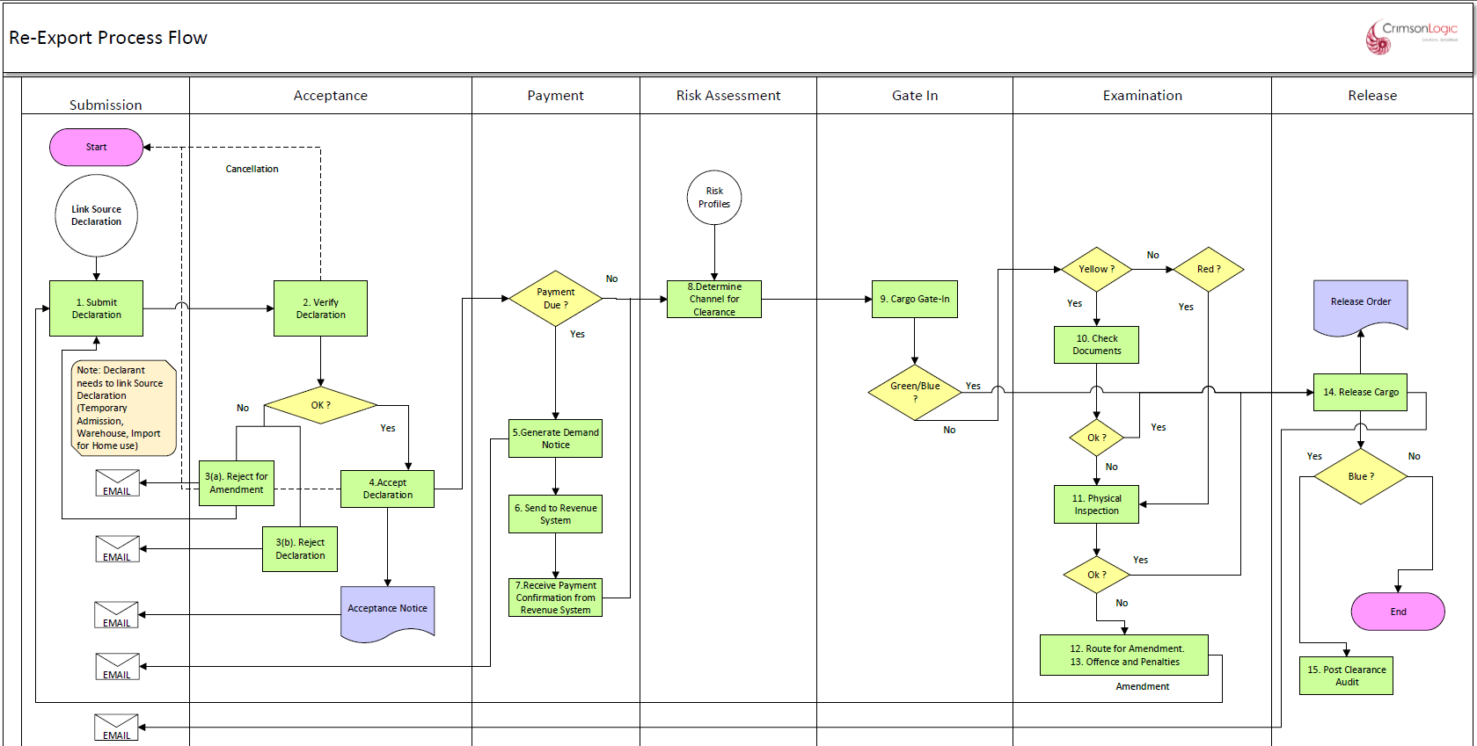

RE-Export Process

- Goods cleared for home use and received by the importer but found not to the specification of the contract of sale and is to be returned to the foreign supplier may be re-exported for the purpose; goods on transfer due to change in residence of persons on completion of their assignment in Bhutan; goods under subsection (2) and (3) of this Regulation shall be re-exported within 30 working days [Excluding Saturdays and Sundays] from entry into the country or date of import declaration made to the Department.

Process Step

PROCESS STEPS
Payment
- System will allow payment for the declaration accepted by customs.
- Upon completion of payment process, System will automatically forward the declaration to the next process
- If the declaration is not subjected for payment, System will automatically forward the declaration to the next process

Risk Assessment
- System will perform the risk assessment based on the risk profile in System
- The lane will be decided based on profile criteria met. The possible outcomes are “Green”, “Blue”, “Yellow” or “Red” lanes.
- “Green” lane will go for release process.
- “Blue” lane will go for Post clearance audit after release.
- “Yellow” will go for document verification.
- “Red” will go for physical inspection.

Gate In
After completing Risk Assessment, Declaration will be routed to Gate In.
Upon completion of Gate in, Declaration shall be routed for Examination or Release based on the Risk Assessment outcomes.
Examination
- Yellow Channel
- If the declaration is directed to yellow lane, the declaration will be reflected in the document verifier’s dashboard
- System will also provide a platform to the document verifier officer to submit the examination report.
- The document verification officer may review the documents and decide to release or route for physical inspection or for re-assessment
- System will then follow the additional payment process
- Red Lane
- If the declaration is directed to red lane, the declaration will be reflected in the inspection’s dashboard
- Upon physical inspection carried out by the inspection team, the system will also provide a platform to the inspection officer to submit the inspection report that is standard and incorporated in the system.
- Based on the inspection REPORT, the assessor will either.
- release the good
- send back to the declarant for amendment.
- Direct the declaration to the offences and penalties: Declaration intercepted with customs offence after examination can be routed to Offence and Penalties process by Inspection Officer
- Blue Lane
- System will automatically direct the declaration submitted by ACT to blue lane
- System will also provide a feature for the customs to direct a particular declaration to the blue lane.
- Green Lane
- The declaration directed to green lane will be released by the customs.

Note: System will provide an option for customs to upgrade the declaration as follows;
- Green Lane to either yellow or red channel
- Yellow lane to red channel

Release
- Upon completion of the customs procedures System will generate a release order.
- System will allow both the declarant and the customs office to print the release order if need be.
- During gate out the gate officer will be presented with the release order. Based on which the gate officer will release the cargo and the same will be recorded in the system.
- System will record the release time

Business Rules

Process | Business Rule
valuation | Valuation as per temporary admission declaration
Risk Assessment | System will assess the risk as per the risk profile created in the system
Yellow Lane | Yellow lane means documentation check. Customs will inform the declarant for submission of additional documents through email to validate the declared value.
Red Lane | At the time of physical inspection, the declarant or the representative of the declarant must be present.
Blue Lane | All goods imported by ACT registered traders will be directed to blue lane, and subject to PCA
Release | It is necessary for the declarant to submit the details of the vehicle where the goods has been transshipped into(if applicable). System will allow the Declarant to modify an approved declaration which is yet to be released and update the vehicle numbers in the Vehicle tab.
Duty Assessment, Re-Assessment and Additional Payment | These processes are not applicable if there is no increase in the value of the goods.  Note: To collect duties and taxes on the increase in value of the re-import, declarant must submit a separate import declaration as agreed

Note: In case of an extension approval is required the system will allow the declarant to submit a request for extension of the same.

Business Validation
Process | Business Validation
valuation | - validate the value as declared during temporary admission declaration submission
Risk Assessment | - System will direct the declaration either to green, yellow, or red lane as per the risk profile created in the system  - The list of declaration along with the lane directed for each declaration will be reflected in the risk officer’s dashboard
Yellow Lane | - From yellow lane, as per the documentation review report, the system will allow the declaration to be released or direct the same to the red lane.  - Re –assessment
Red Lane | - As per the inspection report, the system will allow the declaration to be directed to  - offence and penalties  - amendment or  - re-assessment
Blue Lane | All goods imported by ACT registered traders will be directed to blue lane, and subject to PCA
Release | It is necessary for the declarant to submit the details of the vehicle where the goods have been transshipped into (if applicable). System will allow the Declarant to modify an approved declaration which is yet to be released and update the vehicle numbers in the Vehicle tab.

Temporary Export

Process Flow
Process ID: 04.24 – Temporary Export Process

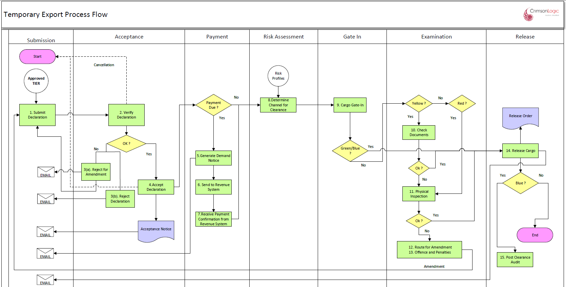
Temporary Export Process

Process Step

PROCESS STEPS
Payment
- System will allow payment for the declaration accepted by customs.
- Upon completion of payment process, System will automatically forward the declaration to the next process
- If the declaration is not subjected for payment, System will automatically forward the declaration to the next process

Risk Assessment
- System will perform the risk assessment based on the risk profile in the system
- The lane will be decided based on profile criteria met. The possible outcomes are “Green”, “Blue”, “Yellow” or “Red” lanes.
- “Green” lane will go for release process.
- “Blue” lane will go for Post clearance audit after release.
- “Yellow” will go for document verification.
- “Red” will go for physical inspection.

Gate In
After completing Risk Assessment, Declaration will be routed to Gate In.
Upon completion of Gate in, Declaration shall be routed for Examination or Release based on the Risk Assessment outcomes.
Examination
- Yellow Channel
- If the declaration is directed to yellow lane, the declaration will be reflected in the document verifier’s dashboard
- System will also provide a platform to the document verifier officer to submit the examination report.
- The document verification officer may review the documents and decide to release or route for physical inspection or for re-assessment
- System will then follow the additional payment process
- Red Lane
- If the declaration is directed to red lane, the declaration will be reflected in the inspection’s dashboard
- Upon physical inspection carried out by the inspection team, System will also provide a platform to the inspection officer to submit the inspection report that is standard and incorporated in the system.
- Based on the inspection REPORT, the assessor will either.
- release the good
- send back to the declarant for amendment.
- Direct the declaration to the offences and penalties: Declaration intercepted with customs offence after examination can be routed to Offence and Penalties process by Inspection Officer
- Blue Lane
- System will automatically direct the declaration submitted by ACT to blue lane
- System will also provide a feature for the customs to direct a particular declaration to the blue lane.
- Green Lane
- The declaration directed to green lane will be released by the customs.

Note: System will provide an option for customs to upgrade the declaration as follows;
- Green Lane to either yellow or red channel
- Yellow lane to red channel

Release
- Upon completion of the customs procedures, System will generate a release order.
- System will allow both the declarant and the customs office to print the release order if need be.
- During gate out the gate officer will be presented with the release order. Based on which the gate officer will release the cargo and the same will be recorded in the system.
- System will record the release time

Business Rules

Process | Business Rule
valuation | Valuation review, will be executed as per valuation law by the system
Risk Assessment | System will assess the risk as per the risk profile created in the system
Yellow Lane | Yellow lane means documentation check. Customs will inform the declarant for submission of additional documents through email to validate the declared value.
Red Lane | At the time of physical inspection, the declarant or the representative of the declarant must be present.
Blue Lane | All goods imported by ACT registered traders will be directed to blue lane, and subject to PCA
Release | It is necessary for the declarant to submit the details of the vehicle where the goods have been transshipped into (if applicable). System will allow the Declarant to modify an approved declaration which is yet to be released and update the vehicle numbers in the Vehicle tab.

Business Validation

Process | Business Validation
valuation | - the system will validate if the declared value is under value, over value or within the range of the customs value based on the past transaction or the valuation profile created in the system.  - Refer the details in the valuation SRS.
Risk Assessment | - System will direct the declaration either to green, yellow, or red lane as per the risk profile created in the system  - The list of declaration along with the lane directed for each declaration will be reflected in the risk officer’s dashboard
Yellow Lane | - From yellow lane, as per the documentation review report, the system will allow the declaration to be released or direct the same to the red lane.  - Re –assessment
Red Lane | - As per the inspection report, the system will allow the declaration to be directed to  - offence and penalties  - amendment or  - re-assessment
Blue Lane | All goods imported by ACT registered traders will be directed to blue lane, and subject to PCA
Release | It is necessary for the declarant to submit the details of the vehicle where the goods have been transshipped into (if applicable). System will allow the Declarant to modify an approved declaration which is yet to be released and update the vehicle numbers in the Vehicle tab.

Warehouse Declaration

Process Flow
Process ID: 04.25 – Warehouse Process
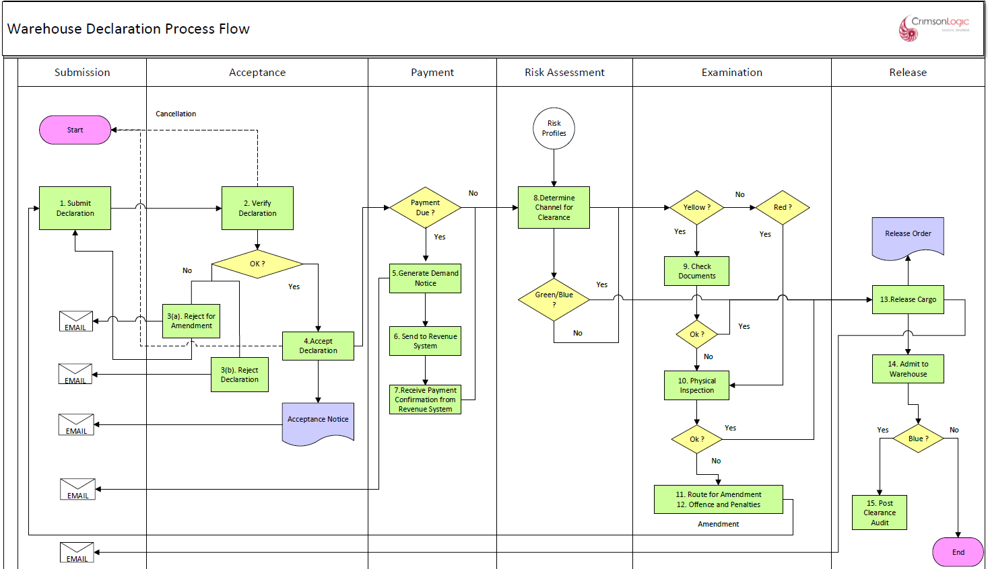
Warehouse declaration Process

Process Step

PROCESS STEPS
Payment
- System will allow payment for the declaration accepted by customs.
- Upon completion of payment process, System will automatically forward the declaration to the next process
- If the declaration is not subjected for payment, System will automatically forward the declaration to the next process

Risk Assessment
- System will perform the risk assessment based on the risk profile in the system
- The lane will be decided based on profile criteria met. The possible outcomes are “Green”, “Blue”, “Yellow” or “Red” lanes.
- “Green” lane will go for release process.
- “Blue” lane will go for Post clearance audit after release.
- “Yellow” will go for document verification.
- “Red” will go for physical inspection.

Examination
- Yellow Channel
- If the declaration is directed to yellow lane, the declaration will be reflected in the document verifier’s dashboard
- System will also provide a platform to the document verifier officer to submit the examination report.
- The document verification officer may review the documents and decide to release or route for physical inspection or for re-assessment
- System will then follow the additional payment process
- Red Lane
- If the declaration is directed to red lane, the declaration will be reflected in the inspection’s dashboard
- Upon physical inspection carried out by the inspection team, System will also provide a platform to the inspection officer to submit the inspection report that is standard and incorporated in the system.
- Based on the inspection REPORT, the assessor will either.
- release the good
- send back to the declarant for amendment.
- Direct the declaration to the offences and penalties: Declaration intercepted with customs offence after examination can be routed to Offence and Penalties process by Inspection Officer
- Blue Lane
- System will automatically direct the declaration submitted by ACT to blue lane
- System will also provide a feature for the customs to direct a particular declaration to the blue lane.
- Green Lane
- The declaration directed to green lane will be released by the customs.

Note: System will provide an option for customs to upgrade the declaration as follows;
- Green Lane to either yellow or red channel
- Yellow lane to red channel

Release
- Upon completion of the customs procedures, System will generate a release order.
- System will allow both the declarant and the customs office to print the release order if need be.
- During gate out the gate officer will be presented with the release order. Based on which the gate officer will release the cargo and the same will be recorded in the system.
- System will record the release time
- Post completion of Release, the goods shall be Admitted into the Warehouse and inventory of the Warehouse shall be updated

Business Rules
Duty Assessment, Re-Assessment and Additional Payment | These processes are not applicable.
Valuation | Valuation is not required for Warehouse Declaration.
Move/Admit to Warehouse | Post release, declaration items will be admitted into the Warehouse indicated during submission of the warehouse declaration.
Inventory | Post admittance in the warehouse, the warehouse will have the list of items goods declared by specific declarant which will be used as an inventory of the warehouse by customs and the concerned warehouse operator

Business Validation
Move/Admit to Warehouse | A particular warehouse will have the list of goods yet to be admitted to the warehouse and approved by customs
Inventory | All new warehouse declaration will be added to the existing list of declaration as and when the goods are approved by customs and admitted

EX-Warehouse Declaration

Process Flow
Process ID: 04.26 – Ex-Warehouse Process

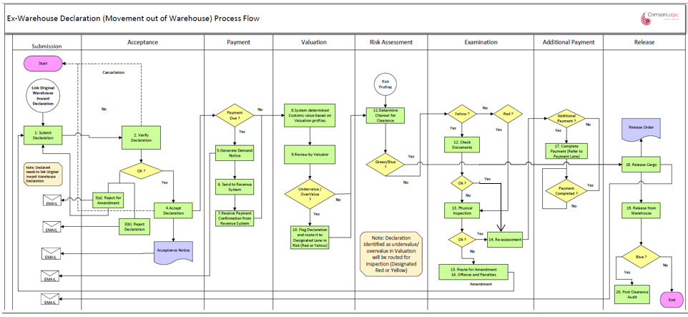
EX-Warehouse declaration Process

Ex warehouse declaration can be one of the following.
2. Import declaration for home use
3. Re-export (if eligible)
4. Duty free sales
5. Stores request
6. Temporary admission declaration (if eligible as per the rules)

Process Step

PROCESS STEPS
Payment
- System will allow payment for the declaration accepted by customs.
- Upon completion of payment process, System will automatically forward the declaration to the next process
- If the declaration is not subjected for payment, System will automatically forward the declaration to the next process
- System will also route the additional payment for a declaration to payment process.
- the additional payment will be linked to a particular declaration.

Valuation
- System will determine the customs value at item level and accordingly determine whether the declared value is under or over value.
- System based on the order of execution (please refer the SRS Valuation) will reflect the system value for items that are either under or overvalued.

Review by the Valuation Officer
- System will allow the customs officer to decide on valuation based on the finding presented by the system and amend the declared value accordingly.
- System will give an option to the valuation officer to direct the declaration to yellow or red channel.

Risk Assessment
- System will perform the risk assessment based on the risk profile in the system
- The lane will be decided based on profile criteria met. The possible outcomes are “Green”, “Blue”, “Yellow” or “Red” lanes.
- “Green” lane will go for release process.
- “Blue” lane will go for Post clearance audit after release.
- “Yellow” will go for document verification.
- “Red” will go for physical inspection.

Examination
- Yellow Channel
- If the declaration is directed to yellow lane, the declaration will be reflected in the document verifier’s dashboard
- System will also provide a platform to the document verifier officer to submit the examination report.
- The document verification officer may review the documents and decide to release or route for physical inspection or for re-assessment
- System will then follow the additional payment process
- Red Lane
- If the declaration is directed to red lane, the declaration will be reflected in the inspection’s dashboard
- Upon physical inspection carried out by the inspection team, System will also provide a platform to the inspection officer to submit the inspection report that is standard and incorporated in the system.
- Based on the inspection REPORT, the assessor will either.
- release the good
- send back to the declarant for amendment.
- Direct the declaration to the offences and penalties: Declaration intercepted with customs offence after examination can be routed to Offence and Penalties process by Inspection Officer
- Blue Lane
- System will automatically direct the declaration submitted by ACT to blue lane
- System will also provide a feature for the customs to direct a particular declaration to the blue lane.
- Green Lane
- The declaration directed to green lane will be released by the customs.

Note: System will provide an option for customs to upgrade the declaration as follows;
- Green Lane to either yellow or red channel
- Yellow lane to red channel

Reassessment
- Once the declaration has been directed to offence and penalties, System will provide an option for the customs to amend the declaration, reassess the additional payment along with the fines and penalties.
- However, System will also maintain the original declaration submitted by the declarant
- Re-assessment by customs can either be
- Called after completion of Inspection.
- offence and penalties, wherein customs have intercepted customs offences and the same has been re-assessed as per the examination report.
Additional Payment
- If the declaration has been reassessed, System will give an option for customs to raise a demand notice for the additional payment linking with the declaration.
Release
- Upon completion of the customs procedures System will generate a release order.
- System will allow both the declarant and the customs office to print the release order if need be.
- During gate out the gate officer will be presented with the release order. Based on which the gate officer will release the cargo and the same will be recorded in the system.
- System will record the release time
- Post Completion of Release, goods shall be released from the Warehouse and inventory of the Warehouse updated accordingly.
- In case of Transfer Warehouse declaration, after release from the Source Warehouse, the transfer declaration shall be admitted into the Destination warehouse. Inventory of both source and destination warehouse shall be updated accordingly.

Business Rules

Process | Business Rule
Link Original Warehouse Declaration | Original Warehouse declaration needs to be provided and linked to the EX-Warehouse declaration. Items which are not part of the original warehouse declaration cannot be added and item quantities shall be restricted to the original warehouse declaration.
Release from Warehouse | Post release, Ex-Warehouse declaration items will be released from the Warehouse as specified in the linked warehouse declaration.

Business Validation

Process | Business Validation
Link Original Warehouse Declaration | When a particular declaration is linked to a warehouse declaration, the system will auto populate the details in the subsequent declaration
Release from Warehouse | Once goods are released from the warehouse, the system will update the inventory accordingly.

Duty Free declaration with Customs Duty

Process Flow
Process ID: 04.27 – Duty Free Declaration with Customs Duty Process

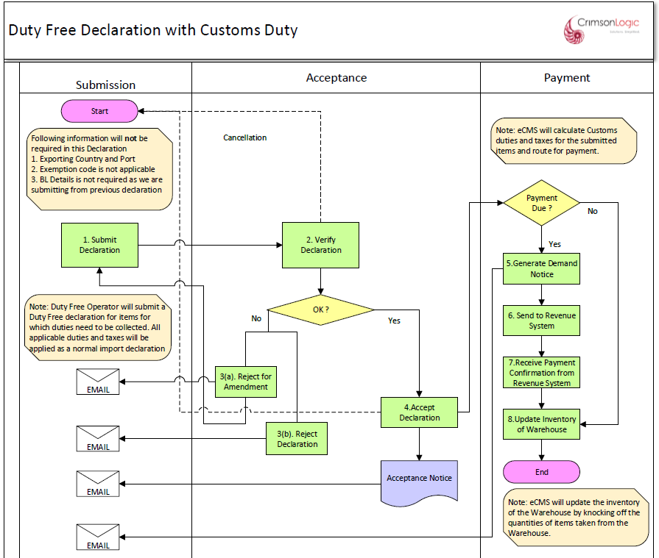
Duty free declaration With Customs duty Process (Non-Quota)

Process Step

PROCESS STEPS
Payment
- System will allow payment for the declaration accepted by customs.

Business Rules

Process | Business Rules
No Valuation, Risk, Inspection and Release process | Duty free declaration with Customs duty will end after payment is collected and clearance controls like valuation, risk, inspection, and release will be suspended for these types of declaration.
Partial Quantity Item | System will give an option to the user to mark a good as “Partial Quantity”. This will allow declarant to mark items as “Partial Quantity” and, such items will not be deducted from Inventory. However, duties and taxes and charges will apply as a regular item,
Inventory Updates | After completion of payment, system will update the inventory and knock off declared item quantities. Inventory will not be updated for items declared as “Partial Quantity”  Note: To knock of duty-free quantities, duty free stores must submit warehouse declaration prior to duty free declaration.
Duty Computation | Duty computation will be based on store officer’s entered invoice value.

Business Validation

Sl No | Business Rule
Verification | Customs at the time of verifying a duty-free declaration, the system will provide an option to view the report of the quota holder profile details (latest). (Total quota issued, total quota used and balance quota)  Note: This must be an operational report

Duty Free declaration without Customs Duty

Process Flow
Process ID: 04.28 – Duty Free Declaration without Customs Duty Process

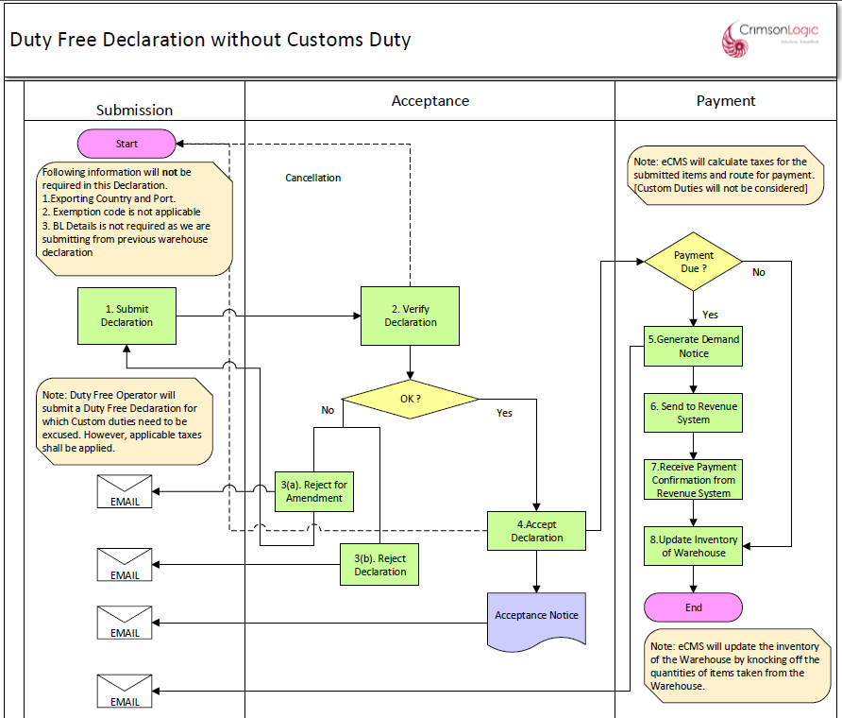
Duty free declaration With Customs duty Process (Quota Sales)

Note: This duty-free declaration process is applicable to airport stores as well. A Report will be available for the officer to approve based on the TPN / Quota number used in that declaration.

Process Step

PROCESS STEPS
Payment
- System will allow payment for the declaration accepted by customs.

Business Rules

Process | Business Rules
No Valuation, Risk, Inspection and Release process | Duty free declaration without Customs duty will end after payment for taxes (no Duties) is collected and clearance controls like valuation, risk, inspection, and release will be suspended for these types of declaration.
Inventory Updates | After completion of payment, system will update the inventory and knock off declared item quantities.  Note: To knock of duty-free quantities, duty free stores must submit warehouse declaration prior to duty free declaration.  Duty-free exemption deduction will be managed by duty free stores team separately and it will be incorporated in the system.
Duty Computation | Duty computation will be based on store officer’s entered invoice value.

Business Validation

Simplified Declaration (Stores)

Process Flow
Process ID: 04.29 – Simplified Declaration (Stores)_Process

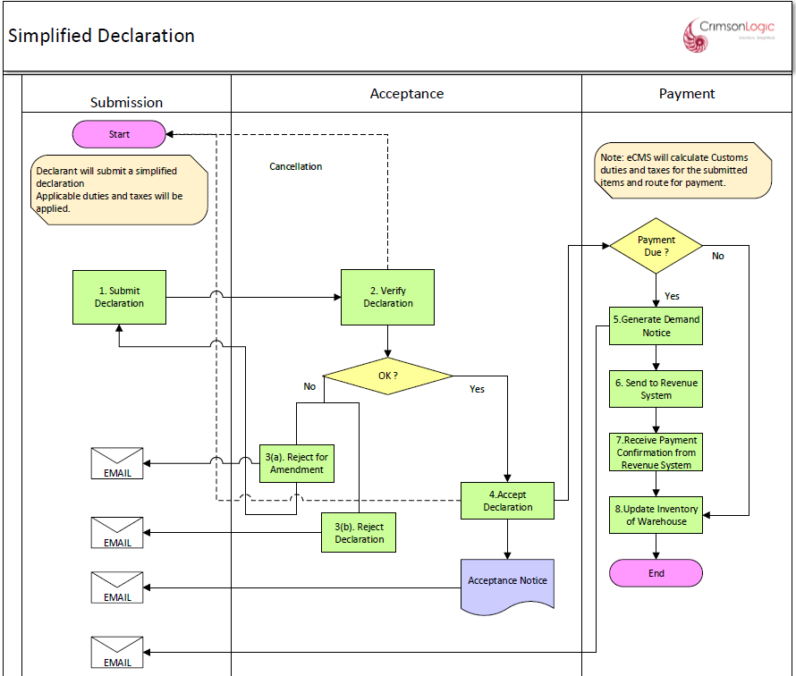

The simplified declaration is used for all duty-free Stores sale (for airport passenger as well as customers procuring from the duty-free shop outside of the airport. Just like the duty-free sales, the sales will be submitted by the Duty-free stores at the end of the day (week or month) The sale submitted by duty free to customs through eCMS is the simplified declaration.
In case of goods sold from duty free shop, the system should validate with the quota issued and in case of duty-free sale from the airport, the declaration must be validated with the passenger manifest.

For Duty free quota, the below process was discussed and accepted.
- Submit a consolidated declaration with for duty free sales with Quota information.
- DRC can view the Quota report.

Process Step

PROCESS STEPS
Payment
- System will allow payment for the declaration accepted by customs.

Business Rules
Process | Business Rules
No Valuation, Risk, Inspection and Release process | Stores declaration will end after payment is collected and clearance controls like valuation, risk, inspection, and release will be suspended for these types of declaration.
Partial Quantity Item | System will give an option to the user to mark a good as “Partial Quantity”. This will allow declarant to mark items as “Partial Quantity” and, such items will not be deducted from Inventory. However, duties and taxes and charges will apply as a regular item,
Inventory Updates | After completion of payment, system will update the inventory and knock off declared item quantities.  Inventory will not be updated for items declared as “Partial Quantity”  Note: To knock of quantities, Stores must submit warehouse declaration prior to duty free declaration.
Duty Computation | Duty computation will be based on store officer’s entered invoice value.

Business Validation

Sl No | Business Rule
Verification | Customs at the time of verifying a duty-free declaration, the system will provide an option to view the report of the quota holder profile details (latest). (Total quota issued, total quota used and balance quota)  Note: This must be an operational report

Simplified Declaration (Customs)

Process Flow
Process ID: 04.30 – Simplified Declaration (Customs)_Process

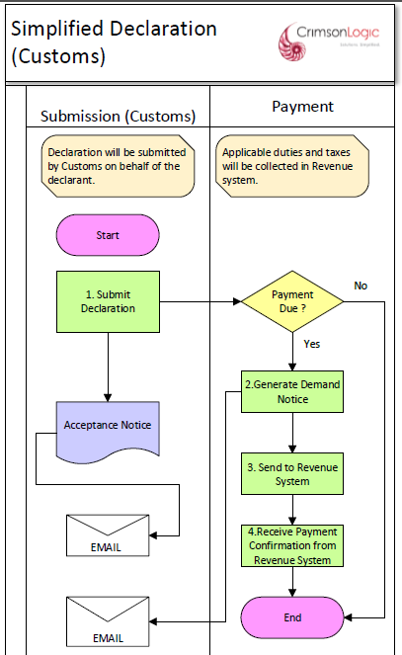

The simplified declaration is used for Customs to submit a simple declaration at the Border for Bhutanese nationals and can be used for quick declaration and clearance of goods at the Border post.

Process Step

PROCESS STEPS
Payment
- System will allow payment for the declaration submitted by customs.

Business Rules
Process | Business Rules
No Approval Process | Since the Declaration is submitted by Customs, it will not go through the approval process.
No Valuation, Risk, Inspection and Release process | Stores declaration will end after payment is collected and clearance controls like valuation, risk, inspection, and release will be suspended for these types of declaration.
Duty Computation | Duty computation will be based on the entered invoice value.

Business Validation

N/A

Passenger Declaration

Process Flow
Process ID: 04.31 – Passenger Declaration Process

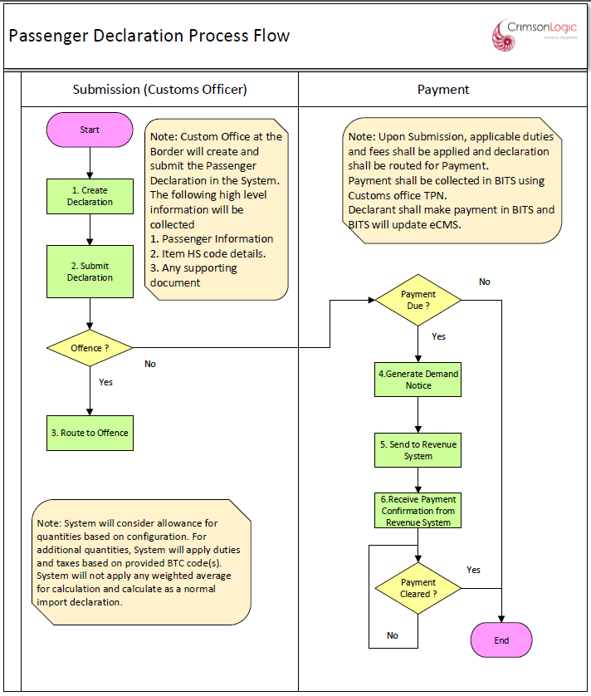

Note: Only Quantity based allowance shall be provided and no Value based allowance is needed. A passenger declaration shall be submitted by a Custom officer at the Custom Office. System will allow allowance for quantities based on the configurated allowance quantities and apply duties and taxes on the additional quantities (No weighted average needed).

Process Step
PROCESS STEPS
Payment
- System will allow payment for the declaration submitted by customs.

Business Rules

Process | Business Rule
No Approval Process | Since the Declaration is submitted by Customs, it will not go through the approval process.
No acceptance, Valuation, Risk, Inspection and Release process | Declaration will end after payment is collected and clearance controls like valuation, risk, inspection, and release will not be applied for these types of declaration.
Declaration Submission | These declarations will be submitted by customs officer. After collection of payment by revenue system, the declaration process shall be deemed completed.

Business Validation
N/A

User Interfaces
Refer to Prototype.

Note: Though we released the prototype, actual UI implementation look, and feel may vary based on SmartGWT framework.

Hardware Interfaces
NA

Software Interfaces
Declaration module may use below component to achieve some functionalities.
- Drools Expert (rule engine)

Appendix

Declaration Clearance Statuses
The following are the declaration statuses at various stages:

Declarant Status | Customs Officer Status | Description
Draft |  | When the declaration is still being updated by the declarant
Submitted | Submitted | When its submitted by the declarant
Pending Approval | Pending Approval | Declaration is pending approval by Verifier at customs office
Pending Payment | Pending Payment | When the payment for duties and taxes are due by the declarant
Compliance | Pending Valuation | Declaration is pending valuation
Compliance | Pending Risk | Declaration is pending risk assessment
Compliance | Document Verification Pending | Document Verification for “Yellow” lane
Compliance | Physical Inspection Pending | Physical Examination of the cargo in “Red” lane
Release Order Completed | Release Order Completed | After completed all the customs processes like Valuation, Risk & Inspection
Cleared | Cleared | Cargo has been completely cleared.
Pending Warehouse Admission | Pending Warehouse Admission | Applicable only for warehouse declaration
Pending Warehouse Release | Pending Warehouse Release | Applicable only for ex-warehouse declaration

Payment Invoice Print
Payment Invoice can be printed for Declaration which have payment instructions associated with them.

Below is the format of the Payment Invoice print in eCMS.

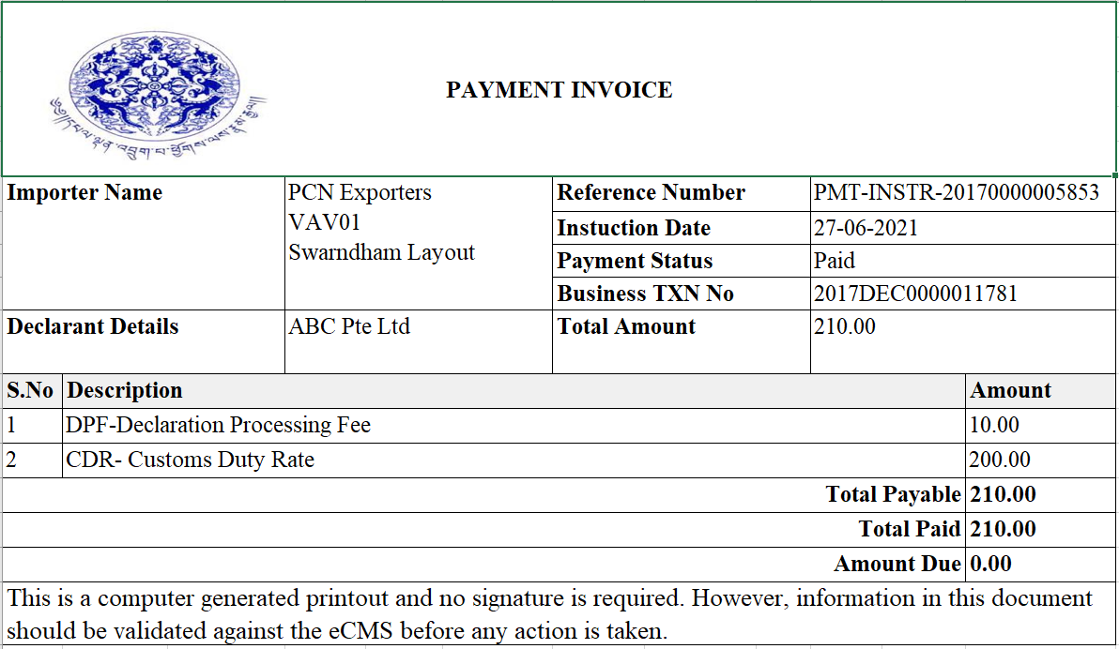

Paid Payment Invoice
The above should also have other tax type details too, as customs will be collecting all the tax type at the point of entry.
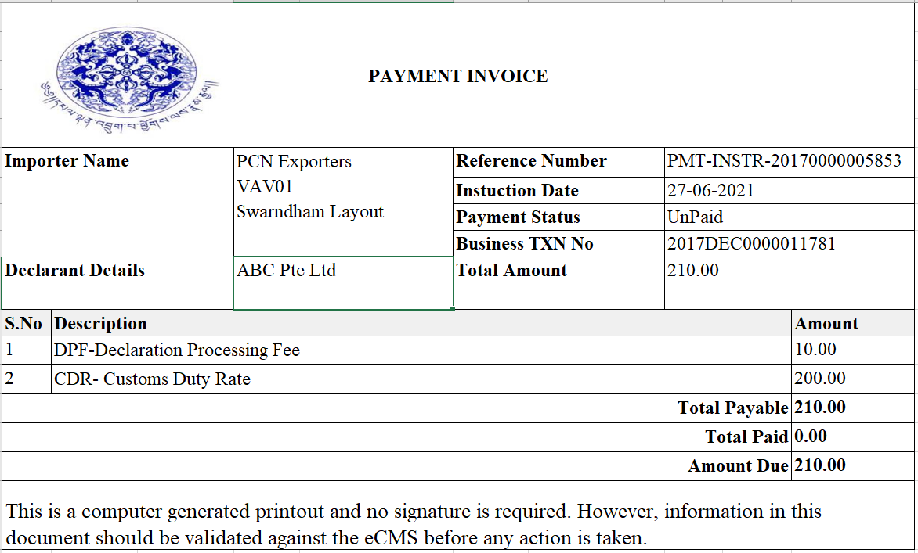

Un-Paid Payment Invoice

Release Order Print
Release Order can be printed for a Declaration after it is released from eCMS.

Below is the format of the Release Order print in eCMS.

