System REQUIREMENTS SPECIFICATION
for
ecms – declaration processing PART II (TRANSIT DECLARATION)

Release No 1.0 – Sep 2021

document identification no 3 char SYS ID/ DOC CODE /NN/ V M.n)  for details refer to document mgmt stds | document title | status  (draft/ released ) | date of release | pages
ECMS/srs/01/V1.0 | System requirements Specifications For ECMS Declaration Processing (Transit) | DRAFT | 09.2021 | 27

 | role in the project | Name | signature | date  (dd-mm-yy)
Authors | Technical Team | Shrinivas Udagatti  Alvin Ian P Paule  Ramoji Lokam
Reviewers | Project Lead | Sujit Patra
Approver | Project Manager | Raghavan Jaganathan

Endorsement by System Owner (internal)
 | Name | designation | signature | date  (dd-mm-yy)

release history
Release Number | associated change request number | Date (mm,yyyy) | Brief Summary of changes | Author
1.0 | First Release | 09.2021 | Initial Release | Sujit Patra

Contents
1. INTRODUCTION 4
1.1 Scope of Declaration Processing 4
1.2 Definitions and Abbreviations 4
1.3 References 5
2. FUNCTIONAL REQUIREMENTS 6
2.1 Overview 6
2.2 Assumptions and Restrictions 6
2.3 Transit 7
2.3.1 Overall Transit Hierarchy: 7
2.3.2 International Transit 8
2.3.3 Customs Expense (International Transit) 11
2.3.4 Import from International Transit 13
2.3.5 Inland Transit from International Transit 16
2.3.6 National Transit from International Transit 19
2.3.7 Warehouse Declaration from International Transit 22
2.3.8 National Transit (without Precedence) 24
2.4 User Interfaces 26
2.5 Hardware Interfaces 26
2.6 Software Interfaces 26
3. Appendix 27
3.1 LOG (Letter of Guarantee) Print 27

INTRODUCTION

This document defines & illustrates the business requirements, process flows as well as the detailed functional requirements of the Transit declaration processing module in eCMS.

The declaration submission is the first step in the eCMS System. After submission, the declaration goes through processing by various department of Customs. This document also illustrates the overall processing of the Transit regime supported by eCMS.

Scope of Declaration Processing
The scope of the Declaration processing implemented in eCMS covers the following:
- Declaration process flows for Transit Regime

Definitions and Abbreviations
The table below lists the different acronyms and abbreviations as well as the definitions used throughout this SRS.

S/N | Abbreviations | Description
 | ACT | Authorized Compliant Trader
 | BACS | Bhutan Automated Customs System
 | BAFRA | Bhutan Agriculture and Food Regulatory Authority
 | BNB | Bhutan National Bank
 | BoB | Bank of Bhutan
 | BITS | Bhutan Integrated Tax System
 | BSTEC | Bhutan Sales Tax Exemption Certificate
 | BTC | Bhutan Tariff Classification
 | CFA | Clearing and Forwarding Agent
 | CDS | Customs Declaration System
 | CAB | Customs Act of Bhutan
 | CID | Citizens Identification Number
 | CRRB | Customs Rules and Regulations of Bhutan
 | DITT | Department of Information Technology & Telecom
 | DRC | Department of Revenue & Customs
 | eCMS | Electronic Customs Management System
 | EMS | Express Mail Service
 | FRS | Functional Requirements Specification
 | GST | Goods and Services Tax
 | IDEC | Import Duty Exemption Certificate
 | LTO | Liaison and Transit Office
 | LoG | Letter of Guarantee
 | LCS | Land Customs Station
 | MoEA | Ministry of Economic Affairs
 | MoHCA | Ministry of Home and Cultural Affairs
 | MoF | Ministry of Finance
 | MIS | Management Information System
 | Nu | Ngultrum
 | RMA | Royal Monetary Authority
 | RGoB | Royal Government of Bhutan
 | RRCO | Regional Revenue and Customs Office
 | RTO | Regional Trade Office
 | RAMIS | Revenue Administration Management Information System
 | SAARC | South Asian Association for Regional Cooperation
 | SITA | International Aeronautical Telecommunications Society
 | SCTS | Single Customs Trade System
 | SAD | Single Administration Document
 | TPN | Taxpayer Number
 | UPU | Universal Postal Union

References
The creation of the Declaration SRS was referenced using the following documents:
- FUNCATIONAL REQUIREMENT SPECIFICATION.docx
- TECHNICAL REQUIREMENT SPECIFICATION.docx
- Bhutan eCMS Technical Proposal TECH-3.pdf
- Bhutan eCMS Technical Proposal TECH-4.pdf
- Bhutan eCMS Technical Proposal TECH-5A.pdf
- Bhutan eCMS Technical Proposal TECH-5B.pdf
- Bhutan eCMS Technical Proposal TECH-6A.pdf
- Bhutan eCMS Technical Proposal TECH-6B.pdf

FUNCTIONAL REQUIREMENTS

Overview
The Declaration processing module in eCMS shows the overall declaration processing for Transit regimes. This SRS is a supplement to the Declaration Processing PART I for Non-Transit regimes and should be referred to for the common processing and core-clearance processes.

Assumptions and Restrictions
The baseline declaration processing module will cover the processes illustrated in the Declaration Processing SRS.

Transit

Overall Transit Hierarchy:
Transit can be either international transit, Inland Transit, or regular National transit (not linked to any preceding procedure). For International transit, below is the hierarchy of the processes and shall be presented accordingly in this document.

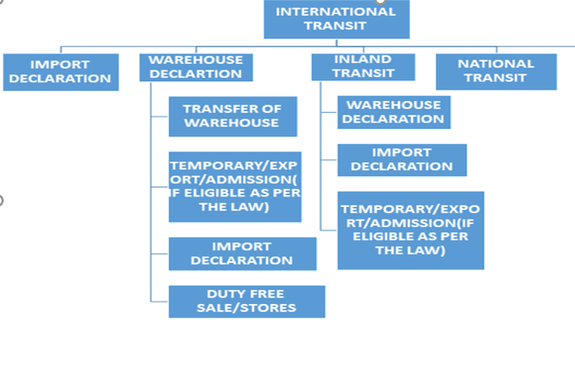

Note: Profile can be configured to route Transit declaration through red lane Alternatively, configuration can be skipped, and risk profiling will be applied, and system will decide the lane.

International Transit

Prerequisite
- The international declarant submitted should be accepted by customs
- The details required to generate LoG should be acquired

Process Flow
Process ID: 04.32 – Import Declaration

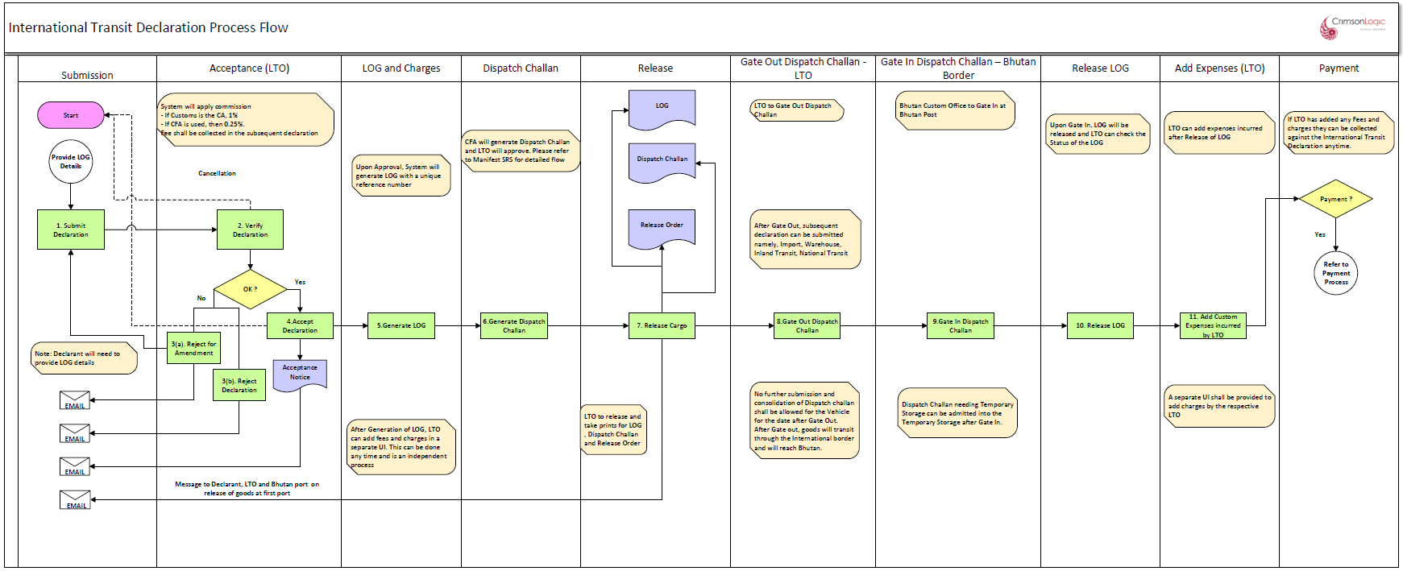

Process Step

PROCESS STEPS
1. Accept Declaration and Generate LoG
- Once the international transit declaration has been accepted by customs, the system will generate a Letter of Guarantee (LoG)
- The LoG will have a unique reference number.
- The system will allow printing of the LoG by both the declarant and the customs.
- The trader can then submit the LoG to the Indian Customs for release of goods from the customs house along with a Bill of Enter No.
- In LOG, CIF value will use Indian customs exchange rate while LOG creation and should convert to INR. System will maintain different exchange rate table for Indian exchange rate to be updated by LTO.

2. Generate Dispatch Challan
- Process flow detailed under Dispatch Challan section of Manifest SRS.
- CFA will submit a consolidated dispatch challan for a vehicle carrying in multiple international transit consignments.
- This consolidate dispatch challan will be used for doing Gate In at the point of Entry.

3. Release Consignment
- Customs after verifying, will approve the dispatch challan and release the good.
- The system will generate the release order. System will allow the declarant to print the release order
4. Gate Out (Customs Transit Office)
- Once the goods are released from LTO/ Customs Transit Office, Customs Transit Office will complete the Gate out process of the consolidated Dispatch challan. Process details are covered under Dispatch Challan Section of Manifest SRS.
5. Gate In (Point of entry)
- The international transited goods will entry the point of entry Bhutan based on the consolidated dispatch challan. Customs office at point of entry will do a Gate In of the consolidated dispatch challan.
- Once the particular dispatch challan has been gate in the system, the system will then complete the transit declaration and allow the customs transit office to view the status of each international transit declaration approved and cleared by them. The system will update the LoG status as released and the customs transit office will be able to check the status of the international transit declaration tin the system.
- The system will then link each transit declaration with a subsequent declaration at the point of entry.
- if there are any discrepancies between the international and the subsequent declaration, then fine and penalties if applicable will be applied to the later declaration.

6. Customs Expenses
- The system will provide a separate UI for customs to calculate the customs expense linked with the international transaction and forward the same to the point of entry customs house.
- The system will allow the declarant to pay the customs expenses against each international transit declaration
- Once the payment has been realized by the point of entry customs, the system will intimate the status of the same against each international declaration to the customs transits office

Additional Functions

Sl No | Additional Functions
1 | Services charges against the International Transit Declaration (1% or 0.25%) shall be collected in the subsequent declaration submitted to clear the International Transit declaration at the Bhutan border (Import, Warehouse, Inland or National Transit Declaration)

Business Rule

Sl No | Business Rule
1 | The dispatch challan can be prepared only after the LOG has been generated and used to acquire The BoE number from the Indian Customs. The BoE no is required to prepare the dispatch challan
2 | A print shall be provided for the LOG for Declarant and Bhutan customs for endorsement. As per the bilateral agreement, “At the Customs House, the importer or his agent (hereinafter referred to as the "Importer") shall present the Letter of Guarantee in the prescribed form (Annex-I) in five copies. The last two columns pertaining to classification of goods and duty shall be completed by the Indian Customs authorities .”
3 | In LOG, CIF value should use Indian Customs Exchange Rate while LOG creation and should convert to INR. System will maintain different Exchange rate table for Indian Exchange rate to be updated by LTO

Business Validation

Sl No | Business Validation
1 | System will check if all LOG details are provided during Submission else it will not allow the submission to go through.

Customs Expense (International Transit)

Prerequisite
- For Containerized International Transit declaration, the declaration should have Gated in, and the LOG should have been released
- For Non-Containerized International Transit declaration, the declaration should have Gated out from LTO

Process Flow
Process ID: 04.33 – Customs Expense (International Transit)

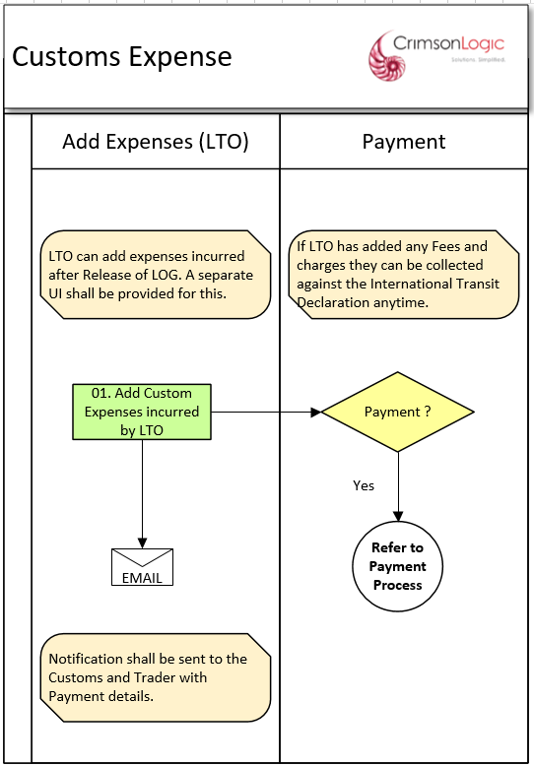
Customs LTO shall also be notified

Process Step

PROCESS STEPS
1. Add Customs Expenses
- The system will provide a separate UI for customs to calculate the customs expense linked with the international transaction and forward the same to the point of entry customs house.
Note: For Containerized International Transit Declaration, Customs expenses can only be added after the declaration has gated in at point of Entry and the LOG has been released. For Non-Containerized International Transit declaration, Custom expenses can be added after the declaration has gated out from LTO.
2. Payment
- The system will allow the declarant to pay the customs expenses against each international transit declaration
- Once the payment has been realized by the point of entry customs, the system will intimate the status of the same against each international declaration to the customs transits office

Business Rule

Sl No | Business Rule
1 | Custom expenses can be added as per the below Rule  - For Containerized International Transit Declaration, Customs expenses can only be added after the declaration has gated in at point of Entry and the LOG has been released.  - For Non-Containerized International Transit declaration, Custom expenses can be added after the declaration has gated out from LTO.

Business Validation

Sl No | Business Validation
1 | System will check if the LOG has been released before allowing Customs expenses to be added against the International Transit Declaration.

Import from International Transit

Prerequisite
- The Declaration should have been accepted by customs.

Process Flow
Process ID: 04.34 – Import from International Transit

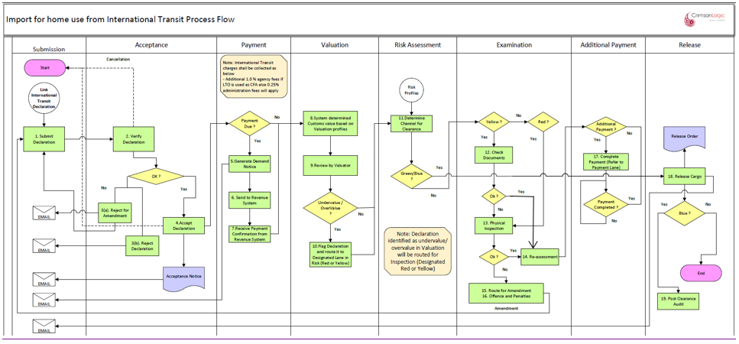

Process Step

PROCESS STEPS
1. Payment
- The system will allow payment for the declaration accepted by customs.
- System will apply services charges for the linked International Transit Declaration (1% or 0.25%) on the Import declaration.
- Upon completion of payment process the system will automatically forward the declaration to the next process
- the system will also route the additional payment for a declaration to payment process.
- the additional payment will be linked to a particular declaration.

2. Valuation
- The system will determine the customs value at item level and accordingly determine whether the declared value is under or over value.
- The system based on the order of execution (please refer the SRS Valuation) will reflect the system value for items that are either under or overvalued.

3. Review by the Valuation Officer
- The system will allow the customs officer to decide on valuation based on the finding presented by the system and amend the declared value accordingly.
- The system will give an option to the valuation officer to direct the declaration to yellow or red channel.

4. Risk Assessment
- The system will perform the risk assessment based on the risk profile in the system
- The lane will be decided based on profile criteria met. The possible outcomes are “Green”, “Blue”, “Yellow” or “Red” lanes.
- “Green” lane will go for release process.
- “Blue” lane will go for Post clearance audit after release.
- “Yellow” will go for document verification.
- “Red” will go for physical inspection.

5. Examination
- Yellow Channel
- If the declaration is directed to yellow lane, the declaration will be reflected in the document verifier’s dashboard
- the system will also provide a platform to the document verifier officer to submit the examination report.
- The document verification officer may review the documents and decide to release or route for physical inspection or for re-assessment
- The system will then follow the additional payment process
- Red Lane
- If the declaration is directed to red lane, the declaration will be reflected in the inspections dash board
- Upon physical inspection carried out by the inspection team, the system will also provide a platform to the inspection officer to submit the inspection report that is standard and incorporated in the system.
- Based on the inspection REPORT, the assessor will either.
- release the good
- send back to the declarant for amendment.
- Direct the declaration to the offences and penalties: Declaration intercepted with customs offence after examination can be routed to Offence and Penalties process by Inspection Officer
- Blue Lane
- The system will automatically direct the declaration submitted by ACT to blue lane
- The system will also provide a feature for the customs to direct a particular declaration to the blue lane.
- Green Lane
- The declaration directed to green lane will be released by the customs.

Note: The system will provide an option for customs to upgrade the declaration as follows;
- Green Lane to either yellow or red channel
- Yellow lane to red channel

6. Reassessment
- Once the declaration has been directed to offence and penalties, the system will provide an option for the customs to amend the declaration, reassess the additional payment along with the fines and penalties.
- However, the system will also maintain the original declaration submitted by the declarant
- Re-assessment by customs can either be
- Called after completion of Inspection. Re-Assessment will be called upon completion of either Documentary Check or Physical Inspection.
- offence and penalties, wherein customs has intercepted customs offences and the same has been re-assessed as per the examination report.
7. Additional Payment
- If the declaration has been reassessed, the system will raise a demand notice for the additional payment linking with the declaration.
8. Release
- Upon completion of the customs procedures the system will generate a release order.
- The system will allow both the declarant and the customs office to print the release order if need be.
- During gate out the gate officer will be presented with the release order. Based on which the gate officer will release the cargo and the same will be recorded in the system.
- The system will record the release time

Business Rule
Please refer to Entry for home use after international transit in Import Section of Declaration Processing SRS for Non-Transit.

Business Validation
Please refer to Entry for home use after international transit in Import Section of Declaration Processing SRS for Non-Transit.

Inland Transit from International Transit

Prerequisite
- The Declaration should have been accepted by customs.

Process Flow
Process ID: 04.35 – Inland Transit from International Transit

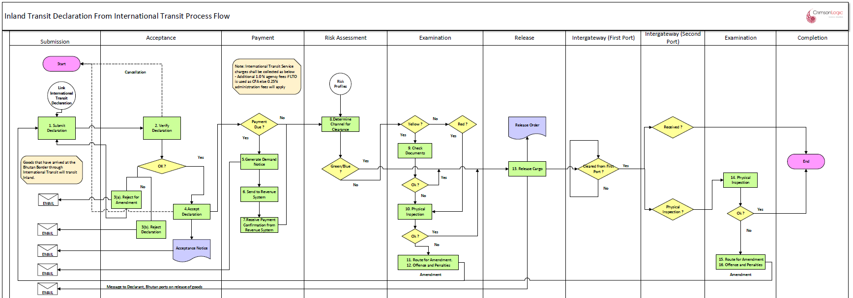

Process Step

PROCESS STEPS
1. Payment
- The system will allow payment for the declaration accepted by customs.
- System will apply services charges for the linked International Transit Declaration (1% or 0.25%) on the Inland Transit declaration.
- Upon completion of payment process the system will automatically forward the declaration to the next process
2.Risk Assessment
- The system will perform the risk assessment based on the risk profile in the system
- The lane will be decided based on profile criteria met. The possible outcomes are “Green”, “Blue”, “Yellow” or “Red” lanes.
- “Green” lane will go for release process.
- “Blue” lane will go for Post clearance audit after release.
- “Yellow” will go for document verification.
- “Red” will go for physical inspection.

3.Examination
- Yellow Channel
- If the declaration is directed to yellow lane, the declaration will be reflected in the document verifier’s dashboard
- the system will also provide a platform to the document verifier officer to submit the examination report.
- The document verification officer may review the documents and decide to release or route for physical inspection or for re-assessment
- The system will then follow the additional payment process
- Red Lane
- If the declaration is directed to red lane, the declaration will be reflected in the inspection’s dashboard
- Upon physical inspection carried out by the inspection team, the system will also provide a platform to the inspection officer to submit the inspection report that is standard and incorporated in the system.
- Based on the inspection REPORT, the assessor will either.
- release the good
- send back to the declarant for amendment.
- Direct the declaration to the offences and penalties: Declaration intercepted with customs offence after examination can be routed to Offence and Penalties process by Inspection Officer
- Blue Lane
- The system will automatically direct the declaration submitted by ACT to blue lane
- The system will also provide a feature for the customs to direct a particular declaration to the blue lane.
- Green Lane
- The declaration directed to green lane will be released by the customs.

Note: The system will provide an option for customs to upgrade the declaration as follows;
- Green Lane to either yellow or red channel
- Yellow lane to red channel

4.Release
- Upon completion of the customs procedures the system will generate a release order.
- The system will allow both the declarant and the customs office to print the release order if need be.
- During gate out the gate officer will be presented with the release order. Based on which the gate officer will release the cargo and the same will be recorded in the system.
- The system will record the release time
5. Inter gateway (First Gate)
- Once the goods are released from Customs office, system will route the Inland Transit declaration for Clearance from First Gate.
6. Inter gateway (Second Gate)
- After the goods reach the second gate, Customs office shall receive the goods at the second Gate. If required, Customs can do inspection on the Goods.
7. Examination
- If needed, Customs can route for Physical Examination at the second port.

Business Rule

Sl No | Business Rule
1 | A Custom cleared International Transit declaration belonging to the same importer should be available.
2 | International Transit declaration must be linked to the Inland Transit declaration and items from International Transit declaration must be indicated in the Inland Transit declaration.

Business Validation

Sl No | Business Validation
1 | The system will ask for an approved International Transit declaration. The system will not allow the declarant to process the declaration further without a valid International Transit declaration reference no.
2 | Only one International Transit declaration can be linked to an Inland Transit declaration and linked declaration should have items available for Inland Transit
3 | Once a valid International Transit admission declaration reference no is keyed in, system will auto populate relevant details in the Inland Transit declaration.
4 | System will validate quantity of goods being Transited inland and it cannot be more than the balance quantity available in the linked International Transit declaration.
5 | Only items from linked International Transit declaration can be transited Inland. System will not allow addition of un-related items in the Inland Transit declaration.

(Note: System will also allow Inland Transit from National Transit. The above process steps will apply for Inland Transit from National Transit with the following difference
1. Instead of an International Transit, an approved National Transit will need to be linked.
2. Services charges which are applicable for International Transit shall not apply if the Inland Transit is being done from National Transit)

National Transit from International Transit

Prerequisite
- The Declaration should have been accepted by customs.

Process Flow
Process ID: 04.36 – National Transit from International Transit

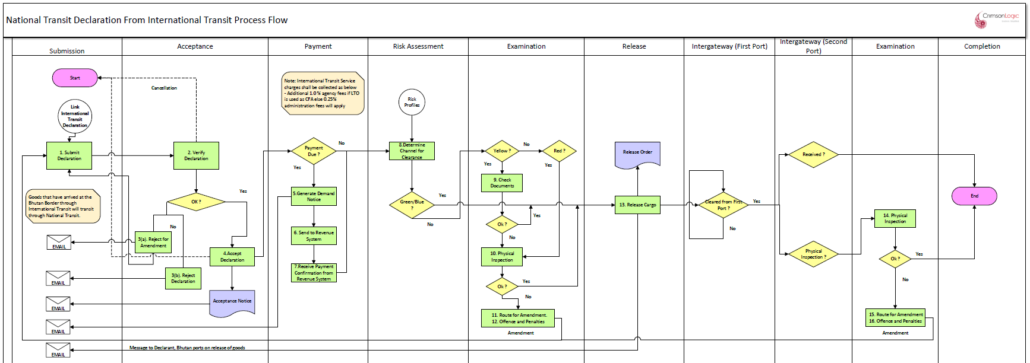

Process Step

PROCESS STEPS
1. Payment
- The system will allow payment for the declaration accepted by customs.
- System will apply services charges for the linked International Transit Declaration (1% or 0.25%) on the National Transit declaration.
- Upon completion of payment process the system will automatically forward the declaration to the next process
2.Risk Assessment
- The system will perform the risk assessment based on the risk profile in the system
- The lane will be decided based on profile criteria met. The possible outcomes are “Green”, “Blue”, “Yellow” or “Red” lanes.
- “Green” lane will go for release process.
- “Blue” lane will go for Post clearance audit after release.
- “Yellow” will go for document verification.
- “Red” will go for physical inspection.

3.Examination
- Yellow Channel
- If the declaration is directed to yellow lane, the declaration will be reflected in the document verifier’s dashboard
- the system will also provide a platform to the document verifier officer to submit the examination report.
- The document verification officer may review the documents and decide to release or route for physical inspection or for re-assessment
- The system will then follow the additional payment process
- Red Lane
- If the declaration is directed to red lane, the declaration will be reflected in the inspection’s dashboard
- Upon physical inspection carried out by the inspection team, the system will also provide a platform to the inspection officer to submit the inspection report that is standard and incorporated in the system.
- Based on the inspection REPORT, the assessor will either.
- release the good
- send back to the declarant for amendment.
- Direct the declaration to the offences and penalties: Declaration intercepted with customs offence after examination can be routed to Offence and Penalties process by Inspection Officer
- Blue Lane
- The system will automatically direct the declaration submitted by ACT to blue lane
- The system will also provide a feature for the customs to direct a particular declaration to the blue lane.
- Green Lane
- The declaration directed to green lane will be released by the customs.

Note: The system will provide an option for customs to upgrade the declaration as follows;
- Green Lane to either yellow or red channel
- Yellow lane to red channel

4.Release
- Upon completion of the customs procedures the system will generate a release order.
- The system will allow both the declarant and the customs office to print the release order if need be.
- During gate out the gate officer will be presented with the release order. Based on which the gate officer will release the cargo and the same will be recorded in the system.
- The system will record the release time
5. Inter gateway (First Gate)
- Once the goods are released from Customs office, system will route the Inland Transit declaration for Clearance from First Gate.
6. Inter gateway (Second Gate)
- After the goods reach the second gate, Customs office shall receive the goods at the second Gate. If required, Customs can do inspection on the Goods.
7. Examination
- If needed, Customs can route for Physical Examination at the second port.

Business Rule

Sl No | Business Rule
1 | A Custom cleared International Transit declaration belonging to the same importer should be available.
2 | International Transit declaration must be linked to the National Transit declaration and items from International Transit declaration must be indicated in the National Transit declaration.

Business Validation

Sl No | Business Validation
1 | The system will ask for an approved International Transit declaration. The system will not allow the declarant to process the declaration further without a valid International Transit declaration reference no.
2 | Only one International Transit declaration can be linked to a National Transit declaration and linked declaration should have items available for National Transit
3 | Once a valid International Transit admission declaration reference no is keyed in, system will auto populate relevant details in the National Transit declaration.
4 | System will validate quantity of goods being transited nationally and it cannot be more than the balance quantity available in the linked International Transit declaration.
5 | Only items from linked International Transit declaration can be transited nationally. System will not allow addition of un-related items in the National Transit declaration.

Warehouse Declaration from International Transit

Prerequisite
- The Declaration should have been accepted by customs

Process Flow
Process ID: 04.37 – Warehouse from International Transit

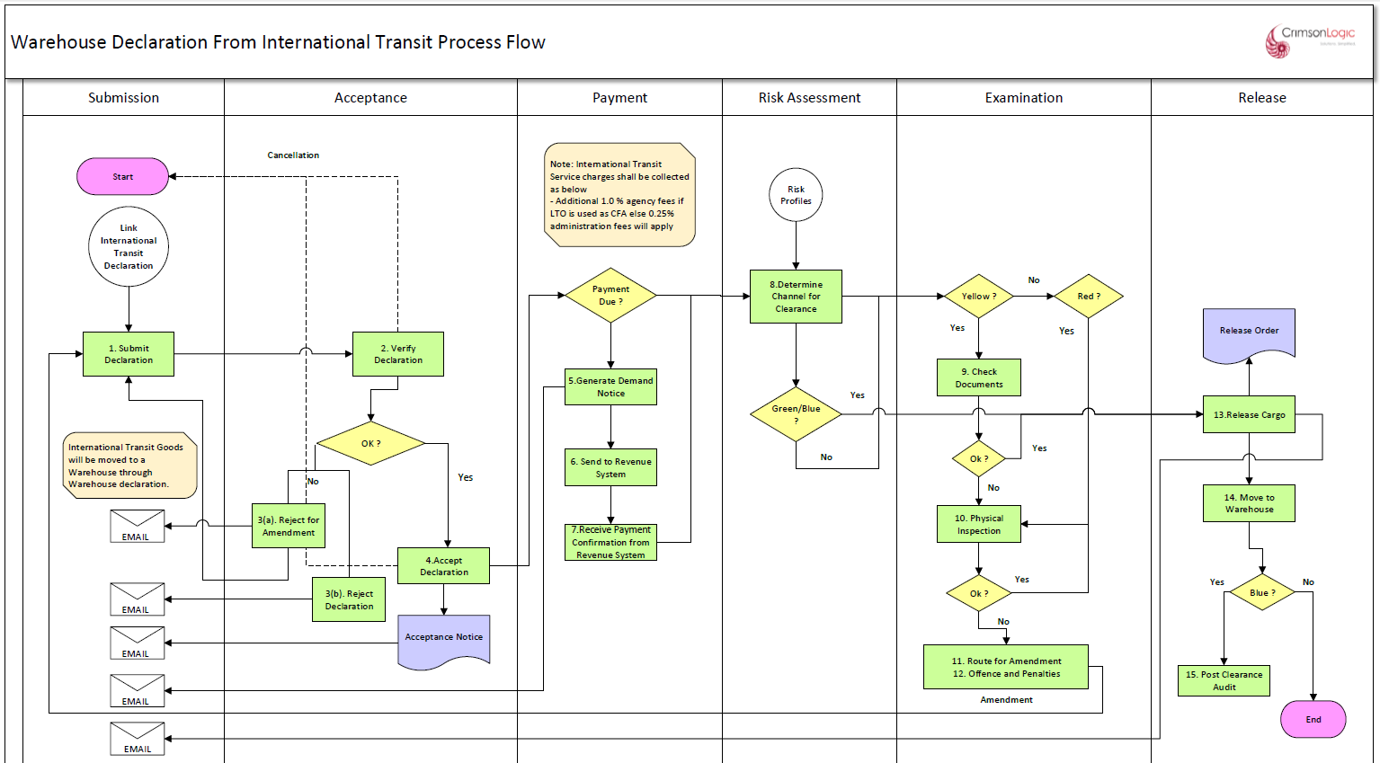

Process Step

PROCESS STEPS
1. Payment
- System will allow payment for the declaration accepted by customs.
- System will apply services charges for the linked International Transit Declaration (1% or 0.25%) on the Warehouse declaration.
- Upon completion of payment process, System will automatically forward the declaration to the next process
2. Risk Assessment
- System will perform the risk assessment based on the risk profile in the system
- The lane will be decided based on profile criteria met. The possible outcomes are “Green”, “Blue”, “Yellow” or “Red” lanes.
- “Green” lane will go for release process.
- “Blue” lane will go for Post clearance audit after release.
- “Yellow” will go for document verification.
- “Red” will go for physical inspection.

3. Examination
- Yellow Channel
- If the declaration is directed to yellow lane, the declaration will be reflected in the document verifier’s dashboard
- System will also provide a platform to the document verifier officer to submit the examination report.
- The document verification officer may review the documents and decide to release or route for physical inspection or for re-assessment
- System will then follow the additional payment process
- Red Lane
- If the declaration is directed to red lane, the declaration will be reflected in the inspection’s dashboard
- Upon physical inspection carried out by the inspection team, System will also provide a platform to the inspection officer to submit the inspection report that is standard and incorporated in the system.
- Based on the inspection REPORT, the assessor will either.
- release the good
- send back to the declarant for amendment.
- Direct the declaration to the offences and penalties: Declaration intercepted with customs offence after examination can be routed to Offence and Penalties process by Inspection Officer
- Blue Lane
- System will automatically direct the declaration submitted by ACT to blue lane
- System will also provide a feature for the customs to direct a particular declaration to the blue lane.
- Green Lane
- The declaration directed to green lane will be released by the customs.

Note: System will provide an option for customs to upgrade the declaration as follows;
- Green Lane to either yellow or red channel
- Yellow lane to red channel
4. Release
- Upon completion of the customs procedures, System will generate a release order.
- System will allow both the declarant and the customs office to print the release order if need be.
- During gate out the gate officer will be presented with the release order. Based on which the gate officer will release the cargo and the same will be recorded in the system.
- System will record the release time
- Post completion of Release, the goods shall be Admitted into the Warehouse and inventory of the Warehouse shall be updated

Business Rule
Please refer to Warehousing after international transit in Warehouse Declaration Section of Declaration Processing SRS for Non-Transit.

Business Validation
Please refer to Warehousing after international transit in Warehouse Declaration Section of Declaration Processing SRS for Non-Transit.

National Transit (without Precedence)

Prerequisite
1. The Declaration should have been accepted by customs

Process Flow
Process ID: 04.38 – National Transit (Without Precedence)

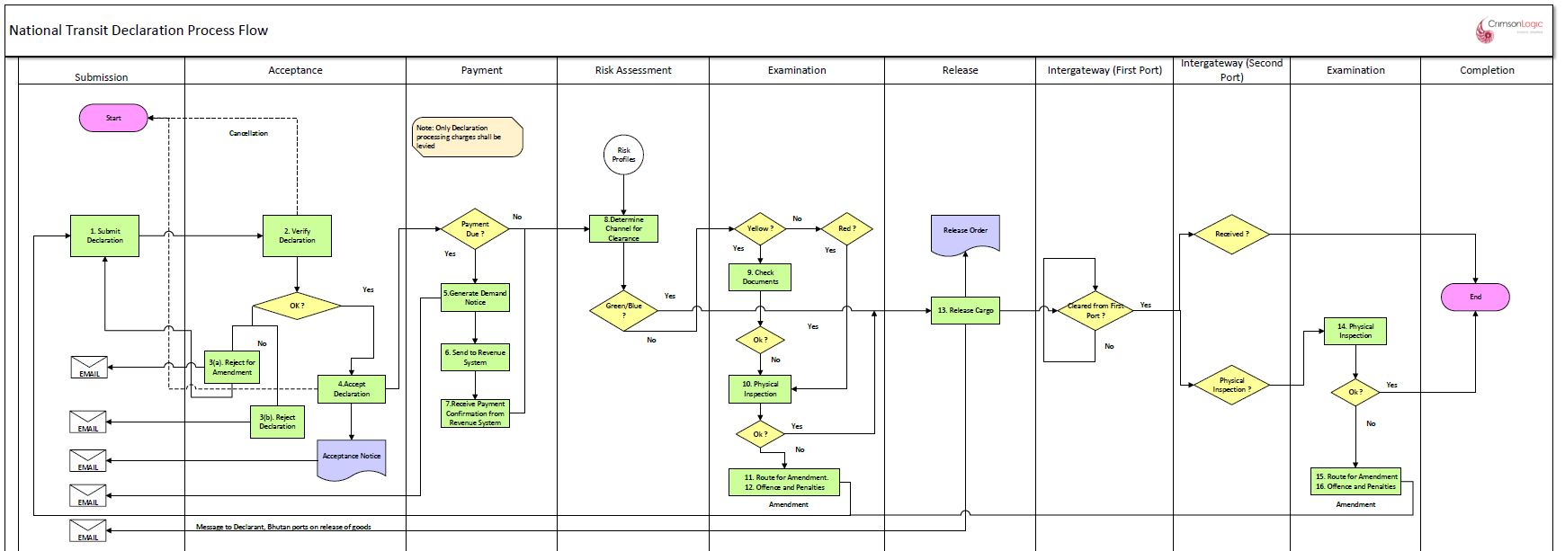

Process Step

PROCESS STEPS
1. Payment
- The system will allow payment for the declaration accepted by customs.
- Upon completion of payment process the system will automatically forward the declaration to the next process.
- If the declaration is not subjected for payment, the system will automatically forward the declaration to the next process
2.Risk Assessment
- The system will perform the risk assessment based on the risk profile in the system
- The lane will be decided based on profile criteria met. The possible outcomes are “Green”, “Blue”, “Yellow” or “Red” lanes.
- “Green” lane will go for release process.
- “Blue” lane will go for Post clearance audit after release.
- “Yellow” will go for document verification.
- “Red” will go for physical inspection.

3.Examination
- Yellow Channel
- If the declaration is directed to yellow lane, the declaration will be reflected in the document verifier’s dashboard
- the system will also provide a platform to the document verifier officer to submit the examination report.
- The document verification officer may review the documents and decide to release or route for physical inspection or for re-assessment
- The system will then follow the additional payment process
- Red Lane
- If the declaration is directed to red lane, the declaration will be reflected in the inspection’s dashboard
- Upon physical inspection carried out by the inspection team, the system will also provide a platform to the inspection officer to submit the inspection report that is standard and incorporated in the system.
- Based on the inspection REPORT, the assessor will either.
- release the good
- send back to the declarant for amendment.
- Direct the declaration to the offences and penalties: Declaration intercepted with customs offence after examination can be routed to Offence and Penalties process by Inspection Officer
- Blue Lane
- The system will automatically direct the declaration submitted by ACT to blue lane
- The system will also provide a feature for the customs to direct a particular declaration to the blue lane.
- Green Lane
- The declaration directed to green lane will be released by the customs.

Note: The system will provide an option for customs to upgrade the declaration as follows;
- Green Lane to either yellow or red channel
- Yellow lane to red channel

4.Release
- Upon completion of the customs procedures the system will generate a release order.
- The system will allow both the declarant and the customs office to print the release order if need be.
- During gate out the gate officer will be presented with the release order. Based on which the gate officer will release the cargo and the same will be recorded in the system.
- The system will record the release time
5. Inter gateway (First Gate)
- Once the goods are released from Customs office, system will route the Inland Transit declaration for Clearance from First Gate.
6. Inter gateway (Second Gate)
- After the goods reach the second gate, Customs office shall receive the goods at the second Gate. If required, Customs can do inspection on the Goods.
7. Examination
- If needed, Customs can route for Physical Examination at the second port.

Business Rule
Sl No | Business Rule
 | N/A

Business Validation
Sl No | Business Validation
 | N/A

User Interfaces
Refer to Prototype.

Note: Though we released the prototype, actual UI implementation look, and feel may vary based on SmartGWT framework.

Hardware Interfaces
NA

Software Interfaces
Declaration module may use below component to achieve some functionalities.
- Drools Expert (rule engine)

Appendix

LOG (Letter of Guarantee) Print
LOG can be printed for International Transit Declaration after the declaration is released from the source port by LTO.

Below is the format of the LOG print in eCMS.

