System REQUIREMENTS SPECIFICATION
for
eCMS – OFFENCE, Penalty AND APPEAL

Release No 1.0 – Jul 2021

document identification no 3 char SYS ID/ DOC CODE /NN/ V M.n)  for details refer to document mgmt stds | document title | status  (draft/ released ) | date of release | pages
eCMS /SRS/01/V1.0 | System Requirement Specifications For Offence, penalty And Appeal | Draft | 07.2021

 | role in the project | Name | signature | date  (dd-mm-yy)
Authors | Technical Team | Shrinivas Udagatti  Alvin Ian P Paule  Ramoji Lokam
Reviewers | Project Lead | Sujit Patra
Approver | Project Manager | Raghavan Jaganathan

Endorsement by System Owner (internal)
 | Name | designation | signature | date  (dd-mm-yy)
Endorsed by System Owner | Chiew Lan Tan | Senior Director

release history
Release Number | associated change request number | Date (mm,yyyy) | Brief Summary of changes | Author
1.0 | First Release | 07.2021

Table of Contents
Table of Contents 3
1 Introduction 4
1.1 Scope 4
1.2 Definitions and Abbreviations 4
1.3 References 6
2 Functional Requirement 7
2.1 Offence 7
2.2 Appeal 15
2.3 Customs Warehouse 21
3 System Integration 28
4 Appendix 29
4.1 Item Statuses 29
4.2 Offence Statuses 29
4.3 Appeal Statuses 31
4.4 Customs Warehouse Statuses 31
4.5 Report templates 31
4.6 Configuration blueprint (CBP) 35
4.7 Scheduler Jobs 35
4.8 User Interface 35

Introduction

This document defines & illustrates the business requirements, process flows as well as the detailed functional requirements of eCMS Offence, Penalty, Appeal modules to be implemented for Department of Revenue and Customs, Bhutan. Also included are modules for Customs Warehouse for detained/seized/confiscated goods.

Enforcement allows customs to manage breach of Customs law, policies, and regulations. It can be triggered at clearance process. Enforcement is also known as Offence Management, and these are used interchangeably.

The function explains management of breach of Customs laws and regulations. The function includes notification of offenders, compounding of offences and waiver of interest on penalties.

Scope
The scope of the Offence module is as below:
- Offence Management
- Penalty
- Appeal
- Customs Warehouse

Definitions and Abbreviations
The table below lists the different acronyms and abbreviations as well as the definitions used throughout this SRS.

S/N | Abbreviations | Description
 | ACT | Authorized Compliant Trader
 | BACS | Bhutan Automated Customs System
 | BAFRA | Bhutan Agriculture and Food Regulatory Authority
 | BITS | Bhutan Integrated Tax System
 | BNB | Bhutan National Bank
 | BoB | Bank of Bhutan
 | BSTEC | Bhutan Sales Tax Exemption Certificate
 | BTC | Bhutan Tariff Classification
 | CAB | Customs Act of Bhutan
 | CDS | Customs Declaration System
 | CFA | Clearing and Forwarding Agent
 | CID | Citizens Identification Number
 | CRRB | Customs Rules and Regulations of Bhutan
 | DITT | Department of Information Technology & Telecom
 | DRC | Department of Revenue & Customs
 | eCMS | Electronic Customs Management System
 | EMS | Express Mail Service
 | FRS | Functional Requirements Specification
 | GST | Goods and Services Tax
 | IDEC | Import Duty Exemption Certificate
 | LCS | Land Customs Station
 | LoG | Letter of Guarantee
 | LTO | Liaison and Transit Office
 | MIS | Management Information System
 | MoEA | Ministry of Economic Affairs
 | MoF | Ministry of Finance
 | MoHCA | Ministry of Home and Cultural Affairs
 | Nu | Ngultrum
 | RAMIS | Revenue Administration Management Information System
 | RGoB | Royal Government of Bhutan
 | RMA | Royal Monetary Authority
 | RRCO | Regional Revenue and Customs Office
 | RTO | Regional Trade Office
 | SAD | Single Administration Document
 | SARC | South Asian Association for Regional Cooperation
 | SCTS | Single Customs Trade System
 | SITA | International Aeronautical Telecommunications Society
 | TPN | Taxpayer Number
 | TPN | Taxpayer Number
 | UPU | Universal Postal Union

References
The creation of the BECMS SRS was referenced using the following documents:
- FUNCATIONAL REQUIREMENT SPECIFICATION.docx
- TECHNICAL REQUIREMENT SPECIFICATION.docx
- Bhutan eCMS Technical Proposal TECH-3.pdf
- Bhutan eCMS Technical Proposal TECH-4.pdf
- Bhutan eCMS Technical Proposal TECH-5A.pdf
- Bhutan eCMS Technical Proposal TECH-5B.pdf
- Bhutan eCMS Technical Proposal TECH-6A.pdf
- Bhutan eCMS Technical Proposal TECH-6B.pdf

Functional Requirement

Offence module shall provide the functionalities for the Enforcement in the Customs to manage the offence committed during the import or export of goods, determine the penalty, admit/release goods from a customs warehouse and allow the declarant/CFA to submit an appeal afterwards.

Below is a diagram of the overview of the Offence process:

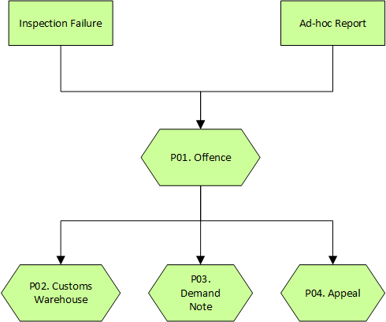

OFFENCE OVERVIEW

Offence

Offence Management
eCMS enables an offence officer to complete offence reports that have been created by a declaration goods inspection failure reported by a customs officer. eCMS also allows an offence officer to create ad-hoc offence reports due to risk/intelligence failure. An offence can involve personnel or declaration goods. The offence report will also contain the demand note to pay and the action applied on the goods involved.

Pre-Requisites
- The user who created the declaration is a registered Declarant (or CFA) in eCMS.
- The customs officer who updated the failed physical examination is a registered customs officer in eCMS.
- The offence officer who will facilitate the offence process is a registered offence officer in eCMS.
- The customs warehouse/temporary storage officer involved in an offence is a registered customs warehouse/temporary storage officer in eCMS.
- The declarant/CFA, customs warehouse/temporary storage officer, customs officer and offence officer are authorized to access eCMS and have access to the required application.

Process Flow

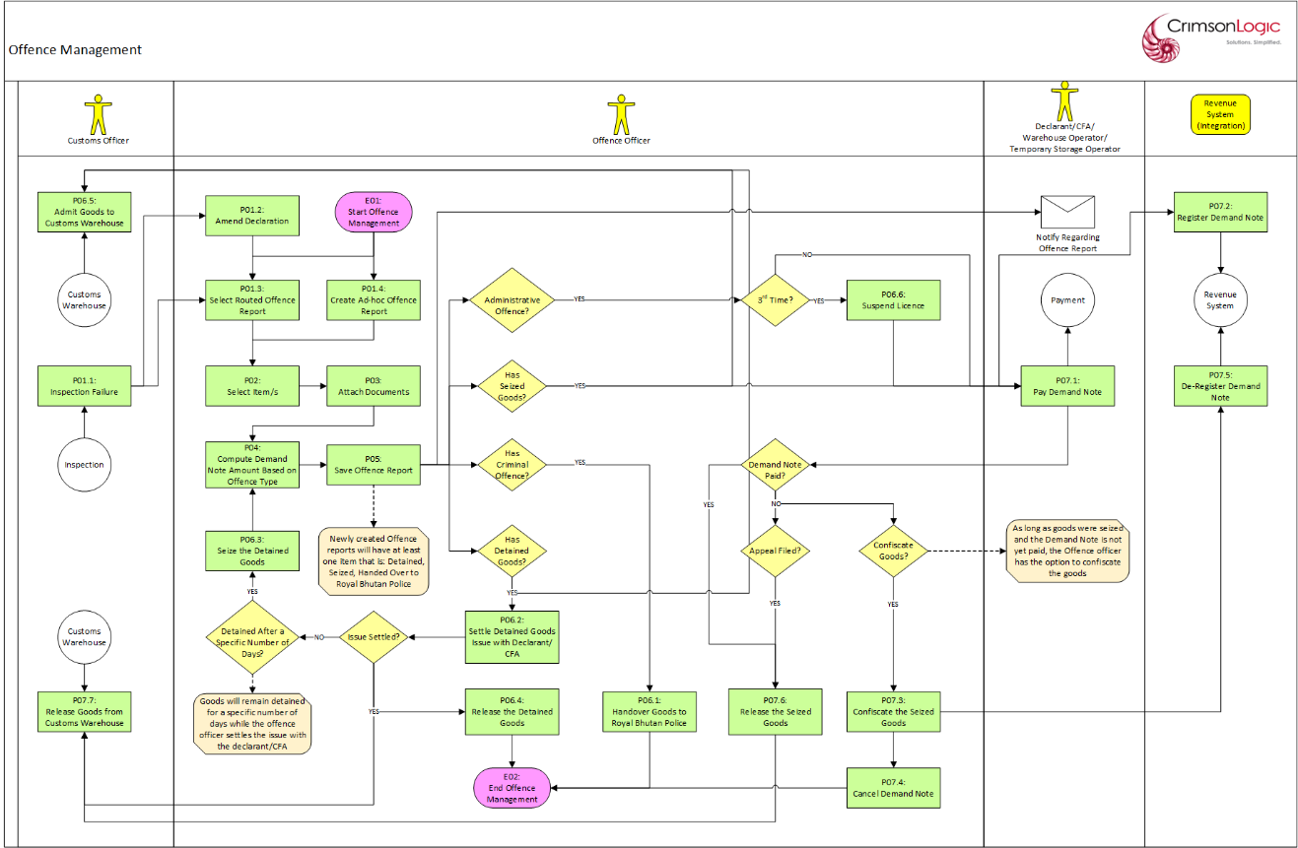

Process Steps
P01.1: Inspection Failure
While processing declaration goods, the customs officer can report an Inspection Failure via the Inspection module. This will trigger the system to create an Offence Report with the following data at the General Information tab:

- Offence Report Number
- Offence Source – set to Inspection Failure
- Business Transaction Module – set to Declaration
- Details of the Declaration involved in the inspection failure
- Status – set to Draft

The Offence Report Number will have the following format:
OFN<YYMMDD#####>

where:
YY – year
MM – month
DD – day
##### - running sequence number

The offence officer will be able to see the draft Offence Report and complete the rest of the details.

Note/s:
- For a declaration that does not have previous declarations, the customs officer can also decide to require a offence officer to update the declaration first after reporting the inspection failure. The Offence Report will still be created but will have a Pending Declaration Amendment status and will be viewable only until the customs officer has completed amending the declaration.
- For inspection failures that are due to undeclared goods, the declarant/CFA can create a new declaration for the undeclared goods and then during inspection, customs can mark that declaration as inspection failure and route to offence.

P01.2: Amend Declaration
The offence officer will amend in a separate menu the declaration that was involved in an offence. After the amendment, the Offence report will use the amended data for the demand note computation.

P01.3: Select Routed Offence Report
An offence officer can select an Offence Report that was created due to an inspection failure and edit the report to complete the rest of the details at the items, documents, and demand note tabs.

Note/s:
- The Offence Report will be viewable only if the customs officer is still amending a declaration after an inspection failure. After the amendment is finished, the Offence Report status will be changed into Draft, and become editable.

P01.4: Create Ad-hoc Offence Report
An offence officer can create an ad-hoc Offence Report. The report will have the Business Transaction Module set to Ad-hoc at the General Information tab. The offence officer can complete the rest of the General Information details.

If the Offence Type is Administrative, the offence officer will need to select the customs warehouse/temporary storage officer involved. Only one customs warehouse/temporary storage officer can be selected for this offence. The Items tab will also be hidden since it is not needed.

If the Offence Type is Customs/Criminal, the offence officer must select the Offence Category and:
- if the category is Declaration, the offence officer will need to select the declaration number involved
- if category is Passenger Cargo, the offence officer will need to enter all the declaration details

After entering all the mandatory inputs, the user can save the General Information data. But before allowing the General Information to be saved, the system will validate the inputs and will display messages if there are errors encountered. If there are no validation issues, the Offence Report Number will be generated the report will have a Draft status. The Offence Report Number will have the following format:

OFN<YYMMDD#####>

where:
YY – year
MM – month
DD – day
##### - running sequence number

Note/s:
- The Items tab is applicable only for Customs/Criminal offences.

P02: Select Item/s
If the Offence Type is Customs/Criminal, the offence officer can select the goods available from the declaration entered at the General Information tab and determine the action applied to them by selecting any of the following statuses:

- Detained (only for Customs offence)
- Seized (only for Customs offence)
- Handover to Royal Bhutan Police (only for Criminal offence)

Note/s:
- At least one of the goods in the declaration involved in the offence should have a corresponding status.

- If at least one of the goods has a Detained status, the Demand Note tab will be hidden. This is to allow the declarant/CFA and offence officer to settle the issue within an allowed period. Once the issue has been settled, the offence officer can update the Offence Report to release the detained goods. If there are seized goods remaining, the Demand Note tab can be shown.

If the issue was not settled after an allowed period, a background process will update the Offence Report so that the detained goods will now become seized and then notify the offence officer. The offence officer can then edit the report and see the computed Demand Note tab.

P03: Attach Documents
The offence officer can update the offence report by attaching related documents (if any).

P04: Compute Demand Note Amount Based on Offence Type
The system will compute the demand note based on the following:

- For Administrative offence:
- 1st Offence – Nu. 10,000
- 2nd Offence – Nu. 20,000
- 3rd Offence – Nu. 100,000

- For Customs offence: 50% of the invoice

The offence officer can update the initial computed amount for the demand note.

Note/s:
- The demand note payment cannot be zero/less than zero.
- If the declaration was amended after inspection failure, the demand note computation for Customs offence will be 50% of the invoice generated after the amendment.

P05: Save Offence Report
The offence officer saves the complete Offence Report after entering all the necessary data. But before allowing the report to be saved, the system will validate the report as a whole and will display messages if there are errors encountered.

If there are no validation issues, the system will save the report and send a notification to the user/party involved in the offence. The system will also determine the status of the offence report:

- If all the goods were handed over the Royal Bhutan Police, then the Offence Report status will become Closed.

- If at least one of the goods was detained, then the Offence Report status will become Submitted.

- If all the goods are seized, then the Offence Report status will become Pending Payment. The user involved in the offence can use the Offence Report Number to see the payment for the demand note via the Payment module.

- Once the Offence Report has been submitted, the Declaration involved in the offence can no longer be amended.

P06.1: Handover Goods to Royal Bhutan Police
The offence officer hands over the goods in the offence report to the Royal Bhutan Police and this will be done outside eCMS.

P06.2: Settle Detained Goods Issue with Declarant/CFA
The declarant/CFA and the offence officer can settle the issue regarding the detained goods outside eCMS.

P06.3: Seize the Detained Goods
If the declarant/CFA and the offence officer were not able to settle the issue regarding the detained goods after an allowed period, a background process will update the Offence Report so that the detained goods will now become seizedoffence. The Offence Report will be set to Draft status again so that the offence officer can update the report with the demand note amount.

After saving the update, the report status will become Pending Payment.

Note/s:
- Goods whose status was changed by the background process from Detained to Seized cannot be updated to Detained again.

P06.4: Release the Detained Goods
If the issue regarding detained goods was settled successfully within an allowed period, the offence officer can update the Offence Report and update the goods status from Detained to Released. The customs warehouse officer will be notified and will facilitate the release of the detained goods via the Customs Warehouse module.

- If all the goods were released, then the Offence Report status will become Closed.

- If there are remaining goods, then these should be the Seized goods. Please refer to Process #04 for setting the final demand note amount, and Process #05 for completing the Offence Report again.

P06.5: Admit Goods to Customs Warehouse
The customs warehouse officer will receive the customs warehouse record with a Pending Admission status. The officer will facilitate the actual movement of the detained/seized/confiscated goods into the warehouse and update the record of goods admitted. These will be done via the Customs Warehouse module.

Note/s:
- Goods admitted as detained and status changed from detained to seized and then confiscate, customs warehouse status remains admitted.

P06.6: Suspend Licence
If the customs warehouse/temporary storage officer involved in the offence has committed the offence for the third consecutive time, the system will suspend/cancel the user’s account in eCMS via the Registration module.

P07.1: Pay Demand Note
The user involved in the offence can use the Offence Report Number to see the payment for the demand note via the Payment module.

- If the offence is an Administrative type, then the Offence Report status will become Closed.

- If the offence is a Customs type, then the Offence Report status will become Paid.

P07.2: Register Demand Note
eCMS will send the details of the Demand Note to the Revenue System via system integration.

Note/s:
- It also expected that, when a payment has been made, the revenue system will return details of the receipt to the eCMS.

P07.3: Confiscate the Seized Goods
The offence officer has the option to confiscate goods that have been seized and while the demand note is still pending payment. The officer can update the Offence Report with a Pending Payment status and update the goods status from Seized to Confiscated.

- If all the goods have been confiscated, then the Offence Report status will become Closed.

- If there are remaining goods, then these should be the Seized goods and the Offence Report status will still be Pending Payment.

P07.4: Cancel Demand Note
If the Offence Report has a Pending Payment status and the offence officer updated it to confiscate all the goods, then the system will cancel the Demand Note payment.

P07.5: De-Register Demand Note
eCMS will send the details of the Demand Note deregistration to the Revenue System via system integration.

P07.6: Release the Seized Goods
The offence officer has the option to release all seized goods only after:
- the trader submitted an appeal to avoid paying the demand note
- the trader paid the demand note

After this, the Offence Report status will become Closed.

P07.7: Release Goods from Customs Warehouse
The customs warehouse officer will update the customs warehouse record associated with the Offence Report and release the goods that have a Release to Trader status. The officer will facilitate the actual release of the detained/seized goods from the warehouse and update the record of goods that are still admitted. These will be done via the Customs Warehouse module.

Use Case Diagram
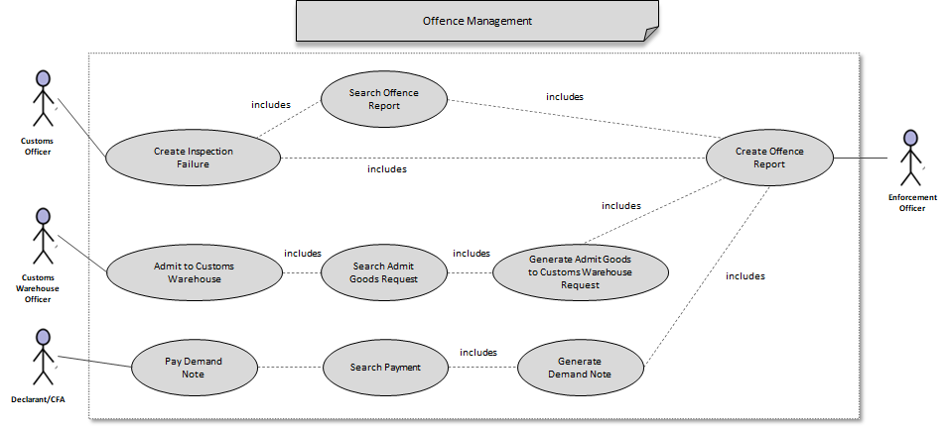

Note/s:
- All Offence Reports can be viewed/updated by offence officers.

Business Validation

S/N | Validation Rules
1 | At least one of the goods in the declaration involved in the offence should have a corresponding status.
2 | The demand note payment cannot be zero/less than zero.
3 | The status of item/goods can be updated from Seized to Released only if the demand note has been paid.
4 | All seized goods must be updated to release to trader after demand note payment.
5 | Confiscated goods cannot be released to trader / declarant.

Appeal

Submit Appeal
eCMS enables a declarant/CFA/warehouse operator/temporary storage operator involved in an offence to appeal for a refund/cancellation of the demand note payment. The appeal is subject to the approval of a Customs Settlement Committee, Customs Head Office, or Ministry of Finance.

Pre-Requisites
- The Declarant/CFA/warehouse operator/temporary storage operator users involved in the appeal (appellant) should be registered in eCMS.
- The user representing the Customs Settlement Committee, Customs Head Office, or Ministry of Finance should be registered in eCMS.
- The appellant and approving officers are authorized to access eCMS and have access to the required application.
- The appellant has an Offence Report with a demand note (Paid or Unpaid).

Process Flow

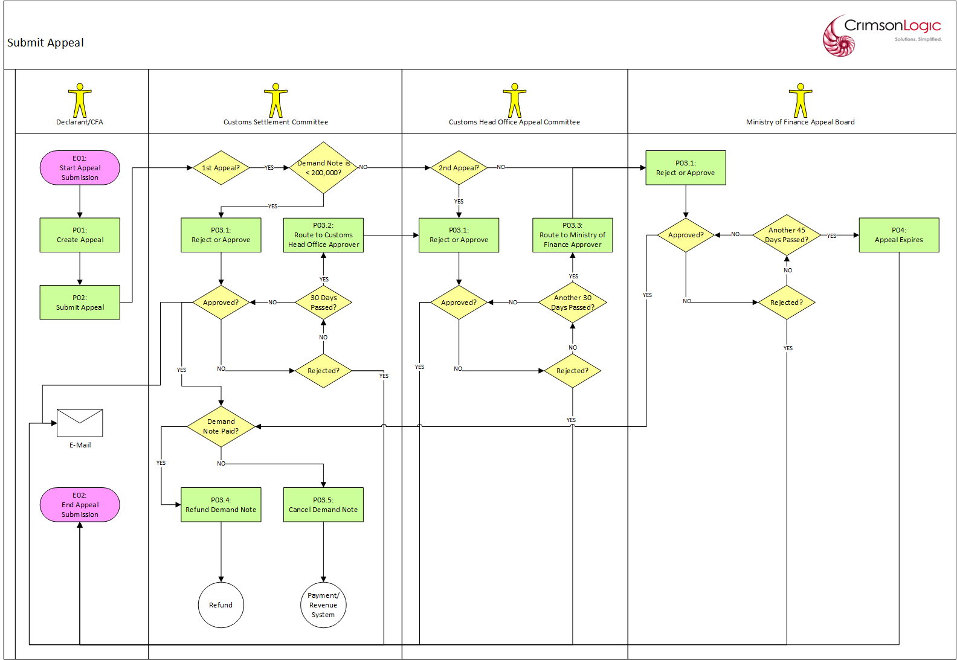

Process Steps
P01: Create Appeal
To create an appeal, the user must first select an Offence Report that that user is involved with. An Offence Report can only be selected if:
- The report is not used in another appeal
- The offence involves a demand note.

The user can edit the appeal to add remarks and attach documents if required.

After updating the appeal, the user can submit.

P02: Submit Appeal
After entering all the mandatory inputs, the user can submit the appeal. But before allowing the appeal data to be saved, the system will validate the inputs and will display messages if there are errors encountered. If there are no validation issues, the Appeal Number will be generated the report will have a Submitted status. The Appeal Number will have the following format:

APL-<YYYY##########>

where:
YYYY – year
########## - running sequence number

Upon submission, the system will determine the officer that will be receiving the appeal for approval:

- If the appeal involves a demand note that is less than Nu. 200,000 (configurable in the system), and is the user’s first appeal submission, the approver will be the Customs Settlement Committee

- If the appeal involves a demand note that is greater than or equal to Nu. 200,000 (configurable in the system), or is the user’s second appeal submission after rejection, the approver will be the Customs Head Office Appeal Committee

- If the appeal is the user’s third appeal submission after rejection, the approver will be the Ministry of Finance.

Note/s:
- At the Offence module, Offence Report associated with the Appeal will have a Pending Approval status under the Appeal column.

P03.1: Reject or Approve
The appeal is routed to an officer for approval. The officer selects the appeal and determines which of the following statuses will be applied:
- Approve
- Reject

The appellant will be notified of the approval result.

If the appeal is to be approved and the appellant had paid the demand note, the approving officer can also set the refund amount less than or equal to the demand note amount. Otherwise, there is no refund required.

If the appeal has been approved, the appellant has not yet paid the demand note, and the Offence Report has a Pending Payment status, then the Offence Report status becomes Closed.

If the appeal has been rejected and the appellant has not yet paid the demand note, the Offence Report status becomes Pending Payment and the appellant must pay the demand note.

If the appeal is rejected for the first time, the appellant can update the appeal and submit again (refer to Process #02 for the officer who will be receiving the re-submitted appeal). Once the appeal has been rejected by the Ministry of Finance, the appeal’s rejection status becomes final, the appeal can no longer be updated, and the appellant can now only do the appeal via the court of law outside eCMS.

Note/s:
- If the appeal has been rejected, the Offence Report associated with the Appeal will have a Rejected status under the Appeal Status column.
- If the appeal has been resubmitted after rejection, the Offence Report associated with the Appeal will have a Pending Approval status under the Appeal Status column.
- If the appeal has been approved, the Offence Report associated with the Appeal will have an Approved status under the Appeal Status column.
- If the appeal has been rejected, the Offence Report associated with the Appeal will have a Rejected status under the Appeal Status column.
- The refund amount cannot be zero.

P03.2: Route to Customs Head Office Appeal Committee Approver
If the current appeal approver is the Customs Settlement Committee and 30 days had passed without any action, the appeal will be routed to the Customs Head Office Appeal Committee via a background job process.

P03.3: Route to Ministry of Finance Approver
If the current appeal approver is the Customs Head Office and 30 days had passed without any action, the appeal will be routed to the Ministry of Finance via a background job process.

P03.4: Refund Demand Note
If the appeal was approved, then the approved status of the appeal becomes final and can no longer be updated. If the appellant has paid a demand note beforehand, the appellant can proceed to do a refund via the Refund module.

P03.5: Cancel Demand Note
If the appeal was approved, then the approved status of the appeal becomes final and can no longer be updated. If the appellant has not yet paid the demand note beforehand, the system will cancel the payment instruction and send a de-registration of the payment to the Revenue System.

P04: Appeal Expires
If the current appeal approver is the Ministry of Finance and 45 days had passed without any action, the appeal will be expired via a background job process. The expired status of the appeal is final, and the appeal no longer be updated. The appellant can now only do the appeal via the court of law outside eCMS.

Note/s:
- At the Offence module, Offence Report associated with the Appeal will have a Expired status under the Appeal column.

Use Case Diagram

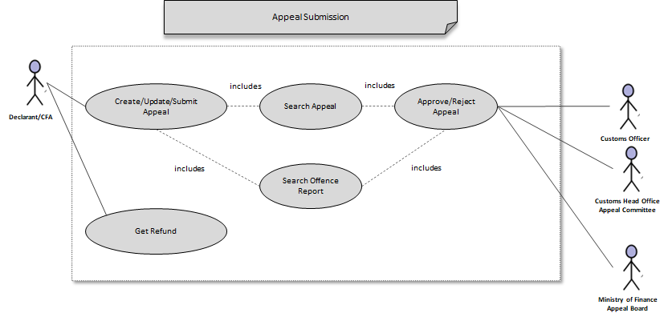

Business Validation

S/N | Validation Rules
1 | If the appeal involves a demand note that is less than Nu. 200,000 (configurable in the system), or is the user’s first appeal, the approver will be the Customs Settlement Committee
2 | If the appeal involves a demand note that is greater than or equal to Nu. 200,000 (configurable in the system), or is the user’s second appeal, the approver will be the Customs Head Office Appeal Committee.
3 | If the appeal is the user’s third appeal, the approver will be the Ministry of Finance.
4 | The expired status of the appeal is final and can no longer be updated.
5 | If the appeal was rejected for the third time, its rejection status is final and can no longer be updated.
6 | Only one appeal record can be created for an offence report
7 | The refund amount cannot be zero.

Note/s:
- All appeals can be viewed/updated by members of the same party that created it.

Withdraw Appeal
eCMS enables a declarant/CFA/warehouse operator/temporary storage operator involved in an offence to withdraw the appeal for a refund of the demand note payment.

Pre-Requisites
- Declarant/CFA/warehouse operator/temporary storage operator users should be registered in eCMS.
- Declarant/CFA/warehouse operator/temporary storage operator users are authorized to access eCMS and have access to the required application.

Process Flow

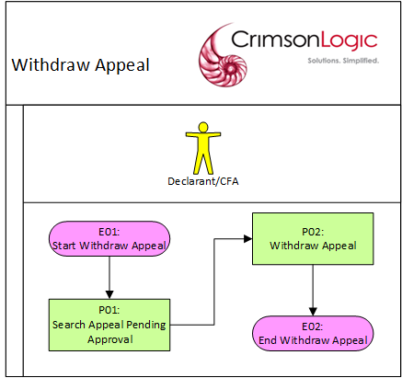

Process Steps
P01: Search Appeal Pending Approval
The user can select an existing appeal that has been submitted and not yet Approved/Rejected. A reason is required before saving the withdrawal update.

P02: Withdraw Appeal
After the user saves the withdrawal update, the status of the appeal becomes Withdrawn and can no longer be re-used.

Use Case Diagram

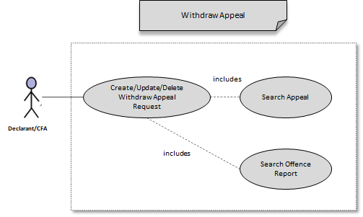

Business Validation

S/N | Validation Rules
1 | Approval is not required for withdrawing an appeal.
2 | Once an appeal has been withdrawn it can no longer be re-used.

Note/s:
- All appeals can be viewed/updated by members of the same party that created it.

Customs Warehouse

Admit Goods
eCMS will enable a customs warehouse officer to admit goods into a customs warehouse. The request to admit goods into a customs warehouse will be generated after an offence officer indicates which goods will be detained/seized/confiscated in an offence report.

Pre-Requisites
- Offence users for determining which goods will be admitted into a customs warehouse should be registered in eCMS.
- Customs warehouse officers for admitting goods should be a registered customs warehouse officer in eCMS.
- Both offence and customs warehouse officers are authorized to access eCMS and have access to the required application.
- Customs warehouse locations have been configured in the system and customs warehouse officers have been assigned to them.

Process Flow

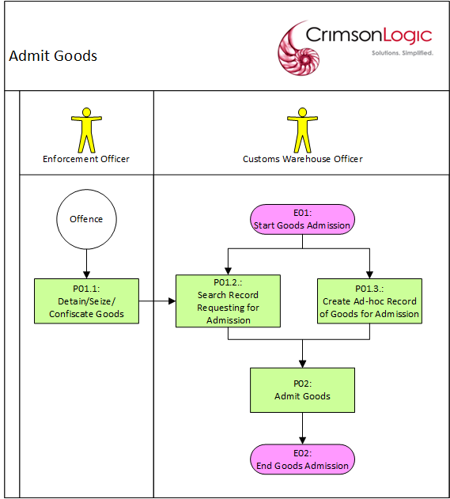

Process Steps
P01.1: Detain/Seize/Confiscate Goods
Offence officer updates a goods status in an offence report so that it declares the number of items detained/seized/confiscated. This is done via the Offence module. This will generate a customs warehouse record with a Pending Admission status and will contain the goods for admission.

P01.2: Search Record Requesting for Admission
Offence officer can select a customs warehouse record that was generated after goods were detained/seized/confiscated in an offence report. Each of the goods in the record will contain a specific number of items pending admission, and this will be initially set to the number of items detained/seized/confiscated. The customs warehouse officer can admit a specific number of items less than or equal to the number of items pending admission.

After entering the number of items to be admitted, the officer can save the record. If there are no validation issues, the system will save the entered data.

Note/s:
- The number of admitted items cannot be zero/less than zero.

P01.3: Create Ad-hoc Record of Goods for Admission
Offence officer can also create an ad-hoc customs warehouse record to admit goods. The offence officer can select the warehouse to admit the goods. Multiple goods can be included in a customs warehouse record.

After entering the HS code details of the goods and the number of items to be admitted, the officer can save the record. If there are no validation issues, the system will save the entered data.

Note/s:
- The number of admitted items cannot be zero/less than zero.

P03: Admit Goods
After the system saves the goods details and number of items admitted:

- If the customs warehouse record was created from an offence report:
- for each of the goods in the record, the number of items admitted will be subtracted from the number of items pending admission
- if one of the goods has items pending admission, then the status of the customs warehouse record will be Partially Admitted
- if all the goods have no items pending admittance, then the status of the customs warehouse record will be Fully Admitted

- If the customs warehouse record is an ad-hoc record, then the status of the customs warehouse record will be Fully Admitted

Use Case Diagram

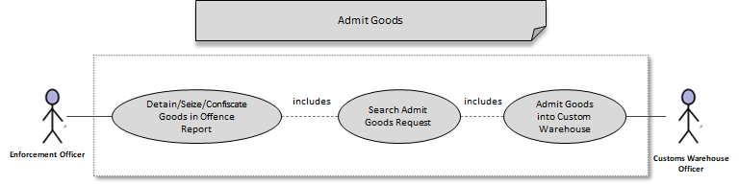

Business Validation

S/N | Validation Rules
1 | For customs warehouse requests generated by an offence report, the number of items to be admitted can be less than or equal to the number of items pending admission.
2 | The number of admitted items cannot be zero/less than zero.

Note/s:
- All customs warehouse officers assigned to the same customs warehouse can view/update the same customs warehouse records.

Release Goods
eCMS will enable a customs warehouse officer to release goods from a customs warehouse. Goods to be released from a customs warehouse can be due to an offence officer releasing detained/seized goods back to the trader or when customs warehouse officer disposing/auctioning goods.

Pre-Requisites
- Offence officers for determining which goods will be released from a customs warehouse should be registered in eCMS.
- Customs warehouse officers for releasing goods should be a registered customs warehouse officer in eCMS.
- Both offence and customs warehouse officers are authorized to access eCMS and have access to the required application.
- Customs warehouse locations have been configured in the system and customs warehouse officers have been assigned to them.

Process Flow

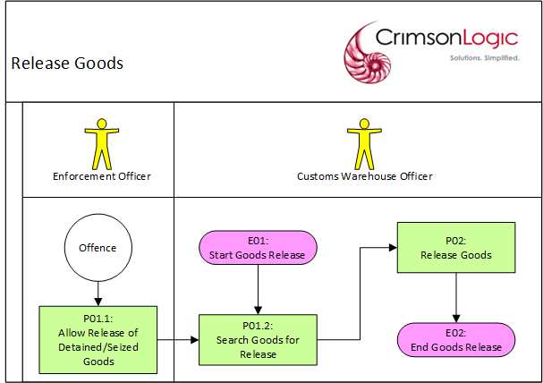

Process Steps
P01: Allow Release of Detained/Seized Goods
Offence officer updates the status of goods in an offence report so that its items that had been detained/seized become released. This is done via the Offence module.

P02: Search Goods for Release
Customs warehouse officer searches a customs warehouse record with admitted goods and determines the number of items to be released and how they will be released. The number of items to be released can be less than or equal to the number of goods admitted.

The release status available will be based on the following:

- If the goods had been released in an offence report, the goods status can be updated to Release to Trader

- If the goods are not associated with an offence report or had been confiscated in an offence report, the goods status can be updated to any of the following:
- Destroy
- Auction

After entering the number of items to be released, the officer can save the record. If there are no validation issues, the system will save the entered data.

Note/s:
- The number of released items cannot be zero/less than zero.

P03: Release Goods
After the system saves the number of items to be released and their release status:

- if the customs warehouse record previously is Fully Admitted and then all the goods became released, then the customs warehouse record will no longer show up the Customs Warehouse menus for Admitting/Releasing Goods

- if the customs warehouse record previously is Partially Admitted and then all the goods became released, then:
- the customs warehouse record will no longer show up the Customs Warehouse menus for Releasing Goods
- the customs warehouse record will still show up in the Customs Warehouse menus for Admitting Goods, so the customs warehouse officer can admit the rest of the items

- if the customs warehouse record previously is Fully/Partially Admitted and then not all the goods became released, then:
- the customs warehouse record will still show up in the Customs Warehouse menu for Admitting Goods, so the customs warehouse officer can admit the rest of the items
- the customs warehouse record will still show up in the Customs Warehouse menus for Releasing Goods, so that the customs warehouse officer can release the rest of the items

A release history of the goods will also be created for reference.

Use Case Diagram

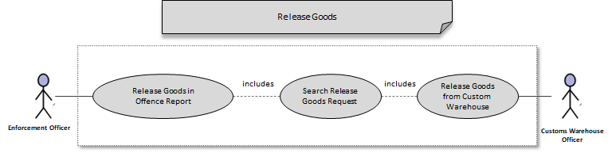

Business Validation

S/N | Validation Rules
1 | The number of items to be released can be less than or equal to the number of goods admitted.
2 | The number of released items cannot be zero/less than zero.
3 | If the goods had been released in an offence report, the goods status can be updated to Release to Trader
4 | If the goods are not associated with an offence report or had been confiscated in an offence report, the goods status can be updated to any of the following:  • Destroy  • Auction

Note/s:
- All customs warehouse officers assigned to the same customs warehouse can view/update the same customs warehouse records.

System Integration

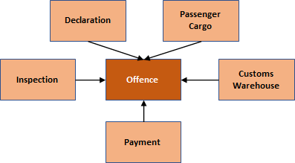

Service Provider | Service Consumer | Service Description
Declaration | Offence | Retrieve the Declaration details for offence report
Passenger Cargo | Offence | Retrieve Declaration details for offence report
Inspection | Offence | Create a draft offence report due to an inspection failure of declaration goods
Payment | Offence | Generate the payment details from the demand note
Customs Warehouse | Offence | Retrieve the Customs warehouse associated with the Customs office assigned to the Declaration involved in the offence

Appendix

Item Statuses

The following are the item statuses at various stages:

Item Status | Description
Detained | For Customs offence type.  Goods will be stored in the customs warehouse and there is no demand note payment required.  Goods can be released to the trader/declarant after settling the issue with offence officer.
Seized | For Customs offence type.  Detained goods become seized if the issue between the trader/declarant and the offence officer was not settled within a specific period.  Goods will be stored in the customs warehouse and demand note payment is required.  Goods can be released to the trader/declarant after demand note has been paid/appeal has been filed.
Handed Over to Royal Bhutan Police | For Criminal offence type.  Goods will be handed over to the Royal Bhutan Police.
Confiscated | For Customs offence type.  Seized goods become confiscated while the demand note is not yet paid.  Goods will be stored in the customs warehouse.  Goods can be released later for auction/disposal.
Released | For Customs offence type.  Can refer to any of the following:  1. Detained goods were released to the trader/declarant after settling the issue with offence officer.  2. Seized goods were released to the trader/declarant after demand note has been paid/appeal has been filed.  3. Confiscated goods were released for auction/disposal.

Offence Statuses

The following are the offence statuses at various stages:

Offence Status | Offence Type | Description
Pending Declaration Amendment | Not Applicable | Offence officer has decided to amend the declaration after reporting the inspection failure.
Draft | Administrative  Customs  Criminal | 1. Offence officer has created/updated the Offence report details but not yet saved at the Summary tab to finalize the report.  2. Offence officer has completed amending the declaration after reporting the inspection failure.
 | Customs | A specific number of days has passed, and the background process has updated the status of goods from Detained into Seized. The Offence Report status will be reverted into Draft status so that the offence officer can update the report, set the final demand note amount and save the report at the Summary tab again to finalize the report.
Submitted | Customs | The offence officer has finalized the report that was in a Draft status and the status of all goods is any combination of the following:  - Detained  - or Detained and Seized  Note: A customs warehouse record will be created with a Pending Admittance status.
Pending Payment | Administrative | 1. The offence officer has finalized the report that was in a Draft status.  2. The appellant has not yet paid the demand note and the appeal was rejected.
 | Customs | 1. The demand note is not yet paid, and the status of all goods is Seized.  2. The demand note is not yet paid, and the offence officer updated the status of some of the goods from Seized into Confiscated.  3. The appellant has not yet paid the demand note and the appeal was rejected.
Paid | Administrative | The demand note has been paid.
 | Customs | The demand note has been paid.
Closed | Administrative | 1. Customs/Warehouse officer has paid the demand note.  2. The appellant has not yet paid the demand note and the appeal was approved so that there is no demand note to pay.
 | Customs | 1. The demand note has been paid and the offence officer has updated the status of all goods into Released.  2. The demand note has not yet been paid and the offence officer has updated the status of all goods into Confiscated.  3. The appellant has not yet paid the demand note and the appeal was approved so that there is no demand note to pay.
 | Criminal | Offence officer has finalized Offence report details for a Criminal offence.

Appeal Statuses

The following are the appeal statuses at various stages:

Appeal Status | Description
Pending Approval | The appeal has been submitted/resubmitted after rejection and is pending approval.
Approved | The appeal has been approved.
Rejected | The appeal has been rejected.
Expired | The appeal has expired.

Customs Warehouse Statuses

The following are the customs warehouse statuses at various stages:

Customs Warehouse Status | Description
Pending Admittance | None of the goods have been admitted into the warehouse.
Partially Admitted | Some of the goods have been admitted into the warehouse.
Fully Admitted | All the goods have been admitted into the warehouse.

Report templates

Detention Report

CUSTOMS AND EXCISE DIVISION
(Detention Notice)
Reference Number: ADH2018000000052
Print Date:04-06-2021

1. Importer/Exporter/Owner/Agent Full Name:
SED Importers
2. Address:
NA
3. Place Of Detention:
MORUPULE COLLIERY
4. Reason For Detention:
5. Goods Detained (Full Description):
NAME
------------------------------- -------------------------------
Full Name of Detaining Officer Signature of Officer
CERTIFICATE OF RETURN OF SERVICE
I ................Butan....I.m...p..o..r.t.e..r.s...............................................................................................................,
owner/importer/exporter/agent, hereby acknowledge being served with this Detention Notice.
N.B. I am aware that I will be required to pay state warehouse rent at the time of collecting the goods.
Signature --------------------------------- Date -------------------------------
Witness's Full Name ---------------------------- Witness's Signature ----------------

Seizure Report

CUSTOMS AND EXCISE DIVISION
(Seizure Notice)
Reference Number: ADH2018000000104
Print Date: 6/4/2021
1. Importer/Exporter/Owner/Agent Full Name:
APM-Maersk
2. Address:
NA
3. Place Of Seizure:
MORUPULE COLLIERY
4. Reason For Seizure:
-----
5. Goods Seized (Full Description):

HSCode Id | Description | Quantity
1012100 | Pure-bred breeding animals | 0

* Following 2 clauses applicable only for Seizure Notice
APM-Maersk
I, Take notice that the below goods
has/have this day been seized as liable to forfeiture under section 99 of Customs and Excise Duty Act (Cap 50:01) on the following grounds
2. If you claim that the said goods are not liable to forfeiture, you should within one month the date of this notice of seizure, give notice of claim in accordance with section 100 of the Act. In default of such notice, the said goods will be deemed to have been lawfully condemned and will be liable to be disposed of in such manner as the Director of Customs and Excise may direct.
---------------------------- ---------------------
NAME Signature of Officer
Name of Seizing Officer
CERTIFICATE OF RETURN OF SERVICE
I ....A...P..M...-.M...a..e..r.s..k..............................................................................................................................,
owner/importer/exporter/agent, hereby acknowledge being served with this notice of seizure by
Name
......................................................................., an officer of the Department of Customs and Excise.
Signature ............................................... Date...................................

Inventory Tracking

Configuration blueprint (CBP)
Configuration Blueprint (CBP) for Offence, Appeal

Configuration Blueprint (CBP) for Customs Warehouse

Scheduler Jobs
Job Name | Running Interval | Remarks
Route-Expire Appeal | Everyday | If the current appeal approver is the Customs Settlement Committee and 30 days had passed without any action, the appeal will be routed to the Customs Head Office Appeal Committee.  If the current appeal approver is the Customs Head Office Appeal Committee and 30 days had passed without any action, the appeal will be routed to the Ministry of Finance.  If the current appeal approver is the Ministry of Finance and 45 days had passed without any action, the appeal will be expired.
Seize Detained Goods | Everyday | If the goods have been detained for a specific number of days (configurable in the system), the goods status will be updated into seized and the offence officer associated with the offence will be notified.

User Interface
Please refer to the prototype.

Note: Though we released the prototype, actual UI implementation look-and-feel may vary based on SmartGWT framework.

