SYSTEM REQUIREMENTS SPECIFICATION
for
ecms -

Payment Module

Release Version 1.1 – Jun 2021

document identification no 3 char SYS ID/ DOC CODE /NN/ V M.n)  for details refer to document mgmt stds | document title | status  (draft/ released ) | date of release | pages
ECMS/srs/01/V1.1 | System requirements Specifications For ECMS Payment | released | 06.2021

 | role in the project | Name | signature | date  (dd-mm-yy)
Authors | Technical Team | <DRC Team Name> |  | <Date>
Reviewers | Project Lead | Sujit Patra
Approver | Project Manager | Raghavan Jaganathan

Endorsement by system Owner (internal)
 | Name | designation | signature | date  (dd-mm-yy)
endorsed by system owner.

release history
release no | author | CR# | date | brief summary of changes
1.1 | karma |  | 8/19/2021 | Initial Release

CONTENTS
1. INTRODUCTION 4
1.1 Scope 4
1.2 Definitions and Abbreviations 4
1.3 References 5
1.4 Constraints 5
2. FUNCTIONAL REQUIREMENTS 6
2.1 Payment Overview 6
2.1.1 Definition of Key Terms Used in Payment Module 6
2.2 Payment Use Cases 7
2.2.1 Register Payment & Completed Payment Use Case 7
2.3 Payment Backend 8
2.3.1 Pre-Requisites 8
2.3.2 Process Flow 8
2.3.3 Assumptions 10
2.4 Payment Instructions 10
2.4.1 Payment Status 11
2.4.2 Payment API 11
3. INTERFACES REQUIREMENTS 12
3.1 System Interfaces 12
4. Appendix 12
4.1 Background Jobs 12
4.2 CONFIGURABLE BLUEPRINT 12

INTRODUCTION

This document defines & illustrates the business requirements, process flows as well as the detailed functional requirements of the Payment module as implemented in the eCMS. This document is a detailed drill down of the high-level requirements.

The payment module is one of the clearance support modules and is primarily used by Customs Broker or Importer for all the payments to be done. The payment is done in the BITS side. The generation of the payment instruction is handled in the eCMS by respective modules for e.g., declaration sends a payment instruction to the payment module for collection, accounting, and reporting. Likewise, any other module which has payment can leverage the payment module. The payment module in turn integrates with BITS and sends the payment advice to BITS for collection.

Scope
The scope of the payment module in the TFB system is as below:
- Payment Instruction
- Payment Registration & Approval
- Payment Configurations
- External Integration to Payment Gateway
- Reports and Accounting

Definitions and Abbreviations
S/N | Abbreviations | Description
 | ACT | Authorized Compliant Trader
 | BACS | Bhutan Automated Customs System
 | BAFRA | Bhutan Agriculture and Food Regulatory Authority
 | BNB | Bhutan National Bank
 | BoB | Bank of Bhutan
 | BITS | Bhutan Integrated Tax System
 | BSTEC | Bhutan Sales Tax Exemption Certificate
 | BTC | Bhutan Tariff Classification
 | CFA | Clearing and Forwarding Agent
 | CDS | Customs Declaration System
 | CAB | Customs Act of Bhutan
 | CID | Citizens Identification Number
 | CRRB | Customs Rules and Regulations of Bhutan
 | DITT | Department of Information Technology & Telecom
 | DRC | Department of Revenue & Customs
 | eCMS | Electronic Customs Management System
 | EMS | Express Mail Service
 | FRS | Functional Requirements Specification
 | GST | Goods and Services Tax
 | IDEC | Import Duty Exemption Certificate
 | LTO | Liaison and Transit Office
 | LoG | Letter of Guarantee
 | LCS | Land Customs Station
 | MoEA | Ministry of Economic Affairs
 | MoHCA | Ministry of Home and Cultural Affairs
 | MoF | Ministry of Finance
 | MIS | Management Information System
 | Nu | Ngultrum
 | RMA | Royal Monetary Authority
 | RGoB | Royal Government of Bhutan
 | RRCO | Regional Revenue and Customs Office
 | RTO | Regional Trade Office
 | RAMIS | Revenue Administration Management Information System
 | SARC | South Asian Association for Regional Cooperation
 | SITA | International Aeronautical Telecommunications Society
 | SCTS | Single Customs Trade System
 | SAD | Single Administration Document
 | TPN | Taxpayer Number
 | UPU | Universal Postal Union

References
Payment SRS uses the following documents as reference:

- FUNCATIONAL REQUIREMENT SPECIFICATION.docx
- TECHNICAL REQUIREMENT SPECIFICATION.docx
- Bhutan eCMS Technical Proposal TECH-3.pdf
- Bhutan eCMS Technical Proposal TECH-4.pdf
- Bhutan eCMS Technical Proposal TECH-5A.pdf
- Bhutan eCMS Technical Proposal TECH-5B.pdf
- Bhutan eCMS Technical Proposal TECH-6A.pdf
- Bhutan eCMS Technical Proposal TECH-6B.pdf

Constraints
NA

FUNCTIONAL REQUIREMENTS

Payment Overview
The payment module in the eCMS is designed flexibly to centralize all payments. This module provided a one-stop 360-degree view of all pending/completed/cancelled payment transactions of a party and update the payment status.
All business modules in eCMS requiring payment will send a payment instruction to the payment module. The payment module has a common interface for payment instructions. The payment module generates the invoice and sends to BITS (Revenue System) for collection of payment. Partial payment is not supported. All payment instructions are identified by a unique payment transaction number.

Definition of Key Terms Used in Payment Module

S/N | Abbreviations | Description
 | Payment Instruction | Instructions to make a payment or series of payments to a third party sent via paper and/or electronic means.
 | Payment Transaction | Payment Transaction will capture the information about the payment like amount, description and sent by BITS
 | Transaction Reference Number | Payment System will generate a unique transaction reference number for each transaction in a payment instruction.
 | Business Transaction | A source for a Payment Instruction can be a business transaction between two parties. An example of business transaction in Customs system could be “submission of declaration” by importer or exporter.
 | Invoice | A nonnegotiable commercial instrument issued by the system on behalf of the agency (Customs or Other Govt. agency) listing the payment to be made for the service rendered.
 | Receipt | A Receipt is a written/printed acknowledgment that a payment has been received.

Payment Use Cases

Register Payment & Completed Payment Use Case
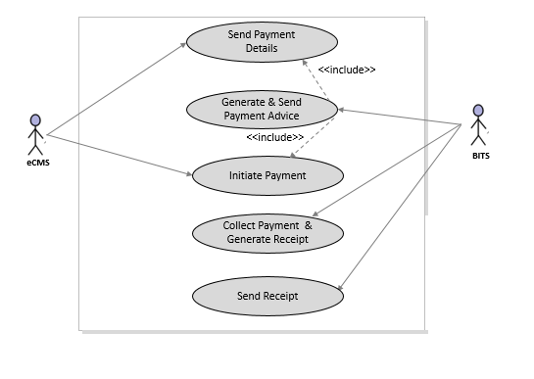
Use CASE diagram for ecms and bits payment integration

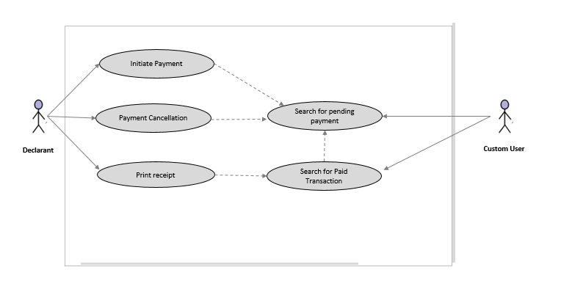
use case diagram for payment in ecms

Payment Backend

Pre-Requisites
BITS is ready to accept and process the payment details sent by eCMS and respond with the transaction details.

Process Flow

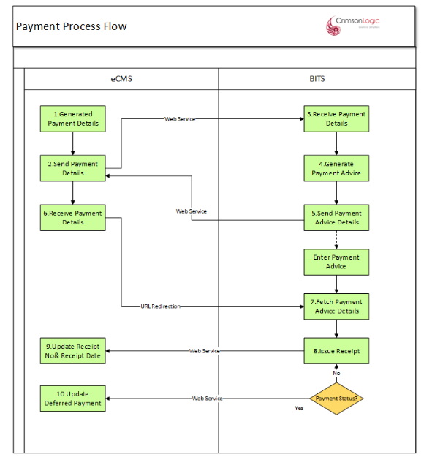

Figure 5: Payment Integration

Process Steps
P01: Generated Payment Details
eCMS will create a payment instruction based on the Business Transaction created in the System (Ex. Declaration submission resulting in duties and fees calculation).

P02: Send Payment Details
After generation of a payment instruction, eCMS will send payment details to BITS in an agreed format. When sending the payment details to BITS, the unique Payment Instruction number will be sent along with the TPN Number, Name of the Party (Importer/Exporter), BTC Code,
Tax type and tax amount.
Note: The actual format and additional required data fields if any will be decided based on the Integration specifications.

P03: Receive Payment Details
BITS will receive the payment details from eCMS through a Web service call
and will process the payment instruction from eCMS.

P04: Generate Payment Advice
BITS will generate the payment advice based on the payment instruction from eCMS. BITS will evaluate if the TPN qualifies for deferred payment and will apply deferred payment for eligible transaction.

P05: Send Payment Advice Details
Finally, BITS will send the Payment advice to eCMS through a Web service call along with the Payment reference number for eCMS to process and initiate the payment. BITS will mark items for deferred payments in the payment advice for eCMS to process accordingly.

P6: Initiate Payment
eCMS will process the payment advice received from BITS and arrive at the final amount for payment minus any deferred payments and enable a URL for the declarant to click for making the payment in BITS (URL Redirection to BITS)

The declarant will click on the link and will be re-directed to BITS for making payment.

P7: Fetch Payment Advice Details
BITS will fetch the payment advice and provide required functionalities for the user to review payment details and complete payment.

P8: Issue Receipt
Upon completion of payment, BITS will generate a receipt and send it to eCMS through Web service call along with the payment transaction details.

P9: Update Receipt Number & Receipt Date
eCMS will receive the payment transaction details and receipt number and proceed to update the details in eCMS and mark the payment instruction as “Paid”, also update the deferred payment and proceed with further downstream processes. User will be notified on completion of payment.

Assumptions
S/N | Description
 | eCMS and BITS are integrated for payment and both the services are up.
 | User has access to eCMS,
 | Processing fee & fines and penalties are not applicable at the BTC code level, and these details will be sent to BITS without any links to BTC code.
 | Additional payment details shall be sent with item wise breakup.
 | Reference number shall be the payment instruction number generate in eCMS. Business transaction will depend on the context of the payment ( e.g. declaration number)

Payment Instructions
Payment Instruction is a message containing unpaid transaction information. It contains the amount to be paid along with the description and other required information.

A Payment Instruction can be issued to collect full payment.

Each “Payment Instruction” carries a single unpaid transaction information for which the payment has be collected. It also carries the payment amount breakdown (if applicable) for invoicing purposes and other transaction related information to easily search and correlate this payment instruction with actual transaction.

The system will allow the payment for each “Payment Instruction” in Full. Each payment for a payment instruction will generate a “Payment Receipt” until it is fully paid.

Payment Status
Below shows the status transition of a Payment Instruction.

Pending: It is pending in the System.
Paid: Payment is collected in BITS and completely paid
Cancelled: Payment is Cancelled.

Status Code | Status Description | Remarks
PENDING | Pending | The “Payment Instruction” is pending to be collected.
FULL_PAID | Fully Paid | Payment is made in full.
DEFERRED | Deferred | Payment is deferred to be paid later.
CANCELLED | Cancelled | Payment Instruction is cancelled. No amendments allowed.
UNP_ERROR | Unpaid/Error | Payment is unpaid or an Error occurred.

Payment API

API Name | Description
Create Payment Instruction | API to create a single payment instruction. The Sender application will prepare the Payment Instruction and sends it over to payment module for processing. Payment module will then create a payment instruction reference number and reverts back
Cancel /Void Payment Instruction | API to cancel/Void a single payment instruction. The sender application will prepare a Payment Instruction cancellation/void message and sends it to payment module. Payment module will process the message and sends an acknowledgement back
Complete Payment | API to completed Payment Instructions
Send Payment | An API to send payment details to BITS through webservice.
Receive Payment advice | API to receive payment advice from BITS through webservice.
Initiate Payment | Initiate payment in eCMS through URL redirection
Receive Payment Receipt | Receive Payment Receipt from BITS through webservice

INTERFACES REQUIREMENTS

System Interfaces

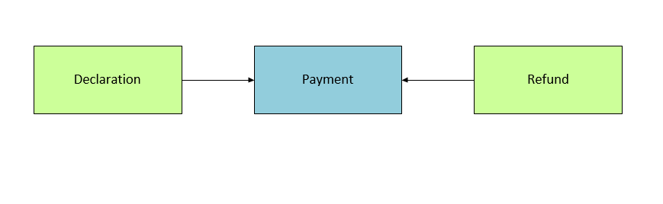

Figure 8: System Interfaces

Appendix

Background Jobs

S/No | Job | Description
1 | Deferred Payment | A batch job to update the Deferred payment status
2 | Payment Alerts | Email trigger alerts for payments due and payments made/received.

CONFIGURABLE BLUEPRINT

