System REQUIREMENTS SPECIFICATION
for
eCMS - Registration

Release No 1.0 – May 2021

document identification no 3 char SYS ID/ DOC CODE /NN/ V M.n)  for details refer to document mgmt stds | document title | status  (draft/ released ) | date of release | pages
eCMS /SRS/01/V1.0 | System Requirement Specifications For eCMS Registration | Draft | 05.2021

 | role in the project | Name | signature | date  (dd-mm-yy)
Authors | Technical Team | Shrinivas Udagatti  Alvin Ian P Paule  Ramoji Lokam  Shubham Sharma
Reviewers | Project Lead | Sujit Patra
Approver | Project Manager | Raghavan Jaganathan

Endorsement by System Owner (internal)
 | Name | designation | signature | date  (dd-mm-yy)

release history
Release Number | associated change request number | Date (mm,yyyy) | Brief Summary of changes | Author
1.0 | First Release | 05.2021 | First Release | Sujit Patra

Table of Contents
Table of Contents 3
Introduction 5
A. Definitions and Abbreviations 5
B. References 6
1. Functional Requirements 7
1.1 Registration System Overview 7
1.1.1 Entity Hierarchy in Registration 9
1.1.2 Customs User Hierarchy 10
1.1.3 Additional Design Considerations 10
1.2 Party Management 11
1.2.1 Description 11
1.2.2 Pre-Requisites 11
1.3 Login Credentials, Password Management Etc. 11
1.4 Fast Track TPN (BITS Integration) 12
1.4.1 Pre-Requisites 12
1.4.2 Process Flow for Fast Track TPN 12
1.5 Application Process 14
1.5.1 Pre-Requisites 15
1.5.2 Process Flow for Application (Generic) 15
1.5.3 Business Validation 17
1.6 Registration Process 18
1.7 Clearing and Forwarding Agents 20
1.7.1 Pre-Requisites 20
1.7.2 Process Flow for Clearing Agents and Forwarding Agents 20
1.7.3 Use Case Diagram for Clearing Agents and Forwarding Agents 21
1.7.4 Business Validation 23
1.8 Warehouse Operators 24
1.8.1 Pre-Requisites 24
1.8.2 Process Flow for Warehouse Operators 24
1.8.3 Use Case Diagram for Warehouse Operator Registration 25
1.8.4 Business Validation 27
1.9 Temporary Storage Operators 28
1.9.1 Pre-Requisites 28
1.9.2 Process Flow for Temporary Storage Operators (TSO) 28
Use Case Diagram for Temporary Storage Operators 29
1.9.3 Business Validation 31
1.10 Declarants (CFA Employees) 32
1.10.1 Pre-Requisites 32
1.10.2 Process Flow for Declarants 33
1.10.3 Use Case Diagrams for Declarants. 34
1.10.4 Business Validation 35
1.11 Traders Registration 36
1.11.1 Pre-Requisites 36
1.11.2 Process Flow for Traders Registration. 36
1.11.3 Use Case Diagrams for Trader Registration 37
1.11.4 Business Validation 38
1.12 Customs Administrator Process 39
1.12.1 Customs User Registrations 39
1.12.2 Pre-Requisites 39
1.12.3 Process Flow for Customs User Registration 40
1.12.4 Use Case Diagram for Customs User Registration 41
1.12.5 Business Validation 41
1.13 Other Government Agency 42
1.13.1 Pre-Requisites 42
1.13.2 Process Flow for Other Government Agency User 42
1.13.3 Use Case Diagram for Other Government Agency 43
1.13.4 Business Validation 43
1.14 Renewal Process 44
1.14.1 Pre-Requisites 44
1.14.2 Process Flow for Renewal 44
1.14.3 Use Case Diagrams for Renewal 45
1.14.4 Business Validation 45
Appendix A 46
1. Configuration blueprint (CBP) 46
2. Backend Job 46
3. Report Templates 46
4. User Interfaces 46
5. Inspection Checklist 46
6. Print Templates 47
7. Fees and Charges 49

Introduction
This document defines & illustrates the business requirements, process flows as well as the detailed functional requirements of eCMS Registration module to be implemented for Department of Revenue and Customs, Bhutan.

Definitions and Abbreviations
The table below lists the different acronyms and abbreviations as well as the definitions used throughout this SRS.

S/N | Abbreviations | Description
 | ACT | Authorized Compliant Trader
 | BACS | Bhutan Automated Customs System
 | BAFRA | Bhutan Agriculture and Food Regulatory Authority
 | BNB | Bhutan National Bank
 | BoB | Bank of Bhutan
 | BITS | Bhutan Integrated Tax System
 | BSTEC | Bhutan Sales Tax Exemption Certificate
 | BTC | Bhutan Tariff Classification
 | CFA | Clearing and Forwarding Agent
 | CDS | Customs Declaration System
 | CAB | Customs Act of Bhutan
 | CID | Citizens Identification Number
 | CRRB | Customs Rules and Regulations of Bhutan
 | DITT | Department of Information Technology & Telecom
 | DRC | Department of Revenue & Customs
 | eCMS | Electronic Customs Management System
 | EMS | Express Mail Service
 | FRS | Functional Requirements Specification
 | GST | Goods and Services Tax
 | IDEC | Import Duty Exemption Certificate
 | LTO | Liaison and Transit Office
 | LoG | Letter of Guarantee
 | LCS | Land Customs Station
 | MoEA | Ministry of Economic Affairs
 | MoHCA | Ministry of Home and Cultural Affairs
 | MoF | Ministry of Finance
 | MIS | Management Information System
 | Nu | Ngultrum
 | RMA | Royal Monetary Authority
 | RGoB | Royal Government of Bhutan
 | RRCO | Regional Revenue and Customs Office
 | RTO | Regional Trade Office
 | RAMIS | Revenue Administration Management Information System
 | SAARC | South Asian Association for Regional Cooperation
 | SITA | International Aeronautical Telecommunications Society
 | SCTS | Single Customs Trade System
 | SAD | Single Administration Document
 | TPN | Taxpayer Number
 | UPU | Universal Postal Union

References
The creation of the BECMS SRS was referenced using the following documents:
- FUNCATIONAL REQUIREMENT SPECIFICATION.docx
- TECHNICAL REQUIREMENT SPECIFICATION.docx
- Bhutan eCMS Technical Proposal TECH-3.pdf
- Bhutan eCMS Technical Proposal TECH-4.pdf
- Bhutan eCMS Technical Proposal TECH-5A.pdf
- Bhutan eCMS Technical Proposal TECH-5B.pdf
- Bhutan eCMS Technical Proposal TECH-6A.pdf
- Bhutan eCMS Technical Proposal TECH-6B.pdf

Functional Requirements

Registration System Overview

Registration module in eCMS contains three main functionalities as listed below.

- Role Creation- To create roles to be used in eCMS applications. Roles are configurable and can be created as per business need.
- Party Creation- To create parties to be used in eCMS applications.
- User creation – This is to register users that are assigned to Party (for ex Customs users, OGA users, Traders, Clearing and forwarding agents, warehouse operators, temporary storage operators etc.). To perform permitted transactions in eCMS, each user of the system must belong to at least one of the parties registered in the system.

The registration module uses Apache Shiro for User Authentication. The authorization (who has access to what) is controlled within the eCMS module.

The major user groups are as below:

Company (Party/Account) Type | Category (Classification) | User Group | Remarks
Commercial | Registered inside Country | - Clearing Agents  - Exporter and Importer  - Freight Forwarders  - Ground Handling Agency  - Airport Authority  - Warehouse Operators  - Temporary Storage Operator | TPN related fields are mandatory
 | Individuals | - Exporter and Importer | TPN related fields are mandatory in case of Bhutanese.  - Passport in case of non- Bhutanese.
Non-Commercial | Government Agency (OGA) | - Other Government Agency | TPN related fields are mandatory
 | Customs | - Customs | Only one account for customs

Category (Classification) | Company (Party/Account) Type | User Role | Remarks
Commercial | Clearing Agent | - Company Admin  - Declarant | TPN related fields are mandatory.  The CFA will be given right to add the declarant in the system
 | Warehouse Operators | - Company Admin  - User | TPN related fields are mandatory.  The WHO will be given right to add the declarant in the system
 | Temporary Storage Operator | - Company Admin  - User to approve incoming and outgoing goods from the stores | TPN related fields are mandatory.  The TSO will be given right to add the declarant in the system
 | Freight Forwarders | - Company Admin  - User | TPN related fields are mandatory.  The FF will be given right to add the declarant in the system
 | Ground Handling Agency | - Company Admin  - User | TPN related fields are mandatory.  The GH will be given right to add the declarant in the system
 | Airlines | - Company Admin  - User to upload manifest | TPN related fields are mandatory.  The Airlines will be given right to add the user in the system as well as to upload manifest
 | Duty Free Limited | Company Admin  User to upload duty free sales | TPN related fields are mandatory.  The BDFL will be given right to add the user in the system as well as to upload the sales in the system (simplified declaration)
 | Traders | - Individual  - Business  - Companies  - Other Agencies  - Passengers | TPN related fields are mandatory in case of Bhutanese.  Passport in case of non- Bhutanese.
Non-Commercial | Government Agency (OGA) | - Other Government Agency | TPN related fields are mandatory
 | Customs | - Customs | Only one account for customs

Entity Hierarchy in Registration

The hierarchy maintained in the eCMS Registration module is as below:

Entity HIErarchy in Registration

TPN is the highest level. TPN represents an entity with a unique Taxpayer number. A Party can be registered using the TPN. Each party may belong to any user group for e.g., Declarant etc. The user group is associated with the roles within the user group. User group is fixed list as it is tied to functionality in the eCMS system. The roles may be user defined and they are associated to the user groups.

The privileges are controlled at the menu and function level. Registration module has implemented the generic way of managing the privileges. The function/sub-function level privileges are implemented inside the core framework. It can be easily configured at the module level.

Customs User Hierarchy

National
National

Regional
Regional 2
Regional 1

Local Office 1
Customs Office
Local Office 5
Local Office 4
Local Office 3
Local Office 2

Customs User Hierarchy

Customs user levels is defined as below:
- User level type maintained at National, Regional and Local users.
- Customs users have these fields: Regional, Customs Office (Check post) which essentially serve as the same meaning of working location.
National users have access to all transactional data in eCMS; Regional user have access to transactions under their own region (includes all the check post under the regional office); local (check post) user have access to transactions under their assigned local office. Reginal and National offices are logical linkage to the customs offices.

Additional Design Considerations

S/N | Design Consideration
 | Audit trail for user logins; register/deregister/reregister.
 | Audit trail and notification for registration, suspension/reinstatement, deregister/reregister of companies.
 | Re-login feature – A user on system timeout may be asked to re-login. The system will not re-direct to the login page but will remain in the last accessed function
 | Apache Shiro authentication types will be supported in eCMS.
Data security filter

To filter the transactional data based on logged in user’s office/port.

Transactional data will have company/account/party id and user id fields. This will cover the case when in case a specific user profile is invalidated in the System, other users under the same account/party/company still can operate on these transactional data and complete the business process pending for these transactions.

Party Management

Description
In eCMS, users are assigned to a Party (for e.g., Traders, Warehouse Operator Clearing and Forwarding agents, Customs, OGA etc.). This module helps the eCMS administrator to manage the party account in eCMS by providing the appropriate web interface.

To perform any transactions, each user of the system should belong to any one of the parties which is already registered in the system.

S/N | Functionality | Description
1 | Create Party | Enables the Administrative Officer to create a party
2 | Search Party | Enables the Administrative Officer to search for party according to the search criteria
3 | Update Party | Enables the Administrative Officer to update the party’s information

Pre-Requisites
- The TPN (Taxpayer Number) Registration needs to be completed prior to the creation of Party.
- Trade License shall be applied separately by CFA / Warehouse/Temporary Storage Operator with the required Trade Department and this process is done outside the system.
- The user has the right to access eCMS application and access Party Management.

Login Credentials, Password Management Etc.
Following are the functions supported in eCMS for any user in the System.
- Upon successful registration, System will send an email to the user with the login credentials (Login ID and Password). User can use the provided credentials and login to eCMS.
- Upon first logging with System provided password, eCMS will force the user to provide a user defined password which should be as per the password policy of eCMS.
- As per the configured password expiry policy, user will be required to change the password periodically.
- User can change the password anytime from eCMS using the Change password option after logging in.
- In case user forgets his/her password, they can use the forget password option or request Company Admin / System admin to reset their password. After receiving new password, user must follow the same steps as laid down in Step 2 above.

Fast Track TPN (BITS Integration)

For Traders who do not have a TPN, eCMS will provide a SSP (Self Service Portal) link of BITS in the portal. Once the fast-track TPN is created in BITS, it shall be updated in eCMS PIN Master through webservice integration with BITS.
In case where a CFA is declaring on behalf of an individual, with no TPN available in PIN master i.e., not registered in BITS, the system will give an option for the CFA to fast track register the importer.

Pre-Requisites
- The applicant has valid ID for registering a fast-track TPN.
- eCMS and BITS are integrated and both services are up.
- CFA must be registered in eCMS

Process Flow for Fast Track TPN

Process ID: 02.01 – Fast Track TPN
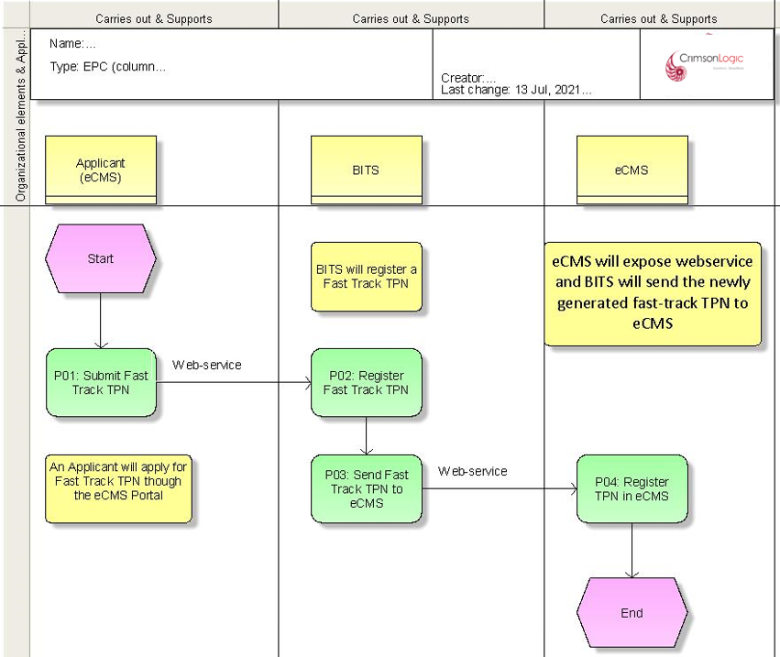

Process Steps
P01: Submit Fast Track TPN Request
A trader with no TPN can access the SSP link from eCMS portal (Outside login), and register a TPN in BITS, which will be sent to eCMS PIN Master. eCMS will validate for mandatory fields and will send the information to BITS through a webservice call
.
In case where a CFA is declaring on behalf of an individual importer with no TPN, the system will give an interface for the CFA to fast track register the importer through BITS integration.

P02: Register Fast-track TPN (BITS)
BITS will validate and register a fast-track TPN for the applicant.
P03: Send Fast-track TPN to eCMS (BITS)
BITS will send the newly generated fast-track TPN to eCMS through webservice call.
P04: Register TPN in eCMS
eCMS will receive the fast-track TPN from BITS and will proceed to register it in PIN Master as a regular TPN.
TPN details will have to be updated in PIN master as and when new TPN are registered in BITS

Application Process

eCMS will allow unregistered Companies and users to apply for registration through an application process through a link provided in the eCMS login page. After submission of application, it shall be reviewed by Customs. Based on review outcomes if the application is approved, then, it shall be registered in eCMS.
The following types of application shall be supported which are grouped as Party/Company or User based on the type of application:

- Party/Company

      - Clearing Agents and Forwarding Agents
      - Warehouse Operators
      - Temporary Storage Operators
      - Traders (EXIM) / Individual

- Users: These types of applicants shall be registered as users in the System once the application is approved by Customs. Following categories of application shall be registered as users upon approval:
      - Declarants
      - Company Admin (e.g., for other government agencies airlines, CFA, Warehouse operators etc.)
      - Customs
      - Other Government agencies for viewing declaration in eCMS system

- Customs Administrator Process: Customs administrator shall have access to all Parties and users in the Systems and can manage all users and parties. In addition, Customs Administrator can register:
      - Customs Users / Customs Officers
      - Other Government Agencies.

- Review and approval Process: After submission of an application, it shall be routed to the work queue of the designated Customs officer for verification by the Resource allocation module using a round-robin method. For instance, if the application needs review from a Verifier at Customs head office, then the application shall be allotted to the work queue of Verifiers. If after verification by Verifier, the application needs further review by an Assessor, then it shall be allotted to the work queue of the next available Assessor by the Resource Allocation module of the System. This shall apply to any review done by a Customs officer in this document and shall apply even if not explicitly stated in the process.

- Application authentication process: To ensure that the applicant is authorized to apply, system will require the applicant to provide additional field to fetch the TPN details in the application based on the Category of application.

CATEGORY | VALIDATION FIELD
Individual | CID Number
Business | Business License Number
Company | Company Registration Number

Pre-Requisites
- The Applicant is a valid citizen of Bhutan and has a valid CID and has a valid TPN.
- The TPN is available in eCMS through BITS integration and the TPN should be active.
- In case of CFA, Warehouse & Temporary storage applications, the applicant should procure the trade license and TPN from the respective departments separately (outside eCMS).
- In case of CFA, Warehouse applications, applicant will need to provide valid Bank guarantees. Guarantee is non-mandatory in case of Temporary storage.
- The applicant has the right to access eCMS application and apply for registration.

Process Flow for Application (Generic)

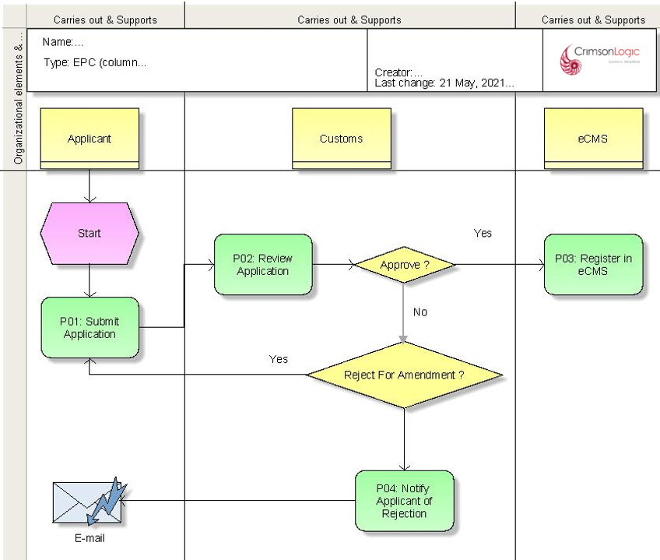
An external user will register with eCMS and prepare an application for Registration.
The applicant will be required to provide either the BITS validated TPN or the importer’s CID
- User shall provide the CID/TPN number.
- The system shall allow the applicant to key in CID as well as TPN. If the applicant keys in the CID, the same should hit the Pin Master, and list all the TPN registered against the CID.
- If the information could not be fetched from the PIN Master, the system will provide an SSP link in the portal (outside login) the user to apply for a TPN registration with BITS. After the user applies for TPN in eCMS, BITS will validate and generate a TPN and update it back to PIN Master.
- Beside the link provided in e CMS for fast-track registration, after logging in into e CMS, the right is given to CFA and Customs to apply for fast-track registration on behalf of the traders.
- If the TPN keyed in is valid then System will fetch the related TPN details and display in the application.

Process Steps
P01: Submit Application
User will submit online application form by providing mandatory information based on the type of application. Upon submission, the status of the Application shall be “Pending Review”.

P02: Review Application
Customs will review the application details submitted by the Applicant. Based on the type of application, different branch of Customs may be involved in the application review process. The Application shall be routed to the work queue of the designated officer in a round-robin method which shall be handled by Resource Allocation module.

P03: Register in eCMS
If the application is determined to be acceptable by Customs, then Customs shall approve the application. The Status of the application shall be set to “Approved” and System will then proceed to register a Party or User in eCMS based on the details provided in the application.
If the application is determined to be un-acceptable, then Customs will reject the application and, in this case, the status of the application shall be “Rejected”.
P04: Rejection of application
If the application is determined to be un-acceptable, then Customs can either:
1. Reject it for amendment: In this case, applicant will need to required amendment in the application and re-submit for review by Customs
2. Reject the application: In this case, officer shall provide remarks for rejection and reject the application. The status of the application shall be “Rejected”, and no further actions are possible on the application. Hence applicate must submit new application for the customs processing.

Additional functionalities

S/N | Additional Features
 | Applicant can track the status of the application through a portlet. The status can be checked based on the TPN, CID and Application reference number.
 | There shall be portlet for Registration / Application (For CFA, Warehouse, TSO and Traders).
 | There will be no DRAFT status for application submission since this will happen without login. The application must be submitted and there will not be a Save option.

Business Validation
S/N | Validation Rules
 | The applicant should have a valid CID and TPN which is available in eCMS.
 | Only one application per TPN shall be allowed in the System.
 | Once an application has been submitted, applicant cannot make any changes to the application unless customs have redirected it back for amendment.
 | The amendment cannot be made in the company profile details.
 | The system should automatically deregister (CFA/WHO/TSO) who has cancelled the trade license and the TPN has become invalid in BITS. BITS system will send updates to eCMS when there are changes in BITS system, based that eCMS will update as de-registered in the PIN master and batch job will be executed to apply same changes in party table accordingly.
 | The system should not allow the applicant to edit the profile details retrieved from BITS before submission of the application too

Registration Process

The purpose of this module is to register internal users, external users like traders, clearing agent and forwarding agents, warehouse operators, temporary storage operators. A user’s role, or roles, will determine which modules they have access to. Registration is further categorized as “Party Registration” and “User Registration.”

Additional Features for CFA/WHO and TSO
The below are the list of common features that shall be supported for clearing agent and forwarding agents (CFA), warehouse operators (WHO), temporary storage operators (TSO)

S/N | Additional Features
 | User will enter CID and retrieve list of TPNs. Upon selection of TPN, System will need user to provide the Business License number for authentication. System will verify that the provided Business license belongs to the selected TPN and, if it matches, then proceed to load the TPN details (including license number) from the PIN master.
 | System to provide an option for the applicant to choose the bank who issued the bank guarantee
The Assessor must be able to check all TPN’s to which a CID number is associated.
Note: Separate screen will be provided to officer to verify and decide based on their business need.
 | If any fees are applicable, System shall collect the fees before issuing the Certificate of Registration. System shall send the payment details to Revenue system after approval of the Registration (CFA, Warehouse Operator, TSO). Post completion of payment and receipt of response from Revenue System, system will allow printing of Certificate mentioned. Applicable fees are included in the appendix section.
The following certificates along with validity are mentioned below.
        - For CFA: A “Certificate of Registration to Act as a Clearing Agent” will be issued, which will be valid for three (3) years. (Configurable)
        - For Warehouse Operator: A “Certificate of Registration for Public or Private Warehouse / Airline Store / Duty Free Shop” will be issued, which will be valid for two (2) years. (Configurable).
        - For TSO: A “Certificate of Registration for Temporary Storage Operator” will be issued, which will be valid for two (2) years. (Configurable)

Applicant can take a print of this certificate after logging into eCMS provided all due payment (if applicable) are cleared
 | The CFA/BWH/TSO must also agree to an agreement with DRC and agree to the terms and conditions before the certificate can be issued. This will be provided as a standard term of agreement in the application and applicant will need to agree to the terms and conditions of this agreement before submission. (The applicant shall be informed in the application that the agreement is applicable only when the registration is approved by customs)
 | CFAs/WHO/TSO must be able to renew their registration after three (3) years. When a CFA/WHO/TSO has been registered, they must be sent automatic reminders to renew their application three (3) months, two (2) months and one (1) before the end of their certificate’s validity period. These reminders must be configurable through the System Administration module.
At any point in time, Customs must be able to cancel a registration. During Cancellation, System will check if TPN is cancelled in PIN Master. If it is cancelled, then the registration will be cancelled in eCMS. If not, it will be De-registered.

In all cases, CFA/WHO/TSO cannot access the system once Customs cancels the registration.

System will also run a batch job to check for Cancelled TPN in the PIN Master and cancel matching party in eCMS.
 | Warehouse and Temporary Storage operators can submit declaration for themselves, and the required privileges can be provided in the system.

Clearing and Forwarding Agents
Clearing and Forwarding Agents (CFA) are qualified and licensed to declare on behalf of any trader (Importer or Exporter) who may engage and act on their behalf. CFA engage declarants who are well versed with Customs procedure of Bhutan and have been authorized by Customs to submit declarations and other trade related documents in the System.

Pre-Requisites

- The applicant for CFA should be a valid citizen of Bhutan and should have a valid CID, TPN and Trade License.
- BITS should be integrated with IBLS, and the CFA should have obtained a valid Trade License and TPN which should be available in eCMS PIN Master through integration with BITS.
- CFA has a valid Bank guarantee.
- The CFA has the right to access eCMS application and apply for registration.

Process Flow for Clearing Agents and Forwarding Agents
The Registration of CFA is depicted below.

Process ID: 02.02 – Application for Clearing and Forwarding Agents

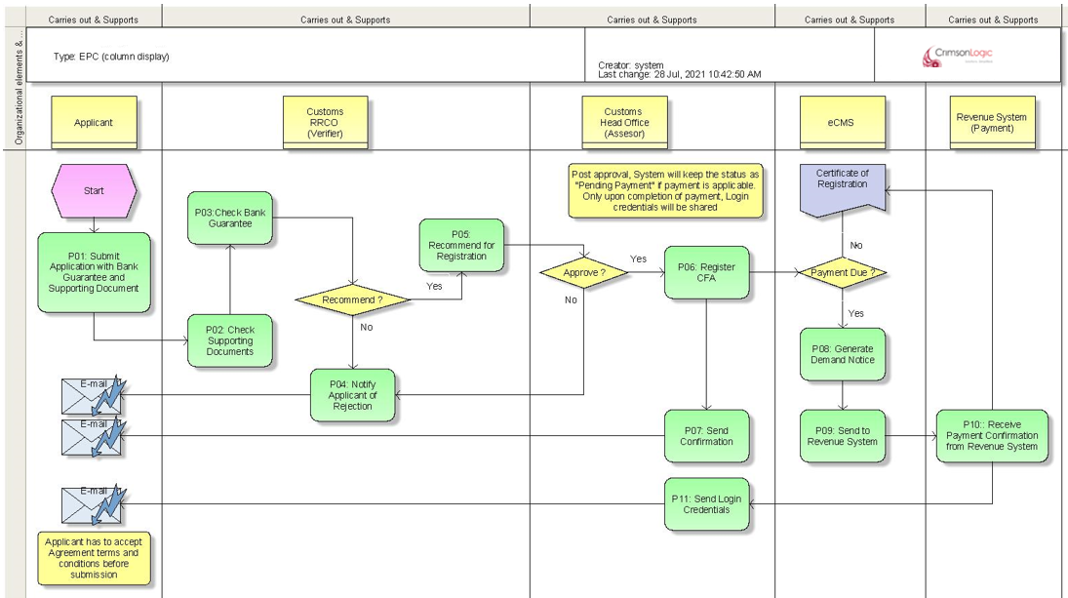

Use Case Diagram for Clearing Agents and Forwarding Agents

CFA application Submission, verification & approval/rejection




Validate Application
Submit Application
Search User Applications
Verifier
RRCO
Assessor
(Head Office)
Clearing and
Forwarding
Agent (CFA)

Recommend/ Reject Applicant

Verify Supporting Document

Approve / Reject Applicant

Process Steps
P01: Submit Application
- An applicant will submit online application form by providing mandatory information including TPN & CID and Business License number.
- The system shall allow the applicant to key in CID, TPN and Business License number. If the applicant keys in the CID, the same will hit the Pin Master, and list all the TPN registered against the CID.
- If the TPN and Business License number keyed in is valid and matching, then System will fetch the related TPN details and display in the application
- If the information could not be fetched from the Pin Master, the system will provide a link for the user to apply for a fast-track TPN with BITS. After the user applies for fast-track TPN in eCMS, BITS will validate and generate a fast-track TPN and update it back to PIN Master. Refer to Fast-Track TPN process.
- Based on the entered value eCMS must retrieve required details (including Trader License Number) from PIN master and populate in the application.
- Applicant will provide Bank Guarantee details along with Reference number.
- Applicant will provide Bank Guarantee supporting documents.
- Applicant shall accept the agreement with DRC and agree to the terms and conditions (however inform the applicant on the application of the agreement only when the registration is approved by customs)

In case of any missed information, System will stop the submission with proper validation message. Upon submission, the status of the Application shall be “Pending Review”.

P02: Check supporting documents.
- Post submission System will route the application to be reviewed by the Verifier. The verifier will verify the supporting document details along with TPN and Trade License information.
- The verifier will verify the applicant details and determine the validity of the application. eCMS will additionally provide a separate tab to enter checklist of items for the verifier to mark and check. Verifier can also attach supporting documents in a separate tab on the outcome of onsite verification (for ex, Site photographs etc.)
P03: Check Bank Guarantee
Verifier will determine the validity and suitability of the provided bank guarantee by the applicate.
P04: Notify Applicant of Rejection
During verification, if the verifier concludes that the application is invalid for any reason, then the verifier will provide reasons for rejection and reject the application. The applicant shall be notified of the rejection including the reason for rejection by email. In this case the status of the application shall be “Rejected”.

In case the application needs to be amended by the applicant, the verifier can “Reject for amendment” and in this case, the applicant can do necessary changes and re-submit for verification.

P05: Recommend for Registration
During verification, the verifier finds all provided details are in order, then the verifier can recommend the applicant for Registration as a CFA. In this case System will route the application for review from an Assessor at the Customs Head Officer.

If assessor decides to reject the application, then assessor shall provide reasons for rejection and reject the application. System shall notify the applicant on the rejection by email including the reasons of rejection and the status of the application shall be “Rejected”.
P06: Register CFA
During verification, if the Assessor concludes that the provided documents and related details are in order, then the Assessor can approve the application for Registration. In this case, System will register the applicant as a CFA in eCMS.

In case fees are applicable and payment is due, the status of the application shall be “Pending Payment”.
In case fees are not applicable, the status of the application shall be “Approved”,

P07: Send Confirmation
Post registration, System will notify the applicant on the successful registration as CFA. If no payments are applicable, then system will send the login credentials and no further processing are required.
If payment is applicable, then the applicant shall be notified on the successful completion of review and pending payment status. No login credentials shall be sent in this case.
P08: Generate Payment advice
Post approval and registration, system will determine if fees are applicable based on configuration. If no fees are applicable, system will allow printing of certificate of registration.
If fees are applicable, a payment advice shall be generated and sent to Revenue and kept CFA as “pending payment”. Registration certificate printing and login access shall be withheld till all payments are completed.

P09: Send to Revenue System
eCMS will integrate with Revenue system and send the payment advice generated in previous step.
P10: Receive payment confirmation from Revenue System
Revenue system will send the payment advice to e CMS, wherein the applicant will be able to view the same. the applicant should be given an interface that will be integrated to the BITS payment from e CMS. Upon payment confirmation from BITS, the system will generate a certificate of Registration.
After receipt of collection message, eCMS will enable printing of Registration certificate and login access will be restored.
P11: Send Login Credentials
System will send the login credentials to the applicant.

Note: A clearing agent should be allowed to declare from any region regardless of where they are registered.

Business Validation

S/N | Validation Rules
 | Applicant for CFA should have a valid CID, TPN and Trade License.
 | A bank guarantee needs to be furnished which is mandatory. However, System will not validate on the authenticity of the bank Guarantee.
 | Applicant needs to provide a valid TPN, and system will check for its validity against the PIN Master. Please note that BITS will integrate with eCMS and share Trade license information along with TPN to eCMS.

Warehouse Operators
Warehouse operators will provide storage of customs released goods in the Warehouse on a temporary basis. During the period of stay, the duties and taxes will be covered under the guarantee of the warehouse. A separate type of declaration indicating the intent of the declarant to store the goods in the warehouse shall need to be submitted in the system for entry and exit of goods from the warehouse.

Pre-Requisites
- The applicant for Warehouse operator should be a valid citizen of Bhutan and should have a valid CID, TPN and Trade License.
- BITS should be integrated with IBLS, and the Warehouse Operator should have obtained a valid Trade License and TPN which should be available in eCMS PIN Master through integration with BITS
- Warehouse operator has obtained a valid Bank guarantee.
- The Warehouse operator has the right to access eCMS application and apply for registration.

Process Flow for Warehouse Operators
The Registration of warehouse operator in eCMS is depicted below.

Process ID: 02.03 - Application for Warehouse Operator

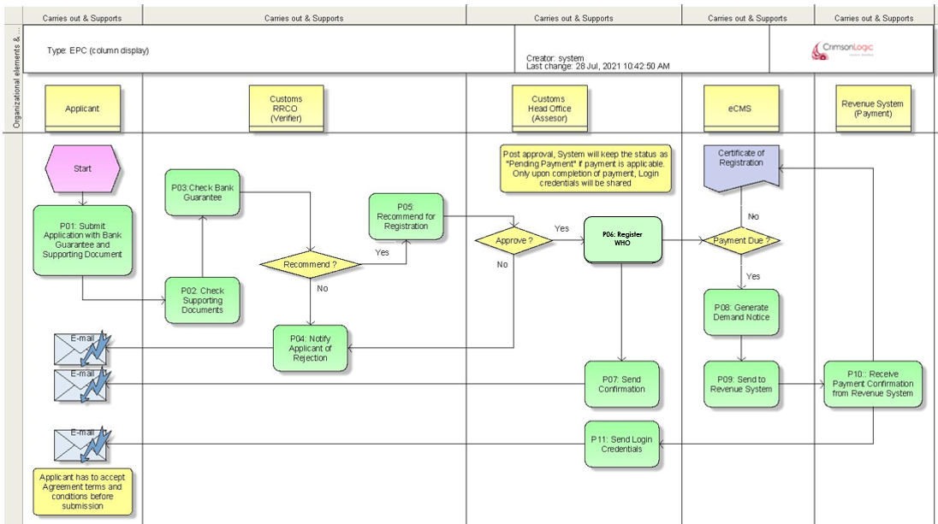

Use Case Diagram for Warehouse Operator Registration

Warehouse Operator application Submission, verification & approval/rejection




Validate Application
Submit Application
Search User Applications
Verifier
RRCO
Assessor
(Head Office)
Warehouse
Operator

Recommend/ Reject Applicant

Verify Supporting Document

Approve / Reject Applicant

Process Steps
P01: Submit Application
- An applicant will submit online application form by providing mandatory information including TPN &CID and Business License number.
- The system shall allow the applicant to key in CID, TPN and Business License number. If the applicant keys in the CID, the same should hit the Pin Master, and list all the TPN registered against the CID.
- If the TPN and Business License number keyed in is valid and matching, then System will fetch the related TPN details and display in the application
- If the information could not be fetched from the Pin Master, the system will provide an option for the user to apply for a fast-track TPN with BITS. After the user applies for fast-track TPN in eCMS, BITS will validate and generate a fast-track TPN and update it back to PIN Master. Refer to Fast-Track TPN process.
- Based on the entered value eCMS must retrieve required details (including Trader License Number) from PIN master and populate in the application.
- Applicant will provide Bank Guarantee details along with Reference number.
- Applicant will provide Bank Guarantee supporting documents.
- Applicant shall accept the agreement with DRC and agree to the terms and conditions (however inform the applicant on the application of the agreement only when the registration is approved by customs)

In case of any missed information, System will stop the submission with proper validation message. Upon submission, the status of the Application shall be “Pending Review”.

P02: Check supporting documents.
- Post submission System will route the application to be reviewed by the Verifier. The verifier will verify the supporting document details along with TPN and Trade License information.
- The verifier will verify the applicant details and determine the validity of the application. eCMS will additionally provide a separate tab to enter checklist of items for the verifier to mark and check. Verifier can also attach supporting documents in a separate tab on the outcome of onsite verification (for ex, Site photographs etc.).

P03: Check Bank Guarantee
Verifier will determine the validity and suitability of the provided bank guarantee by the applicate.

P04: Notify Applicant of Rejection
During verification, if the verifier concludes that the application is invalid for any reason, then the verifier will provide reasons for rejection and reject the application. The applicant shall be notified of the rejection including the reason for rejection by email. In this case the status of the application shall be “Rejected”.

In case the application needs to be amended by the applicant, the verifier can “Reject for amendment” and in this case, the applicant can do necessary changes and re-submit for verification.

P05: Recommend for Registration
During verification, the verifier finds all provided details are in order, then the verifier can recommend the applicant for Registration as a Warehouse Operator. In this case System will route the application for review from an Assessor at the Customs Head Officer.

If assessor decides to reject the application, then assessor shall provide reasons for rejection and reject the application. System shall notify the applicant on the rejection by email including the reasons of rejection and the status of the application shall be “Rejected”.

P06: Register Warehouse Operator
During verification, if the Assessor concludes that the provided documents and related details are in order, then the Assessor can approve the application for Registration. In this case, System will register the applicant as a Warehouse Operator in eCMS.

In case fees are applicable and payment is due, the status of the application shall be “Pending Payment”.
In case fees are not applicable, the status of the application shall be “Approved”,

P07: Send Confirmation
Post registration, System will notify the applicant on the successful registration as Warehouse Operator. If no payments are applicable, then system will send the login credentials and no further processing are required.
If payment is applicable, then the applicant shall be notified on the successful completion of review and pending payment status. No login credentials shall be sent in this case.
P08: Generate Payment advice
Post approval and registration, system will determine if fees are applicable based on configuration. If no fees are applicable, system will allow printing of certificate of registration.
If fees are applicable, a payment advice shall be generated and sent to Revenue. Registration certificate printing and login access shall be withheld till all payments are completed.

P09: Send to Revenue System
eCMS will integrate with Revenue system and send the payment advice generated in previous step.
P10: Receive payment confirmation from Revenue System
Revenue system will send a payment confirmation to eCMS after collecting payment in Revenue system.
After receipt of collection message, eCMS will enable printing of Registration certificate and login access will be restored.
P11: Send Login Credentials
System will send the login credentials to the applicant.

Business Validation
S/N | Validation Rules
 | The applicant for Warehouse operator should have a valid CID, TPN and Trade License/
 | A bank guarantee needs to be furnished. However, System will not validate on the authenticity of the bank Guarantee, and this shall be verified by the respective officer.
 | Applicant needs to provide a valid TPN, and system will check for its validity against the PIN Master. Please note that BITS will integrate with eCMS and share Trade license information along with TPN to eCMS.

Temporary Storage Operators
Temporary storage operators (TSO) will provide temporary storage of consignments after the goods arrive at the Border. Temporary storages are provided within the border post allowing the trader a period to complete the procedure to declare and release the consignment.

Pre-Requisites
- The applicant for TSO should be a valid citizen of Bhutan and should have a valid CID, TPN and Trade License.
- BITS should be integrated with IBLS, and the TSO should have obtained a valid Trade License and TPN which should be available in eCMS PIN Master through integration with BITS.
- TSO has obtained a valid Bank guarantee.
- The TSO has the right to access eCMS application and apply for registration.

Process Flow for Temporary Storage Operators (TSO)
The Registration of temporary storage operator in eCMS is depicted below.

Process ID: 02.04 - Application for Temporary Storage Operator

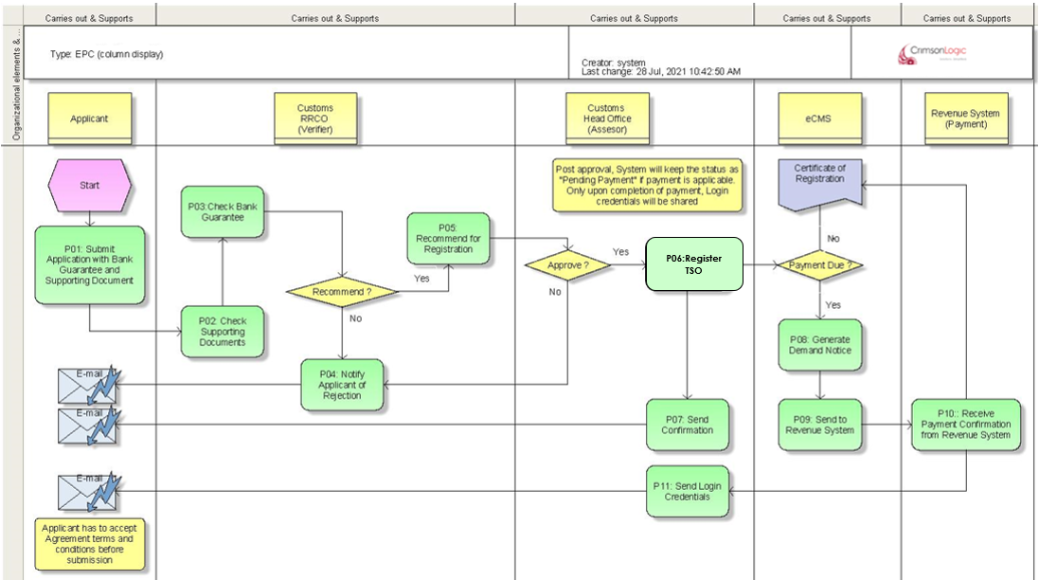

Use Case Diagram for Temporary Storage Operators

Temporary Storage Operator Application Submission, verification & approval/rejection




Submit Application
Search User Applications
Verifier
RRCO
Assessor
(RRCO)
Temporary
Storage
Operator
Validate Application

Recommend Application

Approve/Reject Application

Process Steps
P01: Submit Application
- An applicant will submit online application form by providing mandatory information including TPN, CID and Business License number.
- The system shall allow the applicant to key in CID, TPN and Business License number. If the applicant keys in the CID, the same should hit the Pin Master, and list all the TPN registered against the CID.
- If the TPN and Business License number keyed in is valid and matching, then System will fetch the related TPN details and display in the application
- If the information could not be fetched from the Pin Master, the system will provide an option for the user to apply for a fast-track TPN with BITS. After the user applies for fast-track TPN in eCMS, BITS will validate and generate a fast-track TPN and update it back to PIN Master. Refer to Fast-Track TPN process.
- Based on the entered value eCMS must retrieve required details (including Trader License Number) from PIN master and populate in the application.
- Applicant will provide Bank Guarantee details along with Reference number (non-Mandatory in case of TSO).
- Applicant will provide Bank Guarantee supporting documents (non-Mandatory in case of TSO).
- Applicant shall accept the agreement with DRC and agree to the terms and conditions (however inform the applicant on the application of the agreement only when the registration is approved by customs)

In case of any missed information, System will stop the submission with proper validation message. Upon submission, the status of the Application shall be “Pending Review”.

P02: Check supporting documents.
- Post submission System will route the application to be reviewed by the Verifier. The verifier will verify the supporting document details along with TPN and Trade License information.
- The verifier will verify the applicant details and determine the validity of the application. eCMS will additionally provide a separate tab to enter checklist of items for the verifier to mark and check. Verifier can also attach supporting documents in a separate tab on the outcome of onsite verification (for ex, Site photographs etc.).

P03: Check Bank Guarantee
Verifier will determine the validity and suitability of the provided bank guarantee.

P04: Notify Applicant of Rejection
During verification, if the verifier concludes that the application is invalid for any reason, then the verifier will provide reasons for rejection and reject the application. The applicant shall be notified of the rejection including the reason for rejection by email. In this case the status of the application shall be “Rejected”.

In case the application needs to be amended by the applicant, the verifier can “Reject for amendment” and in this case, the applicant can do necessary changes and re-submit for verification.

P05: Recommend for Registration
During verification, the verifier finds all provided details are in order, then the verifier can recommend the applicant for Registration as a TSO. In this case System will route the application for review from an Assessor at the Customs Head Officer.

If assessor decides to reject the application, then assessor shall provide reasons for rejection and reject the application. System shall notify the applicant on the rejection by email including the reasons of rejection and the status of the application shall be “Rejected”.

P06: Register Warehouse Operator
During verification, if the Assessor concludes that the provided documents and related details are in order, then the Assessor can approve the application for Registration. In this case, System will register the applicant as a TSO in eCMS.

In case fees are applicable and payment is due, the status of the application shall be “Pending Payment”.
In case fees are not applicable, the status of the application shall be “Approved”,

P07: Send Confirmation
Post registration, System will notify the applicant on the successful registration as TSO. If no payments are applicable, then system will send the login credentials and no further processing are required.
If payment is applicable, then the applicant shall be notified on the successful completion of review and pending payment status. No login credentials shall be sent in this case.
P08: Generate Payment advice
Post approval and registration, system will determine if fees are applicable based on configuration. If no fees are applicable, system will allow printing of certificate of registration.
If fees are applicable, a payment advice shall be generated and sent to Revenue. Registration certificate printing and login access shall be withheld till all payments are completed.

P09: Send to Revenue System
eCMS will integrate with Revenue system and send the payment advice generated in previous step.

P10: Receive payment confirmation from Revenue System
Revenue system will send a payment confirmation to eCMS after collecting payment in Revenue system.
After receipt of collection message, eCMS will enable printing of Registration certificate and login access will be restored.

P11: Send Login Credentials
System will send the login credentials to the applicant.

Business Validation
S/N | Validation Rules
 | The applicant for TSO should have a valid CID, TPN and Trade License
 | A bank guarantee needs to be furnished. However, System will not validate on the authenticity of the bank Guarantee, and this shall be verified by the respective officer.
 | Applicant needs to provide a valid TPN, and system will check for its validity against the PIN Master. Please note that BITS will integrate with eCMS and share Trade license information along with TPN to eCMS.

Declarants (CFA Employees)
Declarants are individual citizen who is well versed with the Customs procedure and Customs Act of Bhutan and are certified by Customs to declare consignments in the system.
A registered CFA can apply for certified Declarant to be registered with after Customs review and approval of the Declarant. The below steps detail out this process.

Pre-Requisites
- The Declarant is a citizen of Bhutan and has a valid CID.
- The Declarant has undergone required training on Customs procedure of Bhutan and has been certified by Customs to engage in declaring consignment and other trade activities which require Custom’s intervention.
- The CFA intent on engaging the services of the declarant should be registered in the system with a valid CID and TPN.
- After initial registration with a CFA if the declarant is being engaged by another CFA, then the previous CFA should have de-registered the declarant.

Process Flow for Declarants

Process ID: 02.05 - Declarants
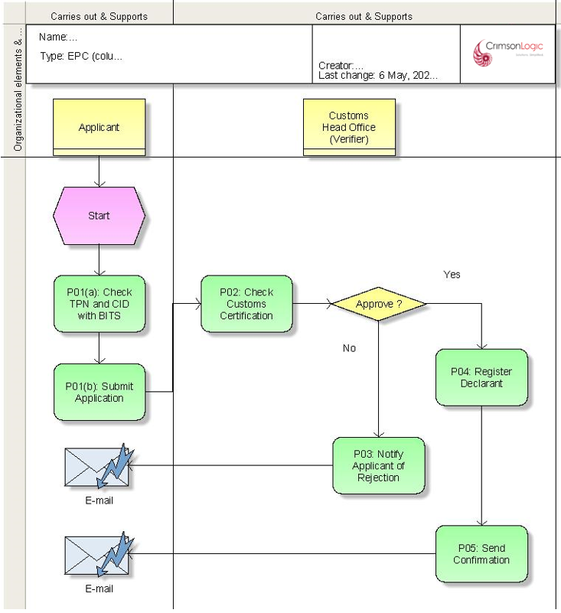
P01: Submit Application
The customs certification shall be validated before submission of the application. At the time of creating an application wherein, the system should check the applicant’s CID with the list of certified customs person in the system.

Use Case Diagrams for Declarants.

Submit Application
Declarant Submission, Verification and Approval

Validate Applicant’s Credentials


Search User Applications

CFA
Admin
Assessor
(Head Office)
Approve/Reject Declarant

Note: Declarant are Custom certified individuals who are engaged by CFA to submit declaration on behalf of external parties.

Process Steps
P01: Submit Application
Applicant will provide required information and complete all mandatory fields and submit the application.
System will check for valid CID and TPN against eCMS PIN Master and will stop the submission if matching CID is not found in the System.
Post validation, if all checks pass, System will accept the application for further processing.

Note : eCMS will provide an option to register certified declarant (i.e. clearing clerks) as code table entry and system will valid before submitting the application to include declarants under their CFA company.
P02: Check Customs Certification
The CID of the applicant will be validated by the system with the list of customs certified person, which the system will maintain before the submission of the application. If the CID number cannot be validated, the system should inform the applicant on the same and the system should not allow the applicant to process further with the application.
P03: Notify Applicant of Rejection
If the application is determined to be unacceptable for any reason, then the Verifier will provide reasons for rejection and reject the application. The applicant shall be notified of the rejection including the reason for rejection by email.

P04: Register Declarant
If the application is determined to be acceptable by the verifier, the verifier shall approve the application. System will then store the Declarant’s profile in the eCMS database.

P05: Send Confirmation
System will send a notification to the declarant as per section 1.3 Login Credentials, Password Management Etc.

Additional Functionalities

S/N | Additional Features
 | Customs can de-register a declarant anytime if needed and no further integration with BITS is required for this. Once a declarant is de-registered, the declarant cannot access the System anymore.
 | A Declarant can be linked to only one CFA at any given time. In case a declarant moves to another CFA, then the previous CFA must de-register the Declarant. After de-registration, the new CFA needs to register the declarant once again as per the steps mentioned above.
 | System will maintain a history of the various CFA's the declarant has worked for.

Note: Declarant are Custom certified individuals who are engaged by CFA for declaration submission. In this context, Declarants are different from a Trader. Warehouse Operators, TSO etc. who can also submit declarations for themselves. In case of Traders, Warehouse Operators, TSO etc., the functionality to submit declaration is provided through access configuration.

Business Validation
S/N | Validation Rules
 | The declarant should have a valid CID.
 | The declarant should not be engaged and active with any other CFA at the point of application.
 | The declarant should be customs certified.

Traders Registration
Traders are individuals and companies who are engaged in the business of importing and exporting of goods across the border of Bhutan. Traders may declare their own consignments in the system or engage CFA’s do it on their behalf.

Pre-Requisites
- The applicant for trader is a citizen of Bhutan and has a valid CID/TPN

Process Flow for Traders Registration.

Process ID: 02.06 – Traders Registration
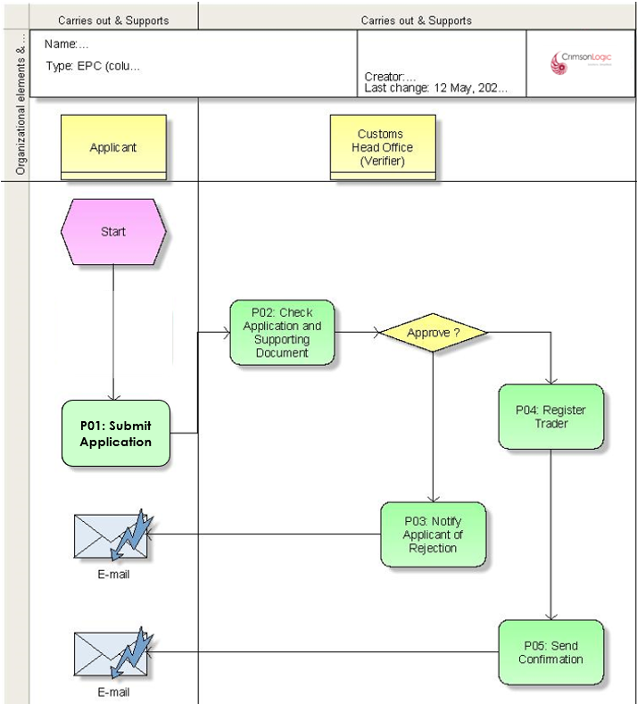

Use Case Diagrams for Trader Registration

Trader application Submission, verification & approval/rejection



Submit Application
Approve / Reject Trader
Search User Applications
Verifier
(Head Office)
Applicant
(Trader)
Validate Trader’s Credentials

Process Steps
P01: Submit Application
Trader will provide additional mandatory detail, attach supporting documents, and proceed to submit the application form. System will check for a valid CID and TPN through the following steps.
- User shall provide the CID/TPN number.
- The system shall allow the applicant to key in CID as well as TPN. If the applicant keys in the CID, the same should hit the PIN Master, and list all the TPN registered against the CID.
- If the TPN belongs to a Company, then the Applicant will be required to provide the Company registration number for authentication. System will validate the TPN and provided company registration number combination and, if it matches, proceed to fetch the TPN details and display in the Application.
- If the information could not be fetched from the Pin Master, the system will provide an option for the user to apply for a fast-track TPN with BITS. After the user applies for fast-track TPN in eCMS, BITS will validate and generate a fast-track TPN and update it back to PIN Master. Refer to Fast-Track TPN process.
- If the TPN keyed in is valid then System will fetch the related TPN details and display in the application (in case the TPN belongs to a Company, then system will follow authentication using Company registration number as mentioned in Step 3 before displaying TPN details).
Applicant can now provide additional details and submit

P02: Check Application details
When an application has been submitted System will route the application for review by the verifier for verification and approval.

P03: Notify Applicant of Rejection
During verification, if application details are not found to be in order, then the Verifier will provide reasons for rejection and reject the application. The applicant shall be notified of the rejection including the reason for rejection by email.
P04: Register Trader
If the application is determined to be valid by the Verifier, the Verifier shall approve the application. System will then register the applicant as a Trader in eCMS.

P05: Send confirmation email
After approval and registration, System will send a notification to the Trader by email as per section 1.3 Login Credentials, Password Management Etc.

Additional functionalities

S/N | Additional Features
 | In case where a license has been cancelled in PIN Master by BITS through integration, the party should be de-registered in eCMS. This will be done using a batch job.
 | Traders can register any number of users (Citizens) on their own and will manage their own users.
 | Traders can declare only for themselves but not for any other external party.

Business Validation
S/N | Validation Rules
 | The applicant for Trader should have a valid CID/TPN.
 | The Trader cannot apply for the same TPN. System will not allow duplicate applications for the same TPN.

Customs Administrator Process

Following are the types of registration which shall be done by Customs Administrator:

Customs User Registrations

Customs users are employees of Bhutan Customs working in various capacities at different office locations and will use the eCMS system to facilitate processing and release of consignments from eCMS. Customs users shall be registered by Customs admin at the Head office who are expected to have the centralized list of all Customs officers working under different regional areas (RRCO) and posted at specific border location under the RRCO. Post registration of the officer in eCMS by head office, specific admin officers at the indicated RRCO shall proceed to assign roles to the registered officer.

The below section details out the process of registration.

Pre-Requisites
- The officer should have a valid CID and employee ID.
- The RRCO admin should have the right to assign different roles to the registered officer.

Process Flow for Customs User Registration

Process ID: 02.07 – Customs User Registration
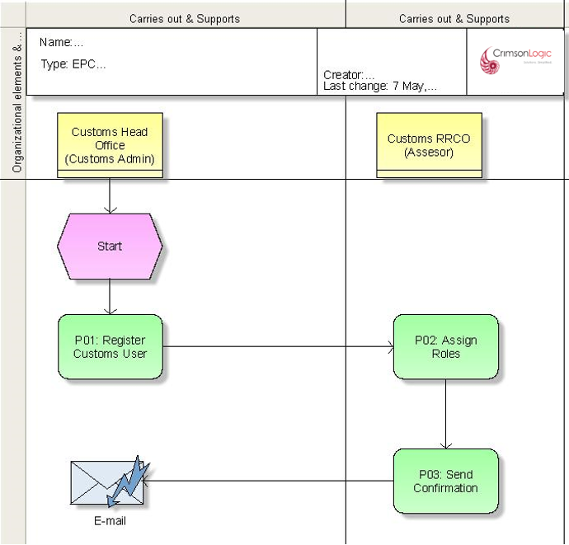

Use Case Diagram for Customs User Registration
Custom user registration and role assignment



Register Customs User
Assign Roles / Access
Search User Applications
Custom Admin
Head Office
Assigner
(RRCO)

Process Steps
P01: Register User
Customs admin will provide necessary information required to register a customs officer including the office to which the user belongs. System will then store the Customs user’s profile in the eCMS database and status of the user shall be set to “Pending Activation.”

P02: Assign Roles/Access Rights
System will route the approved application to the system admin of the specific RRCO. The system admin will assign role(s) to the applicant which will enable Custom user to perform their assigned duties. system admin can change the access rights of Customs users at any time.
The customs officer should be able to access the system once the concerned RRCO assigns the role.
The system will maintain the history of the profile even for the ones that have been deregistered.
P03: Send Confirmation
System will send a notification to the registered Custom user as per section 1.3 Login Credentials, Password Management Etc.

Business Validation
S/N | Validation Rules
 | A custom officer may be registered only once in the System. System will check this through the employee ID of the officer and will not allow duplicate employee ID.

Other Government Agency

OGA are different Government agencies who are responsible for controlling restricted goods and providing permits and license and can register themselves in eCMS by providing registration details (outside the system) to Customs admin. Customs admin shall register the OGA and create an admin user for the registered OGA.

The below section details out the process of registration.

Pre-Requisites
- OGA seeking registration should have provided required details to Customs.
- OGA should provide the details of the user who shall be the admin for the OGA.
- Customs Admin registering the OGA should be familiar with the roles which need to be assigned to the OGA.

Process Flow for Other Government Agency User

Process ID: 02.08 – Other Government Agency User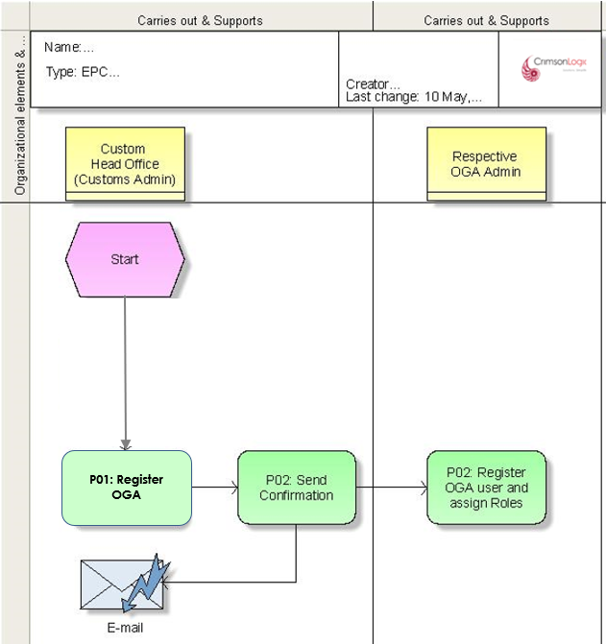

Use Case Diagram for Other Government Agency
OGA User Regsitration



Register OGA
Register OGA User
Custom Admin
Head Office
OGA Admin

Process Steps
P01: Register OGA
Respective OGA will be required to provide the OGA details along with the admin user details for one time registration by Customs.
Customs admin will provide TPN, and other necessary information required to register an OGA and save. System will validate the TPN with eCMS PIN Master and verify provided TPN number. If TPN is in-valid, System will stop the registration with an error message.
If TPN is valid, then system will allow Customs admin to register the OGA.

Customs admin will then provide required information to register an OGA, assign roles to the OGA and submit. System will validate and register the OGA in eCMS.
P02: Send Confirmation
System will send a notification to the registered OGA admin user as per section 1.3 Login Credentials, Password Management Etc.

P03: Register OGA users by OGA Admin
Respective OGA admin can register their own OGA users and assign roles which shall be restricted to the roles assigned by Customs to the OGA during registration.
Registered OGA user shall receive email notification on registration just like any other normal user.

Business Validation
S/N | Validation Rules
 | OGA TPN should be valid and available in the System
 | OGA Admin user should have a valid CID.
 | An OGA can be registered only once (No duplication)

Renewal Process
Certain parties like Clearing agents and Warehouse operators, the license to operate is provided for a certain period and the license needs to be renewed before the expiry of the license.

Below is the process flow for renewal of license and is a generic flow which covers both Clearing and Forwarding agents and Warehouse Operator.

Pre-Requisites
- Party should be registered in the System with a valid license due to expire.
- Party admin should have access to renewal CFA/BHW functionality in eCMS.

Process Flow for Renewal

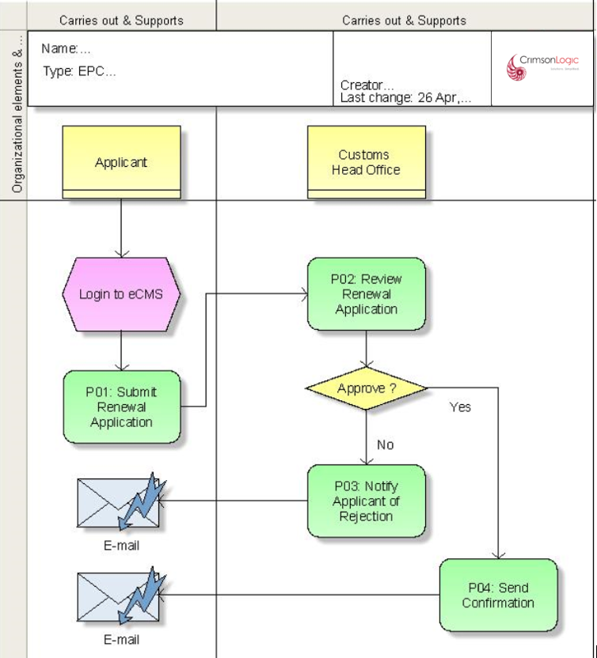

Use Case Diagrams for Renewal

Renewal Application Submission, verification & approval/rejection



Submit Renewal Application
Search Renewal Applications
Verifier
Head Office
Company
Admin
Validate Application

Approve / Reject Renewal

Process Steps
P01: Submit Application
eCMS system will send periodic notifications to the Company admins of parties requiring renewal of Clearing and Forwarding Agents and Warehouse Operators.
Company admin will login to eCMS and prepare and submit a renewal application like what was used for registering the entity. The status of the renewal application shall be “Pending Review.”

P02: Review Renewal Application
After the application has been submitted, System will route the application for review from a Verifier at the Customs Head Office.

P03: Notify Applicant of Rejection
During verification, if any of the application details are not found to be in order, then the Verifier will provide reasons for rejection and reject the application. The applicant shall be notified of the rejection including the reason for rejection by email.

P04: Send confirmation email
If the application is approved by the Verifier, then System will send an approval email to the Company admin.

Business Validation
S/N | Validation Rules
 | Only one renewal request can be submitted at one time for any given party.

Appendix A

Configuration blueprint (CBP)

Configuration Blueprint (CBP) for Application and Registration

Backend Job
- System will check through a batch job if the TPN has been cancelled in PIN Master then matching parties shall be de-registered in eCMS.
- eCMS Update: eCMS will be updated with the review outcomes (Approval or Rejection) by a Batch job and Party shall be updated appropriately to reflect the review decisions.

Report Templates
Please check Reports SRS

User Interfaces
Refer to Prototype.

Note: Though we released the prototype, actual UI implementation look, and feel may vary based on SmartGWT framework.

Inspection Checklist
Verifier can fill in the Inspection checklist in the Inspection tab as per the provided Checklist below for WHO and TSO.

Print Templates

    - CERTIFICATE OF REGISTRATION TO ACT AS CUSTOMS CLEARING AGENT

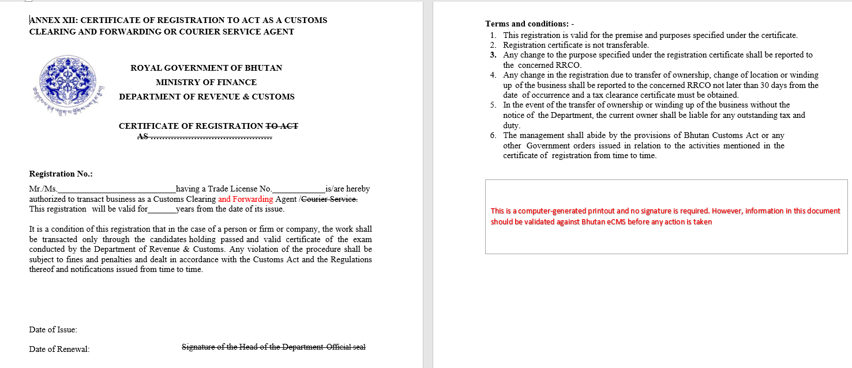

    - CERTIFICATE OF APPROVAL OF A PLACE FOR LOADING / UNLOADING / TEMPORARY STORAGE

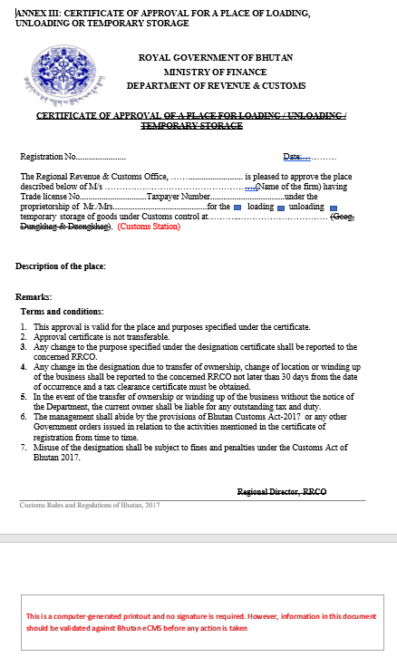

    - CERTIFICATE OF REGISTRATION FOR PUBLIC OR PRIVATE WAREHOUSE

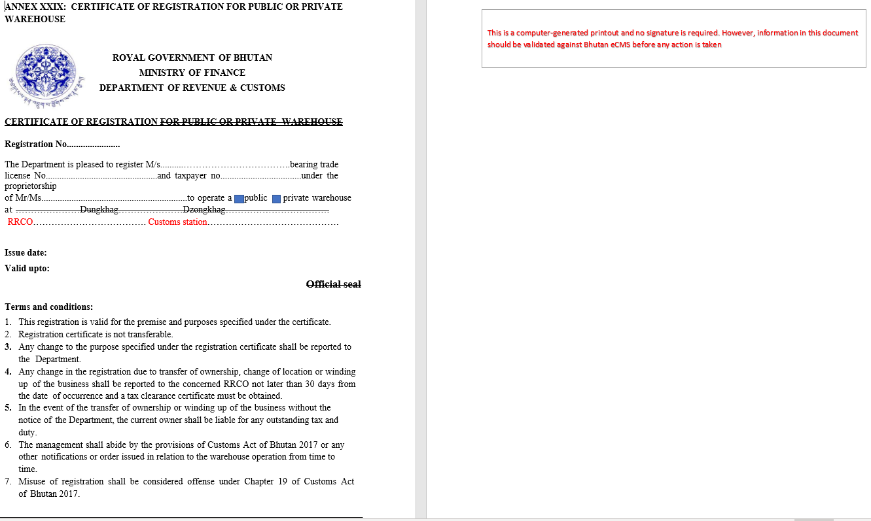

Fees and Charges
Provided below are the list of all applicable Fees and charges for reference.

