Electronic- Custom Managemnt system



Operational Report
User Guide

Version: 1.0
Date: 20/04/2022

About CrimsonLogic
CrimsonLogic Pte Ltd delivers world-class eGovernment solutions by leveraging on best-practice technologies, quality human capital and global experiences. Our proven track record of end-to-end eGovernment solutions spans across trade facilitation and customs, judiciary, tax, healthcare, and IT security domains. With 20 years of experience in developing and managing nationwide, mission-critical IT systems and services in a Public-Private Partnership model, CrimsonLogic has set industry standards with world-first eGovernment solutions such as TradeNet, eStamping, eJudiciary and CertOfOrigin. For more information, visit www.crimsonlogic.com

About Yang Khor Pvt Ltd

Yang Khor IT Solutions is a leading In-country Technology Solutions Provider providing solution in terms of hardware, software, support and services as its complete package.
Yang Khor IT Solutions has been serving its purpose since 2005, it now has emerged to be unprecedented leader as a Solution Integrator with a differentiated vertical approach providing innovative solutions. Yang Khor uses its solution integration capabilities to integrate best of breed products through its key technology alliance partners to provide “End to End” solutions. Provide customized business solutions that help organizations accelerate revenue growth, increase market penetration, optimize operating costs and improve employee productivity, by embedding communication in their business processes.

Yang Khor IT Solutions has achieved to be the Gold Partner of HPE, Service One Partner of HPE, Microsoft Silver Partner and VMWARE Professional Partner and having this Partnership we are able to serve the best of solution to our Clients. Yang Khor IT Solution initially focuses on providing the best solution in terms of hardware and software, to serve the purpose of making life better with the Advance Technology which the world is moving forward with.

Document History

S.No | Date | Version. No | Description | Approved By
1 |  | 1.0 | First Release
2

Contents
Chapter 1- About this Guide 4
Purpose and Audience 4
Chapter 2- Getting Started 4

Chapter 1- About this Guide
Welcome to the Electronic Customs Management System (e-CMS) user guide for generating operational reports of Customs. This user guide aims to enumerate the process and steps involved in generate e-CMS reports.

Purpose and Audience
This user guide will help the user to get a quick reference on usage of the system to generate the reports.

Chapter 2- Getting Started
Refer to this chapter to familiarize yourself with the following:
- e-CMS FE Registration, how to register into the system as Trader, CFA, BWH, TSO.
- Different task performed by the FE user.

- Number of Application submitted
- Click >> Application Report. The subsequent screen will be displayed.
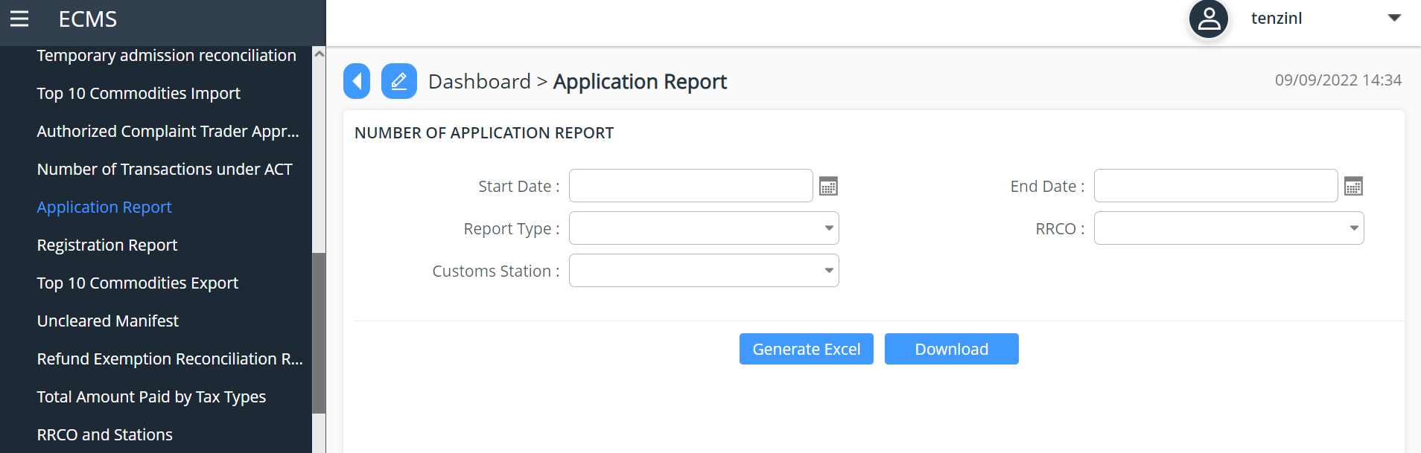
- Input parameters start date and end start which is within the 3 months range.
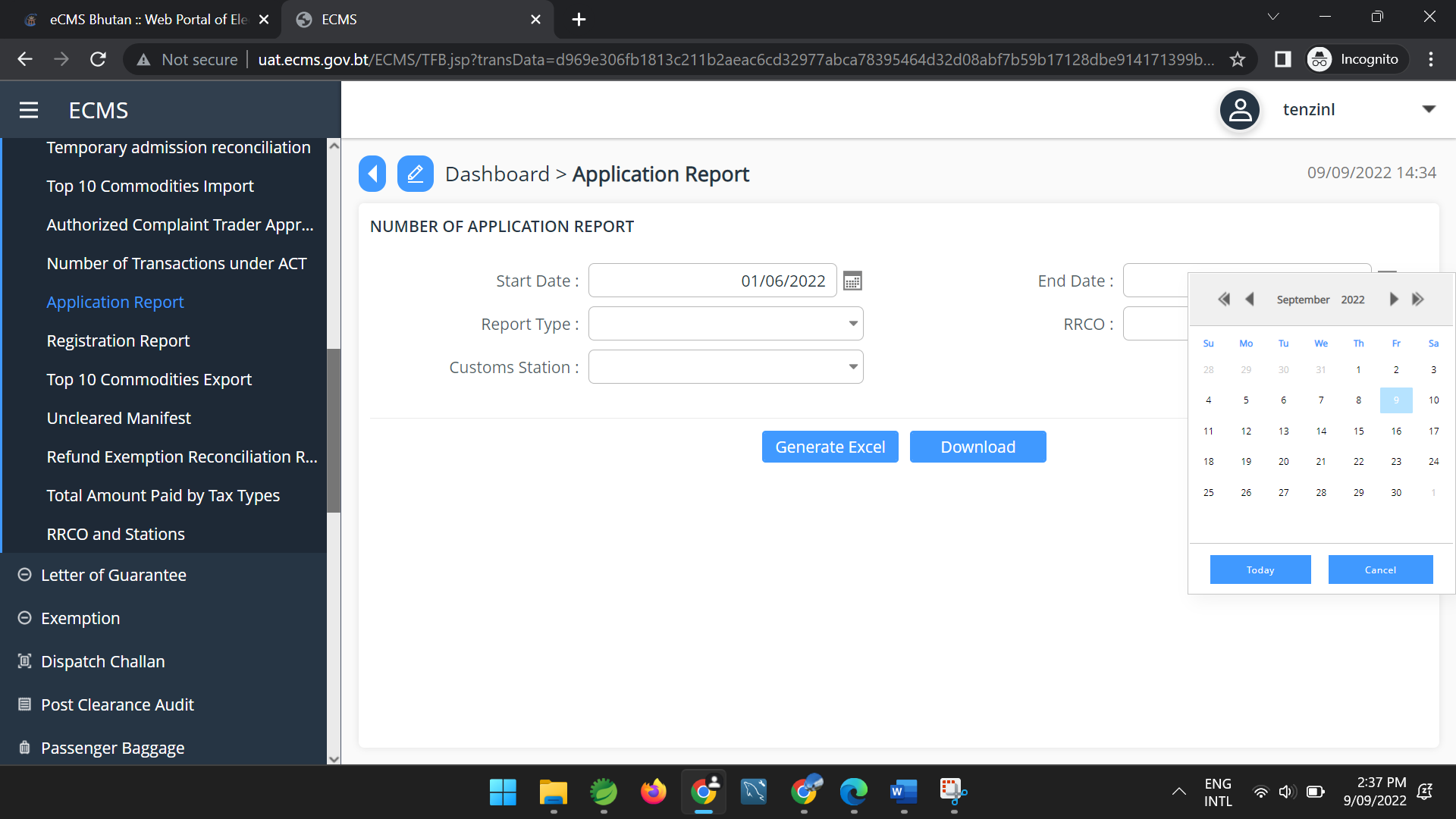

- Choose Application type
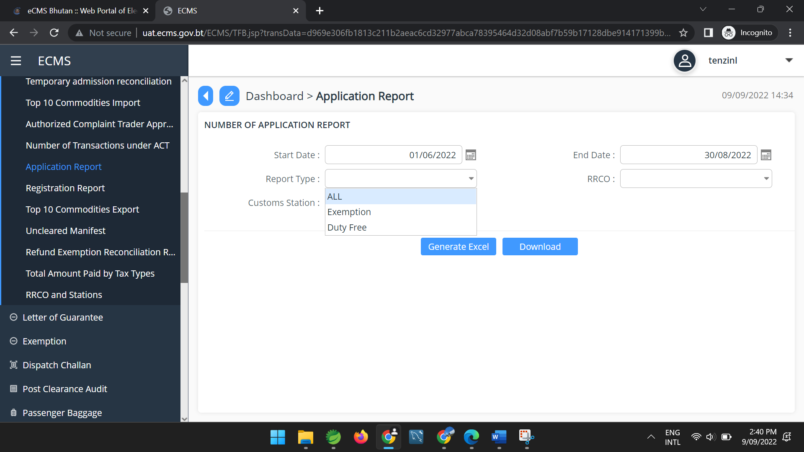

- Select the RRCO
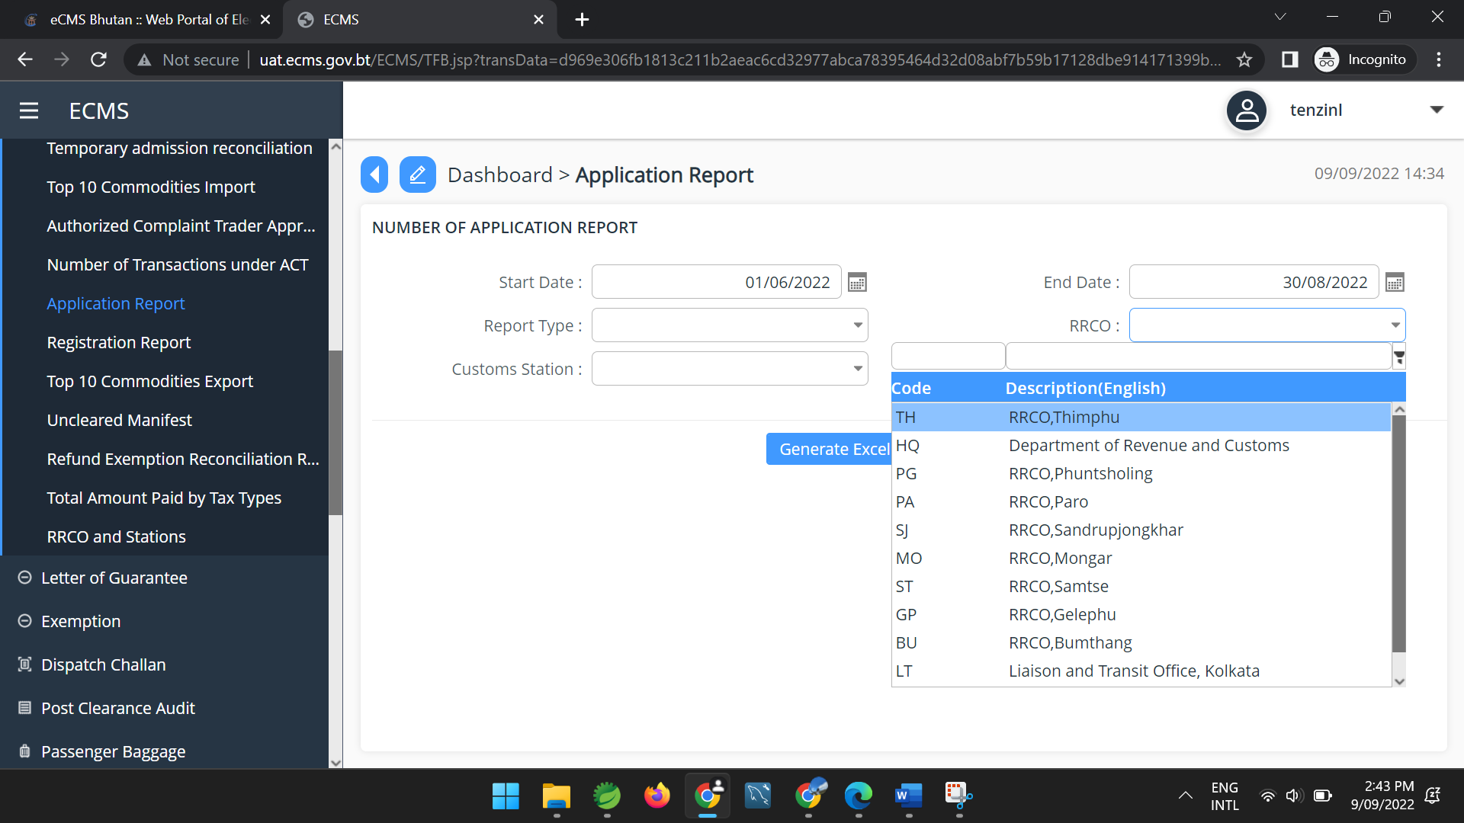
- And according to what RRCO you select , customs Station of that particular RRCO will be listed. (for example; for now Thimphu RRCO is selected and Customs Station of Thimphu RRCO is listed.
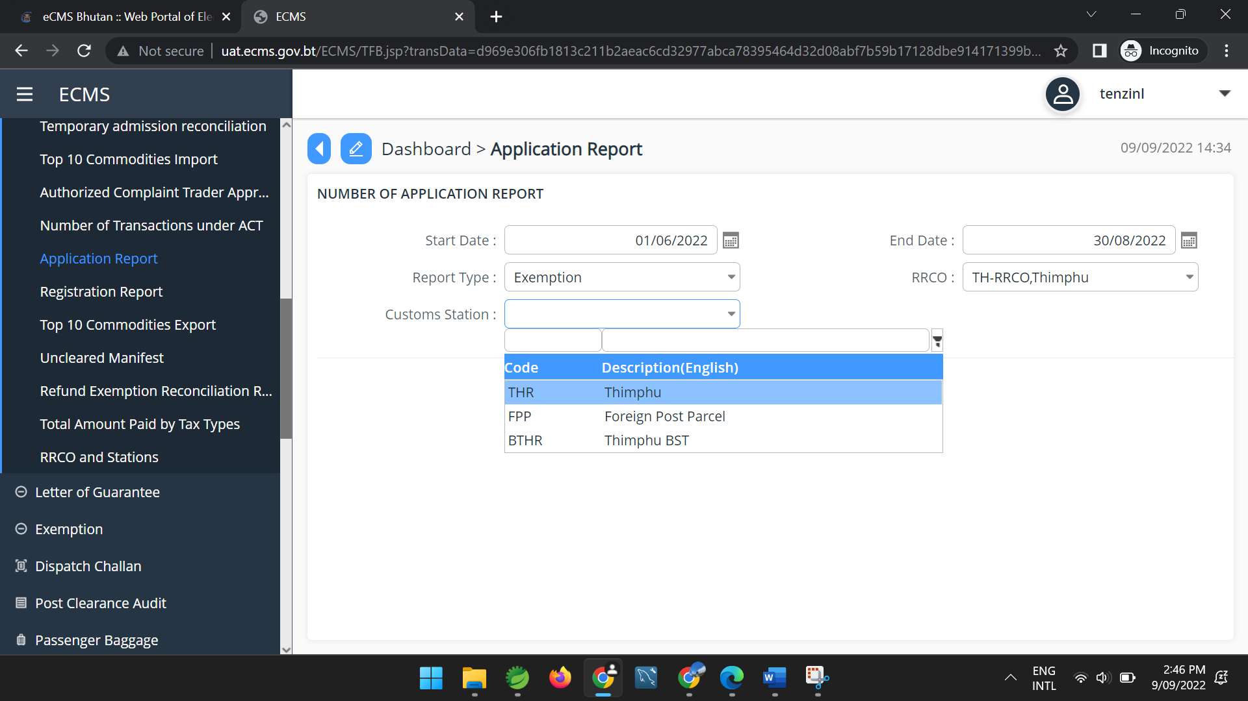

- Finally generate the report(either in pdf or excel).
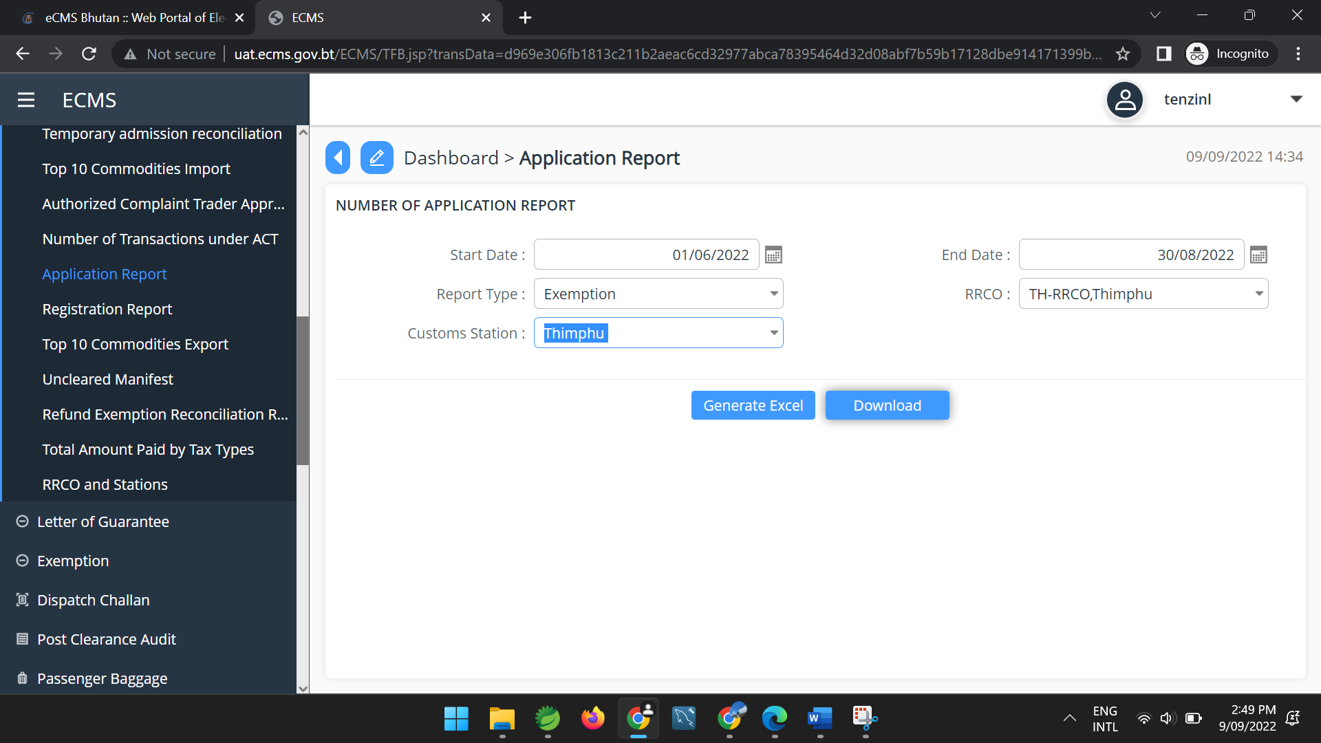

- Number of Registration submitted
- Click >> Registration Report. The subsequent screen will be displayed.
- Input parameters start date and end start which is within the 3 months range.
- Select the RRCO
- Choose Registration type
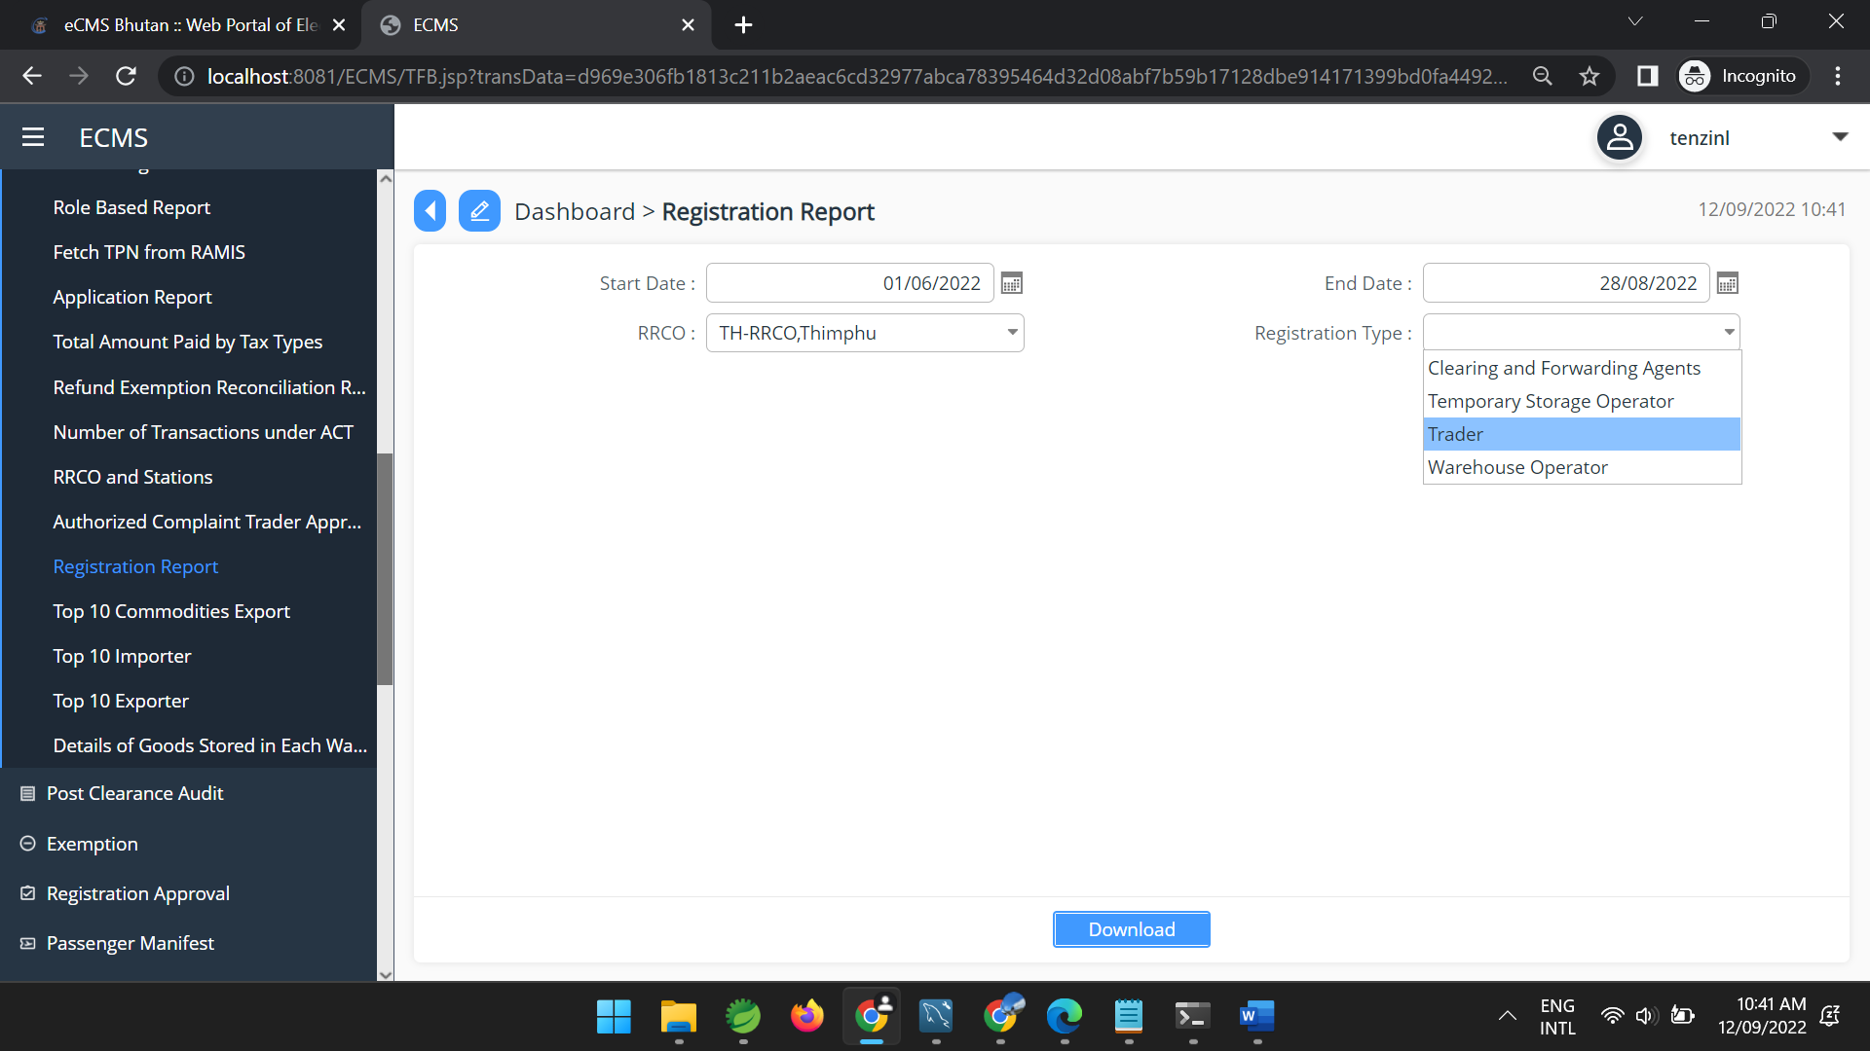
- Finally generate the report(either in pdf or excel).

- Number of manifests submitted
- Click >> Number of Manifest Submitted Report. The subsequent screen will be displayed.
- Input parameters start date and end start which is within the 3 months range.
- Choose Manifest type
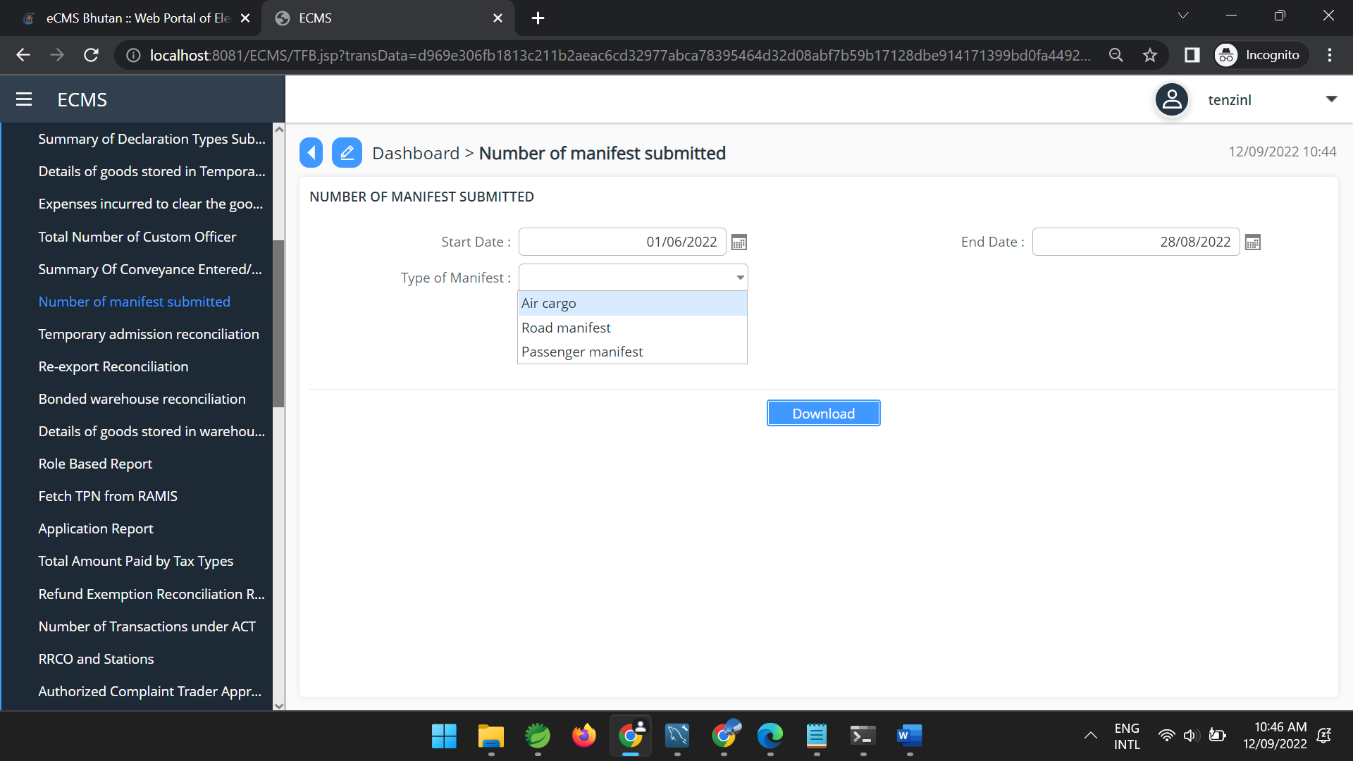

- Finally generate the report(either in pdf or excel).

- Number of declarations made by a particular CFA
- Click >> Number of Declaration made by particular Clearing Agent. The subsequent screen will be displayed.
- Input parameters start date and end start which is within the 3 months range.
- Entry CFA TPN that you want the report for.
- Select the RRCO
- And according to what RRCO you select , customs Station of that particular RRCO will be listed. (for example; for now Thimphu RRCO is selected and Customs Station of Thimphu RRCO is listed.
- Finally generate the report(either in pdf or excel).
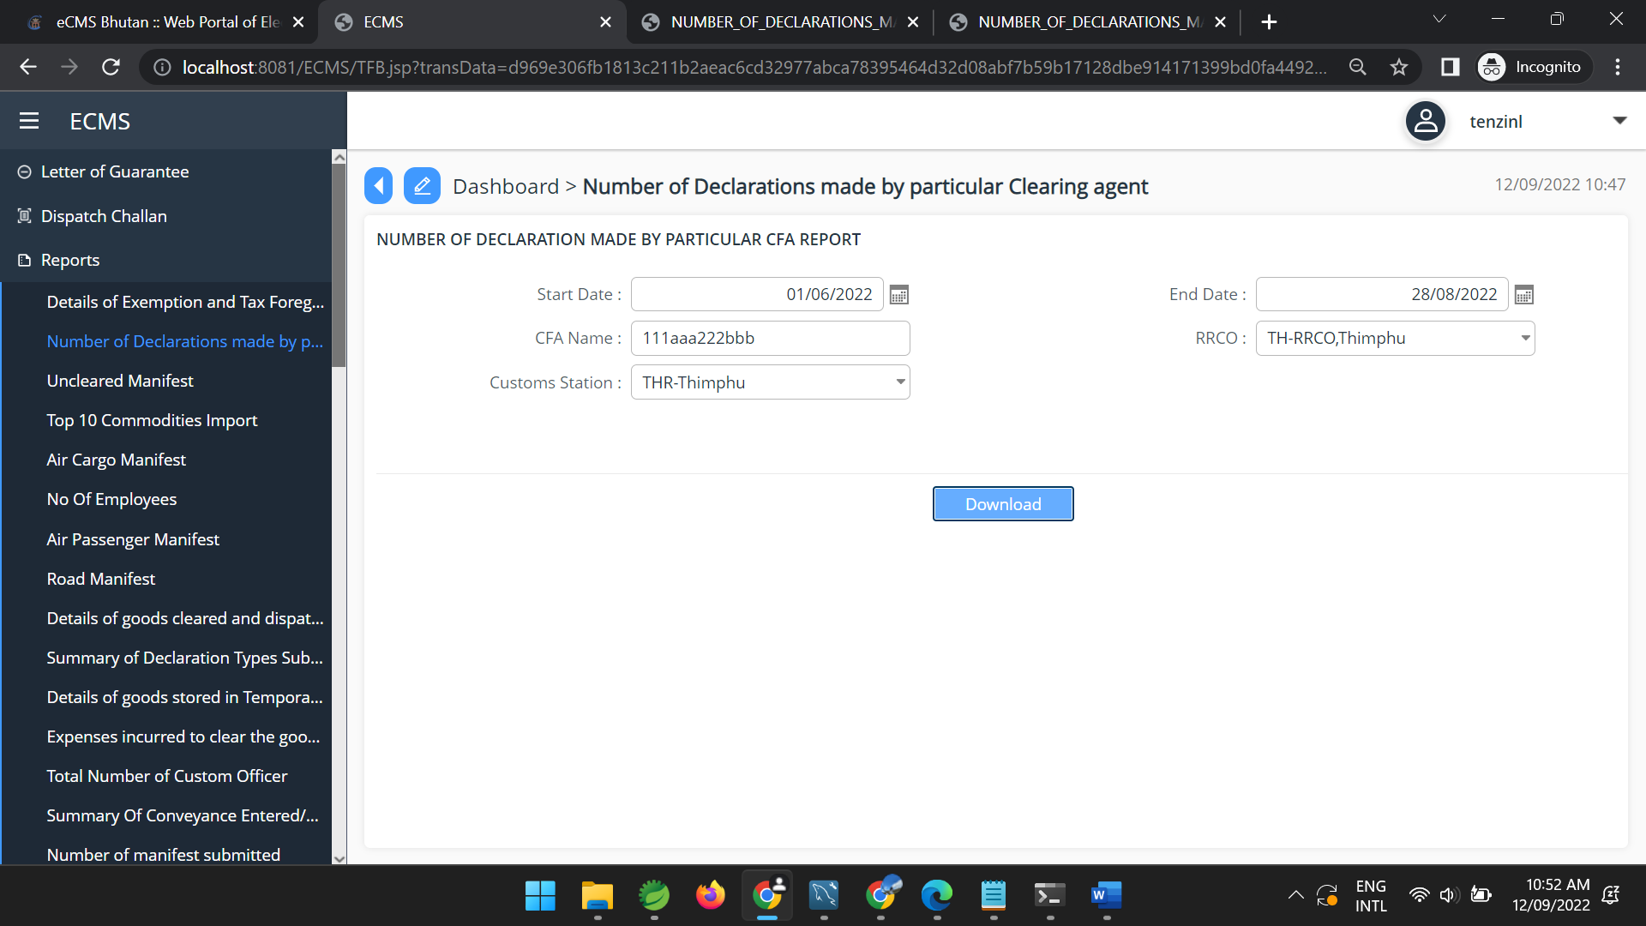
- Number of Transactions under ACT
- Click >> Number of Transaction Under ACT. The subsequent screen will be displayed.
- Input parameters start date and end start which is within the 3 months range.
- Select the RRCO
- And according to what RRCO you select , customs Station of that particular RRCO will be listed. (for example; for now Thimphu RRCO is selected and Customs Station of Thimphu RRCO is listed.
- Finally generate the report(either in pdf or excel).
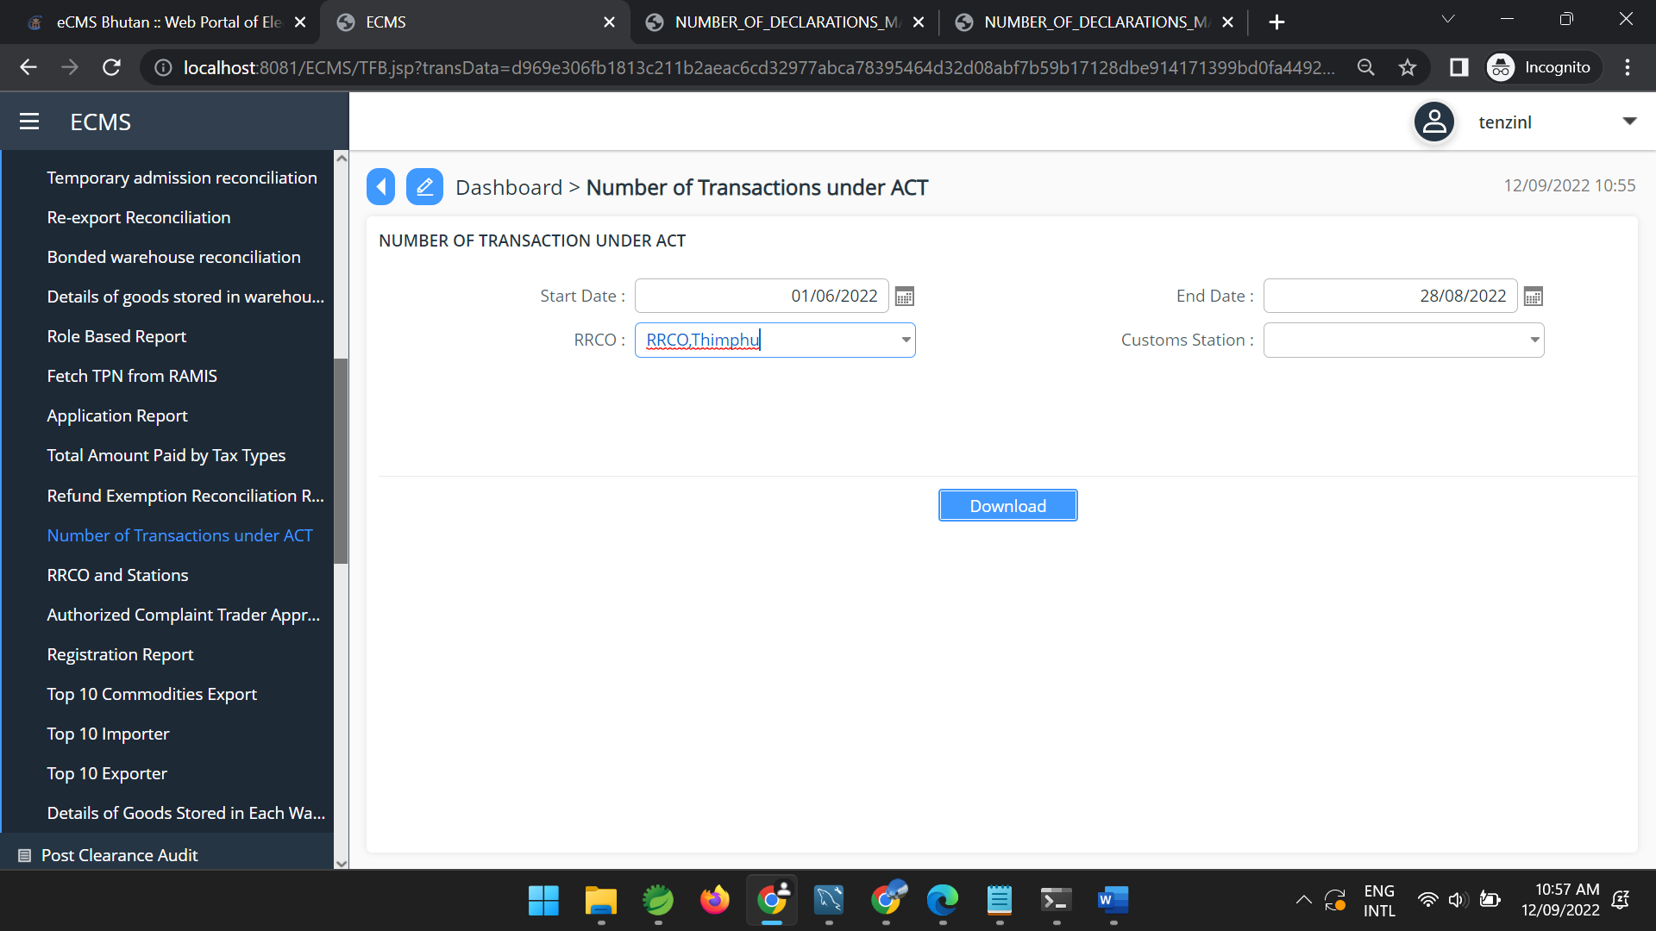

- Number of Detention/Seizure/Confiscation
- Number of Duty-Free Quota issued
- Number of employees(user) Registered
- Air cargo manifest
- Air passenger Manifest
- Road Manifest
- Undeclared manifest
- Summary of conveyance entered/exited
- Summary of Declaration Types Submitted to Customs
- Temporary Admission reconciliation report
- Re-export reconciliation Report
- Refund Exemption reconciliation report
- Bonded Warehouse Reconciliation Report
- Details of Goods stored in Each warehouse
- Details of Exemption and Tax forgone
- Details of Exemption and Tax forgone
- Details of goods cleared and dispatched from LTO
- Total number of customs officers by region and check post
- Total Amount Paid by tax types
- Expenses incurred to clear the goods from Kolkata
- Role based Report
- Top Ten commodities Export
- Top Ten Commodities Import

