Project - Pawn Shop Management

**Software Requirements Specification**

Version 1.0

Da nang, 17 Sep 2024

**Table of content**

**Table of content** 2

1. Textual History 3

2. References document 3

3. Sharing list 3

4. Introduction 3

4.1 Purpose 3

4.2 Scope 3

5. Overview 3

5.1 Use case 3

5.2 Class Diagram 4

5.3 Activity Diagram 4

5.4 Sequences Diagram 4

5.5 Pseudo Code 4

6. Function 4

6.1 Function 1 - 4

7. Non Functionals 4

Performances 4

Enhanced capabilities 4

Security 5

Reliability 5

Backup and Restore 5

Interface 5

Requires operating system and software 5

Language 5

8. Appendix 5

# Textual History

| **Time** | **Summary of changes** | **Version** |
| --- | --- | --- |
| 17/9/2024 | Create the first version SRS | 1.0 |
| 17/9/2024 | Update SRS – Add System Authorization function  Update changes in Activity diagram  Update changes in interface description, Screen Content | 2.0 |
| 22/9/2024 | Edit the description of the Actors, redraw the Use Case and Flow diagrams | 3.0 |

# References document

| **Document name** | **Description** |
| --- | --- |
| SRS_Sample | Refer to sample SRS |
| Use Case Diagram | Refer to how to draw Use Case diagram |
| UML Activity Diagram | See how to draw Systems Pages Flow diagram |
| MockProject | Task division plan |
|  |  |
|  |  |
|  |  |

# Sharing list

This document is distributed to the following stakeholders for comments and modifications.

| **Full name** | **Position** |
| --- | --- |
| Lê Nam Hải | 4.Introduction(Finish) |
| Lê Nguyễn Quốc Đạt  Đặng Trần Gia Huy | 5.Overview(Finish) |
| Trần Thị Khánh Vy | 6.Function (Not Finish) |
| Phan Thanh Tùng | 7.Non-Functional(Not Finish) |

# Introduction

## Purpose

**Build a Pawn Shop Management System with the following goals:**

- Full of basic features, ensuring the needs of users.

- Intuitive, convenient interface.

- Ability to secure, assign access rights, each type of user can only access specific functions.

- Optimise business operations and enhance user experience.

**Through that:**

- Understand how to deploy a software project according to the most general process

- Cultivate the ability to work in groups, serving the learning process better.

## Scope

**Project scope Pawnshop Management:**

- Application in small and medium sized pawn shops.

- Suitable for the subject project limit.

# Overview

## Software architecture diagram (Ex: Layered Architecture (Tầng lớp kiến trúc), Client-Server Architecture (Kiến trúc Máy khách - Máy chủ), **Microservices Architecture (Kiến trúc Vi dịch vụ)**, **Event-Driven Architecture (Kiến trúc Điều khiển Sự kiện)**, **Component Diagram (Sơ đồ Thành phần)**, **Deployment Diagram (Sơ đồ Triển khai)**, **Database Architecture Diagram (Sơ đồ Kiến trúc Cơ sở dữ liệu)**, **Service-Oriented Architecture (Kiến trúc Hướng Dịch vụ - SOA)**, **Cloud Architecture Diagram (Sơ đồ Kiến trúc Đám mây) (**hải)

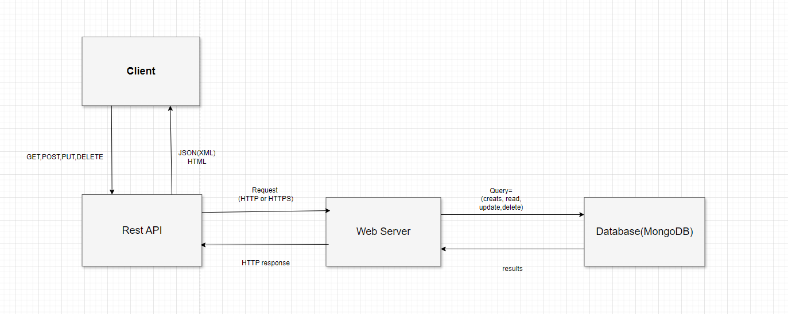

## Use case (huy)

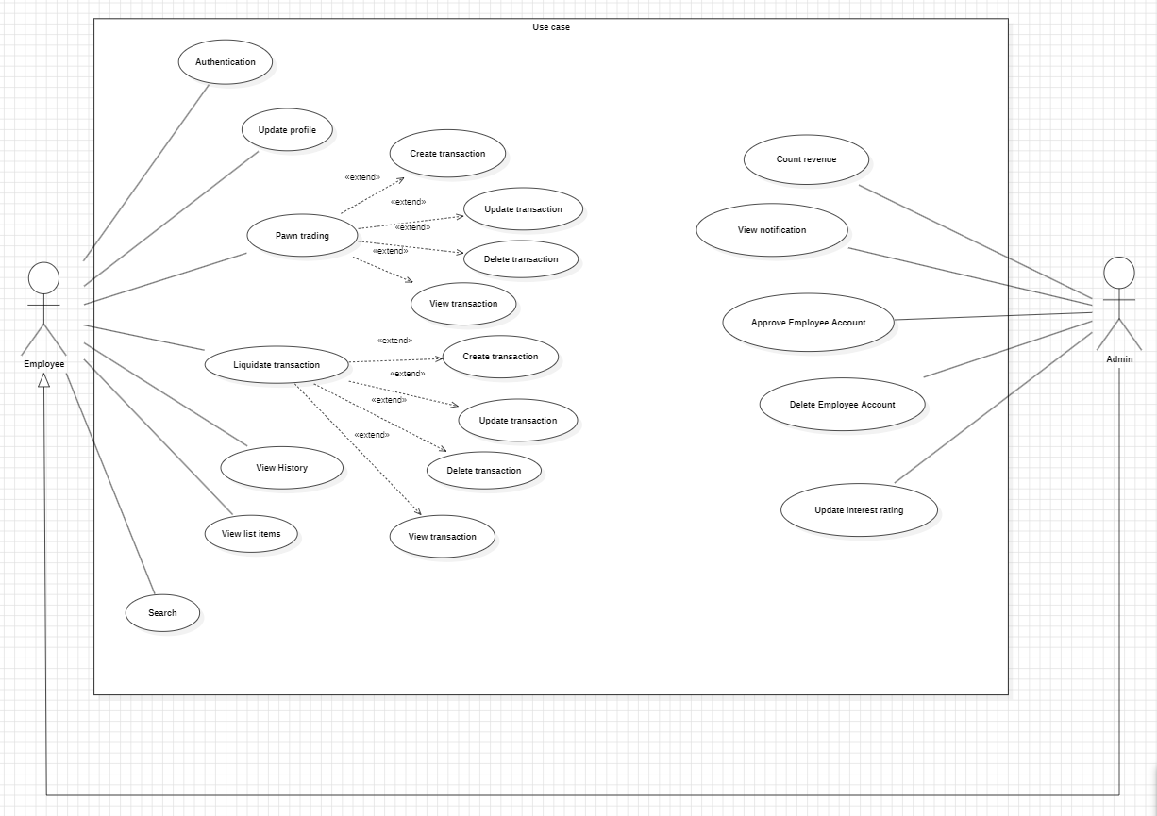

<<Introduction to table>>

| **Use case** | | **Description** |
| --- | --- | --- |
| Authentication | | This use case allows users (customers and employees) to securely log in and access the system. It verifies the user's credentials (username and password) and grants access to the system based on their role. Employees may have different permissions compared to customers. |
| Update Profile | | This use case allows employees to modify their personal information, such as their name, address, contact details, and password. The updated information is stored and reflected in the system. |
| Pawn Trading | | This use case allows users (owner, employees) to initiate pawn transactions by pledging an item as collateral for a loan. The system captures the item details, loan terms, interest rates, and generates a transaction record. The employee approves the transaction after verifying the item’s value. |
| Liquidation Transaction | | This use case allows users (owner, employees) to create liquidation transactions for items where a customer fails to repay a loan within the agreed upon term. The system tracks liquidation details, including the sale price, buyer information, and any surplus or deficit after the loan is paid off. |
| View History | | This use case allows users (owner, employees) to view a history of their transactions, including pawn trades, liquidation, and payments. The system filters transactions by date, type, or item. |
| View List Items | | This use case enables users (owner, employees) to view and manage a list of all pawned items in the system. The system displays item details such as description, pawn date, loan value, and status (active, repaid, liquidated). |
| Search | | This use case allows users (owner, employees) to search for specific items, transactions, or customers within the system. The system provides a search bar and filters to refine the results. |
| Count Revenue | | This use case generates revenue reports for the pawnshop. It calculates revenue from interest payments, liquidation sales, and other transactions over a specified period. The system provides charts and graphs for better analysis. |
| View Notification | | This use case handles automated notifications sent to owner and employees regarding upcoming payments, overdue loans, or liquidation notices. |
| Approve Employee Account | | This use case allows administrators to review and approve new employee accounts that have been created but not yet verified. Once approved, the employee can log in and access the system to perform their tasks. |
| Delete Employee Account | | This use case allows administrators to remove an employee's account from the system. This action is typically taken when an employee leaves the company or is no longer authorized to access the system. |
| Update Interest Rating | | This use case allows authorized employees (e.g., managers) to update the interest rates for pawn transactions in the system. The system ensures that all new transactions apply the updated rates while maintaining historical rates for past transactions. |

## Class Diagram (vy)

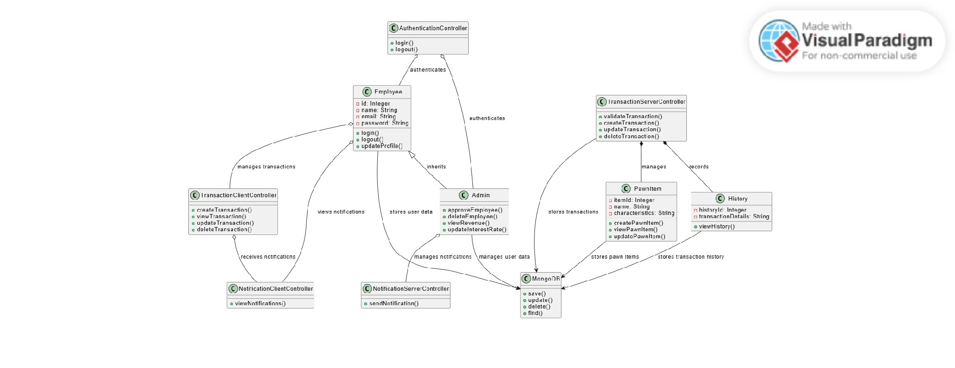

## Object Diagram (đạt)

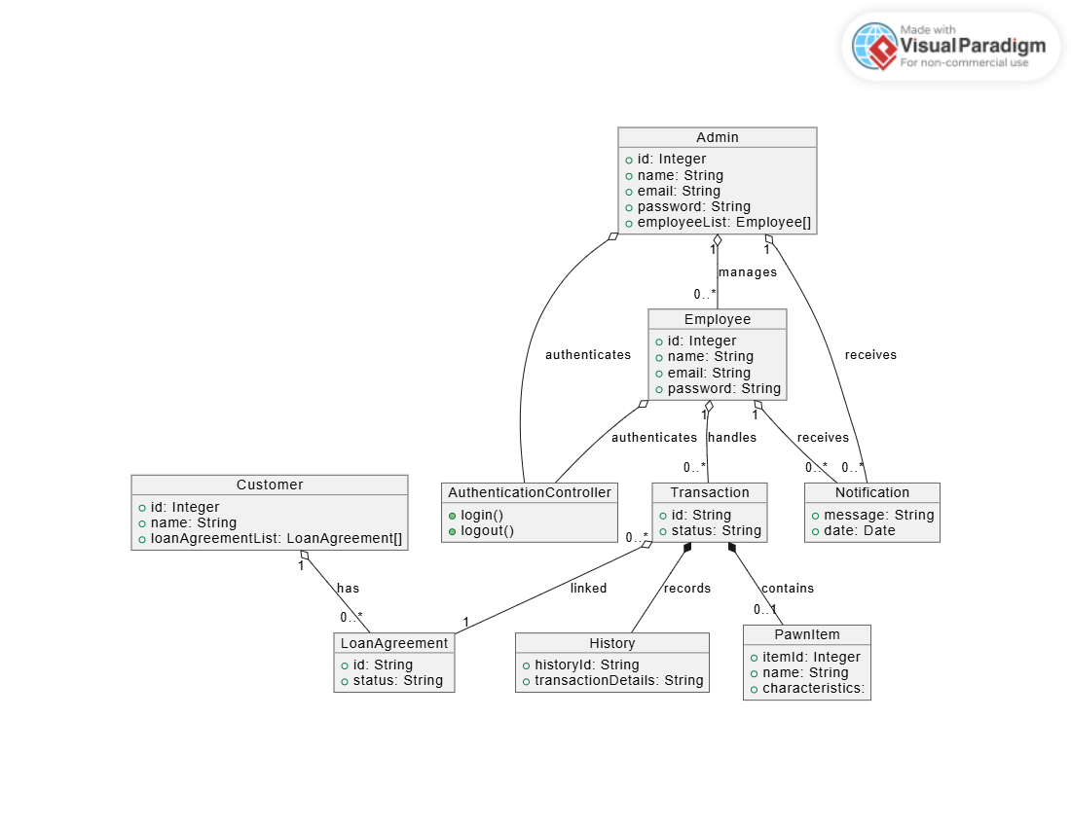

## Deployment Diagram (tùng)

## Activity Diagram(vy, tùng)

**Account Management**

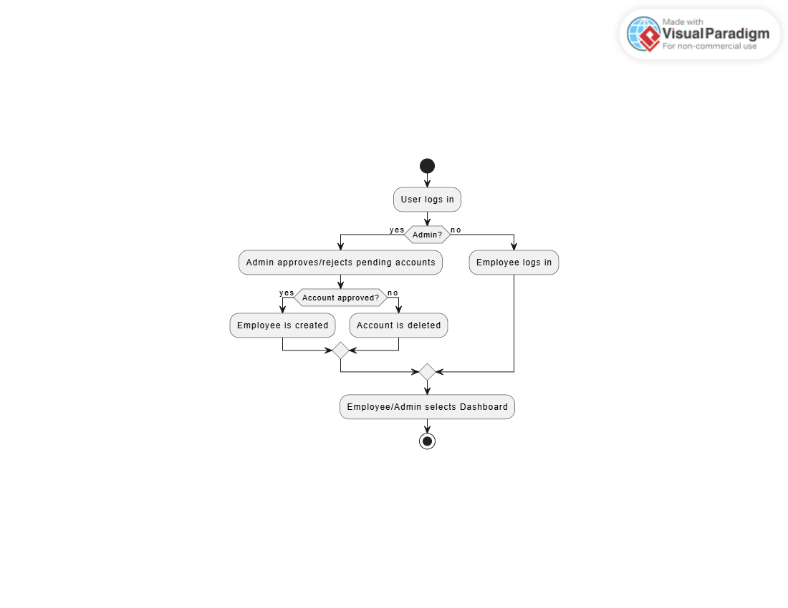

**Pawn Transaction Management**

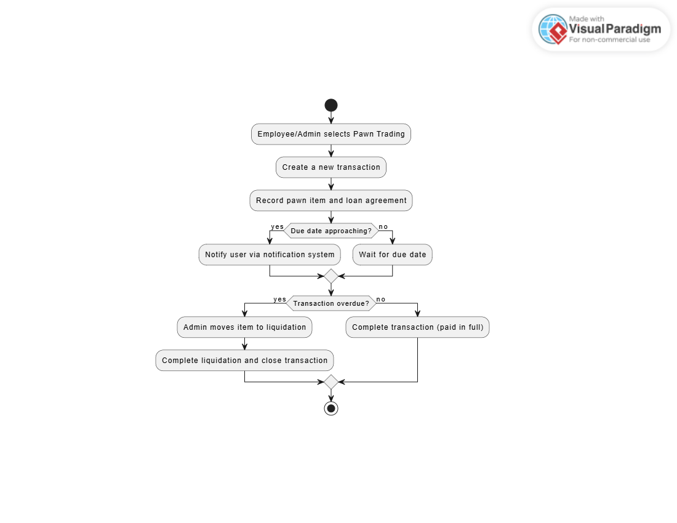

**Update Interest Rates**

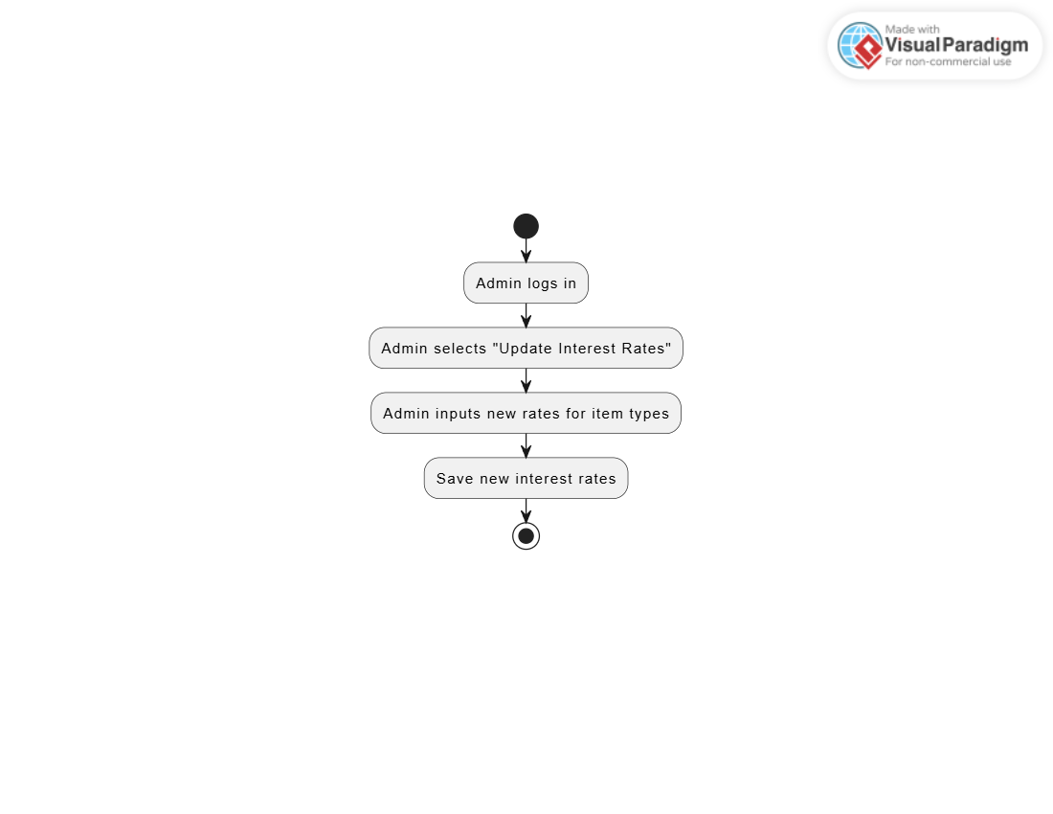

**Reporting and Analytics**

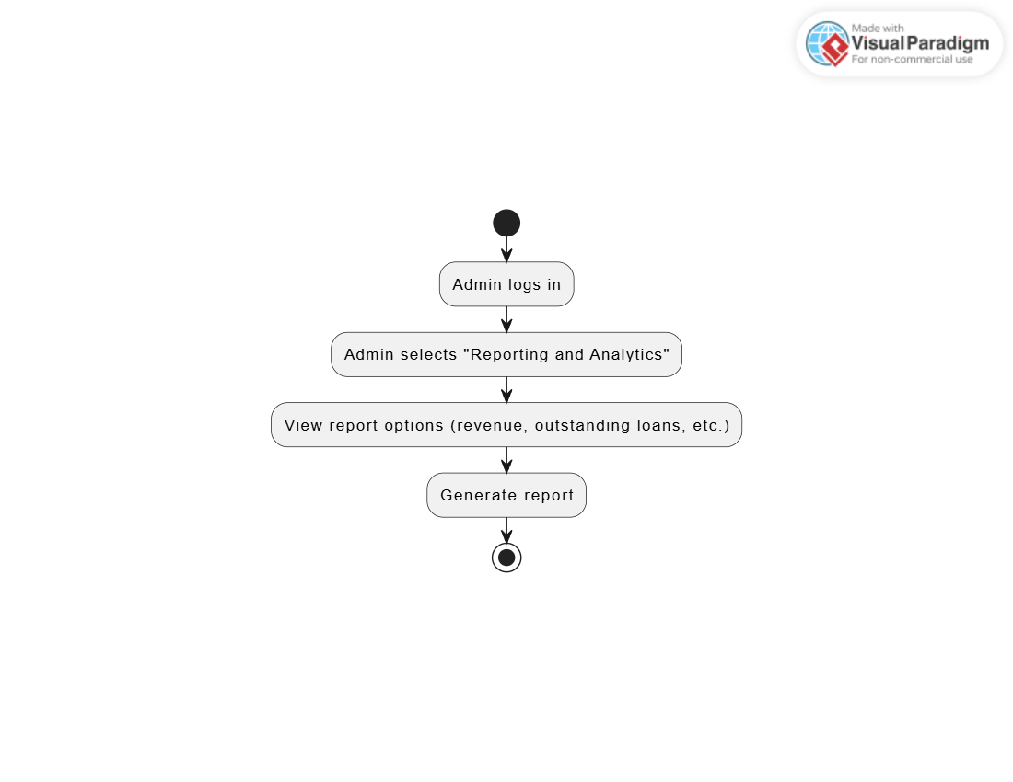

## Sequences Diagram(đạt vs hải)

**Account Management**

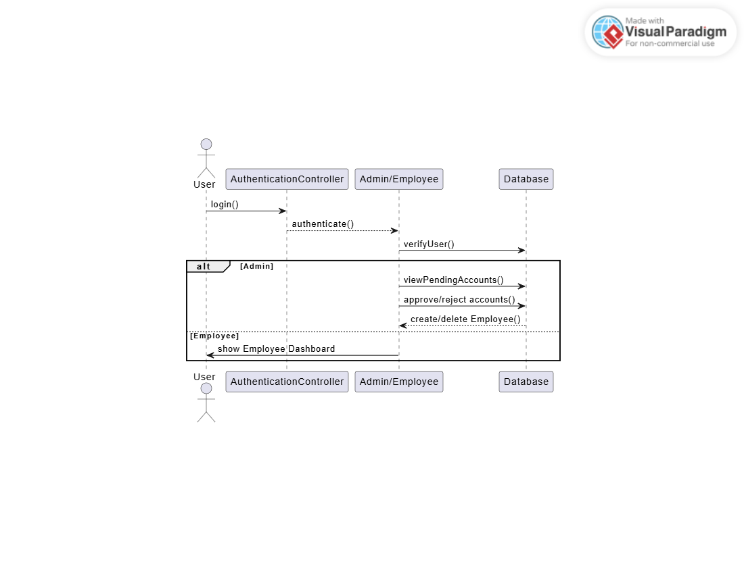

**Pawn Transaction Management**

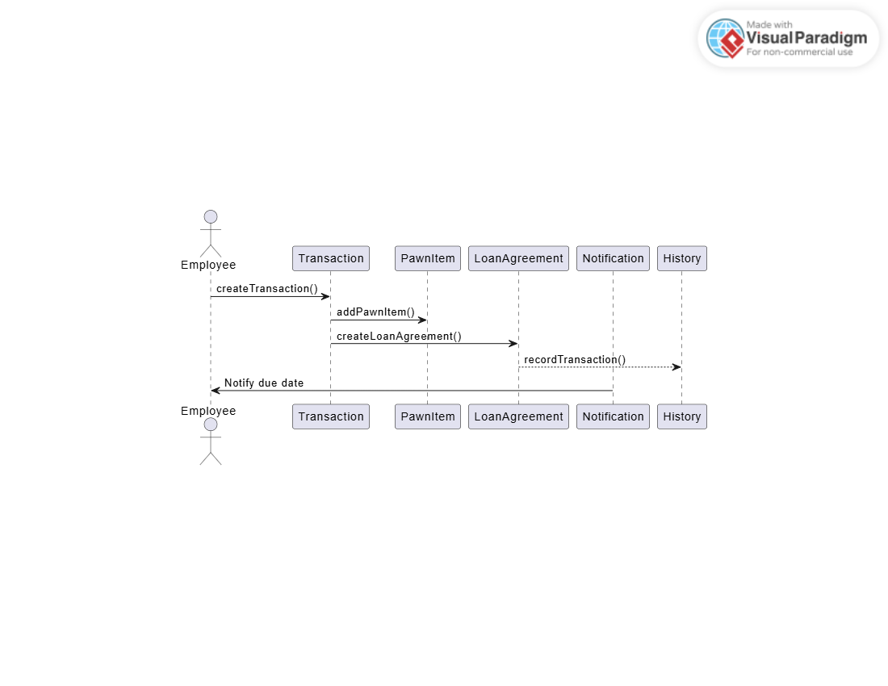

**Liquidation Management**

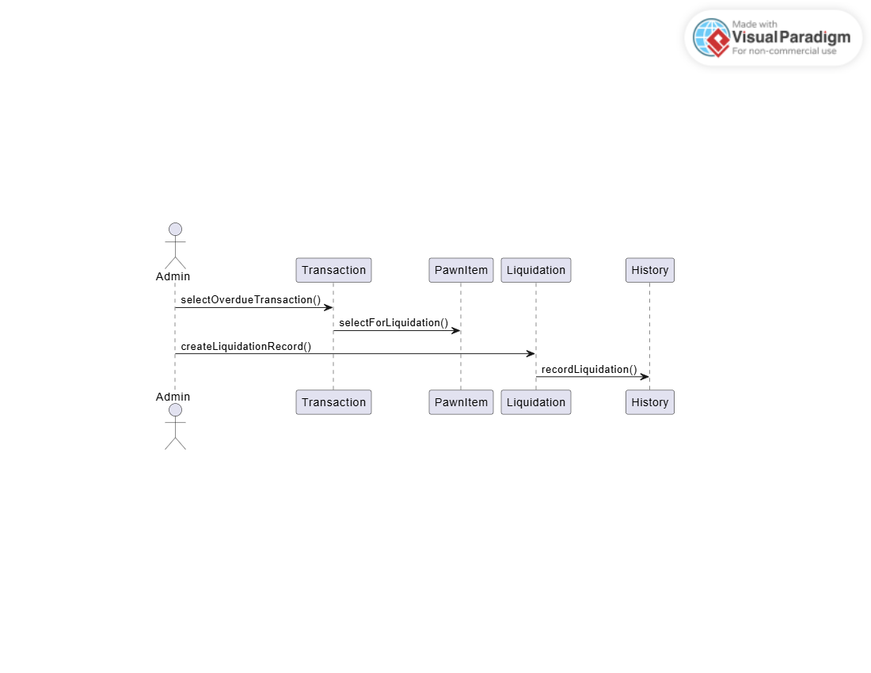

**Update Interest Rates**

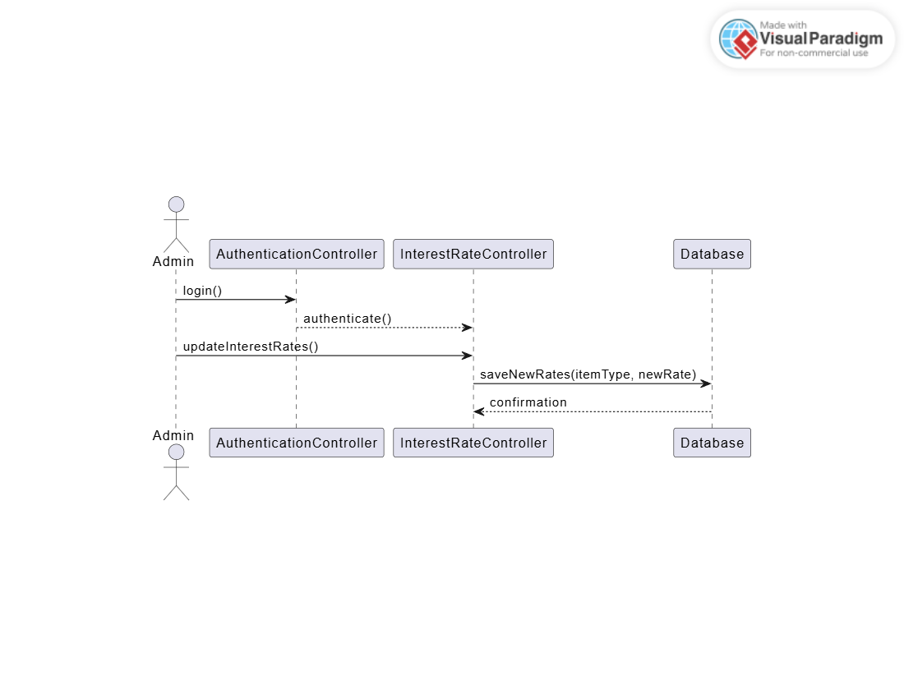

**Reporting and Analytics**

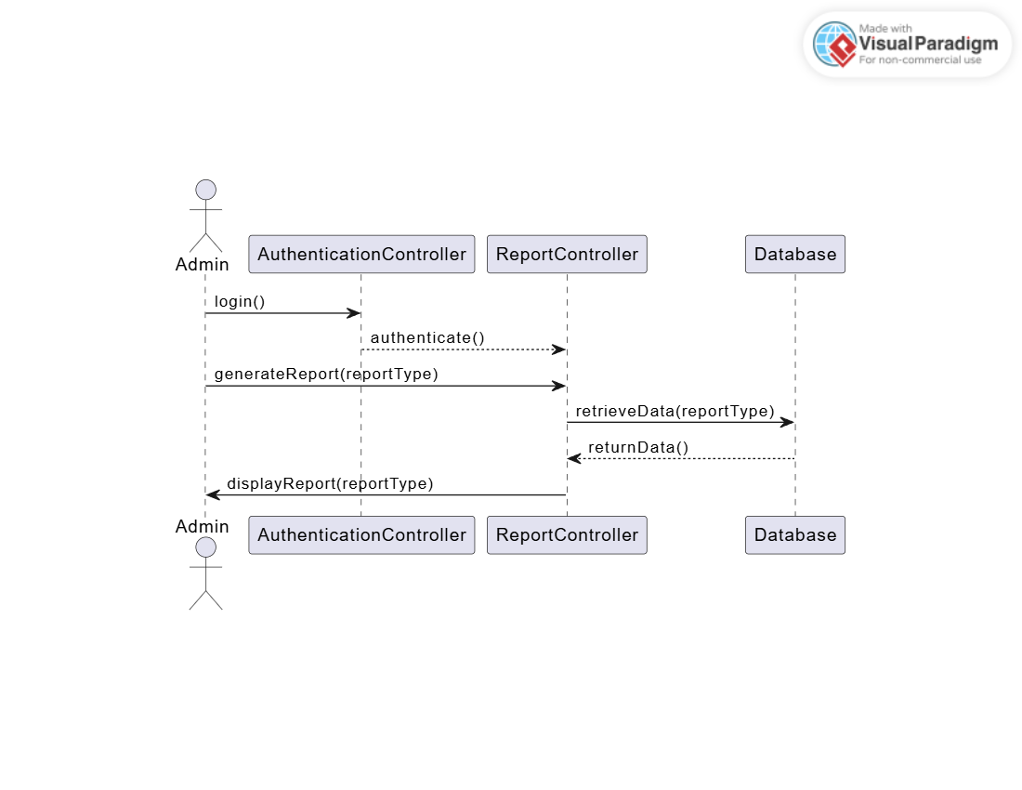

## State Diagram(Huy )

**Account Status**

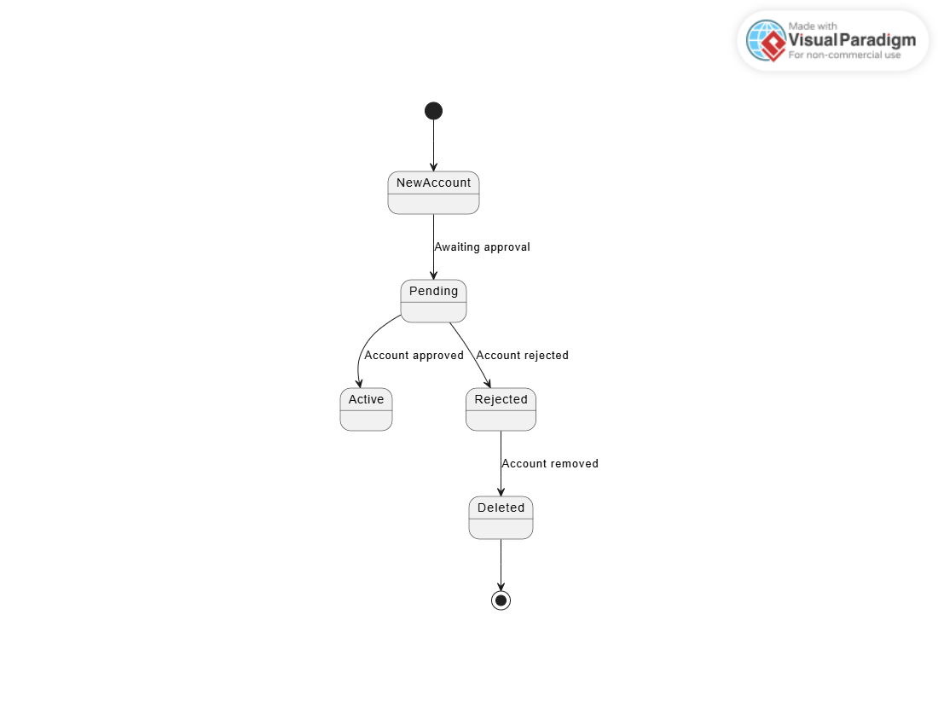

**Pawn Transaction Status**

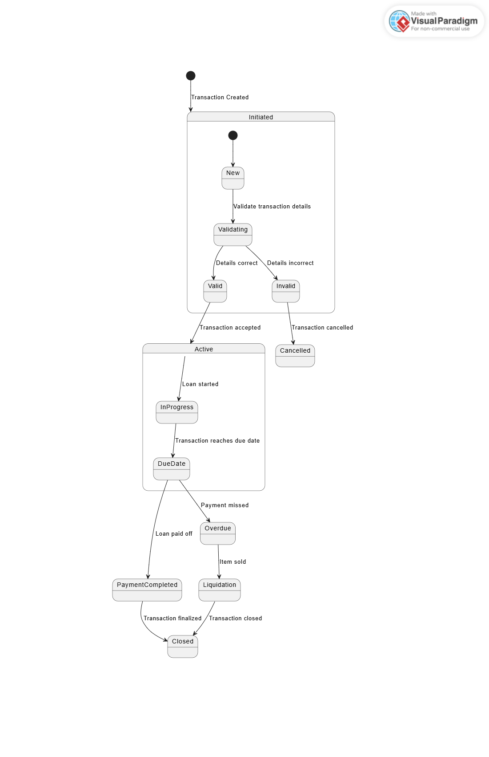

**Liquidation Status**

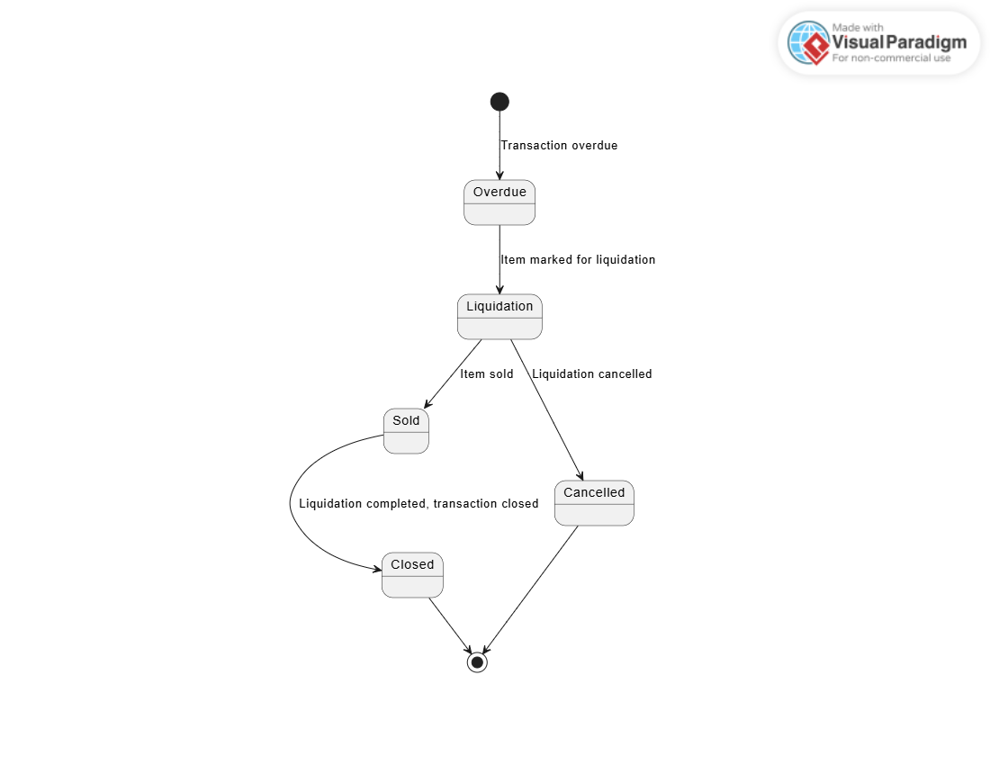

**Update Interest Rates**

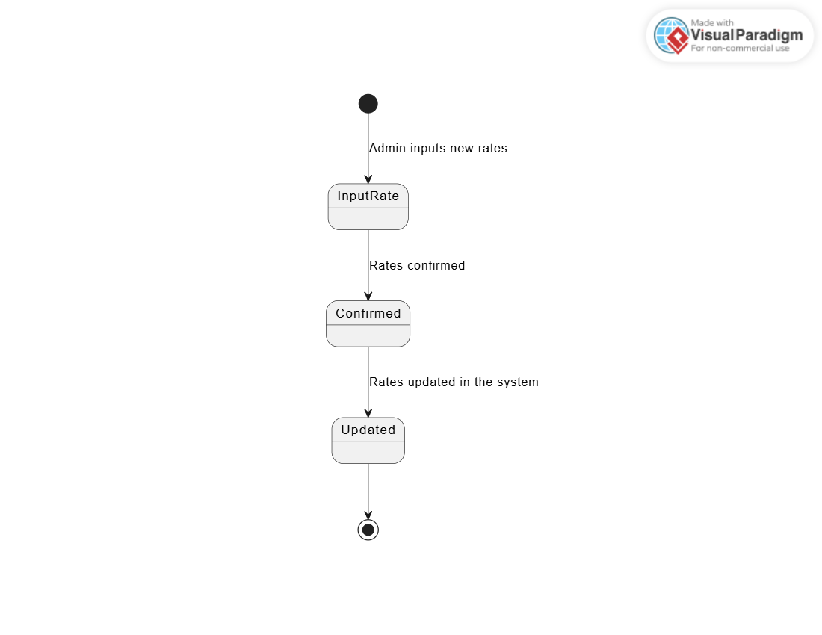

**Reporting and Analytics**

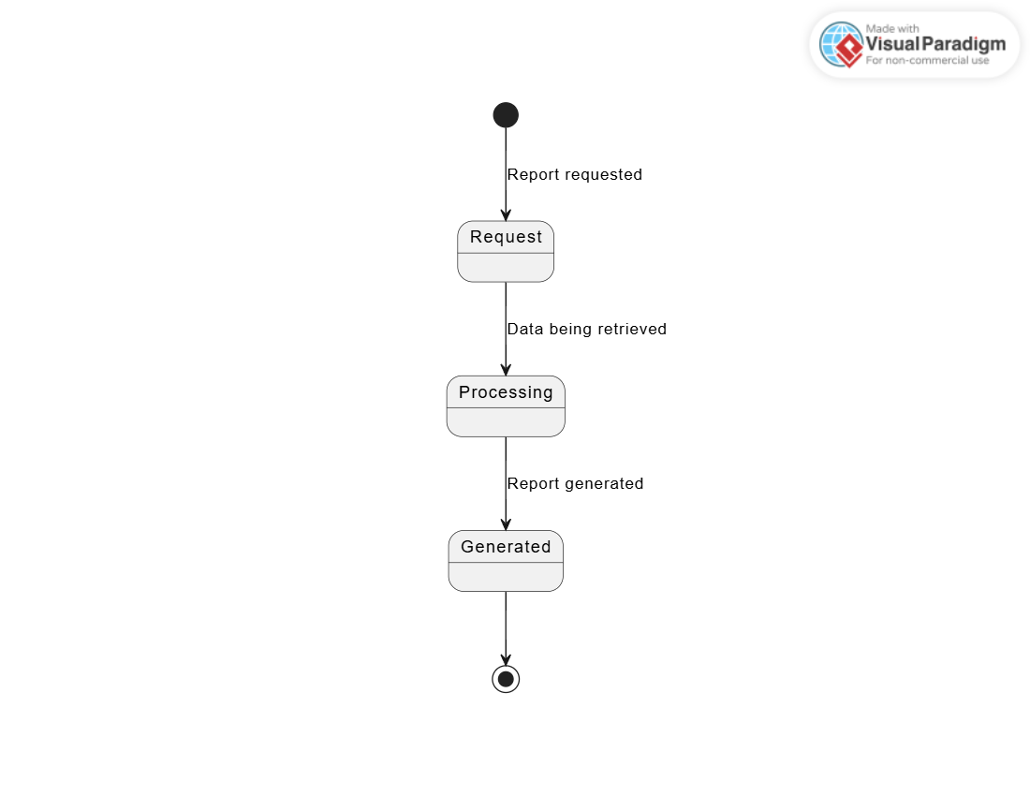

# Function

## Function 1 -

Function Description details

<<GUI>>

| **GUI name** | Đặt vé – Chọn phim và xuất chiếu | | | | |
| --- | --- | --- | --- | --- | --- |
| **Description** | | Hiện thị các phim đang chiếu và các xuất chiếu của phim | | | |
| **Access mode** | | Người dùng truy cập vào đặt vé | | | |
| **GUI of content** | | | | | |
| **Items** | | **Type** | **Data** | **Description** | |
|  | |  |  |  | |
|  | |  |  |  | |
|  | |  |  |  | |
|  | |  |  |  | |
| **Action** | | | | | |
| **Action name** | | **Description** | | **Success** | **Fails** |
|  | |  | |  |  |
|  | |  | |  |  |
|  | |  | |  |  |

# Non Functionals

Performances

| **Id** | **Description** |
| --- | --- |
|  |  |
|  |  |
|  |  |

Enhanced capabilities

| **Id** | **Description** |
| --- | --- |
|  |  |
|  |  |

Security

| **Id** | **Description** |
| --- | --- |
|  |  |

Reliability

| **Id** | **Description** |
| --- | --- |
|  |  |
|  |  |

Backup and Restore

| **Id** | **Description** |
| --- | --- |
|  |  |

Interface

| **Id** | **Description** |
| --- | --- |
|  |  |
|  |  |

Requires operating system and software

| **Id** | **Description** |
| --- | --- |
|  |  |
|  |  |
|  |  |

Language

| **Id** | **Description** |
| --- | --- |
|  |  |
|  |  |

# Appendix

| *Assignment* | Deadline |
| --- | --- |
| 1,2,3,4,5 (5.1 -> 5.5) | 23/09/2024 |
| 5.5 -> 5.8 | 14/10/2024 |
| 6-> End | 28/10/2024 |
|  |  |
|  |  |
|  |  |
|  |  |
|  |  |