Basic concepts:
- HTTP(S): Hyper Text Transfer protocol (Secure)
- CSS: Cascading style sheet
- HTML: Hyper Text Markup Language:
  - Uses tags or symbols
  - Describe structure, not logic
  - Human readable, machine executable
- NaN: Not a Number
- Web address parts: “http://www.domain.edu.au:1000/path/to/file?parameters=true#fragment”
  - Protocol used: https, http, ftp, …
  - Domain name: map to IP address
  - Port number: default of HTTP is 80
  - Path/route to the HTML file that’s going to be executed
  - Parameters pf the request: key-value pairs
  - anchors to a location in a page
CSS precedence rules: if have “!important” then over rule all
- Transition > important user agent > important user > author > normal user > normal user agent
- Inline > style sheet (not external)
- Id > class > tag > elements (specificality win)
- Càng ở dưới càng ưu tiên
Box model: content – padding – border – margin
- Margin is the spacing between the border and neighboring elements
- Padding is the spacing between border and its content
- Box size determines by the border, not margin
Position properties:
- Static: go with normal flow
- Relative: offset relative to the position it would have been in normal flow
- Absolute: offset relative to the most recent position ancestor, deleted from normal flow
- Sticky: switch between fixed and relative depend on scrolling position
Bootstrap grid system: divided into 12 columns
- Structure: col – (sm/md/lg) – (number): sm/md/large is the screen size that the element will behave; the number of columns = 12/number
- Icon in bootstrap are called Glyphicons, and are rendered as texted
JavaScript:
- NaN datatype: short for Not A Number
- == is to compare value ex: 1 == True is true, but === is to compare value and type ex: 1 === True is false
- Object are like dictionary: to access value: object.key; to access key: object[value]
- Const and let have block level scope (only usable inside a set of {})
- Var has function level scope (usable everywhere inside the function it was declared in, rarely use)
- Undeclare have global scope (usable everywhere)
DOM: document object model: tree like structure: document then split into head and body the split…
BOM: browser object model: Window object top of the tree
jQuery:
- Is JavaScript library
Server communication:
- GET: retrieve data from the server; POST: create or alter data on the server; PUT: replace data on the server; DELETE: delete data from the server.
- HTTP request in JavaScript:
  - Old style: GET, POST, PUT, … methods
  - All browser have a XMLHttpRequest objects
  - With jQuery: using the fetch(“url”) method
- CORS: cross origin resource sharing is a mechanism
- AJAX: Asynchronous JavaScript And XML, mainly use to transport JSON file
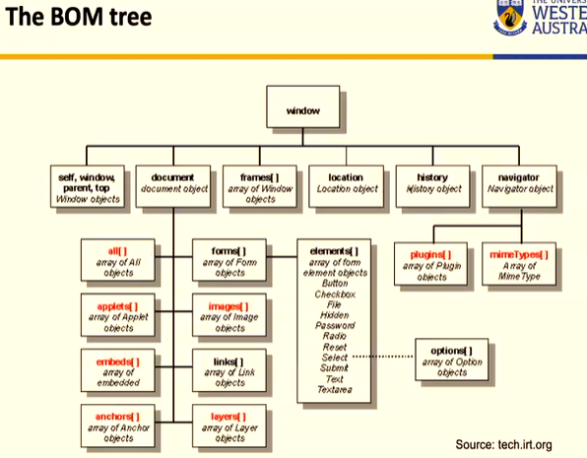s
- Cookies: max 4KB text file containing key-value pairs
- Event driven programing: the flow of the program is determine by sensor output and user action

