Description: cid:image001.gif@01CE9E53.B8D2CCE0

VTC MOBILE – Deposit to game reference from League – API

Index

1.Payment Callback API 4

1.1. Overview 4

1.2. Sequence diagram 4

1.3. API description 4

2.Supporter 5

|  |  |  |  |
| --- | --- | --- | --- |
| Version | Date | Description | Author |
| 1.0 | 08/23/2017 | Creator | Nguyen Phuc |
|  |  |  |  |

# Payment Callback API

## 1.1. Overview

- When client want deposit scoin to game in app League. App League will open webview with base url from Scoin and add parameter into url: ref=T19.

Example: when client deposit to game “Thuy Chien”. Url deposit will: <https://scoin.vn/ScoinPayGame2.aspx?GameId=330215&ref=T19>

- After client deposit. Scoin will call API to League with any status (error and success).

## 1.2. Sequence diagram

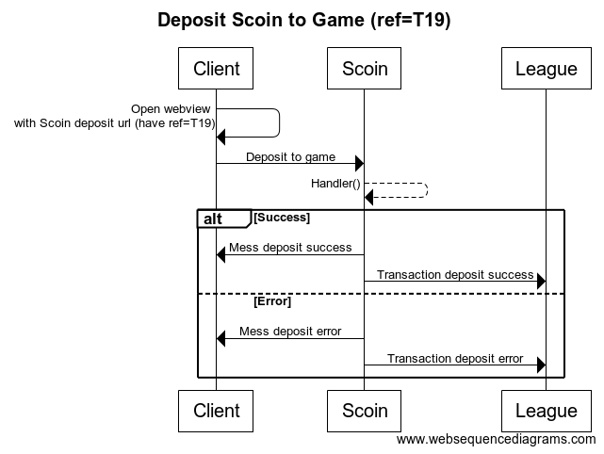

## 1.3. API description

|  |  |
| --- | --- |
| Url | https://api.league.vn/scoin/depositToGame |
| Method | POST |
| Request  Parameters | |  |  |  | | --- | --- | --- | | Name | Type | Description | | billingtransID | BigInt | VTC TransactionId (each transId, you only topup money in game once) | | accountID | Bigint | VTC AccountID | | totalPayment | Long | Amount(Scoin) client deposit | | paymentType | String | Payment Type (Payment Channel)  CARD | SCOIN | MONTHCARD | | gameID | int | ID game VTC client deposit | | errorCode | Int | Error code when client deposit  >=0 Success  < 0 Error | | errorDesc | String | Error description | | signature | String | MD5(secureSecret +  billingtransID.toString() + accountID.toString()+ totalPayment.toString() + paymentType+gameID.toString()  +errorCode.toString()+errorDesc).toUpperCase(); | |
| Response: JSON | |  |  |  | | --- | --- | --- | | Name | Type | Description | | errorCode | Int | >=0 Success <0 Fail | | errorDesc | String | Error description |   Example  {"errorCode": 1, "errorDesc":"success"}  OR  {"errorCode": -1, "errorDesc": "fail"} |

secureSecret will send to email.

# Supporter

VTC Mobile – App League

Full Name: Nguyen Phuc

Mobille: +84 1687 311 551

Email: [phucn@vtc.vn](mailto:phucn@vtc.vn)

Skype ID: nphucptit