Student Name: Hà Khánh Nam
Student ID: HE153151
Class: SE1617

Admin Create Account
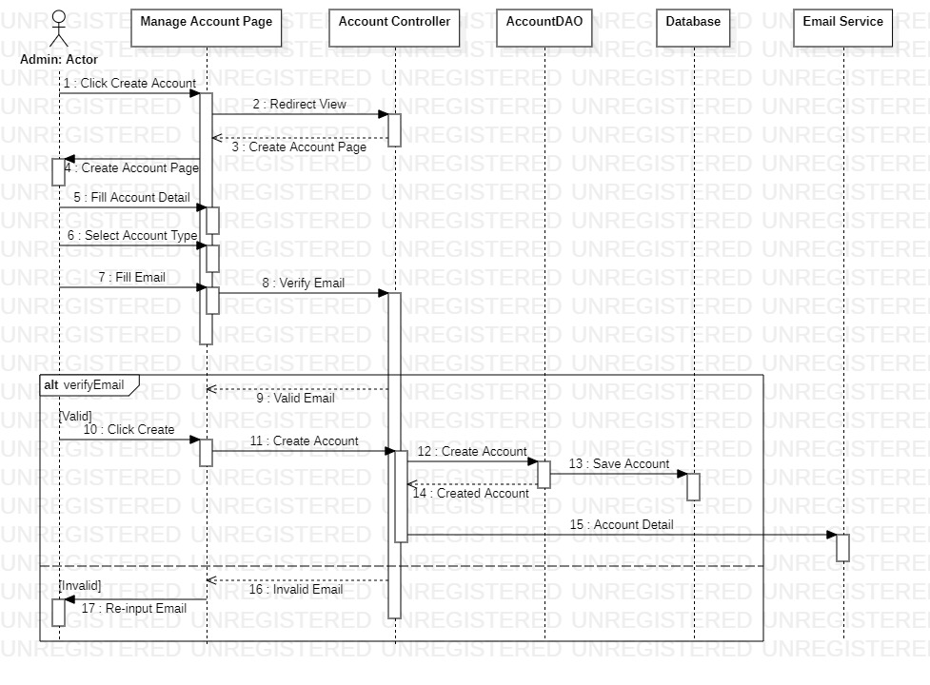

Admin Edit Feedback

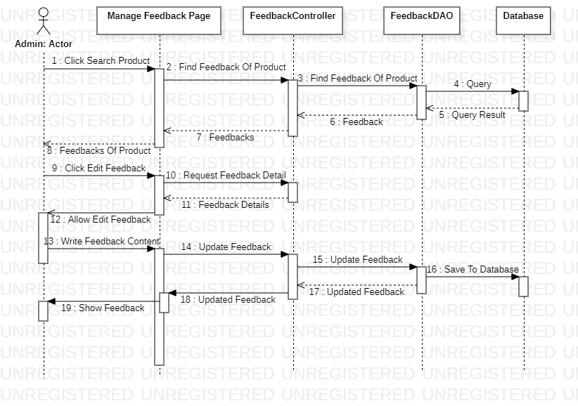

Admin Edit Shipper
