Use Case Document
Online Shopping for Baking Ingredients System
Table of Contents
Contents
Introduction 3
Explanation of Use Case Contents 3
Overview 5
Use Case 6
Class Diagram 9

Introduction
The Use Case Document is a business document which provides a story of how a system, and its actors, will be utilized to achieve a specific goal. An effective Use Case should provide a detailed step-by-step description of how the system will be used by its actors to achieve the planned outcome. This document describes the online store application of Gia Hoa Phat Company, a company operating in the food sector.

Explanation of Use Case Contents
Use Case formats and contents may vary based on system requirements, organizational standards, or unique situations. However, a majority of Use Cases consist of some fundamental contents which may be applied across a wide range of system types. This section will provide explanations for each section of the Use Case.

Name of Use Case: Provide a short name for the use case which should lend itself to the objective of the system.

Description: This section should provide a description of both the reason for using the use case and the expected outcome of the use case.

Actors: Actors may be primary or secondary. Primary actors are the people who will be initiating the system described in the use case. Secondary actors are those will participate in the completion of the use case.

Precondition: This section should describe any conditions that must be true or activities that must be completed prior to executing the use case.

Postcondition: This section should describe the state of the system at the conclusion of the use case. Postconditions may include conditions for both successful and unsuccessful execution of the use case.

Flow: This section should describe all actions of the user and the expected system responses for planned normal execution of the use case. The description should be sequential and provide adequate detail to understand all user actions and system responses.

Alternative Flows: Many use cases have varying or special extensions or conditions which are separate from the main flow but also necessary. Alternative flows are usually the result of options or exceptions built into the use case which may alter the primary flow.

Exceptions: When use cases are executed, there may be various conditions which result in errors. This section should describe any errors that may result during use case execution and how the system will react or respond to those errors.

Requirements: This section should describe any non-functional or special requirements for the system as the use case is executed. These requirements may consist of legal or regulatory requirements, quality standards, or organizational requirements that are outside of the functional requirements the system is expected to perform.

Overview
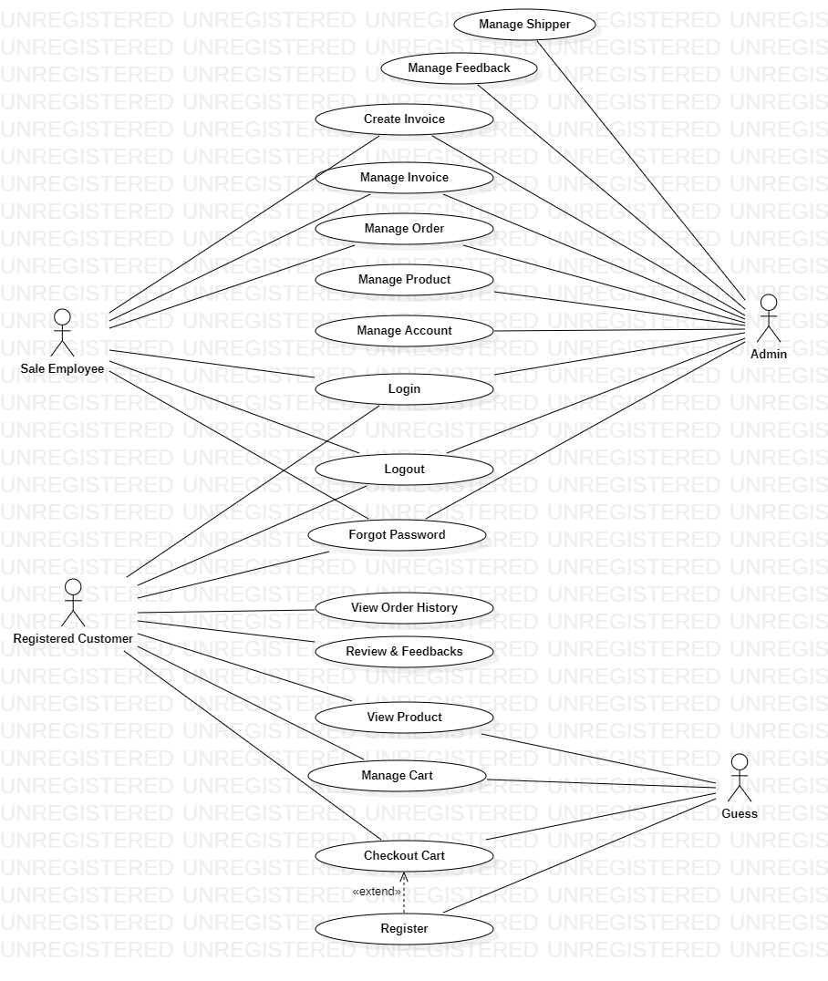

Use Case
- View Product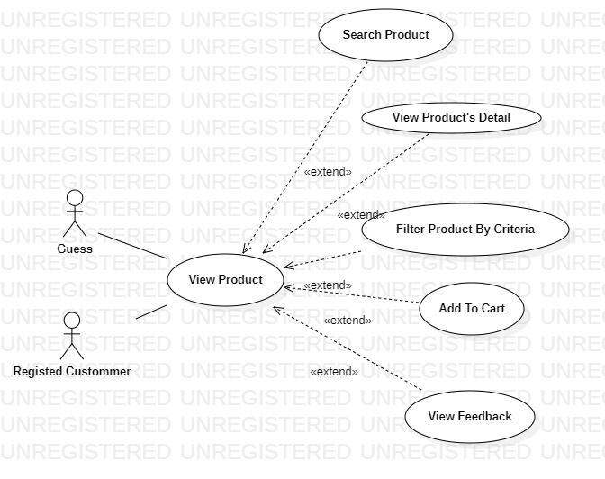
- Manage Product
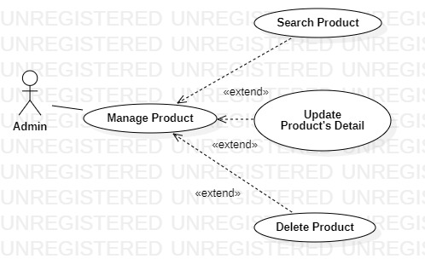
- Checkout Cart
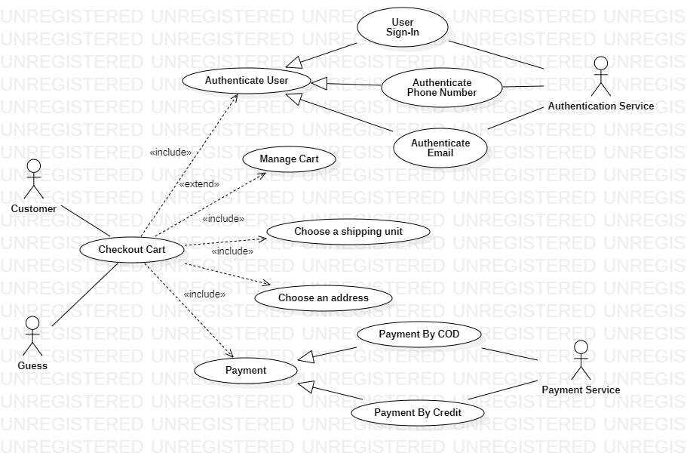
- Manage Order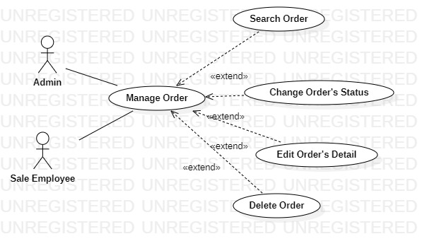
- Manage Shipper
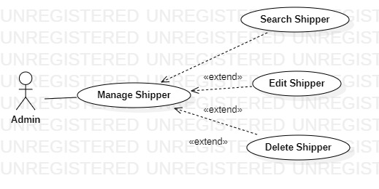

- Manage Feedback
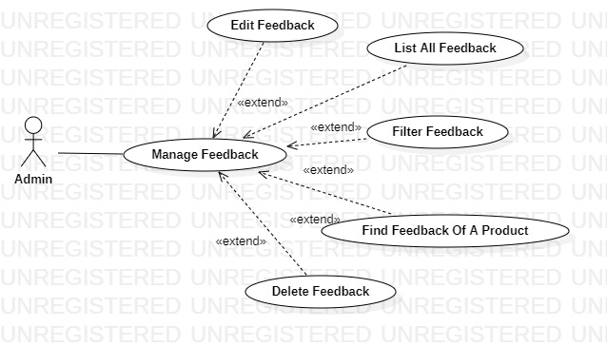

Class Diagram
