

PROJECT 2
UNIVERSITY DOCUMENT MANAGEMENT WEBSITE

BIT03K10-GROUP 2
Member | Vu Thi Ngan
Teacher | Pham Son Tung

Ha Noi, August 14th, 2020
Contents
1. Overview 3
2. Introduction 4
2.1. Overview 4
2.2. Current system 4
2.3. Recommended system 4
2.4. Techlonogy 4
3. Client needs 5
3.1. Non-funtional requirement 5
3.2. Require funtion 5
3.2.1. System user group 5
3.2.2. Functionality 6
4. System design 25
4.1. Database 25
4.1.1 Table 25
4.1.2 Database diagram 29
4.1.3 Entity diagram 30
4.2. Use case 31
4.2.1. Admin 31
4.2.2. Student 31
5. Conclusion 32

1. Overview

Due to time and practical conditions in the project making process, it is difficult for me to avoid mistakes, I hope teachers and teachers help me complete my graduation design task. Until now, the school's book distribution, big or small, has only been operated by handcraft by human. But the current trend, when the strong development of information technology leads to the need for systems to assist people in management. Through the field of information system analysis and design, the management is simpler and faster. As a student of IT-Business Administration, after 1 year of studying and training under the devoted guidance of teachers in IT-Business Administration, I have learned many useful things. According to the graduate design task of the subject, my graduation topic is: "Managing BKACAD books". Stemming from the actual need, there is a need to have a support system to manage the import and export and manipulation of the stages of book management of its academy. Building a management system using technology will increase accuracy and reduce labor. I would like to sincerely thank the teachers and teachers in the subject, especially Th. Pham Son Tung has helped me with this project. Hanoi, August 2020.

2. Introduction

2.1. Overview
The continuous strong development of the modern information technology industry, especially the human needs is also increasingly enhanced. And at present, our school is an IT training school, but the import and export of books of the school is very manual, which leads to a waste of labor. Moreover, the storage will not be accurate and long-term. That's why I want to take advantage of my understanding to build a book management system for the school to minimize labor, time, and more accurate and long-term storage. With a friendly user experience.

2.2. Current system
At present, the import and export of books is still completely done on Execl and manually on paper. That makes the import-export system become cumbersome, inaccurate, and easy to lose related documents.

2.3. Recommended system
So today my team is bringing here a product that can improve the above problems.

2.4. Techlonogy
- PHP
- Framework Laravel
- Javascript
- Bootstrap
- Jquery

3. Client needs

3.1. Non-funtional requirement
Easy-to-understand application, eye-catching interface, can be used on many devices, browsers, age of 18-50.

3.2. Require funtion

System user group

Admin
- Login
- Search
- Edit profile
- Update password
- Course management
- Major management
- Class management
- Student management
- Subject management
- Book management
- Book deliver
- Statistics
- Logout
- Student
- Login
- View status
- Edit profile
- Update password
- Logout

Functionality

- Login Admin
Factors | Admin, student
Description | Login
Activate | User access to admin login page
Input | - Username  - Password
Processing | - Get information from the form, check must not be blank  - :  - Blank: redirect to login page and error message  - Check that the username and password match any one account  - True:  - Create login session, save name, account code in session  - Redirects to the user's website  - False: redirected to the login page and error message
Output | - True: Display the user page  - False: Display login page and failure message
Note | - Check that the input box cannot be left blank using JavaScript  - The Admin login page is different from the Student page

- Edit profile
Factors | Admin, student
Description | Admin edit information
Activate | The user enters the admin homepage, presses the personal info button
Input | Id
Processing | - Home page  - Transmit the code saved at the login session to a file that fixes personal information  - Open the database connection:  - Get personal information at the code passed on to the database to display on the personal information correction form, cannot be blank:  - Blank: error data  - Fill: edit new information at passcode, close connection, redirect to edit form and announce success
Output | - Error: redirect to edit form and announce error  - Success: redirect to edit form and announce success
Note | Check cannot be left blank with laravel

- Search
Factors | Admin
Description | Admin moves information into the search bar, press enter
Activate | Admin moves information into the search bar, press enter
Input | Search keywords in the search bar
Processing | 1. Admin home page  2. Check admin  - True: show the management section on the menu bar, pass the search keyword into the search bar, pass the search keyword into the file, connect to the database, check if the keyword matches the data on the database  - True: retrieve duplicate records from the database and display and close the connection  - False: no records are displayed, close connection  - False: redirects to the login page, with errors
Output | - True: displays records that match a test condition  - Flase: No records are displayed

- Update course:
Factors | Admin
Description | Admin edit course
Activate | The user enters the admin home page, presses the view all courses button on the menu bar, then presses the edit button
Input | Id
Processing | - Admin home page  - View all course  - Get the code of the admin to be edited and pass the file to edit course  - Open database connection:  - Get the course information in the code passed on the database to display on the edited form, check cannot be left blank:  - Blank: cannot be left blank  - Fill: pass new information and course code to processing file, open a database connection, check whether the course code matches on the database  - True: edit new course information at code pass, close connection, redirect to update form with success notification.  - False: close the connection, redirect to the update page with the error message
Output | - Error: close the connection, redirect to the update page with the error message.  - Success: close the connection, redirect to the update page with the success message.
Note | Check cannot be left blank with laravel

- Insert course:
Factors | Admin
Description | Insert course
Activate | The user enters the admin homepage, presses the add course button on the menu bar
Input | Name
Processing | 1. Admin home page  2. Check admin  - True: Show course management on the menu bar and add course button, switch to the form adding course, check cannot be left blank  - Blank: cannot be left blank  - Fill: transfer the new course information to the processing file, open a database connection, check whether the course already exists  - Exist: close the connection, redirect to the customer add form with error message  - Doesn`t exist: insert new information into the database, redirect to the insert course page with success message, close connection  - False: redirects to the login page, with errors
Output | - Error: close the connection, redirect to the insert page with the error message.  - Success: close the connection, redirect to the insert page with the success
Note | Check cannot be left blank with laravel

- Update major:
Factors | Admin
Description | Admin edit major
Activate | The user enters the admin home page, presses the view all major button on the menu bar, then presses the edit button
Input | Id
Processing | - Admin home page  - View all major  - Get the code of the admin to be edited and pass the file to edit major  - Open database connection:  - Get the major information in the code passed on the database to display on the edited form, check cannot be left blank:  - Blank: cannot be left blank  - Fill: pass new information and major code to processing file, open a database connection, check whether the major code matches on the database  - True: edit new major information at code pass, close connection, redirect to update form with success notification.  - False: close the connection, redirect to the update page with the error message
Output | - Error: close the connection, redirect to the update page with the error message.  - Success: close the connection, redirect to the update page with the success message.
Note | Check cannot be left blank with laravel

- Insert major:
Factors | Admin
Description | Insert major
Activate | The user enters the admin homepage, presses the add major button on the menu bar
Input | Name
Processing | 1. Admin home page  2. Check admin  - True: Show major management on the menu bar and add major button, switch to the form adding major, check cannot be left blank  - Blank: cannot be left blank  - Fill: transfer the new course information to the processing file, open a database connection, check whether the major already exists  - Exist: close the connection, redirect to the customer add form with error message  - Doesn`t exist: insert new information into the database, redirect to the insert major page with success message, close connection  - False: redirects to the login page, with errors
Output | - Error: close the connection, redirect to the insert page with the error message.  - Success: close the connection, redirect to the insert page with the success
Note | Check cannot be left blank with laravel

- Update class:
Factors | Admin
Description | Admin edit class
Activate | The user enters the admin home page, presses the view all class button on the menu bar, then presses the edit button
Input | Id
Processing | - Admin home page  - View all class  - Get the code of the admin to be edited and pass the file to edit class  - Open database connection:  - Get the class information in the code passed on the database to display on the edited form, check cannot be left blank:  - Blank: cannot be left blank  - Fill: pass new information and class code to processing file, open a database connection, check whether the class code matches on the database  - True: edit new class information at code pass, close connection, redirect to update form with success notification.  - False: close the connection, redirect to the update page with the error message
Output | - Error: close the connection, redirect to the update page with the error message.  - Success: close the connection, redirect to the update page with the success message.
Note | Check cannot be left blank with laravel

- Insert class:
Factors | Admin
Description | Insert class
Activate | The user enters the admin homepage, presses the add class button on the menu bar
Input | - Name  - Id course  - Id major
Processing | 1. Admin home page  2. Check admin  - True: Show class management on the menu bar and add class button, switch to the form adding class, check cannot be left blank  - Blank: cannot be left blank  - Fill: transfer the new class information to the processing file, open a database connection, check whether the class already exists  - Exist: close the connection, redirect to the customer add form with error message  - Doesn`t exist: insert new information into the database, redirect to the insert class page with success message, close connection  - False: redirects to the login page, with errors
Output | - Error: close the connection, redirect to the insert page with the error message.  - Success: close the connection, redirect to the insert page with the success
Note | Check cannot be left blank with laravel

- Update subject:
Factors | Admin
Description | Admin edit subject
Activate | The user enters the admin home page, presses the view all subject button on the menu bar, then presses the edit button
Input | Id
Processing | - Admin home page  - View all subject  - Get the code of the admin to be edited and pass the file to edit subject  - Open database connection:  - Get the subject information in the code passed on the database to display on the edited form, check cannot be left blank:  - Blank: cannot be left blank  - Fill: pass new information and subject code to processing file, open a database connection, check whether the subject code matches on the database  - True: edit new subject information at code pass, close connection, redirect to update form with success notification.  - False: close the connection, redirect to the update page with the error message
Output | - Error: close the connection, redirect to the update page with the error message.  - Success: close the connection, redirect to the update page with the success message.
Note | Check cannot be left blank with laravel

- Insert subject:
Factors | Admin
Description | Insert subject
Activate | The user enters the admin homepage, presses the add subject button on the menu bar
Input | - Name  - Id major
Processing | 1. Admin home page  2. Check admin  - True: Show subject management on the menu bar and add subject button, switch to the form adding subject, check cannot be left blank  - Blank: cannot be left blank  - Fill: transfer the new subject information to the processing file, open a database connection, check whether the subject already exists  - Exist: close the connection, redirect to the customer add form with error message  - Doesn`t exist: insert new information into the database, redirect to the insert subject page with success message, close connection  - False: redirects to the login page, with errors
Output | - Error: close the connection, redirect to the insert page with the error message.  - Success: close the connection, redirect to the insert page with the success
Note | Check cannot be left blank with laravel

- Update book:
Factors | Admin
Description | Admin edit book
Activate | The user enters the admin home page, presses the view all book button on the menu bar, then presses the edit button
Input | Id
Processing | - Admin home page  - View all book  - Get the code of the admin to be edited and pass the file to edit book  - Open database connection:  - Get the book information in the code passed on the database to display on the edited form, check cannot be left blank:  - Blank: cannot be left blank  - Fill: pass new information and book code to processing file, open a database connection, check whether the book code matches on the database  - True: edit new book information at code pass, close connection, redirect to update form with success notification.  - False: close the connection, redirect to the update page with the error message
Output | - Error: close the connection, redirect to the update page with the error message.  - Success: close the connection, redirect to the update page with the success message.
Note | Check cannot be left blank with laravel

- Insert book:
Factors | Admin
Description | Insert book
Activate | The user enters the admin homepage, presses the add book button on the menu bar
Input | - Name  - Id major  - Id subject  - Quantity
Processing | 1. Admin home page  2. Check admin  - True: Show book management on the menu bar and add book button, switch to the form adding book, check cannot be left blank  - Blank: cannot be left blank  - Fill: transfer the new book information to the processing file, open a database connection, check whether the book already exists  - Exist: close the connection, redirect to the customer add form with error message  - Doesn`t exist: insert new information into the database, redirect to the insert book page with success message, close connection  - False: redirects to the login page, with errors
Output | - Error: close the connection, redirect to the insert page with the error message.  - Success: close the connection, redirect to the insert page with the success
Note | Check cannot be left blank with laravel
- Update student:
Factors | Admin
Description | Admin edit student
Activate | The user enters the admin home page, presses the view all student button on the menu bar, then presses the edit button
Input | Id
Processing | - Admin home page  - View all student  - Get the code of the admin to be edited and pass the file to edit student  - Open database connection:  - Get the student information in the code passed on the database to display on the edited form, check cannot be left blank:  - Blank: cannot be left blank  - Fill: pass new information and student code to processing file, open a database connection, check whether the student code matches on the database  - True: edit new student information at code pass, close connection, redirect to update form with success notification.  - False: close the connection, redirect to the update page with the error message
Output | - Error: close the connection, redirect to the update page with the error message.  - Success: close the connection, redirect to the update page with the success message.
Note | Check cannot be left blank with laravel
- Insert student:
Factors | Admin
Description | Insert student
Activate | The user enters the admin homepage, presses the add student button on the menu bar
Input | - Id class  - Id major  - Id course  - Name  - Date birth  - Gender  - Email  - Password  - Address  - Image
Processing | 1. Admin home page  2. Check admin  - True: Show student management on the menu bar and add student button, switch to the form adding student, check cannot be left blank  - Blank: cannot be left blank  - Fill: transfer the new student information to the processing file, open a database connection, check whether the student already exists  - Exist: close the connection, redirect to the customer add form with error message  - Doesn`t exist: insert new information into the database, redirect to the insert student page with success message, close connection  - False: redirects to the login page, with errors
Output | - Error: close the connection, redirect to the insert page with the error message.  - Success: close the connection, redirect to the insert page with the success
Note | Check cannot be left blank with laravel

- Insert student excel:
Factors | Admin
Description | Insert student
Activate | The user enters the admin homepage, presses the add student excel button on the menu bar
Input | - Id class  - Id course  - Id student  - Name  - Date birth  - Gender  - Email  - Password  - Address
Processing | 1. Admin home page  2. Check admin  - True: Display student management on the menu bar and add student button, switch to the excel form to add students, download the sample excel file, fill in information to add, select the file to add to the database, click the submit button  - Error: close the connection, redirect to the insert page with the error message.  - Success: close the connection, redirect to the insert page with the success
Output | - Error: close the connection, redirect to the insert page with the error message.  - Success: close the connection, redirect to the insert page with the success

- Book distribution:
Factors | Admin
Description | Book distribution
Activate | The user enters the admin homepage, presses the Book distribution button on the menu bar
Input | - Id major  - Id course  - Id class  - Id subject  - Id book  - Id student
Processing | 1. Admin home page  2. Check admin  - True: Admin selects classes and books to be distributed, clicks the button to distribute books to students. Check if the book you want distribution is out of stock.  - It's over: notice is out of book  - There are still books: Successful announcement
Output | - Error: notice is out of book.  - Success: Successful announcement
Note | Display messages using jquery

- Statistical:
Factors | Admin
Description | Statistical
Activate | The user enters the admin homepage, presses the Statisticalbutton on the menu bar
Input | - Id major  - Id course
Processing | 1. Admin home page  2. Check admin  - True: Admin select the industry and course you want to see to see the number of books that have not been played. Display class statistics  - Clicking on each class will show the number of unreleased books by subject
Output | Success: Graphical display of statistics
Note | Show by jquery

4. System design

Database

4.1.1 Table
Major
id_major | int primary key auto_increment
name | varchar(100)

Course
id_course | int primary key auto_increment
name | varchar(100)

Class
id_class | int primary key auto_increment
name | varchar(100)
id_course | int foregin key course(id_course)
id_major | int foregin key major(id_major)

Student
id_student | int primary key auto_increment
name | varchar(100)
date_birth | date
gender | boolean
email | varchar(100)
password | varchar(100)
phone_number | varchar(10)
image | varchar(200)
address | text
Id_class | int foregin key class(id_class)

Admin
id_admin | int primary key auto_increment
name | varchar(100)
date_birth | date
gender | boolean
email | varchar(100)
password | varchar(100)
phone_number | varchar(10)
image | varchar(200)
address | text

Subject
id_subject | int primary key auto_increment
name | varchar(100)

Industry detail
id_major | int foregin key major(id_major)
id_subject | int foregin key subject(id_subject)

Book
id_book | int primary key auto_increment
name | varchar(100)
quantity | int
id_subject | int foregin key subject(id_subject)

Detail book
id_admin | int foregin key admin (id_admin)
id_student | int foregin key student(id_student)
id_book | int foregin key book(id_book)
date | date

4.1.2 Database diagram
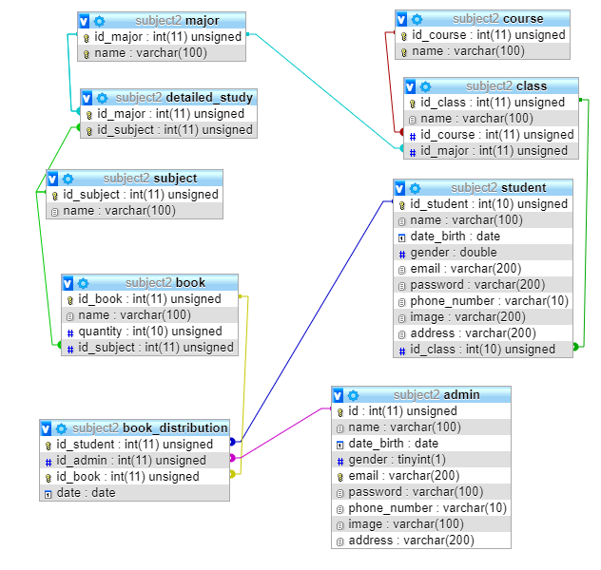

4.1.3 Entity diagram
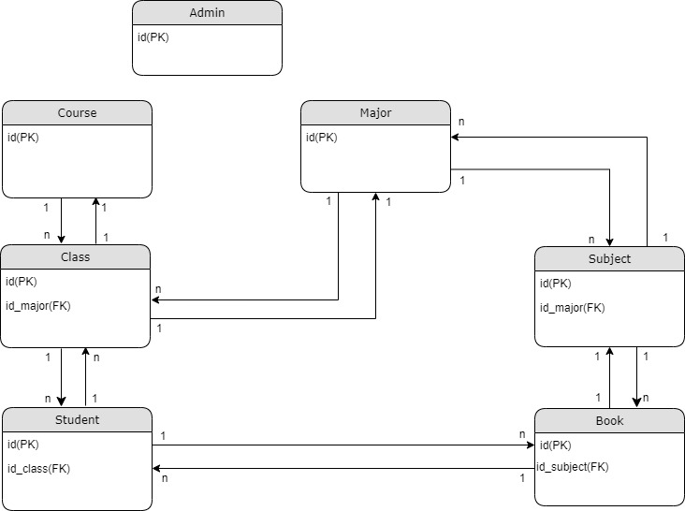

4.2. Use case

4.2.1. Admin

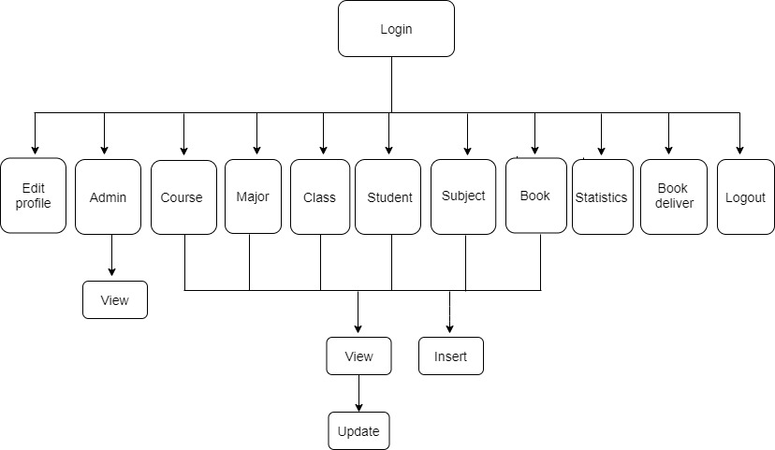

4.2.2. Student
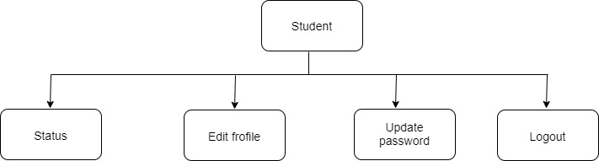

Conclusion
<Đã làm được những gì? Hướng mở rộng? Lời cảm ơn>

