Natalia Miranda
Exercise 2.A Improving Weak Prompts
This document shows how weak AI prompts can be improved for clarity, specificity, and usability. For each weak prompt, an improved version was written, a screenshot of the AI response is included (placeholder), and a rationale explains why the new prompt is stronger.
Prompt: Explain Regression
- Weak Prompt:
Explain regression
- Improved Prompt
Explain linear regression in simple terms, including its purpose, how it works, and an example dataset showing how to predict outcomes using it. Include a small Python example if possible. Thanks
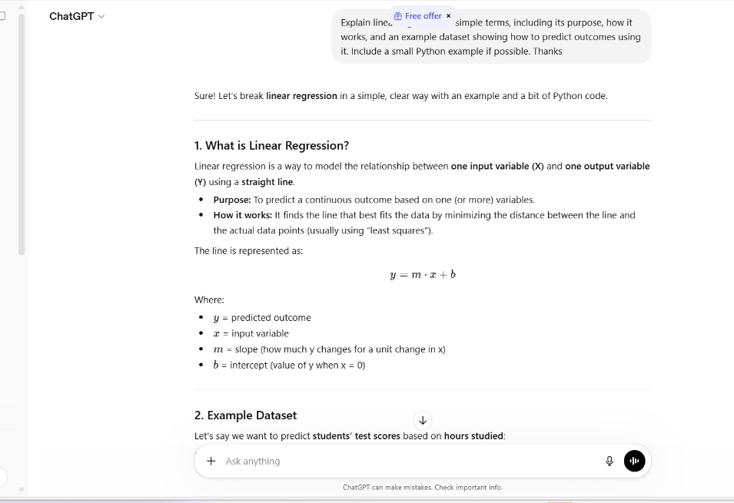
Rationale:
- Specifies linear regression rather than leaving it vague.
- Request’s purpose, explanation, and an example dataset, making it more educational.
- Adds a Python example, making the explanation actionable.

Prompt: Help Me Understand SQL
- Weak Prompt:
Help me understand SQL
- Improved Prompt:
Explain the basics of SQL for beginners, including SELECT, WHERE, and JOIN statements, with clear examples using a sample database of students and courses.
Screenshot of AI Response:
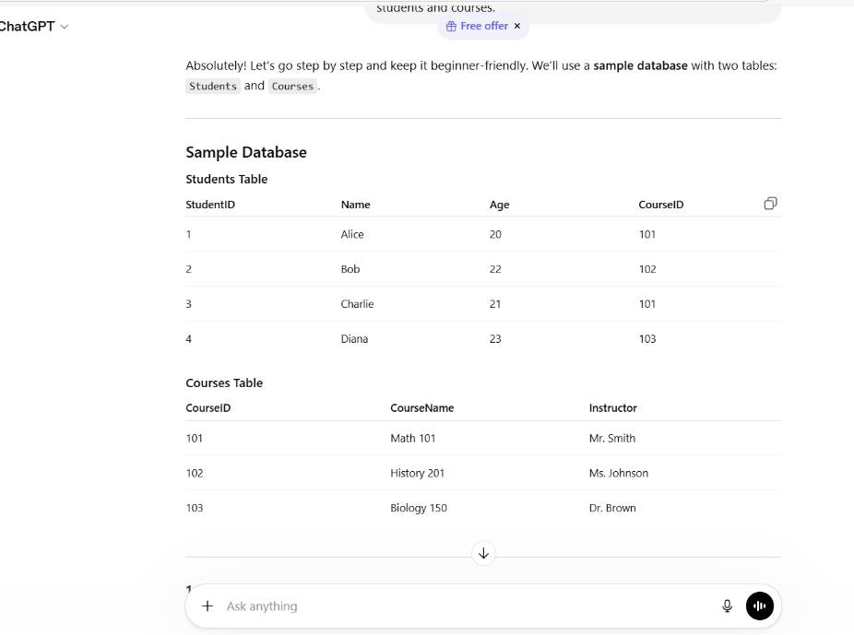
Rationale:
- Specifies SQL topics to guide the AI’s response.
- Provides a practical example to make concepts easier to grasp.
- Targets beginners, prompting simpler and more understandable explanations.

Prompt: Create a Dataset
- Weak Prompt:
Create a dataset
- Improved Prompt:
Create a dataset of 10 fictional students including the columns: StudentID, Name, Age, Grade, and GPA. Provide the data in CSV format with realistic but fictional values.
Screenshot of AI Response:
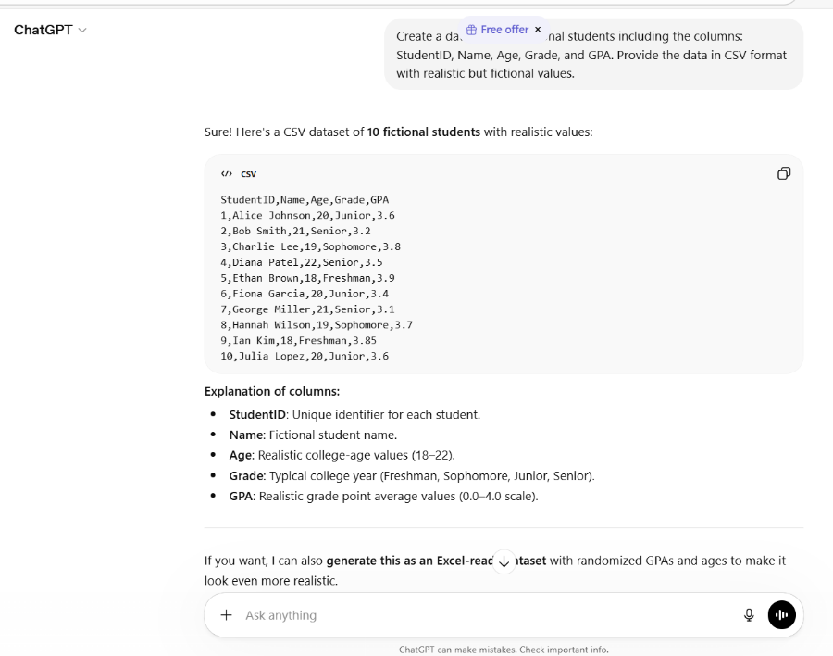
Rationale:
- Specifies number of rows (10) and column names, giving structure.
- Requests CSV format, making it directly usable in Excel or Python.
- Ensuring values is realistic but fictional, improving usability.

