**BLOG using NODE and MySQL**

The schema of the database is:

1.posts table

**Table:posts**  
  
**Columns:**

|  |  |
| --- | --- |
| **id** | int AI PK |
| title | varchar(255) |
| desc | varchar(1000) |
| img | varchar(255) |
| date | datetime |
| **uid** | int |
| cat | varchar(45) |

Here uid is foreign key refrencing id of users table

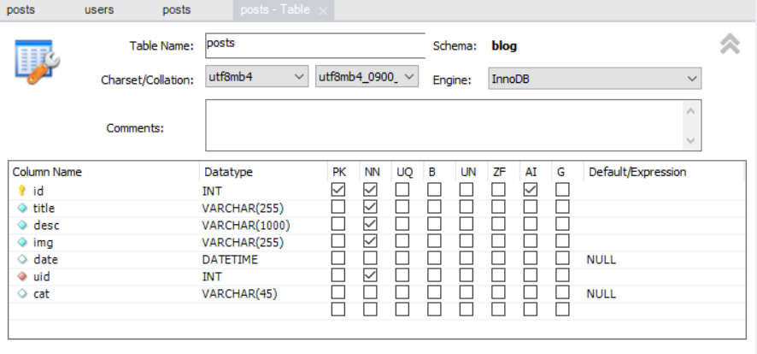

2.users table

**Table:users**  
  
**Columns:**

|  |  |
| --- | --- |
| **id** | int AI PK |
| username | varchar(45) |
| email | varchar(255) |
| password | varchar(255) |
| image | varchar(255) |

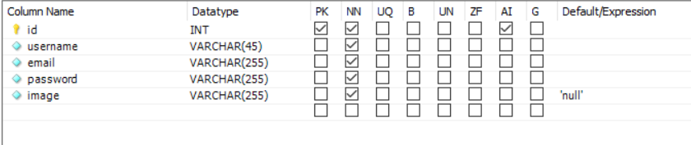

Executing the code:

1.In the terminal change to folders blog\api and blog\client

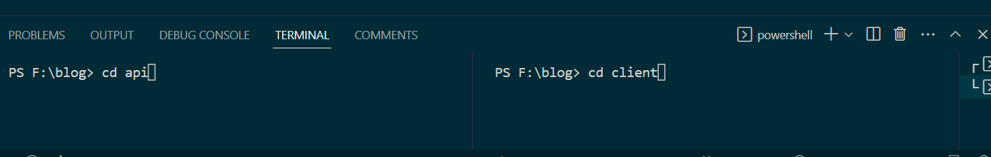

2. run npm start in both the terminal

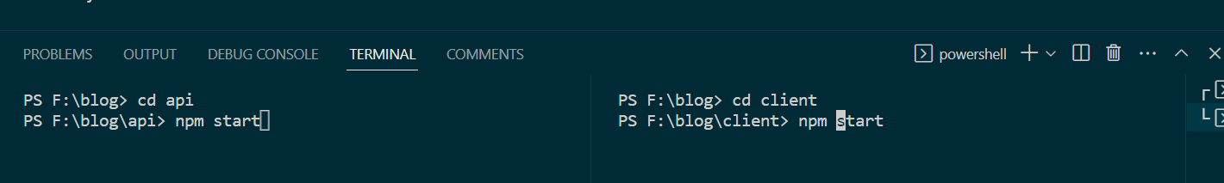

3.the app runs on the browser else follow the link in the terminal

