**BOOK using nodejs and mySql**

The schema:

**Table:books**  
  
**Columns:**

|  |  |
| --- | --- |
| **id** | int AI PK |
| name | varchar(45) |
| desc | varchar(255) |
| cover | varchar(45) |
| price | int |

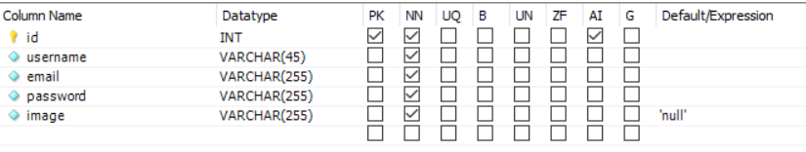

Executing:

1. Change to frontend and backend folder respectively and then type npm start to start the application and backend server
2. 
3. The app start on the selected browser:

