

**ACKNOWLEDGEMENT**

I would like to express my deepest appreciation to all those who provided me the possibility to complete this project. A special gratitude I give to my respected guide ‘PRASHANT KOTHARI’ department in computer science, whose contribution in stimulating suggestions and encouragement helped me to coordinate my project especially in writing this report.

Furthermore, I would also like to acknowledge and thanks to the 'PRERNA SHARMA' of the computer science department, all faculty members and staff for providing me all the facilities and for their support to all activities, and gave the permission to use all required equipment and the necessary materials to complete the Project.

**CERTIFICATE**

This is to certify that the project is titled as “online book store”. This project is submitted by Anjali Gehlod, Namisha Rawat, Tazin Tayabba and Reetika Gadge in fulfilment of the requirements for BCA. This project was an authentic work done by the respective students under the supervision and guidance of Professor Prashant Kothari.

Prof. Prashant Kothari

**CONTENTS**

Introduction 5

Purpose

Module

User

Hardware Requirement

Software Requirement

Advantages

Application

Overall Description

For Administrators

Web Development

PHP

Advantages

MYSQL

Integrating Website and Database

The Shopping Cart Application

Project Design

Function Decomposition Diagram

Feasibility Study

Source code

Images of webapp

ER Diagram

Conclusion

Bibliography

**Introduction**

An online bookstore software projects that acts as a central database containing various books in stock along with their title, author and cost. This project is a website that acts as a central book store. This web project is developed using php as the front end and SQL as a back-end. The SQL database stores various book related details. A user visiting the website can see a wide range of books arranged in respective categories.

The user may select desired book and view its price. The user may even search for specific books on the website. Once the user selects a book, he then has to fill in a form and the book is booked for the user.

The software has the following three main components: -

1. Implement of new user to register and login.

2. Implement user to choose any book.

3. Implement the user to buy books.

The website will be implemented using PHP as the programming language. MYSQL database will be used to link database.

**1.1. Purpose**

For the project, we propose to build an online bookshop for People. The online bookshop will contain stories, study material, any courses books like computer and be available to everyone. Many students find textbooks too expensive to buy at school bookstores and many courses only use the required textbooks a few days in a semester. This becomes very wasteful and frustrating for students & others people.

This online bookstore provides a solution to this. It will provide a service in which students can buy books online without any treble. There will be free shipping. They do need to register with the site in order to books. Payment information will be requested after adding any numbers of books in the cart.

**1.2. Modules**

The site will contain the following features:

• Registration / Login

• Add to Cart

• Searching for book

• Buy book

• Payment option

**1.3. Users:**

Register-The user needs to be registered in order to login.

Login: The users need to login in to get access to the system.

View product-Here the user can view different products and its details.

**1.4. Hardware Requirement:**

Processor: Intel(R) Core(TM) i5-8300H

CPU @ 2.30GHz 2.30 GHz RAM: 2GB or more Hard Disk :80 GB or more Monitor :15^

prime CRT, or LCD Λ monitor

Keyboard: Normal or Multimedia Mouse: Compatible mouse

**1.5. Software Requirement:**

Front End: Visual Studio

Back End: MS Access Server IIS

Operating System: Windows 11

**1.6. Advantages:**

• Customers can get their book delivered instead of actually going and buying the book. They can make payment online itself.

• Managing of inventory in the shop for shopkeeper becomes easier as customers are not visiting and ordering online.

• This system saves both time and travelling cost of customers.

• User can get to know different kinds of books that they were unaware of by just searching in the system using keywords.

**1.7. Applications:**

• The system can be very well used by the book shopkeepers to expand their customers.

**2.0. OVERALL DESCRIPTION**

This project designs an online bookstore provides a web-based interface. It is the graphical user interface. The users interface then pass the input to the control function, which implemented in php. The control function is designed to process the input from the users interface, generate the searching query and then gets data from the database and returns to the users interface. It can generate the query based on the user input and pass them to the commercial bookshop. The bridge can also handle the response from the commercial bookshop and parse the useful information and display to the user in HTML forms.

**For Administrators:**

• Taking backup of the Database.

• Editing / Deleting / Creating the database.

• Changing the password.

**Web development**

Web development broadly refers to the tasks associated with developing websites for hosting via intranet or internet. The web development process includes web design, web content development, client-side/server-side scripting and network security configuration, among other tasks. Web development is also known as website development.

Web development can be classified into two ways:

* Frontend Development
* Backend Development

**Frontend Development:**

The part of a website where the user interacts directly is termed as frontend. It is also referred to as the ‘client side’ of the application

Frontend Roadmap:

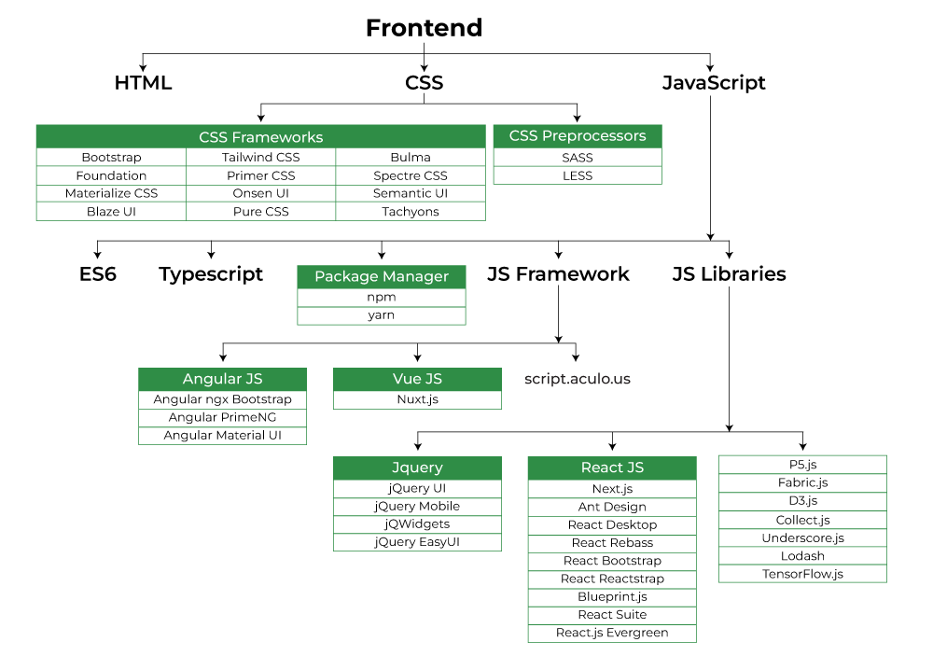

**Backend Development:**

Backend is the server side of a website. It is part of the website that users cannot see and interact with. It is the portion of software that does not come in direct contact with the users. It is used to store and arrange data.

Backend Roadmap: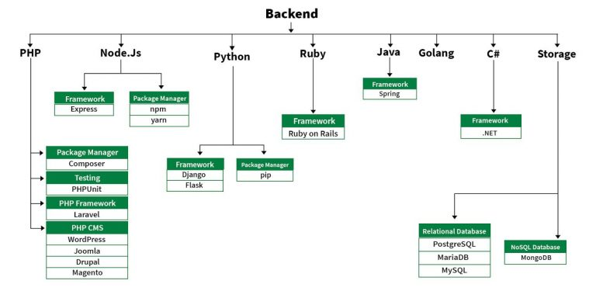

**PHP**

PHP (recursive acronym for PHP: Hypertext Pre-processor) is a widely-used open source general-purpose scripting language that is especially suited for web development and can be embedded into HTML.

<!DOCTYPE HTML>

<html>

<head>

<title>Example</title>

</head>

<body>

<?php

echo "Hi, I'm a PHP script!";

?>

</body>

</html>

**Advantages:**

Stable: Since it is maintained by many developers, so when bugs are found, it can be quickly fixed.

Easy to use: It uses C like syntax, so for those who are familiar with C, it’s very easy for them to pick up and it is very easy to create website scripts.

Speed: It is relative fast since it uses much system resource.

**MySQL**

In this project, MySQL is used as the backend database. MySQL is an open-source database management system. The features of MySQL are given below:

• MySQL is a relational database management system. A relational database stores information in different tables, rather than in one giant table. These tables can be referenced to each other, to access and maintain data easily.

• MySQL is open-source database system. The database software can be used and modify by anyone according to their needs. It is fast, reliable and easy to use. To improve the performance.

• MySQL is multithreaded database engine. A multithreaded application performs many tasks at the same time as if multiple instances of that application was running simultaneously.

• In being multithreaded MySQL has many advantages. A separate thread and les each incoming connection with an extra thread that is always running to manage the connections. Multiple clients can perform read operations simultaneously, but while writing, only hold up another client that needs access to the data being updated. Even though the threads share the same process space, they execute individually and because of this separation, multiprocessor machines can spread the thread across many CPUs as long as the host operating system supports multiple CPUs.

Multithreading is the key feature to support MySQL’s performance design goals. It is the core feature around which MySQL is built.

• MySQL database is connected to JSP using an ODBC driver. Open Database Connectivity (ODBC) is a widely accepted application-programming interface (API) for database access. The ODBC driver is a library that implements the functions supported by ODBC API. It processes

ODBC function calls, submits SQL requests to MySQL server, and returns results back to the application. If necessary, the driver modifies an application's request so that the request conforms to syntax supported by MySQL.

**Integrating the Website and Database**

Customers ordering from an e-commerce website need to be able to get information about a vendor’s products and services, ask questions, select items they wish to purchase, and submit payment information. Vendors need to be able to track customer inquiries and preferences and process their orders. So, a well-organized database is essential for the development and maintenance of an e-commerce site. In a static Web page, content is determined at the time when the page is created. As users access a static page, the page always displays the same information. Example of a static Web page is the page displaying company information. In a dynamic Web page, content varies based on user input and data received from external sources. We use the term “data-based Web pages” to refer to dynamic Web pages deriving some or all of their content from data files or databases. A data-based Web page is requested when a user clicks a hyperlink or the submit button on a Web page form. If the request comes from clicking a hyperlink, the link specifies either a Web server program or a Web page that calls a Web server program. In some cases, the program performs a static query, such as “Display all items from the Inventory”. Although this query requires no user input, the results vary depending on when the query is made. If the request is generated when the user clicks a form’s submit button, instead of a hyperlink, the Web server program typically uses the form inputs to create a query. For example, the user might select five books to be purchased and then submit the input to the Web server program. The Web server program then services the order, generating a dynamic Web page response to confirm the transaction. In either case, the Web server is responsible for formatting the query results by adding HTML tags. The Web server program then sends the program’s output back to the client’s browser as a Web page.

**The Shopping Cart Application**

The objective of this application is to provide the user an online website was they can buy books from the comfort of their home. A shopping cart is used for the purpose. The user can select the desired books, place them in the shopping cart and purchase them using a Credit Card. The user’s order will be shipped according to the type of shipping selected at the time of placing the order.

**Project Design**

In order to design a website, the relational database must be designed first. Conceptual design can be divided into two parts: The **data model** and the **process model**. The data model focuses on what data should be stored in the database while the process model deals with how the data is processed. To put this in the context of the relational database, the data model is used to design the relational tables. The process model is used to design the queries that will access and perform operations on those tables.

**Data model:**

A Data Model in DBMS is the concept of tools that are developed to summarize the description of the database.

1. ER Model
2. Hierarchical Model
3. Network Model
4. Object-Oriented Data Model
5. Float Data Model
6. Context Data Model
7. Semi-Structured Data Model

**Process Model:**

A Process Model is a visual depiction of the flow of work and tasks of specific goals. Often, process model takes graphical forms, and they typically depict workflows that companies complete repeatedly. Some of the essential components of process models include:

1. Arrows
2. Connectors
3. Start and end indicators
4. Activity indicators
5. Decision indicators

**Functional Decomposition Diagram**

A decomposition diagram shows a top-down functional decomposition of a system and exposes the system's structure. The objective of the Functional Decomposition is to break down a system step by step, beginning with the main function of a system and continuing with the interim levels down to the level of elementary functions. The diagram is the starting point for more detailed process diagrams, such as data flow diagrams (DFD). shows the Functional Decomposition Diagram for this project.

**Feasibility Study**

We conducted the feasibility study to select the best system that needs the excellent performance requirement of the agency. This entails an identification description an evaluation of candidate system & the selection of the best system the job. Three key considerations are involved in feasibility analysis economical, technical & behavioural.

**• Economical Feasibility:**

Economic analysis determines whether the adoption of a system can be cost justified. The time required to any manual task is an always more than the time required by computer to do the same job. Before this project management of the medical shop management is done manually which takes lot of time and manpower?

**• Technical Feasibility:**

In this stage we try to know about the availability, applicability & usability of software & hardware in developing system to accomplish our packages. We are using the vb.net front end & MS SQL Server as backend make easy for system users.

**• Operational Feasibility:**

In this stage we study easiness/easy handling of software & hardware operation of developing system. In this project with the facility if GUI we try our best efforts of provide information to users by graphics as a result operation problem can reduces.

**Source Code**

**Login.php**

<?php

if(isset($_SESSION['login']) && $_SESSION['login']== true)

{

require "./template/loggedin_header.php";

}

else{

require "./template/header.php";

}

?>

<html>

<head>

<title>Login Page</title>

<style>

#headline{

color:#A8A8A8;

}

#box{

width:200px;

background-color: white;

color:black;

border-color:#A8A8A8;

margin:5px;

padding:3px

}

.button{

padding:7px;

margin:15px;

width:130px;

color:black;

background-color: #A8A8A8;

border-radius:15px;

font: arial;

text:bold;

border:none;

font-family:verdana;

font-size:100%;

}

</style>

</head>

<body style="background-color:whitesmoke"><center><br><br>

<h2 id="headline">Hello Again!!!<br>You can Login now..</h2><br><br>

<form action="login_verify.php" method="post">

<div>

<label for="email"><b style="color:#A8A8A8">Email:</b></label>

<input id="box" type="text" name="email"><br>

</div>br>

<div>

<label for="password"><b style="color:#A8A8A8">Password:</b></label>

<input id="box" type="password" name="password"><br><br>

</div>

<section>

<button class="button" type="submit" name="submit">Login</button>

<input class="button" type="reset" value="Reset">

<br><br><p id="headline">First time? Join our community <ahref="registration.php">JOIN US</a></p>

</section>

</form>

<br><br><br><br><br><br><br><br><br><br><br><br>

</center>

<footer><?php

require_once "./template/footer.php"

?>

</footer>

</body>

</html>

**BookperPub.php**

<?php

session_start();

require_once "./functions/database_functions.php";

// get pubid

if(isset($_GET['pubid'])){

$pubid = $_GET['pubid'];

} else {

echo "Wrong query! Check again!";

exit;

}

// connect database

$conn = db_connect();

$pubName = getPubName($conn, $pubid);

$query = "SELECT book_isbn, book_title, book_image FROM books WHERE publisherid = '$pubid'";

$result = mysqli_query($conn, $query);

if(!$result){

echo "Can't retrieve data " . mysqli_error($conn);

exit;

}

if(mysqli_num_rows($result) == 0){

echo "Empty books ! Please wait until new books coming!";

exit;

}

$title = "Books Per Publisher";

if(isset($_SESSION['login']) && $_SESSION['login']== true)

{

require "./template/loggedin_header.php";

}

else{

require "./template/header.php";

}

?>

<p class="lead"><a href="publisher_list.php">Publishers</a> > <?php echo $pubName; ?></p>

<?php

while($row = mysqli_fetch_assoc($result)){

?>

<div class="row">

<div class="col-md-3">

<img class="img-responsive img-thumbnail" src="./bootstrap/img/<?php echo $row['book_image'];?>">

</div>

<div class="col-md-7">

<h4><?php echo $row['book_title'];?></h4>

<a href="book.php?bookisbn=<?php echo $row['book_isbn'];?>" class="btn btn-primary">Get Details</a>

</div>

</div>

<br>

<?php

}

if(isset($conn)) { mysqli_close($conn);}

require "./template/footer.php";

?>

**Index.php**

<?php

$server= 'localhost';

$user= 'root';

$password=" ";

$database='book-seller';

session_start();

$count = 0;

// connecto database

$title = "Index";

if(isset($_SESSION['login']) && $_SESSION['login']== true)

{

require "./template/loggedin_header.php";

}

else{

require "./template/header.php";

}

require_once "./functions/database_functions.php";

$conn = db_connect($server, $user, $password,$database);

$row = select4LatestBook($conn);

?>

<!-- Example row of columns -->

<p class="lead text-center text-muted">Latest books</p>

<div class="row">

<?php foreach($row as $book) { ?>

<div class="col-md-3">

<a href="book.php?bookisbn=<?php echo $book['book_isbn']; ?>">

<img class="img-responsive img-thumbnail" src="./bootstrap/img/<?php echo $book['book_image']; ?>">

</a>

</div>

<?php } ?>

</div>

<?php

if(isset($conn)) {mysqli_close($conn);}

require_once "./template/footer.php";

?>

**Images Of Webapp**

**Home Page:**

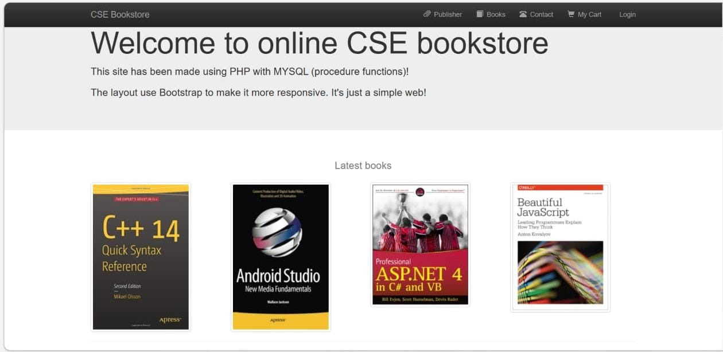

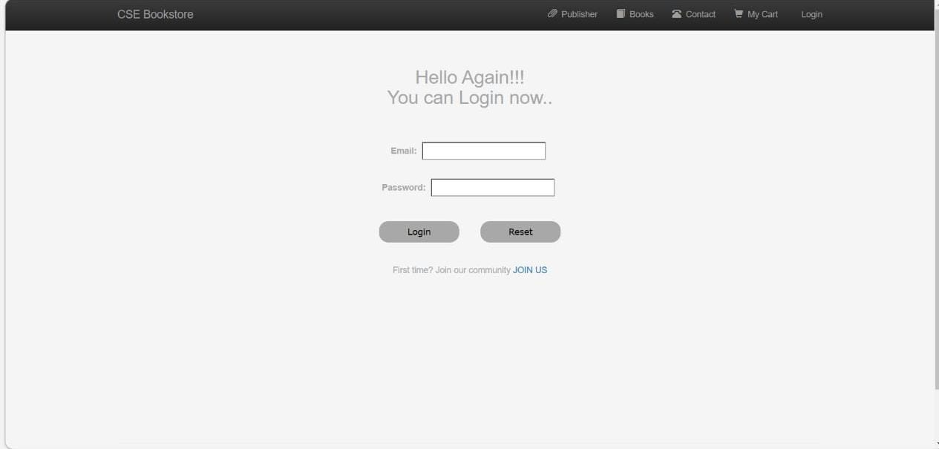**Login Page:**

**Books:**

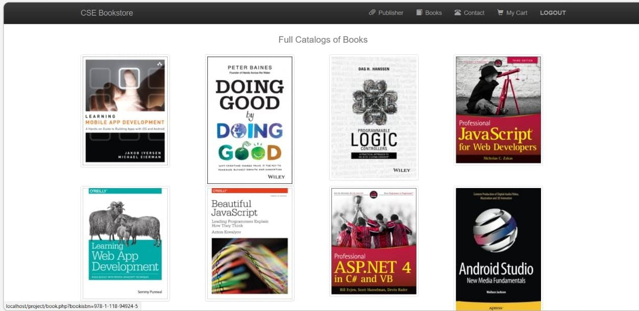

**Books Details:**

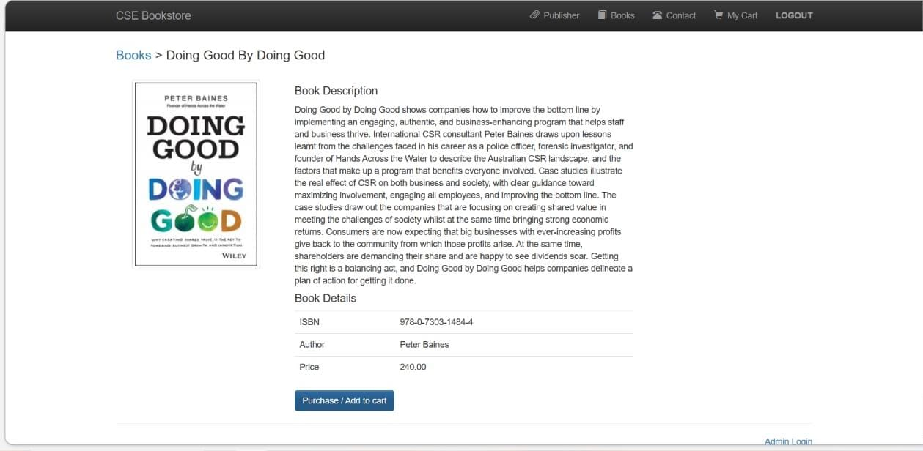

**Cart:**

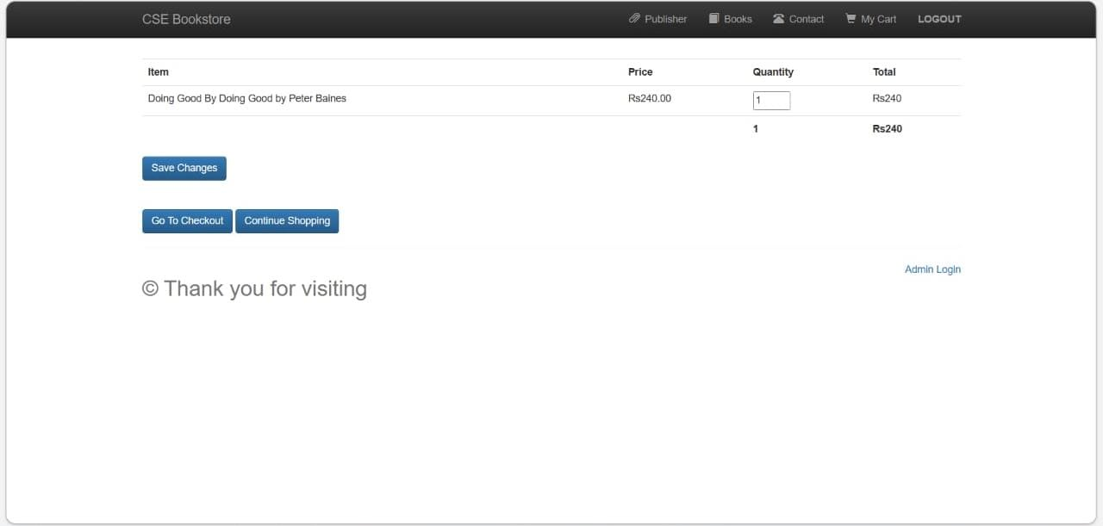

**Checkout:**

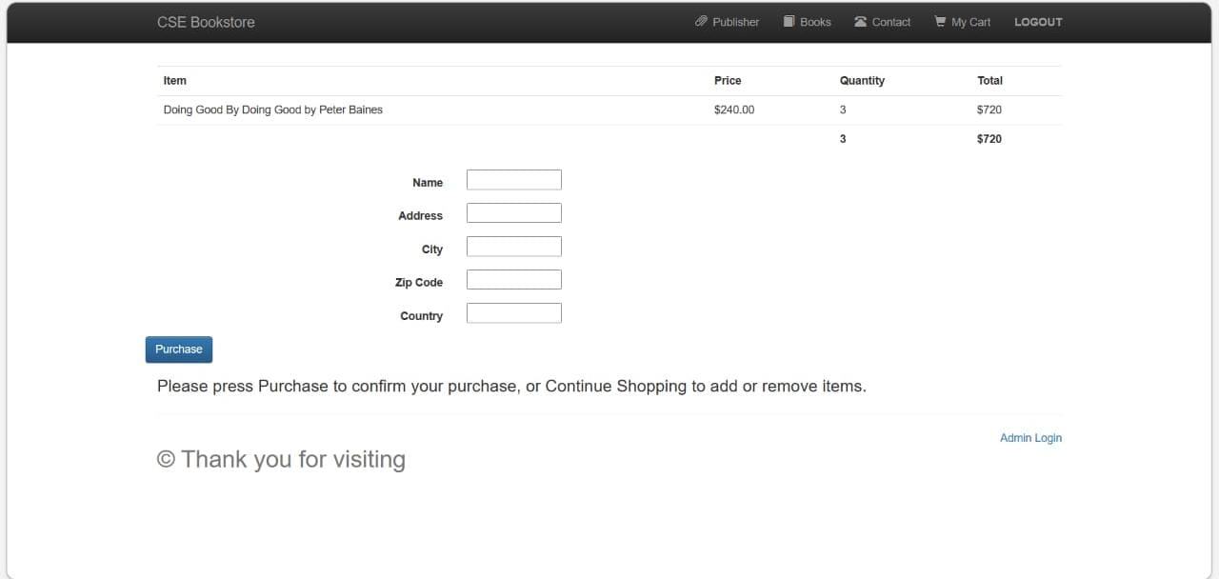

**Purchase:**

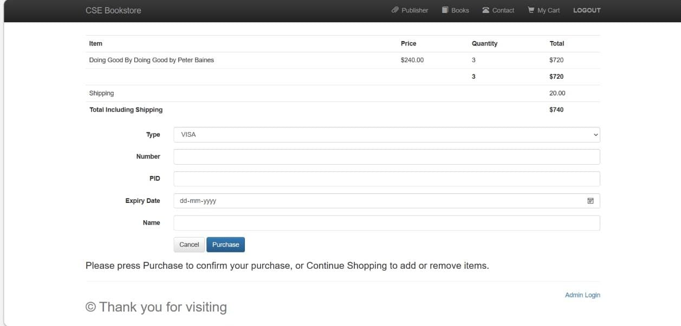

**Contact Page:**

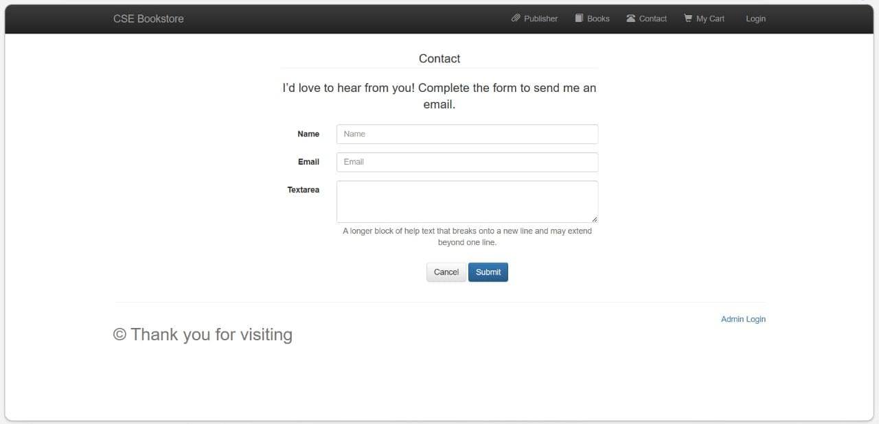

**All Author List:**

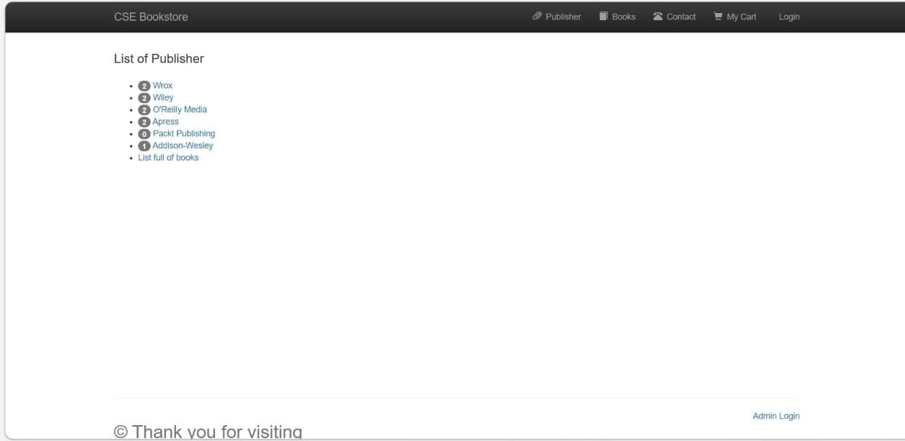

**ER Diagram**

**Conclusion**

The Internet has become a major resource in modern business, thus electronic shopping has gained significance not only from the entrepreneur’s but also from the customer’s point of view. For the entrepreneur, electronic shopping generates new business opportunities and for the customer, it makes comparative shopping possible. As per a survey, most consumers of online stores are impulsive and usually make a decision to stay on a site within the first few seconds. “Website design is like a shop interior. If the shop looks poor or like hundreds of other shops the customer is most likely to skip to the other site”. Hence, we have designed the project to provide the user with easy navigation, retrieval of data and necessary feedback as much as possible. In this project, the user is provided with an e-commerce web site that can be used to buy books online. To implement this as a web application we used PHP as the Technology. PHP (XAMPP) has several advantages such as enhanced performance, scalability, built- in security and simplicity. To build any web application using PHP we need a programming language such as JAVA, HTML # and so on. JAVA SCRIPT was the language used to build this application. PHP uses MySQL server to interact with the database as it provides in-memory caching that eliminates the need to contact the database server frequently and it can easily deploy and maintain an PHP application. MySQL was used as back-end database since it is one of the most popular open-source databases, and it provides fast data access, easy installation and simplicity.

A good shopping cart design must be accompanied with user-friendly shopping cart application logic. It should be convenient for the customer to view the contents of their cart and to be able to remove or add items to their cart. The shopping cart application described in this project provides a number of features that are designed to make the customer more comfortable. This project helps in understanding the creation of an interactive web page and the technologies used to implement it. The design of the project which includes Data Model and Process Model illustrates how the database is built with different tables, how the data is accessed and processed from the tables. The building of the project has given me a precise knowledge about how PHP is used to develop a website, how it connects to the database to access the data and how the data and web pages are modified to provide the user with a shopping cart application.

# Bibliography