Structured Data Management
Final Project



Submitted By:
NAMITA CHHANTYAL
DARLINGTON MASODZI
BILLY MUCHIPISI

Submission Date: 8th May, 2025

Table of Contents
Step 1: Business Problem Definition 1
Step 2: Relational ERD & Data Dictionary 1
Step 3: PostgreSQL OLTP Database 9
3.1 Table Creation Sql 9
3.2 Insertion into Table 11
Step 4: Run Operational Queries & DML Operations 13
4.1 Operational Queries (Reports) 13
4.2 DML Operations (Insert, Update & Delete) 16
Step 5: Dimensional Model (Star Schema) 18
5.1 Creation of dimension tables 18
5.2 Population of Dimension Tables 20
SCD 2 21
5.3 Dimensional Modeling 22
Step 6: Analytical Queries on Star Schema 26
Step 7: NoSQL Comparison Summary 29
A. MongoDB – Document-Oriented NoSQL 29
B. Neo4j – Graph Database 30
Step 8 AWS Lamda Architecture & Deployment Plan 31
Step 9: Snowflake Advantages Summary 33
Dashboard: 34
CONCLUSION 36

Step 1: Business Problem Definition
Goal: Improve public health outcomes through disease tracking, treatment effectiveness, patient demographics, and risk factor analysis.
Problem Statement
Public health agencies need a reliable database system to track diseases, assess racial and geographic disparities, evaluate medication effectiveness, and identify patterns for early intervention. This system should support operational decision-making and strategic analytics.

Step 2: Relational ERD & Data Dictionary
ER diagram:
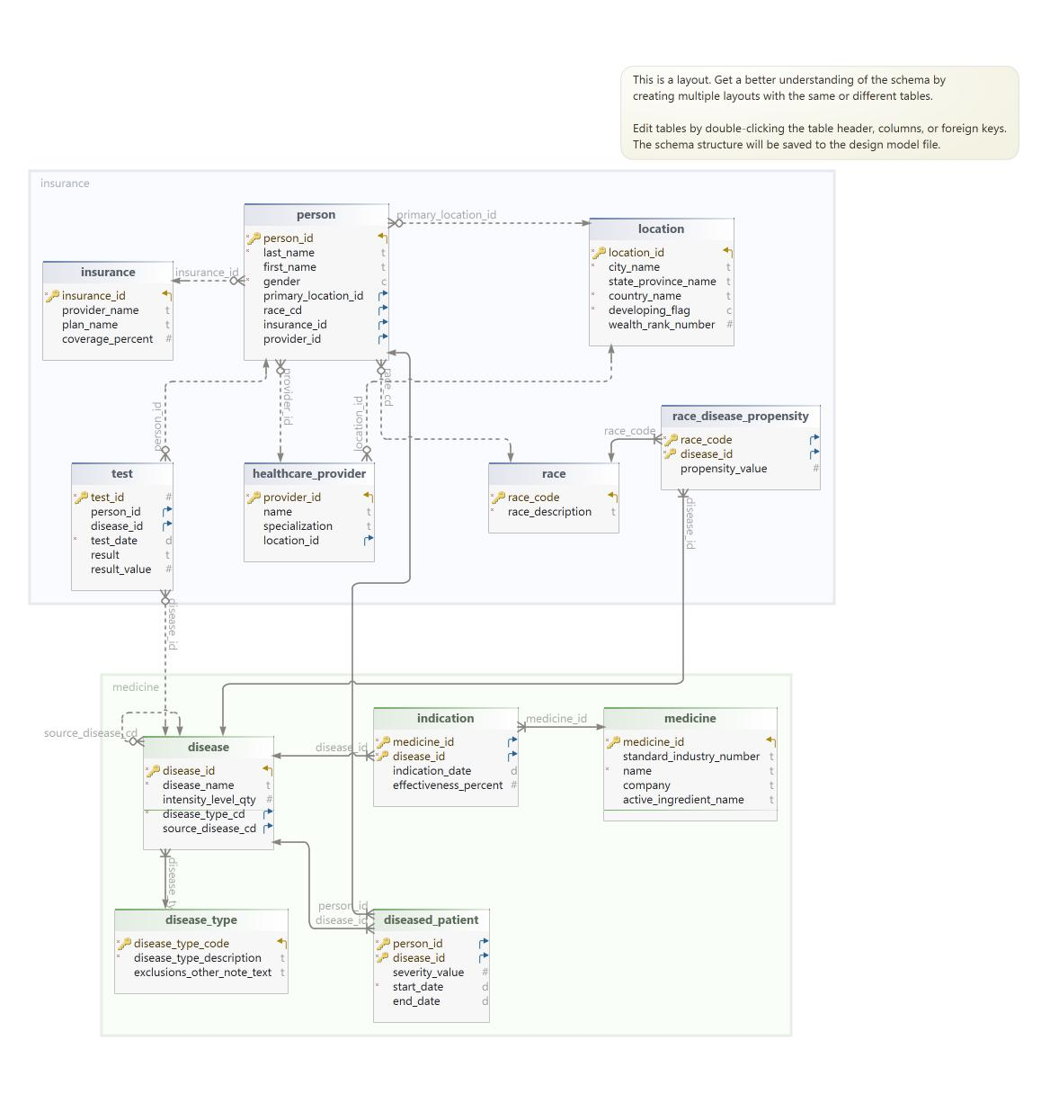
This ER (Entity-Relationship) diagram represents a comprehensive Disease Data Management System used to analyze public health outcomes. The diagram is structured into three key components: Patient and Demographics, Healthcare and Disease Events, and Insurance and Medication Details. Below is an explanation of each section and the relationships between the entities.

1. Patient and Demographics Section:
This section includes entities that record patient information and demographic data:
- Person Table:
  - Attributes: person_id, last_name, first_name, gender, primary_location_id, race_cd, insurance_id, provider_id.
  - Represents individuals registered in the system with demographic details.
  - Relationships:
    - Linked to Location through primary_location_id.
    - Connected to Insurance and Healthcare Provider entities via insurance_id and provider_id.
    - Associated with the Race table via race_cd.
- Location Table:
  - Attributes: location_id, city_name, state_province_name, country_name, developing_flag, wealth_rank_number.
  - Represents the geographic data related to patients and providers.
- Race Table:
  - Attributes: race_code, race_description.
  - Stores ethnicity or racial background.
- Race Disease Propensity Table:
  - Attributes: race_code, disease_id, propensity_value.
  - Provides insight into the likelihood of certain diseases being prevalent among specific racial groups.
Key Insight:
This section focuses on capturing patient demographics and geographic data, crucial for analyzing disease trends and healthcare accessibility.

2. Healthcare and Disease Events Section:
This section contains information about healthcare providers, disease diagnosis, and testing:
- Healthcare Provider Table:
  - Attributes: provider_id, name, specialization, location_id.
  - Represents doctors or medical personnel responsible for diagnosis or treatment.
- Test Table:
  - Attributes: test_id, person_id, disease_id, test_date, result, result_value.
  - Stores the diagnostic tests taken by patients, linking to the Person and Disease tables.
- Disease Table:
  - Attributes: disease_id, disease_name, intensity_level_qty, disease_type_cd, source_disease_cd.
  - Represents information about different diseases, including intensity and type.
- Disease Type Table:
  - Attributes: disease_type_code, disease_type_description, exclusions_other_note_text.
  - Categorizes diseases by type, enabling better classification.
- Diseased Patient Table:
  - Attributes: person_id, disease_id, severity_value, start_date, end_date.
  - Tracks patients diagnosed with specific diseases and records the severity and duration of the illness.
Key Insight:
This section is pivotal for tracking medical events and healthcare provider roles in managing diseases.

3. Insurance and Medication Details Section:
This section tracks insurance plans and medication information:
- Insurance Table:
  - Attributes: insurance_id, provider_name, plan_name, coverage_percent.
  - Records the insurance details associated with each patient.
- Medicine Table:
  - Attributes: medicine_id, standard_industry_number, name, company, active_ingredient_name.
  - Stores details about prescribed medications.
- Indication Table:
  - Attributes: medicine_id, disease_id, indication_date, effectiveness_percent.
  - Links medications to diseases they treat, showing effectiveness percentages.
Key Insight:
This section aids in analyzing the effectiveness of treatments and understanding insurance coverage trends.

Relationships Between Tables:
- The Person table serves as the central entity for patient demographics, connecting to Healthcare Providers, Insurance, Tests, and Diseased Patient.
- The Disease table links to the Medicine and Indication tables, providing insights into treatment plans and medication effectiveness.
- Location acts as a shared reference for both patients and providers, helping to map healthcare delivery geographically.
- Race Disease Propensity bridges racial demographics and disease occurrences, highlighting the correlation between ethnicity and disease risk.

Key Features of the ER Diagram:
- Comprehensive Data Coverage:
  - Captures demographic, healthcare, disease, insurance, and medication information in one model.
- Logical Data Flow:
  - Clear connections between patients, healthcare providers, and diagnostic tests, enabling integrated data analysis.
- Support for Analytical Insights:
  - Allows analysis of disease prevalence, treatment effectiveness, and patient demographics, making it suitable for healthcare research and policy-making.
- Flexibility and Scalability:
  - The modular design allows for easy addition of new attributes or tables as healthcare data requirements evolve.

Use Cases for Healthcare Providers:
- Disease Prevalence Tracking:
  - Analyzing how diseases spread across regions and demographic groups.
- Healthcare Provider Efficiency:
  - Comparing test outcomes and treatment success rates among providers.
- Insurance Utilization:
  - Identifying which insurance plans are most effective in covering critical treatments.
- Medication Effectiveness:
  - Correlating medication types with disease recovery rates for evidence-based healthcare planning.

Data definition schemas are also created. The file name is FinalDataDictionary.html. Also the screenshots of the datadictionary are below:
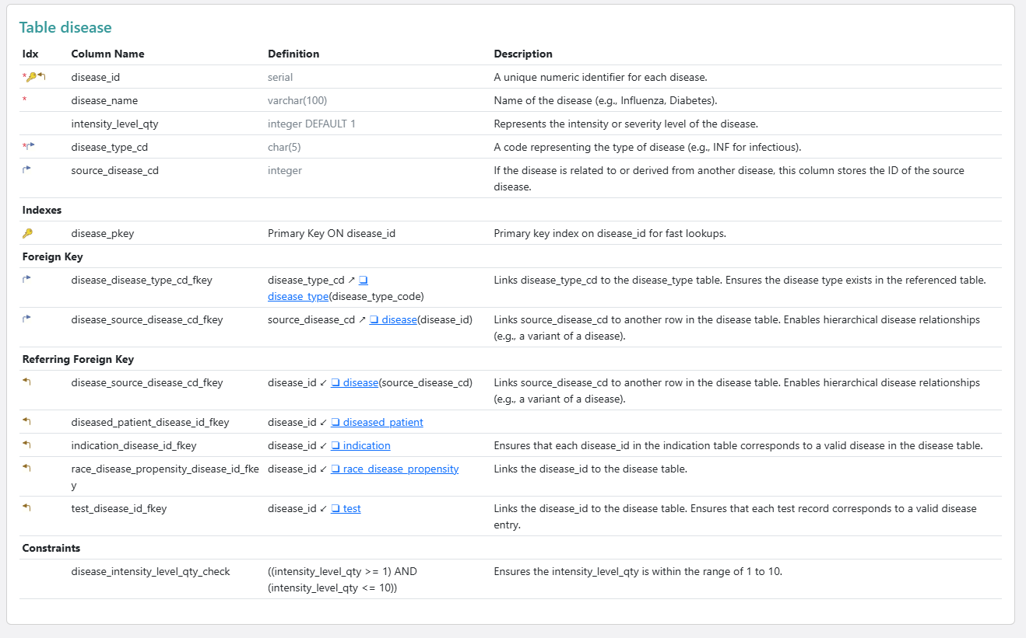
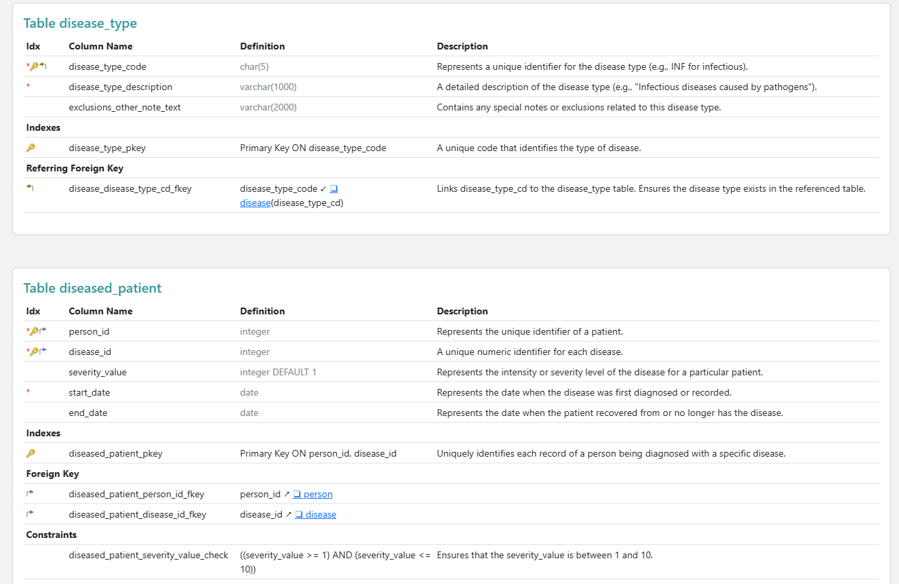
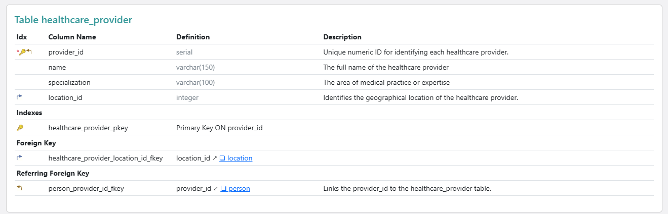
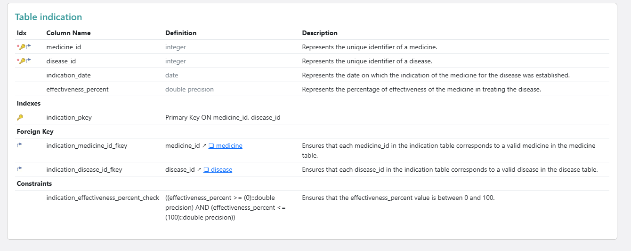
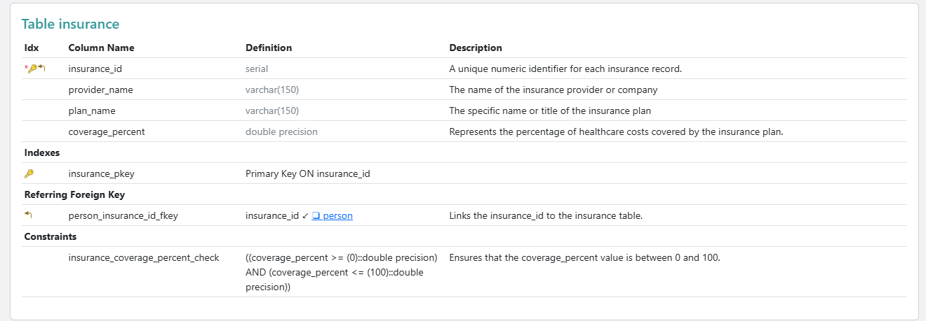
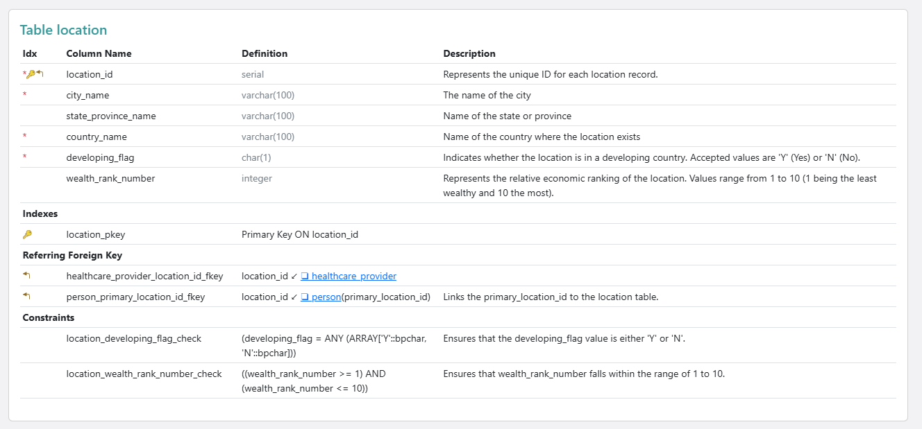
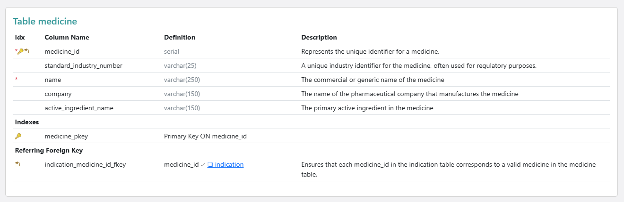
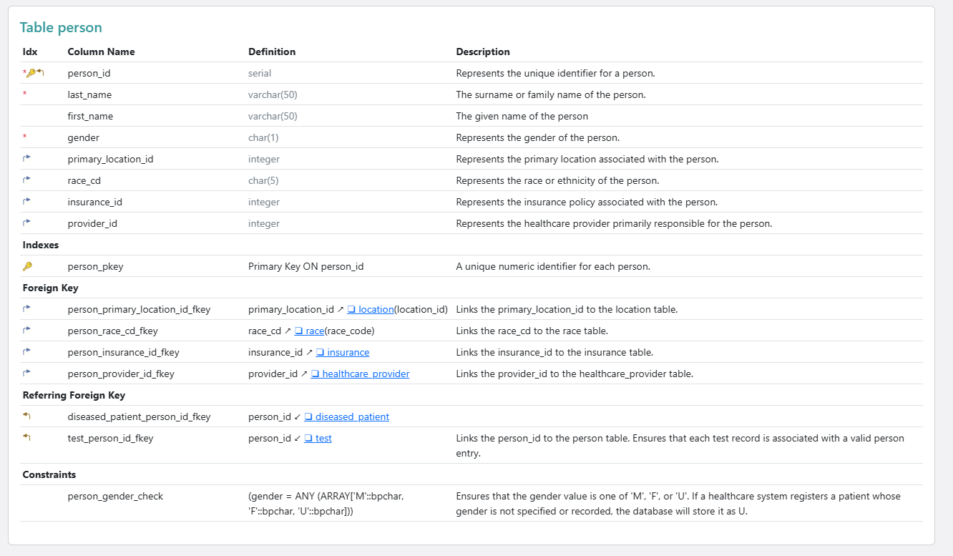
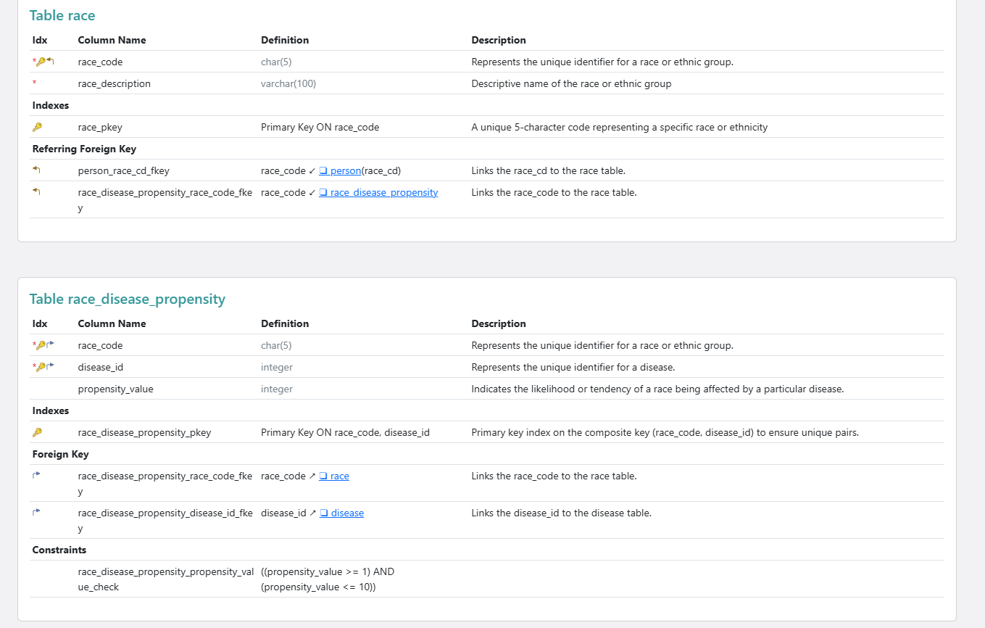
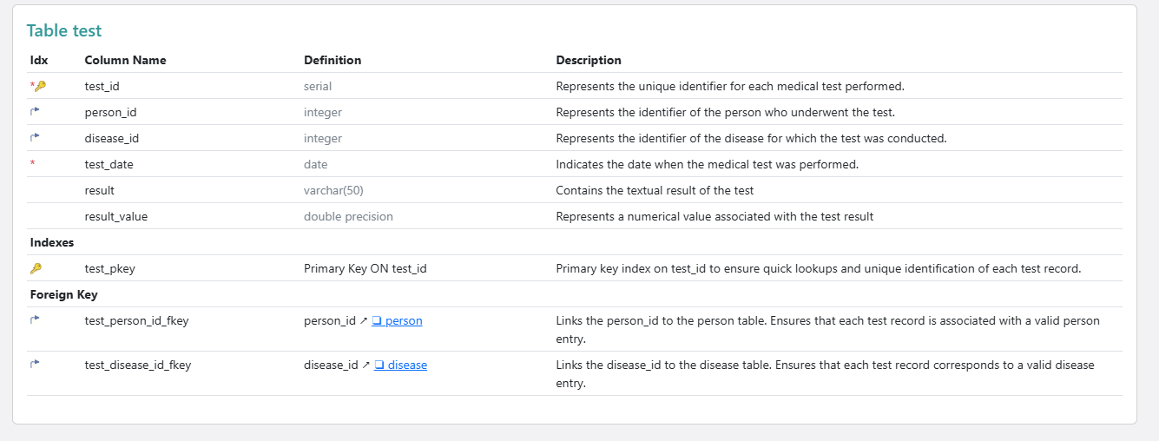

Step 3: PostgreSQL OLTP Database

3.1 Table Creation Sql
File Name: Table Creation queries.sql
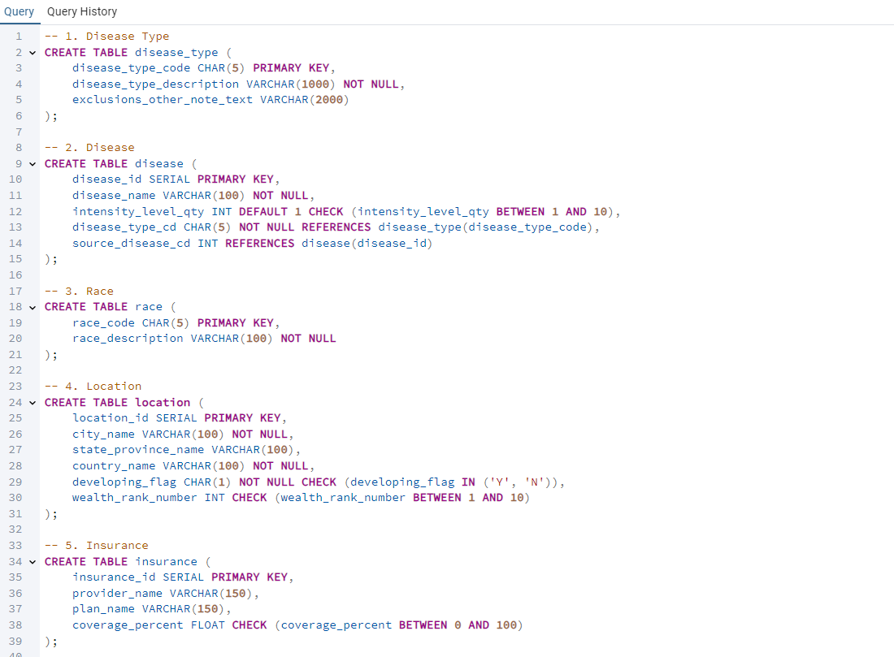
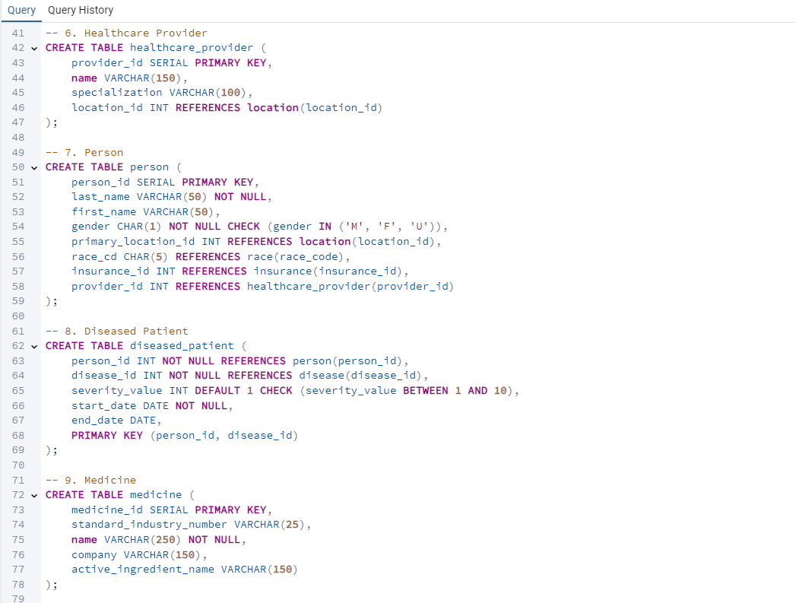
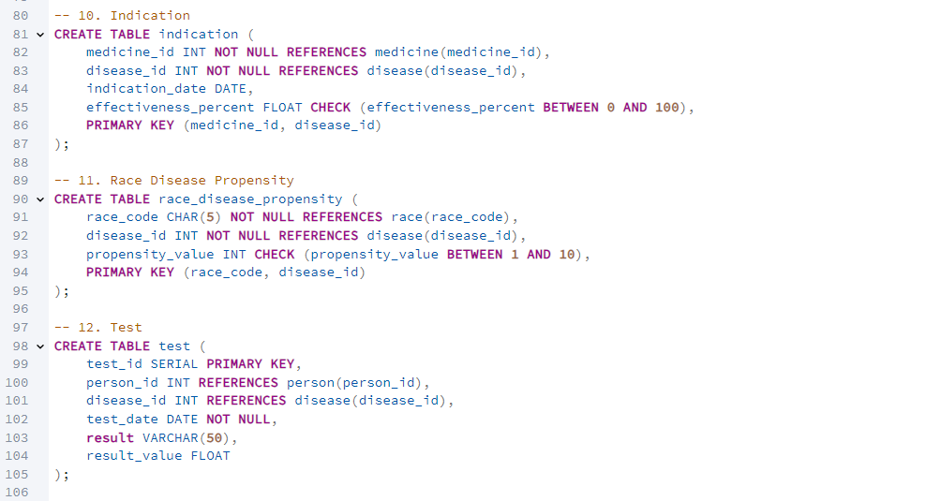

3.2 Insertion into Table
File name: Table insertion queries.sql
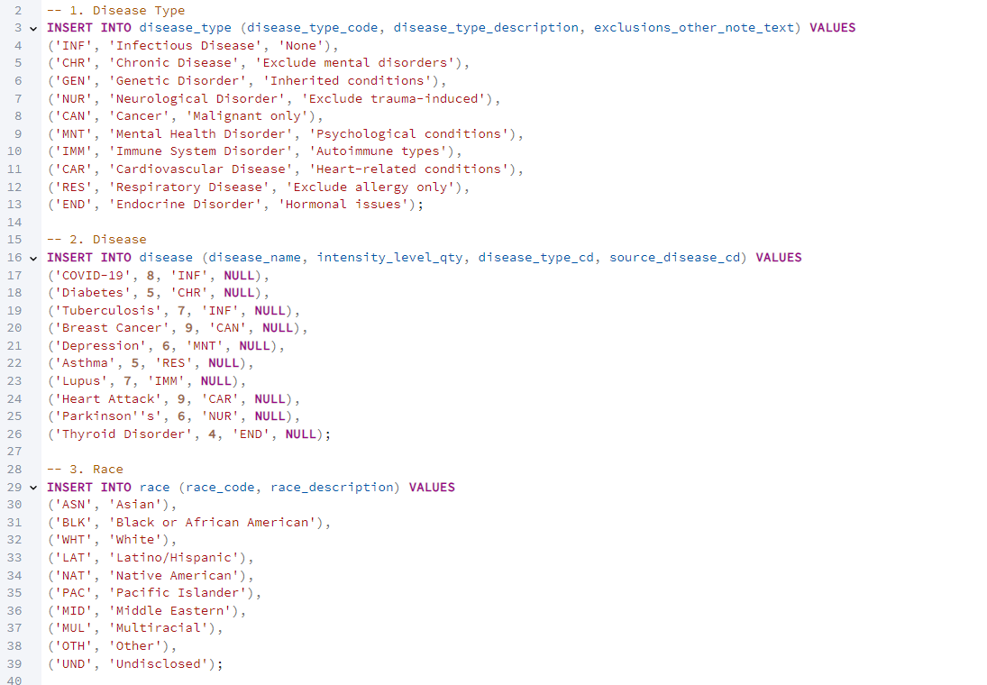
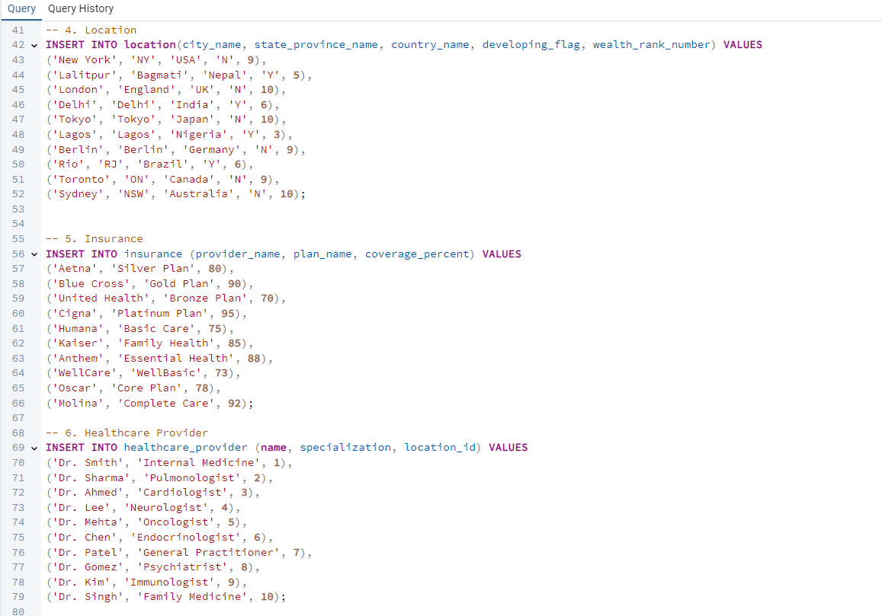
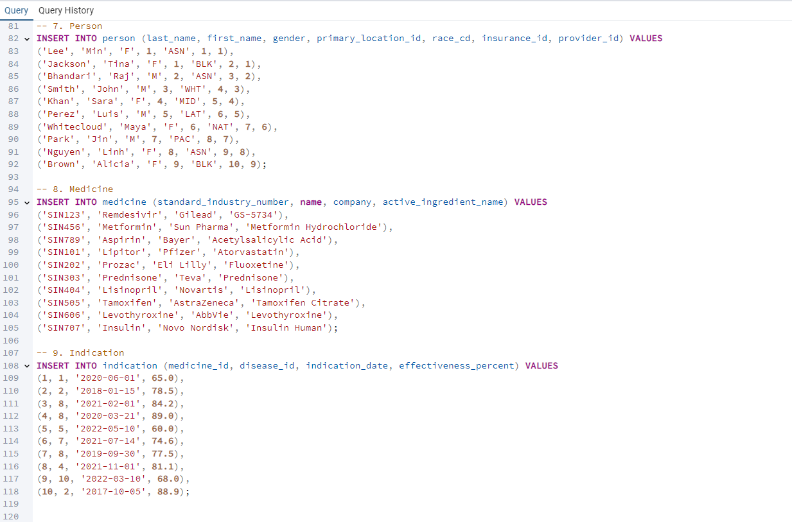
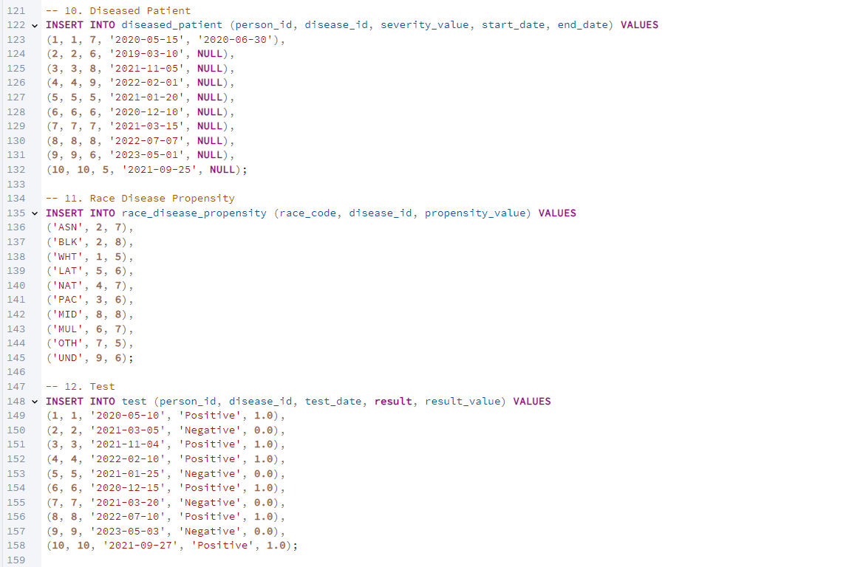

Step 4: Run Operational Queries & DML Operations

4.1 Operational Queries (Reports)
File name: operationalquery.sql
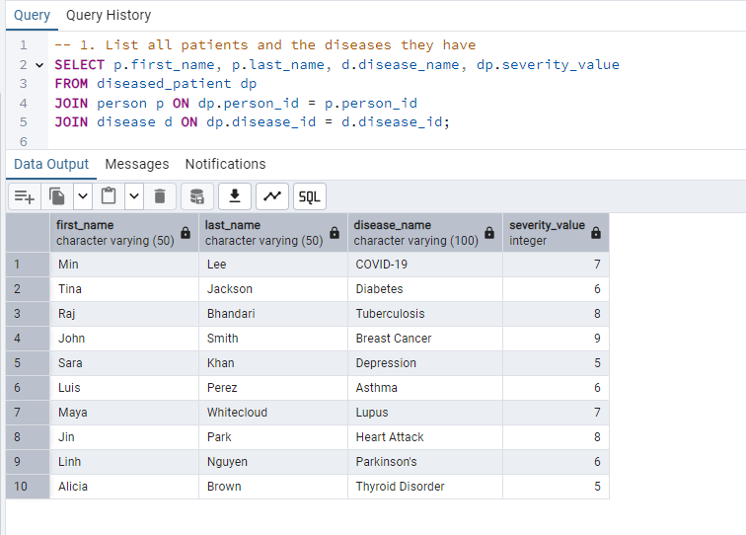
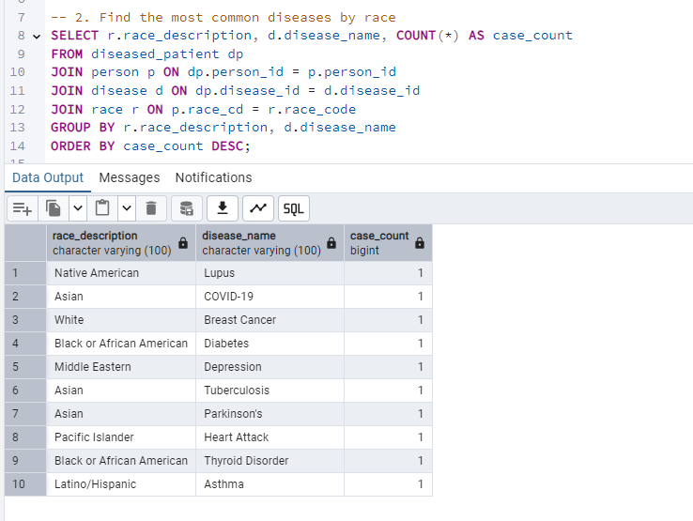
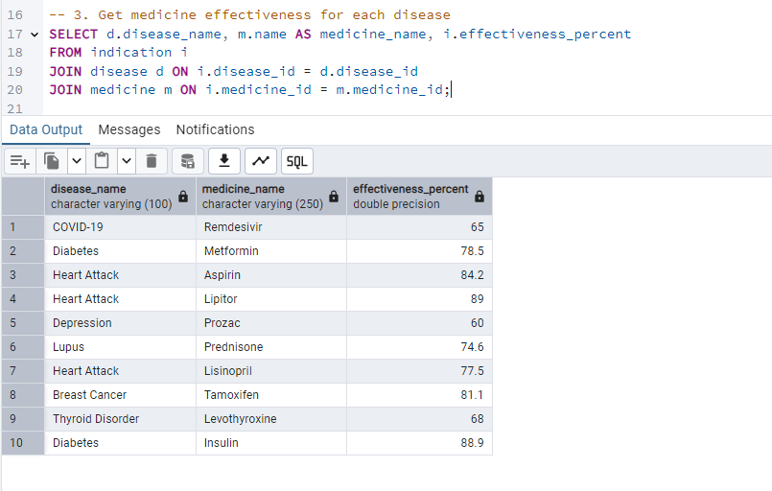
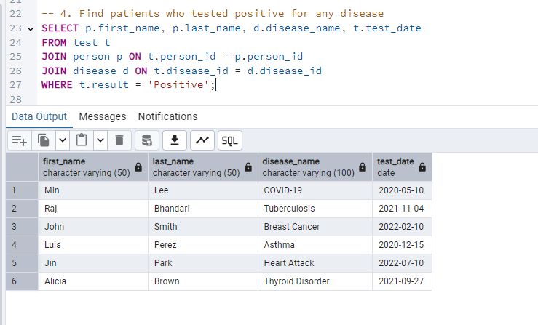
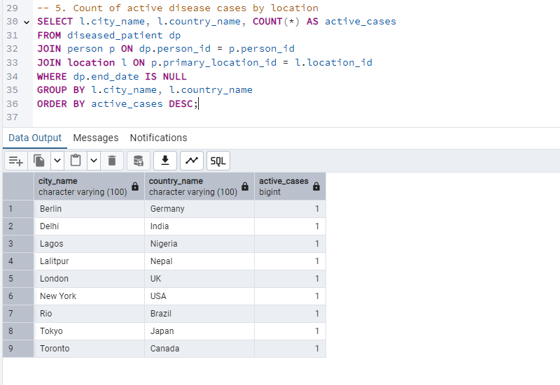

4.2 DML Operations (Insert, Update & Delete)
File name: dmloperation.sql
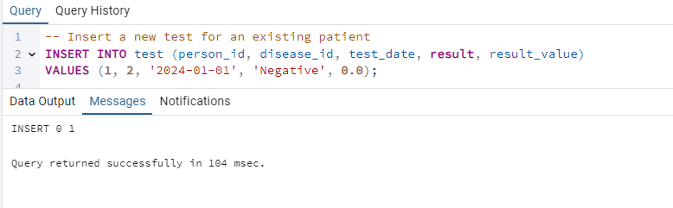
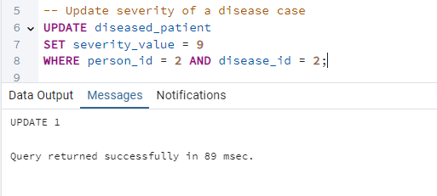
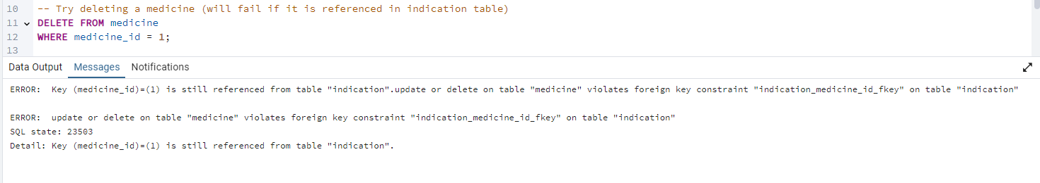
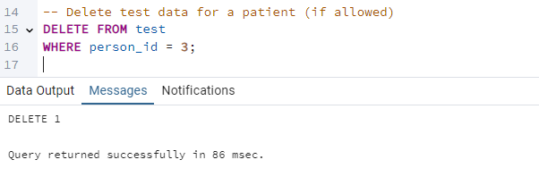

Step 5: Dimensional Model (Star Schema)

5.1 Creation of dimension tables
File name: dimcreation.sql
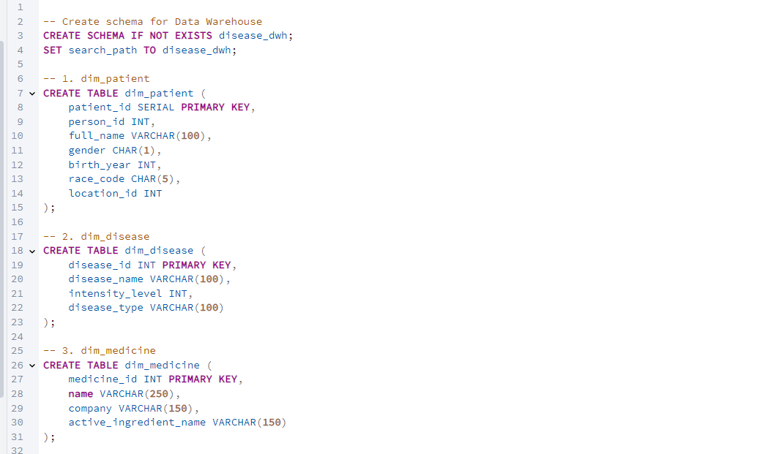
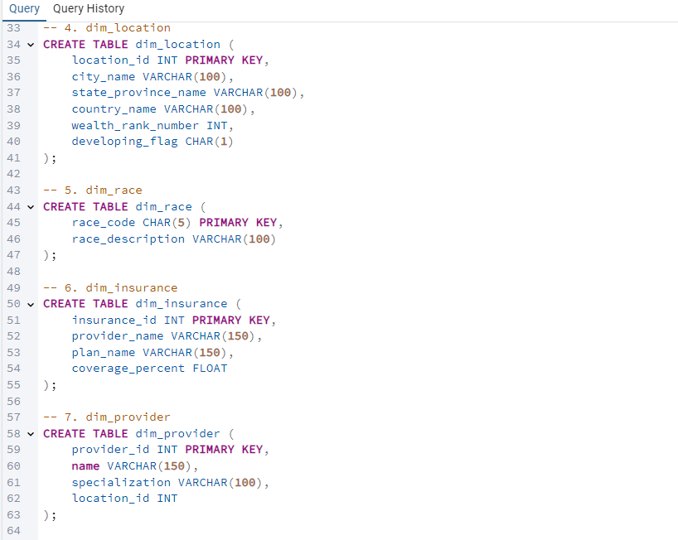
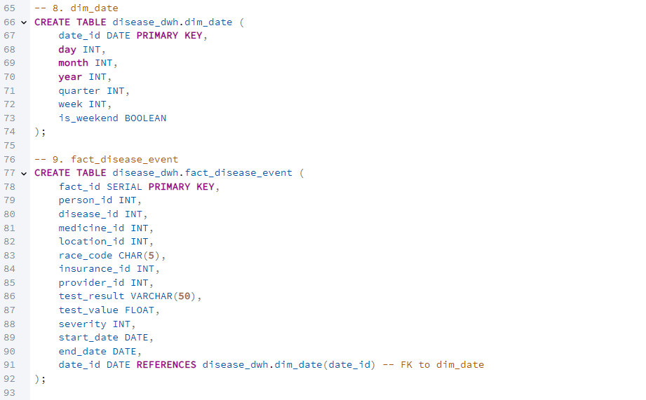

5.2 Population of Dimension Tables
File name: dimensiontablepopulate.sql
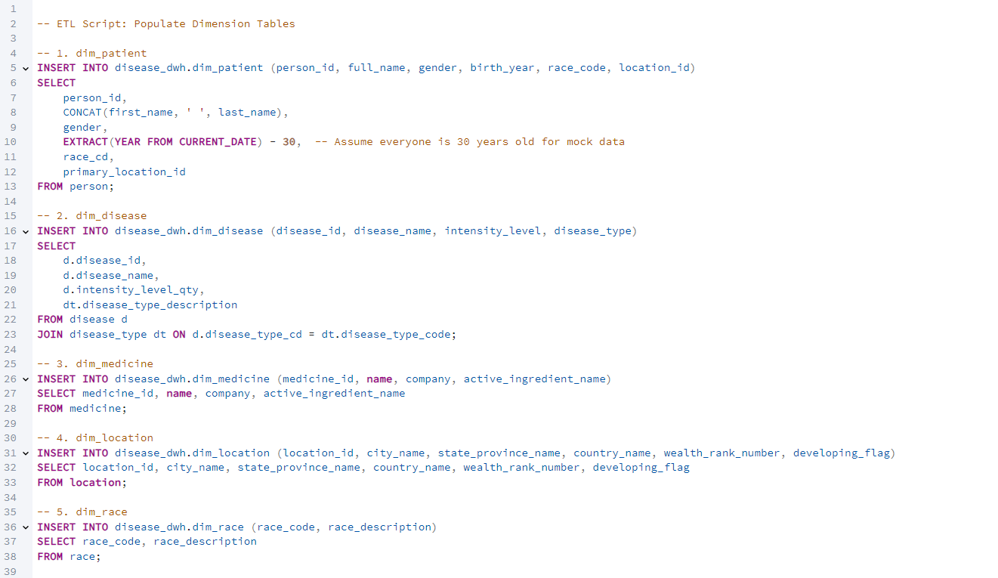
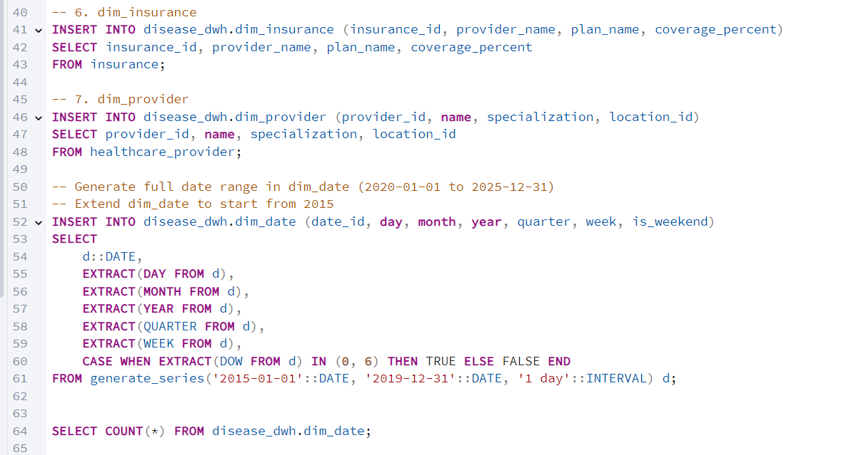
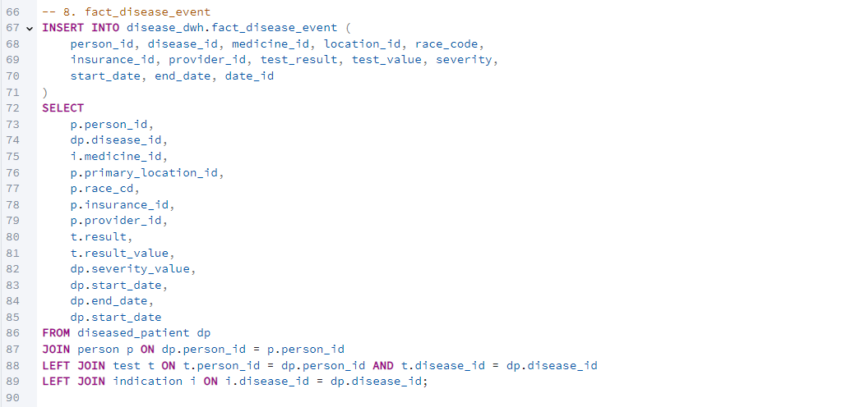

SCD 2
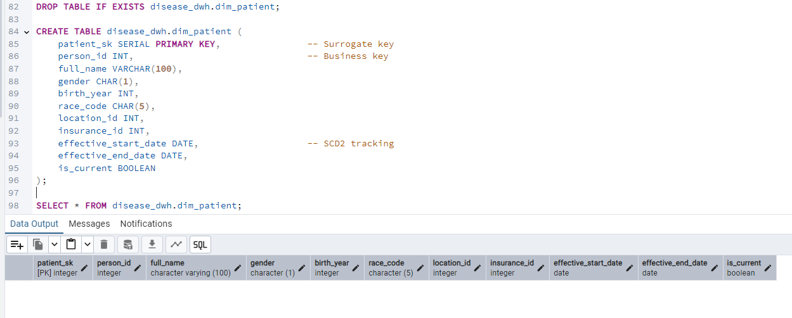
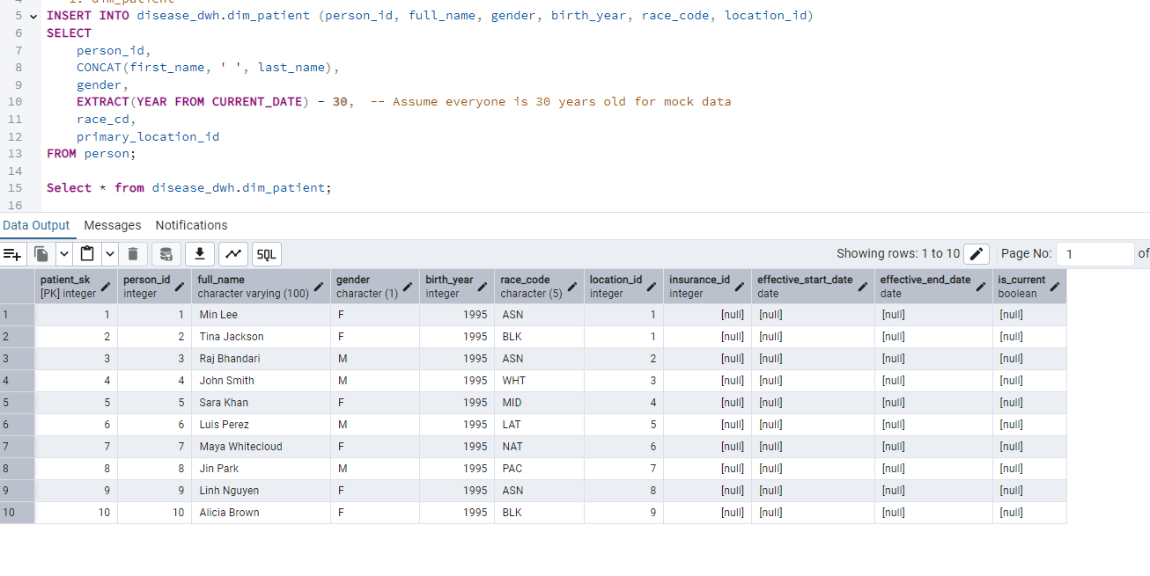
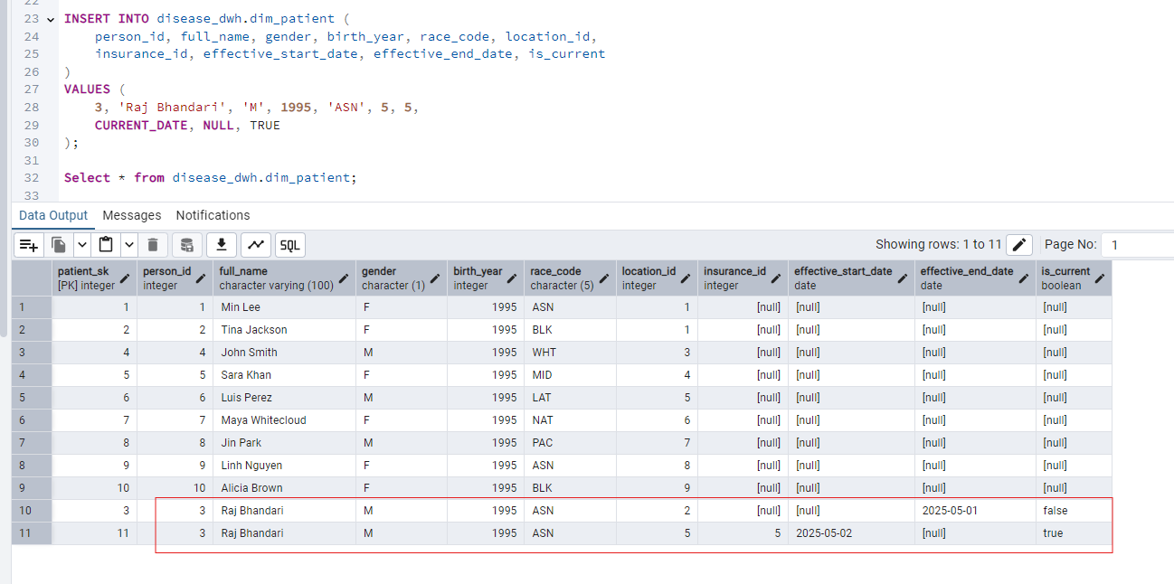

5.3 Dimensional Modeling
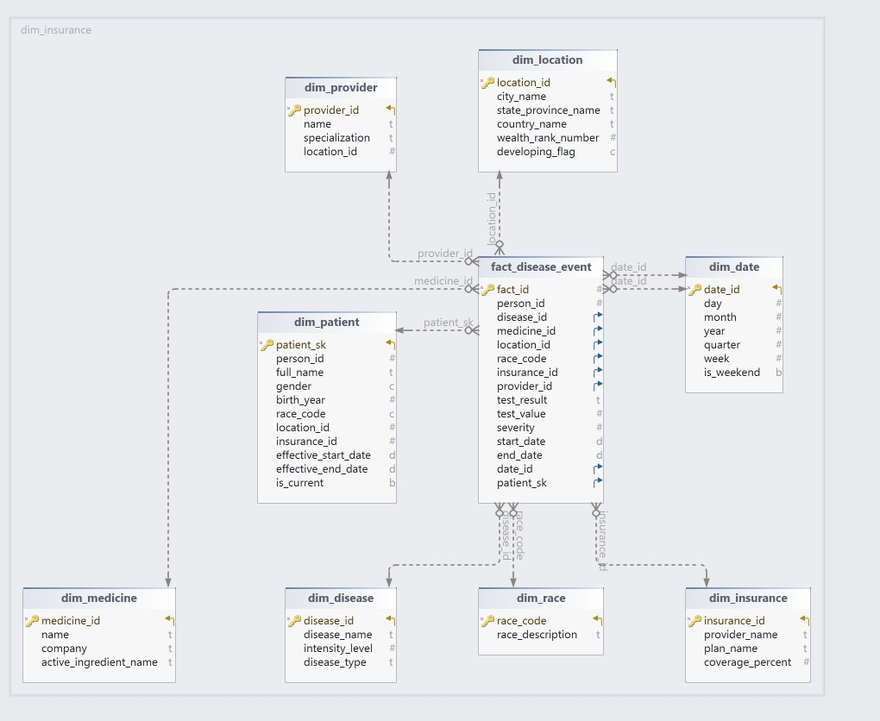
This dimensional model represents the Disease Data Management and Analytics System in a data warehouse context. It uses a star schema structure, where the central fact table is surrounded by dimension tables. This schema is designed to facilitate analytical queries and reporting related to healthcare data.
1. Fact Table: fact_disease_event
The fact table at the center stores the measurable data related to disease events. It includes the following key attributes:
- fact_id: Unique identifier for each event.
- person_id: ID linking to the patient.
- disease_id: ID referring to the disease diagnosed.
- medicine_id: ID of the prescribed medicine.
- location_id: Location where the event took place.
- insurance_id: Insurance coverage associated with the event.
- provider_id: Healthcare provider responsible.
- test_result: Outcome of a medical test (e.g., positive, negative).
- test_value: Numeric value representing test intensity or result.
- severity: Indicates the intensity level of the disease.
- start_date and end_date: Duration of the event or treatment.
- date_id: Foreign key to the date dimension.
- patient_sk: Surrogate key linking to the patient dimension.
Purpose:
The fact table consolidates various attributes from multiple dimensions to record medical events, allowing analysis on:
- Disease prevalence
- Treatment outcomes
- Regional distribution of diseases
- Healthcare provider performance

2. Dimension Tables:
a. dim_patient
This table captures patient-specific information:
- patient_sk: Surrogate key.
- person_id: Unique identifier.
- full_name, gender, birth_year: Demographic details.
- race_code: Categorical data representing ethnicity.
- location_id: Reference to geographical data.
- insurance_id: Insurance coverage details.
- effective_start_date, effective_end_date: Validity of patient records.
- is_current: Indicates whether the record is active.
b. dim_disease
Describes disease-related information:
- disease_id: Primary key.
- disease_name: Name of the disease.
- intensity_level: Indicates the severity (1 to 10 scale).
- disease_type: Categorizes the disease.
c. dim_provider
Contains healthcare provider data:
- provider_id: Unique identifier.
- name: Provider's name.
- specialization: Area of expertise.
- location_id: Location of the provider.
d. dim_location
Captures geographic details:
- location_id: Unique identifier.
- city_name, state_province_name, country_name: Location hierarchy.
- wealth_rank_number: Socioeconomic status indicator.
- developing_flag: Indicates whether the region is classified as developing.
e. dim_date
Tracks date-related data:
- date_id: Unique identifier.
- day, month, year, quarter, week: Time components.
- is_weekend: Boolean indicator for weekends.
f. dim_medicine
Information about medicines:
- medicine_id: Primary key.
- name: Medicine name.
- company: Manufacturer.
- active_ingredient_name: Main ingredient.
g. dim_race
Stores race/ethnicity descriptions:
- race_code: Unique identifier.
- race_description: Descriptive name of the race.
h. dim_insurance
Contains insurance plan details:
- insurance_id: Unique key.
- provider_name: Name of the insurance provider.
- plan_name: Insurance plan type.
- coverage_percent: Coverage ratio for medical expenses.

Key Features of the Model:
- Star Schema Design:
  - The central fact table is linked to multiple dimension tables.
  - Ensures efficient querying and faster aggregation.
- Historical Data Tracking (SCD2):
  - The dim_patient table uses effective_start_date, effective_end_date, and is_current to track patient data changes over time.
- Data Integration:
  - Integrates geographic, demographic, medical, insurance, and time-related data for comprehensive analysis.
- Facilitates Advanced Analytics:
  - Supports complex queries, including disease trend analysis, patient demographic insights, provider performance tracking, and geographic disease mapping.

Usage Scenarios for Healthcare Providers:
- Patient Demographics Analysis: Understanding the distribution of diseases based on gender, race, and age.
- Healthcare Service Efficiency: Evaluating the performance of healthcare providers based on treatment outcomes.
- Regional Disease Mapping: Identifying hotspots and trends related to specific diseases.
- Insurance Plan Effectiveness: Analyzing the correlation between insurance plans and treatment

Step 6: Analytical Queries on Star Schema
File name: analyticalqueriesstarschema.sql
Sample Analytical Queries (Star Schema)
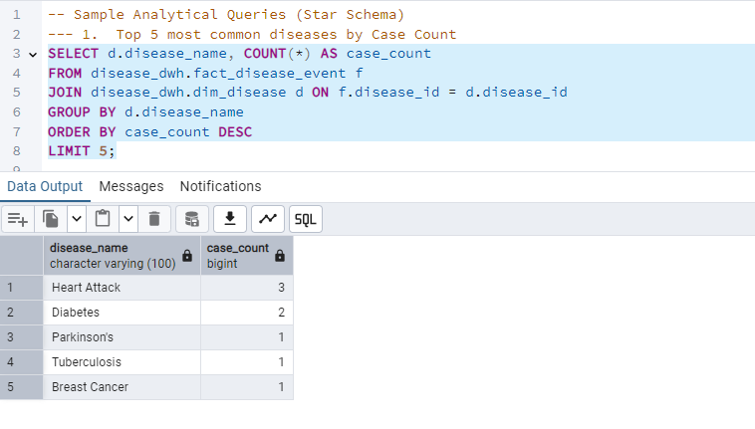

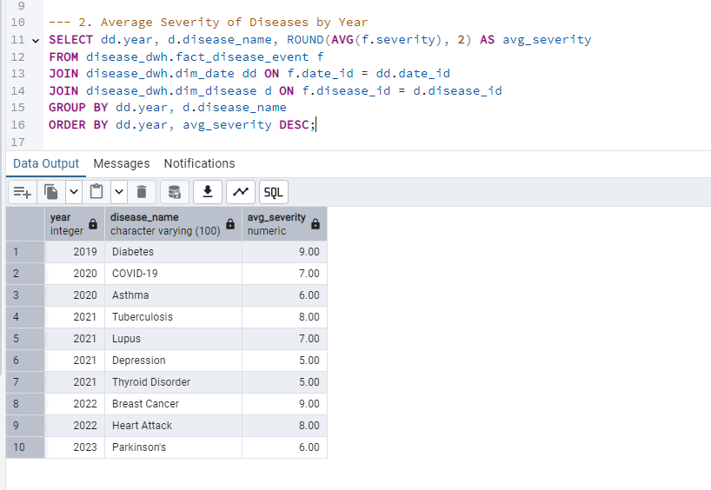
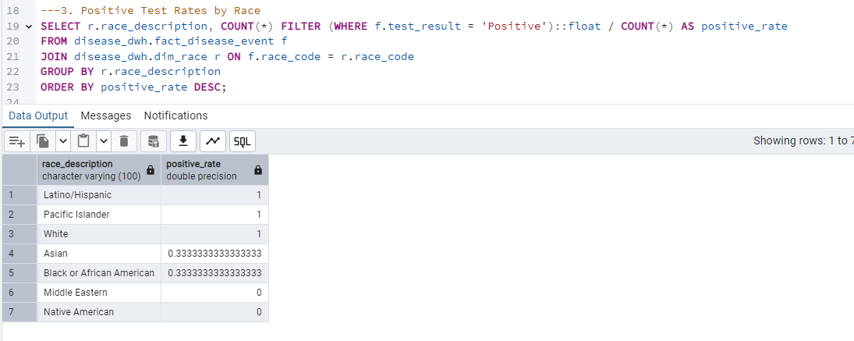
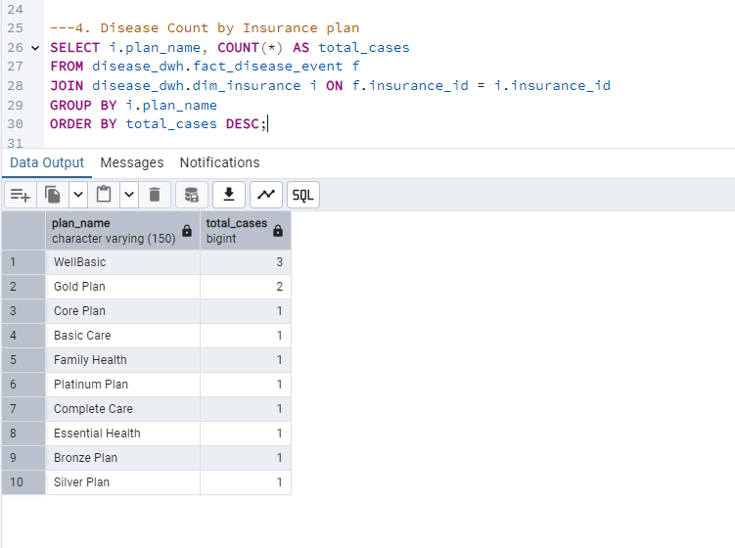
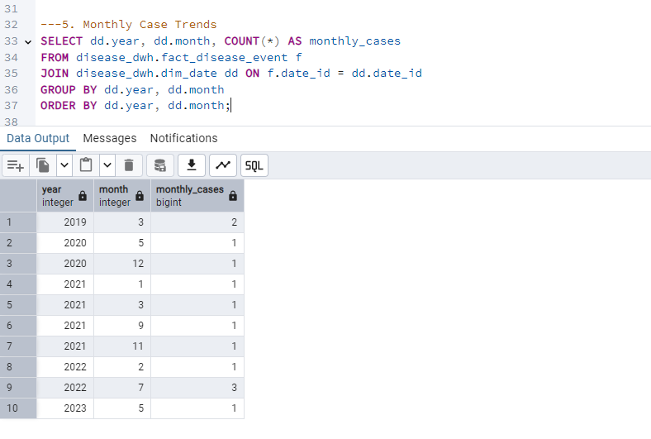

Step 7: NoSQL Comparison Summary
While the disease data model has been implemented in a relational format using PostgreSQL, exploring how this model would be structured in a NoSQL environment reveals important trade-offs and opportunities. This section compares the relational implementation with MongoDB (a document database) and Neo4j (a graph database) to evaluate how these alternative models would handle disease-related data.

A. MongoDB – Document-Oriented NoSQL
MongoDB stores data in collections of documents, similar to JSON objects. Rather than normalizing data across multiple related tables (as in a relational model), MongoDB encourages embedding related data within documents.
Structural Differences
In the relational model:
- person, disease, test, and location are separate tables
- Relationships are enforced through foreign keys
In MongoDB:
- A person document might embed everything related to that person: demographics, location, insurance, test results, and diseases.
Example Document:
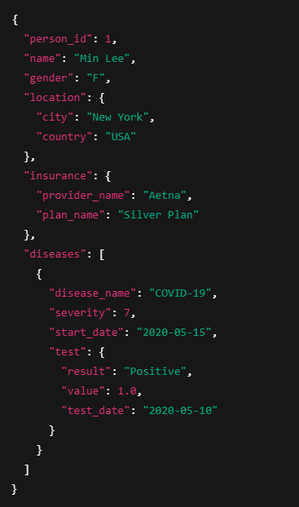
Benefits of MongoDB:
- Simpler and faster queries for retrieving a person’s full medical history
- Schema can evolve over time (no need to ALTER TABLE)
- Ideal for real-time applications and REST APIs (e.g., a mobile disease tracker)
Limitations:
- Data duplication (e.g., the same disease might be stored repeatedly across documents)
- No referential integrity where inconsistencies may arise if embedded documents are not synced
- Difficult to perform complex analytical queries like grouping by race or comparing across locations
- Joins are possible using $lookup, but inefficient
Conclusion:
MongoDB is great for individual-centric systems like patient portals, mobile health trackers, or simple health history apps. However, for public health analytics, trend analysis, and BI dashboards, a relational model is more appropriate.

B. Neo4j – Graph Database
Neo4j represents data as nodes (entities) and relationships (edges), making it well-suited for highly connected datasets like disease transmission, referrals, and family histories.
Graph Model Example:
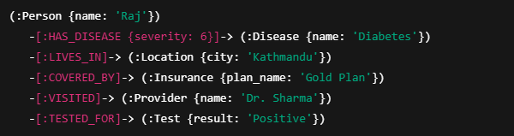
Benefits of Neo4j:
- Excellent for tracking relationships such as:
  - "Who did a patient come in contact with before testing positive?"
  - "Which provider treats the most patients with asthma?"
- Pattern-matching with Cypher makes querying networks (e.g., outbreaks) intuitive
- Ideal for epidemiological models, contact tracing, or tracing genetic disease lines

Limitations:
- Less suitable for tabular analytics
- Requires learning Cypher (a new query language)
- Smaller ecosystem for BI tools and ETL support compared to SQL or MongoDB
Overall Conclusion of this step:
While NoSQL systems offer flexibility and performance advantages for specific scenarios, the relational model remains the most robust and scalable choice for structured analytics and data warehousing. However, integrating MongoDB or Neo4j could enhance specific modules such as building a real-time contact tracing app or storing flexible medical notes alongside PostgreSQL analytics stack.

Step 8 AWS Lamda Architecture & Deployment Plan
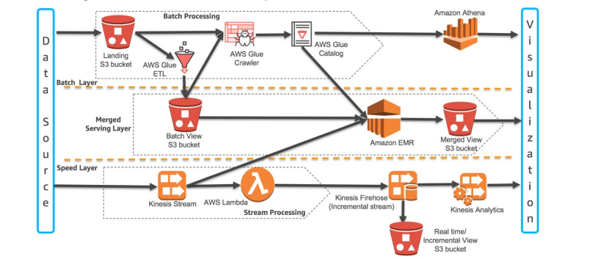
This diagram illustrates how a Lambda Architecture framework in AWS integrates both batch and real-time data streams into a unified data pipeline, which is highly applicable to your disease data project.
At the top of the architecture is the Batch Layer, which processes high-volume, historical data such as multi-year patient records, test results, and hospital reports. The batch data initially lands in an Amazon S3 bucket as raw files. These files are then processed using AWS Glue ETL jobs to clean and transform the data into a structured format. An AWS Glue Crawler scans the data to infer schema and stores metadata in the AWS Glue Catalog. Once processed, the structured batch data is saved in a different S3 bucket. This data becomes queryable through Amazon Athena, which allows SQL-based analysis over S3. This layer enables retrospective analytics, such as trend analysis over several years of disease cases.
The Real-Time Layer, depicted at the bottom of the diagram, is responsible for processing live data streams such as real-time test results, hospital alert systems, or data from wearable health devices. Real-time data is ingested through Amazon Kinesis Data Streams. AWS Lambda functions are triggered upon new data arrival to transform and cleanse the stream before sending it to Amazon Kinesis Data Firehose. Firehose stores the processed data in another S3 bucket and can optionally route data to analytics tools like Amazon Kinesis Data Analytics, which provides near real-time insights using streaming SQL queries. This layer enables detection of disease spikes and urgent events as they occur.
Between the batch and speed layers is the Merged Serving Layer. This layer merges historical batch data with real-time data to provide a comprehensive and unified dataset. Amazon EMR is used to run Spark or Hive jobs that integrate both types of data into a “merged view,” which is stored in another S3 bucket or delivered to a data warehouse like Amazon Redshift or a relational database like RDS. Optionally, DynamoDB can be used to serve flexible, fast-access views of patient or disease-specific information. This unified layer allows downstream applications and dashboards to query data that reflects both long-term trends and recent developments, providing a full picture for decision-making.
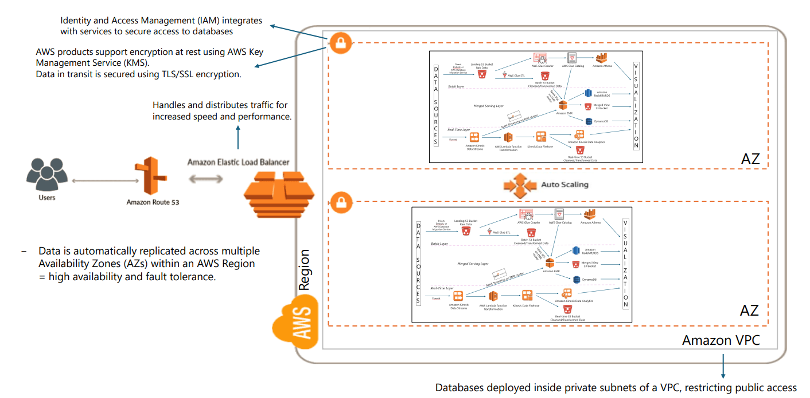
The second diagram focuses on how the architecture is deployed in a secure, scalable, and fault-tolerant AWS infrastructure using best practices. The entire data processing framework is hosted within an Amazon Virtual Private Cloud (VPC), which provides network-level isolation and ensures that components are not directly exposed to the public internet.
To ensure high availability, the infrastructure is replicated across multiple Availability Zones (AZs) within a single AWS Region. These zones are independent data centers that operate in parallel. If one zone fails, traffic is automatically rerouted to the other zone without service disruption. This replication ensures both high availability and fault tolerance, which are critical for healthcare-related applications.
User and application traffic is managed through Amazon Route 53, which handles DNS routing, and an Elastic Load Balancer (ELB), which distributes traffic intelligently to the appropriate availability zone and resources for optimal performance. All components, including Lambda functions, EMR clusters, databases, and data streams, scale automatically depending on usage patterns through AWS Auto Scaling. For example, a sudden spike in real-time disease data due to an outbreak would automatically trigger more processing capacity without manual intervention.
Security is enforced through multiple layers. Identity and Access Management (IAM) ensures that only authorized users and services can access specific resources. AWS Key Management Service (KMS) provides encryption at rest, while all data in transit is secured using TLS/SSL encryption. Databases are deployed inside private subnets within the VPC, making them inaccessible from the public internet and reducing exposure to external threats.

Step 9: Snowflake Advantages Summary
Snowflake is a modern, fully managed cloud-based data warehouse designed for performance, scalability, and flexibility. It differs significantly from traditional RDBMS systems like PostgreSQL.
Benefits of Using Snowflake
    - Performance Without Tuning
- Snowflake automatically handles indexing and partitioning
- No need to manage VACUUM, ANALYZE, or tuning manually
2️. Elastic Scalability
- Can handle large volumes of test results, patient data, and historical records
- Query performance remains consistent regardless of data size
3️. Separation of Storage & Compute
- You can pause compute when not querying — save cost
- Useful for academic or proof-of-concept projects with burst usage
4️. Concurrent Dashboards and Queries
- Doctors, analysts, and researchers can run dashboards simultaneously without contention
- BI tools like Tableau can connect directly to Snowflake via built-in connectors
5️. Data Sharing & Real-Time Integration
- You could share disease trend data securely with government or hospitals without ETL
- Snowpipe can load new test results in real-time

Summary of Part 9
While PostgreSQL serves well as a traditional relational database for OLTP and dimensional modeling, Snowflake offers significant advantages for large-scale analytical workloads. Its ability to scale compute and storage independently, handle concurrency, and simplify performance tuning makes it a highly attractive platform for healthcare analytics, especially when working with real-time or historical patient data at scale.

Dashboard:
File name: updatedimtables.sql (More data were inserted in between to make the dashboard clear and realistic.)

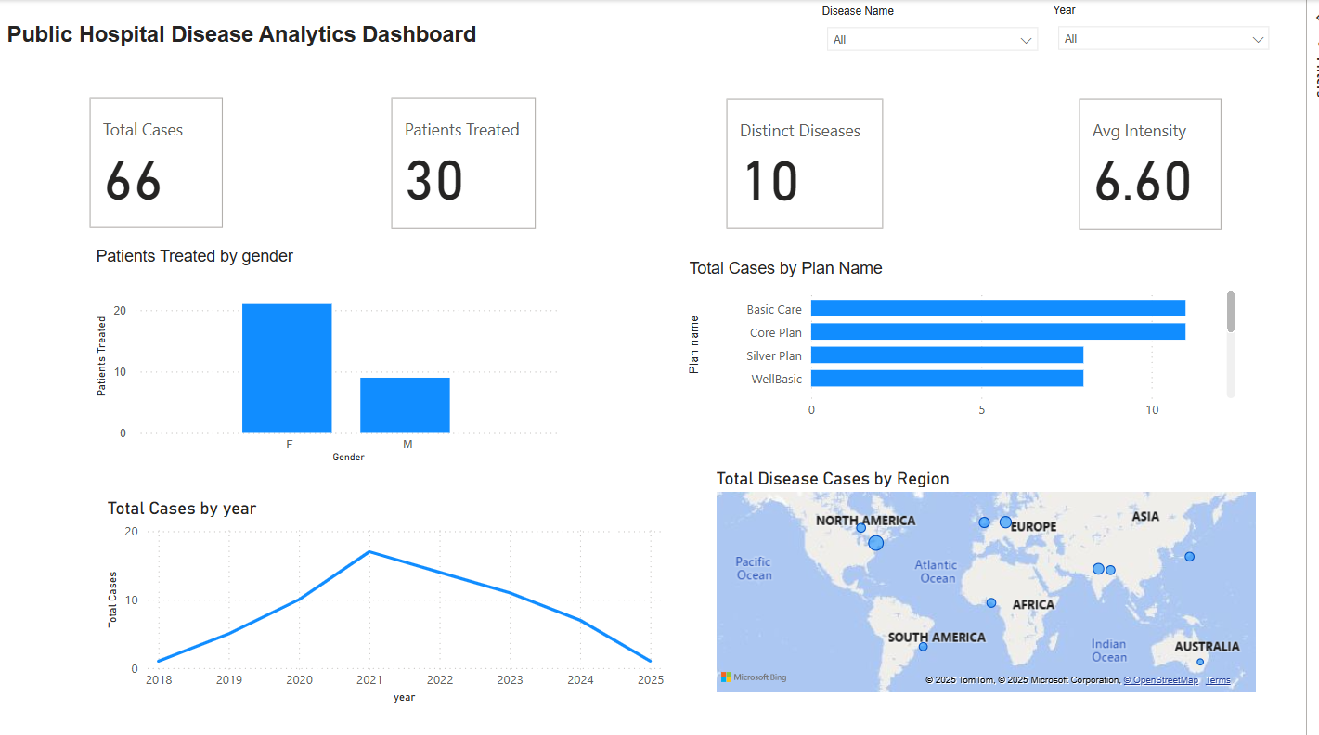
This dashboard, titled "Public Hospital Disease Analytics Dashboard", provides healthcare providers with a comprehensive overview of key metrics related to disease cases and treatment statistics. Below is a detailed breakdown of each section:
1. Key Metrics Overview (Top Row):
- Total Cases (66): The total number of disease cases recorded in the system.
- Patients Treated (30): The number of patients who have received treatment.
- Distinct Diseases (10): The number of unique diseases documented in the dataset.
- Average Intensity (6.60): The average severity level of the diseases, measured on a scale (likely from 1 to 10).
These metrics give healthcare providers a quick snapshot of the overall situation, including the volume of cases, treatment coverage, diversity of diseases, and average disease severity.

2. Patients Treated by Gender (Bar Chart):
- This bar chart shows the number of patients treated, categorized by gender (Female - "F" and Male - "M").
- Observation: A significantly higher number of female patients (around 20) compared to male patients (around 10), indicating a possible gender disparity in healthcare access or disease prevalence.

3. Total Cases by Plan Name (Horizontal Bar Chart):
- This chart displays the number of cases categorized by insurance plan or care plan name.
- The plans listed include:
  - Basic Care
  - Core Plan
  - Silver Plan
  - WellBasic
- Observation: The Basic Care plan has the highest number of cases, followed by other plans, indicating it may be the most commonly used or most accessible plan.

4. Total Cases by Year (Line Chart):
- This line graph displays the trend of total cases over time, from 2018 to 2025.
- Observation: A notable increase in cases from 2018, peaking around 2021, and then a gradual decline towards 2025. This trend may indicate the effectiveness of disease prevention measures or changes in healthcare practices.

5. Total Disease Cases by Region (Map):
- An interactive map visualizing the geographical distribution of disease cases.
- Observation: The map shows cases spread across major regions, including North America, Europe, Asia, Africa, South America, and Australia. This global spread suggests that the data might be aggregated from multiple healthcare facilities or global health monitoring systems.

Filters (Top Right):
- Disease Name and Year: Allows healthcare providers to filter the data based on a specific disease or year, enabling more targeted analysis.

Insights for Healthcare Providers:
- Patient Demographics: Identifying gender disparities can help allocate resources better or initiate gender-specific healthcare programs.
- Plan Utilization: Understanding which care plans are most used can guide policy adjustments or funding allocations.
- Yearly Trends: Monitoring changes in total cases over the years can assist in evaluating the impact of public health interventions.
- Geographical Insights: Knowing where diseases are most prevalent supports targeted healthcare initiatives in affected regions.

CONCLUSION
The Disease Data Management and Analytics System is designed to enhance public health outcomes by leveraging a robust relational database model coupled with a star schema to facilitate analytical insights. This system incorporates Slowly Changing Dimension Type 2 (SCD2) to ensure the accuracy of historical data, allowing for comprehensive tracking of changes over time. To support scalable and real-time data processing, the system utilizes AWS Lambda architecture, which enables the efficient handling of dynamic healthcare data. Additionally, it integrates Snowflake to optimize the performance and management of large-scale healthcare datasets, providing both speed and flexibility. By comparing relational databases with NoSQL alternatives, the system achieves a balanced approach, managing structured data while supporting flexible, real-time analytics. This comprehensive data management and analytics approach empowers public health agencies to make informed decisions, ultimately improving health outcomes through data-driven insights.

