Project Report

SkillForge AI Adaptive Learning and Exam Generator

Project Title : Skill Forge-AI Adaptive Learning and Exam Generator
Name : Namita Sinha
Date : November 28, 2025
Mentor : Miss. Isayarasi

About the Project
SkillForge AI is an advanced, AI-driven adaptive learning ecosystem designed to transform traditional digital learning through personalized educational content, intelligent assessment generation, and real-time performance analytics. The platform supports three key user roles—Learner, Admin, and Guardian—each equipped with a dedicated dashboard tailored to their specific needs. SkillForge AI aims to optimize learning efficiency by delivering adaptive content, generating AI-curated quizzes and exams, and providing continuous monitoring of academic progress.

Objectives
The primary objectives of SkillForge AI are as follows:
- Deliver personalized and adaptive learning experiences based on user performance and preferences.
- Provide AI-generated quizzes, MCQs, and instant evaluation to streamline assessment workflows.
- Implement dedicated dashboards for Learner, Admin, and Guardian roles.
- Track learner progress, provide performance analytics, and recommend the next best course or topic.
- Offer guardians real-time visibility into their ward’s academic activity and performance trends.
- Maintain a clean, professional, and responsive UI/UX using React and pastel-gradient design principles.

System Actors
SkillForge AI operates with three primary user roles:
- Learner / User: Engages with the adaptive learning modules, assessments, and progress tracking tools.
- Admin / Instructor: Manages users, oversees learning content, creates assessments, and monitors performance.
- Guardian: Tracks the ward's academic progress, receives alerts, and communicates with administrators.

Learner Features
The Learner module provides a personalized learning experience with the following features:
- Secure authentication via email or phone.
- Self-centric dashboard displaying private ranking and personalized progress.
- Adaptive learning module recommending the next best course or chapter.
- Multi-format content delivery: blog, PDF, video, images, diagrams.
- AI-generated assessments, instant scoring, and performance feedback.
- Progress metrics including streaks, points, and completion percentage.
- AI chatbot restricted to academic and progress-related queries.
- Clean, modern, responsive UI built with pastel-gradient aesthetics.

Admin Features
The Admin dashboard enables full system supervision through:
- User and course enrollment management.
- Content upload, updates, and organization.
- AI-generated test and assessment creation.
- Visual analytics and performance graphs for learners.
- Monitoring active learners and course completion levels.
- Direct communication with guardians.
- Full control over course access, permissions, and learning flows.

Guardian Features
The Guardian panel provides monitoring and engagement tools such as:
- Login and dashboard access to track ward’s academic analytics.
- Performance, assessment history, and learning progress review.
- Alerts for inactivity, poor scores, or significant achievements.
- AI chatbot for retrieving ward-specific insights.
- Ability to add or manage linked learner accounts.
- Message interface to communicate directly with Admins.

Adaptive Learning Model
The adaptive learning model intelligently adjusts content difficulty and presentation format based on:
- Learner performance trends
- Preferred content modes
- Response speed and accuracy
- Historical assessment analytics
Using these insights, the system predicts knowledge gaps and suggests personalized next steps to enhance comprehension and retention.

Assessment Engine
The AI-powered assessment module includes:
- Dynamic test generation using AI.
- Multiple question formats: MCQs, short answers, concept-based prompts.
- Instant evaluation and scoring with detailed feedback.
- Difficulty adaptation based on learner history.
- Optional manual test assignment by Admins.

Technology Stack
- Frontend: React (Vite), HTML5, CSS3
- Backend: Node.js / Java (future integration planned)
- Database: MongoDB
- AI System: Custom LLM-powered assessment and content generation models
- Version Control: Git + GitHub

Frontend Modules Completed
The following UI components have been fully designed and implemented:
- Home page with responsive layout
- Role-based login pages
- Complete Learner Dashboard
- Admin Dashboard (UI skeleton)
- Guardian Dashboard (UI skeleton)
- Routing and navigation for all modules
- Unified theme integration with consistent pastel gradients
Frontend Images
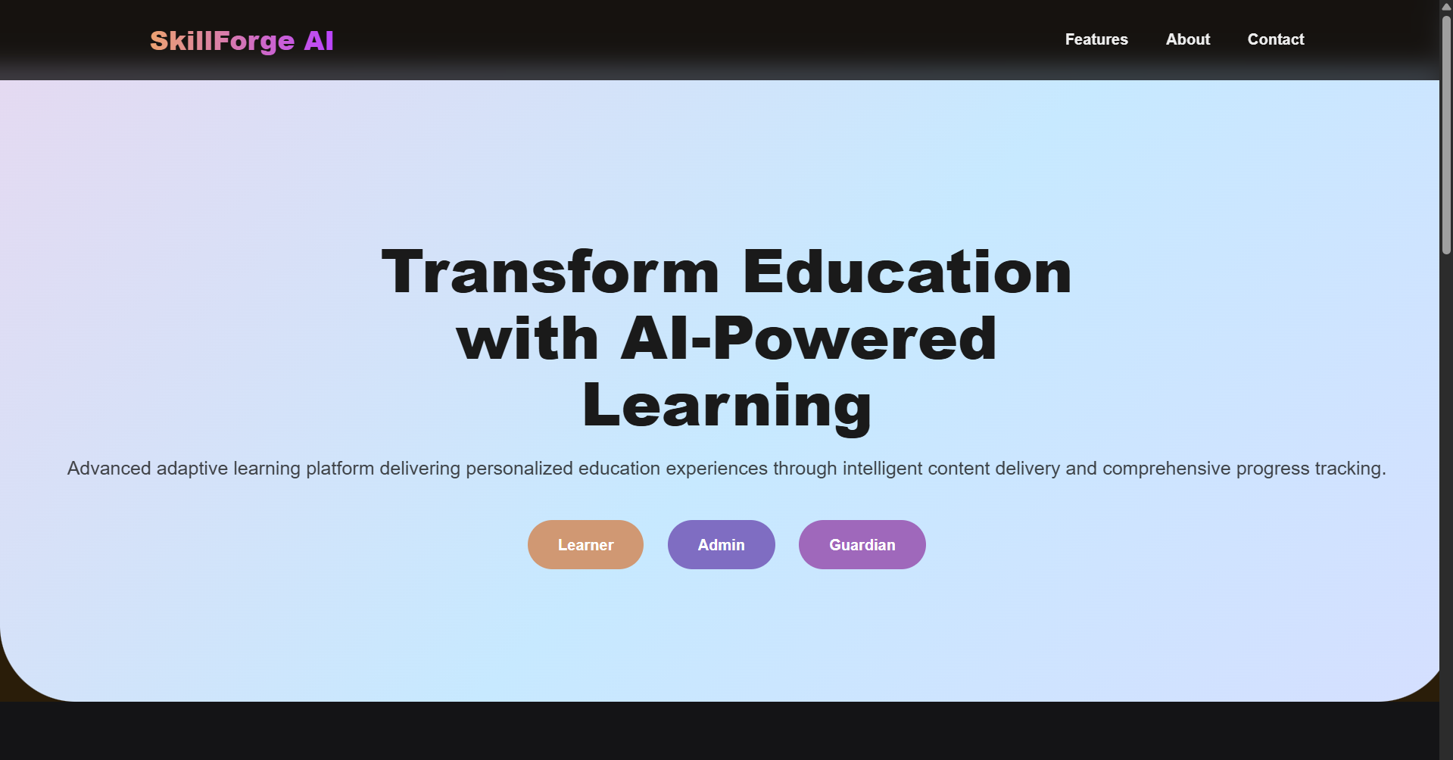

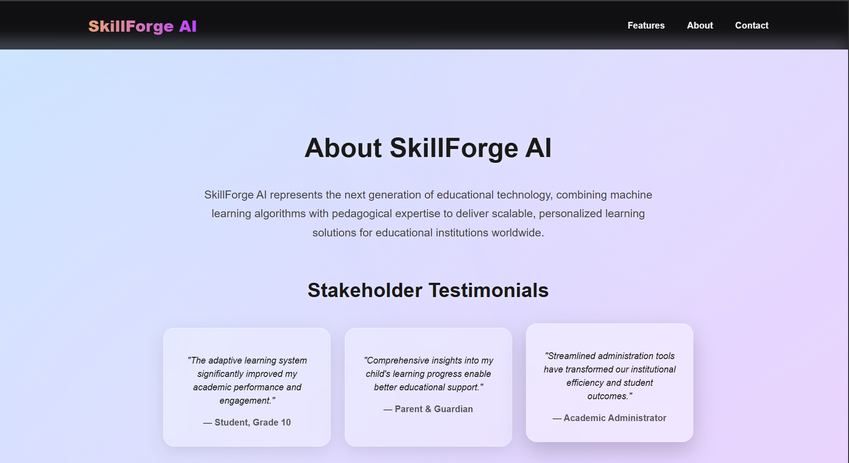

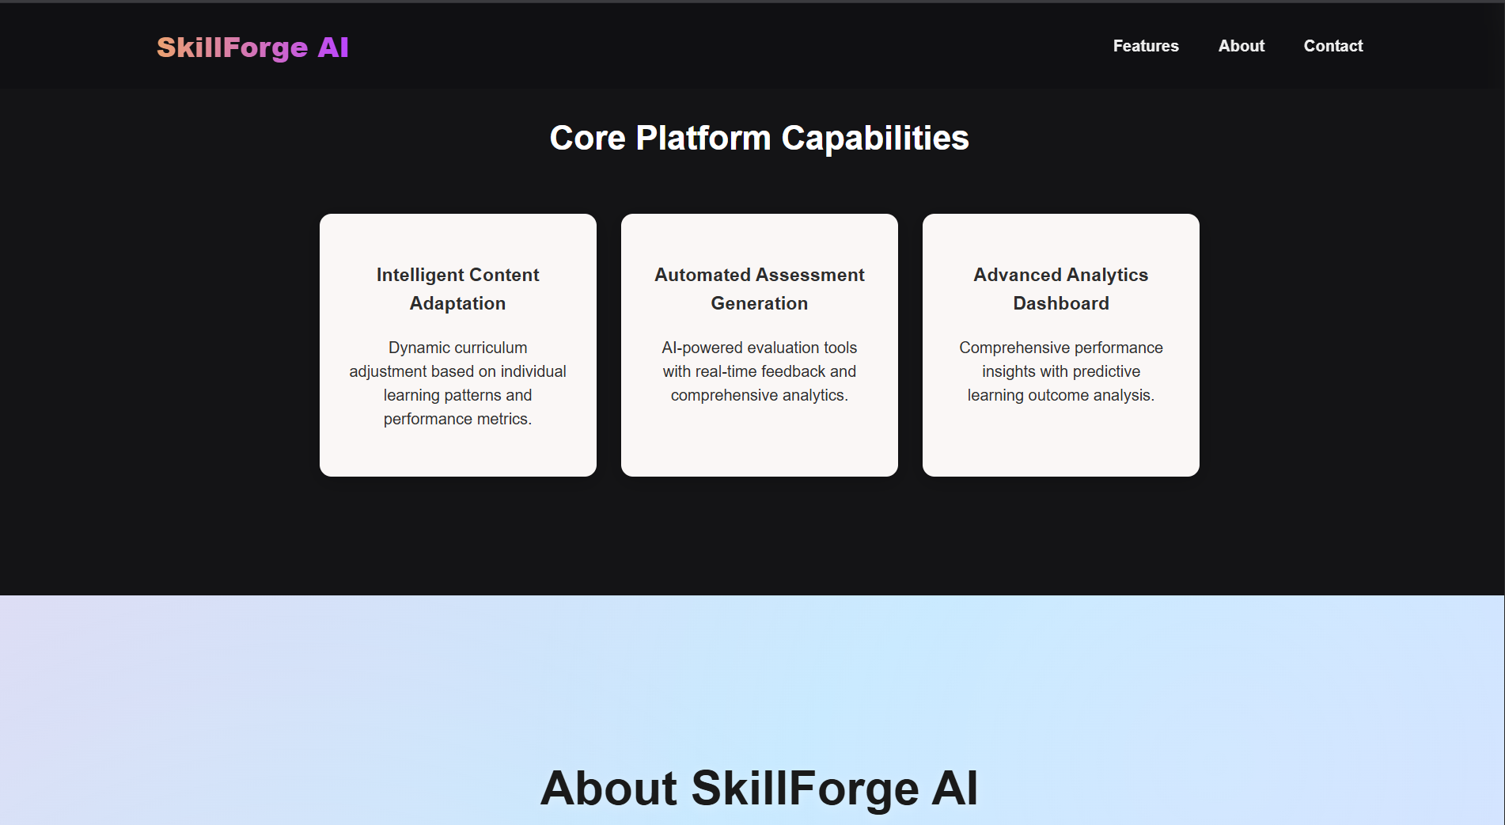

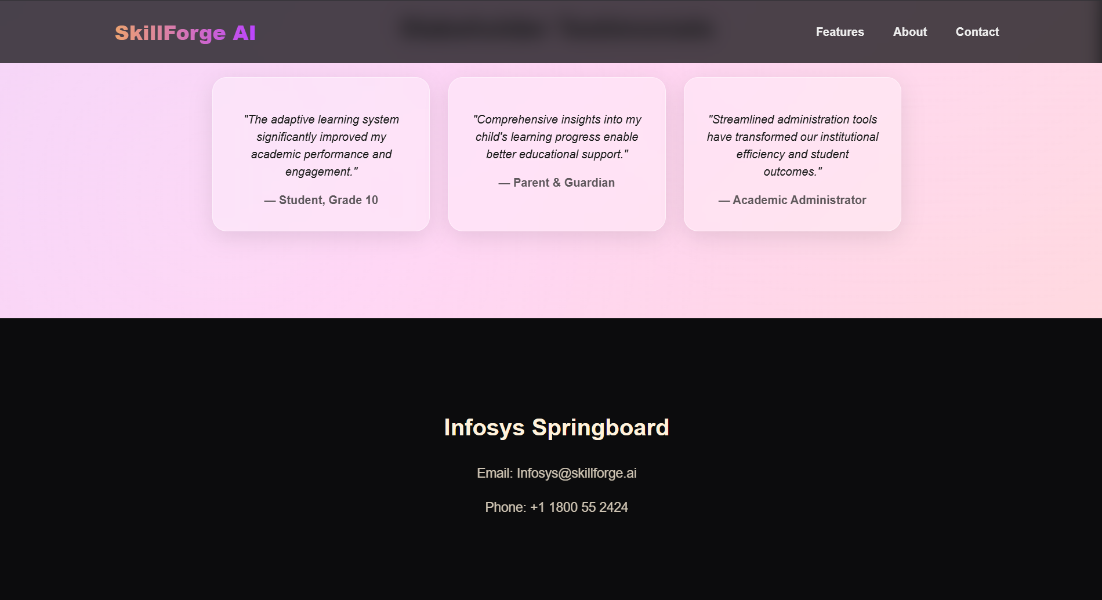

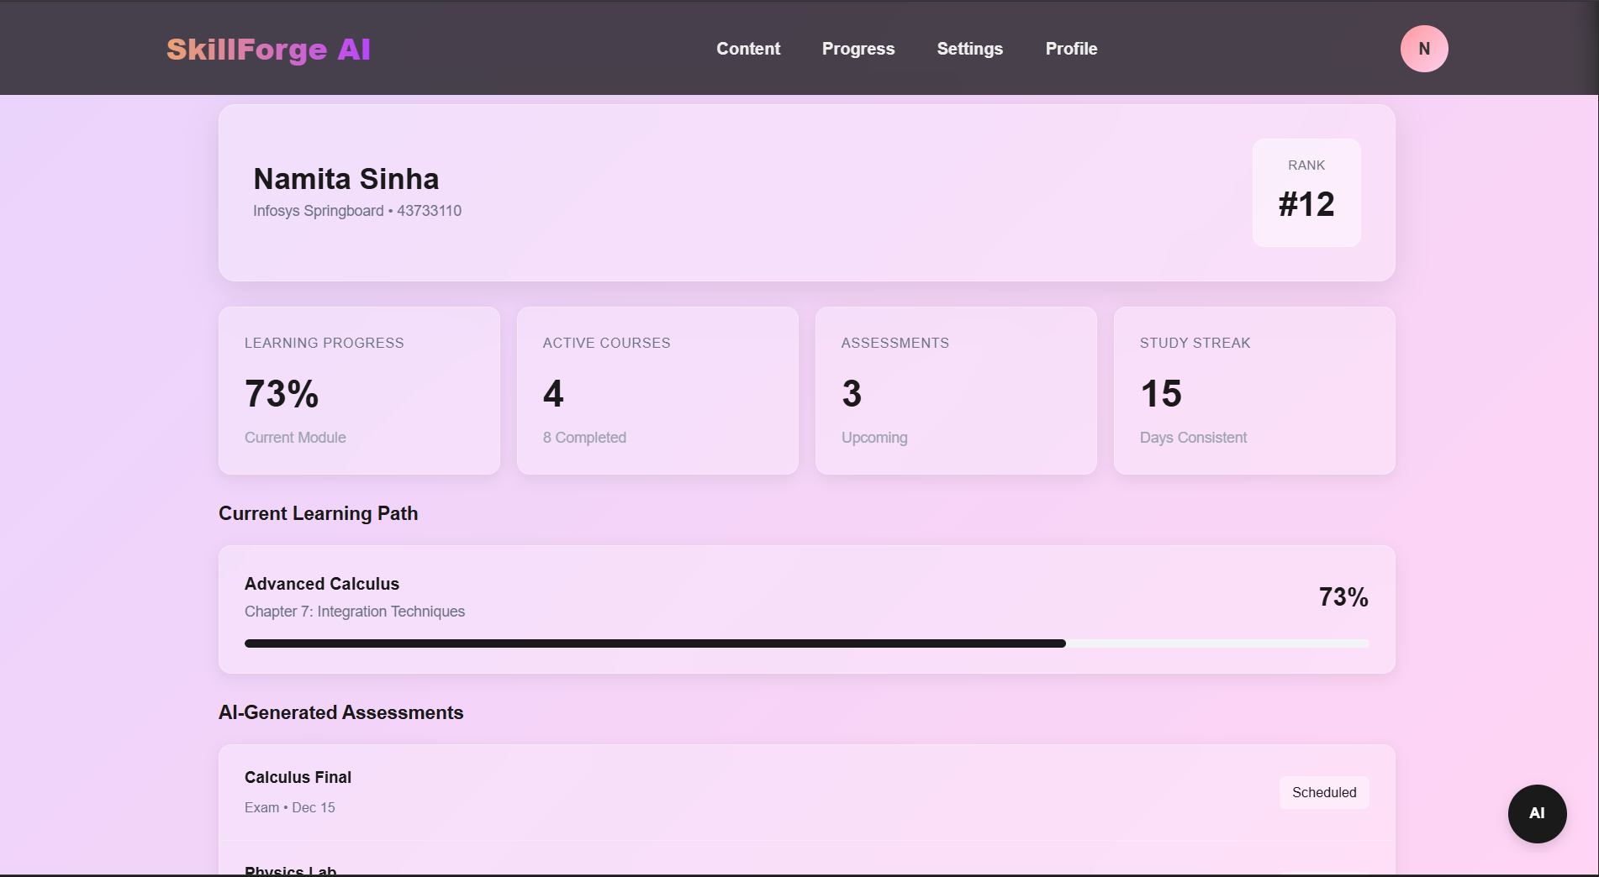
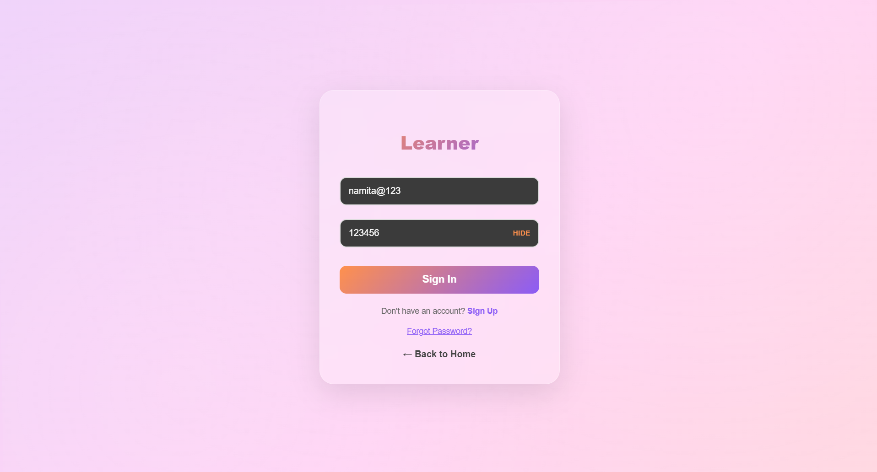

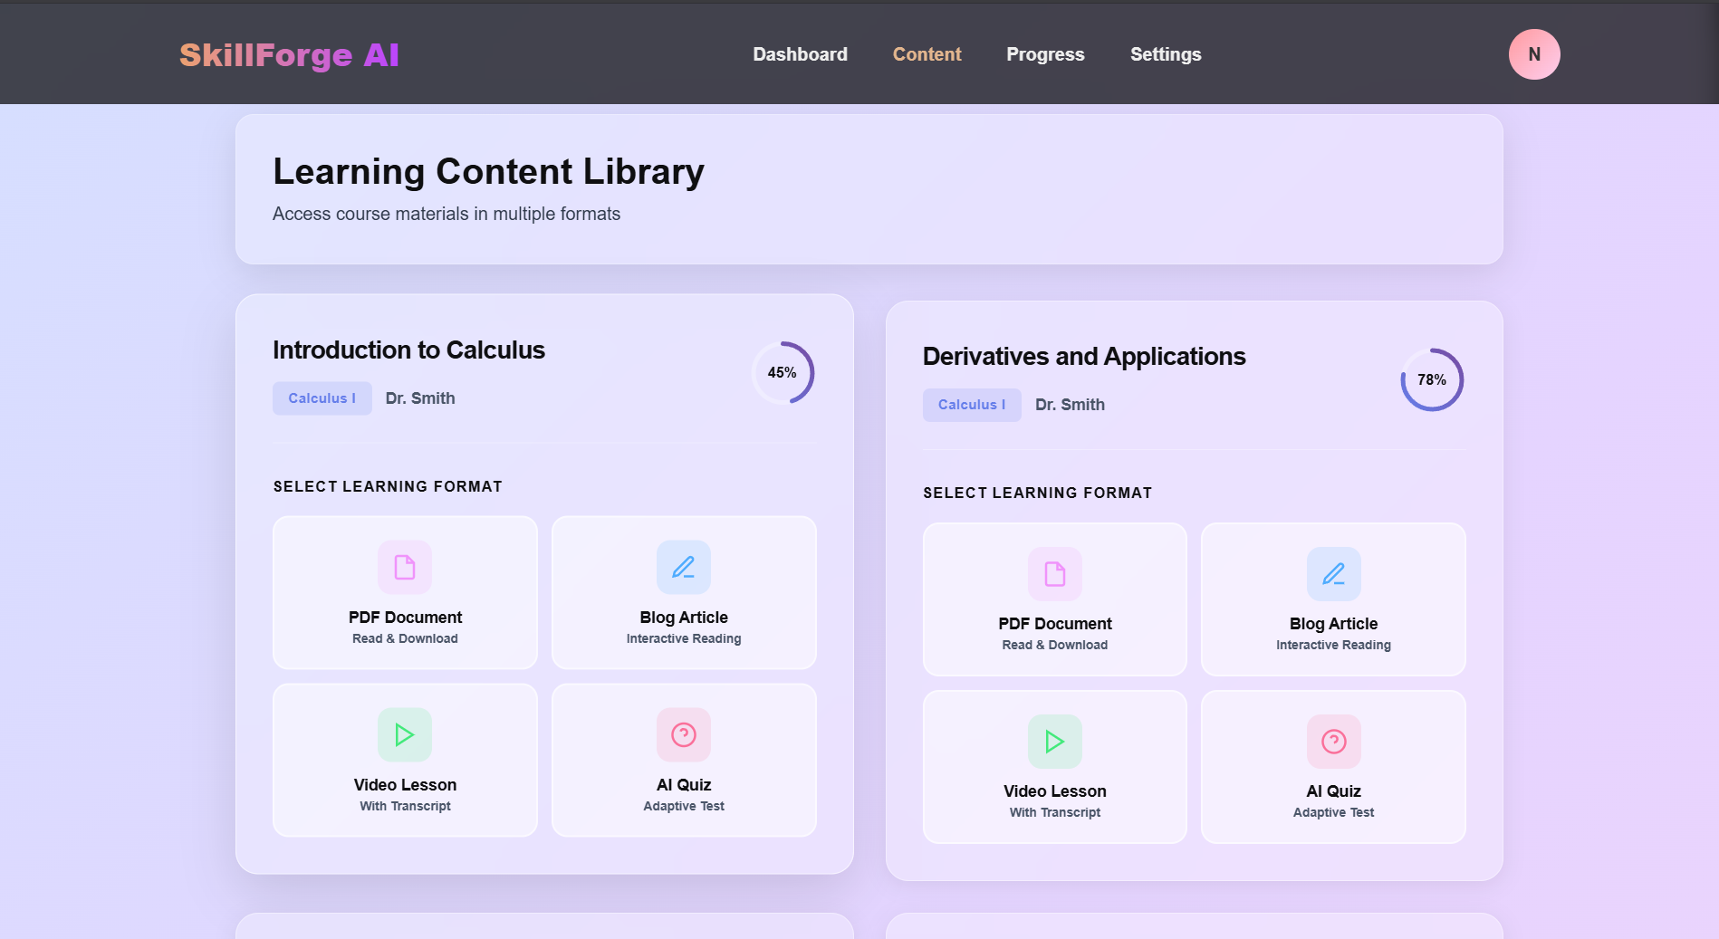
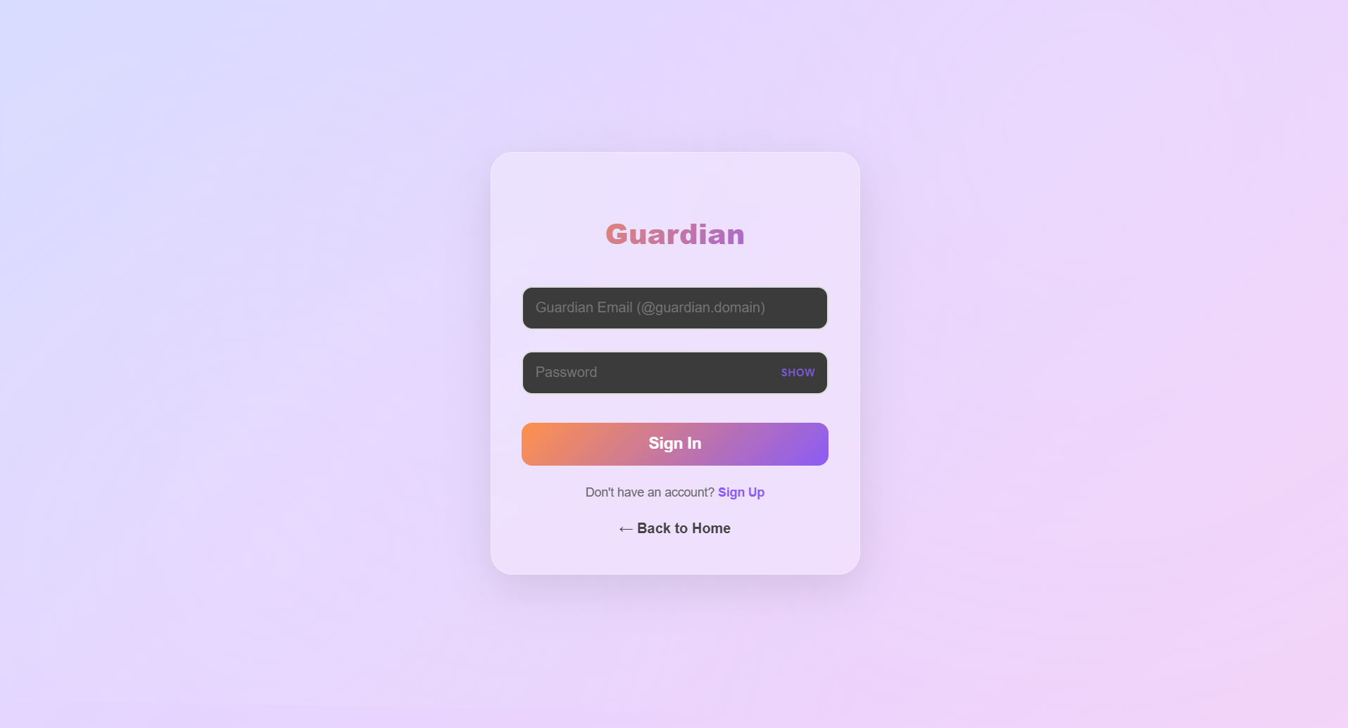
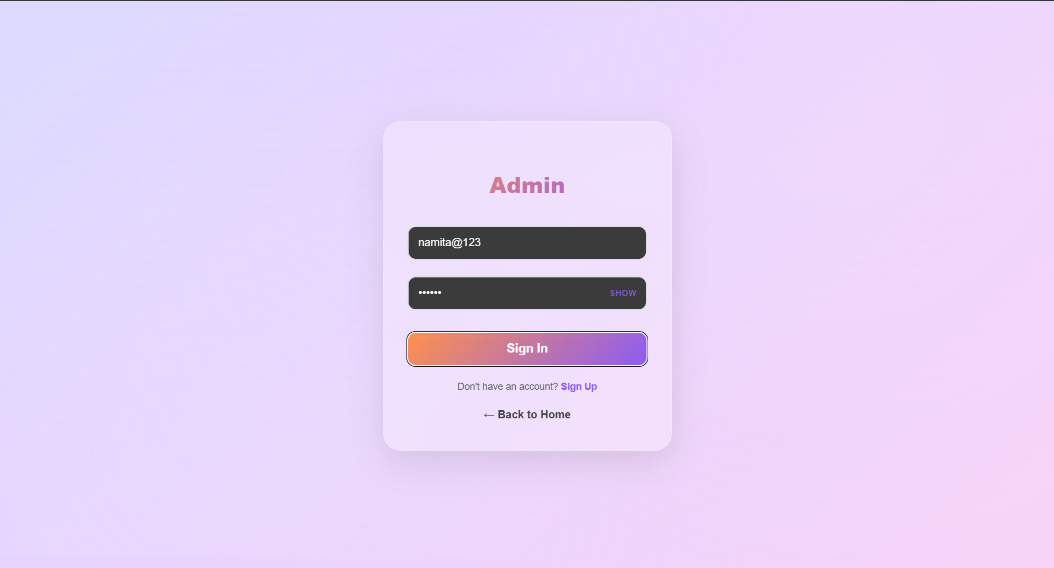

Challenges Faced
During development, several challenges were addressed:
- Ensuring consistent theme alignment across all components.
- Achieving responsive behaviour for gradient-rich layouts.
- Designing intuitive adaptive content selection interfaces.
- Managing role-specific dashboard navigation effectively.
- Handling Git versioning issues and resolving merge conflicts.

Conclusion
SkillForge AI successfully delivers a refined, adaptive-learning-first UI prototype that establishes clear role segregation, visually polished dashboards, and a scalable structure for future enhancements. The completed UI lays a strong foundation for integrating backend systems, implementing the adaptive AI engine, connecting databases, and enabling secure authentication. This project marks a significant milestone toward building a comprehensive, intelligent learning platform that supports students, educators, and guardians alike.

