DATABASE MANAGEMENT SYSTEM (DBMS)
DETAILED ANSWERS
Theory Questions — Exam-Ready Notes

1. Explain the Role of DBA (Database Administrator)
A Database Administrator (DBA) is the person or team responsible for managing, maintaining, securing, and ensuring the efficient operation of an organisation’s database system. The DBA makes sure that authorised users can access accurate data when required, while preventing data loss, unauthorised access, and unnecessary downtime.

Major responsibilities of a DBA
- Database installation and configuration: Installs the DBMS software and configures the database environment.
- Database design and creation: Helps define database structures, tables, indexes, storage settings, and access methods in coordination with database designers and developers.
- Security and authorisation: Creates user accounts, assigns roles and privileges, and prevents unauthorised access to sensitive information.
- Backup and recovery: Schedules backups and restores data after accidental deletion, hardware failure, corruption, or other disasters.
- Performance monitoring and tuning: Monitors query speed, memory, storage, indexes, and server load to improve performance.
- Integrity and consistency: Enforces constraints and rules so that data remains correct, valid, and consistent.
- Concurrency and availability: Helps multiple users work with the database safely and keeps database services available.
- Maintenance and upgrades: Applies patches, upgrades DBMS versions, manages storage growth, and resolves technical problems.
- Disaster recovery planning: Prepares procedures to recover the database and minimise downtime after a major failure.
Example: In a college database, the DBA ensures that student records are backed up, only authorised staff can change marks, and the system remains available during result declaration.
Conclusion: The DBA protects the database, maintains its reliability and performance, and ensures that data is available to authorised users.

2. Explain the Three-Tier Architecture of DBMS
Three-tier architecture divides an application into three separate layers: the presentation tier, application tier, and data tier. Each tier has a specific responsibility. This separation makes applications easier to maintain, secure, and scale.
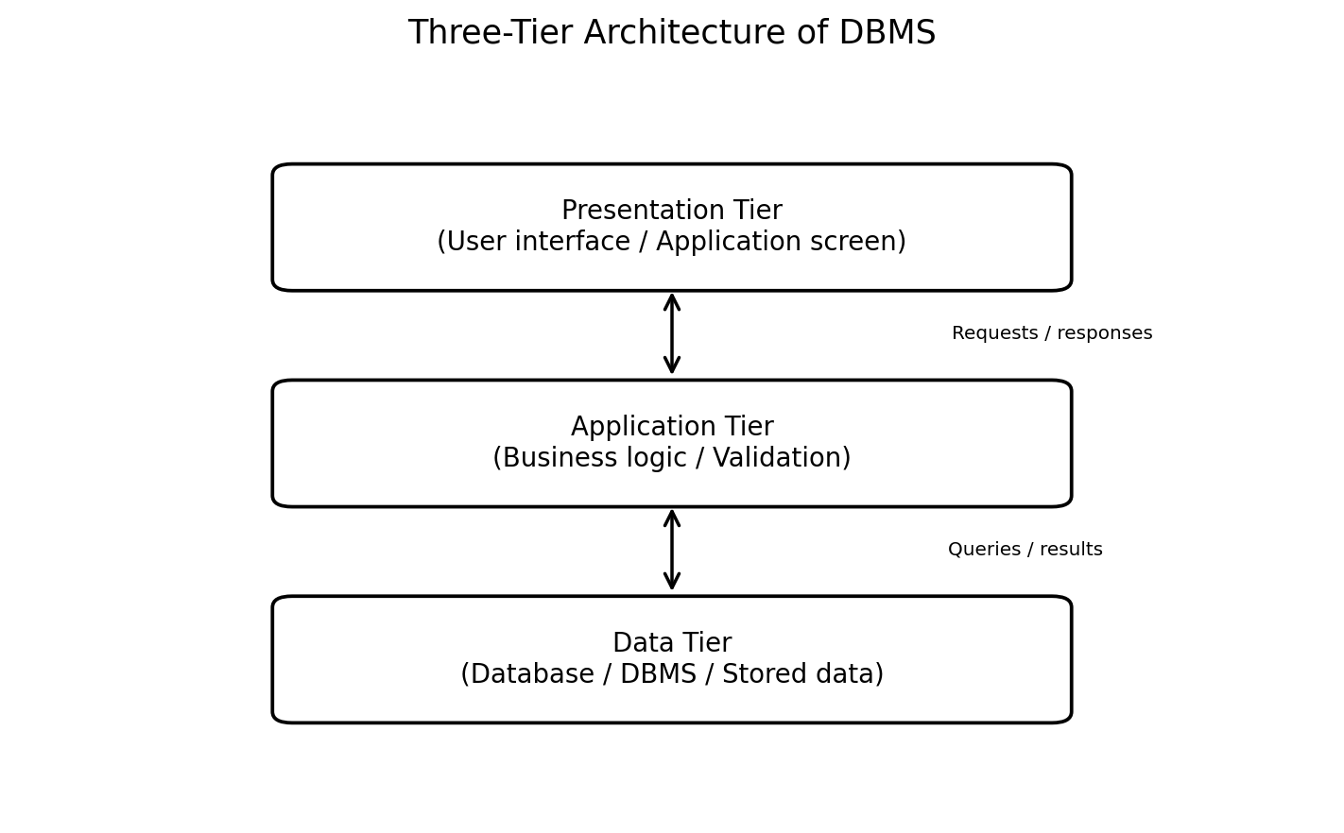

1. Presentation Tier (User Interface)
This is the layer with which the user interacts. It displays information and accepts input through a website, desktop application, or mobile application. It sends user requests to the application tier and displays the returned results.

2. Application Tier (Business Logic)
This layer processes requests and applies the rules of the application. It validates input, performs calculations, checks permissions, and communicates with the database. It acts as an intermediary between the user interface and the data tier.

3. Data Tier (Database Layer)
This layer stores and manages data using a DBMS such as MySQL, Oracle, PostgreSQL, or SQL Server. It processes database queries and returns the required data to the application tier.

Working example
- A student enters their roll number on a college portal (presentation tier).
- The application checks the request and determines which student record is needed (application tier).
- The DBMS retrieves the record from the database and sends it back through the application tier to the screen (data tier and return path).

Advantages
- Separation of responsibilities makes the system easier to develop and maintain.
- Security improves because users do not normally access the database directly.
- Each tier can be upgraded or scaled independently.
- Code reuse and testing become easier.

3. What Is the ER Model? Explain with Diagram and Suitable Example
The Entity–Relationship (ER) model is a high-level conceptual model used to represent the data requirements of a system. It describes entities, their attributes, and the relationships between entities. An ER diagram (ERD) presents this information graphically before the database tables are created.

Main components of the ER model
- Entity: A real-world object or concept about which data is stored, such as Student, Course, Employee, or Department. It is represented by a rectangle.
- Attribute: A property of an entity, such as RollNo, Name, or Age. It is commonly represented by an oval.
- Relationship: An association between entities, such as a Student ENROLS in a Course. It is represented by a diamond in traditional ER notation.
- Key attribute: An attribute that uniquely identifies an entity, such as RollNo for Student. It is commonly underlined in a traditional ER diagram.

Example: Student and Course
A college stores information about students and courses. Each student has a RollNo and Name. Each course has a CourseID and Title. A student may enrol in several courses, and each course may have many students. Therefore, ENROLS is a many-to-many (M:N) relationship.
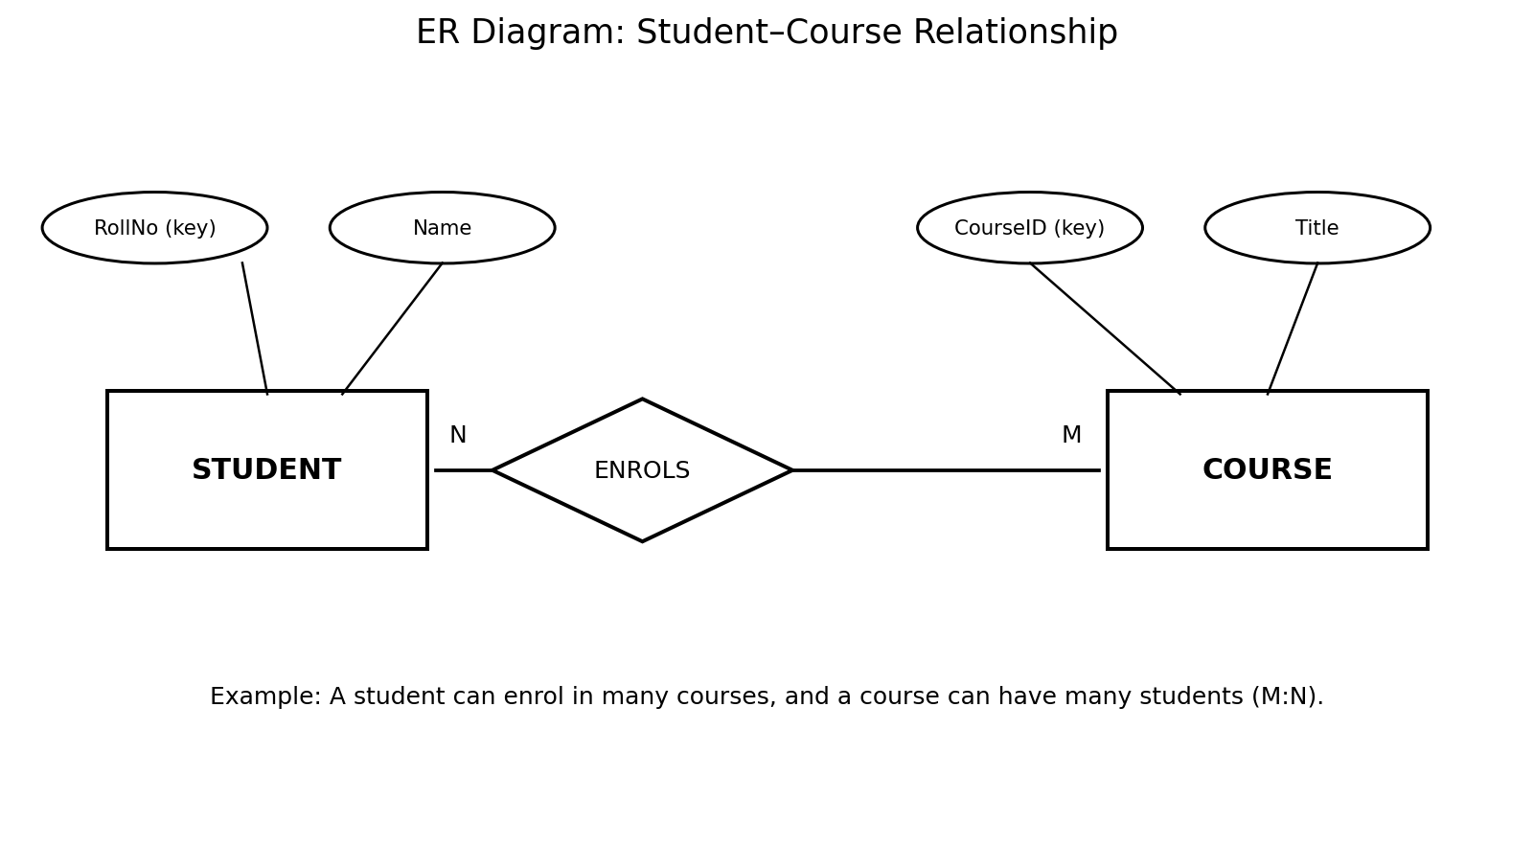
The diagram shows STUDENT and COURSE as entities, their attributes as ovals, and ENROLS as the relationship. The M and N labels indicate that many students can enrol in many courses.

Importance of the ER model
- It helps identify the data that must be stored before implementation.
- It shows relationships and constraints clearly.
- It provides a blueprint for converting a conceptual design into relational tables.
- It helps developers and users discuss database requirements.

4. Explain Different Mapping Cardinalities Used in DBMS
Mapping cardinality (or cardinality ratio) specifies how many entities of one entity set can be associated with entities of another entity set through a relationship. The four common types are one-to-one, one-to-many, many-to-one, and many-to-many.
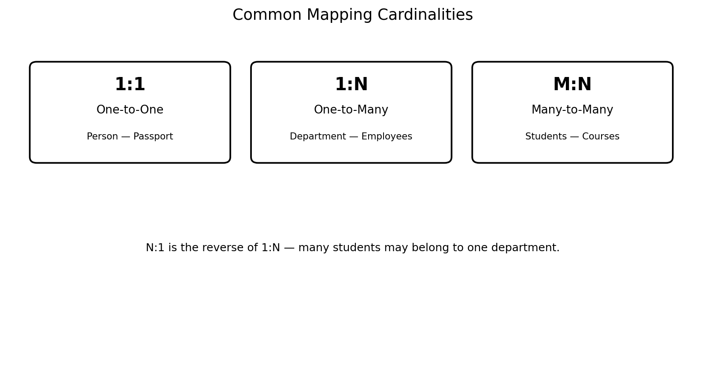

1. One-to-One (1:1)
One entity in set A is associated with at most one entity in set B, and one entity in B is associated with at most one entity in A. Example: Under a suitable rule, each person has one passport, and each passport belongs to one person.

2. One-to-Many (1:N)
One entity in set A can be associated with many entities in set B, but each entity in B is associated with at most one entity in A. Example: One department can have many employees, while each employee belongs to one department.

3. Many-to-One (N:1)
Many entities in set A can be associated with one entity in set B. It is the reverse view of one-to-many. Example: Many employees may belong to the same department.

4. Many-to-Many (M:N)
Many entities in set A can be associated with many entities in set B. Example: A student can enrol in many courses, and each course can have many students.
Note: Cardinality describes the maximum number of related entities. Minimum participation (such as optional or mandatory participation) is a separate constraint.

5. Student Relation: Attributes, Tuple, Degree, and Possible Primary Key
Given relation: Student(RollNo, Name, Course, Marks). The following sample values are assumed for illustration.
RollNo | Name | Course | Marks
101 | Ayesha | BCA | 85
102 | Rahul | BSc CS | 78
103 | Meera | BCA | 91
104 | Kabir | BCom | 74

Definitions and answers
- Attribute: A column or property of a relation. The attributes are RollNo, Name, Course, and Marks.
- Tuple: A row or record in a relation. For example, (101, Ayesha, BCA, 85) is one tuple.
- Degree: The number of attributes (columns) in a relation. Here, degree = 4.
- Possible primary key: RollNo, assuming every student has a unique roll number and it is never NULL. It uniquely identifies each row.
Additional note: The relation has 4 tuples in the sample table. The number of tuples is called the cardinality of the relation. Do not confuse this with mapping cardinality in Question 4.

6. Explain Set Intersection Operation and Assignment Operation with Suitable Example

A. Set Intersection Operation
In relational algebra, the intersection operation (∩) returns only those tuples that are present in both relations. The two relations must be union-compatible: they should have the same number of attributes, and corresponding attributes should have compatible domains.
Example: Consider the following relations containing students enrolled in two activities.
SPORTS
(RollNo, Name)
(101, Ayesha)
(102, Rahul)
(103, Meera)
MUSIC
(RollNo, Name)
(102, Rahul)
(103, Meera)
(105, Sana)
Expression: SPORTS ∩ MUSIC
Result: (102, Rahul) and (103, Meera), because these tuples occur in both relations.
Uses: Intersection can identify common records, such as students who participate in both sports and music.

B. Assignment Operation
The assignment operation in relational algebra assigns the result of an expression to a temporary relation variable. It is usually represented by the left arrow (←). It allows a complex query to be divided into smaller, readable steps.
Example: Suppose STUDENT(RollNo, Name, Course, Marks) contains student records. To store students who scored more than 80 in a temporary relation:
HIGH_SCORERS ← σ Marks > 80 (STUDENT)
Here, σ (sigma) is the selection operator. HIGH_SCORERS temporarily represents all rows from STUDENT where Marks > 80. For the sample table in Question 5, the result contains Ayesha (85) and Meera (91).
Difference: Intersection combines two compatible relations to return common tuples, while assignment stores the result of an expression under a temporary relation name.

7. Explain Partial and Multivalued Dependency

A. Partial Dependency
A partial dependency occurs when a non-prime attribute depends on only a proper subset of a candidate key, rather than on the whole composite candidate key. It is relevant when a candidate key contains more than one attribute.
Example: Consider ENROLMENT(StudentID, CourseID, StudentName, CourseName, Grade), with composite primary key (StudentID, CourseID). Assume StudentName depends only on StudentID, CourseName depends only on CourseID, and Grade depends on the combination of StudentID and CourseID.
- StudentID → StudentName (partial dependency)
- CourseID → CourseName (partial dependency)
- (StudentID, CourseID) → Grade (depends on the whole composite key)
Why it is a problem: Partial dependencies can cause repeated data and insertion, update, and deletion anomalies. They violate Second Normal Form (2NF), assuming the relation is already in 1NF.
How to remove it: Decompose the relation into STUDENT(StudentID, StudentName), COURSE(CourseID, CourseName), and ENROLMENT(StudentID, CourseID, Grade).

B. Multivalued Dependency (MVD)
A multivalued dependency occurs when, for a given value of one attribute (or attribute set), there is a set of values of another attribute that is independent of the remaining attributes. It is written X ↠ Y (read as “X multidetermines Y”).
Example: Consider STUDENT_INFO(Student, Hobby, Language). A student may have several hobbies and may know several languages, and the hobbies are independent of the languages.
- (Anam, Reading, English)
- (Anam, Painting, English)
- (Anam, Reading, Hindi)
- (Anam, Painting, Hindi)
If hobbies and languages are independent for each student, then Student ↠ Hobby and Student ↠ Language. The table stores every combination, causing repeated data.
How to remove it: Decompose the relation into STUDENT_HOBBY(Student, Hobby) and STUDENT_LANGUAGE(Student, Language). This removes unnecessary combinations and is associated with Fourth Normal Form (4NF), when the MVD is non-trivial.

Key difference
Basis | Partial Dependency | Multivalued Dependency
Meaning | A non-prime attribute depends on part of a composite candidate key. | Two sets of values are independent for a given determinant.
Notation | X → Y (where X is a proper subset of a candidate key) | X ↠ Y
Normal form | Violation of 2NF | Non-trivial MVDs are addressed by 4NF

8. What Is Normalization? State Its Advantages
Normalization is the systematic process of organising data in relational tables to reduce unnecessary duplication and prevent data anomalies. It divides data into appropriately related tables and defines relationships using keys. A good decomposition should preserve the required information and, where possible, dependencies.

Main normal forms
- First Normal Form (1NF): Each attribute contains a single, atomic value; repeating groups and multivalued fields are not stored in one cell.
- Second Normal Form (2NF): The relation is in 1NF, and every non-prime attribute is fully dependent on every candidate key; partial dependencies are removed.
- Third Normal Form (3NF): The relation is in 2NF and has no inappropriate transitive dependency of non-prime attributes on candidate keys; formally, for every non-trivial FD X → A, X is a superkey or A is prime.
- Boyce–Codd Normal Form (BCNF): For every non-trivial functional dependency X → Y, X must be a superkey.
- Fourth Normal Form (4NF): The relation is in BCNF and has no non-trivial multivalued dependency unless its determinant is a superkey.

Advantages of normalization
- Reduces data redundancy: The same fact does not need to be stored repeatedly in many rows.
- Prevents update anomalies: A fact can be updated in one appropriate place instead of several rows.
- Prevents insertion anomalies: Information can be added without being forced to enter unrelated information.
- Prevents deletion anomalies: Removing one record does not accidentally remove a different important fact.
- Improves data integrity and consistency: Related facts are stored in a logical structure with suitable keys and constraints.
- Makes database design clearer: Each table represents a more focused entity or relationship.
- Simplifies maintenance: Changes are easier to manage when dependencies are represented correctly.

Simple example
Suppose one table stores StudentID, StudentName, CourseID, and CourseName for every enrolment. If many students take the same course, CourseName is repeated many times. A normalized design can separate STUDENT(StudentID, StudentName), COURSE(CourseID, CourseName), and ENROLMENT(StudentID, CourseID). This reduces duplication and avoids having to update the same course name in many rows.
Conclusion: Normalization improves the logical design of a database by reducing redundancy and anomalies. However, the appropriate normal form depends on the requirements; excessive decomposition can sometimes make queries require more joins.

