Practical 1 - Python Basics

Section A
Q1.
Write a Python program to input two numbers and perform all arithmetic operations (+, -, *, /, %, //, **).
Program:
num1=int(input("Enter First Number:"))
num2=int(input("Enter Second Number:"))
print("Addition: ",num1+num2)
print("Subtraction: ",num1-num2)
print("Multiplication: ",num1*num2)
print("Division: ",num1/num2)
print("Floor Division: ",num1//num2)
print("Modulus: ",num1%num2)
print("Exponent: ",num1**num2)

Output:
Enter First Number: 5
Enter Second Number: 2
Addition: 7
Subtraction: 3
Multiplication: 10
Division: 2.5
Floor Division: 2
Modulus: 1
Exponent: 25

Q2.
Write a Python program to check whether a number is even or odd.
Program:
num=int(input("Enter Number:"))
if(num%2==0):
print("Even number")
else:
print("Odd number")

Output:
Enter Number: 8
Even number
Enter Number: 5
Odd number

Section B

Section B
Q3.
Create a list of five numbers. Display: Largest number, Smallest number, Sum of all numbers, Sorted list.
Program:
numbers=[12,45,8,23,18]
print("Largest:",max(numbers))
print("Smallest:",min(numbers))
print("Sum:",sum(numbers))
numbers.sort()
print("Sorted List: ",numbers)

Output:
Largest: 45
Smallest: 8
Sum: 106
Sorted List: [8, 12, 18, 23, 45]

Q4.
Write a Python program to add, remove, and insert elements in a list.
Program:
Fruits=["Apple","Banana","Mango"]
Fruits.append("Orange")
Fruits.insert(1,"Grapes")
Fruits.remove("Banana")
print(Fruits)

Output:
['Apple', 'Grapes', 'Mango', 'Orange']

Q5.
Create a dictionary to store student details (Name, Roll No., Marks) and display all keys and values.
Program:
Student={"Name":"Rahul","Roll No.":101,"Marks":92}
print("Keys:",Student.keys())
print("Values:",Student.values())
print("Items:",Student.items())

Output:
Keys: dict_keys(['Name', 'Roll No.', 'Marks'])
Values: dict_values(['Rahul', 101, 92])
Items: dict_items([('Name', 'Rahul'), ('Roll No.', 101), ('Marks', 92)])

Section C

Section C
Q6.
Write a Python program to count vowels and consonants in a string.
Program:
text=input("Enter a string: ")
vowels=0
consonants=0
for ch in text.lower():
if ch.isalpha():
if ch in "aeiou":
vowels+=1
else:
consonants+=1
print("Vowels: ",vowels)
print("Consonants: ",consonants)

Output:
Enter a string: Nagpur
Vowels: 2
Consonants: 4

Q7.
Write a Python program to reverse a string and check whether it is a palindrome.
Program:
text=input("Enter a string: ")
reverse=text[::-1]
print("Reversed string: ",reverse)
if text==reverse:
print("The string is a palindrome.")
else:
print("The string is not a palindrome.")

Output:
Enter a string: madam
Reversed string: madam
The string is a palindrome.
Enter a string: gupta
Reversed string: atpug
The string is not a palindrome.

Q8.
Write a Python program demonstrating the following string methods: upper(), lower(), title(), replace(), split().
Program:
text=input("Enter a string: ")
print("Upper Case: ",text.upper())
print("Lower Case: ",text.lower())
print("Title Case: ",text.title())
print("Replace 'Python' with 'Java': ",text.replace("Python","Java"))
print("Split String: ",text.split())

Output:
Enter a string: i am learning Python
Upper Case: I AM LEARNING PYTHON
Lower Case: i am learning python
Title Case: I Am Learning Python
Replace 'Python' with 'Java': i am learning Java
Split String: ['i', 'am', 'learning', 'Python']

Section D

Section D
Q9.
Write a Python program to demonstrate sequence operations: Indexing, Slicing, Concatenation, Repetition.
Program:
text=input("Enter a string: ")
print("First Character: ",text[0])
print("Last Character: ",text[-1])
print("First five characters: ",text[:5])
print("Last five characters: ",text[-5:])
new_text=text+" Python"
print("After concatenation: ",new_text)
print("After repetition: ",text*2)

Output:
Enter a string: Hello
First Character: H
Last Character: o
First five characters: Hello
Last five characters: Hello
After concatenation: Hello Python
After repetition: HelloHello

Q10.
Write a Python program to demonstrate: len(), max(), min(), sum(), Membership operator (in).
Program:
numbers=[10,20,30,40]
print("Length: ",len(numbers))
print("Maximum: ",max(numbers))
print("Minimum: ",min(numbers))
print("Sum: ",sum(numbers))
print(20 in numbers)
print(50 in numbers)

Output:
Length: 4
Maximum: 40
Minimum: 10
Sum: 100
True
False

Practical 2 - NumPy

Q1.
Import NumPy and create a one-dimensional array containing the numbers 10, 20, 30, 40, 50. Display the array.

Program:
import numpy as np

arr = np.array([10, 20, 30, 40, 50])
print(arr)

Output:
[10 20 30 40 50]

Q2.
Create the following two-dimensional array and display it:
1 2 3
4 5 6
7 8 9

Program:
import numpy as np

arr2d = np.array([[1, 2, 3],
[4, 5, 6],
[7, 8, 9]])
print(arr2d)

Output:
[[1 2 3]
[4 5 6]
[7 8 9]]

Q3.
Create and display an array of 5 zeros using np.zeros() and an array of 5 ones using np.ones().

Program:
import numpy as np

zeros_arr = np.zeros(5)
ones_arr = np.ones(5)
print("Array of zeros:", zeros_arr)
print("Array of ones:", ones_arr)

Output:
Array of zeros: [0. 0. 0. 0. 0.]
Array of ones: [1. 1. 1. 1. 1.]

Q4.
Create an array containing numbers from 1 to 10 using np.arange(), and 5 equally spaced numbers between 10 and 50 using np.linspace().

Program:
import numpy as np

arr_range = np.arange(1, 11)
arr_linspace = np.linspace(10, 50, 5)
print("Array using arange():", arr_range)
print("Array using linspace():", arr_linspace)

Output:
Array using arange(): [ 1 2 3 4 5 6 7 8 9 10]
Array using linspace(): [10. 20. 30. 40. 50.]

Q5.
Create a 3x3 identity matrix using np.eye() and display it.

Program:
import numpy as np

identity_matrix = np.eye(3)
print(identity_matrix)

Output:
[[1. 0. 0.]
[0. 1. 0.]
[0. 0. 1.]]

Q6.
Create the array A = np.array([[10,20,30],[40,50,60]]) and display its Shape, Size, Number of Dimensions (ndim) and Data Type (dtype).

Program:
import numpy as np

A = np.array([[10, 20, 30],
[40, 50, 60]])
print("Shape:", A.shape)
print("Size:", A.size)
print("Number of Dimensions:", A.ndim)
print("Data Type:", A.dtype)

Output:
Shape: (2, 3)
Size: 6
Number of Dimensions: 2
Data Type: int64

Q7.
Create two arrays A = [10,20,30] and B = [2,4,5]. Perform and display Addition, Subtraction, Multiplication, Division.

Program:
import numpy as np

A = np.array([10, 20, 30])
B = np.array([2, 4, 5])

print("Addition:", A + B)
print("Subtraction:", A - B)
print("Multiplication:", A * B)
print("Division:", A / B)

Output:
Addition: [12 24 35]
Subtraction: [ 8 16 25]
Multiplication: [ 20 80 150]
Division: [5. 5. 6.]

Q8.
Create a NumPy array containing the marks of 5 students: 65, 72, 80, 90, 78. Display the original marks, add 5 grace marks to every student, and display the updated marks.

Program:
import numpy as np

marks = np.array([65, 72, 80, 90, 78])
print("Original marks:", marks)

updated_marks = marks + 5
print("Updated marks (with 5 grace marks):", updated_marks)

Output:
Original marks: [65 72 80 90 78]
Updated marks (with 5 grace marks): [70 77 85 95 83]

Q9.
Store the temperatures of 7 days in a NumPy array. Display the temperature array, Shape, Size, Number of Dimensions and Data Type.

Program:
import numpy as np

temperatures = np.array([30.5, 32.0, 31.2, 29.8, 33.1, 30.0, 28.5])
print("Temperature array:", temperatures)
print("Shape:", temperatures.shape)
print("Size:", temperatures.size)
print("Number of Dimensions:", temperatures.ndim)
print("Data Type:", temperatures.dtype)

Output:
Temperature array: [30.5 32. 31.2 29.8 33.1 30. 28.5]
Shape: (7,)
Size: 7
Number of Dimensions: 1
Data Type: float64

Q10.
Create a 2D NumPy array containing the marks of 3 students in 3 subjects. Display the original marks, shape, size, ndim and dtype, add 5 bonus marks to every student's marks, and display the updated marks.

Program:
import numpy as np

marks = np.array([[85, 90, 78],
[92, 88, 95],
[70, 65, 80]])
print("Original marks:")
print(marks)
print("Shape:", marks.shape)
print("Size:", marks.size)
print("Number of Dimensions:", marks.ndim)
print("Data Type:", marks.dtype)

updated_marks = marks + 5
print("Updated marks (with 5 bonus marks):")
print(updated_marks)

Output:
Original marks:
[[85 90 78]
[92 88 95]
[70 65 80]]
Shape: (3, 3)
Size: 9
Number of Dimensions: 2
Data Type: int64
Updated marks (with 5 bonus marks):
[[ 90 95 83]
[ 97 93 100]
[ 75 70 85]]

Q11.
Mini Project - A shop has 3 branches, and each branch records sales for 4 days. Create a 2D NumPy array. Display the sales data, shape, size, ndim, dtype; increase all sales values by Rs.500; multiply all sales values by 2; display the updated sales arrays.

Program:
import numpy as np

sales = np.array([[5000, 5500, 6000, 4800],
[7000, 6800, 7200, 7100],
[4500, 4700, 4900, 5000]])
print("Sales data:")
print(sales)
print("Shape:", sales.shape)
print("Size:", sales.size)
print("Number of Dimensions:", sales.ndim)
print("Data Type:", sales.dtype)

sales_plus_500 = sales + 500
print("Sales after increasing by Rs.500:")
print(sales_plus_500)

sales_doubled = sales_plus_500 * 2
print("Sales after multiplying by 2:")
print(sales_doubled)

Output:
Sales data:
[[5000 5500 6000 4800]
[7000 6800 7200 7100]
[4500 4700 4900 5000]]
Shape: (3, 4)
Size: 12
Number of Dimensions: 2
Data Type: int64
Sales after increasing by Rs.500:
[[5500 6000 6500 5300]
[7500 7300 7700 7600]
[5000 5200 5400 5500]]
Sales after multiplying by 2:
[[11000 12000 13000 10600]
[15000 14600 15400 15200]
[10000 10400 10800 11000]]

Practical 3 - Pandas / DataFrames

Q1.
Write a Python program using Pandas to create a DataFrame containing Name, Age, Marks, and City. Display the complete DataFrame.

Program:
import pandas as pd
data = {
'Sr. No': [1, 2, 3, 4, 5, 6],
'Name': ['Amit', 'Priya', 'Rahul', 'Sneha', 'Vikas', 'Neha'],
'Age': [20, 21, 19, 22, 20, 21],
'Marks': [85, 90, 78, 95, 88, 76],
'City': ['Pune', 'Mumbai', 'Pune', 'Nashik', 'Mumbai', 'Pune']
}
df1 = pd.DataFrame(data)
df1.set_index('Sr. No', inplace=True)
print(df1)

Output:
Name Age Marks City
Sr. No
1 Amit 20 85 Pune
2 Priya 21 90 Mumbai
3 Rahul 19 78 Pune
4 Sneha 22 95 Nashik
5 Vikas 20 88 Mumbai
6 Neha 21 76 Pune

Q2.
Write a Python program to read a file named worldcities.csv and display its contents.

Program:
import pandas as pd
df = pd.read_csv("worldcities.csv")
print(df)

Output:
city city_ascii lat ... capital population id
0 Tokyo Tokyo 35.6897 ... primary 37977000.0 1392685764
1 Jakarta Jakarta -6.2146 ... primary 34540000.0 1360771077
2 Delhi Delhi 28.6600 ... admin 29617000.0 1356872604
3 Mumbai Mumbai 18.9667 ... admin 23355000.0 1356226629
4 Manila Manila 14.5958 ... primary 23088000.0 1608618140
... ... ... ... ... ... ... ...
26564 Nord Nord 81.7166 ... NaN 10.0 1304217709
26565 Timmiarmiut Timmiarmiut 62.5333 ... NaN 10.0 1304206491
26566 Cheremoshna Cheremoshna 51.3894 ... NaN 0.0 1804043438
26567 Ambarchik Ambarchik 69.6510 ... NaN 0.0 1643739159
26568 Nordvik Nordvik 74.0165 ... NaN 0.0 1643587468

[26569 rows x 11 columns]

Q3.
Write a program to display the statistical summary of the City column.

Program:
import pandas as pd
df = pd.read_csv("worldcities.csv")
print(df["city"].describe())

Output:
count 26569
unique 23927
top Richmond
freq 14
Name: city, dtype: object

Q4.
Write a program to display only the City and Country columns from the DataFrame.

Program:
import pandas as pd
df = pd.read_csv("worldcities.csv")
print(df[["city", "country"]])

Output:
city country
0 Tokyo Japan
1 Jakarta Indonesia
2 Delhi India
3 Mumbai India
4 Manila Philippines
... ... ...
26564 Nord Greenland
26565 Timmiarmiut Greenland
26566 Cheremoshna Ukraine
26567 Ambarchik Russia
26568 Nordvik Russia

[26569 rows x 2 columns]

Q5.
Write a program to display the first 50 rows of the DataFrame using slicing.

Program:
import pandas as pd
df = pd.read_csv("worldcities.csv")
print(df[:50])

Output:
city city_ascii ... population id
0 Tokyo Tokyo ... 37977000.0 1392685764
1 Jakarta Jakarta ... 34540000.0 1360771077
2 Delhi Delhi ... 29617000.0 1356872604
3 Mumbai Mumbai ... 23355000.0 1356226629
4 Manila Manila ... 23088000.0 1608618140
5 Shanghai Shanghai ... 22120000.0 1156073548
6 São Paulo Sao Paulo ... 22046000.0 1076532519
7 Seoul Seoul ... 21794000.0 1410836482
8 Mexico City Mexico City ... 20996000.0 1484247881
9 Guangzhou Guangzhou ... 20902000.0 1156237133
10 Beijing Beijing ... 19433000.0 1156228865
11 Cairo Cairo ... 19372000.0 1818253931
12 New York New York ... 18713220.0 1840034016
13 Kolkāta Kolkata ... 17560000.0 1356060520
14 Moscow Moscow ... 17125000.0 1643318494
15 Bangkok Bangkok ... 17066000.0 1764068610
16 Buenos Aires Buenos Aires ... 16157000.0 1032717330
17 Shenzhen Shenzhen ... 15929000.0 1156158707
18 Dhaka Dhaka ... 15443000.0 1050529279
19 Lagos Lagos ... 15279000.0 1566593751
20 Istanbul Istanbul ... 15154000.0 1792756324
21 Ōsaka Osaka ... 14977000.0 1392419823
22 Karachi Karachi ... 14835000.0 1586129469
23 Bangalore Bangalore ... 13707000.0 1356410365
24 Tehran Tehran ... 13633000.0 1364305026
25 Kinshasa Kinshasa ... 13528000.0 1180000363
26 Ho Chi Minh City Ho Chi Minh City ... 13312000.0 1704774326
27 Los Angeles Los Angeles ... 12750807.0 1840020491
28 Rio de Janeiro Rio de Janeiro ... 12272000.0 1076887657
29 Nanyang Nanyang ... 12010000.0 1156192287
30 Chennai Chennai ... 11324000.0 1356374944
31 Chengdu Chengdu ... 11309000.0 1156421555
32 Lahore Lahore ... 11021000.0 1586801463
33 Paris Paris ... 11020000.0 1250015082
34 London London ... 10979000.0 1826645935
35 Linyi Linyi ... 10820000.0 1156086320
36 Tianjin Tianjin ... 10800000.0 1156174046
37 Shijiazhuang Shijiazhuang ... 10784600.0 1156217541
38 Baoding Baoding ... 10700000.0 1156256829
39 Zhoukou Zhoukou ... 9901000.0 1156272098
40 Lima Lima ... 9848000.0 1604728603
41 Hyderābād Hyderabad ... 9746000.0 1356871768
42 Bogotá Bogota ... 9464000.0 1170483426
43 Weifang Weifang ... 9373000.0 1156912965
44 Nagoya Nagoya ... 9113000.0 1392407472
45 Wuhan Wuhan ... 8962000.0 1156117184
46 Heze Heze ... 8750000.0 1156225008
47 Ganzhou Ganzhou ... 8677600.0 1156832475
48 Tongshan Tongshan ... 8669000.0 1156241678
49 Chicago Chicago ... 8604203.0 1840000494

[50 rows x 11 columns]

Q6.
Write a program to display the details of the City at index position 390.

Program:
import pandas as pd
df = pd.read_csv("worldcities.csv")
print(df.iloc[390])

Output:
city Şanlıurfa
city_ascii Sanliurfa
lat 37.1583
lng 38.7917
country Turkey
iso2 TR
iso3 TUR
admin_name Şanlıurfa
capital admin
population 1985753.0
id 1792937570
Name: 390, dtype: object

Q7.
Write a program to sort the DataFrame according to Population in descending order.

Program:
import pandas as pd
df = pd.read_csv("worldcities.csv")
df = df.dropna(subset=["population"])
df_sorted = df.sort_values("population", ascending=False)
print(df_sorted)

Output:
city city_ascii lat ... capital population id
0 Tokyo Tokyo 35.6897 ... primary 37977000.0 1392685764
1 Jakarta Jakarta -6.2146 ... primary 34540000.0 1360771077
2 Delhi Delhi 28.6600 ... admin 29617000.0 1356872604
3 Mumbai Mumbai 18.9667 ... admin 23355000.0 1356226629
4 Manila Manila 14.5958 ... primary 23088000.0 1608618140
... ... ... ... ... ... ... ...
26516 Logashkino Logashkino 70.8504 ... NaN 0.0 1643050775
26503 Ağdam Agdam 40.9053 ... NaN 0.0 1031834023
26566 Cheremoshna Cheremoshna 51.3894 ... NaN 0.0 1804043438
26567 Ambarchik Ambarchik 69.6510 ... NaN 0.0 1643739159
26568 Nordvik Nordvik 74.0165 ... NaN 0.0 1643587468

[25596 rows x 11 columns]

Q8.
Write a program to find how many countries belong to worldwide in population (using value_counts()).

Program:
import pandas as pd
df = pd.read_csv("worldcities.csv")
print("Number of unique countries:", df["country"].nunique())
print()
print(df["country"].value_counts())

Output:
Number of unique countries: 224

country
United States 7768
United Kingdom 1798
Germany 1606
Russia 1161
Japan 827
...
Turks And Caicos Islands 1
Cook Islands 1
Vatican City 1
Falkland Islands (Islas Malvinas) 1
South Georgia And South Sandwich Islands 1
Name: count, Length: 224, dtype: int64

Q9.
Write a program to display the city who have population more than 1,99,00,000.

Program:
import pandas as pd
df = pd.read_csv("worldcities.csv")
result = df[df["population"] > 19900000]
print(result)

Output:
city city_ascii lat ... capital population id
0 Tokyo Tokyo 35.6897 ... primary 37977000.0 1392685764
1 Jakarta Jakarta -6.2146 ... primary 34540000.0 1360771077
2 Delhi Delhi 28.6600 ... admin 29617000.0 1356872604
3 Mumbai Mumbai 18.9667 ... admin 23355000.0 1356226629
4 Manila Manila 14.5958 ... primary 23088000.0 1608618140
5 Shanghai Shanghai 31.1667 ... admin 22120000.0 1156073548
6 São Paulo Sao Paulo -23.5504 ... admin 22046000.0 1076532519
7 Seoul Seoul 37.5833 ... primary 21794000.0 1410836482
8 Mexico City Mexico City 19.4333 ... primary 20996000.0 1484247881
9 Guangzhou Guangzhou 23.1288 ... admin 20902000.0 1156237133

[10 rows x 11 columns]

Q10.
Write a program to display the city and population of worldcity whose population are less than 80,00,000.

Program:
import pandas as pd
df = pd.read_csv("worldcities.csv")
result = df[df["population"] < 8000000][["city", "population"]]
print(result)

Output:
city population
55 Dongguan 7981000.0
56 Hanoi 7785000.0
57 Pune 7764000.0
58 Chongqing 7739000.0
59 Changchun 7674439.0
... ... ...
26564 Nord 10.0
26565 Timmiarmiut 10.0
26566 Cheremoshna 0.0
26567 Ambarchik 0.0
26568 Nordvik 0.0

[25541 rows x 2 columns]

Practical 4 - Data Preprocessing Using Pandas

Q1.
Import Pandas and load the student dataset into a DataFrame. Display the first five and last five records.

Program:
import pandas as pd

df = pd.read_excel("student_records.xlsx")
print("First five records:")
print(df.head())
print("\nLast five records:")
print(df.tail())

Output:
First five records:
Roll_No Name Age Gender City Marks Attendance
0 101 Rahul 20.0 Male Pune 85.0 90.0
1 102 Sneha 19.0 Female Mumbai 91.0 95.0
2 103 Amit 21.0 Male Nagpur 78.0 88.0
3 104 Priya 20.0 Female Nashik 82.0 92.0
4 105 Karan 22.0 Male Pune 76.0 85.0

Last five records:
Roll_No Name Age Gender City Marks Attendance
20 121 Rahul 20.0 Male pune 85.0 90.0
21 122 Sneha 19.0 Female Mumbai 91.0 95.0
22 123 " Amit " 21.0 Male Nagpur 78.0 88.0
23 124 Priya 20.0 Female Nashik 82.0 92.0
24 125 Karan 22.0 Male Pune 76.0 85.0

Q2.
Display the number of rows and columns, column names, data types, and basic information of the dataset.

Program:
print("Number of rows and columns:", df.shape)
print("\nColumn names:", df.columns.tolist())
print("\nData types:")
print(df.dtypes)
print("\nBasic information:")
df.info()

Output:
Number of rows and columns: (25, 7)

Column names: ['Roll_No', 'Name', 'Age', 'Gender', 'City', 'Marks', 'Attendance']

Data types:
Roll_No int64
Name str
Age float64
Gender str
City str
Marks float64
Attendance float64
dtype: object

Basic information:
<class 'pandas.DataFrame'>
RangeIndex: 25 entries, 0 to 24
Data columns (total 7 columns):
# Column Non-Null Count Dtype
--- ------ -------------- -----
0 Roll_No 25 non-null int64
1 Name 25 non-null str
2 Age 24 non-null float64
3 Gender 25 non-null str
4 City 25 non-null str
5 Marks 24 non-null float64
6 Attendance 24 non-null float64
dtypes: float64(3), int64(1), str(3)
memory usage: 1.5 KB

Q3.
Generate descriptive statistics for the numerical variables Age, Marks, and Attendance.

Program:
print(df[["Age", "Marks", "Attendance"]].describe())

Output:
Age Marks Attendance
count 24.000000 24.000000 24.000000
mean 24.791667 85.041667 90.500000
std 27.068318 10.153085 3.878592
min -2.000000 74.000000 84.000000
25% 20.000000 78.750000 87.750000
50% 20.000000 83.500000 90.500000
75% 21.000000 88.250000 93.250000
max 150.000000 125.000000 97.000000

Q4.
Check the dataset for missing values and display the total number of missing values in each column.

Program:
print("Missing values in each column:")
print(df.isnull().sum())

Output:
Missing values in each column:
Roll_No 0
Name 0
Age 1
Gender 0
City 0
Marks 1
Attendance 1
dtype: int64

Q5.
Handle the missing values in the Age, Marks, and Attendance columns by replacing them with their respective median values.

Program:
df["Age"] = df["Age"].fillna(df["Age"].median())
df["Marks"] = df["Marks"].fillna(df["Marks"].median())
df["Attendance"] = df["Attendance"].fillna(df["Attendance"].median())
print("Missing values after handling:")
print(df.isnull().sum())

Output:
Missing values after handling:
Roll_No 0
Name 0
Age 0
Gender 0
City 0
Marks 0
Attendance 0
dtype: int64

Q6.
Identify and remove leading and trailing white spaces from the Name and City columns.

Program:
df["Name"] = df["Name"].str.strip()
df["City"] = df["City"].str.strip()
print(df[["Name", "City"]])

Output:
Name City
0 Rahul Pune
1 Sneha Mumbai
2 Amit Nagpur
3 Priya Nashik
4 Karan Pune
5 Neha Mumbai
6 Rohit Nagpur
7 Pooja Nashik
8 Vivek Pune
9 Anjali Mumbai
10 Rahul Pune
11 Sneha Mumbai
12 Amit " Nagpur "
13 Priya nashik
14 Karan Pune
15 Neha Mumbai
16 Rohit Nagpur
17 Pooja Pune
18 Vivek Mumbai
19 Anjali Pune
20 Rahul pune
21 Sneha Mumbai
22 " Amit " Nagpur
23 Priya Nashik
24 Karan Pune

Q7.
Standardize the values in the Name, City, and Gender columns so that they follow a consistent capitalization format.

Program:
df["Name"] = df["Name"].str.replace('"', "", regex=False).str.strip().str.title()
df["City"] = df["City"].str.replace('"', "", regex=False).str.strip().str.title()
df["Gender"] = df["Gender"].str.strip().str.title()
print(df[["Name", "City", "Gender"]])

Output:
Name City Gender
0 Rahul Pune Male
1 Sneha Mumbai Female
2 Amit Nagpur Male
3 Priya Nashik Female
4 Karan Pune Male
5 Neha Mumbai Female
6 Rohit Nagpur Male
7 Pooja Nashik Female
8 Vivek Pune Male
9 Anjali Mumbai Female
10 Rahul Pune Male
11 Sneha Mumbai Female
12 Amit Nagpur Male
13 Priya Nashik Female
14 Karan Pune Male
15 Neha Mumbai Female
16 Rohit Nagpur Male
17 Pooja Pune Female
18 Vivek Mumbai Male
19 Anjali Pune Female
20 Rahul Pune Male
21 Sneha Mumbai Female
22 Amit Nagpur Male
23 Priya Nashik Female
24 Karan Pune Male

Q8.
Identify invalid values in the Age column (valid range: 15 to 30 years). Replace invalid ages with missing values and impute them using the median age.

Program:
invalid_age_count = ((df["Age"] < 15) | (df["Age"] > 30)).sum()
print("Number of invalid Age values:", invalid_age_count)
df.loc[(df["Age"] < 15) | (df["Age"] > 30), "Age"] = None
df["Age"] = df["Age"].fillna(df["Age"].median())
print("Age column after fixing invalid values:")
print(df["Age"])

Output:
Number of invalid Age values: 2
Age column after fixing invalid values:
0 20.0
1 19.0
2 21.0
3 20.0
4 22.0
5 20.0
6 21.0
7 19.0
8 20.0
9 21.0
10 20.0
11 20.0
12 21.0
13 20.0
14 20.0
15 20.0
16 21.0
17 19.0
18 20.0
19 21.0
20 20.0
21 19.0
22 21.0
23 20.0
24 22.0
Name: Age, dtype: float64

Q9.
Identify invalid values in the Marks column (valid range: 0 to 100). Replace invalid marks with missing values and impute them using the median marks.

Program:
invalid_marks_count = ((df["Marks"] < 0) | (df["Marks"] > 100)).sum()
print("Number of invalid Marks values:", invalid_marks_count)
df.loc[(df["Marks"] < 0) | (df["Marks"] > 100), "Marks"] = None
df["Marks"] = df["Marks"].fillna(df["Marks"].median())
print("Marks column after fixing invalid values:")
print(df["Marks"])

Output:
Number of invalid Marks values: 1
Marks column after fixing invalid values:
0 85.00
1 91.00
2 78.00
3 82.00
4 76.00
5 89.00
6 81.00
7 87.00
8 74.00
9 90.00
10 85.00
11 88.00
12 79.00
13 84.00
14 80.00
15 83.50
16 83.00
17 95.00
18 77.00
19 83.25
20 85.00
21 91.00
22 78.00
23 82.00
24 76.00
Name: Marks, dtype: float64

Q10.
Check the dataset for duplicate records. Also check whether there are duplicate Roll_No values and duplicate student names.

Program:
print("Total duplicate records:", df.duplicated().sum())
print("Duplicate Roll_No values:", df["Roll_No"].duplicated().sum())
print("Duplicate student names:", df["Name"].duplicated().sum())

Output:
Total duplicate records: 0
Duplicate Roll_No values: 0
Duplicate student names: 15

Q11.
Convert the columns into appropriate data types and verify the final data types of all variables.

Program:
df["Age"] = df["Age"].astype(int)
df["Marks"] = df["Marks"].astype(int)
df["Attendance"] = df["Attendance"].astype(int)
df["Gender"] = df["Gender"].astype("category")
df["City"] = df["City"].astype("category")
print("Final data types:")
print(df.dtypes)

Output:
Final data types:
Roll_No int64
Name str
Age int64
Gender category
City category
Marks int64
Attendance int64
dtype: object

Q12.
Perform complete data preprocessing on the dataset by combining the above steps and display the final cleaned dataset. Verify that the cleaned dataset contains no missing values and no invalid values.

Program:
df = pd.read_excel("student_records.xlsx")

df["Age"] = df["Age"].fillna(df["Age"].median())
df["Marks"] = df["Marks"].fillna(df["Marks"].median())
df["Attendance"] = df["Attendance"].fillna(df["Attendance"].median())

df["Name"] = df["Name"].str.replace('"', "", regex=False).str.strip().str.title()
df["City"] = df["City"].str.replace('"', "", regex=False).str.strip().str.title()
df["Gender"] = df["Gender"].str.strip().str.title()

df.loc[(df["Age"] < 15) | (df["Age"] > 30), "Age"] = None
df["Age"] = df["Age"].fillna(df["Age"].median())

df.loc[(df["Marks"] < 0) | (df["Marks"] > 100), "Marks"] = None
df["Marks"] = df["Marks"].fillna(df["Marks"].median())

df["Age"] = df["Age"].astype(int)
df["Marks"] = df["Marks"].astype(int)
df["Attendance"] = df["Attendance"].astype(int)
df["Gender"] = df["Gender"].astype("category")
df["City"] = df["City"].astype("category")

print("Final Cleaned Dataset:")
print(df)

print("\nMissing values check:")
print(df.isnull().sum())

print("\nInvalid Age values remaining:", ((df["Age"] < 15) | (df["Age"] > 30)).sum())
print("Invalid Marks values remaining:", ((df["Marks"] < 0) | (df["Marks"] > 100)).sum())

Output:
Final Cleaned Dataset:
Roll_No Name Age Gender City Marks Attendance
0 101 Rahul 20 Male Pune 85 90
1 102 Sneha 19 Female Mumbai 91 95
2 103 Amit 21 Male Nagpur 78 88
3 104 Priya 20 Female Nashik 82 92
4 105 Karan 22 Male Pune 76 85
5 106 Neha 20 Female Mumbai 89 94
6 107 Rohit 21 Male Nagpur 81 89
7 108 Pooja 19 Female Nashik 87 93
8 109 Vivek 20 Male Pune 74 86
9 110 Anjali 21 Female Mumbai 90 96
10 111 Rahul 20 Male Pune 85 90
11 112 Sneha 20 Female Mumbai 88 92
12 113 Amit 21 Male Nagpur 79 87
13 114 Priya 20 Female Nashik 84 91
14 115 Karan 20 Male Pune 80 84
15 116 Neha 20 Female Mumbai 83 95
16 117 Rohit 21 Male Nagpur 83 90
17 118 Pooja 19 Female Pune 95 97
18 119 Vivek 20 Male Mumbai 77 85
19 120 Anjali 21 Female Pune 83 93
20 121 Rahul 20 Male Pune 85 90
21 122 Sneha 19 Female Mumbai 91 95
22 123 Amit 21 Male Nagpur 78 88
23 124 Priya 20 Female Nashik 82 92
24 125 Karan 22 Male Pune 76 85

Missing values check:
Roll_No 0
Name 0
Age 0
Gender 0
City 0
Marks 0
Attendance 0
dtype: int64

Invalid Age values remaining: 0
Invalid Marks values remaining: 0

Practical 5 - Exploratory Data Analysis (Probability)

Frequency Table
Q1.
Create a frequency table for Gender.

Program:
import pandas as pd
df = pd.read_excel("hospital_patient_dataset.xlsx")
print(df["Gender"].value_counts())

Output:
Gender
Male 15
Female 15
Name: count, dtype: int64

Q2.
Create a frequency table for Department.

Program:
import pandas as pd
df = pd.read_excel("hospital_patient_dataset.xlsx")
print(df["Department"].value_counts())

Output:
Department
Medicine 11
Cardiology 6
Orthopedics 6
Dermatology 4
Pediatrics 3
Name: count, dtype: int64

Q3.
Find the frequency of each Blood Group.

Program:
import pandas as pd
df = pd.read_excel("hospital_patient_dataset.xlsx")
print(df["Blood_Group"].value_counts())

Output:
Blood_Group
A+ 7
B+ 7
O+ 7
AB+ 3
O- 2
A- 2
B- 2
Name: count, dtype: int64

Section B

Two-way Tables - Joint Probability
Q4.
Display only the Age and Treatment Cost columns.

Program:
import pandas as pd
df = pd.read_excel("hospital_patient_dataset.xlsx")
print(df[["Age", "Treatment_Cost"]])

Output:
Age Treatment_Cost
0 25 2500
1 34 8500
2 52 6200
3 41 3100
4 29 2800
5 63 15000
6 37 4200
7 45 6800
8 56 5200
9 31 3500
10 48 9200
11 67 12500
12 22 2200
13 39 7500
14 54 4800
15 71 18000
16 33 4500
17 46 3200
18 28 6900
19 59 2700
20 42 5500
21 36 11000
22 65 7200
23 50 3900
24 27 2600
25 73 14500
26 44 5100
27 58 8300
28 35 4700
29 61 13500

Q5.
Create a two-way table between Gender and Department.

Program:
import pandas as pd
df = pd.read_excel("hospital_patient_dataset.xlsx")
two_way = pd.crosstab(df["Gender"], df["Department"])
print(two_way)

Output:
Department Cardiology Dermatology Medicine Orthopedics Pediatrics
Gender
Female 2 3 5 2 3
Male 4 1 6 4 0

Q6.
Find the joint probability that a patient is Female AND belongs to Cardiology.

Program:
import pandas as pd
df = pd.read_excel("hospital_patient_dataset.xlsx")
total = len(df)
female_cardio = len(df[(df["Gender"]=="Female") & (df["Department"]=="Cardiology")])
joint_prob = female_cardio / total
print("Number of Female Cardiology patients:", female_cardio)
print("Total patients:", total)
print("Joint Probability P(Female AND Cardiology):", round(joint_prob, 4))

Output:
Number of Female Cardiology patients: 2
Total patients: 30
Joint Probability P(Female AND Cardiology): 0.0667

Section C

Marginal Probability
Q7.
Find the marginal probability that a patient belongs to Nagpur.

Program:
import pandas as pd
df = pd.read_excel("hospital_patient_dataset.xlsx")
total = len(df)
nagpur = len(df[df["City"]=="Nagpur"])
prob = nagpur / total
print("Patients from Nagpur:", nagpur)
print("Marginal Probability P(Nagpur):", round(prob, 4))

Output:
Patients from Nagpur: 10
Marginal Probability P(Nagpur): 0.3333

Q8.
Find the marginal probability that a patient have Blood group A+.

Program:
import pandas as pd
df = pd.read_excel("hospital_patient_dataset.xlsx")
total = len(df)
apos = len(df[df["Blood_Group"]=="A+"])
prob = apos / total
print("Patients with Blood group A+:", apos)
print("Marginal Probability P(A+):", round(prob, 4))

Output:
Patients with Blood group A+: 7
Marginal Probability P(A+): 0.2333

Q9.
Find the marginal probability that a patient have satisfaction Rate is 5.

Program:
import pandas as pd
df = pd.read_excel("hospital_patient_dataset.xlsx")
total = len(df)
sat5 = len(df[df["Satisfaction"]==5])
prob = sat5 / total
print("Patients with Satisfaction Rate 5:", sat5)
print("Marginal Probability P(Satisfaction Rate = 5):", round(prob, 4))

Output:
Patients with Satisfaction Rate 5: 9
Marginal Probability P(Satisfaction Rate = 5): 0.3

Section D

Conditional Probability
Q10.
Find the conditional probability of Cardiology given that the patient is Male.

Program:
import pandas as pd
df = pd.read_excel("hospital_patient_dataset.xlsx")
male = df[df["Gender"]=="Male"]
male_cardio = male[male["Department"]=="Cardiology"]
prob = len(male_cardio) / len(male)
print("Total Male patients:", len(male))
print("Male Cardiology patients:", len(male_cardio))
print("Conditional Probability P(Cardiology | Male):", round(prob, 4))

Output:
Total Male patients: 15
Male Cardiology patients: 4
Conditional Probability P(Cardiology | Male): 0.2667

Q11.
Find the conditional probability of Female patient given that the Cardiology Department.

Program:
import pandas as pd
df = pd.read_excel("hospital_patient_dataset.xlsx")
cardio = df[df["Department"]=="Cardiology"]
female_cardio = cardio[cardio["Gender"]=="Female"]
prob = len(female_cardio) / len(cardio)
print("Total Cardiology patients:", len(cardio))
print("Female Cardiology patients:", len(female_cardio))
print("Conditional Probability P(Female | Cardiology):", round(prob, 4))

Output:
Total Cardiology patients: 6
Female Cardiology patients: 2
Conditional Probability P(Female | Cardiology): 0.3333

Q12.
Find the probability that a patient has a satisfaction rating of 5 given that the patient had a Regular visit.

Program:
import pandas as pd
df = pd.read_excel("hospital_patient_dataset.xlsx")
regular = df[df["Visit_Type"]=="Regular"]
sat5_regular = regular[regular["Satisfaction"]==5]
prob = len(sat5_regular) / len(regular)
print("Total Regular visit patients:", len(regular))
print("Regular visit patients with Satisfaction Rate 5:", len(sat5_regular))
print("Conditional Probability P(Satisfaction Rate=5 | Regular):", round(prob, 4))

Output:
Total Regular visit patients: 20
Regular visit patients with Satisfaction Rate 5: 7
Conditional Probability P(Satisfaction Rate=5 | Regular): 0.35

Q13.
Find the probability that a patient belongs to Medicine given that the patient is from Nagpur.

Program:
import pandas as pd
df = pd.read_excel("hospital_patient_dataset.xlsx")
nagpur = df[df["City"]=="Nagpur"]
medicine_nagpur = nagpur[nagpur["Department"]=="Medicine"]
prob = len(medicine_nagpur) / len(nagpur)
print("Total Nagpur patients:", len(nagpur))
print("Nagpur patients in Medicine:", len(medicine_nagpur))
print("Conditional Probability P(Medicine | Nagpur):", round(prob, 4))

Output:
Total Nagpur patients: 10
Nagpur patients in Medicine: 8
Conditional Probability P(Medicine | Nagpur): 0.8

Section E

Correlation
Q14.
Find the correlation between Age and Treatment Cost.

Program:
import pandas as pd
df = pd.read_excel("hospital_patient_dataset.xlsx")
corr = df["Age"].corr(df["Treatment_Cost"])
print("Correlation between Age and Treatment Cost:", round(corr, 4))

Output:
Correlation between Age and Treatment Cost: 0.6765

Q15.
Find the correlation between Hospital Days and Treatment Cost.

Program:
import pandas as pd
df = pd.read_excel("hospital_patient_dataset.xlsx")
corr = df["Hospital_Days"].corr(df["Treatment_Cost"])
print("Correlation between Hospital Days and Treatment Cost:", round(corr, 4))

Output:
Correlation between Hospital Days and Treatment Cost: 0.9658

Practical 6 - Data Visualization

Scatter Plot
Q1.
Create a scatter plot between Attendance and Marks. Put Attendance on the X-axis, Marks on the Y-axis, add an appropriate title, label both axes, display the plot and interpret the result.

Program:
import pandas as pd
import matplotlib.pyplot as plt

df = pd.read_excel("Student_Performance_Data.xlsx")

plt.figure(figsize=(6,4))
plt.scatter(df["Attendance"], df["Marks"], color="blue")
plt.title("Attendance vs Marks")
plt.xlabel("Attendance")
plt.ylabel("Marks")
plt.tight_layout()
plt.show()
print("Scatter plot of Attendance vs Marks displayed.")
print("Interpretation: As Attendance increases, Marks also tend to increase, showing a positive relationship between attendance and performance.")

Output:
Scatter plot of Attendance vs Marks displayed.
Interpretation: As Attendance increases, Marks also tend to increase, showing a positive relationship between attendance and performance.

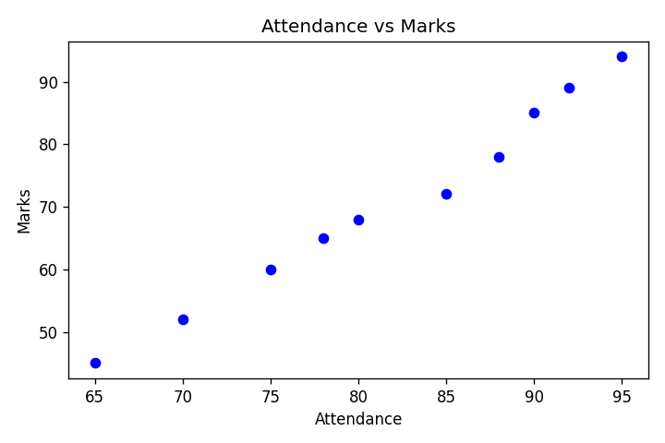

Q2.
Create a scatter plot of Study Hours vs Marks and distinguish students according to Gender, and interpret the result.

Program:
import pandas as pd
import matplotlib.pyplot as plt

df = pd.read_excel("Student_Performance_Data.xlsx")

colors = {"Male": "blue", "Female": "red"}
plt.figure(figsize=(6,4))
for gender in df["Gender"].unique():
subset = df[df["Gender"] == gender]
plt.scatter(subset["Study_Hours"], subset["Marks"], label=gender, color=colors[gender])
plt.title("Study Hours vs Marks (by Gender)")
plt.xlabel("Study Hours")
plt.ylabel("Marks")
plt.legend(title="Gender")
plt.tight_layout()
plt.show()
print("Scatter plot of Study Hours vs Marks, distinguished by Gender, displayed.")
print("Interpretation: Both Male and Female students show increasing Marks with more Study Hours; the pattern is similar across genders, so Gender does not create a major difference in this relationship.")

Output:
Scatter plot of Study Hours vs Marks, distinguished by Gender, displayed.
Interpretation: Both Male and Female students show increasing Marks with more Study Hours; the pattern is similar across genders, so Gender does not create a major difference in this relationship.

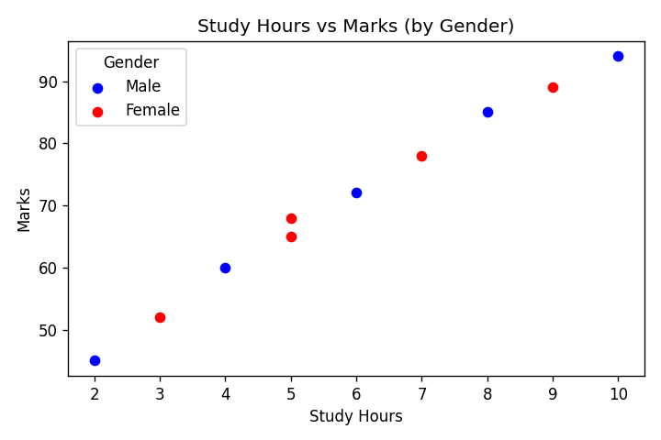

Q3.
Create a scatter plot of Study Hours vs Marks and distinguish students according to Subject, and interpret the result.

Program:
import pandas as pd
import matplotlib.pyplot as plt

df = pd.read_excel("Student_Performance_Data.xlsx")

colors = {"Statistics": "green", "Economics": "orange"}
plt.figure(figsize=(6,4))
for subject in df["Subject"].unique():
subset = df[df["Subject"] == subject]
plt.scatter(subset["Study_Hours"], subset["Marks"], label=subject, color=colors[subject])
plt.title("Study Hours vs Marks (by Subject)")
plt.xlabel("Study Hours")
plt.ylabel("Marks")
plt.legend(title="Subject")
plt.tight_layout()
plt.show()
print("Scatter plot of Study Hours vs Marks, distinguished by Subject, displayed.")
print("Interpretation: Both Subjects show a positive relationship between Study Hours and Marks. Economics students have slightly higher average Marks than Statistics students for similar Study Hours.")

Output:
Scatter plot of Study Hours vs Marks, distinguished by Subject, displayed.
Interpretation: Both Subjects show a positive relationship between Study Hours and Marks. Economics students have slightly higher average Marks than Statistics students for similar Study Hours.

Section B

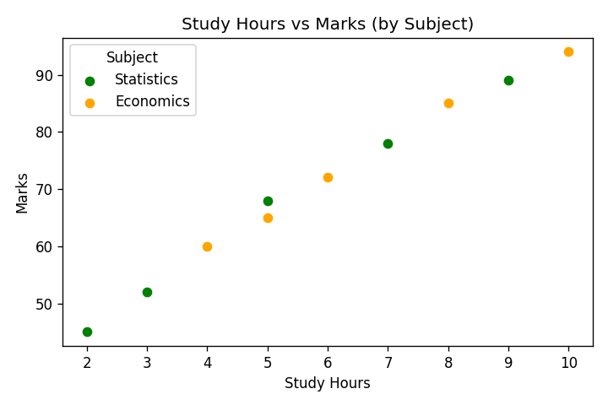

Histogram
Q4.
Create a histogram showing the distribution of Marks (use 5 bins, add title and axis labels). Which marks range contains the highest number of students?

Program:
import pandas as pd
import matplotlib.pyplot as plt
import numpy as np

df = pd.read_excel("Student_Performance_Data.xlsx")

plt.figure(figsize=(6,4))
counts, bins, patches = plt.hist(df["Marks"], bins=5, color="skyblue", edgecolor="black")
plt.title("Distribution of Marks")
plt.xlabel("Marks")
plt.ylabel("Number of Students")
plt.tight_layout()
plt.show()

print("Bin edges:", bins)
print("Counts per bin:", counts)
max_count = counts.max()
ranges = [f"{bins[i]:.1f}-{bins[i+1]:.1f}" for i in range(len(counts)) if counts[i] == max_count]
print(f"Marks range(s) with highest number of students ({int(max_count)} students):", ", ".join(ranges))
print("Interpretation: Marks are spread fairly evenly across the range, with two bins tied for the highest count. This shows the class has a mix of average and high scorers rather than being concentrated at one level.")

Output:
Bin edges: [45. 54.8 64.6 74.4 84.2 94. ]
Counts per bin: [2. 1. 3. 1. 3.]
Marks range(s) with highest number of students (3 students): 64.6-74.4, 84.2-94.0
Interpretation: Marks are spread fairly evenly across the range, with two bins tied for the highest count. This shows the class has a mix of average and high scorers rather than being concentrated at one level.

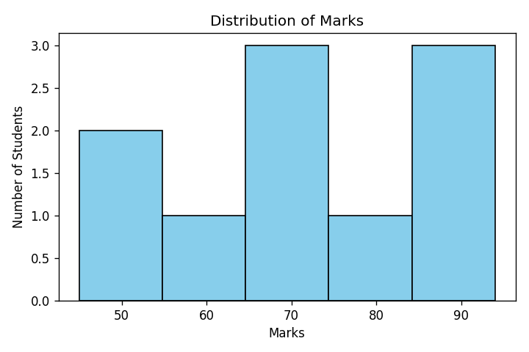

Q5.
Create a histogram of Study Hours. Which study-hour range contains the highest number of students?

Program:
import pandas as pd
import matplotlib.pyplot as plt

df = pd.read_excel("Student_Performance_Data.xlsx")

plt.figure(figsize=(6,4))
counts, bins, patches = plt.hist(df["Study_Hours"], bins=5, color="lightgreen", edgecolor="black")
plt.title("Distribution of Study Hours")
plt.xlabel("Study Hours")
plt.ylabel("Number of Students")
plt.tight_layout()
plt.show()

max_idx = counts.argmax()
print("Bin edges:", bins)
print("Counts per bin:", counts)
print(f"Study Hours range with highest number of students: {bins[max_idx]:.1f} - {bins[max_idx+1]:.1f}")
print("Interpretation: Most students study between roughly 3.6 and 5.2 hours, with fewer students at the very low and very high ends. This is a fairly balanced spread rather than being heavily skewed to one side.")

Output:
Bin edges: [ 2. 3.6 5.2 6.8 8.4 10. ]
Counts per bin: [2. 3. 1. 2. 2.]
Study Hours range with highest number of students: 3.6 - 5.2
Interpretation: Most students study between roughly 3.6 and 5.2 hours, with fewer students at the very low and very high ends. This is a fairly balanced spread rather than being heavily skewed to one side.

Section C

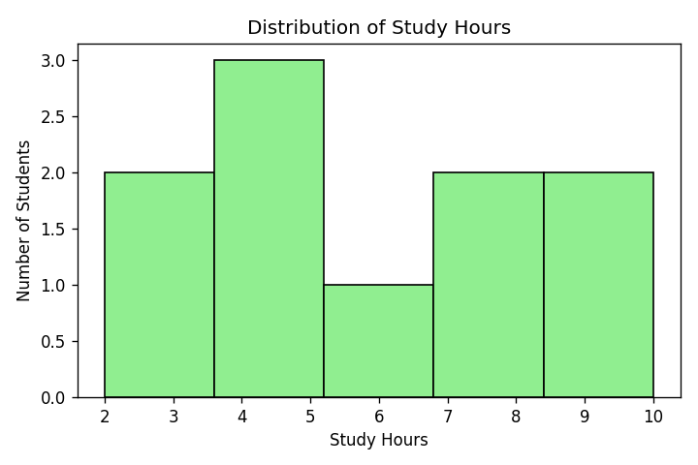

Bar Plot
Q6.
Create a bar plot showing the number of students in each subject.

Program:
import pandas as pd
import matplotlib.pyplot as plt

df = pd.read_excel("Student_Performance_Data.xlsx")

counts = df["Subject"].value_counts()
plt.figure(figsize=(6,4))
plt.bar(counts.index, counts.values, color=["orange","green"])
plt.title("Number of Students in Each Subject")
plt.xlabel("Subject")
plt.ylabel("Number of Students")
plt.tight_layout()
plt.show()
print(counts)
print("Interpretation: Students are split evenly between Statistics and Economics (5 each), so the class has balanced representation from both subjects with no major skew in enrollment.")

Output:
Subject
Statistics 5
Economics 5
Name: count, dtype: int64
Interpretation: Students are split evenly between Statistics and Economics (5 each), so the class has balanced representation from both subjects with no major skew in enrollment.

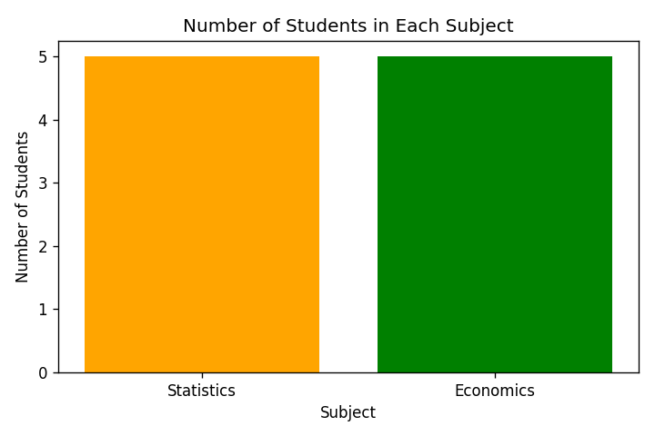

Q7.
Calculate the average marks by subject and display them using a bar plot.

Program:
import pandas as pd
import matplotlib.pyplot as plt

df = pd.read_excel("Student_Performance_Data.xlsx")

avg_marks = df.groupby("Subject")["Marks"].mean()
plt.figure(figsize=(6,4))
plt.bar(avg_marks.index, avg_marks.values, color=["orange","green"])
plt.title("Average Marks by Subject")
plt.xlabel("Subject")
plt.ylabel("Average Marks")
plt.tight_layout()
plt.show()
print(avg_marks)
print("Interpretation: Economics students average about 75.2 marks compared to 66.4 for Statistics students, so on average Economics students are scoring higher in this dataset.")

Output:
Subject
Economics 75.2
Statistics 66.4
Name: Marks, dtype: float64
Interpretation: Economics students average about 75.2 marks compared to 66.4 for Statistics students, so on average Economics students are scoring higher in this dataset.

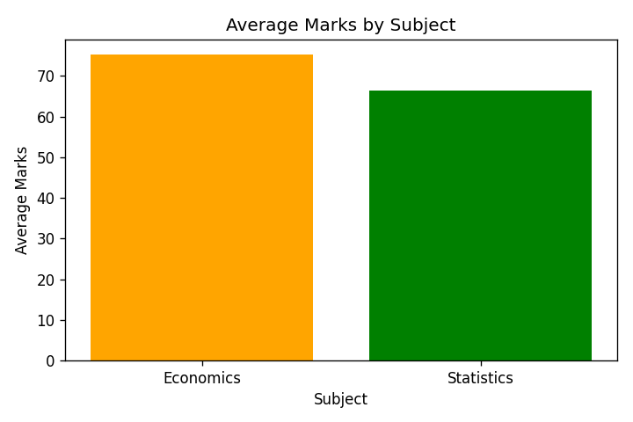

Q8.
Create a grouped bar plot showing average marks for each subject according to gender.

Program:
import pandas as pd
import matplotlib.pyplot as plt
import numpy as np

df = pd.read_excel("Student_Performance_Data.xlsx")

grouped = df.groupby(["Subject", "Gender"])["Marks"].mean().unstack()
print(grouped)

x = np.arange(len(grouped.index))
width = 0.35
plt.figure(figsize=(6,4))
plt.bar(x - width/2, grouped["Male"], width, label="Male", color="blue")
plt.bar(x + width/2, grouped["Female"], width, label="Female", color="red")
plt.xticks(x, grouped.index)
plt.title("Average Marks by Subject and Gender")
plt.xlabel("Subject")
plt.ylabel("Average Marks")
plt.legend(title="Gender")
plt.tight_layout()
plt.show()
print("Interpretation: The pattern is mixed rather than one gender leading overall - Male students average higher in Economics (77.75 vs 65.00) while Female students average higher in Statistics (71.75 vs 45.00). With only 5 students per subject, this is likely driven by individual students rather than a strong gender effect.")

Output:
Gender Female Male
Subject
Economics 65.00 77.75
Statistics 71.75 45.00
Interpretation: The pattern is mixed rather than one gender leading overall - Male students average higher in Economics (77.75 vs 65.00) while Female students average higher in Statistics (71.75 vs 45.00). With only 5 students per subject, this is likely driven by individual students rather than a strong gender effect.

Section D

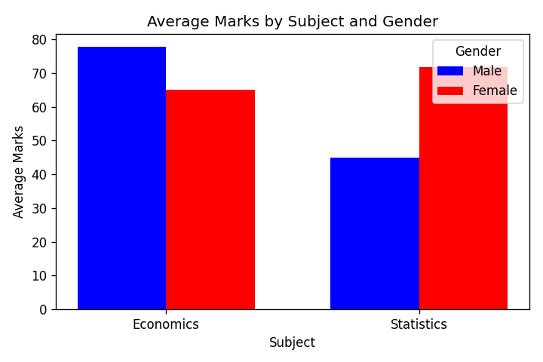

Box Plot
Q9.
Create a box plot for Marks. Find the Median, First Quartile, Third Quartile, Minimum and Maximum.

Program:
import pandas as pd
import matplotlib.pyplot as plt

df = pd.read_excel("Student_Performance_Data.xlsx")

plt.figure(figsize=(5,5))
plt.boxplot(df["Marks"], tick_labels=["Marks"])
plt.title("Box Plot of Marks")
plt.ylabel("Marks")
plt.tight_layout()
plt.show()

median = df["Marks"].median()
q1 = df["Marks"].quantile(0.25)
q3 = df["Marks"].quantile(0.75)
minimum = df["Marks"].min()
maximum = df["Marks"].max()
print("Median:", median)
print("First Quartile (Q1):", q1)
print("Third Quartile (Q3):", q3)
print("Minimum:", minimum)
print("Maximum:", maximum)
print("Interpretation: The middle 50% of students (between Q1 and Q3) scored between about 61 and 83 marks, with a median of 70. There are no extreme outliers, and the box plot shows a reasonably symmetric spread of marks across the class.")

Output:
Median: 70.0
First Quartile (Q1): 61.25
Third Quartile (Q3): 83.25
Minimum: 45
Maximum: 94
Interpretation: The middle 50% of students (between Q1 and Q3) scored between about 61 and 83 marks, with a median of 70. There are no extreme outliers, and the box plot shows a reasonably symmetric spread of marks across the class.

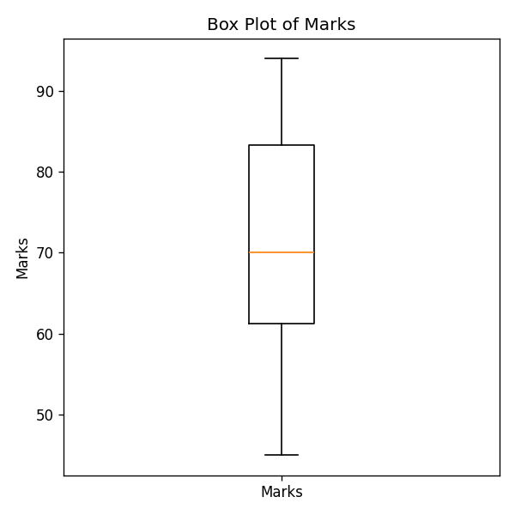

Q10.
Create box plots for Study Hours, Attendance, and Marks.

Program:
import pandas as pd
import matplotlib.pyplot as plt

df = pd.read_excel("Student_Performance_Data.xlsx")

plt.figure(figsize=(6,5))
plt.boxplot([df["Study_Hours"], df["Attendance"], df["Marks"]],
tick_labels=["Study Hours", "Attendance", "Marks"])
plt.title("Box Plots of Study Hours, Attendance and Marks")
plt.ylabel("Value")
plt.tight_layout()
plt.show()
print("Box plots for Study Hours, Attendance, and Marks displayed.")
print("Interpretation: Study Hours (2-10) and Marks (45-94) show a similar relative spread, while Attendance is tightly packed in a higher range (65-95) since most students attend regularly. None of the three variables show major outliers, and their boxes sit at different scales, which is expected since they are measured in different units.")

Output:
Box plots for Study Hours, Attendance, and Marks displayed.
Interpretation: Study Hours (2-10) and Marks (45-94) show a similar relative spread, while Attendance is tightly packed in a higher range (65-95) since most students attend regularly. None of the three variables show major outliers, and their boxes sit at different scales, which is expected since they are measured in different units.

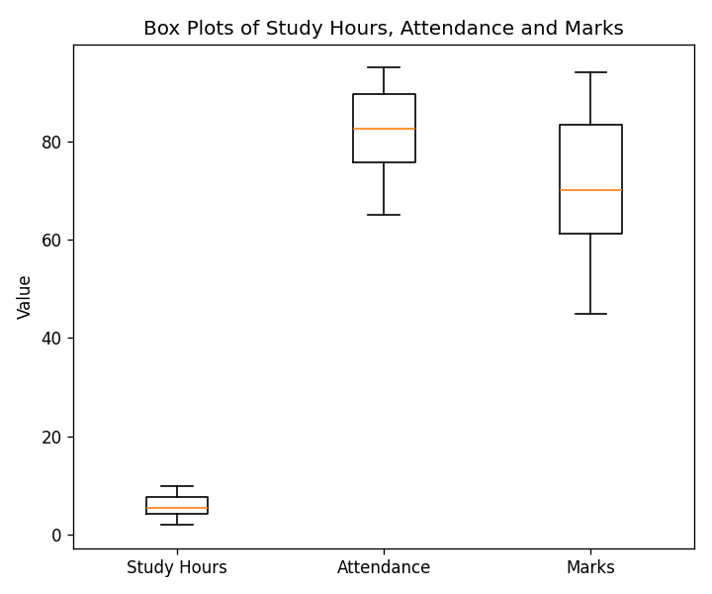

Q11.
Create a box plot of Marks according to Gender.

Program:
import pandas as pd
import matplotlib.pyplot as plt

df = pd.read_excel("Student_Performance_Data.xlsx")

male = df[df["Gender"]=="Male"]["Marks"]
female = df[df["Gender"]=="Female"]["Marks"]

plt.figure(figsize=(5,5))
plt.boxplot([male, female], tick_labels=["Male", "Female"])
plt.title("Box Plot of Marks by Gender")
plt.ylabel("Marks")
plt.tight_layout()
plt.show()
print("Box plot of Marks grouped by Gender displayed.")
print("Interpretation: Male marks range more widely (45 to 94, median 72) while Female marks are more tightly clustered (52 to 89, median 68). Median scores are close between the two groups, so there is no large overall gender gap, though Male students show slightly more variability.")

Output:
Box plot of Marks grouped by Gender displayed.
Interpretation: Male marks range more widely (45 to 94, median 72) while Female marks are more tightly clustered (52 to 89, median 68). Median scores are close between the two groups, so there is no large overall gender gap, though Male students show slightly more variability.

Section E

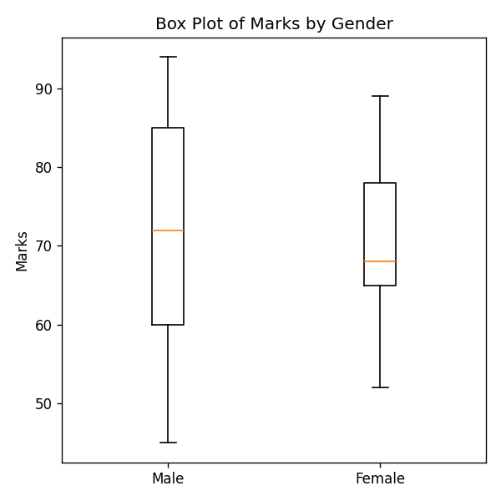

Pairwise Plot
Q12.
Create a pairwise plot for Study Hours, Attendance & Marks.

Program:
import pandas as pd
import seaborn as sns
import matplotlib.pyplot as plt

df = pd.read_excel("Student_Performance_Data.xlsx")

sns.pairplot(df[["Study_Hours", "Attendance", "Marks"]])
plt.show()
print("Pairwise plot for Study Hours, Attendance and Marks displayed.")
print("Interpretation: All three scatter panels show a clear positive linear trend - as Study Hours and Attendance increase, Marks increase as well. This matches the strong correlations calculated earlier (around 0.99 for both), confirming that these variables move closely together.")

Output:
Pairwise plot for Study Hours, Attendance and Marks displayed.
Interpretation: All three scatter panels show a clear positive linear trend - as Study Hours and Attendance increase, Marks increase as well. This matches the strong correlations calculated earlier (around 0.99 for both), confirming that these variables move closely together.

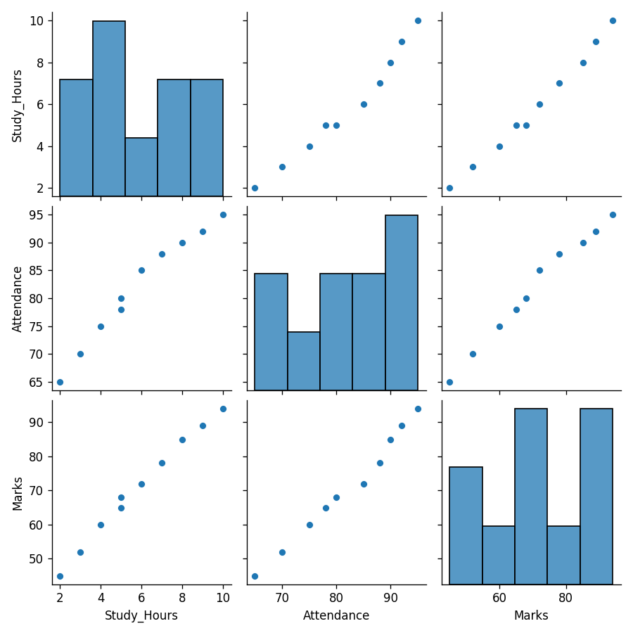

Q13.
Create a pairwise plot and distinguish observations according to Gender.

Program:
import pandas as pd
import seaborn as sns
import matplotlib.pyplot as plt

df = pd.read_excel("Student_Performance_Data.xlsx")

sns.pairplot(df[["Study_Hours", "Attendance", "Marks", "Gender"]], hue="Gender")
plt.show()
print("Pairwise plot distinguished by Gender displayed.")
print("Interpretation: Male and Female points follow the same overall positive trend across Study Hours, Attendance, and Marks, with no separate cluster forming for either gender. This suggests Gender does not change the underlying relationship between these variables.")

Output:
Pairwise plot distinguished by Gender displayed.
Interpretation: Male and Female points follow the same overall positive trend across Study Hours, Attendance, and Marks, with no separate cluster forming for either gender. This suggests Gender does not change the underlying relationship between these variables.

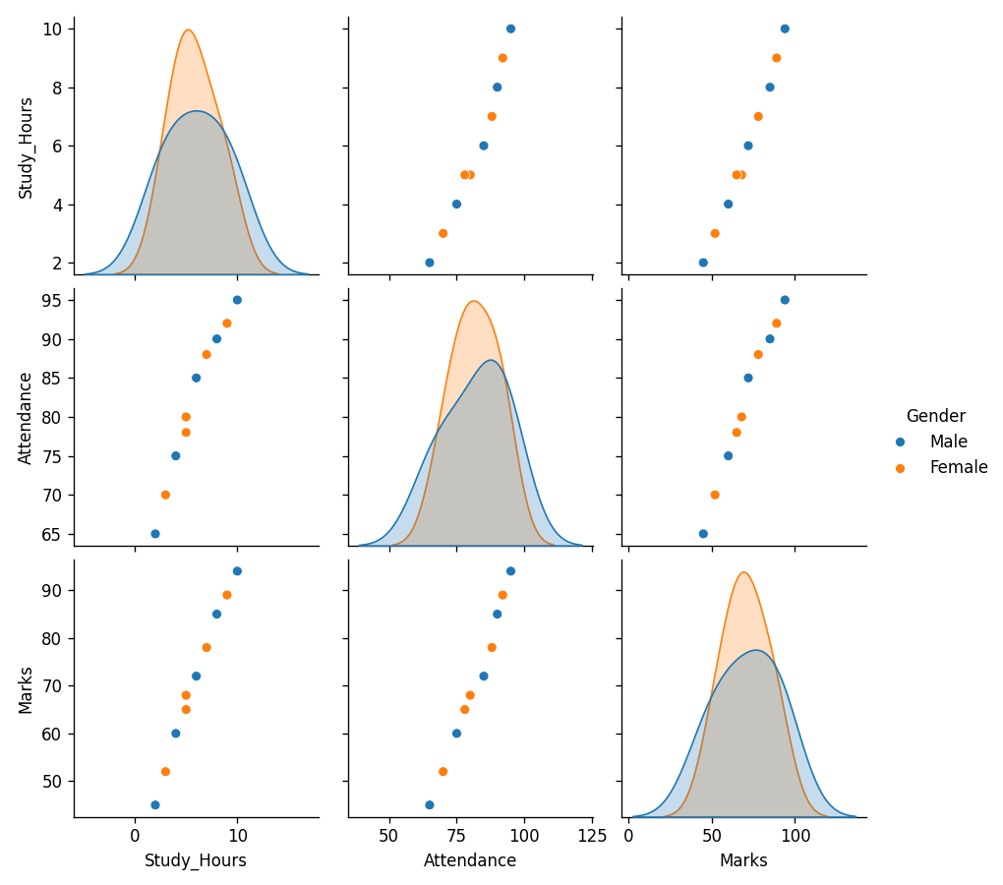

Q14.
Create a pairwise plot and distinguish observations according to Subject.

Program:
import pandas as pd
import seaborn as sns
import matplotlib.pyplot as plt

df = pd.read_excel("Student_Performance_Data.xlsx")

sns.pairplot(df[["Study_Hours", "Attendance", "Marks", "Subject"]], hue="Subject")
plt.show()
print("Pairwise plot distinguished by Subject displayed.")
print("Interpretation: Both Economics and Statistics students follow the same positive direction between Study Hours, Attendance, and Marks, but Economics points sit slightly higher on the Marks axis for similar Study Hours, matching the higher average marks seen earlier for Economics.")

Output:
Pairwise plot distinguished by Subject displayed.
Interpretation: Both Economics and Statistics students follow the same positive direction between Study Hours, Attendance, and Marks, but Economics points sit slightly higher on the Marks axis for similar Study Hours, matching the higher average marks seen earlier for Economics.

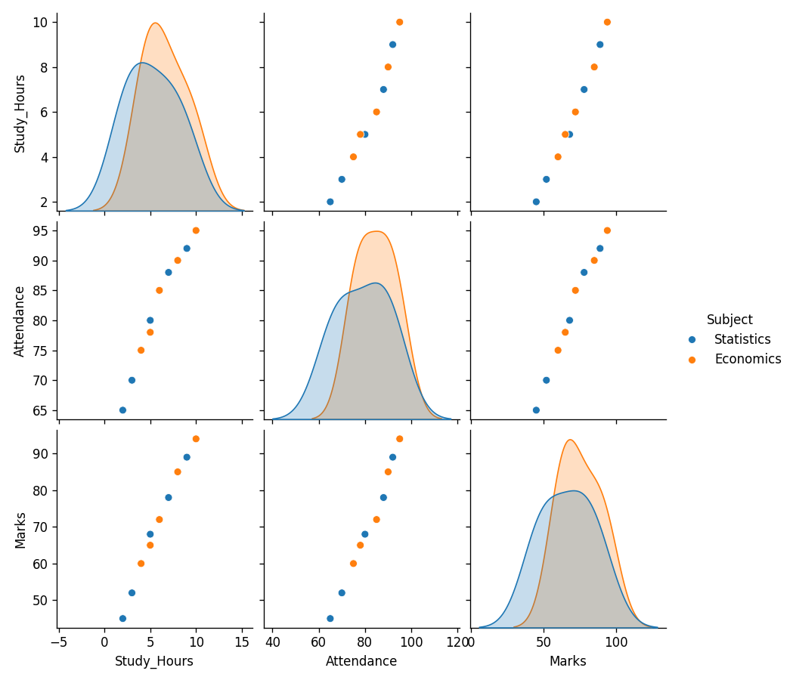

Practical 7 - Machine Learning (Supervised Learning)

Instructions: Load the dataset, separate features (X) and target (y), split into train/test sets, create and train the model, predict, calculate the evaluation metric, and write a short conclusion.

Q1.
Q1. Iris Classification - Decision Tree
Use the Iris dataset available in Scikit-learn (load_iris()). Model: DecisionTreeClassifier. Split: 80% training, 20% testing. Perform classification, calculate Accuracy, display the Confusion Matrix, and print the predicted and actual classes for the test data.

Program:
# Q1. Iris Classification using Decision Tree

from sklearn.datasets import load_iris
from sklearn.model_selection import train_test_split
from sklearn.tree import DecisionTreeClassifier
from sklearn.metrics import accuracy_score, confusion_matrix

# 1. Load the dataset
iris = load_iris()
# 2. Separate features (X) and target (y)
X = iris.data
y = iris.target
# 3. Split the data into training and testing sets
X_train, X_test, y_train, y_test = train_test_split(
X, y, test_size=0.20, random_state=42
)
# 4. Create the Decision Tree model
model = DecisionTreeClassifier(random_state=42)
# 5. Train the model
model.fit(X_train, y_train)
# 6. Make predictions
y_pred = model.predict(X_test)
# 7. Calculate Accuracy
accuracy = accuracy_score(y_test, y_pred)
print("Accuracy:", accuracy)
# Display Confusion Matrix
cm = confusion_matrix(y_test, y_pred)
print("\nConfusion Matrix:")
print(cm)
# Print predicted and actual classes
print("\nActual and Predicted Classes:")
for actual, predicted in zip(y_test, y_pred):
print(
"Actual:", iris.target_names[actual],
"| Predicted:", iris.target_names[predicted]
)

Output:
Accuracy: 1.0

Confusion Matrix:
[[10 0 0]
[ 0 9 0]
[ 0 0 11]]

Actual and Predicted Classes:
Actual: versicolor | Predicted: versicolor
Actual: setosa | Predicted: setosa
Actual: virginica | Predicted: virginica
Actual: versicolor | Predicted: versicolor
Actual: versicolor | Predicted: versicolor
Actual: setosa | Predicted: setosa
Actual: versicolor | Predicted: versicolor
Actual: virginica | Predicted: virginica
Actual: versicolor | Predicted: versicolor
Actual: versicolor | Predicted: versicolor
Actual: virginica | Predicted: virginica
Actual: setosa | Predicted: setosa
Actual: setosa | Predicted: setosa
Actual: setosa | Predicted: setosa
Actual: setosa | Predicted: setosa
Actual: versicolor | Predicted: versicolor
Actual: virginica | Predicted: virginica
Actual: versicolor | Predicted: versicolor
Actual: versicolor | Predicted: versicolor
Actual: virginica | Predicted: virginica
Actual: setosa | Predicted: setosa
Actual: virginica | Predicted: virginica
Actual: setosa | Predicted: setosa
Actual: virginica | Predicted: virginica
Actual: virginica | Predicted: virginica
Actual: virginica | Predicted: virginica
Actual: virginica | Predicted: virginica
Actual: virginica | Predicted: virginica
Actual: setosa | Predicted: setosa
Actual: setosa | Predicted: setosa

Conclusion:
The Decision Tree Classifier achieved an accuracy of 1.00 (100%) on the test dataset. The confusion matrix shows that all 30 test samples were correctly classified, with 10 Setosa, 9 Versicolor, and 11 Virginica samples predicted correctly. There were no misclassified samples. Therefore, the Decision Tree model performed perfectly on this test set and was able to accurately distinguish between the three Iris species.

Q2.
Q2. Breast Cancer Classification - KNN
Use the Breast Cancer dataset available in Scikit-learn (load_breast_cancer()). Model: KNeighborsClassifier with n_neighbors=5. Split 80% training / 20% testing. Train the model, make predictions, calculate Accuracy, display the Confusion Matrix, and write a conclusion about the model's performance.

Program:
# Q2. Breast Cancer Classification using KNN

from sklearn.datasets import load_breast_cancer
from sklearn.model_selection import train_test_split
from sklearn.neighbors import KNeighborsClassifier
from sklearn.metrics import accuracy_score, confusion_matrix

cancer = load_breast_cancer()
X = cancer.data
y = cancer.target
X_train, X_test, y_train, y_test = train_test_split(
X, y, test_size=0.20, random_state=42
)
model = KNeighborsClassifier(n_neighbors=5)
model.fit(X_train, y_train)
y_pred = model.predict(X_test)
accuracy = accuracy_score(y_test, y_pred)
print("Accuracy:", accuracy)
cm = confusion_matrix(y_test, y_pred)
print("\nConfusion Matrix:")
print(cm)

Output:
Accuracy: 0.956140350877193

Confusion Matrix:
[[38 5]
[ 0 71]]

Conclusion:
The KNN Classifier with 5 neighbors achieved an accuracy of approximately 95.61% on the test dataset. The confusion matrix shows that 109 out of 114 samples were correctly classified, while 5 samples were misclassified. The model correctly identified all 71 samples of the second class and misclassified 5 samples from the first class. Overall, the KNN model demonstrated very good classification performance on the Breast Cancer dataset, with a relatively small number of incorrect predictions.

Q3.
Q3. Diabetes Regression - Decision Tree Regressor
Use the Diabetes dataset available in Scikit-learn (load_diabetes()). Model: DecisionTreeRegressor. Split 80% training / 20% testing. Train the model and predict the target values. Calculate Mean Absolute Error (MAE) and R2 Score, display the first 5 actual and predicted values, and write a short conclusion.

Program:
# Q3. Diabetes Regression using Decision Tree Regressor
from sklearn.datasets import load_diabetes
from sklearn.model_selection import train_test_split
from sklearn.tree import DecisionTreeRegressor
from sklearn.metrics import mean_absolute_error, r2_score

diabetes = load_diabetes()
X = diabetes.data
y = diabetes.target
X_train, X_test, y_train, y_test = train_test_split(
X, y, test_size=0.20, random_state=42
)
model = DecisionTreeRegressor(random_state=42)
model.fit(X_train, y_train)
y_pred = model.predict(X_test)
mae = mean_absolute_error(y_test, y_pred)
r2 = r2_score(y_test, y_pred)
print("Mean Absolute Error (MAE):", mae)
print("R2 Score:", r2)
print("\nFirst 5 Actual and Predicted Values:")
for actual, predicted in zip(y_test[:5], y_pred[:5]):
print("Actual:", actual, "| Predicted:", predicted)

Output:
Mean Absolute Error (MAE): 54.52808988764045
R2 Score: 0.060653981041140725

First 5 Actual and Predicted Values:
Actual: 219.0 | Predicted: 206.0
Actual: 70.0 | Predicted: 99.0
Actual: 202.0 | Predicted: 170.0
Actual: 230.0 | Predicted: 268.0
Actual: 111.0 | Predicted: 183.0

Conclusion:
The Decision Tree Regressor achieved a Mean Absolute Error (MAE) of 54.53 and an R² score of 0.061. The MAE indicates that the model's predictions differ from the actual diabetes progression values by about 54.53 units on average. The R² score of approximately 0.06 is quite low, meaning that the model explains only about 6.1% of the variation in the target values. Therefore, the Decision Tree Regressor showed poor predictive performance on this test set and does not generalize well to the unseen diabetes data.

Q4.
Q4. California Housing Regression - Random Forest
Use the California Housing dataset available in Scikit-learn (fetch_california_housing()). Model: RandomForestRegressor. Split 80% training / 20% testing. Train the model and predict house prices. Calculate Mean Absolute Error (MAE) and R2 Score, display the first 5 actual and predicted values, and write a short conclusion.

Program:
# Q4. California Housing Regression using Random Forest
from sklearn.datasets import fetch_california_housing
from sklearn.model_selection import train_test_split
from sklearn.ensemble import RandomForestRegressor
from sklearn.metrics import mean_absolute_error, r2_score

housing = fetch_california_housing()
X = housing.data
y = housing.target
X_train, X_test, y_train, y_test = train_test_split(
X, y, test_size=0.20, random_state=42
)
model = RandomForestRegressor(
n_estimators=100,
random_state=42
)
model.fit(X_train, y_train)
y_pred = model.predict(X_test)
mae = mean_absolute_error(y_test, y_pred)
r2 = r2_score(y_test, y_pred)
print("Mean Absolute Error (MAE):", mae)
print("R2 Score:", r2)
print("\nFirst 5 Actual and Predicted Values:")
for actual, predicted in zip(y_test[:5], y_pred[:5]):
print("Actual:", actual, "| Predicted:", predicted)

Output:
Mean Absolute Error (MAE): 0.32773108008720936
R2 Score: 0.8046244867176197

First 5 Actual and Predicted Values:
Actual: 0.477 | Predicted: 0.5080899999999999
Actual: 0.458 | Predicted: 0.7506400000000002
Actual: 5.00001 | Predicted: 4.958207299999991
Actual: 2.186 | Predicted: 2.50172
Actual: 2.78 | Predicted: 2.247780000000001

Conclusion:
The Random Forest Regressor achieved a Mean Absolute Error (MAE) of 0.328 and an R² score of 0.805. This means that the model's predicted house values differ from the actual values by approximately 0.328 units on average. The R² score of 0.805 indicates that the model explains approximately 80.5% of the variation in the house prices. Therefore, the Random Forest model performed well on the California Housing dataset and provided reasonably accurate predictions. Its strong R² score indicates good generalization to the test data.

