ELECTRONICS PRACTICALS
CIRCUIT DIAGRAMS
Simple wiring diagrams for last-minute exam revision
These are simplified wiring diagrams for the five practicals in your study guide. If your class notebook gives different pin numbers, follow your notebook.

Practical 1 — LED blinking
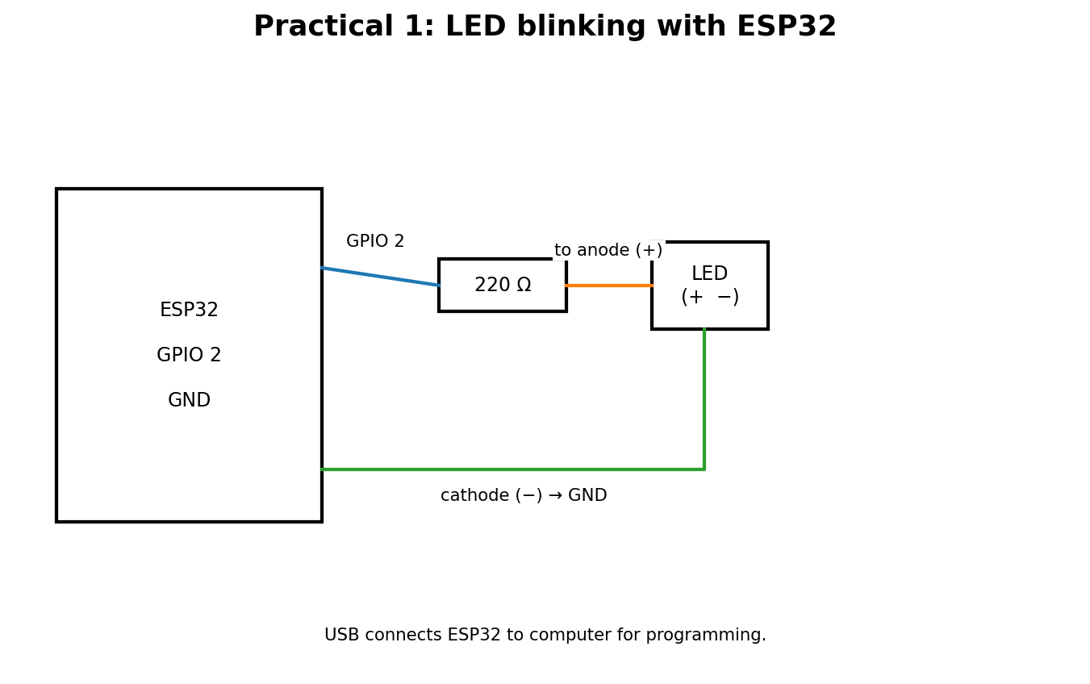

Connections to remember
- GPIO 2 → 220 Ω resistor → LED anode (+).
- LED cathode (−) → GND.

Practical 2 — LED webpage control
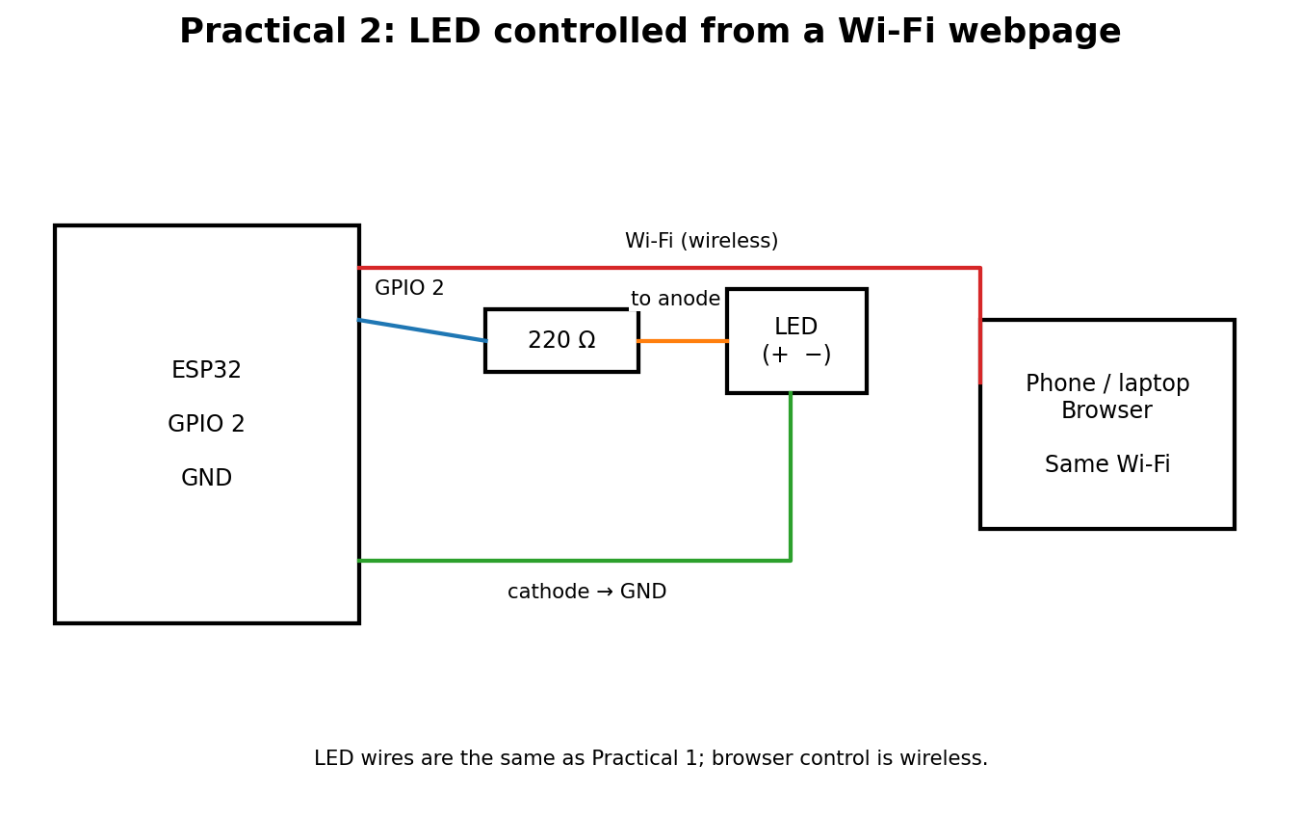

Connections to remember
- LED hardware is the same as Practical 1.
- Phone/laptop and ESP32 communicate over the same Wi-Fi network.

Practical 3 — DHT11 sensor
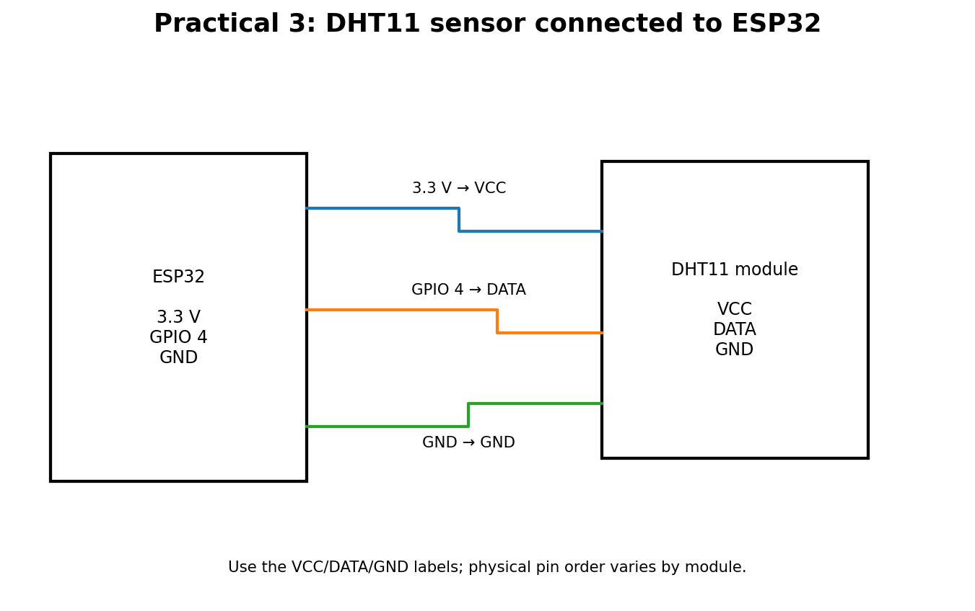

Connections to remember
- VCC → 3.3 V; DATA → GPIO 4; GND → GND.
- Check the printed sensor labels; module pin order can vary.

Practical 4 — I²C LCD
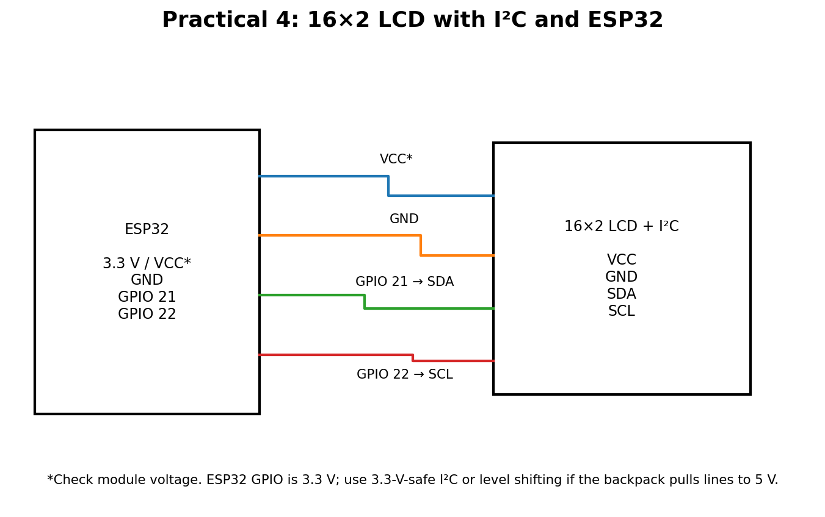

Connections to remember
- SDA → GPIO 21; SCL → GPIO 22; GND → GND.
- Check LCD supply voltage and ensure I²C lines are safe for 3.3-V ESP32 GPIO.

Practical 5 — DC motor + L298N
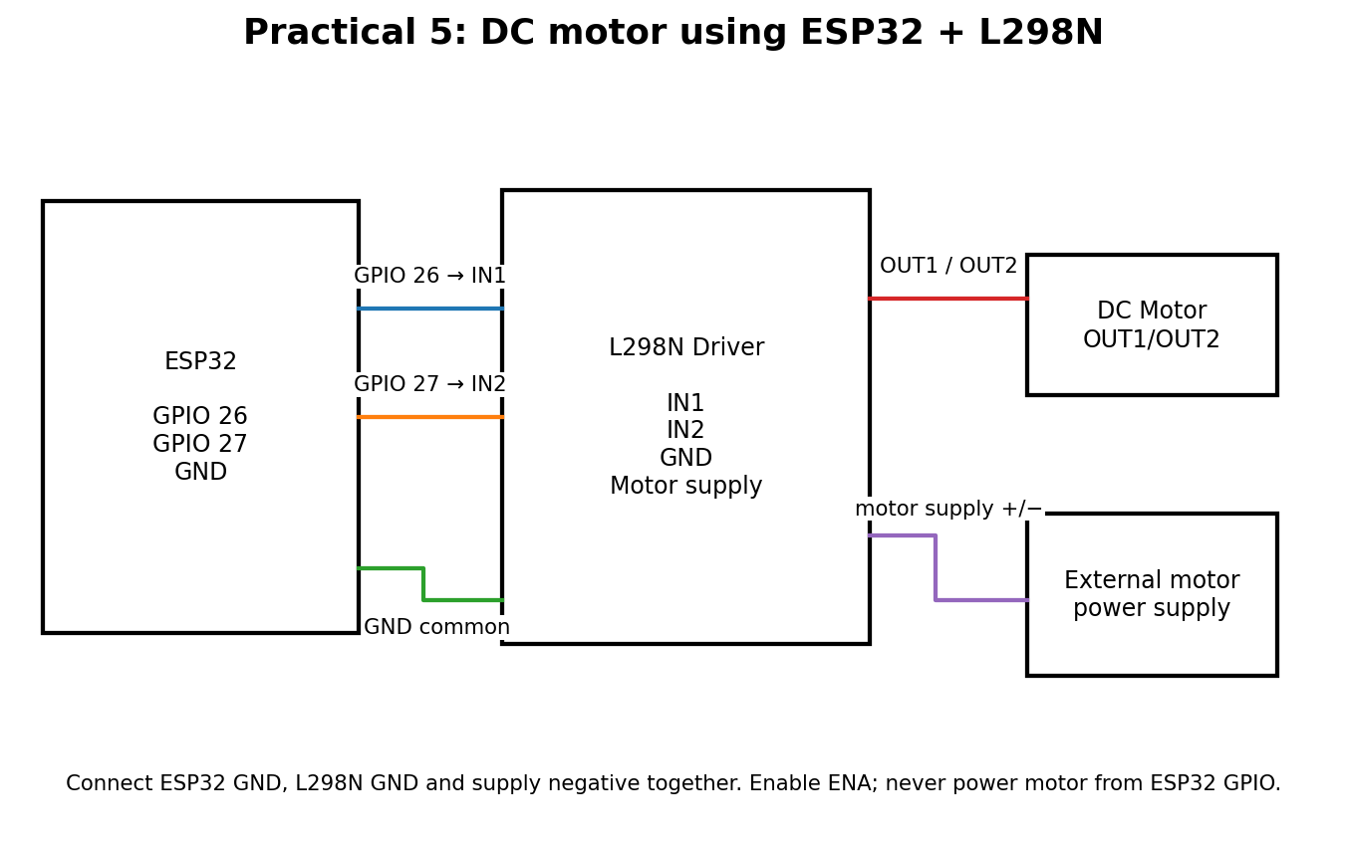

Connections to remember
- GPIO 26 → IN1; GPIO 27 → IN2.
- Motor → OUT1/OUT2; external motor supply → L298N motor supply terminals.
- Common ground is required; ensure ENA is enabled and disconnect power before changing wires.

Quick pin revision
Practical | ESP32 pins | Connect to
1. LED blink | GPIO 2 | Resistor + LED; cathode to GND
2. LED webpage | GPIO 2 | Same LED circuit; Wi-Fi control
3. DHT11 | GPIO 4 | Sensor DATA; VCC 3.3 V; GND
4. LCD I²C | GPIO 21, 22 | SDA, SCL; VCC and GND
5. DC motor | GPIO 26, 27 | L298N IN1, IN2; motor on OUT1/OUT2

Safety
Disconnect power before rewiring. Never connect a DC motor directly to an ESP32 GPIO. Use a suitable driver and motor power supply. Check module voltage requirements.

