CandleLang
Automata-Theoretic Detection of Candlestick Trading Patterns
Field | Detail
Student | Namit Gupta (Reg. No. 25BDE0068)
Course | Theory of Computation — MOC
Project scope | Automata theory (regex → NFA → DFA) + Flutter app + ML confidence scoring
Review | Review 1 — progress checkpoint
Overall completion | ~25% (Week 1 of a 5-week plan complete; DFA minimization from Week 2 done early)

1. Problem Statement & Real-World Motivation
Traders reading candlestick charts look for recurring visual patterns — such as ‘Three White Soldiers’ or a bullish reversal — that hint at where price may move next. Commercial charting tools (e.g. TradingView) detect these patterns with hardcoded, closed-source rules: a trader sees ‘pattern found’ with no way to see why, or how confident that signal really is historically.
CandleLang treats a stock's price history as a string over a small finite alphabet, and treats each candlestick pattern as a formal language recognized by an automaton built openly, from first principles, using the exact algorithms taught in this course (Thompson's Construction, Subset Construction, DFA Minimization). Every detection can be explained state-by-state instead of taken on faith — and it is layered with a historical reliability score so a pattern match becomes ‘found, and this has worked X% of the time before’ rather than a bare yes/no.
The goal is a working, explainable tool — published on GitHub and demonstrable on LinkedIn — that shows automata theory solving a real analytical problem, not a toy textbook exercise.

2. Objectives
- Encode real OHLC price history into a finite-alphabet string, making pattern detection a formal language-membership problem.
- Express real candlestick trading patterns as regular expressions and build their recognizers from scratch (no library regex engine).
- Implement the full theoretical pipeline: Thompson's Construction (regex→NFA), Subset Construction (NFA→DFA), and DFA Minimization — and prove NFA/DFA equivalence by cross-verifying every match.
- Attach a lightweight ML confidence score (logistic regression) to every automaton match, using historical outcome data.
- Deliver the result as a Flutter app: live candlestick chart, highlighted pattern matches, and confidence score — usable by an actual retail trader.

3. System Architecture
Stage | What it does | Status
1. Data ingestion | OHLC price history (daily candles) | Synthetic data working; live API integration planned Week 3
2. Candle encoding | Maps each candle to one of U / D / F / G | Done
3. Pattern definitions | Real candlestick patterns as regular expressions | Done (7 patterns + 1 documented hybrid case)
4. Thompson's Construction | Regex → ε-NFA (own parser, own builder) | Done
5. Substring search | Multi-threaded NFA simulation finds every match position | Done
6. Subset Construction | NFA → DFA (powerset construction) | Done (ahead of schedule)
7. DFA Minimization | Partition refinement to the minimal equivalent DFA | Done (ahead of schedule)
8. ML confidence layer | Logistic regression over historical pattern outcomes | Planned Week 3
9. Flutter app | Chart rendering, live matches, confidence display | Planned Week 4

4. Theory of Computation Foundations Used
This project is deliberately built to exercise the exact syllabus modules, not around them:
- Regular expressions and finite automata — every pattern is a regular expression; every recognizer is a hand-built automaton.
- Thompson's Construction — implemented via a recursive-descent regex parser producing an AST, then the classical inductive construction rules (concatenation, union, Kleene star) building an ε-NFA fragment by fragment.
- Subset (powerset) Construction — converts each ε-NFA into an equivalent DFA by tracking sets of NFA states as single DFA states.
- DFA Minimization — Moore's partition-refinement algorithm reduces each DFA to its minimal equivalent form.
- Regular language limits, made concrete — the 'Double Top' pattern is used as a worked example of where a regular language stops being sufficient: the up-down-up-down shape is regular, but comparing two peak heights for similarity is a numeric check outside a finite automaton's power. This distinction is documented and handled with a small hybrid post-filter, rather than glossed over.

5. Progress So Far (Demonstrated, Working Code)

5.1 Candle encoding
A configurable encoder converts OHLC candles into a string over {U, D, F, G} using a deterministic, documented priority rule (gap check first, then body-size classification), so every price history maps to exactly one candle string.

5.2 Patterns implemented as regular expressions
Pattern | Regex | Meaning
Three White Soldiers | U{3,} | 3+ consecutive up-candles — bullish continuation
Three Black Crows | D{3,} | 3+ consecutive down-candles — bearish continuation
Bullish Reversal | D+FU+ | Downtrend, pause, then upside resumes
Bearish Reversal | U+FD+ | Uptrend, pause, then downside resumes
Gap and Go | GU+ | Gap open followed by sustained upside
Exhaustion Gap | U{2,}GD | Run-up, gap, then immediate reversal down
Indecision Cluster | F{2,} | 2+ flat/doji candles — market undecided
Double Top (hybrid) | U+DU+D (shape only) | Regular shape only; peak-height similarity needs a numeric post-check — documented limitation

5.3 Thompson's Construction + Subset Construction + Minimization — demo run
Run on a 250-candle synthetic OHLC series (real market API access is blocked in the current dev sandbox; live data integration is scheduled for Week 3 and requires no change to the automaton code, since it operates purely on the encoded string). Symbol distribution: U 41.6%, D 43.2%, F 8.8%, G 6.4%.
Pattern | NFA states | DFA states | Minimized DFA states | Occurrences found | DFA cross-check
Three White Soldiers | 10 | 5 | 4 | 12 | PASS
Three Black Crows | 10 | 5 | 4 | 13 | PASS
Bullish Reversal | 14 | 6 | 4 | 5 | PASS
Bearish Reversal | 14 | 6 | 4 | 4 | PASS
Gap and Go | 8 | 4 | 3 | 8 | PASS
Exhaustion Gap | 12 | 6 | 5 | 1 | PASS
Indecision Cluster | 8 | 4 | 3 | 2 | PASS

“DFA cross-check: PASS” means every match the NFA found was independently re-verified by running the corresponding minimized DFA over that exact substring — a direct, working demonstration that the NFA and its derived DFA accept the same language, not just a claim from the textbook.

5.4 State diagrams (generated directly from the code, not hand-drawn)
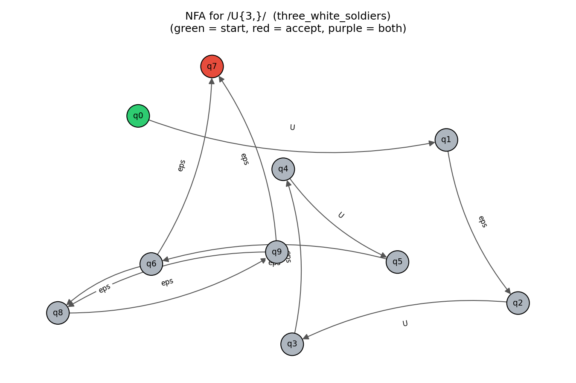
Figure 1 — ε-NFA built by Thompson's Construction for /U{3,}/ (Three White Soldiers). Green = start, red = accept.
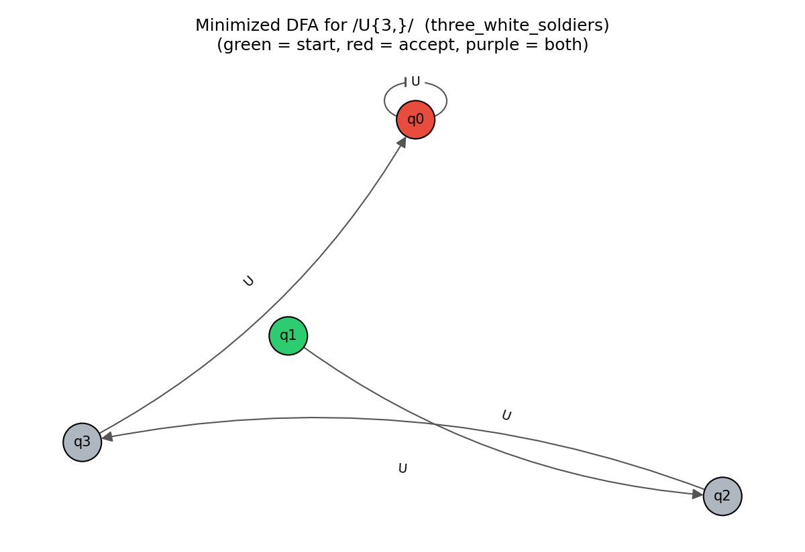
Figure 2 — Minimized DFA for the same pattern, after Subset Construction + Moore's minimization. 4 states: exactly the minimum needed to count “0, 1, 2, or 3+ U's seen so far.”
state U D F G accepting?
q0 q0 - - - yes (the "3-or-more seen" state; self-loops on U)
q1 q2 - - - no (start: 0 U's seen)
q2 q3 - - - no (1 U seen)
q3 q0 - - - no (2 U's seen)
(‘-’ entries go to an implicit dead/trap state on a non-U symbol, omitted from the diagram for clarity — standard practice per Hopcroft & Ullman.)

6. Real-World Impact This Aims For
- Transparency: every detected pattern comes with a state-by-state trace instead of a black-box yes/no, unlike existing charting tools.
- Honesty about reliability: pairing each automaton match with a historical success-rate score (via the planned ML layer) gives a more useful signal than raw pattern detection alone.
- Usable output: delivered as an actual Flutter app a retail trader could open and use, not just a report or a notebook.
- A public, defensible artifact: the finished project is meant to be published on GitHub and shown on LinkedIn as evidence of applying formal automata theory to a real, non-trivial domain.

7. Next Steps (Weeks 2–5)
Week | Focus
2 | Integrate live market data (daily OHLC via a market data API); expand pattern regex library; add the numeric post-filter for hybrid patterns like Double Top.
3 | Build the historical pattern-outcome dataset and train the logistic regression confidence model.
4 | Flutter app: fetch data, render candlestick charts, plug in the DFA matches and ML confidence scores.
5 | Polish, finalize state-diagram visuals for the report, write-up, and rehearse the defense/demo.

8. Honest Scope Note
What is solid and demonstrated today: the encoding, the regex pattern set, and the full Thompson's Construction → Subset Construction → DFA Minimization pipeline, tested and cross-verified end-to-end on real code (not pseudocode) against a realistic 250-day synthetic series. What is not yet built: live market data integration, the ML confidence layer, and the Flutter app — these are the Week 2–4 work explicitly scoped above. This puts the project at roughly 25% complete against the 5-week plan, concentrated in the automata-theory core that is this course's actual subject matter.

