Game Design Document

Fill up the Following document

1. Write the title of your project.

Rising Splashers

1. What is the goal of the game?

To score as many baskets/points as possible to get into the NBA.

1. Write a brief story of your game?

You are given a chance to showcase your talents in front of the

Selectors of the NBA. Try your best to impress them and get into the

NBA.

1. Which are the playing characters of this game?

* Playing characters are the ones which respond to the user based on the input from the user
* Cars, monkeys, dinos, wizards etc, are the playing characters in the game.

|  |  |  |
| --- | --- | --- |
| Number | Character Name | What can this character do? |
| 1 | Player | The player shoots the ball. |
| 2 | Ball | Moves when the player shoots it. |
| 3 |  |  |
| 4 |  |  |
| 5 |  |  |
| 6 |  |  |
| 7 |  |  |
| 8 |  |  |

1. Which are the Non Playing Characters of this game?

* Non Playing characters are the ones which don't have an action or a behaviour when the user interacts with the game.
* Hurdles, stones, bananas, coins, etc are non playing characters in the game.

|  |  |  |
| --- | --- | --- |
| Number | Character Name | What can this character do? |
| 1 | Basketball court | The place where the player plays. |
| 2 | Basket | The ball goes into the basket when the player shoots the ball. |
| 3 | Flood lights | Provides light to the entire stadium |
| 4 | Scoreboard | Increases the score when the player makes a basket. |
| 5 | Timer | Keeps the track of the allowed time for a player to shoot the ball |
| 6 |  |  |
| 7 |  |  |
| 8 |  |  |

Draw your imagination of this game. What does this game look like?

* Draw the game either on your computer or on paper,
* Add images of scenes of the game to show each of the playing and non-playing characters at least once.

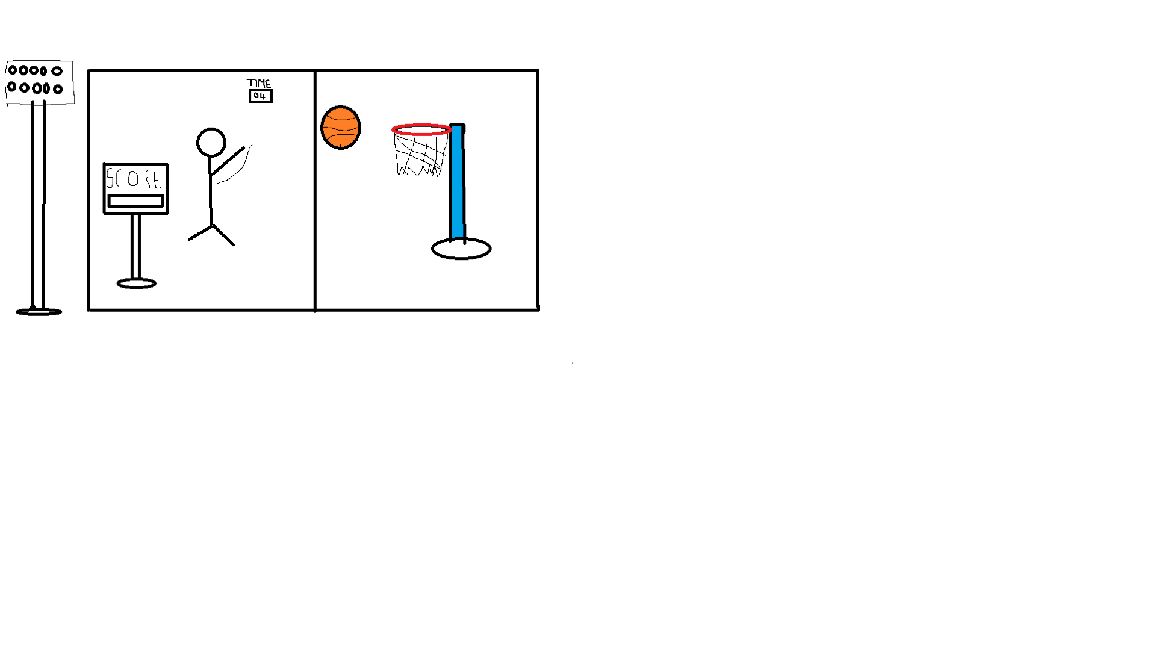

How do you plan to make your game engaging?

1. Adding sound effects when a basket is made/missed.
2. Increasing the level of difficulty as the game goes on.
3. Time limit for making each shot.
4. Making the rules of the game easy to understand.