Machine: 10.75.205.122  
In Admin page (Check below checkbox) click on save and verify the message

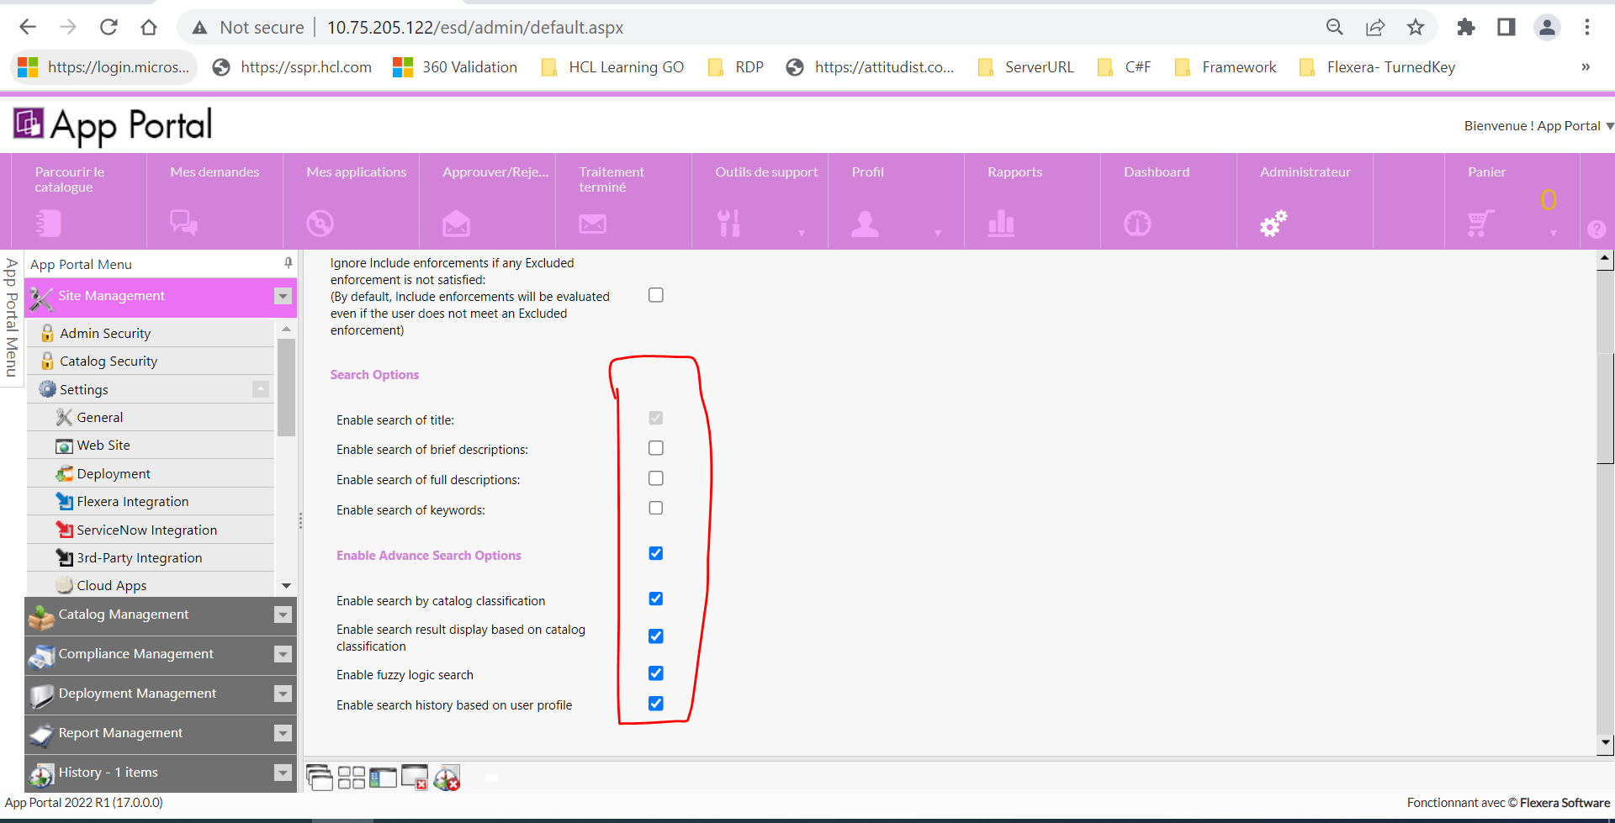  
  
Copy any/some word from anywhere, click/focus on search textbox, it will display list of earlier search keyword, now right click and paste and try to click on search button, pasted word will disappear.  
