EN2533 – Robot Design and Competition

Homework 4 – Arduino Mega 2560

Name: Wijetunga W.L.N.K Index number : 200733D

Arduino 2560 is an open-source microcontroller board.

**Specifications of Arduino Mega 2560**

* Microcontroller present - Atmega2560
* Operating voltage of the microcontroller - 5 V
* Number of digital I/O pins - 54 including 15 which can supply PWM output
* Number of analog input pins - 16
* DC current rating per I/O pin - 20 mA
* DC current drawn from chip - 50 mA
* Flash memory - 256 KB
* SRAM - 8KB
* EEPROM - 4KB
* Clock speed - 16 MHz
* Communication - USB (Programming with ATmega2560)

ICSP (Programming)

SPI

I2C

USART

**Power Pins**

* Recommended supply voltage (VIN) - 7V to 12 V
* GND - Ground
* 5 V Supply - For External hardware power supply
* 3.3 V Supply - For External low voltage hardware supply

**Controller Pins**

* RESET - A low level longer that 4 clock cycles on this pin, will generate a

reset.

* XTAL1, XTAL2 - Crystal oscillator is connected to supply clock for the controller with

bypass capacitor to the GND.

* AREF - Used when Adc for analog to digital conversion with external reference

voltage for conversion and don’t want to use internal reference

voltages.

**Alternative Pins**

* SPI - Pin 22 - SS, Pin 23 - SCK, Pin 24 - MOSI, Pin 25 – MISO

Used for serial communication with Serial Peripheral Interface (SPI) protocol for communication between 2 or more devices.

(Ex: Programming the ATmega, Communication with other peripherals such as LCD, SD)

* I2C - Digital pin 20 for SDA and 21 for SCK (Speed 400kHz) to enable 2 wire

communication with other devices. (Ex: LCD and other multiple devices)

* PWM - Digital pin 2 – 13 can be used as PWM output to write PWM value from 0 – 255.

(Ex: Speed control of motor, light dimmer)

* USART - Pin 0 – RXD0, Pin 1 – TXD0, Pin 19 – RXD1, Pin 18 – TXD1

Pin 17 – RXD2, Pin 16 – TXD2, Pin 15 – RXD3, Pin 14 – TXD3

For serial USART communication with PC or other system for data sharing and logging. (Ex: Two controller communication)

* Pinchange Interrupt - Digital Pins - 0,22,23,24,25,10,11,12,13,15,14

Analog Pins - 6,7,8,9,10,11,12,13,14,15

Used for pin change interrupt.

(Ex: Push button-based interrupt and others)

* Hardware Interrupt - Digital pin 2,3,18 - 21

Used for interrupt services

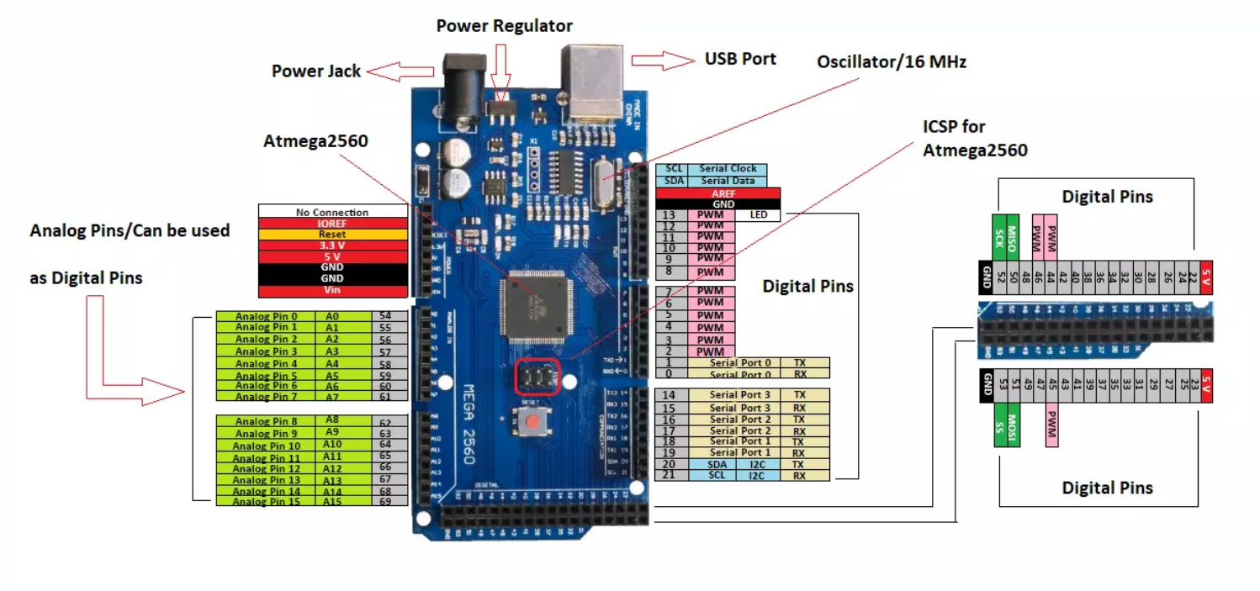 (Ex: Sensors like ultrasonic and other)

Figure - Pinout Diagram of Arduino Mega 2560

**Reference**

<https://www.circuitstoday.com/arduino-mega-pinout-schematics>

<https://www.elprocus.com/arduino-mega-2560-board/>

<https://www.theengineeringprojects.com/2018/06/introduction-to-arduino-mega-2560.html>