**TASK II: SYSTEM MODELLING**

*2.3 Draw a class diagram of Task Assignment module as comprehensive as possible*

+ Class diagram

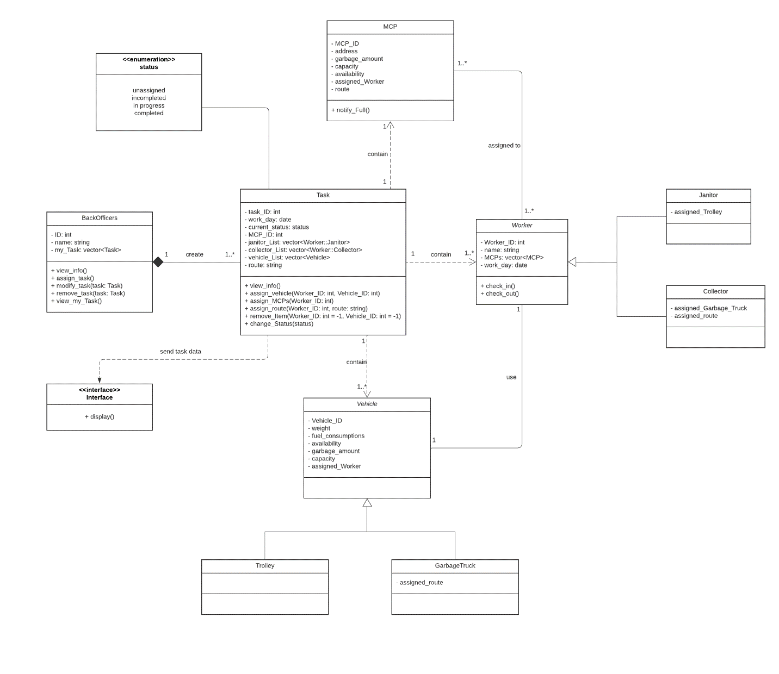

+ Description  
- Back Officers can view information, assign tasks, modify tasks and delete tasks.  
- During assigning tasks, Back Officers can see relevant information. These information can be Janitors and Collectors' information, MCPs and vehicles' details.  
- After every Task Assignment, every tasks will be stored in my_Task. Back Officers can always check their current assigned tasks using view_my_Task().  
- Back Officers can assign multiple tasks and can only modify tasks had been assigned, which are stored in my_Task.  
- Each task is about assigning Janitors, Collectors and vehicles to each MCPs. Therefore, each contains one MCP, one or many Workers and one or many vehicles.  
- Back Officers can remove Workers or vehicles from the task's list using remove_Item(), removing one may affect of removing the other. For example, removing a vehicle causes all Workers using that vehicle to be removed.  
- Workers can check in/ check out and change task's status. Back Officers can check task's current_status to track their current progress.