1. ASSIGN TASK TO JANITOR

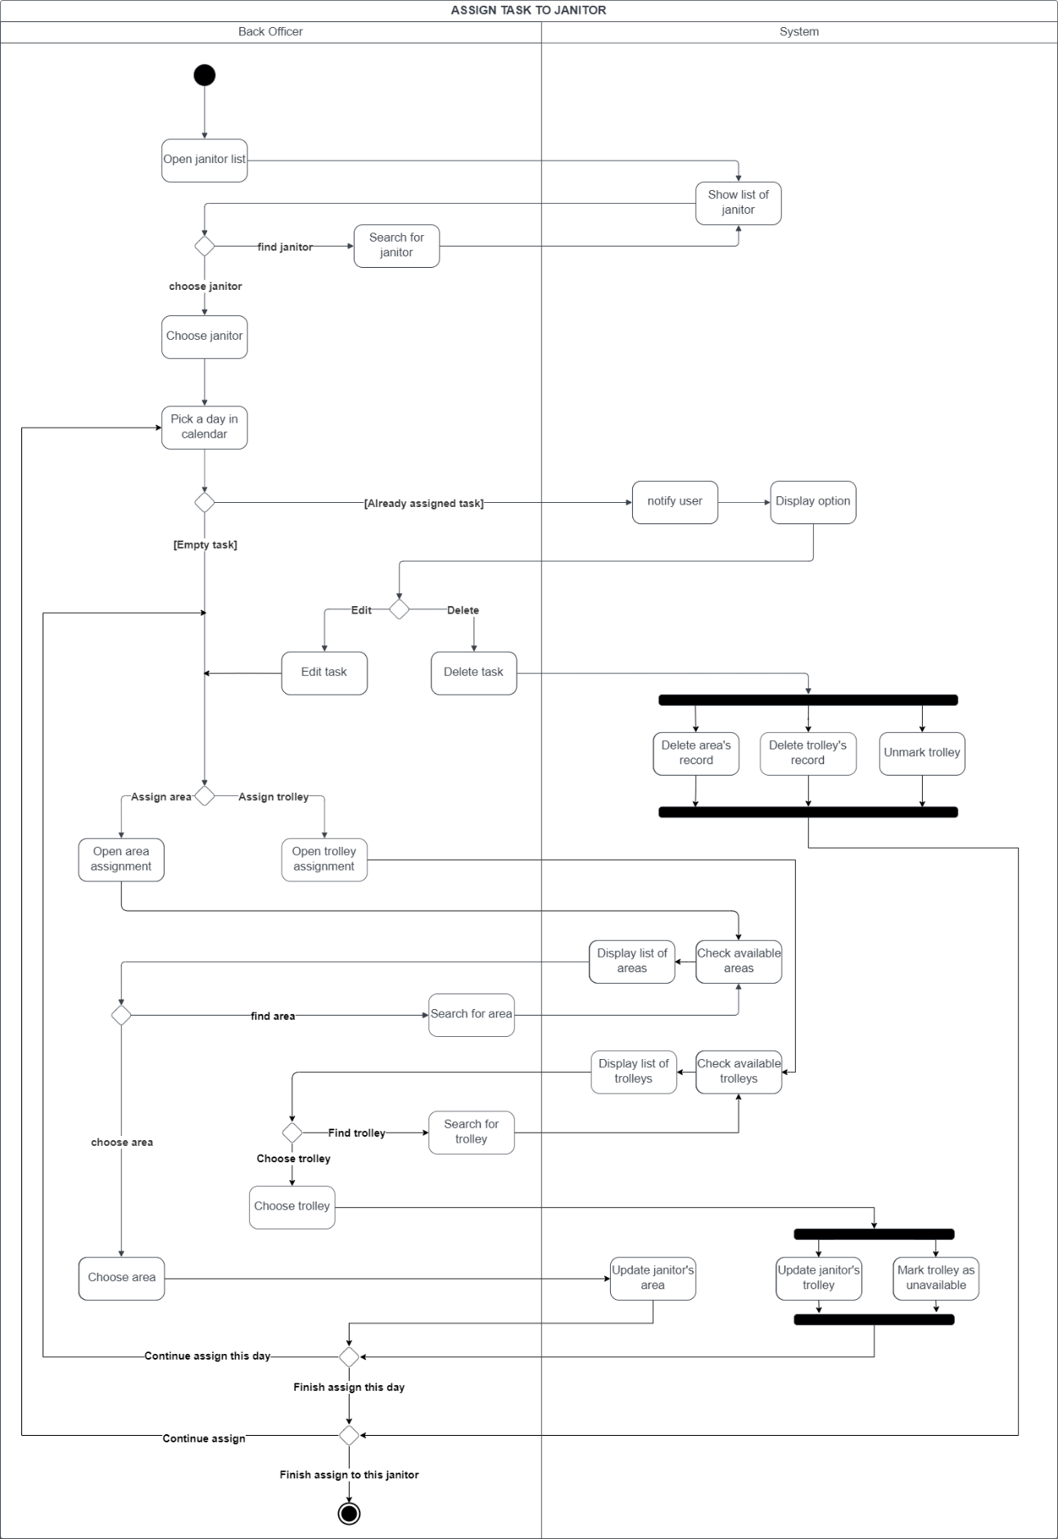

**Description:**

* Back officer start assigning task to janitor by open the janitor list, the system will display the default list of janitors.

+ If back officer wants to find janitor, he will input ID to search janitor and system return a result list.

+ If back officer finds the janitor, he clicks on that janitor.

* Back officer chooses a day in janitor’s calendar.

+ If that day is already assigned, system notifies “Task is assigned” and displays 2 options: Edit or Delete:

* If choose Edit, back officer can choose to edit area or trolley
* If choose Delete, system deletes all record for that day.

+ If that day is empty, back officer will choose to assign area or trolley.

* Back officer start assigning area to janitor by open the area assignment, the system will display the default list of area.

+ If back officer wants to find area, he will input ID to search area and system return a result list.

+ If back officer finds the area he wants, he clicks on that area and system save janitor’s area.

* Back officer start assigning trolley to janitor by open the trolley assignment, the system will display the default list of trolley.

+ If back officer wants to find trolley, he will input ID to search trolley and system return a result list.

+ If back officer finds the trolley he wants, he clicks on that trolley and system save janitor’s area as well as mark that trolley unavailable for other janitors .

* After assigning area and trolley, back officer can choose to assign another task or finish assigning to this janitor and leave.

1. ASSIGN TASK TO COLLECTOR

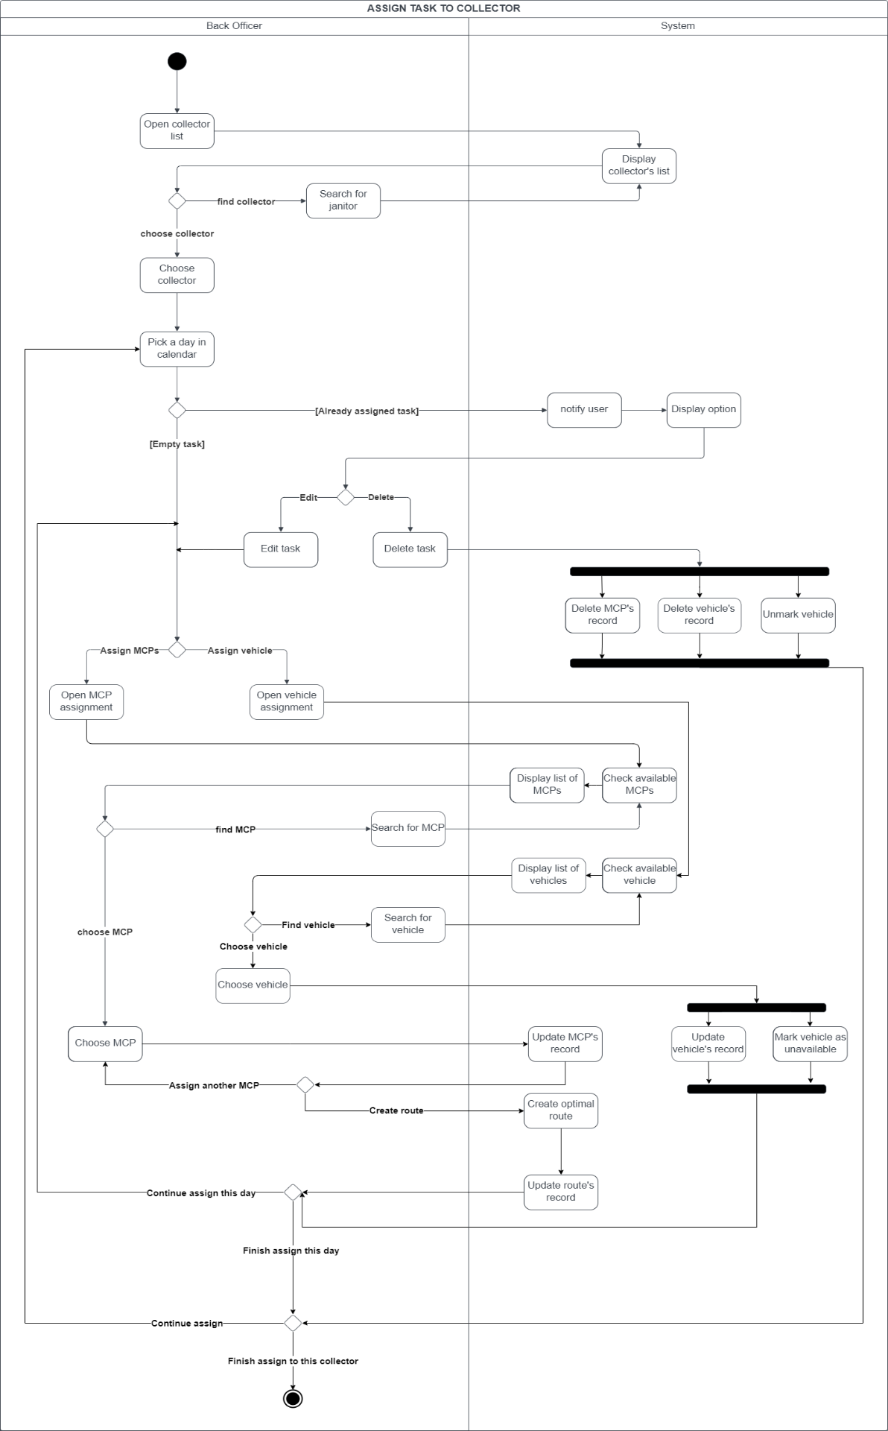

**Description:**

* Back officer start assigning task to collector by open the collector list, the system will display the default list of collectors.

+ If back officer wants to find collector, he will input ID to search collector and system return a result list.

+ If back officer finds the collector, he clicks on that collector.

* Back officer chooses a day in collector’s calendar.

+ If that day is already assigned, system notifies “Task is assigned” and displays 2 options: Edit or Delete:

* If choose Edit, back officer can choose to edit MCP or vehicle
* If choose Delete, system deletes all record for that day.

+ If that day is empty, back officer will choose to assign MCP or vehicle.

* Back officer start assigning MCP to collector by open the MCP assignment, the system will display the default list of MCP.

+ If back officer wants to find MCP, he will input ID to search MCP and system return a result list.

+ If back officer finds the MCP he wants, he clicks on that MCP and system save collector’s MCP.

+ If back officer wants to assign more MCP, he continues to choose from the MCP list.

+ When back officer doesn’t want to add more MCP, system will calculate and update the optimal route for collector.

* Back officer start assigning vehicle to collector by open the vehicle assignment, the system will display the default list of vehicles.

+ If back officer wants to find vehicle, he will input ID to search vehicle and system return a result list.

+ If back officer finds the vehicle he wants, he clicks on that vehicle and system save collector’s MCP as well as mark that vehicle unavailable for other collectors .

* After assigning MCP and vehicle, back officer can choose to assign another day or finish assigning to this collector and leave.