BÁO CÁO THỰC HÀNH LAB 3

LẬP TRÌNH HƯỚNG ĐỐI TƯỢNG

Contents

1. Working with method overloading 1

1.1 Overloading by differing types of paramete 1

1.2 Overloading by differing the number of parametes 2

2. Passing parameter 2

3. Classifer Member and Instance Member 4

4. Open the Cart class 5

4.1 Method to print cart 5

4.2 ToString() method and isMatch() method 5

4.3 Search DVD by ID and by tile 6

4.4 Result 7

5. Implement the Store class 8

6. String, StringBuilder and StringBuffer 11

Table of Figure

Figure 1. Overloading by differing types of paramete 2

Figure 2. Overloading by differing the number of paramete 3

Figure 3. Passing parameter 4

Figure 4. Result 4

Figure 5. Classifer Member and Instance Member 5

Figure 6. Print cart method 6

Figure 7. ToString and isMatch method 6

Figure 8. Search method 7

Figure 9. Result 8

Figure 10. Implement the Store class 11

Figure 11. Result 11

Figure 12. String, StringBuilder and StringBuffer 12

Figure 13. Result 12

# 1. Working with method overloading

## 1.1 Overloading by differing types of paramete

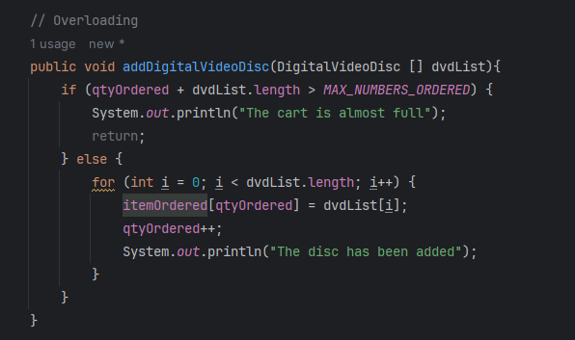

Figure 1. Overloading by differing types of paramete

## 1.2 Overloading by differing the number of parametes

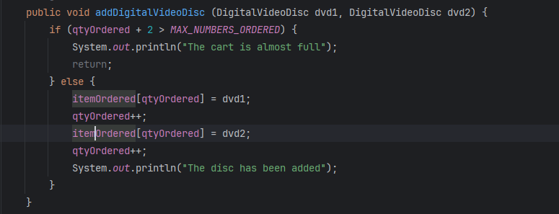

Figure 2. Overloading by differing the number of paramete

# 2. Passing parameter

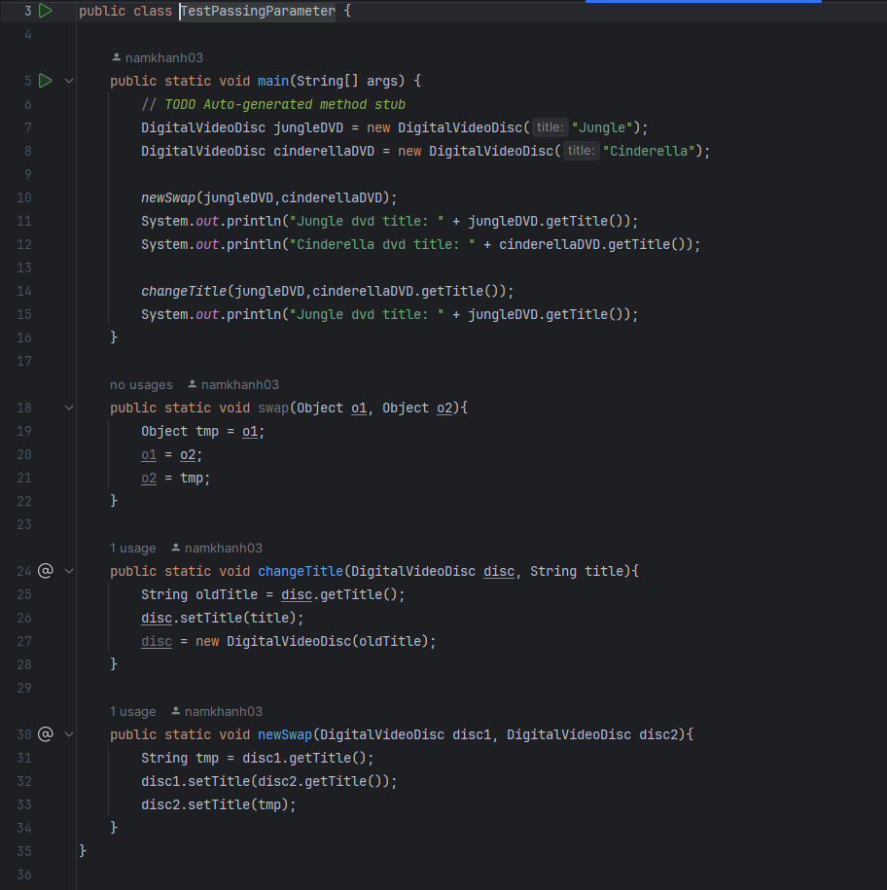

Figure 3. Passing parameter

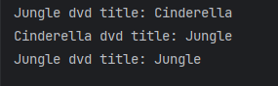

Figure 4. Result

# 3. Classifer Member and Instance Member

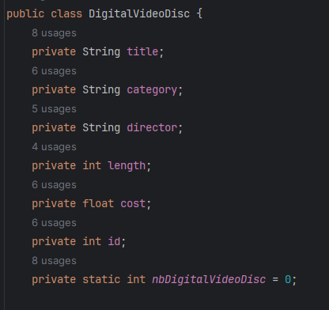

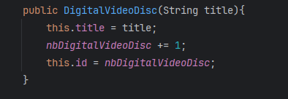

Figure 5. Classifer Member and Instance Member

# 4. Open the Cart class

## 4.1 Method to print cart

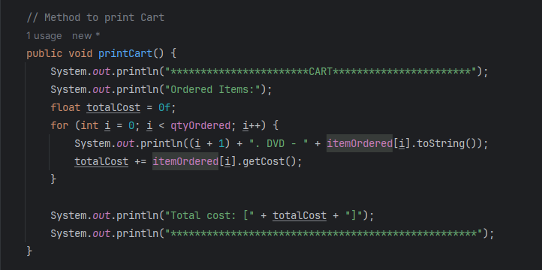

Figure 6. Print cart method

## 4.2 ToString() method and isMatch() method

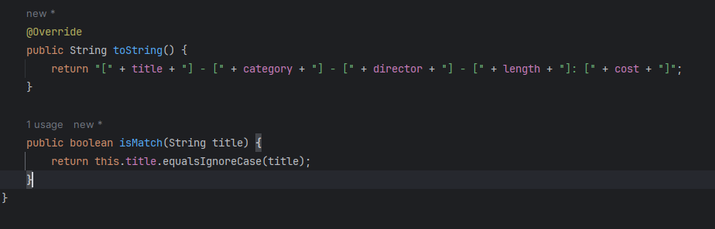

Figure 7. ToString and isMatch method

## 4.3 Search DVD by ID and by tile

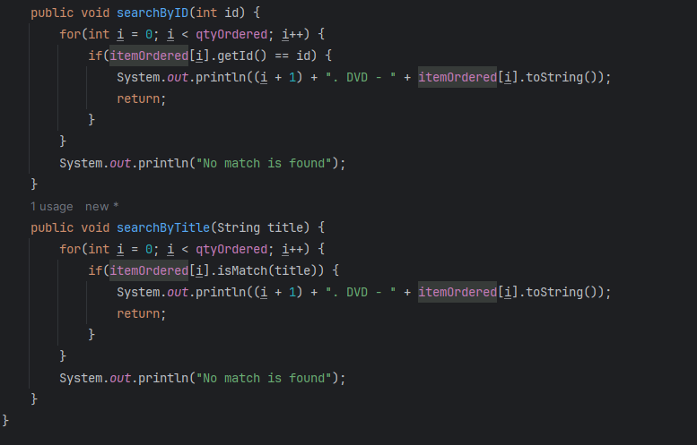

Figure 8. Search method

## 4.4 Result

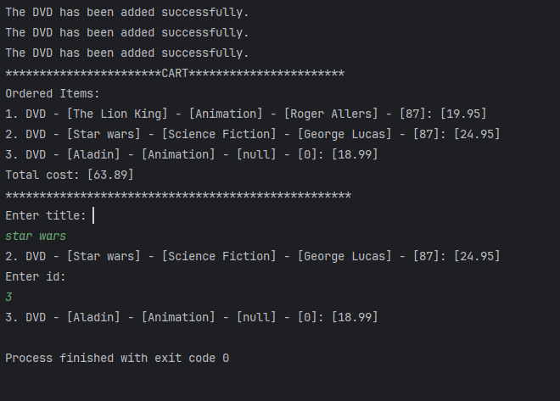

Figure 9. Result

# 5. Implement the Store class

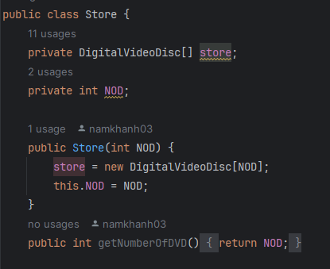

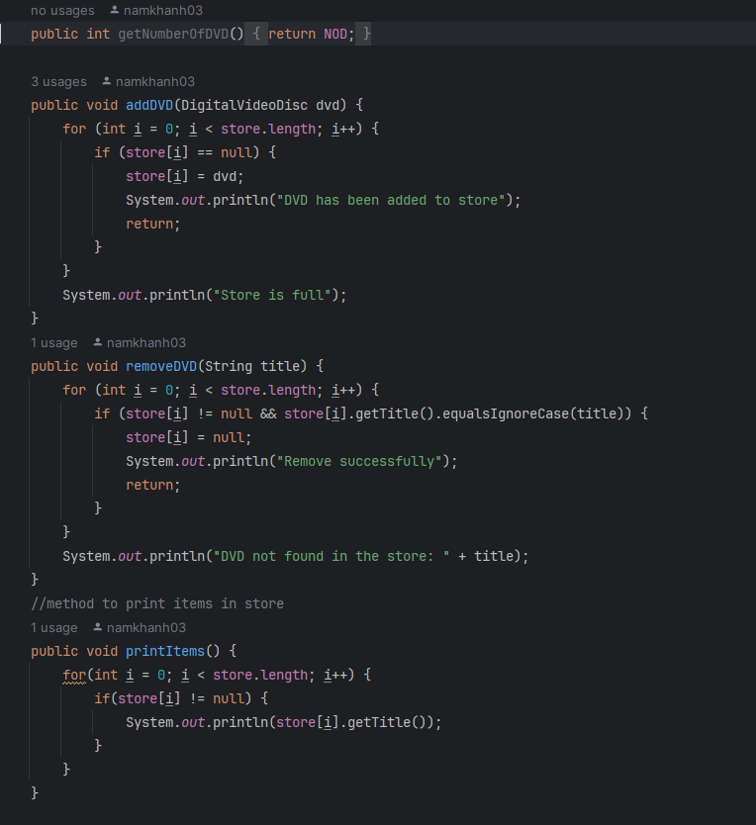

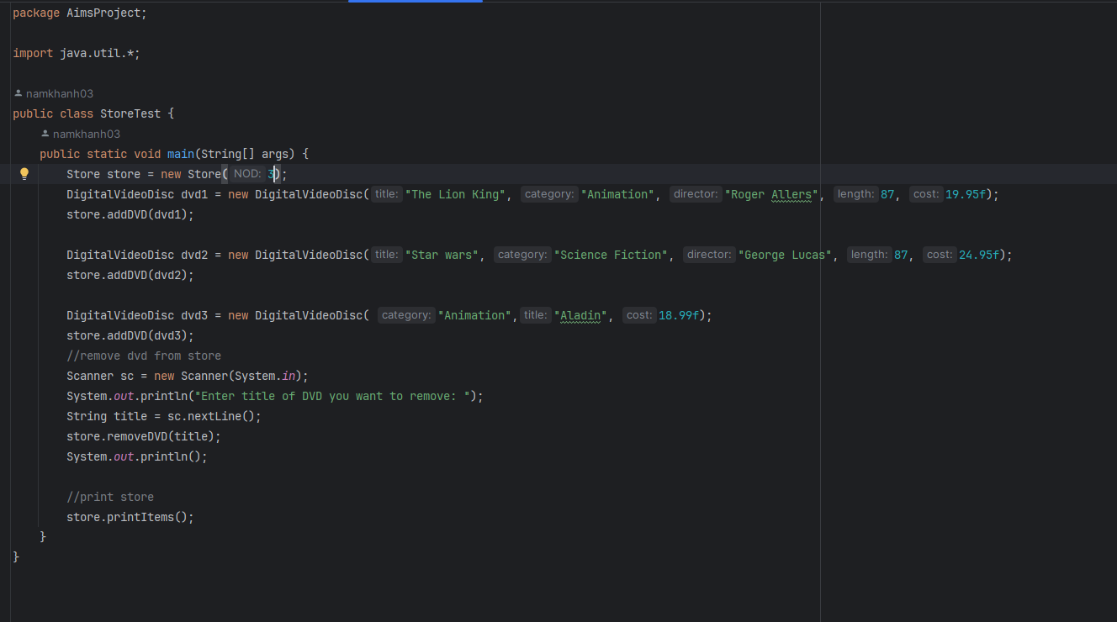

Figure 10. Implement the Store class

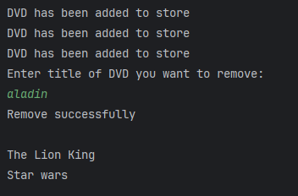

Figure 11. Result

# 6. String, StringBuilder and StringBuffer

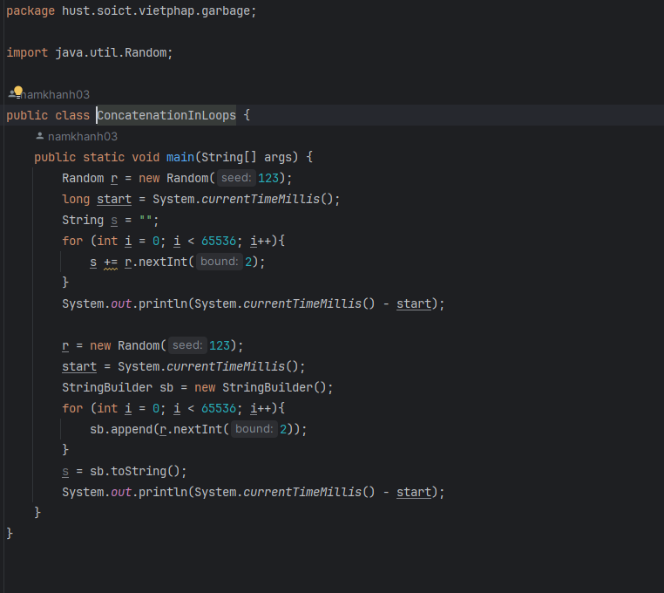

Figure 12. String, StringBuilder and StringBuffer

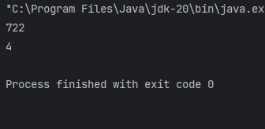

Figure 13. Result