BÁO CÁO THỰC HÀNH LAB 4

LẬP TRÌNH HƯỚNG ĐỐI TƯỢNG

Contents

1. Creating the Book class 1

2. Creating the abstract Media class 2

3. Create the Playable interface 4

4. Create Track class 5

5. Creating CompactDisc class 6

6. Update DigitalVideoDisc class 8

7. Update Cart class 9

8. Update Store class 12

9. Update Aims class 15

Table of figure

Hình 1. Book class 2

Hình 2. Media class 4

Hình 3. Playable interface 5

Hình 4. Track class 7

Hình 5. Update DigitalVideoDisc class 8

Hình 6. Update Cart class 12

Hình 7. Update Store class 15

Hình 8. Update Aims class 18

# 1. Creating the Book class

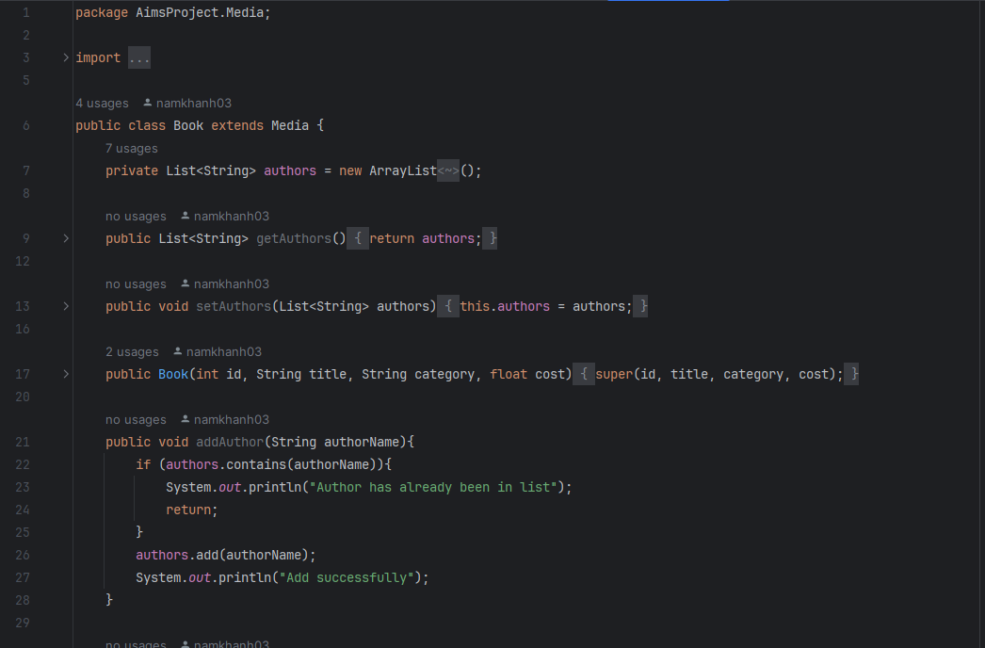

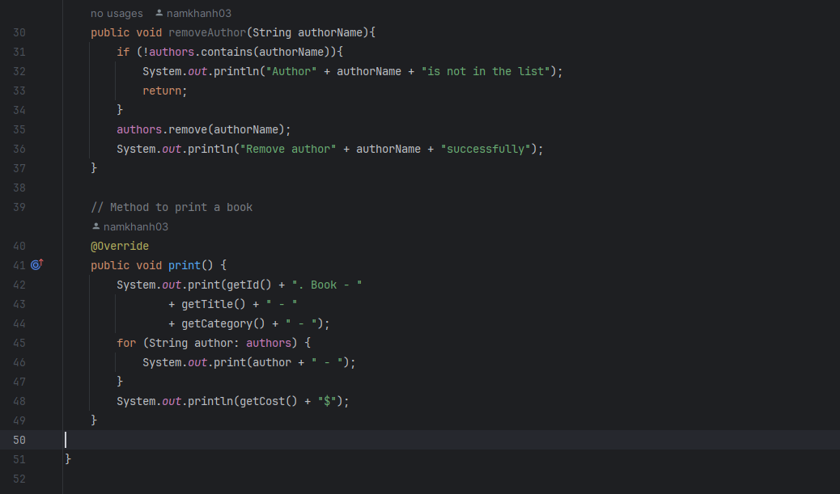

Hình 1. Book class

# 2. Creating the abstract Media class

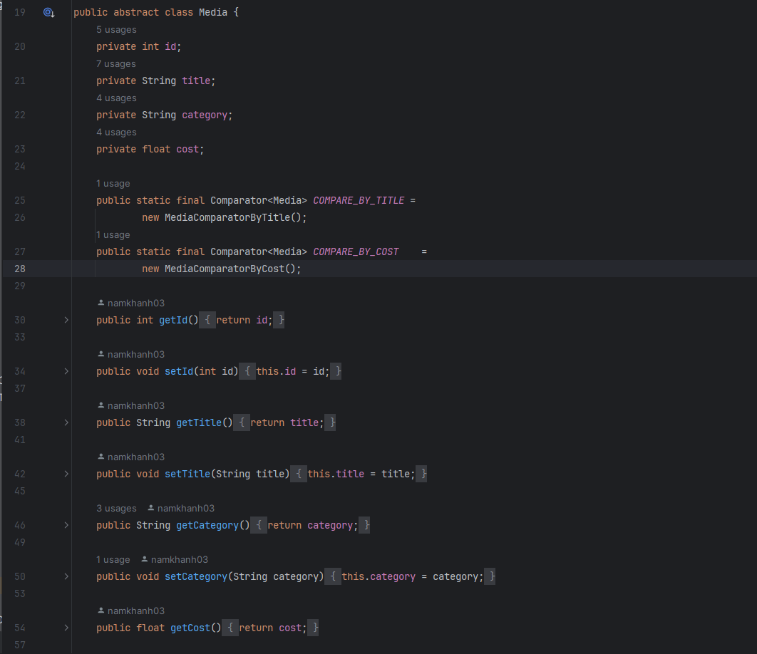

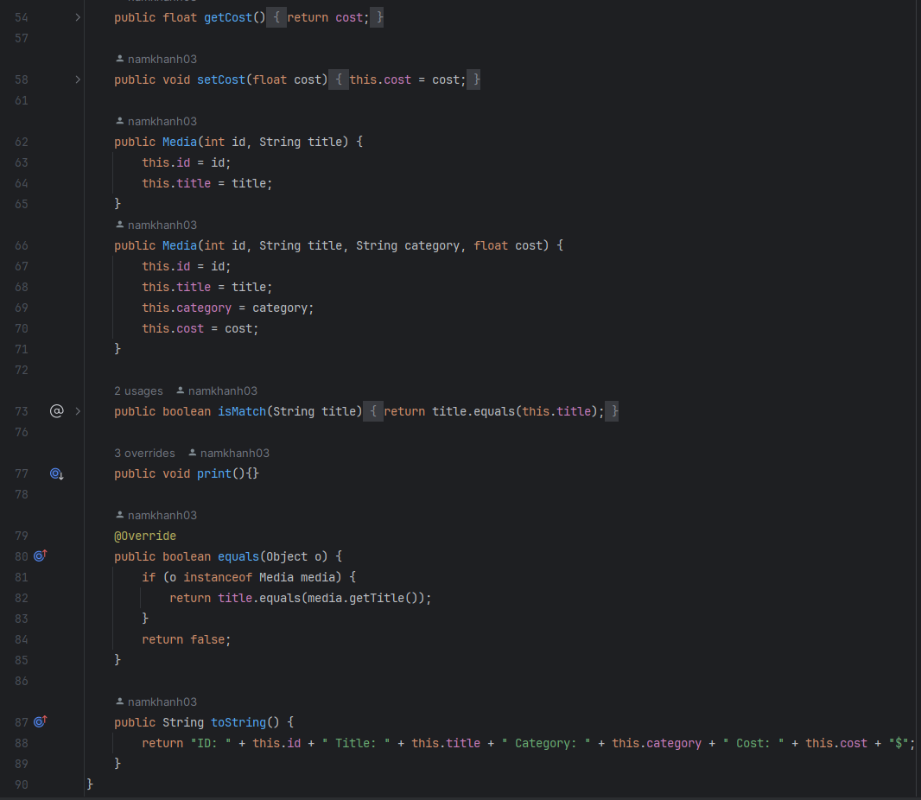

Hình 2. Media class

# 3. Create the Playable interface

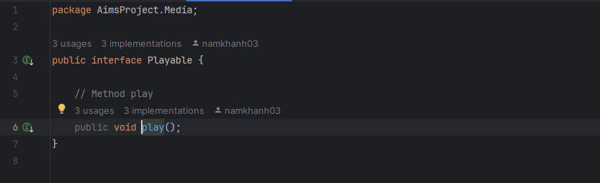

Hình 3. Playable interface

# 4. Create Track class

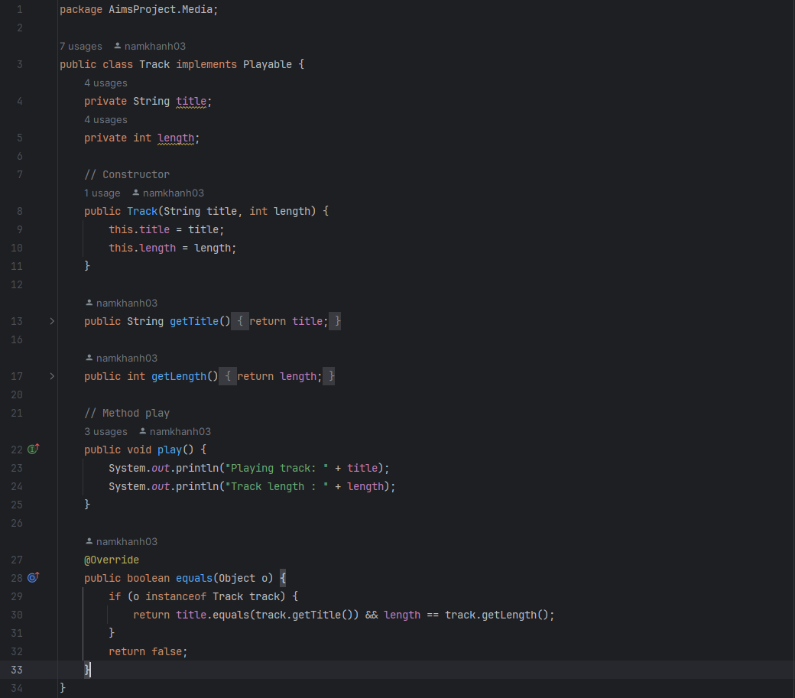

# 5. Creating CompactDisc class

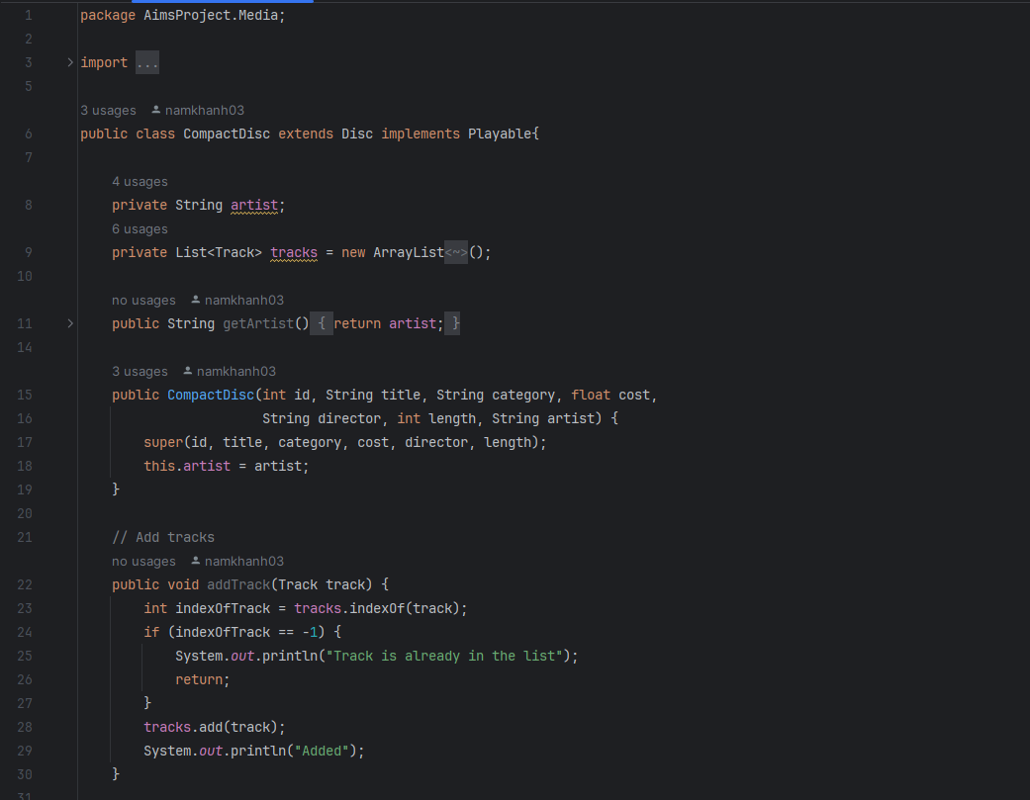

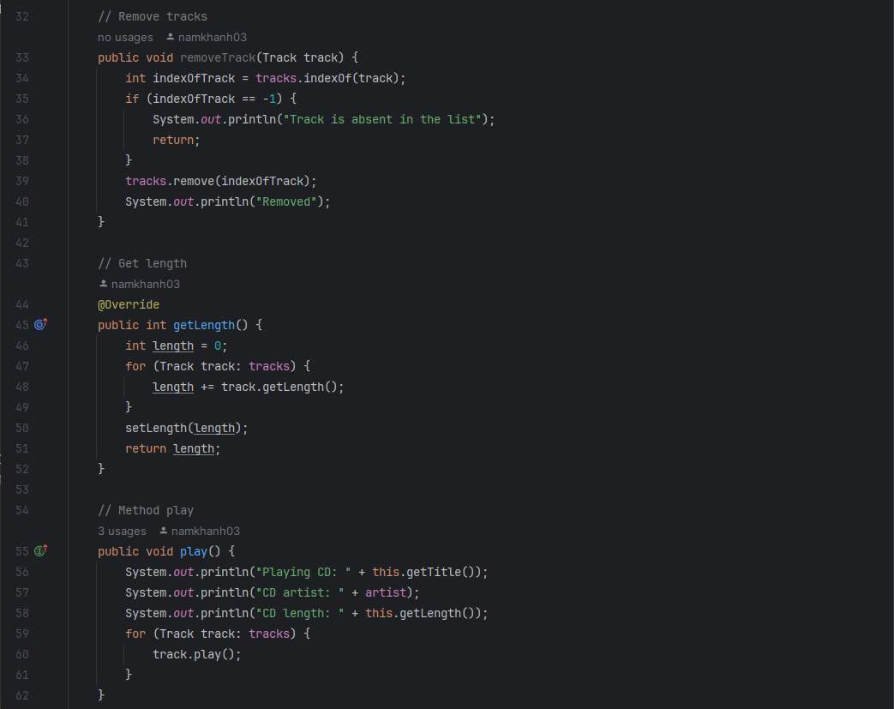

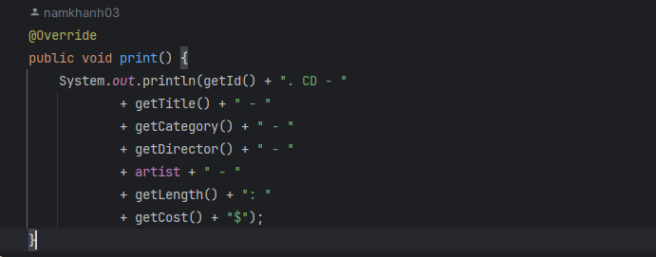

Hình 4. Track class

# 6. Update DigitalVideoDisc class

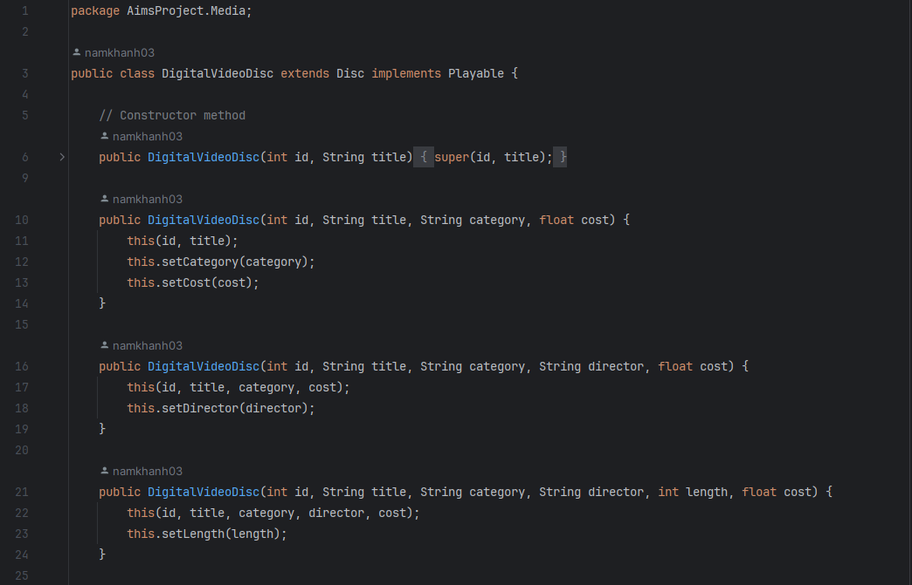

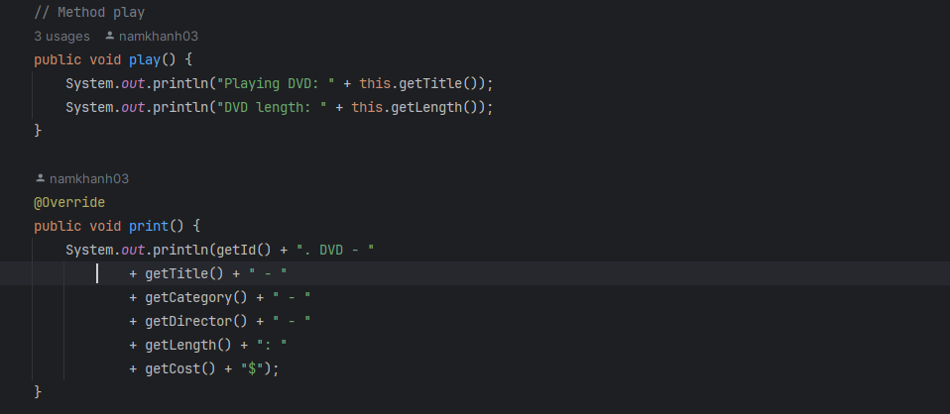

Hình 5. Update DigitalVideoDisc class

# 7. Update Cart class

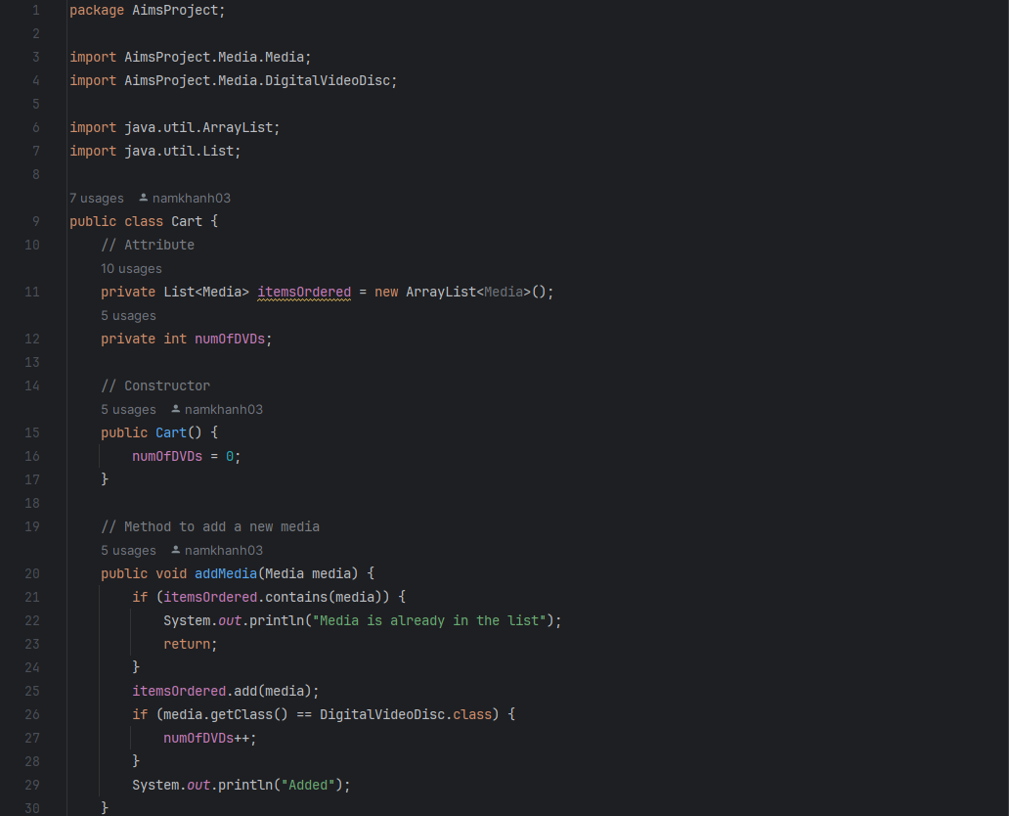

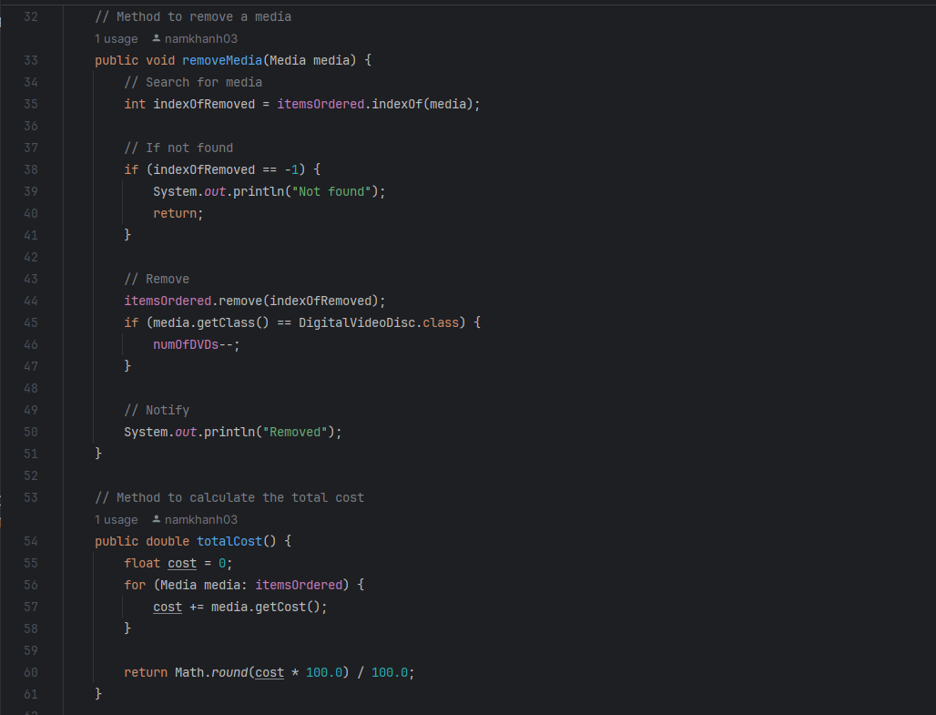

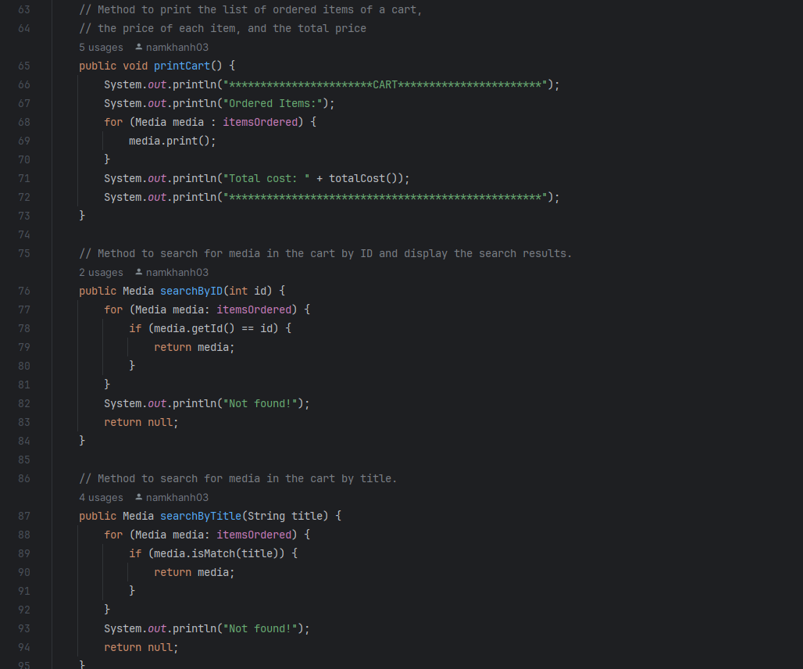

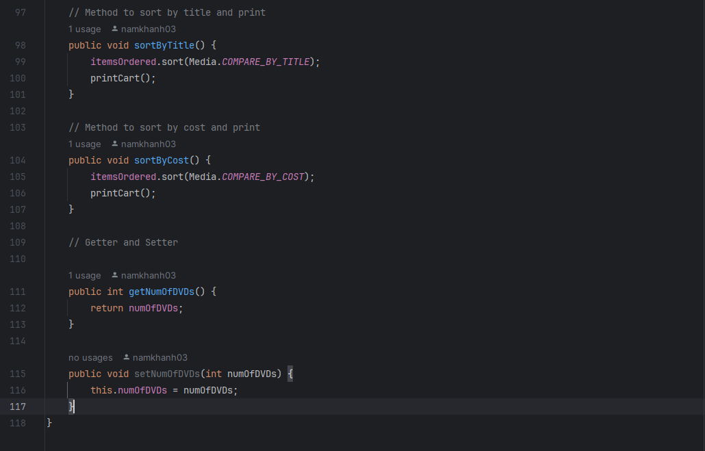

Hình 6. Update Cart class

# 8. Update Store class

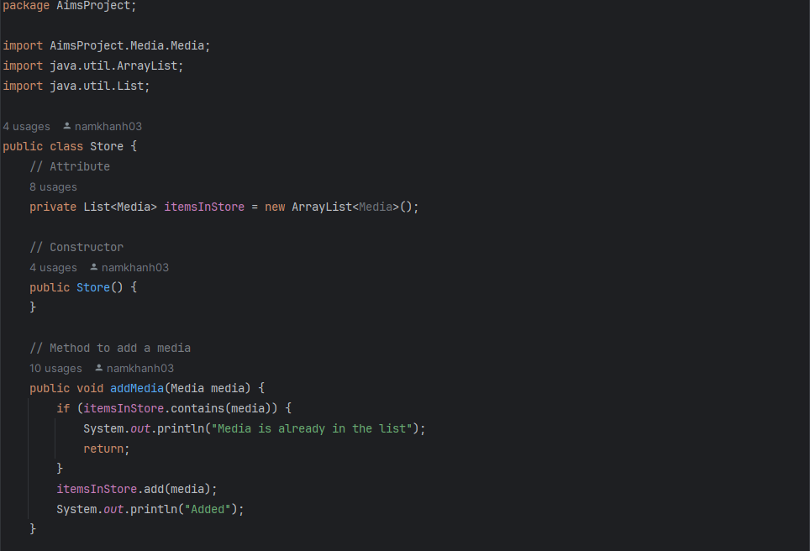

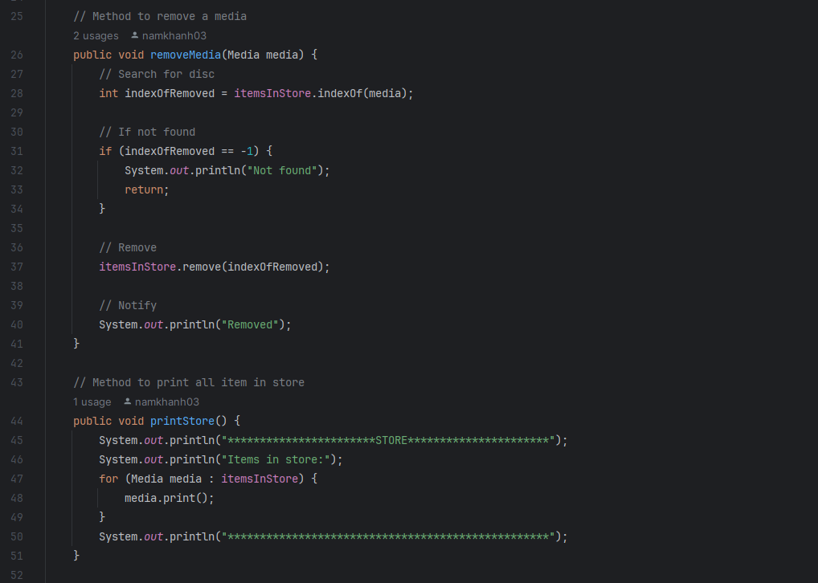

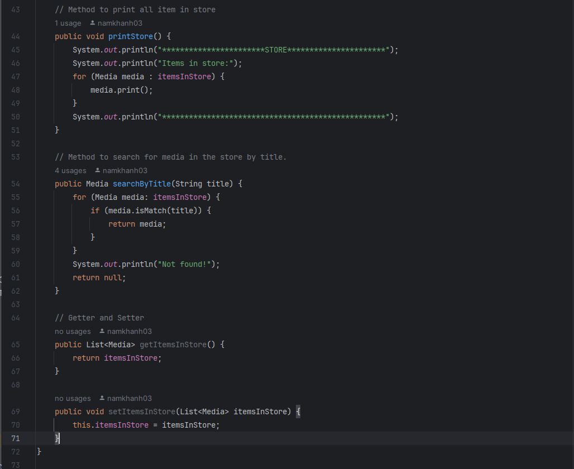

Hình 7. Update Store class

# 9. Update Aims class

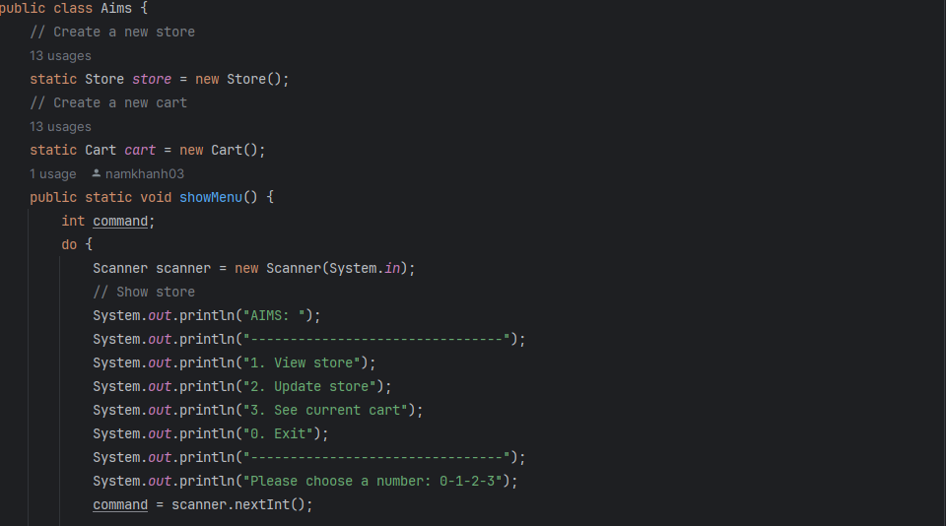

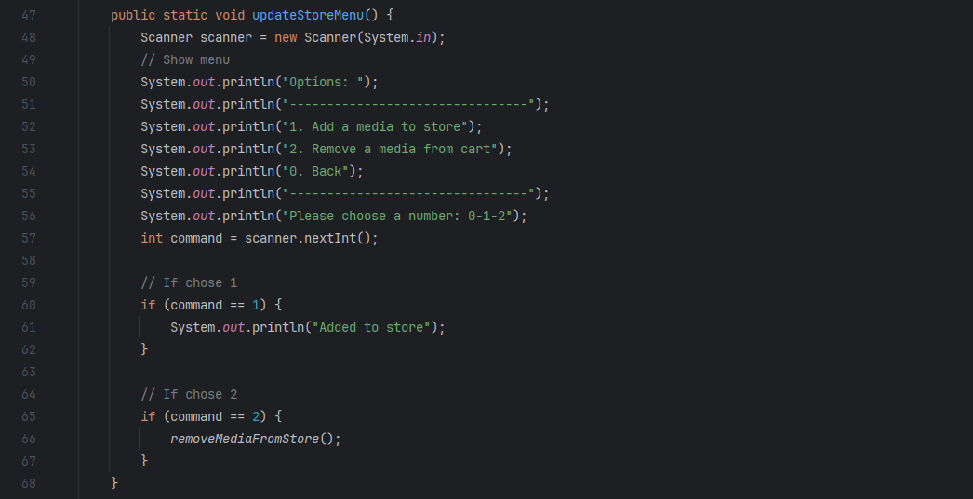

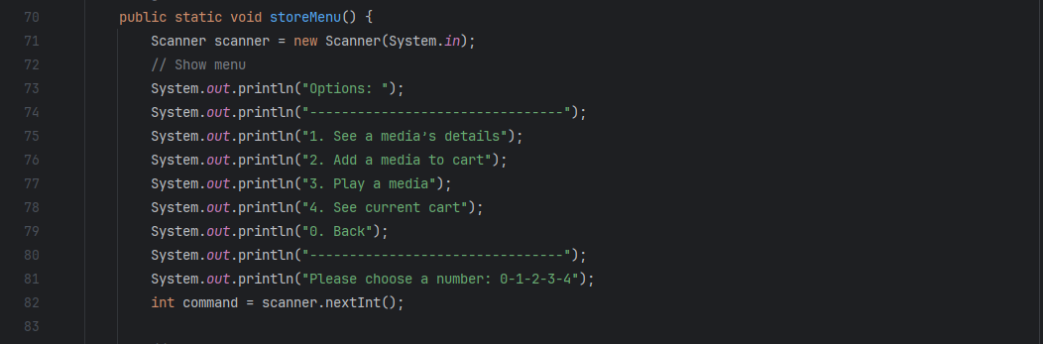

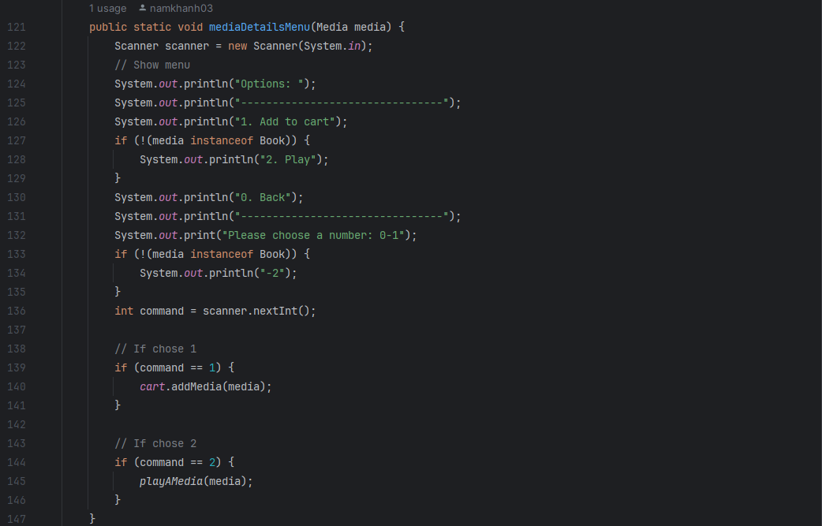

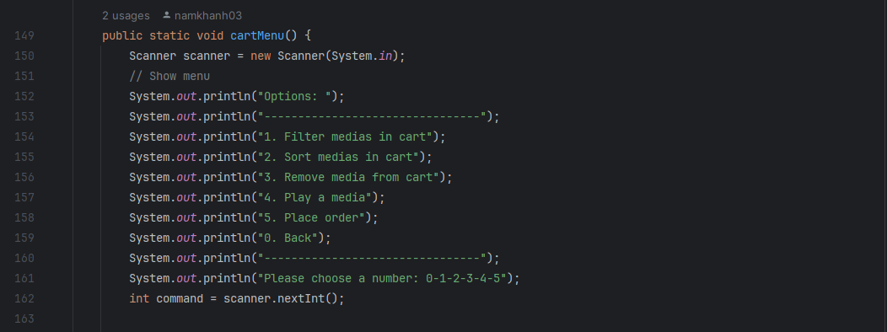

Hình 8. Update Aims class