1, What is Boolean?

-Boolean is an expression that evaluates to produce a result which is a Boolean value.

Write down 3 different expression that results a Boolean type:

->>> 69==6*9+6+9

>>>True

->>>lv = 31

>>>able_to_play_ranked = lv >= 30

>>>print(able_to_play_ranked)

>>>True

->>>69 == 6+9

>>>False

2, What is a flow chart? Draw flow chart for the following code snippet:

-A flowchart is a type of diagram that represents an algorithm, workflow or process.

- 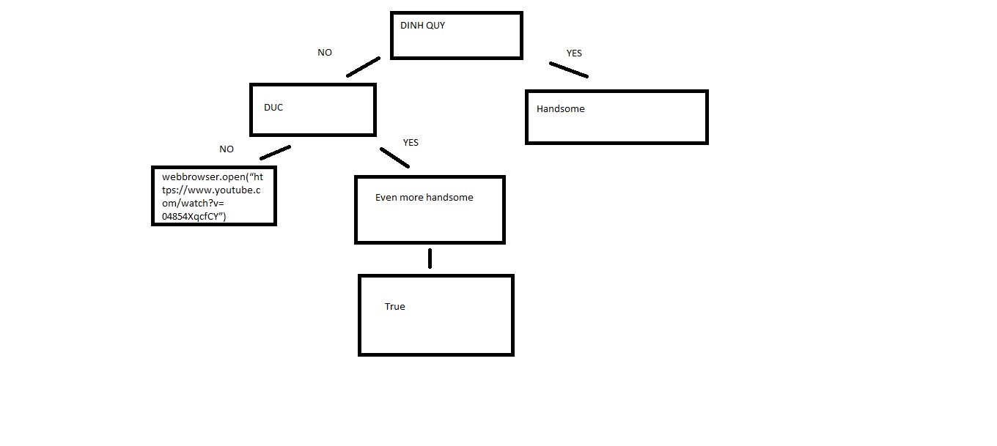

3.What is nested conditionals? Write a piece of code that uses nested conditionals.

- One conditional can also be nestedwithin another.

- if yasuo > leesin :

Print(“yasuo is better than lee sin”)

Elif lee sin > yasuo :

Print(“lee sin is better than yasuo”)

Else :

Print(“ they are both equally stupid ”)