# LAB REPORT No. 2

## discipline: Computer architecture

Students: Vuong Nam Khanh Group: NKAbd-02-23

# DESCRIPTION OF THE RESULTS OF COMPLETION OF TASKS

Work order

1. I open a terminal and enter commands, specify the username and email address 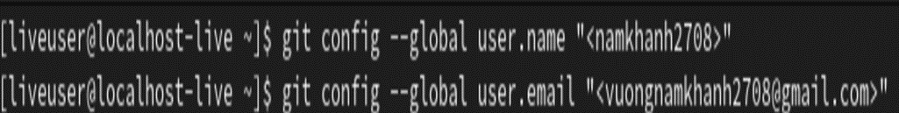
2. I have configured utf-8 in git message output 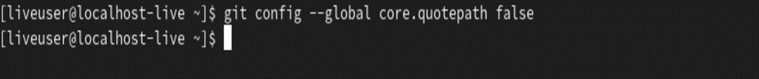
3. I will set the name of the initial branch 
4. I enter the autocrlf parameter and the safecrlf parameter 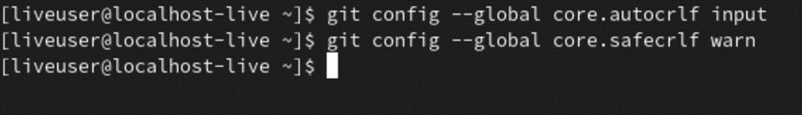
5. To further identify the user on the repository server, I generate a key pair 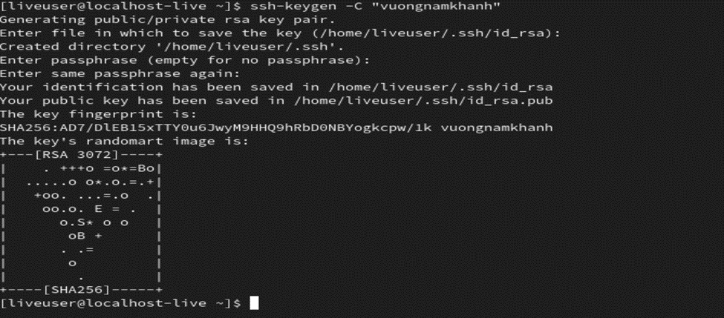
6. Then I download the generated public key. I went to http://github.org/, went to Menu and went to settings. After that, select SSH and GPG keys in the side menu and click the New SSH key button 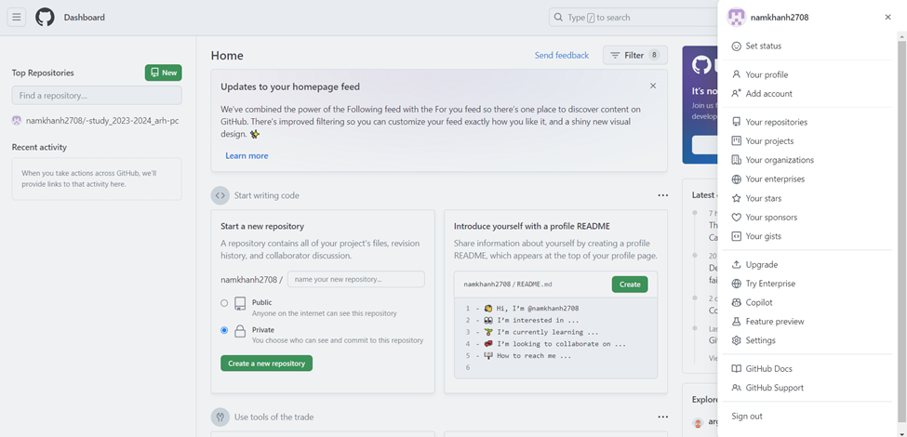 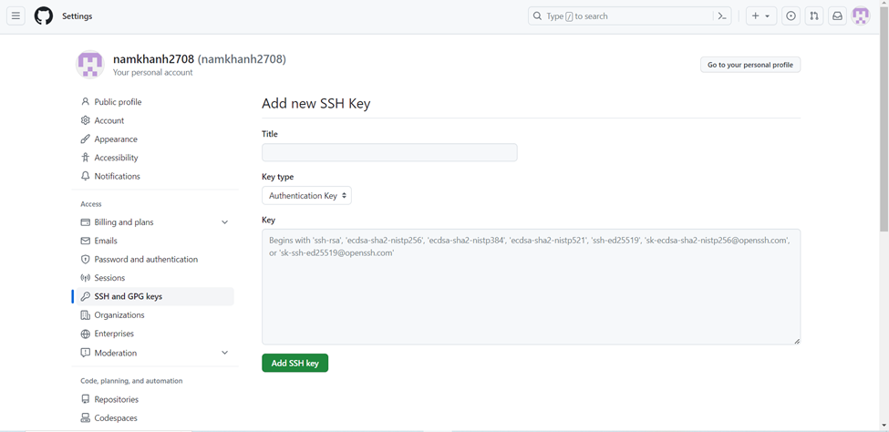 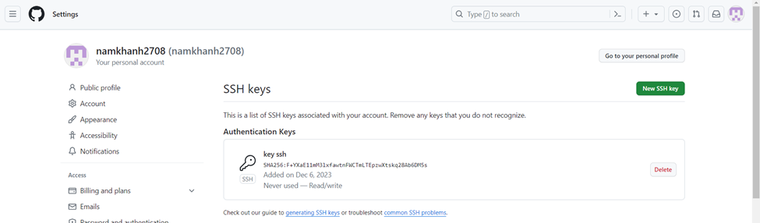
7. Go to the repository page with the course template https://github.com/yamadharma/cour se-directory-student-template and select Use this template. 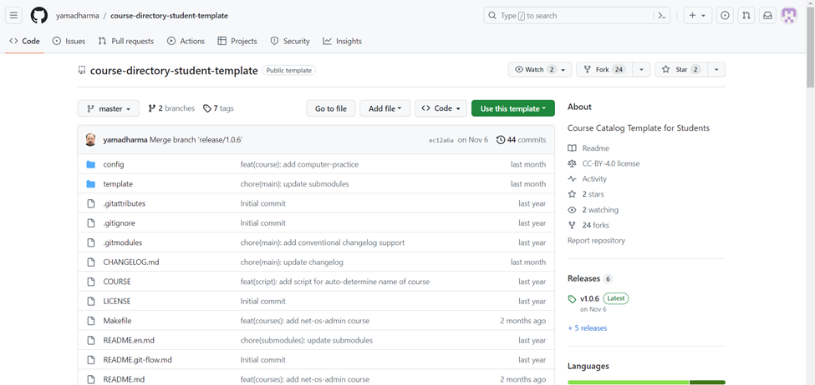 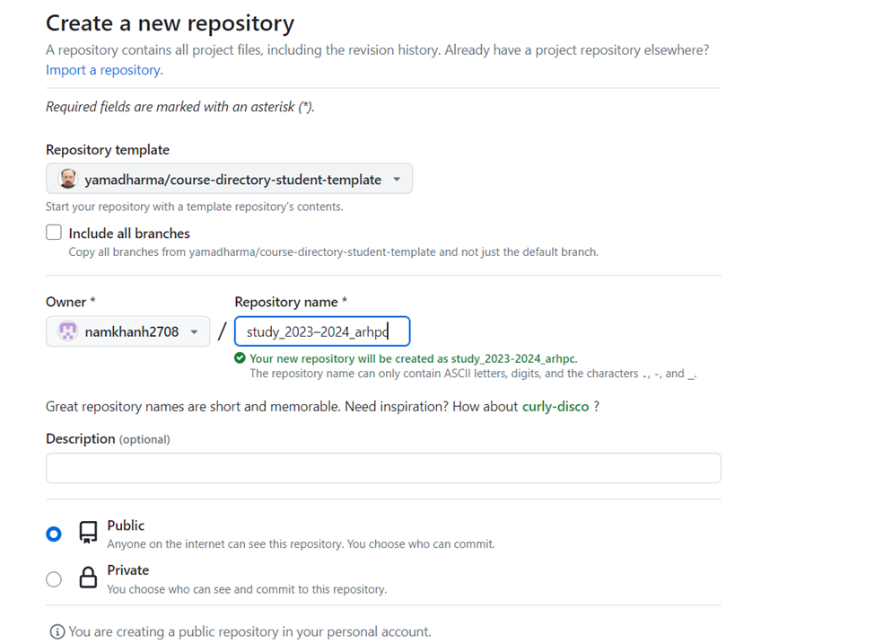
8. I opened a terminal and navigated to the course folder: 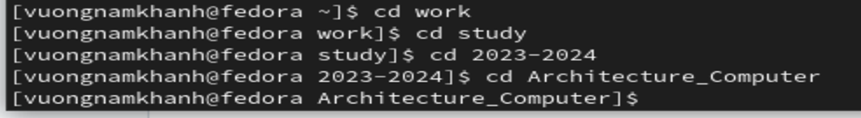
9. I clone the created repository: 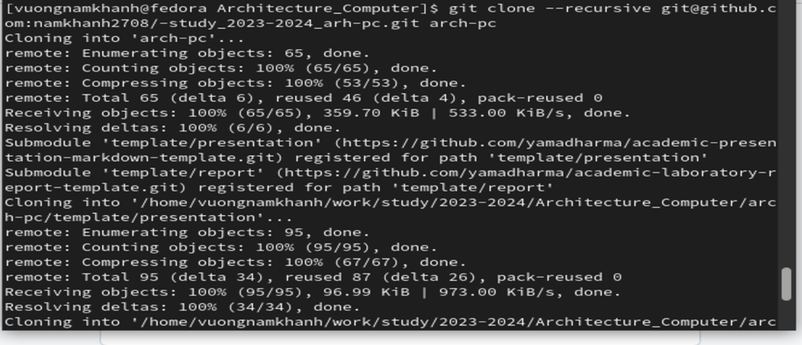 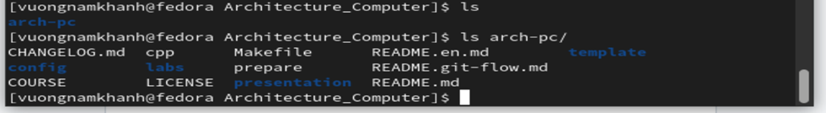
10. I will go to the course directory, delete unnecessary files, create the necessary directories and upload the files to the server 