Lab 3 - Networks and protocols
Soussou Adam
Gandois Clément
Pinsard Cédric
Partie 1 :
- Configure the internal interfaces with the given addresses on the diagram
Machine 1 : Machine 2 :
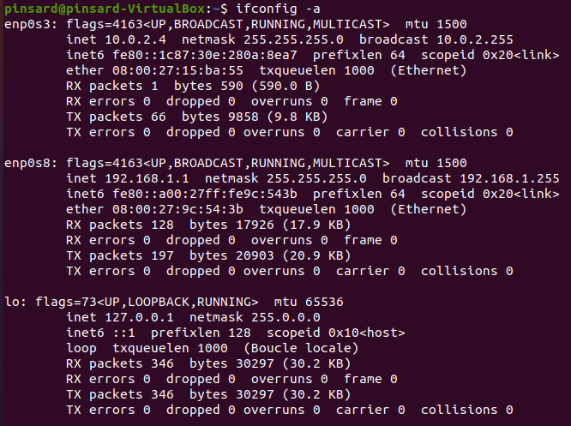
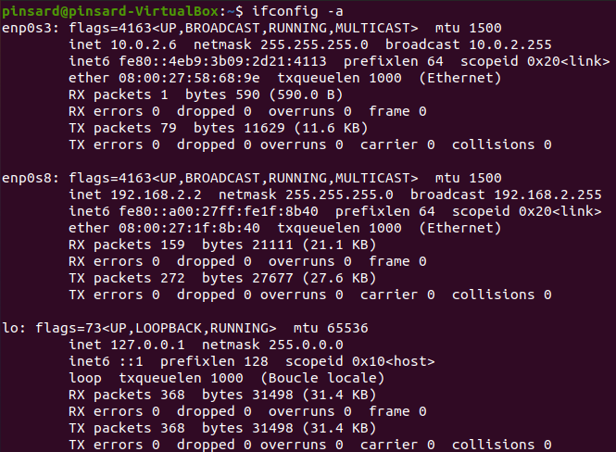

Machine 3 :
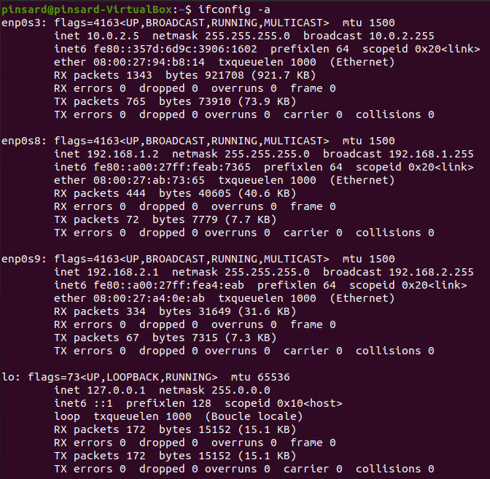
2) With Ping tool, test the connectivity between machines 1 and 3 then between 3 and 2.
It works :
Machine 1 → 3 :
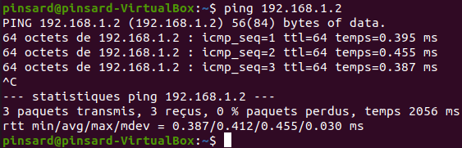
Machine 3 → 2 :
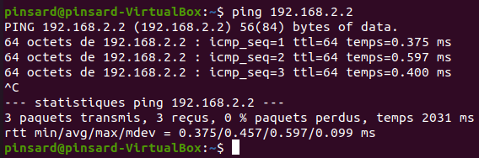
3) Now test the connectivity between machine 1 and 2. What happens?
It doesn’t work because Machine 1 and Machine 2 are not in the same subnetwork. So we need a router.
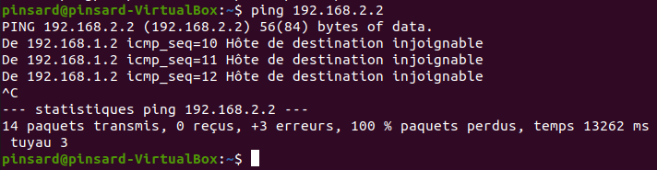
4) We want now to configure machine 3 to act as a router and connect the two subnets, to do, we need to:
a) Configure routes on machine 1 and 2 to use machine 3 as a router, the commands to use are the following:
Machine 1 :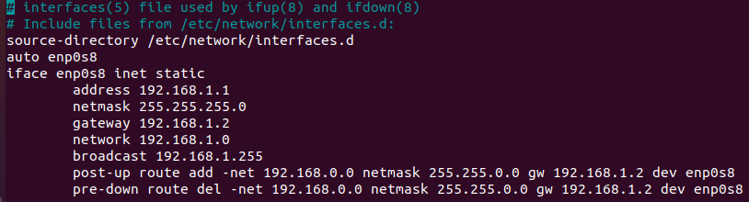
Machine 2 : 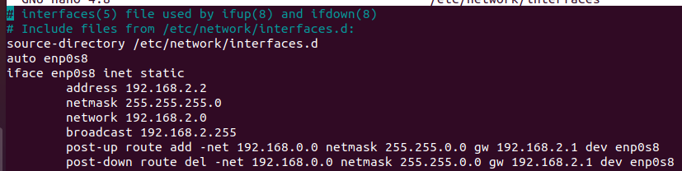
b) Ping machine 2 from machine 1. What happens?
There is a connection error :
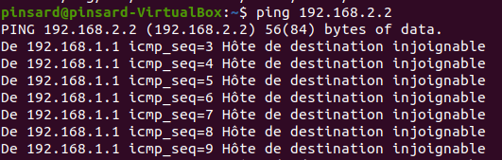
c) Use Wireshark (a graphical alternative to Tcpdump) to visualize the traffic (on different points) when pinging machine 2 from machine 1. Describe what happens and locate the problem.
We need to configure Machnie 3 as a router.
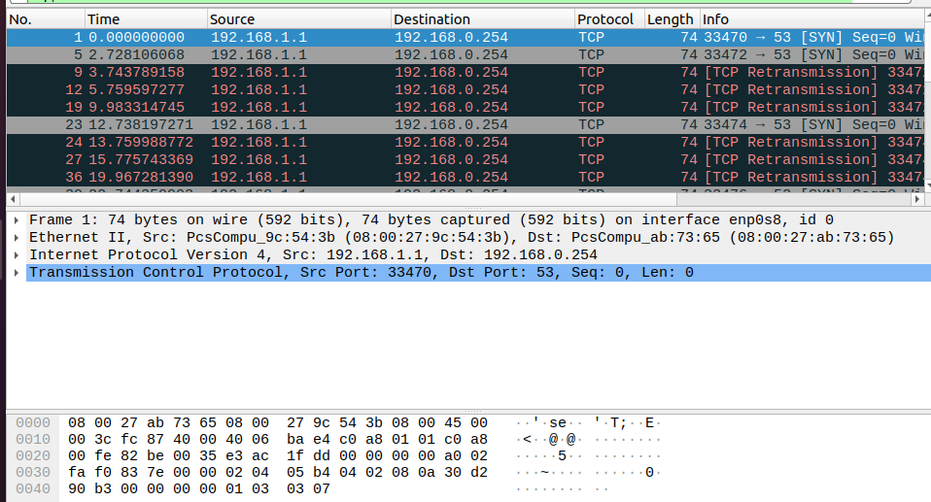
d) To make the routing possible, enable the IP forwarding on machine 3 by changing the value of the file /proc/sys/net/ipv4/ip_forward to 1.
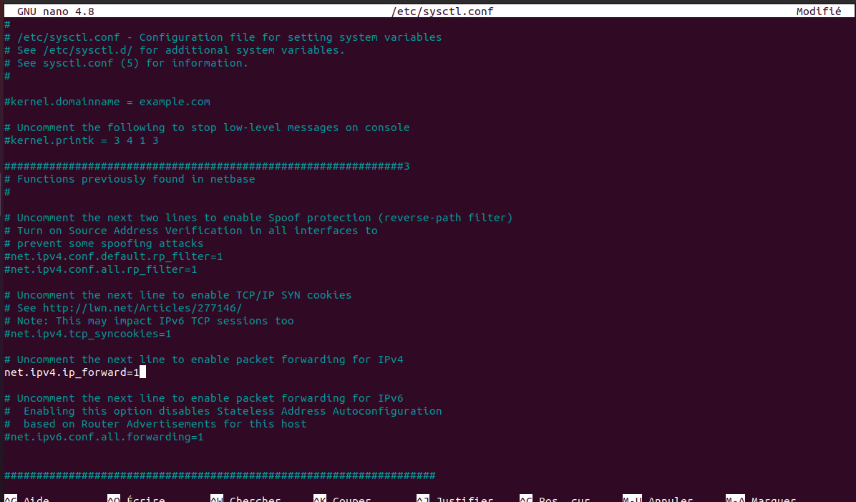
e) Ping again and see what happens.
Now it works.
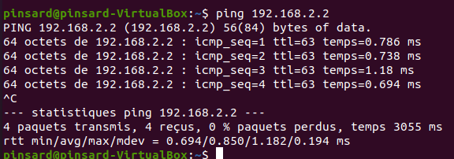

5) We want now to have only one internet access using the machine 2 NAT link. Shut-down the NAT interfaces on machine 1 and 3 and, check that there is no internet connection by pinging Google server (using 8.8.8.8 - which is a Google server address - as destination instead of the IP address).
Machine 1 :
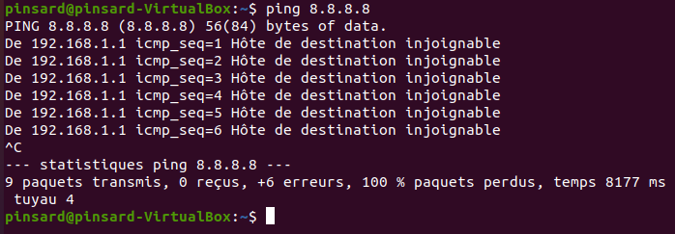

a) Add a route on machine 3 to set machine 2 as a default gateway:
b) Enable the IP forward on machine 2 and test the internet access on machine 3. Sometimes VirtualBox does not allow the Ping reply due to the NAT, in this case test with Wireshark on machine 2 to be sure that you receive ICMP messages from machine 3.
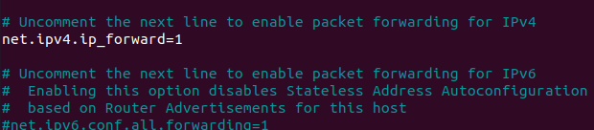
c) Test the internet access on machine 1, why it does not work? solve the problem
It doesn’t work. I tried to configure Machine 3 as a router, but it didn’t work.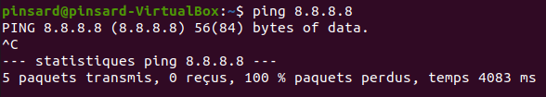
Partie 2 :
- Use the command arp -a to show and analyze the ARP table content on the three machines, copy un save in a text file the machine 2 ARP table content.
Machine 2 :
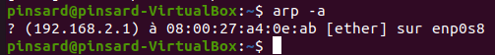
Machine 3 :
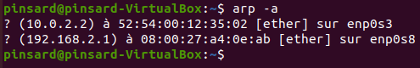
- On machine 1, run arp -a -d to delete the ARP table content
- On machine 1, run Wireshark (on a separate terminal) then ping machine 2.
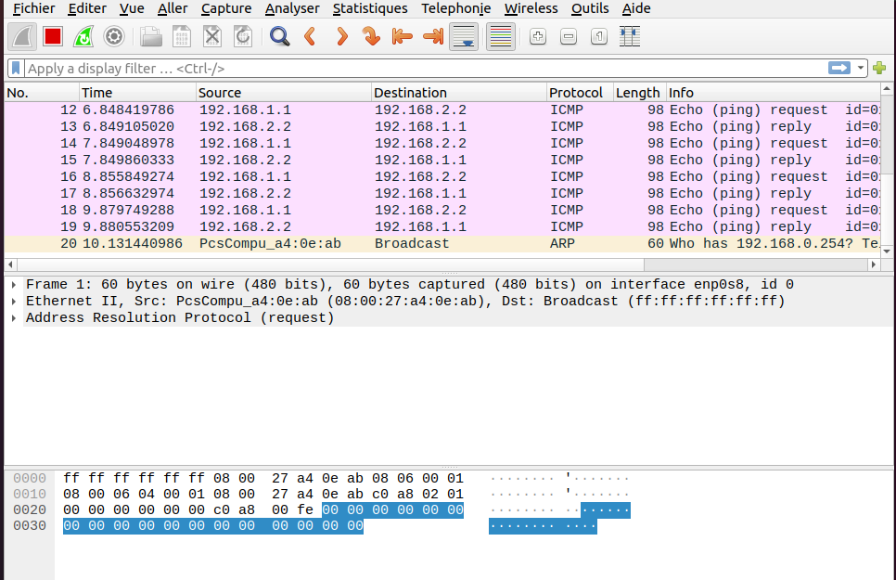
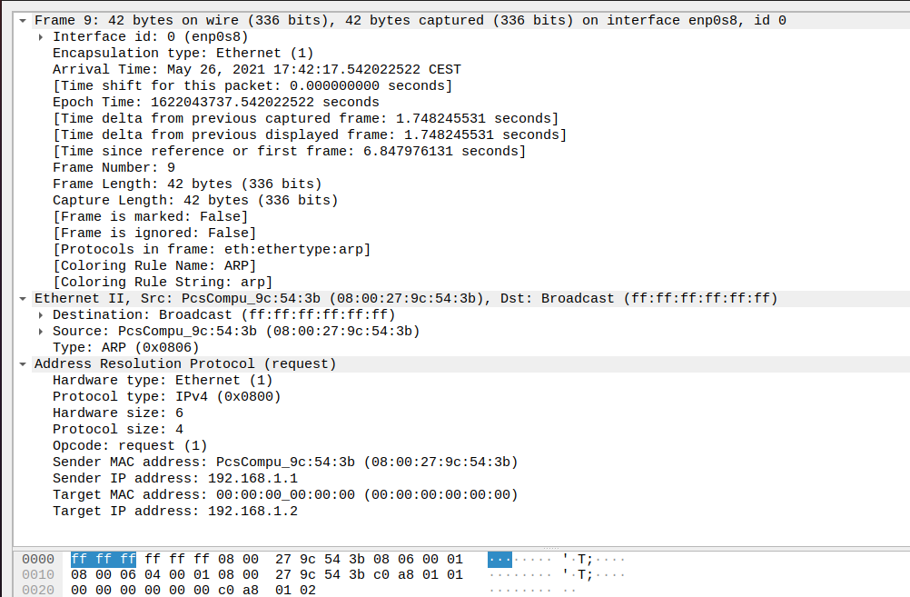
- Analyze the captured ARP packet content: the different addresses and the corresponding machines.
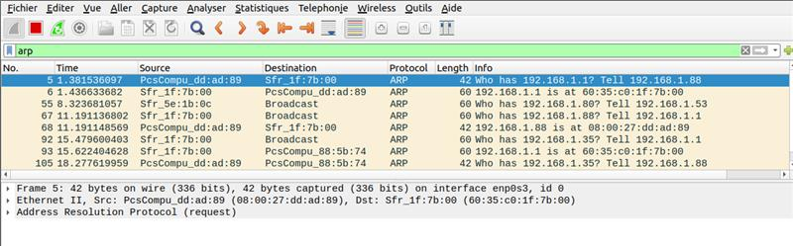
- Now we will put ourselves in the shoes of a malicious person who wants to intercept the messages exchanged between machine 2 and 3 from machine 1.
a) We start by adding a new Internal interface on machine 1 and configure it with the address 192.168.2.3 to be in the same network as machine 2 and 3.
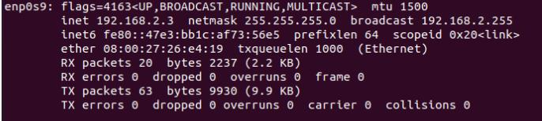
b)

