Asset Management

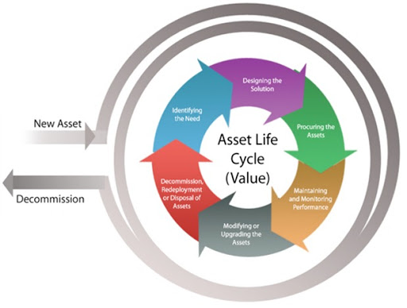

**Asset Management is the optimal allocation of the scarce budget between the new arrangement of asset and rehabilitation/maintenance of the existing assets to maximize the value of the stock of assets and to realize the maximum outcomes for the stakeholders.**

Arcadis is capable of providing asset management services for various types of engineering and infrastructure systems such as water and waste water utilities (Water Treatment Plants, Pump Stations, and Pipeline), mechanical and electrical assets of industrial plants, bridge and pavement systems, and building assets.

Our services encompasses

* Asset inspection and monitoring for capturing physical condition and operational condition of assets.
* Development of asset hierarchy and classification.
* Preparation of blue-print and strategic framework for organizations aiming to establish a long-term integrated asset management.
* Reliability study and modelling based on both qualitative and quantitative approaches;
* [Weibull analysis](/apps/weibulllcc).
* Fault Tree and Event Tree analysis;
* Deterioration prediction and modelling based on historical, inspection and monitoring data.
* Life cycle cost estimation and calculation of Return on Investment.
* Determination of optimal intervention programs.
* [Energy audit](/post/energy).

We are fully committed to apply the state-of-the-art asset management standards (e.g. FMEA, ISO 55000/01/02) to realize the best and optimal solutions for keeping and maintaining your assets in good conditions and constantly provide adequate level of services.

|  |  |
| --- | --- |
|  |  |