Technical Due Diligence

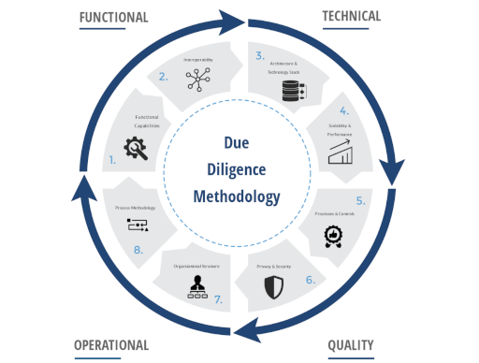

We provide Technical Due Diligence (TDD) services that involve a process of systematic review, analysis, and discovery of the conditions of assets from various view points such as architectural, constructional, structural, MEP, fire safety and external façade checking.

The TDD services also consists of a review and analysis of cost estimation for short, medium, or long term preventive intervention program. We utilize experience and knowledge of asset management in the context of TDD to provide optimal set of advices regarding future investment on the assets. All identified defects are being assessed as per their seriousness and are being added with a qualified investment costs estimation for their removal. Arcadis owns a rich set of cost database on investment projects both locally and globally, thus we will be able to provide Clients accurate cost estimation for TDD services through a rigorous benchmarking process.

TDD can also cover a building review from legal point of view (building conformity with valid construction standards). This is being provided by creating a summary and analyses of the most important issued permits including identification of possible neglects or related risks. Our services may also include assessment of environmental risks, Environmental Due Diligence. This is being provided by commenting the project in terms of possible site contamination risks and environmental impacts assessed on the basis of available documentation.

Technical audit can further control actual measurements of lease or other areas and revise related contracts and guarantees. Technical audit / feasibility study can be also conducted during the Project preparation phase based on the evaluation of Project documentation and other available documents.

The benefits of having us to provide TDD services to you includes, but not limited, to the followings - Gaining a good perception on the physical condition states of the assets and the overall deficiencies compared to the intended design; - Establishing a set of Level of Services that assets are required to provide adequately for their intended use; - Estimating a high level Cost Estimate for a Preventive Intervention Program - Providing a level of security and protection for investors regarding acquisition or investment on assets; - Providing a certain level of confident on asset pricing for allocation of risk or price negotiations.

Back to [Services](/service)