

GROUP PROJECT REPORT:
HILL CLIMBING RACING GAME

MEMBERS:
- PHAN NGỌC BẢO TRÂM (QE190111)
- NGUYỄN HỮU NHẬT DUY (QE190171)
- LÊ NHẬT NAM (SE194800)
- PHẠM HỒNG PHÚC (QE190133)
- HOÀNG TRẦN MẠNH DŨNG(QE190133)
COURSE/CLASS: SE19B.NET_PRU213

Table of Contents
1. PROJECT OVERVIEW 3
1.1. Introduction 3
1.2. Game Objective 3
1.3. Technologies Used 4
1.4. Design Inspiration 4
1.5. Player Experience 5
1.6. Endless Gameplay Design 5
1.7. Resource and Progression Design 5
2. Game Systems and Features 6
2.1 Main Menu System 6
2.2 Level Select and Map System 6
2.3 Gameplay System 8
2.4 Garage and Vehicle System 8
2.5 Coin Economy System 9
2.6 Lucky Spin System 10
2.7 Daily Reward System 11
2.8 Save System and Data Persistence 12
2.9 UI/UX Design 13
2.10 Audio Design and Sound Toggle System 14
3. Game Architecture 15
3.1 Overall Architecture 16
3.2 Scene Flow Architecture 16
3.3 Core Gameplay Architecture 17
3.4 Save and Data Architecture 18
3.5 Vehicle Architecture 18
3.6 Economy and Reward Architecture 18
3.7 UI Architecture 19
3.8 Audio Architecture 19
3.9 Architecture Summary 20
4. Main Scripts and Responsibilities 20
4.1 Main Script Responsibility Table 20
4.2 Script Groups by System 25
4.3 Important Script Connections 27
5. Testing 27
5.1 Testing Scope 27
5.2 Test Cases 28
5.3 Testing Result 30
6. Conclusion 31

1. PROJECT OVERVIEW

1.1. Introduction
This project is a 2D side-scrolling hill climbing racing game developed using Unity. The game is designed in a casual mobile game style, where players control a vehicle to move across endless terrain, collect coins, collect fuel, and try to reach the longest possible distance.
The player starts from the Main Menu and can access different systems such as Map Selection, Garage, Lucky Spin, and Daily Reward. The game includes multiple map themes, vehicle selection, coin economy, fuel management, reward systems, and local data saving. The main goal of the game is not to reach a finish line, but to survive as long as possible and achieve a new high score.
The game applies a scene-based architecture. Each main function is separated into a different Unity scene, such as Menu, Level Select, Garage, Spin, Daily Reward, and Gameplay Maps. Player progress such as coins, unlocked maps, unlocked vehicles, selected vehicle, and high score is stored locally using PlayerPrefs through the Save System.
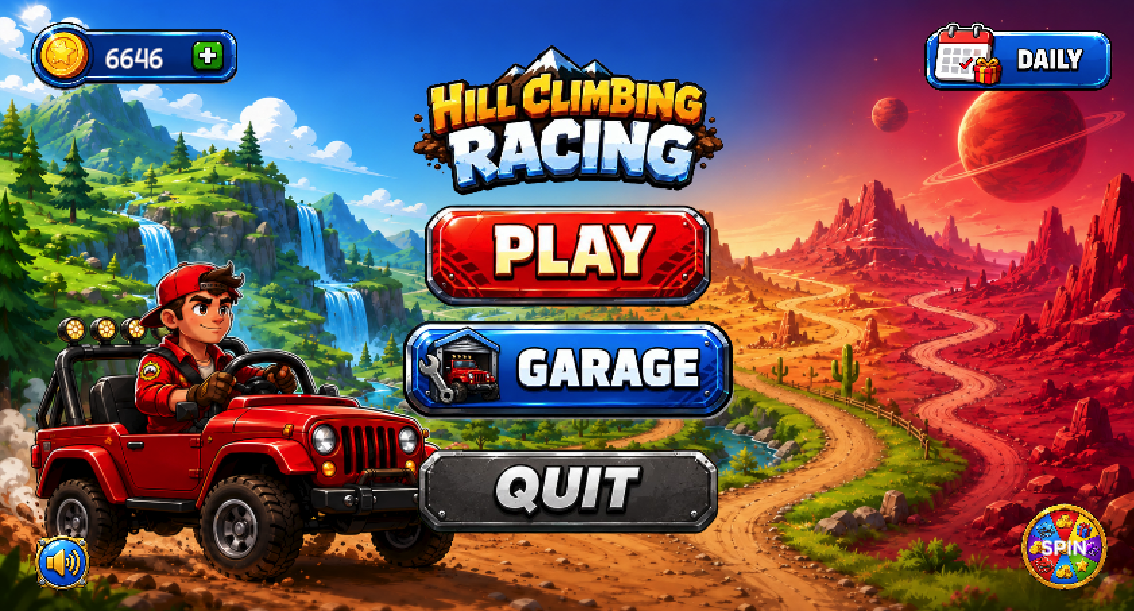
Figure 1. Main Menu of the 2D Hill Climbing Racing Game.

1.2. Game Objective
The main objective of this project is to build a complete 2D racing game with core gameplay mechanics and supporting game systems. The project focuses on creating a playable game loop, a clear user interface, and a progression system that encourages players to continue playing.
The specific objectives of the project are:
- To develop a 2D hill climbing racing game using Unity.
- To implement vehicle movement and physics-based gameplay.
- To create endless terrain gameplay where the player tries to reach the longest distance.
- To implement coin and fuel collection systems.
- To create a Game Over system based on fuel depletion, crash, or head collision.
- To build a Map Selection system with multiple unlockable maps.
- To build a Garage system that allows the player to select unlocked vehicles.
- To implement Lucky Spin and Daily Reward systems to increase player engagement.
- To save player progress such as coins, high score, unlocked maps, unlocked vehicles, and selected vehicle.
- To design a casual mobile-style user interface with buttons, popups, HUD, and sound toggle.

1.3. Technologies Used
The project was developed using Unity as the main game engine. Unity was used to build the game scenes, UI system, physics-based vehicle control, object spawning, collision detection, and scene navigation.
The main technologies and tools used in the project include:
- Unity Engine: used for game development, scene management, physics, UI, and gameplay implementation.
- C#: used as the main programming language for game logic and system scripts.
- Unity UI System: used to create Main Menu, Level Select, Garage, Lucky Spin, Daily Reward, HUD, and Game Over screens.
- PlayerPrefs: used to save local player data such as coins, high score, unlocked maps, unlocked vehicles, selected vehicle, and daily reward progress.
- 2D Physics: used for vehicle movement, collision detection, pickups, and crash detection.
- Sprite Assets: used for vehicles, maps, UI buttons, reward popups, icons, and backgrounds.
- Audio System: used for background music, sound effects, and global mute/unmute functionality.
Overall, the project combines gameplay programming, UI design, asset integration, scene management, and data persistence to create a complete 2D racing game prototype.

1.4. Design Inspiration
The game is inspired by hill climbing and physics-based driving games. These games are enjoyable because the main mechanics are simple, but the player must still carefully control the vehicle to avoid flipping or crashing. This project follows that design idea by combining simple controls with challenging terrain.
The game also uses a casual mobile game style, with colorful UI, clear buttons, reward popups, and progression systems. These elements make the game feel more engaging and suitable for short play sessions.

1.5. Player Experience
The intended player experience is quick, simple, and rewarding. Players can start a run quickly, collect coins and fuel, and try to beat their previous high score. Each run gives the player a chance to earn coins, improve their performance, and unlock more content.
The game is designed so that players can understand the goal without reading complex instructions. The main motivation comes from trying again after each Game Over and using collected coins to unlock new maps or rewards.

1.6. Endless Gameplay Design
The game uses endless gameplay instead of a fixed finish line. This design makes the player’s goal based on distance and survival. The longer the player survives, the better the result.
Endless gameplay also increases replayability because each run can be different depending on the terrain, fuel collection, and vehicle control. The player is not only trying to complete a level, but also trying to improve their own record.

1.7. Resource and Progression Design
The game uses coins and fuel as the two main resources. Fuel directly affects the gameplay because the player needs it to continue driving. Coins are used for long-term progression, such as unlocking maps, using Lucky Spin, and receiving rewards.
Progression systems such as Map Unlocking, Garage, Lucky Spin, and Daily Reward are included to give the player more goals outside the main gameplay. These systems help connect short gameplay sessions with long-term player progress.

No | Item | Description
1 | Design Focus | Single-player distance-based racing experience
2 | Player Motivation | Beat high score and unlock new content
3 | Gameplay Style | Simple controls with physics-based challenge
4 | Main Challenge | Balance the vehicle, manage fuel, and avoid crashing
5 | Endless Design | No finish line; player tries to survive as long as possible
6 | Resource Design | Fuel supports survival, coins support progression
7 | Progression Design | Unlock maps, vehicles, and rewards
8 | Visual Direction | Colorful casual mobile game style

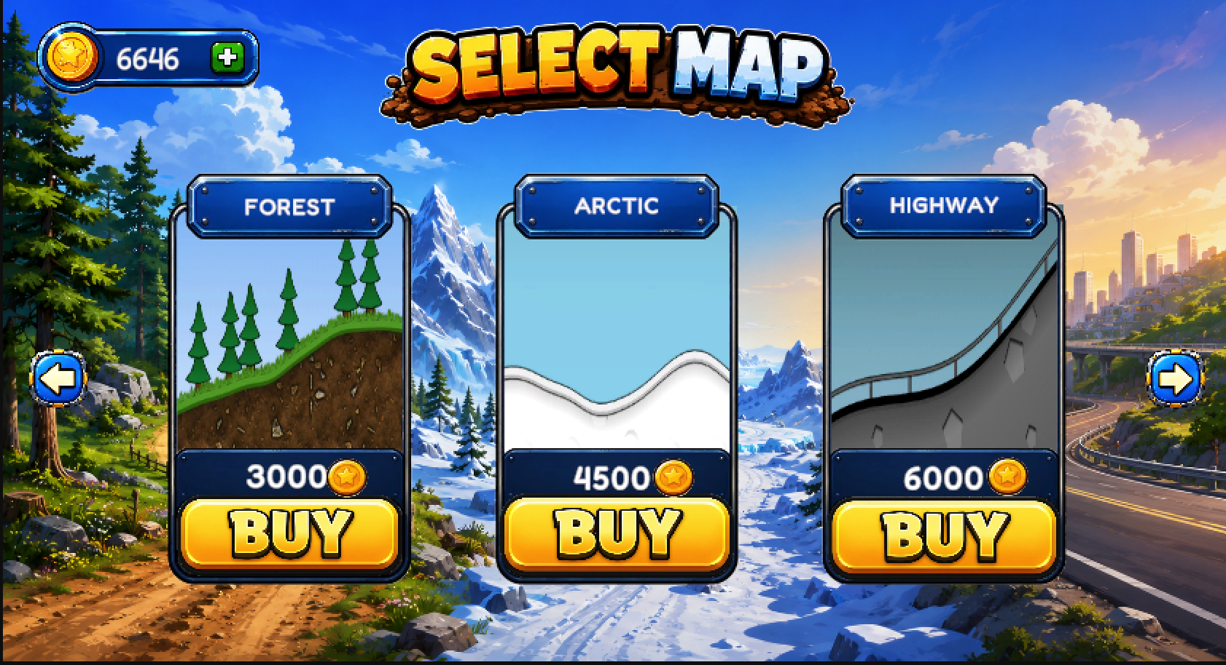
Figure 2. Game concept showing map selection and progression through unlockable maps.

2. Game Systems and Features
This section describes the main systems and features implemented in the game. These systems support the core gameplay loop and provide progression for the player outside the main gameplay scene.
The game includes multiple systems such as Main Menu, Level Select, Map Unlocking, Garage, Vehicle Selection, Coin Economy, Lucky Spin, Daily Reward, Save System, UI/UX, and Audio Toggle. Each system has a clear role and is connected to the player's progression.

2.1 Main Menu System
The Main Menu is the central hub of the game. From this screen, the player can access the main features of the game, including Play, Garage, Lucky Spin, Daily Reward, and Sound Toggle.
The Play button opens the Level Select screen. The Garage button allows the player to view and select unlocked vehicles. The Lucky Spin button opens the reward wheel, while the Daily Reward button allows the player to claim daily rewards. The Sound Toggle button allows the player to mute or unmute all game audio.

2.2 Level Select and Map System
The Level Select system allows the player to choose a map before entering gameplay. The maps are divided into multiple selection pages. Some maps are available by default, while others require coins to unlock.
Locked maps display their coin price and a BUY button. Once a map is unlocked, the button changes to PLAY, allowing the player to enter the selected gameplay scene.
The game currently includes three Level Select pages:
- LevelSelect: Ground, Desert, Mars
- LevelSelect2: Forest, Arctic, Highway
- LevelSelect3: Moon, Alien

No. | Map | Price | Unlock Method
1 | Ground | Free | Default
2 | Desert | 500 Coins | Coin Purchase
3 | Mars | 1500 Coins | Coin Purchase
4 | Forest | 3000 Coins | Coin Purchase
5 | Arctic | 4500 Coins | Coin Purchase
6 | Highway | 6000 Coins | Coin Purchase
7 | Moon | 8500 Coins | Coin Purchase
8 | Alien | 10000 Coins | Coin Purchase
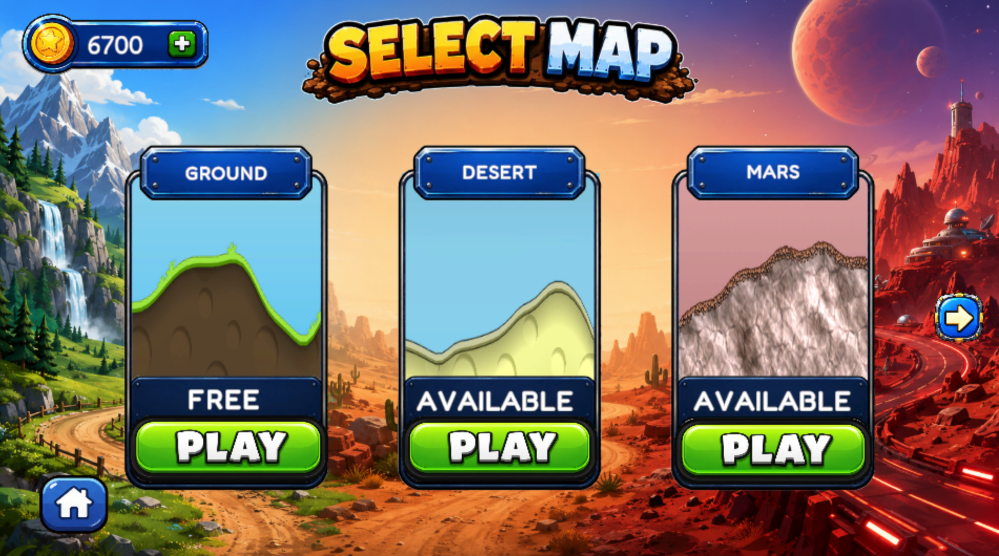
Figure 3: Level Select page showing Ground, Desert, and Mars maps.
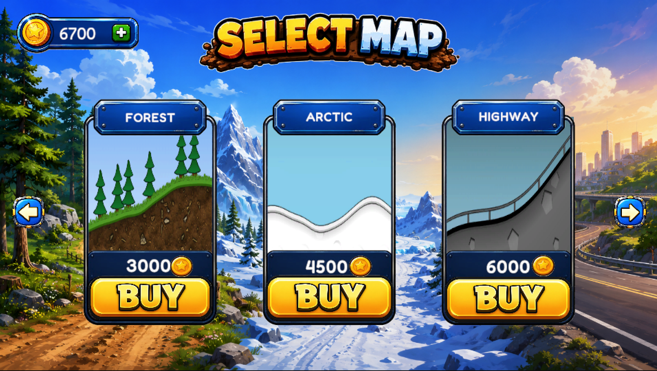
Figure 4. Level Select page showing Forest, Arctic, and Highway maps.
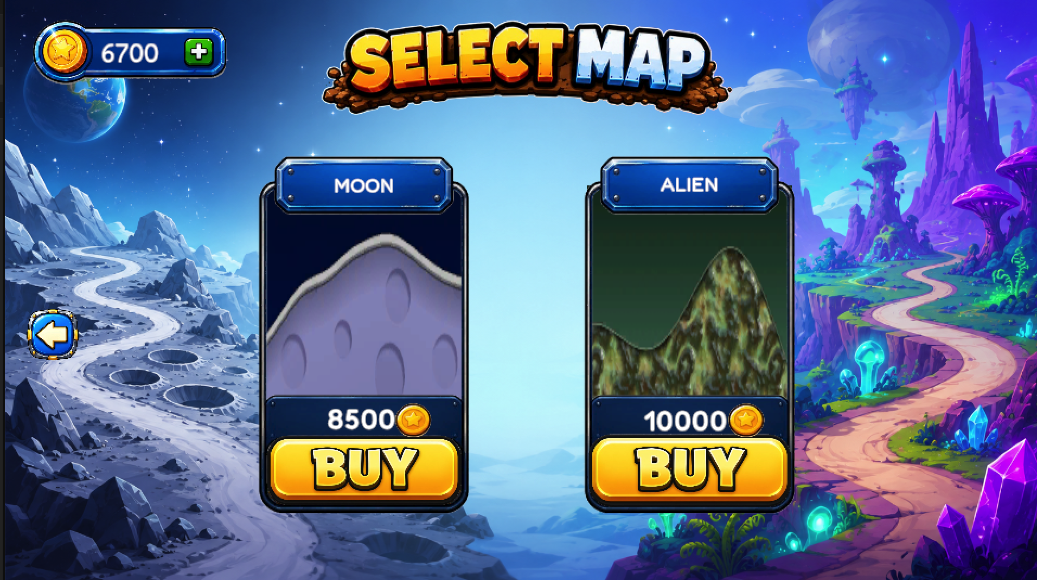
Figure 5: Level Select page showing Moon and Alien maps.

2.3 Gameplay System
The Gameplay system is the core part of the game. After selecting an unlocked map, the player enters the gameplay scene and controls the selected vehicle across endless terrain.
The gameplay system includes vehicle control, terrain interaction, coin collection, fuel collection, distance tracking, high score tracking, and Game Over handling. The player must collect fuel to continue driving and avoid crashing to survive longer.
The gameplay system connects directly with the Save System because collected coins and high score need to be saved after a run.
Main gameplay features include:
- Vehicle movement and physics-based control
- Endless terrain generation
- Coin pickup system
- Fuel pickup system
- Distance tracking
- High score tracking
- Game Over system
- Restart and return to menu functions
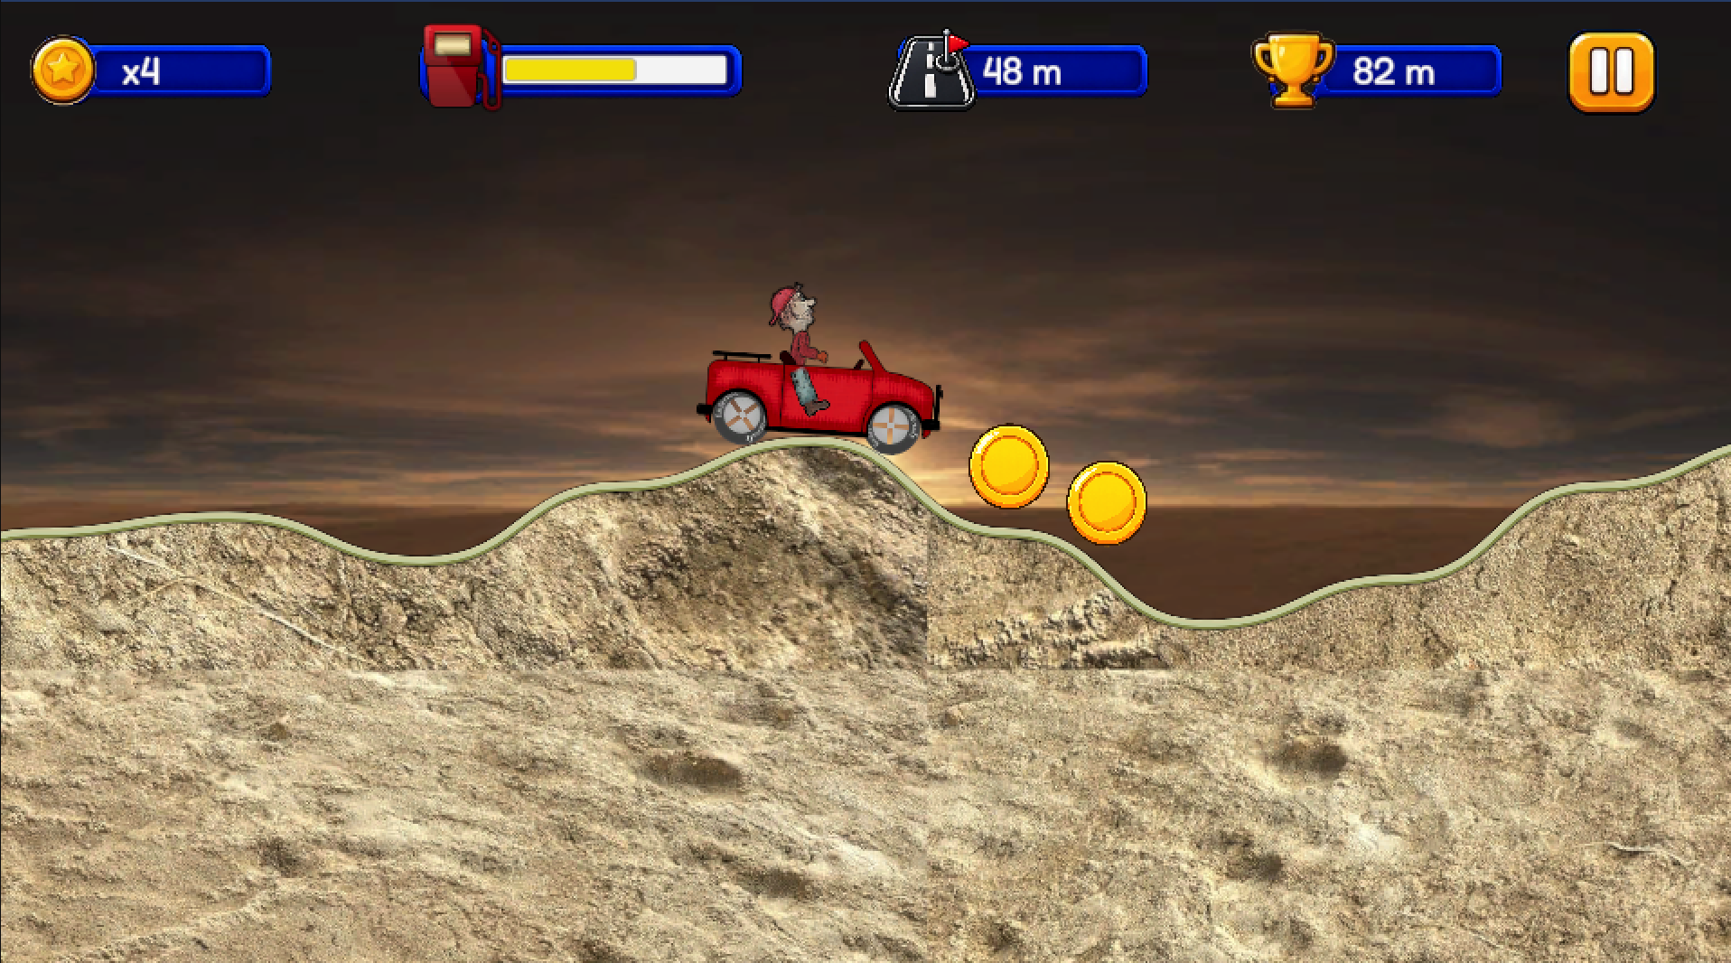
Figure 6. Gameplay system showing vehicle, terrain, pickups, and HUD.

2.4 Garage and Vehicle System
The Garage system allows the player to view and select vehicles. The selected vehicle is saved and automatically loaded when the player enters a gameplay scene.
The game currently includes three main vehicles: Basic Car, F1 Car, and Motor. Basic Car is available by default, while special vehicles can be unlocked through reward systems such as Lucky Spin and Daily Reward.
Table 7. Vehicle List and Unlock Methods
No | Vehicle | Unlock Method | Description
1 | Basic Car | Default | Default vehicle available from the beginning
2 | F1 Car | Lucky Spin | Special vehicle unlocked from Lucky Spin reward
3 | Motor | Daily Reward Day 7 | Special vehicle unlocked from Daily Reward

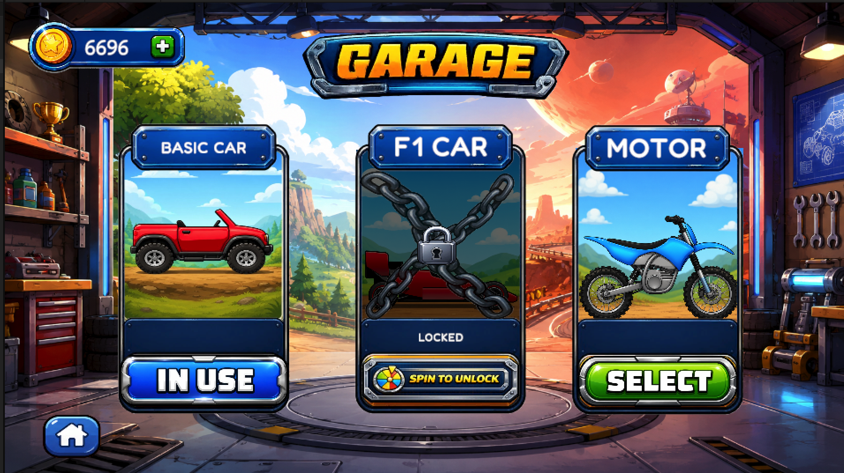
Figure 7 Garage system showing vehicle selection and locked/unlocked states.

2.5 Coin Economy System
Coins are the main currency in the game. The player can collect coins during gameplay and receive coins from reward systems. Coins are used to unlock new maps and participate in Lucky Spin.
The coin economy gives the player long-term progression. Even if a run ends, the player still keeps collected coins and can use them to unlock more content.

No | Coin Source / Usage | Description
1 | Coin Pickup | Coins collected during gameplay
2 | Daily Reward | Coins received from daily login rewards
3 | Lucky Spin Reward | Coins received from spin rewards
4 | Duplicate Vehicle Reward | Duplicate vehicle rewards are converted into coins
5 | Map Unlock | Coins are spent to unlock locked maps
6 | Lucky Spin Cost | Coins are spent to spin the reward wheel
Table 8. Coin Economy Usage

2.6 Lucky Spin System
The Lucky Spin system is a reward feature where the player spends coins to spin a wheel and receive a random reward. Each spin costs coins, and the reward can be coins or a special vehicle.
The most important reward in Lucky Spin is the F1 Car. If the player already owns the F1 Car and receives it again, the duplicate reward is converted into coins. This prevents duplicate rewards from becoming useless.

No | Reward | Type | Description
1 | Coins | Currency | Adds coins to the player's total coins
2 | F1 Car | Vehicle Unlock | Unlocks the F1 Car
3 | Duplicate F1 | Converted Reward | Converted into 500 coins if F1 is already unlocked
Table 9. Lucky Spin Rewards
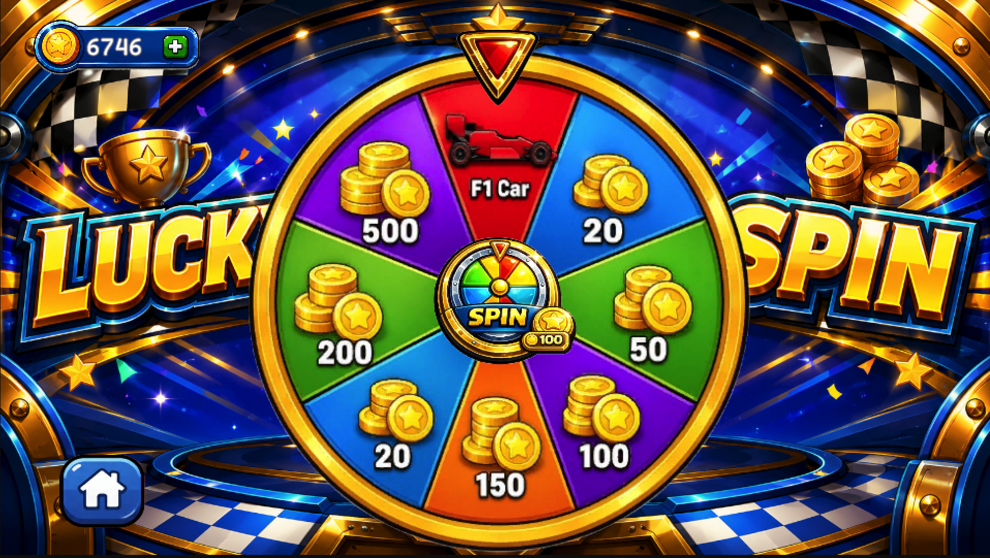
Figure 8 Lucky Spin system with reward wheel and spin button.
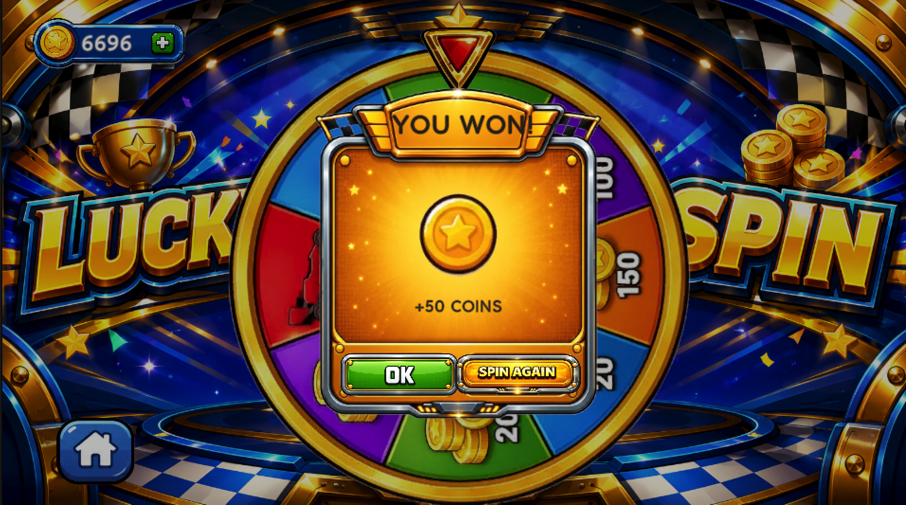
Figure 9 Reward popup displayed after the spin result.

2.7 Daily Reward System
The Daily Reward system gives the player rewards based on daily login progress. The system contains a 7-day reward cycle. From Day 1 to Day 6, the player receives coins. On Day 7, the player can unlock the Motor vehicle.
If the Motor is already unlocked, the Day 7 reward is converted into coins. This system encourages the player to return to the game and continue progressing.
Table 10. Daily Reward List
No. | Day | Reward
1 | Day 1 | 50 Coins
2 | Day 2 | 100 Coins
3 | Day 3 | 150 Coins
4 | Day 4 | 200 Coins
5 | Day 5 | 250 Coins
6 | Day 6 | 300 Coins
7 | Day 7 | Motor Vehicle

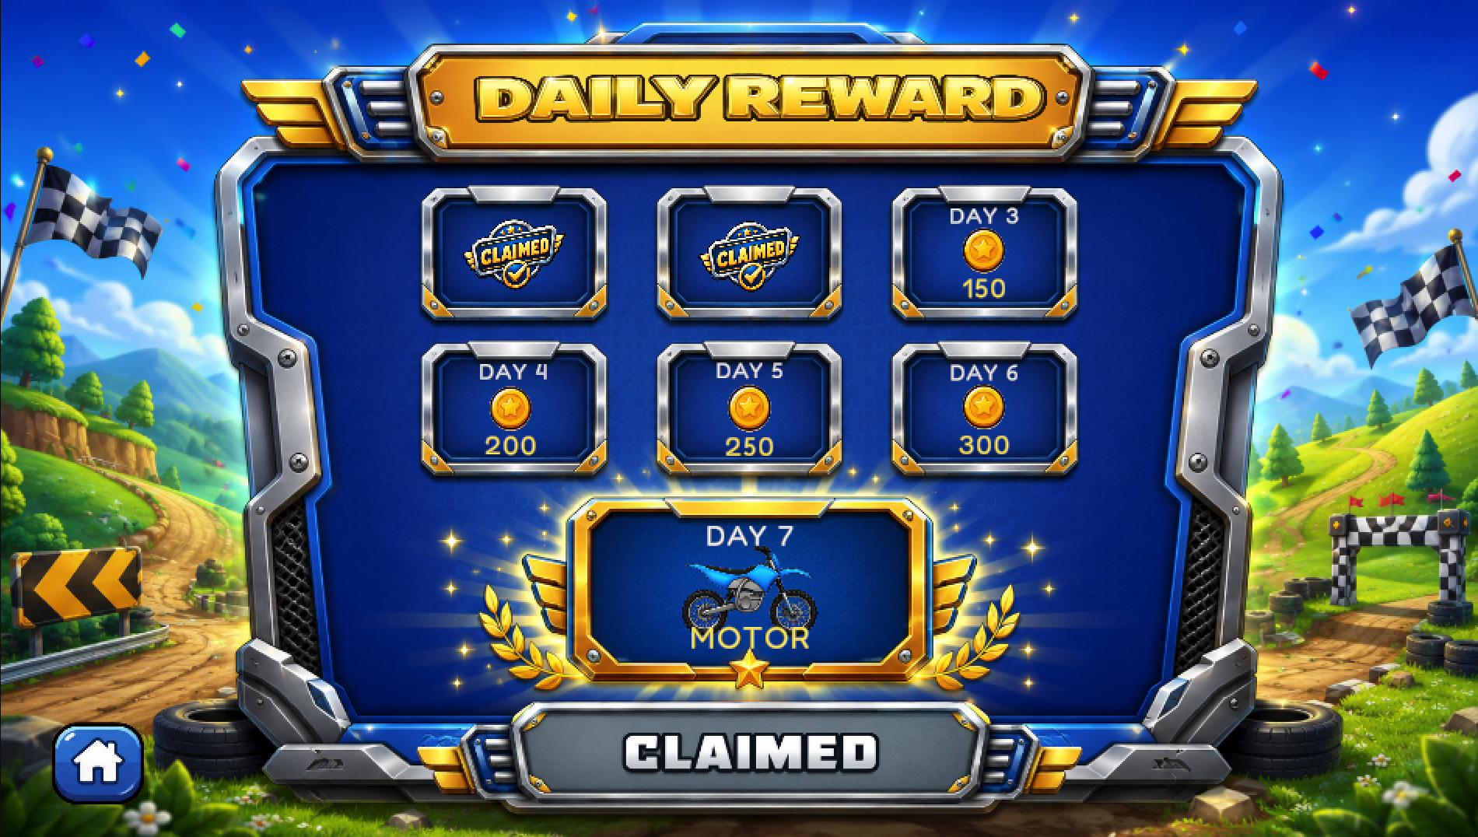
Figure 10. Daily Reward system showing the 7-day reward cycle.
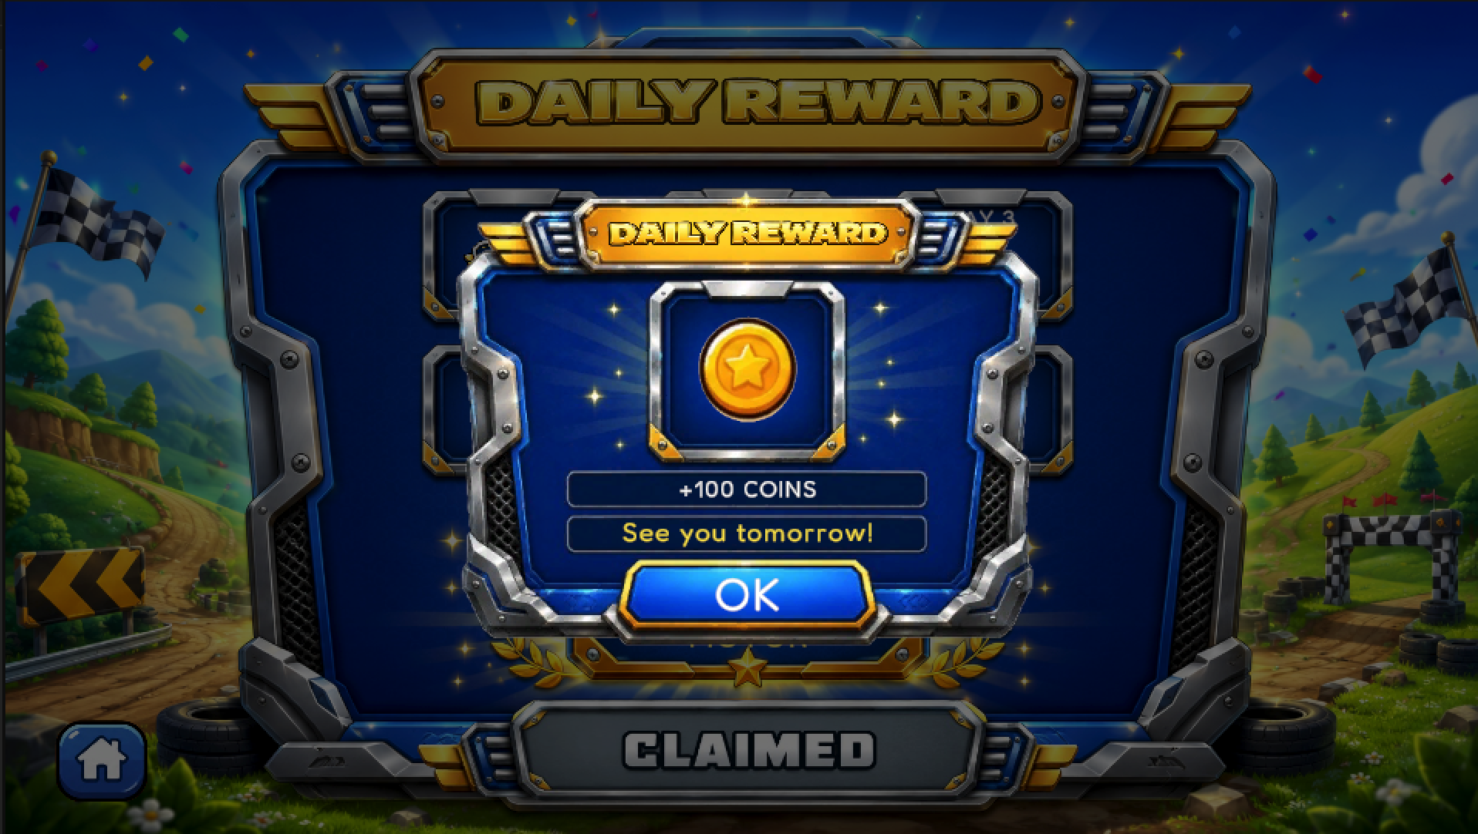
Figure 11. Reward popup displayed after claiming a daily reward.

2.8 Save System and Data Persistence
The Save System is used to store player progress locally. The game saves important data such as total coins, high score, unlocked maps, unlocked vehicles, selected vehicle, daily reward progress, and audio setting.
The project uses PlayerPrefs for local data persistence. This allows the game to keep player progress even after changing scenes or reopening the game.

No | Saved Data | Purpose
1 | Total Coins | Stores the player's current coin amount
2 | High Score | Stores the best distance achieved by the player
3 | Unlocked Maps | Stores which maps have been unlocked
4 | Unlocked Vehicles | Stores which vehicles have been unlocked
5 | Selected Vehicle | Stores the vehicle selected in Garage
6 | Daily Reward Progress | Stores current daily reward status
7 | Audio Muted State | Stores whether game audio is muted or unmuted
Table 11. Saved Data
The Save System helps connect different systems together. For example, the Level Select system checks saved map unlock data, the Garage system checks saved vehicle data, and the Gameplay system saves coins and high score after a run.

2.9 UI/UX Design
The game uses a colorful casual mobile game style. The user interface is designed to be simple, readable, and easy to interact with. Most buttons are large and touch-friendly, which makes the game suitable for mobile-style gameplay.
The UI includes multiple screens such as Main Menu, Level Select, Garage, Lucky Spin, Daily Reward, Gameplay HUD, Pause Menu, and Game Over panel. Each screen has a clear purpose and provides feedback to the player.

No | UI Screen | Purpose
1 | Main Menu | Allows the player to access main game systems
2 | Level Select | Allows the player to choose and unlock maps
3 | Garage | Allows the player to view and select vehicles
4 | Lucky Spin | Allows the player to spin for random rewards
5 | Daily Reward | Allows the player to claim daily rewards
6 | Gameplay HUD | Shows coins, fuel, distance, and high score
7 | Game Over Panel | Shows the result after the run ends
8 | Reward Popup | Shows reward result from spin or daily reward
Table 12. UI Screens
The UI design focuses on clarity and consistency. Locked and unlocked states are displayed clearly, and popups are used to show important results such as rewards, unlocks, and game over.

2.10 Audio Design and Sound Toggle System
The audio system improves the player experience by adding background music and sound effects. Background music is used for menu and gameplay scenes, while sound effects are used for actions such as button clicks, coin pickup, fuel pickup, crash, game over, spin, and rewards.
The game also includes a Sound Toggle button in the Main Menu. This button uses a speaker icon to show the current audio state. When audio is muted, the icon changes to a muted speaker with a red slash. The audio state is saved so that the player's preference remains the same after changing scenes or reopening the game.

No | Audio Feature | Purpose
1 | Menu Background Music | Provides atmosphere in UI scenes
2 | Gameplay Background Music | Provides energy during gameplay
3 | Button Click Sound | Provides feedback when pressing buttons
4 | Coin Pickup Sound | Plays when the player collects coins
5 | Fuel Pickup Sound | Plays when the player collects fuel
6 | Crash Sound | Plays when the vehicle crashes
7 | Game Over Sound | Plays when the run ends
8 | Spin Sound | Plays during Lucky Spin
9 | Reward Sound | Plays when the player receives a reward
10 | Sound Toggle | Allows the player to mute or unmute all game audio
Table 13. Audio Features

Figure 12. Sound Toggle button used to mute or unmute all game audio.

3. Game Architecture
This section describes the overall architecture of the game and explains how the main systems are connected. The project follows a scene-based architecture, where each major feature is separated into its own Unity scene and managed by specific controller scripts.
The architecture is designed to keep the project organized and easy to extend. Main systems such as gameplay, map selection, garage, rewards, saving data, and audio are separated but still connected through shared systems such as SaveSystem and PlayerPrefs.

3.1 Overall Architecture
The game uses the Main Menu as the central hub. From the Main Menu, the player can navigate to different systems such as Level Select, Garage, Lucky Spin, Daily Reward, and gameplay maps.
Each system has its own responsibility:
- Main Menu controls navigation to other scenes.
- Level Select manages map unlocking and map loading.
- Garage manages vehicle selection.
- Gameplay scenes manage vehicle movement, terrain, pickups, HUD, and Game Over.
- Lucky Spin and Daily Reward manage reward systems.
- SaveSystem stores player progress.
- Audio system manages background music, sound effects, and mute/unmute state.
The architecture allows the player to move between different parts of the game while keeping progress saved across scenes.

3.2 Scene Flow Architecture
The project is organized around multiple Unity scenes. The Menu scene acts as the entry point and navigation hub of the game. From the Menu scene, the player can access different systems.
The scene flow can be described as follows:
Menu
→ LevelSelect / LevelSelect2 / LevelSelect3
→ Gameplay Maps
Menu
→ GarageScene
Menu
→ SpinScene
Menu
→ DailyRewardScene
The Level Select scenes are used to choose and unlock maps. When the player selects an unlocked map, the corresponding gameplay scene is loaded. Each gameplay map uses the same general gameplay structure but has different terrain and visual theme.
The main gameplay map scenes include:
- GroundMap
- DessertMap
- MarsMap
- ForestMap
- ArcticMap
- HighwayMap
- MoonMap
- AlienMap
This scene-based structure makes it easier to separate UI scenes from gameplay scenes and reward scenes.

3.3 Core Gameplay Architecture
The gameplay architecture is centered around GameSession. GameSession is responsible for managing the state of a gameplay run, including fuel, coins, distance, high score, and Game Over state.
During gameplay, different objects interact with GameSession:
- HUDController reads data from GameSession and updates the HUD.
- CoinPickup sends coin collection events to GameSession.
- FuelPickup sends fuel collection events to GameSession.
- PlayerHeadCrashDetector triggers Game Over when the player's head collides with terrain.
- GameOverPanel displays the result when the run ends.
The gameplay scene also includes InfiniteTerrain and PickupSpawnerRuntime. InfiniteTerrain is responsible for creating endless terrain, while PickupSpawnerRuntime spawns coin and fuel pickups during gameplay.
This design keeps gameplay logic centralized while allowing pickups, HUD, terrain, and crash detection to work as separate systems.

3.4 Save and Data Architecture
The game uses SaveSystem and PlayerPrefs to store player progress locally. SaveSystem acts as the main access point for saving and loading important player data.
The saved data includes:
- Total coins
- High score
- Unlocked maps
- Unlocked vehicles
- Selected vehicle
- Audio mute/unmute state
- Daily reward progress
Different systems use saved data for different purposes. The Level Select system checks whether a map has been unlocked. The Garage system checks which vehicles are available. The gameplay system saves coins and high score after a run. The reward systems update coins and vehicle unlock status when rewards are received.
Using PlayerPrefs is suitable for this project because the game stores simple local progress data and does not require an online database.

3.5 Vehicle Architecture
The vehicle system connects the Garage scene with the gameplay scenes. In the Garage, the player selects a vehicle. The selected vehicle is saved using SaveSystem. When the player enters a gameplay scene, SelectedVehicleLoader reads the saved vehicle ID and spawns the correct vehicle prefab.
The main vehicle prefabs are:
- Car
- F1Car
- Motor
SelectedVehicleLoader is an important part of the architecture because it ensures that the correct vehicle is used across different gameplay maps. It also helps gameplay scenes share the same vehicle loading logic instead of manually placing a different vehicle in each scene.
This design makes the vehicle system easier to extend. More vehicles can be added in the future by adding new prefabs, unlock logic, and selection data.

3.6 Economy and Reward Architecture
The economy system is based on coins. Coins can be earned from gameplay pickups, Lucky Spin rewards, Daily Rewards, and duplicate reward conversion. Coins can be spent to unlock maps and use Lucky Spin.
The reward systems are connected to the economy system:
- Lucky Spin can reward coins or unlock the F1 Car.
- Daily Reward can reward coins or unlock the Motor vehicle.
- Duplicate vehicle rewards are converted into coins.
Both Lucky Spin and Daily Reward interact with SaveSystem to update player progress. This allows rewards to remain saved after changing scenes or restarting the game.
The economy and reward systems create long-term progression because the player can use resources earned from gameplay to unlock more content.

3.7 UI Architecture
The UI architecture is divided across different scenes. Each scene has its own UI controller or related scripts.
Main UI systems include:
- Main Menu UI
- Level Select UI
- Garage UI
- Lucky Spin UI
- Daily Reward UI
- Gameplay HUD
- Pause Menu
- Game Over Panel
- Reward Popup
The UI is designed to provide clear feedback to the player. For example, locked maps show a BUY button and price, unlocked maps show a PLAY button, selected vehicles show the selected state, and reward popups show the result of Lucky Spin or Daily Reward.
Gameplay HUD is connected to GameSession and displays important gameplay information such as coins, fuel, distance, and high score.

3.8 Audio Architecture
The audio system is used to improve player feedback and game atmosphere. Background music is used in menu and gameplay scenes, while sound effects are used for interactions such as button clicks, coin pickup, fuel pickup, crash, game over, spin, and reward popup.
The game also includes a global sound toggle system. The sound toggle button is placed in the Main Menu and allows the player to mute or unmute all game audio. The audio state is saved so that the player’s preference remains consistent after changing scenes or reopening the game.
A simple global audio control approach can be implemented using AudioListener.volume. When the game is muted, the volume is set to 0. When sound is enabled, the volume is set back to 1.

3.9 Architecture Summary
The game architecture is built around clear separation of responsibilities. Scene navigation is handled from the Menu and UI scenes, gameplay state is managed by GameSession, player progress is saved through SaveSystem, and vehicle loading is handled by SelectedVehicleLoader.
This architecture makes the project easier to manage because each major system has a specific role. It also allows the game to be expanded in the future with more maps, vehicles, rewards, audio features, and progression systems.

4. Main Scripts and Responsibilities
This section describes the main scripts used in the project and explains their responsibilities. Each script is connected to a specific system such as menu navigation, map selection, gameplay, saving data, vehicle loading, rewards, UI, or audio.
The project follows a component-based Unity structure, where different GameObjects contain scripts responsible for different parts of the game. This structure makes the project easier to manage, test, and expand.

4.1 Main Script Responsibility Table
No. | Script | Path | Responsibility | Connected Systems
1 | MainMenuController | Assets/Scipts/Loadgame/MainMenuController.cs | Handles Main Menu navigation to Level Select, Garage, Daily Reward, and Lucky Spin | SaveSystem, SceneManager
2 | MapSelectController | Assets/Scipts/Loadgame/MapSelectController.cs | Manages Level Select page 1 with Ground, Desert, and Mars maps | MapCardUI, SaveSystem, SceneManager
3 | MapSelect2Controller | Assets/Scipts/Loadgame/MapSelect2Controller.cs | Manages Level Select page 2 with Forest, Arctic, and Highway maps | MapCardUI, SaveSystem, SceneManager
4 | MapSelect3Controller | Assets/Scipts/Loadgame/MapSelect3Controller.cs | Manages Level Select page 3 with Moon and Alien maps | MapCardUI, SaveSystem, SceneManager
5 | MapCardUI | Assets/Scipts/Loadgame/MapCardUI.cs | Updates map card UI such as BUY, PLAY, price, and unlocked state | Map Select System, SaveSystem
6 | GameSession | Assets/Scipts/Economy/GameSession.cs | Manages core gameplay state such as fuel, coins, distance, high score, and game over | HUDController, Pickups, SaveSystem, GameOverPanel
7 | HUDController | Assets/Scipts/Economy/HUDController.cs | Updates gameplay HUD information such as coin, fuel, distance, and high score | GameSession
8 | CoinPickup | Assets/Scipts/Economy/CoinPickup.cs | Handles coin pickup collision and adds coins to the current run | GameSession, Pickup System
9 | FuelPickup | Assets/Scipts/Economy/FuelPickup.cs | Handles fuel pickup collision and increases current fuel | GameSession, Pickup System
10 | GameOverPanel | Assets/Scipts/Economy/GameOverPanel.cs | Displays Game Over UI and handles restart or return to menu | GameSession, SceneManager
11 | PauseManager | Assets/Scipts/Loadgame/PauseManager.cs | Handles pause, resume, restart, and return to menu during gameplay | GameSession, SceneManager
12 | SaveSystem | Assets/Scipts/Economy/SaveSystem.cs | Saves and loads player progress such as coins, high score, unlocked maps, unlocked vehicles, and selected vehicle | PlayerPrefs, All Main Systems
13 | GaragePlaceholderController | Assets/Scipts/Loadgame/GaragePlaceholderController.cs | Manages Garage UI, vehicle locked state, selection state, and selected vehicle saving | SaveSystem, Vehicle System
14 | SelectedVehicleLoader | Assets/Scipts/Vehicel/SelectedVehicleLoader.cs | Loads and spawns the selected vehicle prefab into gameplay scenes | SaveSystem, Vehicle Prefabs, GameSession
15 | VehicelControl | Assets/Scipts/Vehicel/VehicelControl.cs | Controls vehicle movement and physics behavior | Gameplay System, Vehicle Prefabs
16 | PlayerHeadCrashDetector | Assets/Scipts/Vehicel/PlayerHeadCrashDetector.cs | Detects head collision and triggers Game Over | GameSession, Terrain
17 | InfiniteTerrain | Assets/Scipts/Maps/InfiniteTerrain.cs | Generates endless terrain for gameplay maps | Player, GameSession, Map System
18 | PickupSpawnerRuntime | Assets/Scipts/Maps/PickupSpawnerRuntime.cs | Spawns coin and fuel pickups during gameplay | CoinPickup, FuelPickup, Terrain
19 | LuckySpinController | Assets/Scipts/Loadgame/LuckySpinController.cs | Handles spin cost, reward selection, wheel animation, reward popup, and F1 unlock | SaveSystem, SpinScene, Reward System
20 | DailyRewardController | Assets/Scipts/Loadgame/DailyRewardController.cs | Handles 7-day reward cycle, reward popup, coin rewards, and Motor unlock | SaveSystem, PlayerPrefs, DailyRewardScene
21 | PersistentBackgroundMusic | Assets/Scipts/Audio/PersistentBackgroundMusic.cs | Manages persistent background music across UI scenes | AudioSource, Menu/UI Scenes
22 | AudioSettingsController | Assets/Scipts/Audio/AudioSettingsController.cs | Manages global mute/unmute state for all game audio | AudioListener, PlayerPrefs
23 | SoundToggleButtonUI | Assets/Scipts/Loadgame/SoundToggleButtonUI.cs | Updates speaker icon and toggles audio state from Main Menu | AudioSettingsController, Main Menu UI
Table 14. Main Scripts and Responsibilities

4.2 Script Groups by System
The scripts can be grouped based on the system they belong to. This helps explain how different parts of the project are organized.

No | System | Scripts | Purpose
1 | Menu and Navigation | MainMenuController, PauseManager | Handles navigation between scenes and gameplay pause actions
2 | Map Selection | MapSelectController, MapSelect2Controller, MapSelect3Controller, MapCardUI | Handles map display, map purchase, and map loading
3 | Core Gameplay | GameSession, HUDController, GameOverPanel | Handles gameplay state, HUD updates, and Game Over flow
4 | Pickup System | CoinPickup, FuelPickup, PickupSpawnerRuntime | Handles coin and fuel spawning and collection
5 | Terrain System | InfiniteTerrain | Handles endless terrain generation
6 | Vehicle System | GaragePlaceholderController, SelectedVehicleLoader, VehicelControl, PlayerHeadCrashDetector | Handles vehicle selection, loading, movement, and crash detection
7 | Reward System | LuckySpinController, DailyRewardController | Handles spin rewards and daily rewards
8 | Save System | SaveSystem | Handles persistent player data
9 | Audio System | PersistentBackgroundMusic, AudioSettingsController, SoundToggleButtonUI | Handles background music, audio state, and sound toggle button
Table 15. Script Groups by System

4.3 Important Script Connections
Several scripts act as bridges between systems. SaveSystem is one of the most important scripts because it connects many parts of the game. It stores coins, high score, unlocked maps, unlocked vehicles, and selected vehicle data.
GameSession is the core script for gameplay scenes. It connects with HUDController, CoinPickup, FuelPickup, GameOverPanel, and SaveSystem. This makes GameSession responsible for managing what happens during a gameplay run.
SelectedVehicleLoader connects the Garage system with gameplay scenes. It reads the selected vehicle from SaveSystem and spawns the correct vehicle prefab when the gameplay scene starts.
MapCardUI connects the visual UI of map cards with the map selection controllers. It updates the card state based on whether the map is locked or unlocked.
LuckySpinController and DailyRewardController connect reward systems with SaveSystem. They can add coins, unlock vehicles, and update player progress.

5. Testing
This section describes the testing process used to verify the main features of the game. The purpose of testing is to ensure that core gameplay, UI navigation, map unlocking, vehicle selection, reward systems, save data, and audio controls work correctly.
Testing was performed manually by running the game in Unity Editor and checking each system through normal player actions. Each test case was designed based on the expected behavior of the game.

5.1 Testing Scope
The testing scope includes the main systems that affect the player experience and game progression. These systems include menu navigation, level selection, gameplay, garage, economy, rewards, save system, and audio toggle.
The tested systems are:
- Main Menu navigation
- Level Select and map unlocking
- Gameplay scene loading
- Vehicle selection and spawning
- Coin and fuel collection
- Fuel depletion and Game Over
- Crash and head hit detection
- Garage vehicle selection
- Lucky Spin reward system
- Daily Reward system
- Save and load player progress
- Audio mute/unmute toggle

5.2 Test Cases
No | Test Case | Test Steps | Expected Result | Status
1 | Open Main Menu | Run the game from the first scene | Main Menu is displayed correctly | Pass
2 | Click Play | Click the Play button in Main Menu | Level Select scene is opened | Pass
3 | Open Garage | Click the Garage button in Main Menu | GarageScene is opened | Pass
4 | Open Lucky Spin | Click the Lucky Spin button in Main Menu | SpinScene is opened | Pass
5 | Open Daily Reward | Click the Daily Reward button in Main Menu | DailyRewardScene is opened | Pass
6 | Buy locked map with enough coins | Select a locked map when player has enough coins | Coins are deducted and the map becomes unlocked | Pass
7 | Buy locked map without enough coins | Select a locked map when player does not have enough coins | Map is not unlocked and the player cannot enter | Pass
8 | Play unlocked map | Click PLAY on an unlocked map | Correct gameplay scene is loaded | Pass
9 | Navigate map pages | Click left or right navigation button | Correct Level Select page is loaded | Pass
10 | Select vehicle in Garage | Choose an unlocked vehicle in Garage | Selected vehicle is saved | Pass
11 | Enter gameplay after selecting vehicle | Start gameplay after selecting a vehicle | Correct vehicle is spawned in gameplay scene | Pass
12 | Collect coin | Drive into a coin pickup | Coin amount increases | Pass
13 | Collect fuel | Drive into a fuel pickup | Fuel amount increases | Pass
14 | Fuel reaches zero | Let fuel decrease to zero | Game Over panel is displayed | Pass
15 | Head hits terrain | Make the player's head collide with terrain | Game Over panel is displayed | Pass
16 | Restart after Game Over | Click restart on Game Over panel | Current gameplay scene restarts | Pass
17 | Return to Menu after Game Over | Click menu/home button on Game Over panel | Main Menu is loaded | Pass
18 | Use Lucky Spin | Spin the reward wheel with enough coins | Coins are deducted and reward popup is displayed | Pass
19 | Claim Daily Reward | Click claim button in Daily Reward scene | Reward is received and saved | Pass
20 | Toggle sound off | Click speaker button in Main Menu | All game audio is muted and icon changes to muted state | Pass
21 | Toggle sound on | Click speaker button again | Game audio is enabled and icon returns to normal state | Pass
22 | Check save data after scene change | Unlock map or select vehicle, then change scene | Progress remains saved | Pass
23 | Check save data after restarting game | Close and reopen the game | Coins, unlocked maps, selected vehicle, and audio state remain saved | Pass
Table 16. Game Testing Test Cases

5.3 Testing Result
The testing results show that the main systems of the game work as expected. The player can navigate between scenes, unlock maps, select vehicles, play gameplay maps, collect coins and fuel, trigger Game Over, receive rewards, and save progress.
The Save System was also tested to ensure that important player data remains available after changing scenes or restarting the game. The audio toggle was tested to confirm that all game audio can be muted and unmuted from the Main Menu.
Overall, the game is playable and the main features are functional. Minor improvements can still be added in the future, such as more sound effects, more vehicles, better visual effects, and additional gameplay balancing.

6. Conclusion
This project successfully developed a complete 2D hill climbing racing game using Unity. The game includes the main elements of a casual racing game, such as vehicle control, endless terrain, coin collection, fuel management, distance tracking, high score saving, and Game Over handling.
In addition to the core gameplay, the project also implemented several supporting systems to improve player engagement and progression. These systems include Level Select, map unlocking, Garage, vehicle selection, Lucky Spin, Daily Reward, Save System, UI/UX design, audio effects, and global sound toggle. These features help make the game feel more complete and provide the player with both short-term and long-term goals.
The game uses a scene-based architecture, where each major feature is separated into different Unity scenes. Important gameplay and data systems are managed by scripts such as GameSession, SaveSystem, MapSelectController, GaragePlaceholderController, SelectedVehicleLoader, LuckySpinController, and DailyRewardController. This structure helps keep the project organized and makes it easier to maintain or expand in the future.
Testing results show that the main systems of the game work as expected. The player can navigate between scenes, unlock maps, select vehicles, play gameplay maps, collect coins and fuel, trigger Game Over, receive rewards, save progress, and control the audio state.
Overall, the project achieved its main objectives by creating a playable 2D racing game prototype with multiple game systems and progression features. In the future, the game can be improved further by adding more vehicles, more maps, a vehicle upgrade system, online leaderboard, missions, particle effects, and better mobile optimization.

