# v1

# Created on June 12 2018

# Table of Contents

1.0. BasicDisplay

2.0. DisplayModelDetail

# 1.0. BasicDisplay

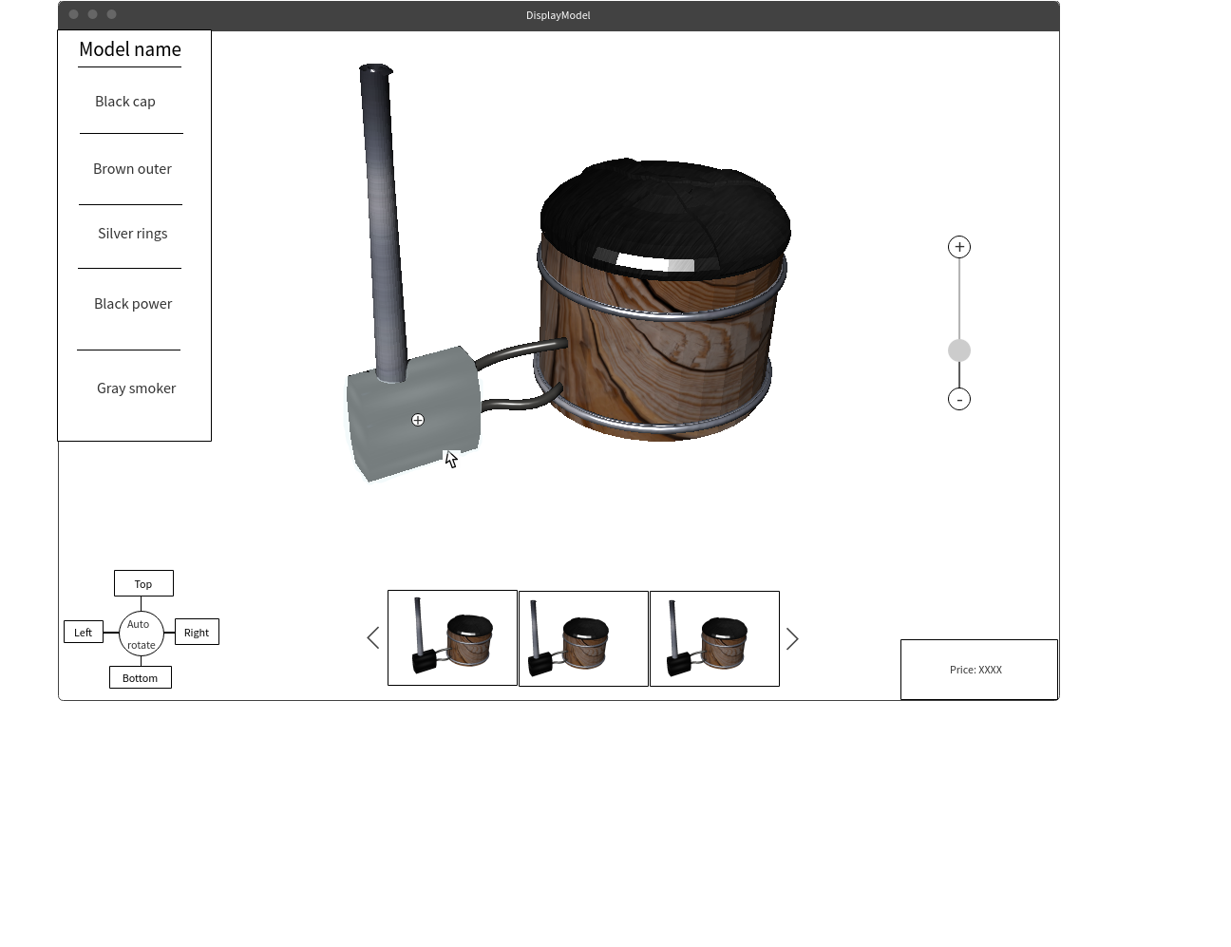

A sidebar is added, for information purpose. It displays the current option of each object of model. User will not interact with this sidebar. When users hover pointer on object, it will be blur (opposite to what we have discussed, but it’s worked better I think). Together with being blurred, the (+) button will appear as well. There are two functions:

-Users click on this blurred area of the object and the list of available option of that object will be displayed.

-Users click on the plus button, the table of keys/values will be displayed. The table can be expanded to a modal.

# 2.0. DisplayModelDetail

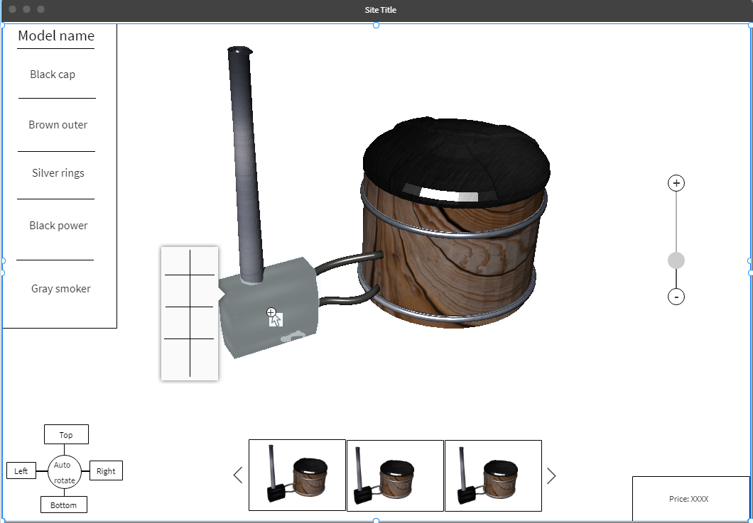

Above is the vertical list of object’s options. Each object has its own list of options, will be fetched JSON file.