**controllers/Account.java**

This is used to process request from several actions, such as “dologin”, “dologout”, “docomment”…

The action “docomment” is recently added to serve the POST comment purpose.

**Configuration Files/context.xml**

This file is used to connect to the database, either remote or local.

**data/AccountDB**

Method comment is added to query comment action to the database.

Web Pages/shop.jsp

Display all the articles, which is fetched using GET method from table articles in the database. Search function use GET method which is being served in this file.

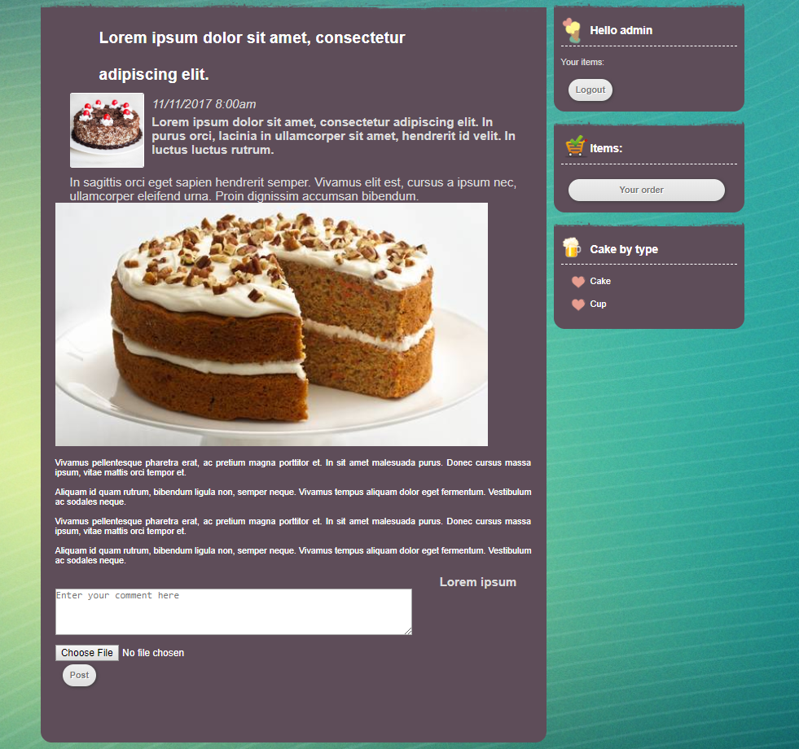

Comment and post photo box is displayed only when users are logged in.

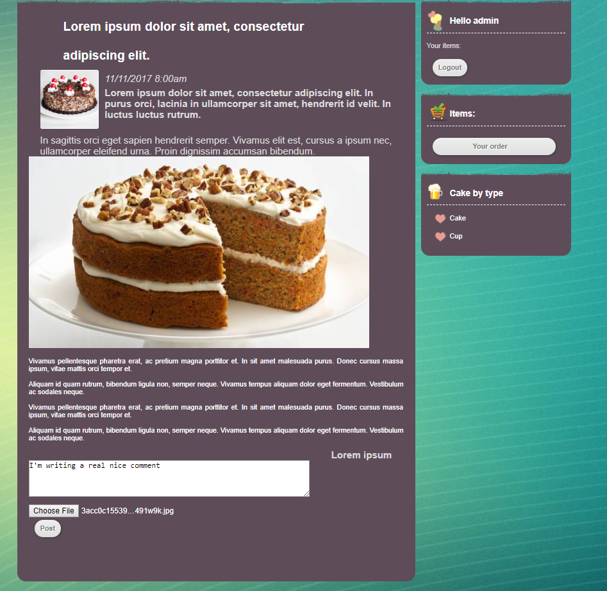



Pictures and comments are saved to database using POST method.