Supplementary Material 1

Physiologically-based Pharmacokinetic Modeling as a New Approach Methodology for Monoclonal Antibodies

S1A.
(i) Monkey
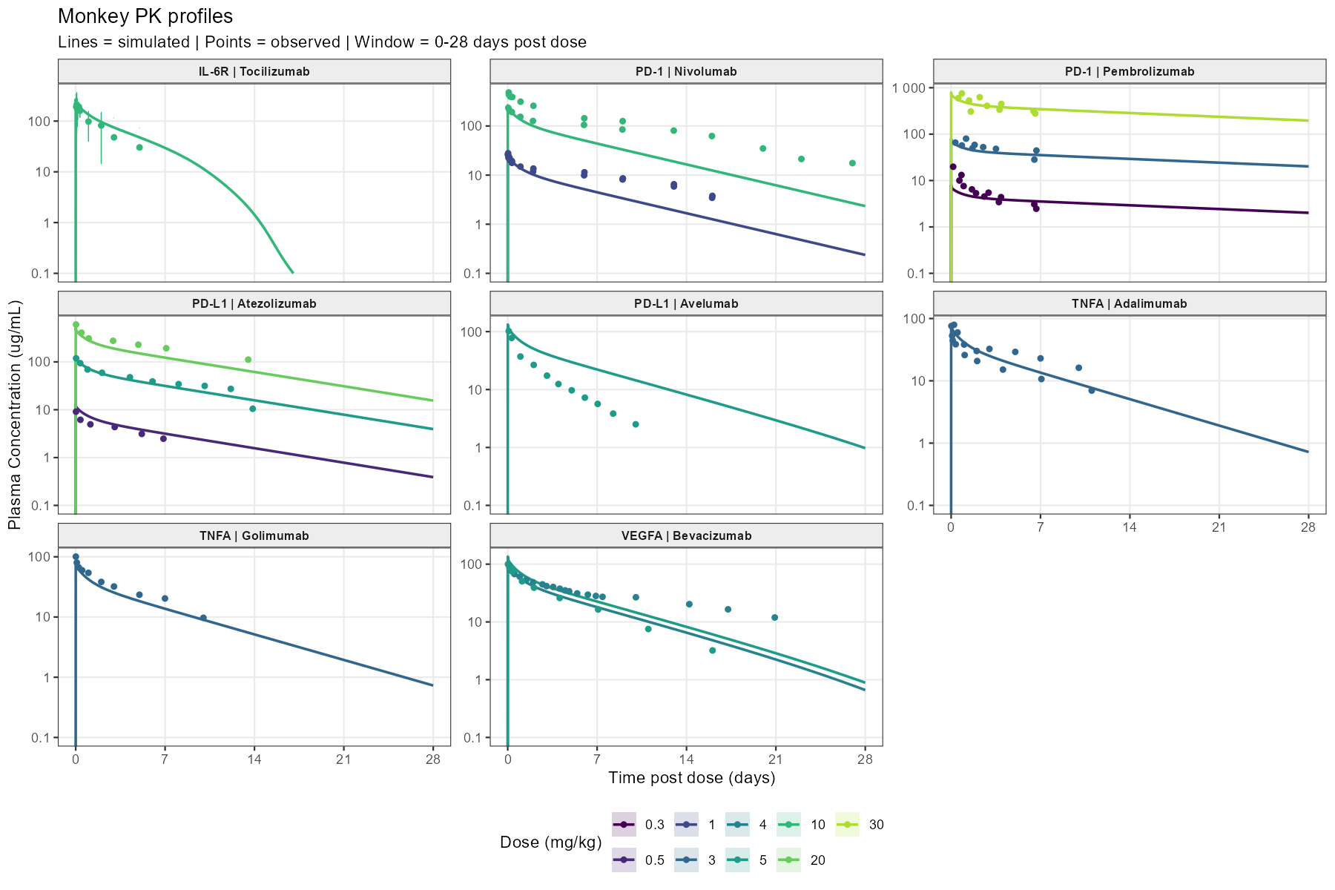
(ii) Human
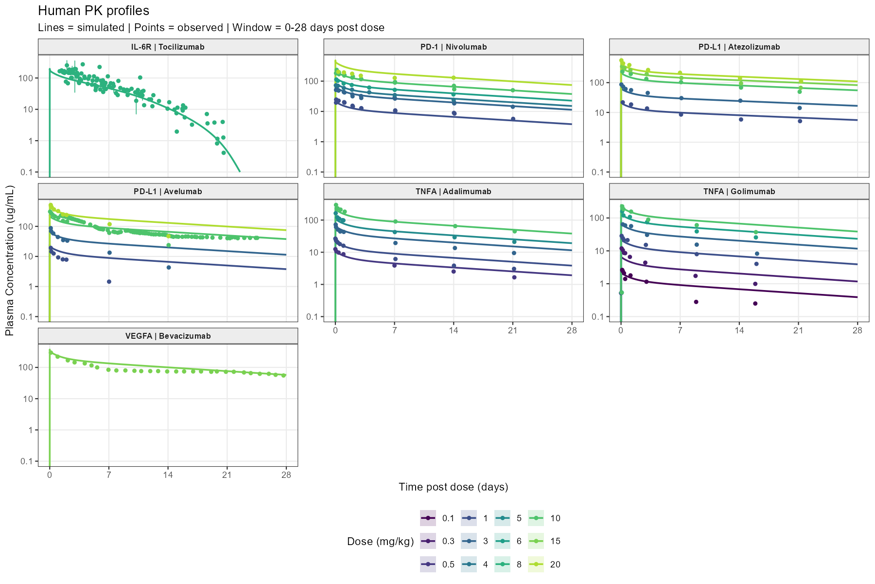

S1B.
(i) Monkey
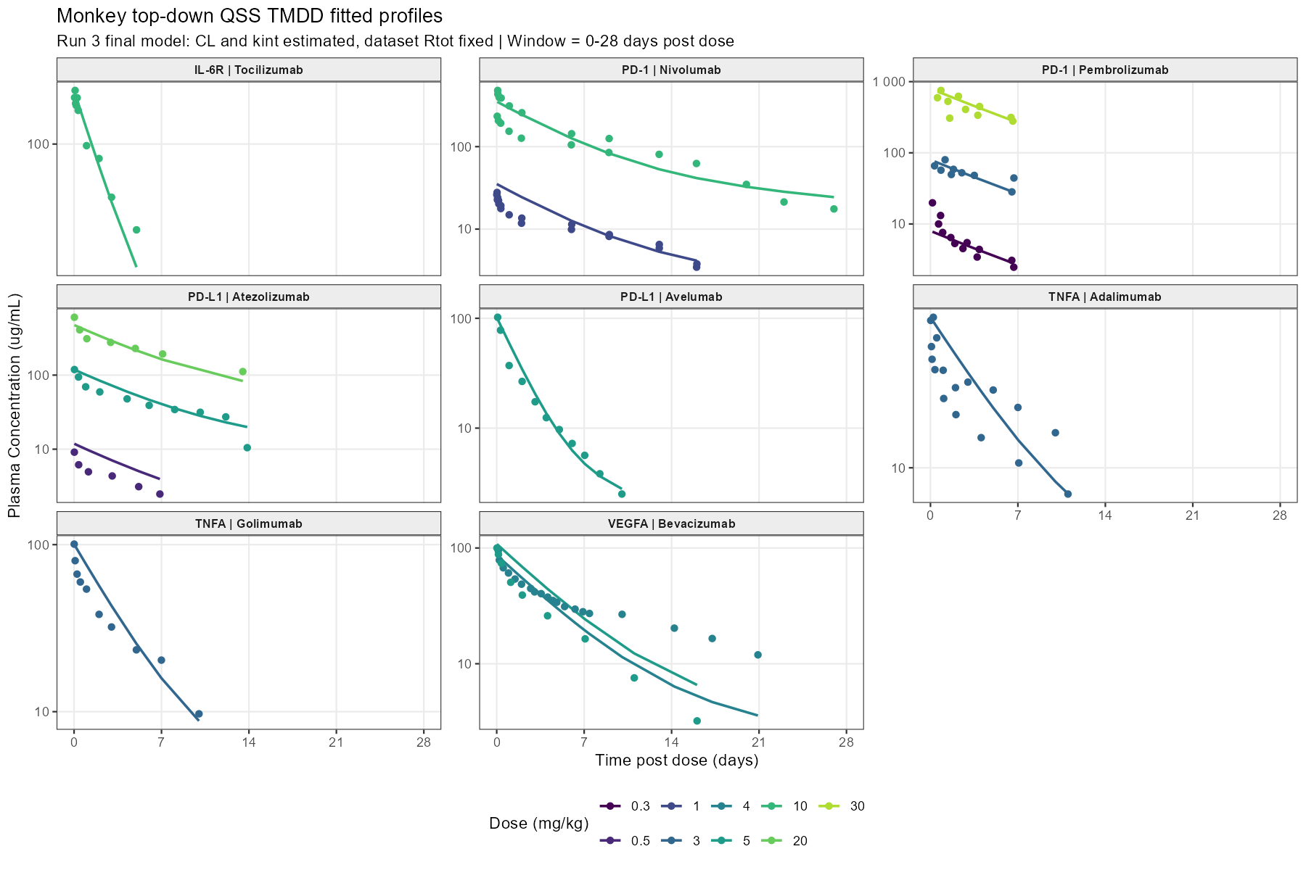
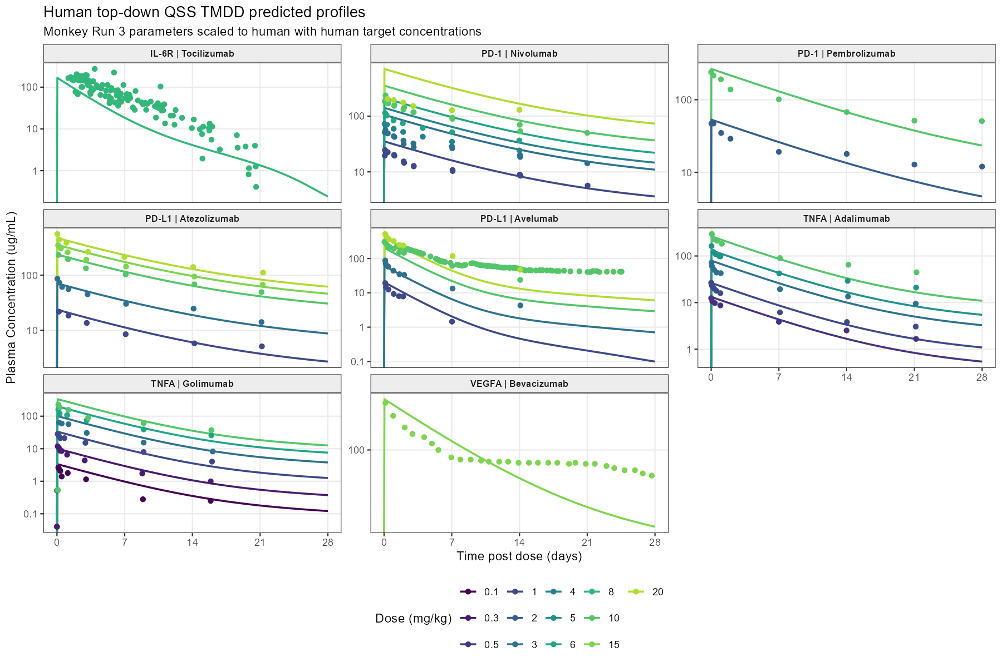
(ii) Human

